Pin
Pin | Function | ESP-8266 Pin
TX | TXD | TXD
RX | RXD | RXD
A0 | Analog input, max 3.3V input | A0
D0 | IO | GPIO16
D1 | IO, SCL | GPIO5
D2 | IO, SDA | GPIO4
D3 | IO, 10k Pull-up | GPIO0
D4 | IO, 10k Pull-up, BUILTIN_LED | GPIO2
D5 | IO, SCK | GPIO14
D6 | IO, MISO | GPIO12
D7 | IO, MOSI | GPIO13
D8 | IO, 10k Pull-down, SS | GPIO15
G | Ground | GND
5V | 5V | -
3V3 | 3.3V | 3.3V
RST | Reset | RST
All IO have interrupt/pwm/I2C/one-wire supported(except D0)

Programming
The D1 mini has a micro USB for auto programming.
Also you can programming it using OTA.

Warnings
All IO is work at 3.3V.

Installing Hardware package
There is two ways to install hardware package, Boards Manager and git.

Installing with Boards Manager
Starting with 1.6.4, Arduino allows installation of third-party platform packages using Boards Manager. We have packages available for Windows, Mac OS, and Linux (32 and 64 bit).
1. Install Arduino 1.6.7 from the Arduino website.

2. Start Arduino and open Preferences window.

3. Enter

http://arduino.esp8266.com/stable/package_esp8266com_index.json

into Additional Boards Manager URLs field.
You can add multiple URLs, separating them with commas.

4. Open Tools→Board:xxx→Boards Manager and install esp8266 by ESP8266 Community
(and don't forget to select your ESP8266 board from Tools > Board menu after installation).

Installing use git (Recommend)
We recommend using git to install Hardware package, you can always get the latest version of it.

Install Arduino
Install Arduino 1.6.7 from the Arduino website.

Clone repository
Clone repository into Sketchbook_directory/hardware/esp8266com/esp8266 directory (or clone it elsewhere and create a symlink), you may need to create the hardware directory if it does not exist.
cd hardware
mkdir esp8266com
cd esp8266com
git clone https://github.com/esp8266/Arduino.git esp8266
You should end up with the following directory structure:
─┬ Arduino
└─┬ hardware
└─┬ esp8266com
└─┬ esp8266
├── bootloaders
├── cores
├── doc
├── libraries
├── package
├── tests
├── tools
├── variants
├── platform.txt
├── programmers.txt
├── README.md
├── boards.txt
├── LICENSE

Download binary tools
cd esp8266/tools
python get.py

Restart the Arduino IDE
To get the latest version anytime, in Sketchbook_directory/hardware/esp8266com/esp8266 simply run
git pull

Restart the Arduino IDE
To get the latest version anytime, in Sketchbook_directory/hardware/esp8266com/esp8266 simply run
git pull

Configure Board
After install hardware package, you will see WeMos boards in the Tools→Board:xxx
Choose your own board.
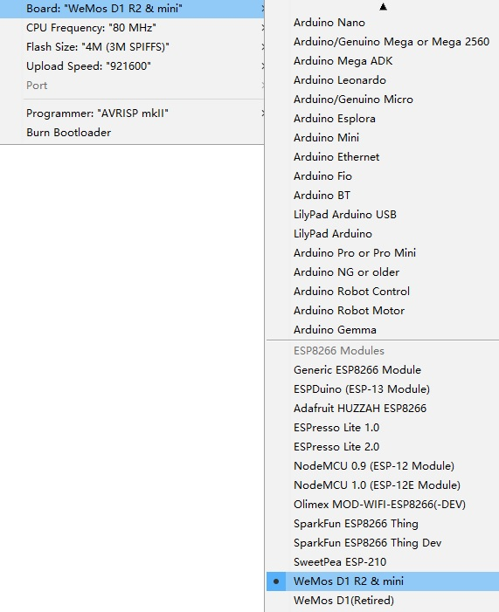
Upload Using:
Serial – Use USB port on board to upload flash
OTA – Use OTA to upload flash

CPU Frequency:
80MHz
160MHz

Flash Size:
4M (3M SPIFFS) – 3M File system size
4M (1M SPIFFS) – 1M File system size

Upload Speed:
921600 bps – recommend

Installing Examples

Simple Way
- Download Examples files form here.
- Rename the uncompressed directory to D1_mini_Examples
- Move directory to Sketchbook_directory
- The path will look like Sketchbook_directory/D1_mini_Examples
- Restart the Arduino IDE
- All examples are under File→Sketchbook→D1_mini_Examples

Git Way (Recommend)
We recommend using git to install Examples, you can always get the latest version of it.
- Clone repository into Sketchbook_directory directory (or clone it elsewhere and create a symlink).
cd Sketchbook_directory
git clone https://github.com/wemos/D1_mini_Examples.git

