中南大学

Web应用开发技术
实验报告

姓 名： | 范文韬
学 号： | XJ20192501226
班 级： | 软件工程1903
指导老师： | 宋 铁
完成时间： | 2021/2/9
分 数：
批阅日期：
实验一 基于MVC用JSP/Servlet实现JPetStore

- 实验内容——基本任务。
- 商品展示业务模块，包括大类Category、小类Product和具体商品Item的展示和搜索功能。

1.1实现Category类：

（1）实现思路：大类Category先实现Category.jsp进行大类的具体展示，利用jsp中c:foreach语法对每个大类进行展示，具体类的ID利用a标签进行跳转到小类进行查看，接下来实现domain层的Category.java，完成大类的基础设计，接下来实现persistence中的数据库连接层，先写DAO定义所有接口，再写实现的Implement方法，对数据库进行操作；再写一个Category的Service类，可以在Servlet层中调用该类的相关方法进行进一步操作，最后完成ViewCategoryServlet对jsp页面与业务层进行连接跳转。

（2）Category类实现代码：
- package org.csu.mypetstore.domain;

- import java.io.Serializable;

- public class Category implements Serializable {

- private static final long serialVersionUID = 3992469837058393712L;

- private String categoryId;
- private String name;
- private String description;

- public String getCategoryId() {
- return categoryId;
- }

- public void setCategoryId(String categoryId) {
- this.categoryId = categoryId.trim();
- }

- public String getName() {
- return name;
- }

- public void setName(String name) {
- this.name = name;
- }

- public String getDescription() {
- return description;
- }

- public void setDescription(String description) {
- this.description = description;
- }

- public String toString() {
- return getCategoryId();
- }

- }

（2）web.Servlet中的 ViewCategoryServlet实现代码：
- public class ViewCategoryServlet extends HttpServlet {
- private static final String VIEW_CATEGORY = "/WEB-INF/jsp/catalog/Category.jsp";
- private String categoryId;

- protected void doPost(HttpServletRequest request, HttpServletResponse response) throws ServletException, IOException {
- doGet(request, response);
- }

- protected void doGet(HttpServletRequest request, HttpServletResponse response) throws ServletException, IOException {
- categoryId = request.getParameter("categoryId");
- CatalogService service = new CatalogService();
- Category category = service.getCategory(categoryId);
- List<Product> productList = service.getProductListByCategory(categoryId);

- //保存数据
- HttpSession session = request.getSession();
- session.setAttribute("category", category);
- session.setAttribute("productList", productList);

- //跳转页面
- request.getRequestDispatcher(VIEW_CATEGORY).forward(request, response);
- }

（3）商品展示截图：

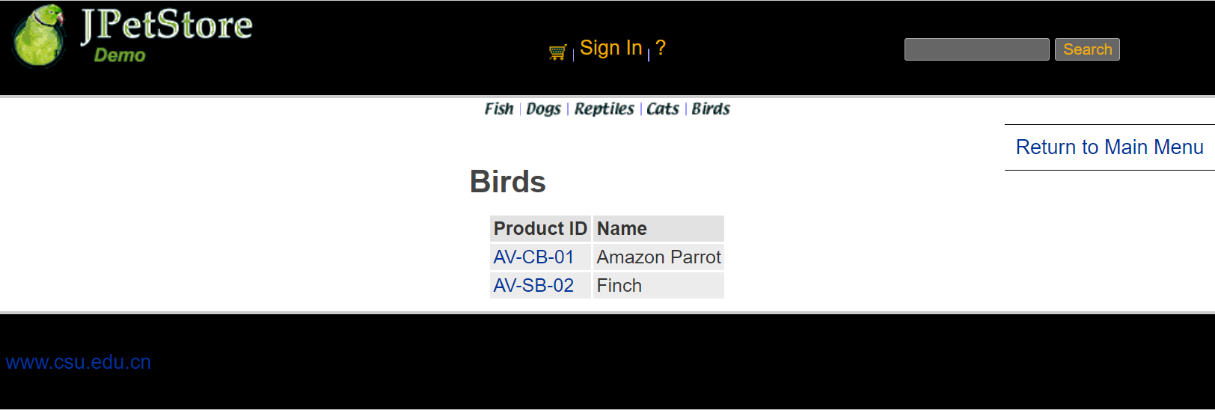

1.2实现小类Product：

（1）实现思路：小类Product先完善Product.jsp，主要是通过productId对产品类进行信息展示，之后再实现Product.java，接下进行ProductDAOImpl数据库的连接进行编写，最后完成Servlet的编写。

（2）实现Product类代码展示：
- public class Product implements Serializable {

- private static final long serialVersionUID = -7492639752670189553L;
- private String productId;
- private String categoryId;
- private String name;
- private String description;

- public String getProductId() {
- return productId;
- }

- public void setProductId(String productId) {
- this.productId = productId.trim();
- }

- public String getCategoryId() {
- return categoryId;
- }

- public void setCategoryId(String categoryId) {
- this.categoryId = categoryId;
- }

- public String getName() {
- return name;
- }

- public void setName(String name) {
- this.name = name;
- }

- public String getDescription() {
- return description;
- }

- public void setDescription(String description) {
- this.description = description;
- }

- public String toString() {
- return getName();
- }

- }

（3）web.Servlet中的ViewProductServlet代码实现：
- public class ViewProductServlet extends HttpServlet {
- private static final String VIEW_PRODUCT = "/WEB-INF/jsp/catalog/Product.jsp";
- private String productId;

- protected void doGet(HttpServletRequest request, HttpServletResponse response) throws ServletException, IOException {
- productId = request.getParameter("productId");
- CatalogService service = new CatalogService();
- Product product = service.getProduct(productId);
- List<Item> itemList = service.getItemListByProduct(productId);

- HttpSession session = request.getSession();
- session.setAttribute("product", product);
- session.setAttribute("itemList", itemList);

- request.getRequestDispatcher(VIEW_PRODUCT).forward(request, response);
- }
- }

（4）界面截图：

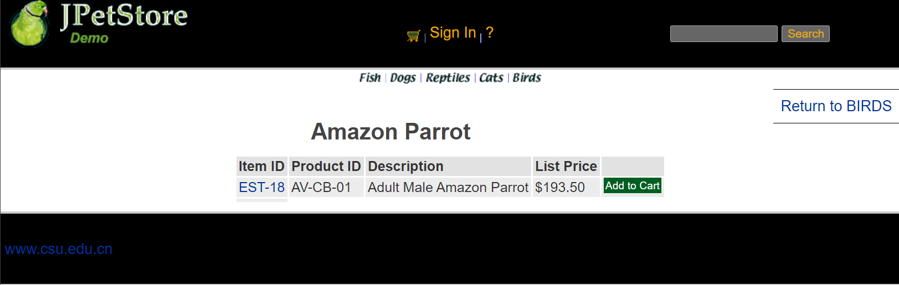

1.3实现具体商品展示类Item：

（1）实现思路：用户点击产品后进入查看具体商品，完善Item.jsp，Copy代码模版中的Item.java，实现ItemDAOImpl的具体数据库连接操作，完成最后的Servlet连接。

（2）Item类实现代码：
- public class Item implements Serializable {

- private static final long serialVersionUID = -2159121673445254631L;

- private String itemId;
- private String productId;
- private BigDecimal listPrice;
- private BigDecimal unitCost;
- private int supplierId;
- private String status;
- private String attribute1;
- private String attribute2;
- private String attribute3;
- private String attribute4;
- private String attribute5;
- private Product product;
- private int quantity;

- public String getItemId() {
- return itemId;
- }

- public void setItemId(String itemId) {
- this.itemId = itemId.trim();
- }

- public int getQuantity() {
- return quantity;
- }

- public void setQuantity(int quantity) {
- this.quantity = quantity;
- }

- public Product getProduct() {
- return product;
- }

- public void setProduct(Product product) {
- this.product = product;
- }

- public String getProductId() {
- return productId;
- }

- public void setProductId(String productId) {
- this.productId = productId;
- }

- public int getSupplierId() {
- return supplierId;
- }

- public void setSupplierId(int supplierId) {
- this.supplierId = supplierId;
- }

- public BigDecimal getListPrice() {
- return listPrice;
- }

- public void setListPrice(BigDecimal listPrice) {
- this.listPrice = listPrice;
- }

- public BigDecimal getUnitCost() {
- return unitCost;
- }

- public void setUnitCost(BigDecimal unitCost) {
- this.unitCost = unitCost;
- }

- public String getStatus() {
- return status;
- }

- public void setStatus(String status) {
- this.status = status;
- }

- public String getAttribute1() {
- return attribute1;
- }

- public void setAttribute1(String attribute1) {
- this.attribute1 = attribute1;
- }

- public String getAttribute2() {
- return attribute2;
- }

- public void setAttribute2(String attribute2) {
- this.attribute2 = attribute2;
- }

- public String getAttribute3() {
- return attribute3;
- }

- public void setAttribute3(String attribute3) {
- this.attribute3 = attribute3;
- }

- public String getAttribute4() {
- return attribute4;
- }

- public void setAttribute4(String attribute4) {
- this.attribute4 = attribute4;
- }

- public String getAttribute5() {
- return attribute5;
- }

- public void setAttribute5(String attribute5) {
- this.attribute5 = attribute5;
- }

- public String toString() {
- return "(" + getItemId() + "-" + getProductId() + ")";
- }

- }

（3）web.Servlet中的ViewItemServlet代码：
- public class ViewItemServlet extends HttpServlet {
- private static final String VIEW_ITEM = "/WEB-INF/jsp/catalog/Item.jsp";
- private String itemId;

- protected void doPost(HttpServletRequest request, HttpServletResponse response) throws ServletException, IOException {
- doGet(request, response);
- }

- protected void doGet(HttpServletRequest request, HttpServletResponse response) throws ServletException, IOException {
- itemId = request.getParameter("itemId");
- CatalogService service = new CatalogService();
- Item item = service.getItem(itemId);

- HttpSession session = request.getSession();
- session.setAttribute("item", item);

- request.getRequestDispatcher(VIEW_ITEM).forward(request, response);
- }
- }

（4）界面截图：

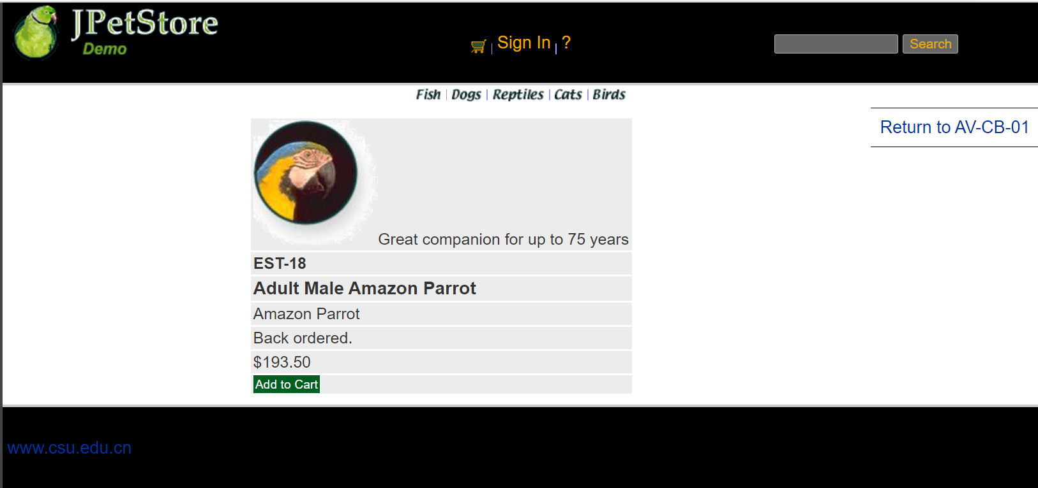

1.4实现搜索功能：

（1）实现思路：搜索功能先完善显示的SearchProducts.jsp，接下直接进行SearchProductServlet编写和配置，通过获得输入的关键字再通过CatalogService的方法进行查找并显示。

（2）web.Servlet中的SearchProductServlet代码：
- public class SearchProductServlet extends HttpServlet {
- private static final String SEARCH_PRODUCTS = "/WEB-INF/jsp/catalog/SearchProducts.jsp";

- private String keyword;

- protected void doPost(HttpServletRequest request, HttpServletResponse response) throws ServletException, IOException {
- doGet(request, response);
- }

- protected void doGet(HttpServletRequest request, HttpServletResponse response) throws ServletException, IOException {
- keyword = request.getParameter("keyword");

- CatalogService service = new CatalogService();
- List<Product> productList = service.searchProductList(keyword);
- HttpSession session = request.getSession();
- session.setAttribute("keyword", keyword);
- session.setAttribute("productList", productList);

- request.getRequestDispatcher(SEARCH_PRODUCTS).forward(request, response);
- }
- }

（3）界面截图：

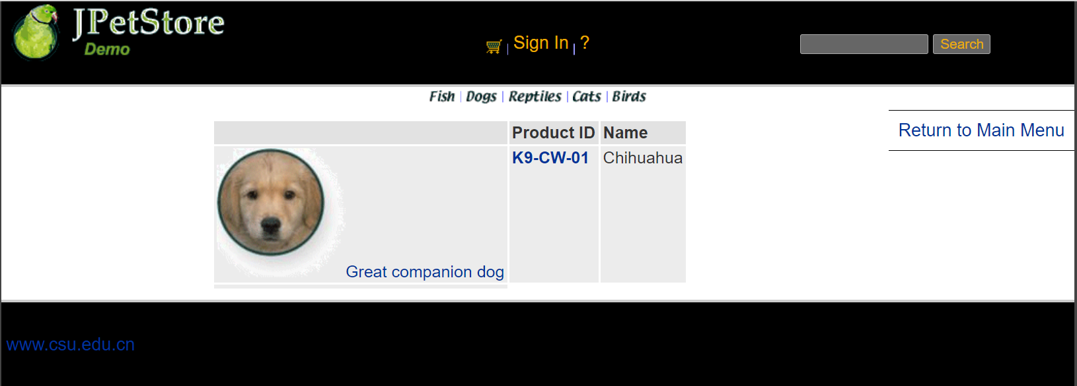
- 用户管理业务模块，包括用户注册、登录、修改用户信息、查询用户相关订单等业务功能。

2.1注册功能：

（1）实现思路：用户注册时，需要一个全新的包含用户所有信息的输入界面即NewAccountForm.jsp，之后需要先进行设计NewAccountFormServlet，该Servlet的功能仅为实现用户点击注册后跳转用户输入新账号信息的表格，接下实现Account.java，完成Account的基础功能，之后进行AccountDAO接口定义以及完成AccountDAOImpl连接数据库的实现，接下来完成AccountService的编写，之后进行NewAccountServlet配置，获取网页界面的信息，赋值给一个新账号，再将该账号插入到数据库中。

（2）AccountService类实现：
- public class AccountService {

- private AccountDAO accountDAO;

- public AccountService(){
- accountDAO = new AccountDAOImpl();
- }

- public Account getAccount(String username) {
- return accountDAO.getAccountByUsername(username);
- }

- public Account getAccount(String username, String password) {
- Account account = new Account();
- account.setUsername(username);
- account.setPassword(password);
- return accountDAO.getAccountByUsernameAndPassword(account);
- }

- public void insertAccount(Account account) {
- accountDAO.insertAccount(account);
- accountDAO.insertProfile(account);
- accountDAO.insertSignon(account);
- }

- public void updateAccount(Account account) {
- accountDAO.updateAccount(account);
- accountDAO.updateProfile(account);

- if (account.getPassword() != null && account.getPassword().length() > 0) {
- accountDAO.updateSignon(account);
- }
- }
- }

（3）界面截图：

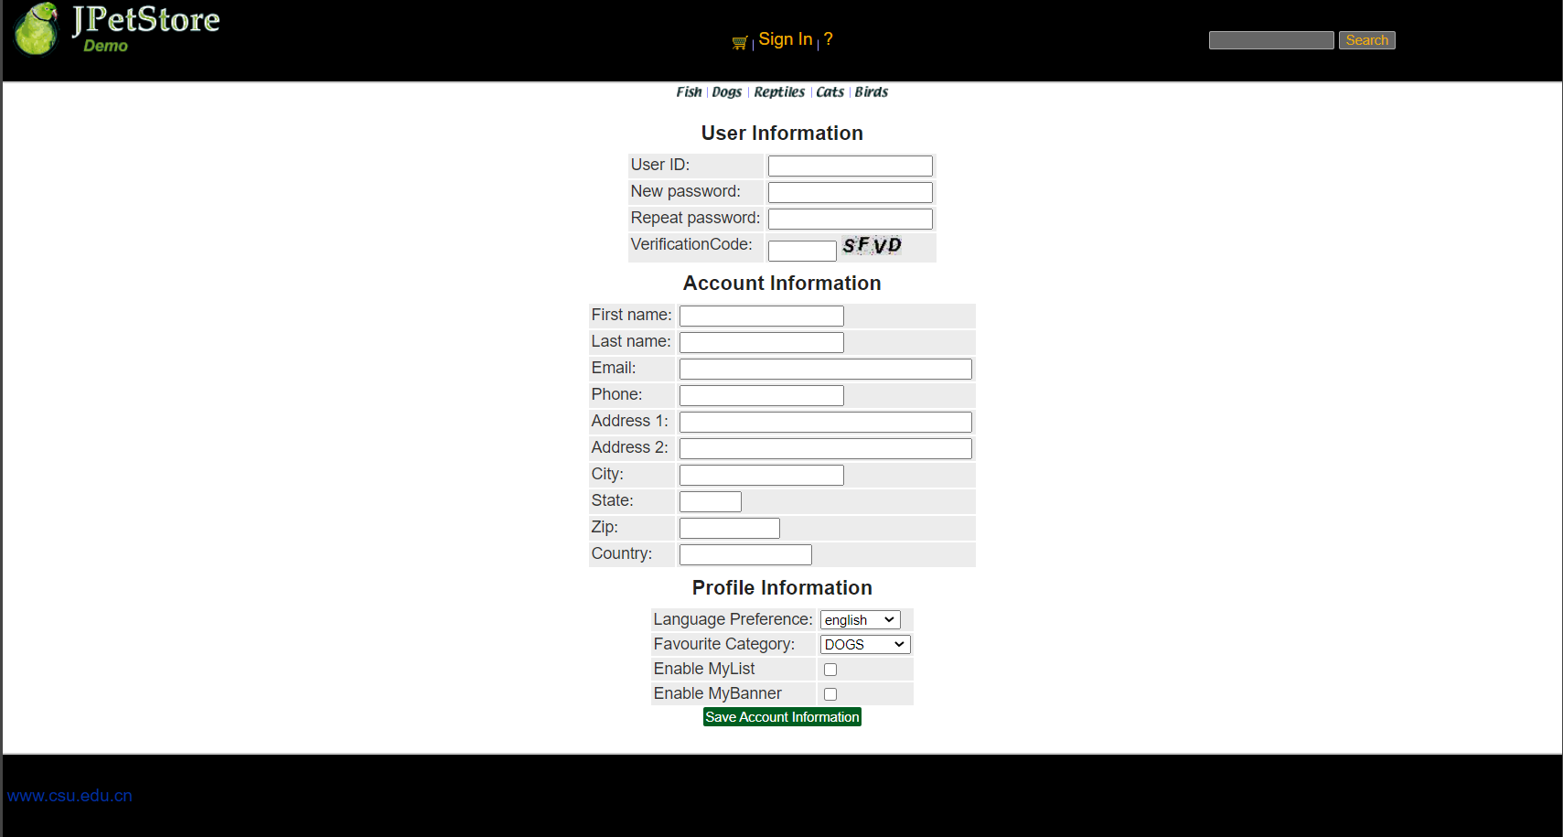

2.2登录功能：

（1）实现思路：用户登录先完成SignonForm.jsp，能够使用户输入登入的账号与密码，接下来先用一个Servlet实现SignOnFormServlet实现点击登录时网页跳转到用户输入账号密码的界面，接下来使用SignOnServlet实现获取用户的账号密码对数据库进行核查，如果存在则登录，反之则给予一定的错误信息提示。

（2）SignOnFormServlet类：
- public class SignOnFormServlet extends HttpServlet {

- private static final String SIGNONFORM = "/WEB-INF/jsp/account/SignonForm.jsp";

- private Account account;

- protected void doPost(HttpServletRequest request, HttpServletResponse response) throws ServletException, IOException {
- doGet(request, response);
- }

- protected void doGet(HttpServletRequest request, HttpServletResponse response) throws ServletException, IOException {

- HttpSession session = request.getSession();
- account = (Account)session.getAttribute("account");

- request.getRequestDispatcher(SIGNONFORM).forward(request, response);
- }
- }

（3）SignOnServlet类：
- public class SignOnServlet extends HttpServlet {
- private static final String MAIN = "/WEB-INF/jsp/catalog/Main.jsp";
- private static final String SIGNONFORM = "/WEB-INF/jsp/account/SignonForm.jsp";

- private Account account;
- private AccountService accountService;

- protected void doPost(HttpServletRequest request, HttpServletResponse response) throws ServletException, IOException {
- doGet(request, response);
- }

- protected void doGet(HttpServletRequest request, HttpServletResponse response) throws ServletException, IOException {

- String username = request.getParameter("username");
- String password = request.getParameter("password");

- accountService = new AccountService();
- account = accountService.getAccount(username, password);

- HttpSession session = request.getSession();
- session.setAttribute("account", account);

- //获得输入的验证码值
- String value1=request.getParameter("vCode");
- /*获取图片的值*/
- String value2=(String)session.getAttribute("checkcode");
- Boolean isSame = false;
- /*对比两个值（字母不区分大小写）*/
- if(value2.equalsIgnoreCase(value1)){
- isSame = true;
- }

- if (account == null || !isSame){
- if(!isSame){
- session.setAttribute("messageSignOn", "Invalid Verification Code. Signon failed.");
- }else{
- session.setAttribute("messageSignOn", "Invalid username or password. Signon failed.");
- }
- session.setAttribute("account", null);
- request.getRequestDispatcher(SIGNONFORM).forward(request, response);
- }else{
- account.setPassword(null);
- request.getRequestDispatcher(MAIN).forward(request, response);
- }
- }
- }

（4）界面截图：

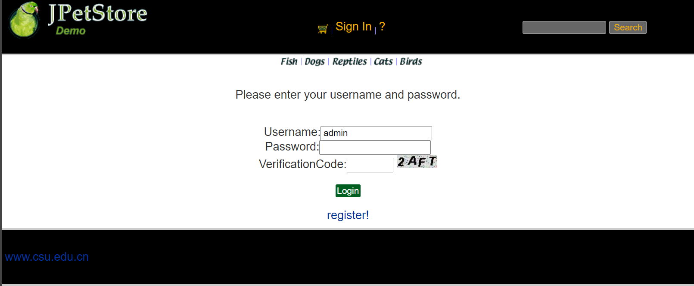

2.3查询用户相关订单功能：

（1）实现思路：账户订单查看，先完成ListOrders.jsp的实现，接下来实现Order.java的基础模块，创建OrderDAO接口，完成数据库的具体操作OrderDAOImpl，接下来实现OrderService，成功完成业务层调用，最后完成ViewListOrderServlet实现用户可以从数据库中查看到自己的订单信息。

（2）OrderService类：
- public class OrderService {

- private ItemDAO itemDAO;
- private OrderDAO orderDAO;
- private SequenceDAO sequenceDAO;
- private LineItemDAO lineItemDAO;

- public OrderService(){
- itemDAO = new ItemDAOImpl();
- orderDAO = new OrderDAOImpl();
- sequenceDAO = new SequenceDAOImpl();
- lineItemDAO = new LineItemDAOImpl();
- }

- public void insertOrder(Order order) {
- order.setOrderId(getNextId("ordernum"));
- for (int i = 0; i < order.getLineItems().size(); i++) {
- LineItem lineItem = (LineItem) order.getLineItems().get(i);
- String itemId = lineItem.getItemId();
- Integer increment = new Integer(lineItem.getQuantity());
- Map<String, Object> param = new HashMap<String, Object>(2);
- param.put("itemId", itemId);
- param.put("increment", increment);
- itemDAO.updateInventoryQuantity(param);
- }

- orderDAO.insertOrder(order);
- orderDAO.insertOrderStatus(order);
- for (int i = 0; i < order.getLineItems().size(); i++) {
- LineItem lineItem = (LineItem) order.getLineItems().get(i);
- lineItem.setOrderId(order.getOrderId());
- lineItemDAO.insertLineItem(lineItem);
- }
- }

- public Order getOrder(int orderId) {
- Order order = orderDAO.getOrder(orderId);
- order.setLineItems(lineItemDAO.getLineItemsByOrderId(orderId));

- for (int i = 0; i < order.getLineItems().size(); i++) {
- LineItem lineItem = (LineItem) order.getLineItems().get(i);
- Item item = itemDAO.getItem(lineItem.getItemId());
- item.setQuantity(itemDAO.getInventoryQuantity(lineItem.getItemId()));
- lineItem.setItem(item);
- }

- return order;
- }

- public List<Order> getOrdersByUsername(String username) {
- return orderDAO.getOrdersByUsername(username);
- }
- }

（3）界面截图：

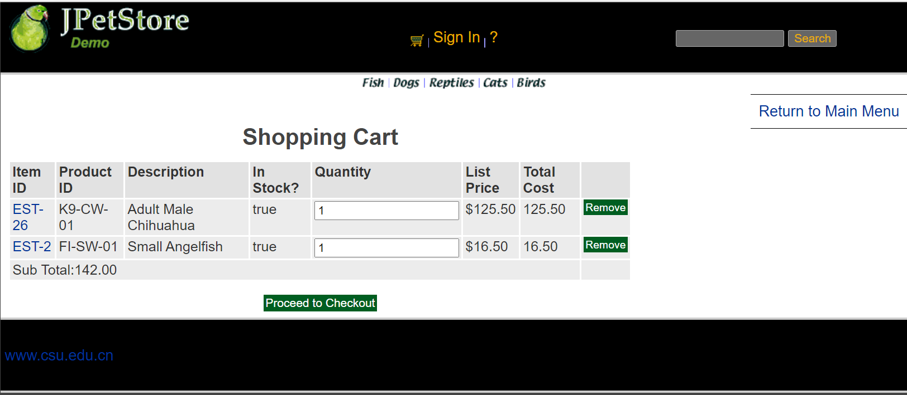
- 订单管理模块，包括购物车管理、新增订单、地址信息等业务功能。

3.1购物车商品修改功能：

（1）实现思路：在购物车的数量栏输入想要更改后的商品数量，点击Update Cart即可更新购物车中的商品数量、总价。点击之后利用UpdateCartQuantitiesServlet实现信息更新以及页面更新，传递商品的数量信息获取后进行相关操作。

（2）UpdateCartQuantitiesServlet类：
- public class UpdateCartQuantitiesServlet extends HttpServlet {

- private static final String VIEW_CART = "/WEB-INF/jsp/cart/Cart.jsp";

- private String workingItemId;
- private Cart cart;

- protected void doPost(HttpServletRequest request, HttpServletResponse response) throws ServletException, IOException {
- doGet(request, response);
- }

- protected void doGet(HttpServletRequest request, HttpServletResponse response) throws ServletException, IOException {
- workingItemId = request.getParameter("workingItemId");
- CatalogService catalogService = new CatalogService();

- //从对话中，获取购物车
- HttpSession session = request.getSession();
- cart = (Cart)session.getAttribute("cart");

- Iterator<CartItem> cartItemIterator = cart.getAllCartItems();

- while (cartItemIterator.hasNext()){

- CartItem cartItem = (CartItem)cartItemIterator.next();
- String itemId = cartItem.getItem().getItemId();

- try {
- int quantity = Integer.parseInt((String) request.getParameter(itemId));
- cart.setQuantityByItemId(itemId, quantity);
- if (quantity < 1) {
- cartItemIterator.remove();
- }
- } catch (Exception e) {

- e.printStackTrace();
- }

- }

- session.setAttribute("cart", cart);
- }
- }

（3）功能界面截图（结合上图）

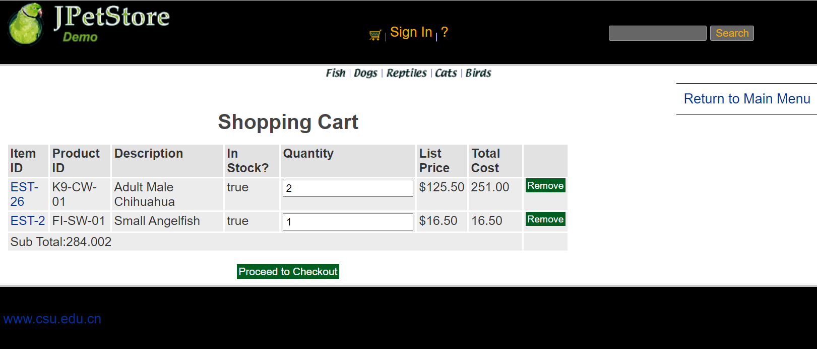

3.2购物车商品移除功能：

（1）实现思路：点击购物车中Remove按钮，获取购物车中的信息，之后进入RemoveItemFromCartServlet进行删除操作，并更新该购物车中的信息，如果误操作，则提示该误操作信息。

（2）RemoveItemFromCartServlet类：
- public class RemoveItemFromCartServlet extends HttpServlet {

- private static final String VIEW_CART = "/WEB-INF/jsp/cart/Cart.jsp";
- private static final String ERROR = "/WEB-INF/jsp/common/Error.jsp";

- private String workingItemId;
- private Cart cart;

- protected void doPost(HttpServletRequest request, HttpServletResponse response) throws ServletException, IOException {
- doGet(request, response);
- }

- protected void doGet(HttpServletRequest request, HttpServletResponse response) throws ServletException, IOException {
- workingItemId = request.getParameter("workingItemId");

- HttpSession session = request.getSession();
- cart = (Cart)session.getAttribute("cart");

- Item item = cart.removeItemById(workingItemId);
- }
- }

（3）功能界面截图(结合上图)
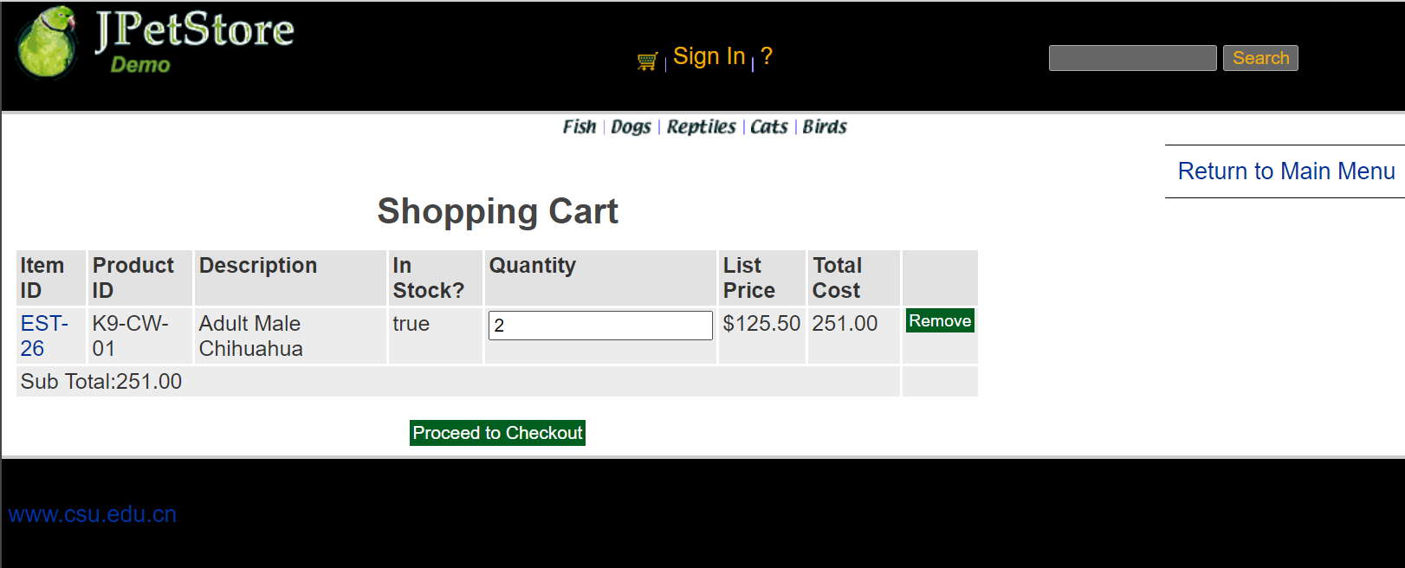

3.3生成订单功能

（1）实现思路：通过ViewOrderServlet生成最终的订单，包含地址信息、商品清单等信息。

（2）ViewOrderServlet类：
- public class ViewOrderServlet extends HttpServlet {
- private static final String VIEWORDER = "/WEB-INF/jsp/order/ViewOrder.jsp";
- private static final String ERROR = "/WEB-INF/jsp/common/Error.jsp";

- private Order order;
- private OrderService orderService;
- private Cart cart;

- protected void doPost(HttpServletRequest request, HttpServletResponse response) throws ServletException, IOException {
- doGet(request, response);
- }

- protected void doGet(HttpServletRequest request, HttpServletResponse response) throws ServletException, IOException {

- HttpSession session = request.getSession();
- order = (Order) session.getAttribute("order");
- cart = (Cart) session.getAttribute("cart");

- if (order != null) {
- orderService = new OrderService();
- orderService.insertOrder(order);
- session.setAttribute("order", order);

- cart = null;
- session.setAttribute("cart", cart);
- }
- }

（3）功能截图：

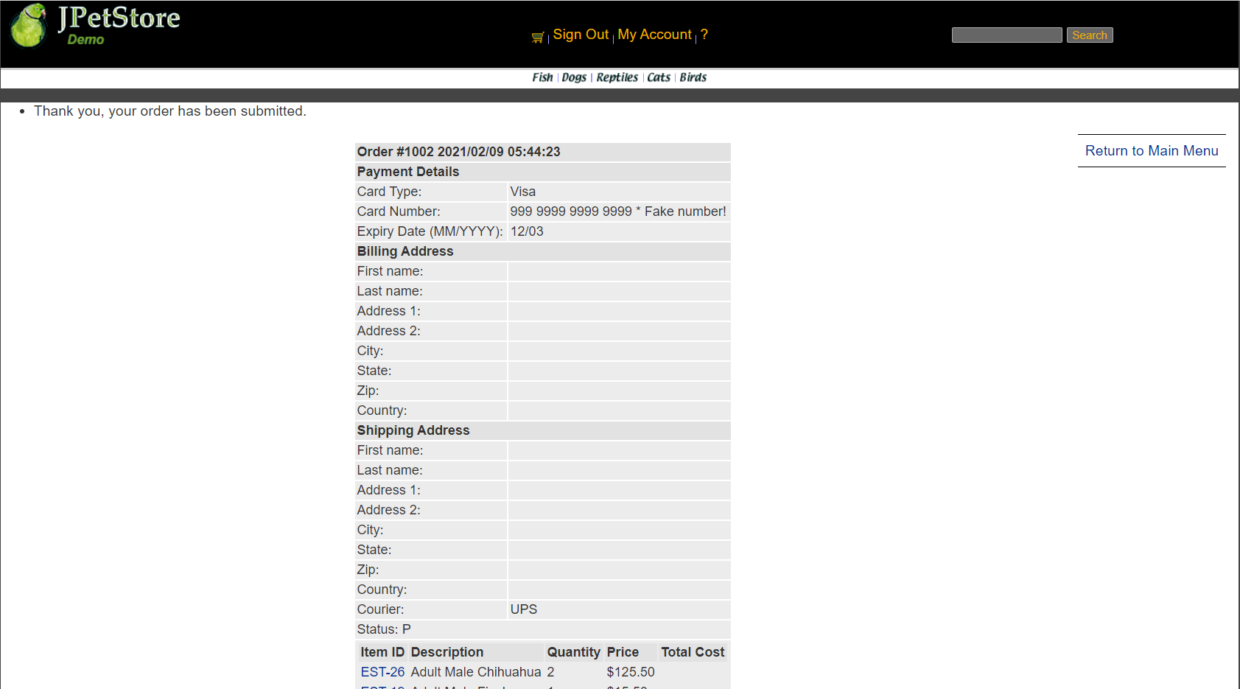
- 实验内容——扩展任务。
- 添加验证码功能：在用户注册和用户登录模块中添加验证码功能。

（1）实验思路：先设置字符表即26个字母和各个数字，接下来利用字符表产生随机验证码，同时随机产生120个干扰点（点数适合即可，具体没有特别要求），产生图像，画背景，在不同高度输出验证码的不同字符，设置设置浏览器不要缓存此图片，然后创建内存图像并获得图形，将图像传到客户端，验证码功能即可实现随机显示。用VerificationCode.java实现随机生成数字和字母组成图片的功能，在SigninForm.jsp 和NewAccountForm.jsp页面中添加实现显示验证码和用户输入验证码的功能，再用SignOnServlet和NewAccountServlet分别获取图片和用户输入的数据，判断两个数据是否一致，之后再进行登录功能与注册功能的实现。

（2）VerificationCode类代码展示：
- public void doPost(HttpServletRequest request, HttpServletResponse response)
- throws ServletException, IOException {

- response.setContentType("image/jpeg");
- HttpSession session=request.getSession();
- int width=60;
- int height=20;

- //设置浏览器不要缓存此图片
- response.setHeader("Pragma", "No-cache");
- response.setHeader("Cache-Control", "no-cache");
- response.setDateHeader("Expires", 0);

- //创建内存图像并获得图形上下文
- BufferedImage image=new BufferedImage(width, height,BufferedImage.TYPE_INT_RGB);
- Graphics g=image.getGraphics();

- String chars="0123456789ABCDEFGHIJKLMNOPQRSTUVWXYZ";
- char[] rands=new char[4];
- for(int i=0;i<4;i++){
- int rand=(int) (Math.random() *36);
- rands[i]=chars.charAt(rand);
- }

- g.setColor(new Color(0xDCDCDC));
- g.fillRect(0, 0, width, height);

- for(int i=0;i<120;i++){
- int x=(int)(Math.random()*width);
- int y=(int)(Math.random()*height);
- int red=(int)(Math.random()*255);
- int green=(int)(Math.random()*255);
- int blue=(int)(Math.random()*255);
- g.setColor(new Color(red,green,blue));
- g.drawOval(x, y, 1, 0);
- }
- g.setColor(Color.BLACK);
- g.setFont(new Font(null, Font.ITALIC|Font.BOLD,18));

- //在不同高度输出验证码的不同字符
- g.drawString(""+rands[0], 1, 17);
- g.drawString(""+rands[1], 16, 15);
- g.drawString(""+rands[2], 31, 18);
- g.drawString(""+rands[3], 46, 16);
- g.dispose();

- //将图像传到客户端
- ServletOutputStream sos=response.getOutputStream();
- ByteArrayOutputStream baos=new ByteArrayOutputStream();
- ImageIO.write(image, "JPEG", baos);
- byte[] buffer=baos.toByteArray();
- response.setContentLength(buffer.length);
- sos.write(buffer);
- baos.close();
- sos.close();

- session.setAttribute("checkcode", new String(rands));
- }

（3）界面截图：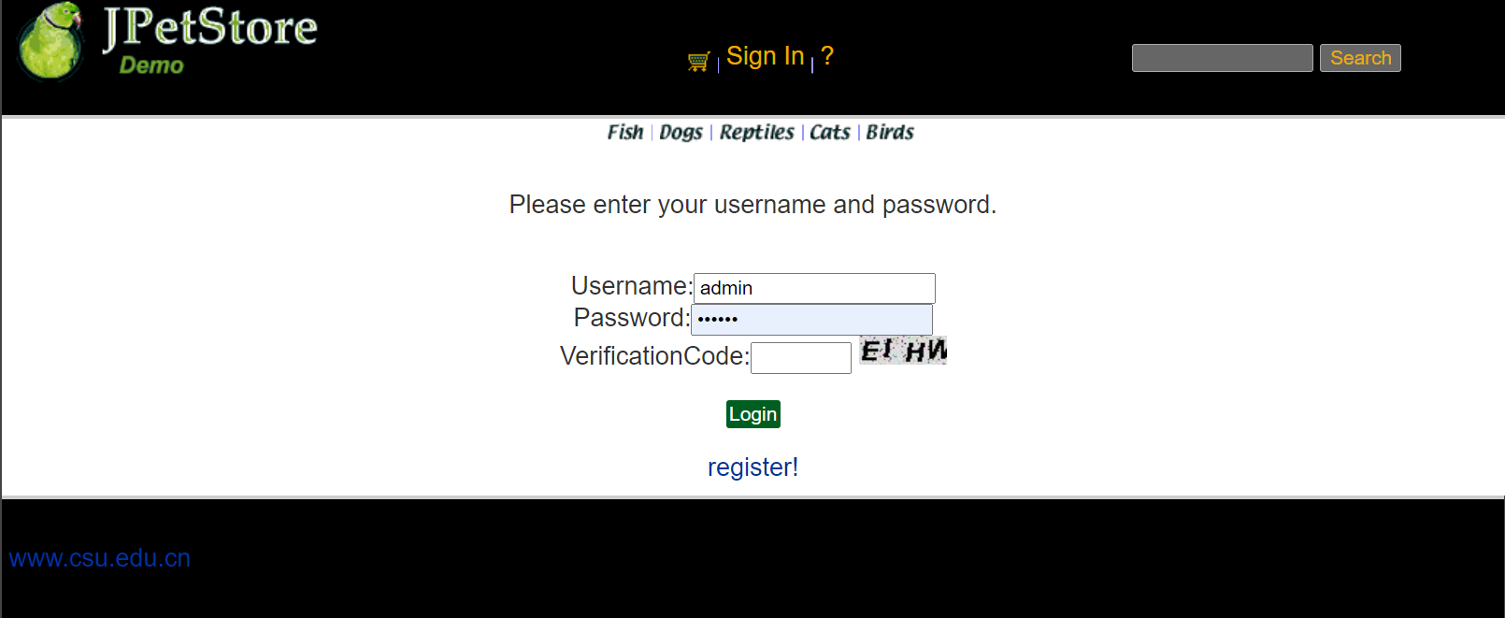

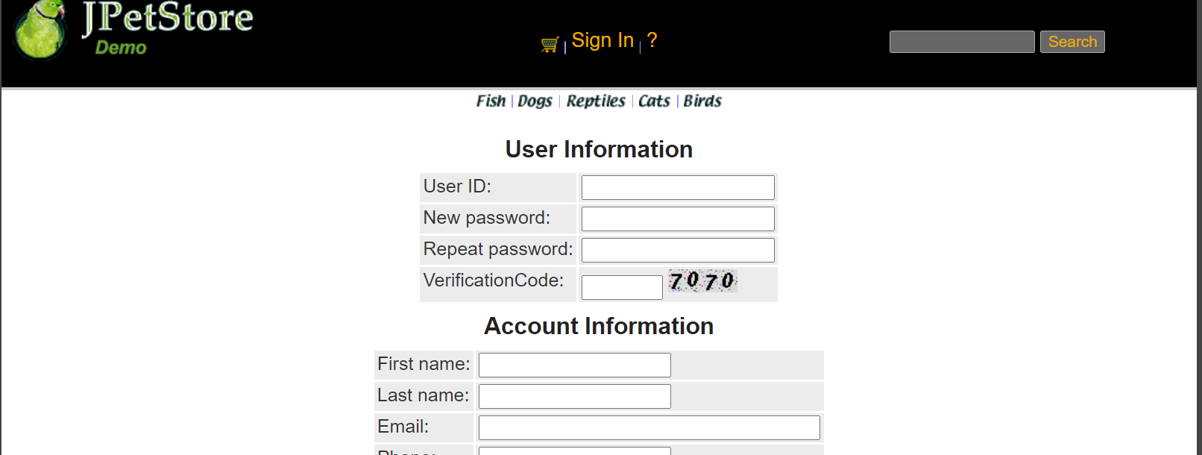
- 购物车功能：原项目中购物车为内存购物车，即将用户相关的购物车存储在session中；在数据库中添加购物车表，将购物车数据持久化，以便用户下次登录时可查看或修改自己的购物车数据。（无）
- 日志功能：数据库中添加日志信息表，给项目添加日志功能，用户登录后记录用户行为，比如浏览了哪些商品、将商品添加进购物车、生成订单等。

（1）实现思路（未实现）：利用Log.java和HTTPServletRequest的各种方法获取当前页面跳转时的用户账号、跳转时间、当前操作页面的网址、具体操作页面的名字、操作的商品信息，再加上自定义的具体操作说明，传输给LogService的相关方法即可将其插入到数据库中记录下来。在每次页面跳转之前先获取当前对话中用户是否已登录，如果账号不为空，那么进行获取日志记录操作，并插入到数据库中，之后正常跳转。如果用户未登录则不记录该操作。
（2）核心类Log.java实现:
- public class Log {
- public final static int OUT_CONSOLE=1;
- public final static int OUT_FILE=2;
- public final static int OUT_BOTH=3;
- public final static int DEBUG_LEVEL=0;
- public final static int LOG_LEVEL=3;
- public final static int INFO_LEVEL=6;
- public final static int WARN_LEVEL=9;
- public final static int ERROR_LEVEL=12;
- public final static int FATAL_LEVEL=15;
- protected static int level=DEBUG_LEVEL;// 输出的级别开关，高于指定级别的输出
- protected static int out=OUT_CONSOLE; //输出模式，输出到控制台，文件或者都输出
- public static String logdir="log"; // 保存日志文件的目录
- protected static BufferedWriter bw =null;
- protected static String currentDate = "";
- protected static Date data=null;
- protected static StringBuilder bb=new StringBuilder();
- protected static String marsk=" [ERROE] ";
- /**
- * 日志函数，不受 level 限制，始终打印，最高级别
- * @param s
- */
- synchronized public static String log(Object ...s) {
- bb.delete(0, bb.length());
- bb.append(time());
- bb.append(marsk);
- // 获取调用的位置

- bb.append(" ");

- for(Object str : s) {
- bb.append(str);
- bb.append(" ");
- }

- return bb.toString();
- }

- public static String logInfomation(Object ...s){
- marsk = " ";
- return log(s);
- }

- /*
- public static void debug(Object ...s) {
- if(level<=DEBUG_LEVEL) {
- marsk=" [DEBUG] ";
- log(s);
- }

- }
- public static void info(Object ...s) {
- if(level<=INFO_LEVEL){
- marsk=" [INFO ] ";
- log(s);
- }
- }
- public static void warn(Object ...s) {
- if(level<=WARN_LEVEL){
- marsk=" [WARN ] ";
- log(s);
- }
- }
- public static void error(Object ...s) {
- if(level<=ERROR_LEVEL){
- marsk=" [ERROR] ";
- log(s);
- }
- }
- public static void fatal(Object ...s) {
- if(level<=FATAL_LEVEL){
- //marsk=" [FATAL] ";
- marsk = " ";
- log(s);
- }
- }
- protected static void out(String s) {
- if(out==OUT_BOTH) {
- System.out.println(s);
- tofile(s);
- }else if(out==OUT_FILE) {
- tofile(s);
- }else if(out==OUT_CONSOLE) {
- System.out.println(s);
- }
- }
- protected static void tofile(String s) {
- getWriter();
- try {
- bw.newLine();
- bw.write(s);
- bw.flush();
- }catch(Exception e) {

- }
- }
- */

- protected static BufferedWriter getWriter() {
- if(currentDate.equals(new SimpleDateFormat("dd").format(data))) {
- return bw;
- }
- File fi=new File(logdir
- +File.separator+new SimpleDateFormat("yyyy年").format(data)
- +File.separator+new SimpleDateFormat("MM月").format(data)
- +File.separator+new SimpleDateFormat("dd").format(data)+"日.log");
- try {
- if(!fi.exists()) {
- if(!fi.getParentFile().exists())
- fi.getParentFile().mkdirs();
- fi.createNewFile();
- }
- FileOutputStream fiou = new FileOutputStream(fi,true);
- OutputStreamWriter opw = new OutputStreamWriter(fiou, "UTF-8");
- bw= new BufferedWriter(opw);
- }catch(Exception e) {

- }
- return bw;
- }
- protected static String time() {
- data = new Date();
- return new SimpleDateFormat("yyyy-MM-dd HH:mm:ss").format(data);
- }

- public static void init(int out_put_level,int out2where,String log_dir) {
- level = out_put_level;
- out = out2where;
- logdir = log_dir;
- }

- public static void main(String[] args) {

- }
- }
（3）LogService类：
- public class LogService {
- Log log;
- private LogDAO logDAO;

- public LogService(){
- log = new Log();
- logDAO = new LogDAOImpl();
- }

- public String logInfo(Object ...s){
- return log.logInfomation(s);
- }

- public void insertLogInfo(String username, String logInfo){
- logDAO.insertLog(username, logInfo);
- }
- }
- 小组成员分工及实验总结
- 小组分工：本实验由个人完成。

- 实验总结：本学期学习了Web程序设计课程，对制作一个网站有一个系统的学习和体验。经过个人学习并完成实验，我认为本次实验非常锻炼我的个人能力对我的各方面能力有着非常大的提高，最初其实我的基础是很差的，没有学过Java、CSS、HTML在实验初期会有点影响，就是太多东西不懂会打击我学习积极性。我非常感谢老师不会因为我基础差而放弃我，而是对我更加关心，而且无论是上课还是实验都会更加照顾我这样基础差的学生。本次实验对我来说难度较高，虽然老师有发布过很多视频，系统化将实验的内容都有讲解，但是在最初开始实验时也还是存在各种问题，就比如说环境配置出问题，原因是以前安装过Intellij IDEA卸载的时候没有卸载干净导致编译一直出问题。Tomcat安装一直不成功最后在安装最新的Tomcat在写代码的时候出现的问题会稍微少点，不过是因为老师有视频讲解，但是还是会出现代码出错的时候，完成业务逻辑的时候总是不成功，跟着老师代码敲感觉自己会了，但是自己写就出问题，总之本次实验真可谓一波三折。本次实验最大的收获就是能自己完成一些简单的业务逻辑，理解了MVC框架，经典MVC模式中，M是指业务模型，V是指用户界面，C则是控制器，使用MVC的目的是将M和V的实现代码分离，从而使同一个程序可以使用不同的表现形式。其中，View的定义比较清晰，就是用户界面。总之通过本次实验我有了非常大的收获。

实验二 使用AJAX和jQuery改善用户体验
- 实验内容——基本任务。
- 账号管理模块。在新建账号和修改账号信息页面上用AJAX技术进行表单验证，如“判断用户名是否已存在”等功能。

（1）实现思路：首先在jsp页面中使用传统的HTML绑定方法使得其能够运行js事务即检测用户名是否已存在，接下来在js代码中通过XML异步通信技术，将该用户名传到servlet中调用业务逻辑功能访问数据库判断该有户名是否已存在，从servlet中返回一个用户区别用户名是否已存在的变量到js中，再到js中根据该变量的值进行相应的输出，即该用户已存在或者可用。

（2）核心代码：

1、servlet：
- tring username = request.getParameter("username");
- Account account = new Account();
- account.setUsername(username);
- AccountService accountService = new AccountService();
- response.setContentType("text/xml");
- PrintWriter out = response.getWriter();
- if(accountService.getAccount(account.getUsername()) != null){
- out.println("<msg>Exist</msg>");
- }else {
- out.println("<msg>NotExist</msg>");
- }
- out.flush();
- out.close();

2、jsp：
- <input type="text" name="username" id="username" onblur="usernameIsExist();"/>
- <div id="usernameMsg"></div>
- <script type="text/javascript" src="${pageContext.request.contextPath }/js/register.js"></script>

3、js:
- var xmlHttpRequest;
- function createXMLHttpRequest()
- {
- if (window.XMLHttpRequest) //非IE浏览器
- {
- xmlHttpRequest = new XMLHttpRequest();
- }
- else if (window.ActiveObject)//IE6以上版本的IE浏览器
- {
- xmlHttpRequest = new ActiveObject("Msxml2.XMLHTTP");
- }
- else //IE6及以下版本IE浏览器
- {
- xmlHttpRequest = new ActiveObject("Microsoft.XMLHTTP");
- }
- }

- function usernameIsExist() {
- //var username = document.NewAccountForm.username.value;
- var username = document.getElementById('username').value;
- sendRequest("usernameIsExistServlet?username=" + username);
- }

- function sendRequest(url) {
- createXMLHttpRequest();
- xmlHttpRequest.open("GET", url, true);
- xmlHttpRequest.onreadystatechange = processResponse;
- xmlHttpRequest.send(null);
- }

(3)功能截图：

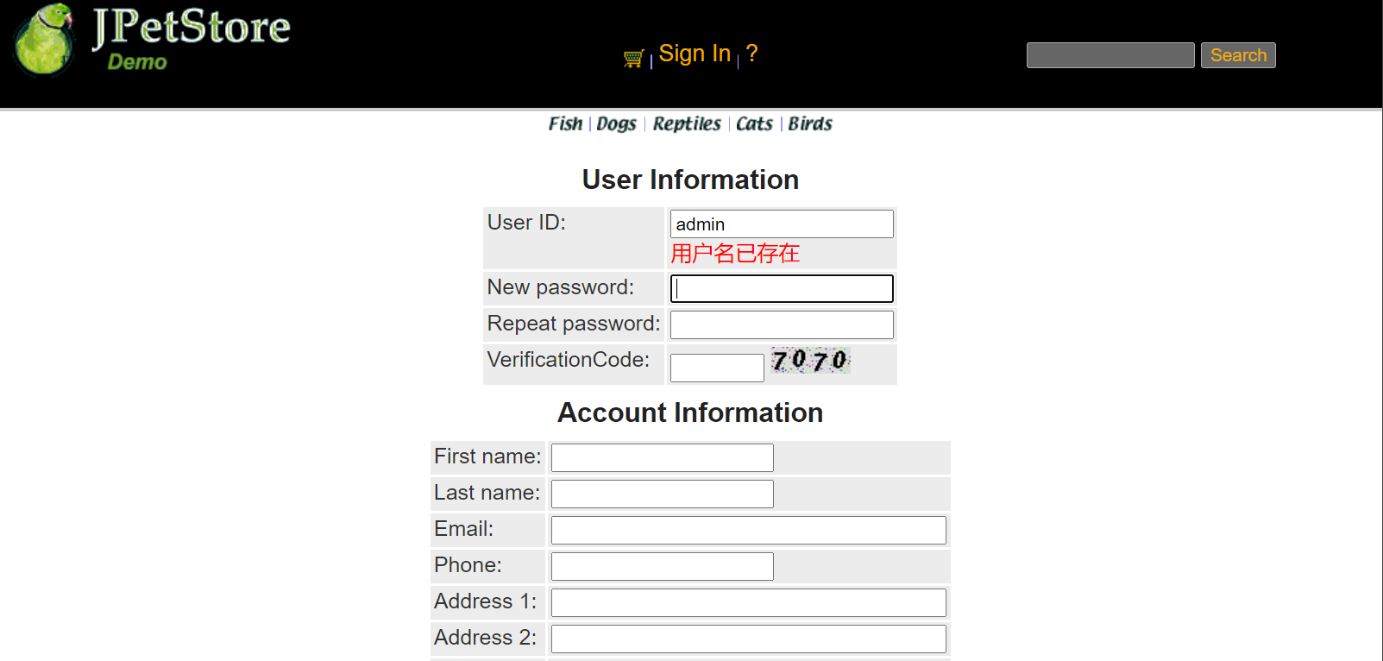

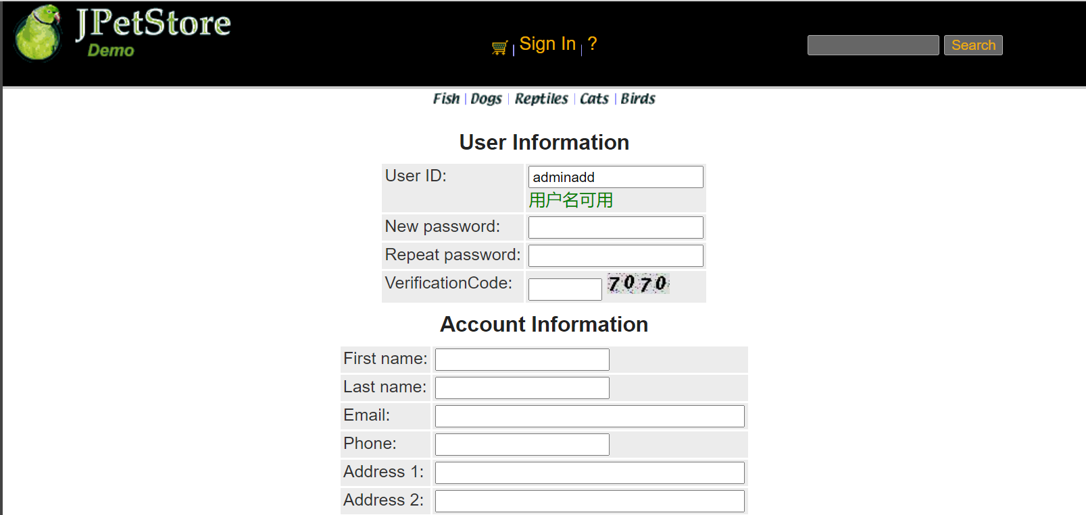
- 查询商品模块。在主页面右上角的查询商品功能中添加自动补全功能。

（1）实现思路：查询商品的自动补全功能基本设计流程是一样，本功能的难点在于js中对搜索到的结果的样式和事务处理。

首先在jsp中引入该js文件，接下来js中首先进行获取搜索关键字，然后通过servlet层获取所有的结果，并将结果以字符串的形式返回到js中，最后，js则将结果转化为数组形式然后通过相对应的样式显示在搜索框下方。

js中还需要处理的是对于搜索到的结果进行样式匹配加以区分，当加入关键字或者删除关键字时，搜索到的结果要及时进行变更，搜索栏得到结果中包含的关键字需要进行加粗的样式处理从而能够区分开。

（2）核心代码：

1、servlet：
- String keyword = request.getParameter("keyword");

- CatalogService service = new CatalogService();
- List<Product> productList = service.searchProductList(keyword);

- response.setContentType("text/xml");
- PrintWriter out = response.getWriter();

- //返回结果
- String res = "";
- for(int i=0; i<productList.size(); i++){
- if(i>0){
- res += "," + productList.get(i);
- }else{
- res += productList.get(i);
- }
- }
- out.write(res);

- out.flush();
- out.close();

2、js：
- var xmlHttpRequest;
- function createXMLHttpRequest()
- {
- if (window.XMLHttpRequest) //非IE浏览器
- {
- xmlHttpRequest = new XMLHttpRequest();
- }
- else if (window.ActiveObject)//IE6以上版本的IE浏览器
- {
- xmlHttpRequest = new ActiveObject("Msxml2.XMLHTTP");
- }
- else //IE6及以下版本IE浏览器
- {
- xmlHttpRequest = new ActiveObject("Microsoft.XMLHTTP");
- }
- }

- var keyword = document.getElementById('keyword').value;
- sendRequest("findResultServlet?keyword=" + keyword);

- function sendRequest(url) {
- createXMLHttpRequest();
- xmlHttpRequest.open("GET", url, true);
- xmlHttpRequest.onreadystatechange = processResponse;
- xmlHttpRequest.send(null);
- }

- function processResponse() {
- if (xmlHttpRequest.readyState == 4) {
- if (xmlHttpRequest.status == 200) {
- var resp = xmlHttpRequest.responseText;

- var array = resp.split(",");
- var autoComplete = new AutoComplete("keyword","auto",array);
- document.getElementById("keyword").onkeyup = function(event){
- autoComplete.start(event);
- }
- }
- }
- }

（3）功能截图：

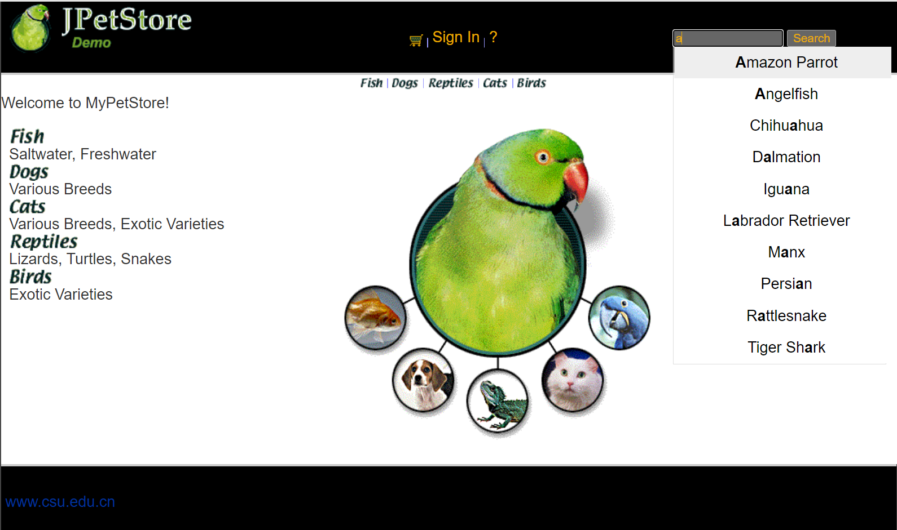
- 购物车模块。在购物车模块中修改购买数量时，通过AJAX修改购物车信息。

（1）实现思路：购物车修改数量功能改善前是需要用户点击更新按钮，商品相关信息才会更新。通过AJAX功能改善后用户在数量框输入相应数量后，鼠标离开输入框，商品相对应的数量、总价等信息即会发生改变。在jsp页面中设置对应的id用户获取js操作的节点，通过HTML绑定调用js中的功能，接下来，在js页面中回去更改商品的数量值，调用servlet更改相对应的信息并将更改后的信息通过字符串传输回来，再在js中对字符串进行处理并显示到jsp页面上。

（2）核心代码：

1、servlet：
- HttpSession session = request.getSession();
- cart = (Cart)session.getAttribute("cart");

- Iterator<CartItem> cartItemIterator = cart.getAllCartItems();

- while (cartItemIterator.hasNext()) {
- //产品数量增加
- CartItem cartItem = (CartItem) cartItemIterator.next();
- String itemId = cartItem.getItem().getItemId();

- try {
- int quantity = Integer.parseInt((String) request.getParameter("quantity"));
- cart.setQuantityByItemId(itemId, quantity);
- if (quantity < 1) {
- cartItemIterator.remove();
- }
- } catch (Exception e) {
- e.printStackTrace();
- }
- }
- session.setAttribute("cart", cart);

- Cart cart2 = (Cart)session.getAttribute("cart");
- Iterator<CartItem> cartItemIterator2 = cart2.getAllCartItems();
- String quantityAll = "";
- while (cartItemIterator2.hasNext()) {
- //产品数量增加
- CartItem cartItem2 = cartItemIterator2.next();
- int quantity2 = cartItem2.getQuantity();
- quantityAll += quantity2 + "," + cartItem2.getTotal() + "," + cart2.getSubTotal();
- }
- response.setContentType("text/xml");
- PrintWriter out = response.getWriter();
- out.write(quantityAll);

2、jsp：
- <input type="text" id="quantity" onblur="updateCart();" name="${cartItem.item.itemId}" value="${cartItem.quantity}">
- <script type="text/javascript" src="${pageContext.request.contextPath }/js/updateCart.js"></script>

3、js：
- var xmlHttpRequest;
- function createXMLHttpRequest()
- {
- if (window.XMLHttpRequest) //非IE浏览器
- {
- xmlHttpRequest = new XMLHttpRequest();
- }
- else if (window.ActiveObject)//IE6以上版本的IE浏览器
- {
- xmlHttpRequest = new ActiveObject("Msxml2.XMLHTTP");
- }
- else //IE6及以下版本IE浏览器
- {
- xmlHttpRequest = new ActiveObject("Microsoft.XMLHTTP");
- }
- }

- function updateCart() {
- //var username = document.NewAccountForm.username.value;
- //var workingItemId = document.getElementById('workingItemId').value;
- //sendRequest("updateCartQuantities?username=" + username);
- var quantity = document.getElementById("quantity").value;
- sendRequest("updateCartJSServlet?quantity="+ quantity);
- //sendRequest("updateCartQuantities");
- }

- function sendRequest(url) {
- createXMLHttpRequest();
- xmlHttpRequest.open("GET", url, true);
- xmlHttpRequest.onreadystatechange = processResponse;
- xmlHttpRequest.send(null);
- }

- function processResponse() {
- if (xmlHttpRequest.readyState == 4) {
- if (xmlHttpRequest.status == 200) {
- var resp = xmlHttpRequest.responseText;
- var array = resp.split(",");
- var quantity = document.getElementById("quantity");
- var total = document.getElementById("total");
- var subtotal = document.getElementById("subtotal");

- quantity.innerText = array[0];
- total.innerText = array[1];
- subtotal.innerText = array[2];
- }
- }
- }

（3）功能截图展示：

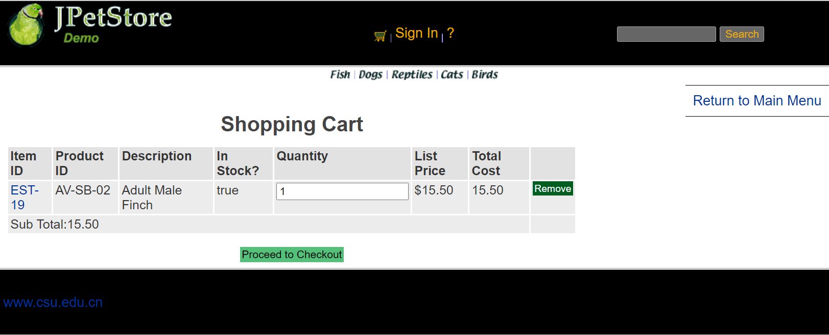

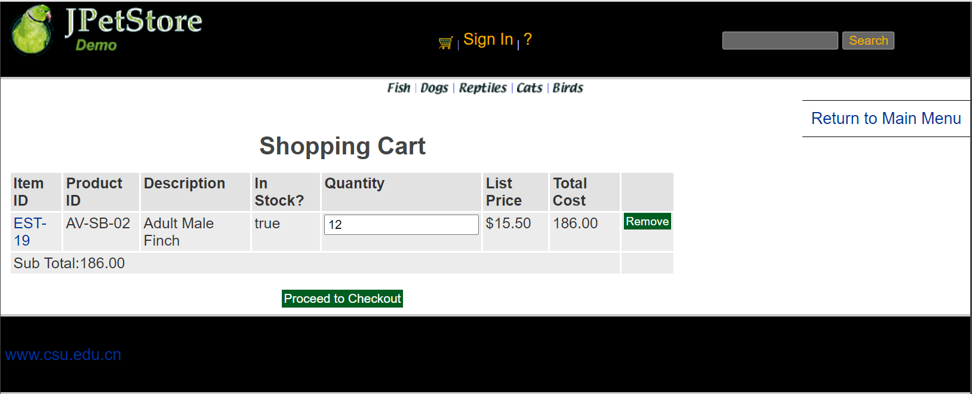
- 实验内容——选做任务。
- 商品展示模块。在首页展示商品的图片上添加AJAX效果，即当鼠标移到某个商品图片上时，用悬浮窗展示该类型商品的信息。（无）
- 订单模块。通过选项卡或模版内容实现订单多个信息部分的录入，不需要页面跳转，在一个页面完成订单所有内容的录入。（无）
- 其他效果：可自行选择其他UI模版，或选择其他功能点进行用户体验的优化。（无）
- 小组成员分工及实验总结
- 小组分工：本实验由个人完成。

2．实验总结：本次实验考察的是我们前端的能力，但是由于能力有限所以并没有修改前端、没有美化界面还是较为遗憾的，因为自己有去学习基础HTML和CSS，而且自己对于前端技术也挺感兴趣的。虽然本次课程结束啦，我也会去自己再学习学习前端。话说回来，本次实验由于内容较少，而且有着前一个实验的基础，所以实验出现的问题较少，由于老师这次并没有把实验的内容全部展示，在实现自动补全功能的时候较为困难，因为实在个人完成不了自动补全功能，所以我在网上查找了很多完成自动补全的功能的教程，就是设置键盘抬起事件（keyup），然后就是Ajax实现异步交互。还需要使用onmouseover事件，离开时恢复原色onmouseout事件，点击时将内容填写到搜索框onclick事件。尽管有很多的教程，但是我没有找到一个较为全面讲解实现该功能的教程，基本上都是直接把代码放上，没有什么注解，最后通过同学的帮助还是完成了该功能。通过本次实验我能较为系统的了解AJAX的流程和使用AJAX。

