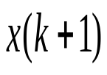
u(k)
x(k)
y(k)
G
C
D
H
单位延迟
