Product Visual Search and Retrieval Using ResNet18 and CLIP
Course Project Report
Date: April 26, 2026
Author: Student Name

Abstract
This project implements an end-to-end product visual search and retrieval pipeline for fashion product images. The system supports both supervised convolutional representation learning with ResNet18 and frozen pretrained visual-semantic retrieval with CLIP ViT-B/32. Instead of treating the task as ordinary image classification, the project frames product understanding as a search problem: a query image is embedded into a vector representation and compared against a gallery of product embeddings to retrieve visually similar items.
The project begins with a debug-scale experiment to validate the pipeline safely, then extends ResNet18 to the full cleaned dataset of 44,405 valid images across 132 articleType categories. CLIP is also evaluated on the same full train/test split so the Streamlit demo can switch between CLIP and ResNet18 using aligned query and gallery sets. Retrieval quality is measured with Recall@K, which better reflects real product search behavior than classification accuracy alone.
On the full dataset, ResNet18 reaches a test Top-1 accuracy of 0.8851 and Top-5 accuracy of 0.9892. For retrieval, ResNet18 full dataset achieves Recall@1 of 0.8991, Recall@5 of 0.9351, and Recall@10 of 0.9466. CLIP full retrieval achieves Recall@1 of 0.8283, Recall@5 of 0.9541, and Recall@10 of 0.9724. These results show that ResNet18 is strong at dataset-specific category recognition, while CLIP provides very strong Top-K candidate recall without local supervised training.

Introduction
Product visual search is a common capability in modern e-commerce and content platforms. A user may see a product in a social media post, a short video, a screenshot, or a catalog image, but may not know the exact brand, product title, or keywords needed to search for it. In these cases, image-based search provides a more natural interaction: the user supplies an image, and the system returns a ranked list of visually similar products.
This task is related to image classification, but it is not the same problem. Classification asks the model to assign a single label such as 'Tshirts' or 'Flip Flops'. Visual search asks the system to retrieve multiple relevant products from a gallery. A perfect class prediction does not guarantee useful search results, and a visually useful search result may still have small differences in color, shape, brand, or style. Therefore, the project evaluates both supervised classification metrics and retrieval-oriented Recall@K metrics.
The motivation of this project is to connect convolutional neural networks, representation learning, and search retrieval in a realistic product discovery setting. ResNet18 is used as a supervised baseline that learns dataset-specific articleType boundaries. CLIP is used as a pretrained foundation model that produces general visual-semantic embeddings without fine-tuning. Both models are then used as embedding extractors for a Top-K visual retrieval system.
The final deliverable is not only a notebook experiment. The project also includes reusable scripts for full-dataset training, checkpointing, evaluation, and index construction, plus a Streamlit demo that allows users to upload a product image or choose a random query image and compare CLIP and ResNet18 retrieval results interactively.

Dataset and Preprocessing
The project uses the Fashion Product Images dataset stored locally under the project data directory. The primary image source is `data/raw/images/`, and the metadata file is `data/raw/styles.csv`. The label used throughout the project is `articleType`, which provides product category labels such as Tshirts, Shirts, Casual Shoes, Watches, Flip Flops, Backpacks, and many others.
The raw extraction contains a duplicate-style path under `data/raw/myntradataset/images/`. The project intentionally avoids using that duplicate folder as the canonical source. This choice matters because duplicate image paths can cause train/test leakage: if the same image appears in both the gallery and query sets, retrieval metrics become artificially high. The final split and indexes use `data/raw/images/` as the canonical source.
- Valid full dataset images: 44405
- Number of articleType classes: 132
- Train / validation / test sizes: 31070 / 6666 / 6669
- Dropped rare classes: 10
- The canonical source is data/raw/images/; duplicate extracted image folders are avoided to reduce train/test leakage.
Rare articleType categories with fewer than three valid images are removed before splitting because they cannot support a reliable stratified train/validation/test split. After filtering, 132 articleType classes remain. The split strategy assigns approximately 70% of each class to training, 15% to validation, and 15% to testing. The train split acts as the retrieval gallery, while the test split acts as the query set.
All models use 224 by 224 resized RGB images. ResNet18 uses ImageNet mean and standard deviation normalization. CLIP uses the preprocessing transform returned by OpenCLIP for the ViT-B/32 model. These preprocessing steps are necessary because both models expect images to be presented in the same distribution as their training or pretraining environment.

Methodology

ResNet18 Supervised Baseline
ResNet18 is a residual convolutional neural network. Its residual connections allow layers to learn corrections to earlier representations, which makes optimization easier than a plain deep convolutional network. In this project, ResNet18 is initialized with ImageNet pretrained weights, then its final fully connected layer is replaced with a new classification head matching the number of articleType classes.
The supervised training objective is cross-entropy loss. During training, the model learns to classify product images into articleType categories. After training, the final classification layer is not used for retrieval. Instead, the 512-dimensional feature vector before the final classifier is extracted and L2-normalized. This vector becomes the image embedding used for similarity search.

CLIP-based Frozen Embedding Retrieval
CLIP, or Contrastive Language-Image Pre-training, learns image and text representations from large-scale image-text pairs. The model used here is CLIP ViT-B/32 through OpenCLIP, loaded from a local checkpoint. CLIP is not trained or fine-tuned on the current product dataset. It is used as a frozen image encoder to test whether a pretrained vision-language model can serve as a strong retrieval embedding model.
The CLIP setup is valuable because it represents a practical product scenario. A platform may want to launch visual search before collecting enough labeled product data for supervised training. In that case, a frozen pretrained model can provide a strong first version of retrieval. The project later synchronizes CLIP and ResNet18 to the same full train/test split for fair demo behavior.

Image Embedding and Cosine Similarity Retrieval
For retrieval, every gallery image is converted into an embedding vector and stored in an index file. At search time, the query image is encoded with the selected model, normalized, and compared against gallery embeddings using cosine similarity. The Top-K most similar gallery items are returned to the user.
Recall@K measures whether at least one item with the same articleType appears in the top K retrieved results. Recall@1 is strict because only the first retrieved item counts. Recall@5 and Recall@10 better reflect search and recommendation scenarios, where users inspect a set of candidate products rather than only one result.

System Implementation
The implementation is organized around a report notebook plus reusable scripts. The notebook remains a course project artifact that explains the pipeline, shows outputs, and summarizes results. Long-running full-dataset work is deliberately moved into scripts so that training can be resumed safely and does not require running the entire notebook.
- `scripts/prepare_full_dataset_split.py` prepares the full cleaned split.
- `scripts/train_resnet18_full.py` trains ResNet18 with checkpoint and resume support.
- `scripts/evaluate_resnet18_full.py` evaluates classification performance on the test split.
- `scripts/build_resnet18_full_index.py` builds the ResNet18 train-gallery embedding index.
- `scripts/evaluate_resnet18_full_retrieval.py` computes full retrieval Recall@K.
- `scripts/build_clip_full_index.py` builds the CLIP train-gallery embedding index on the same split.
- `scripts/evaluate_clip_full_retrieval.py` evaluates CLIP retrieval on the same full query set.
- `app.py` provides the Streamlit product demo with model switching.
The Streamlit application uses cached gallery indexes instead of computing gallery embeddings at request time. This makes the app responsive and avoids accidental long-running computation during a product demo. The app also validates whether indexes are smoke-test artifacts or full indexes, which reduces the risk of presenting incomplete results as final.

Experimental Setup
- ResNet18 debug: 20 classes, 50 images per class.
- CLIP debug: frozen ViT-B/32 image encoder on the debug subset.
- ResNet18 full: 132 articleType classes, ImageNet initialization, AdamW, 10 epochs, CUDA mixed precision.
- CLIP full: frozen ViT-B/32 image encoder using the same full train-gallery and test-query split as ResNet18 full.
The full ResNet18 model is trained for 10 epochs with batch size 64 and num_workers 4. CUDA is used, and mixed precision is enabled when available. The training script saves both a last checkpoint and the best validation Top-1 checkpoint after every epoch. This makes the process recoverable and traceable.
The full CLIP experiment does not train any model. It loads the local OpenCLIP checkpoint and extracts embeddings for the full train gallery. This allows the Streamlit app to compare CLIP and ResNet18 on the same random query set without split mismatch.

Results
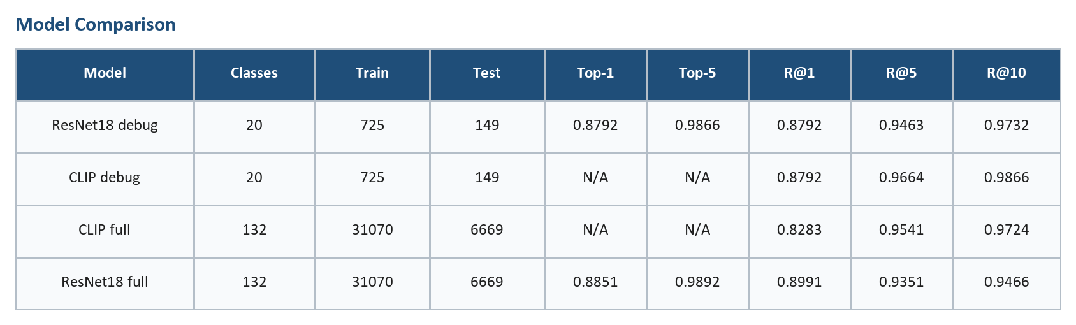
Table 1. Comparison of debug and full-dataset experiments.
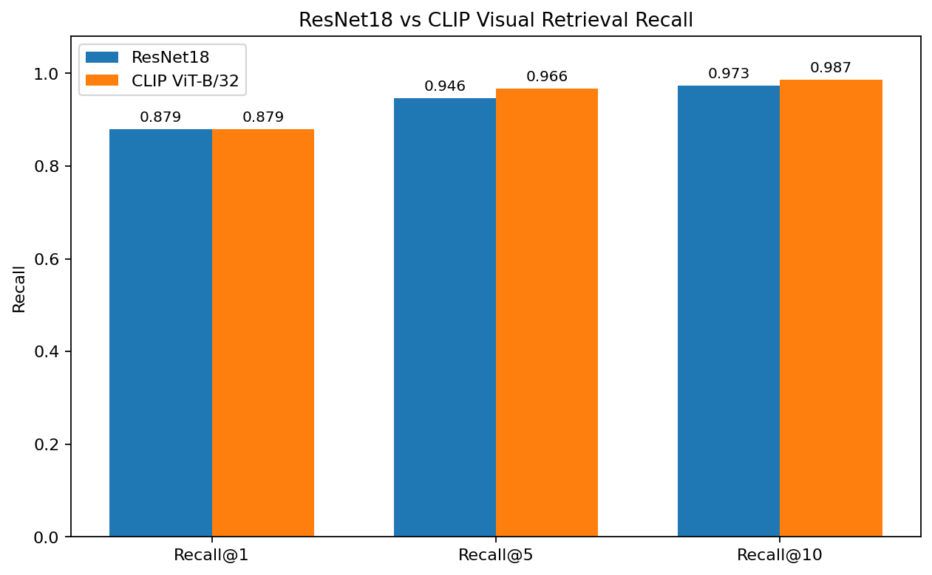
Figure 1. Original debug Recall@K comparison.
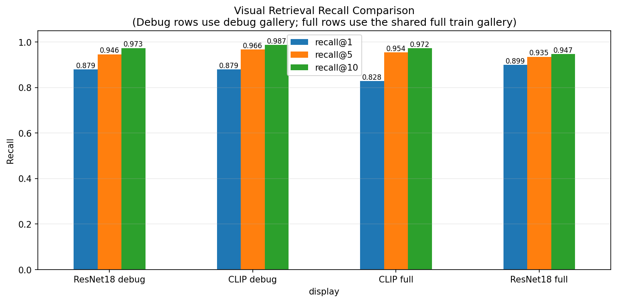
Figure 2. Recall@K comparison including ResNet18 full dataset.
The comparison table shows that the debug experiments validate the core pipeline, while the full experiments move the project closer to a realistic product visual search setting. ResNet18 full dataset has the strongest Recall@1 among the full-scope models, while CLIP full achieves stronger Recall@5 and Recall@10. This means ResNet18 is better at returning the first same-category item, whereas CLIP is stronger at placing at least one relevant category match somewhere in a short candidate list.
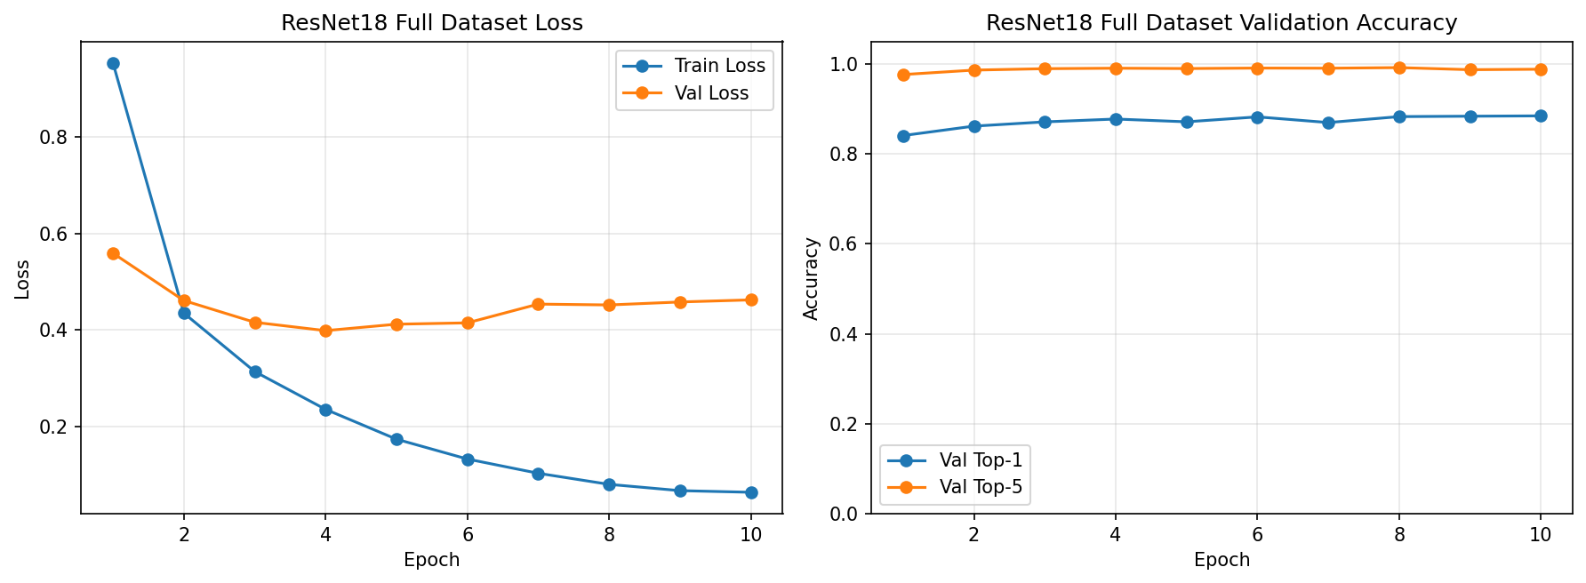
Figure 3. ResNet18 full training curves.
The training curves show rapid improvement during early epochs followed by more gradual validation gains. The best validation Top-1 accuracy occurs at epoch 10, while the best validation Top-5 accuracy occurs earlier. This pattern is reasonable for a supervised product classifier: the model quickly learns broad category structure and then slowly improves fine category boundaries.
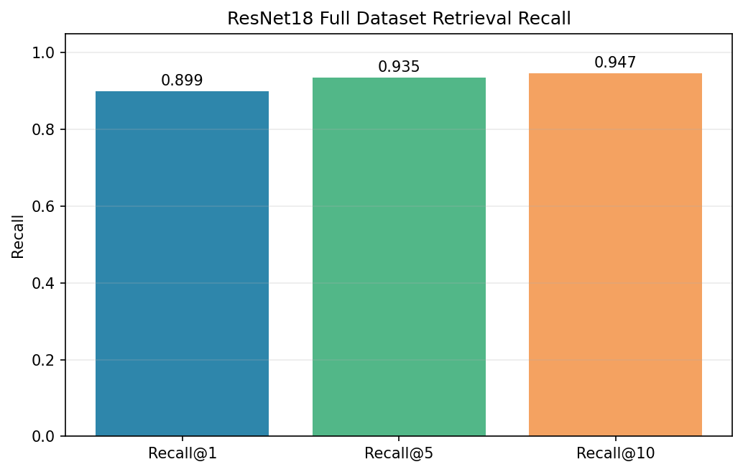
Figure 4. ResNet18 full retrieval summary.
The full ResNet18 retrieval results are computed with train images as the gallery and test images as queries. This avoids evaluation leakage and gives a realistic estimate of whether the model can retrieve similar unseen products from a known catalog.
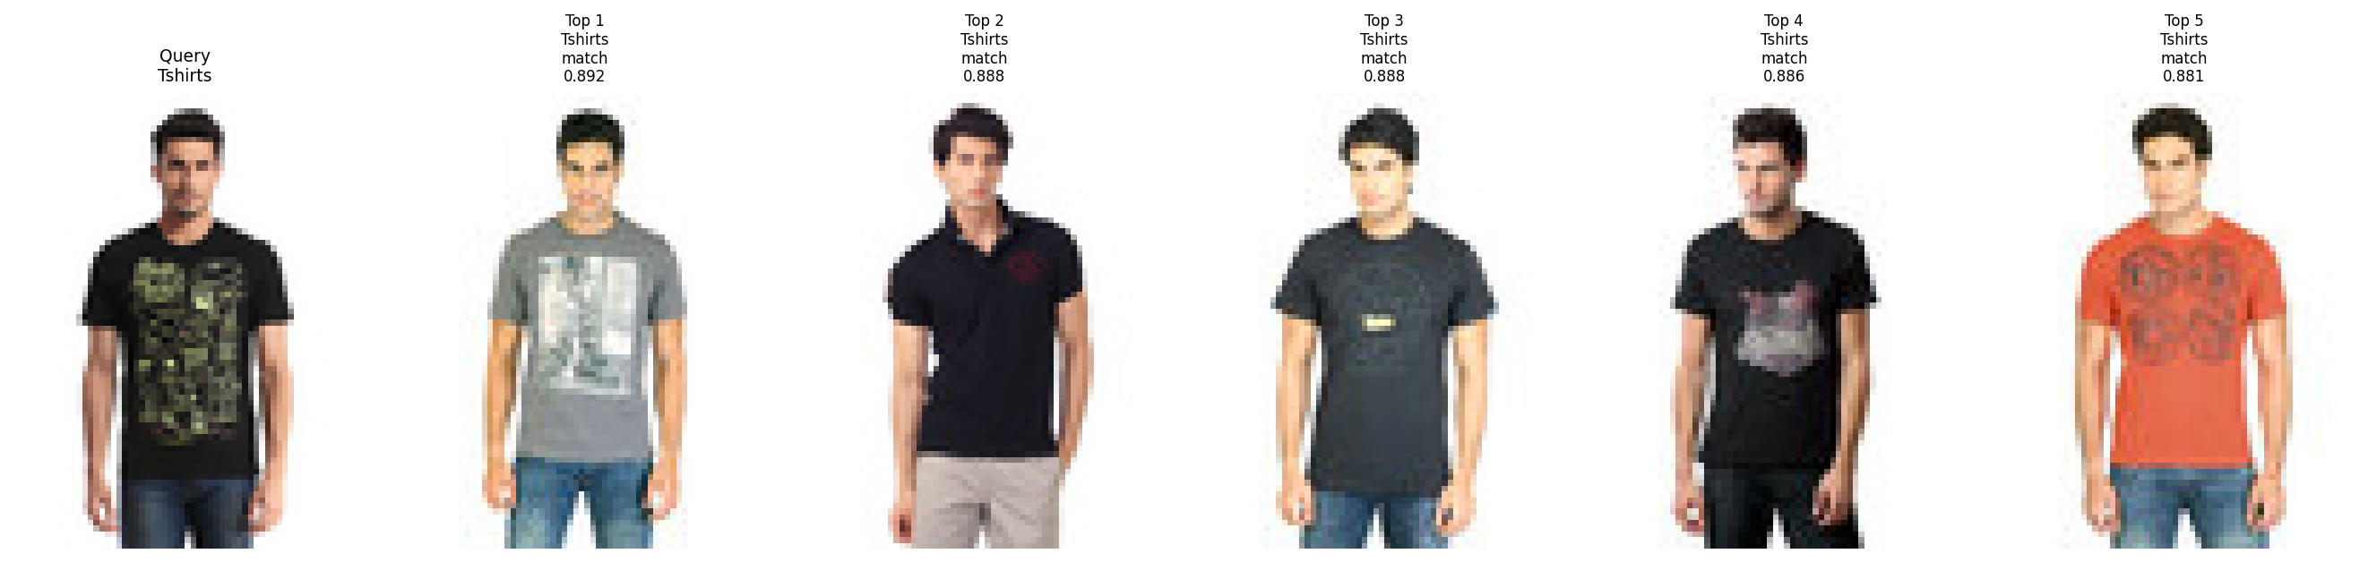
Figure 5. CLIP retrieval example.
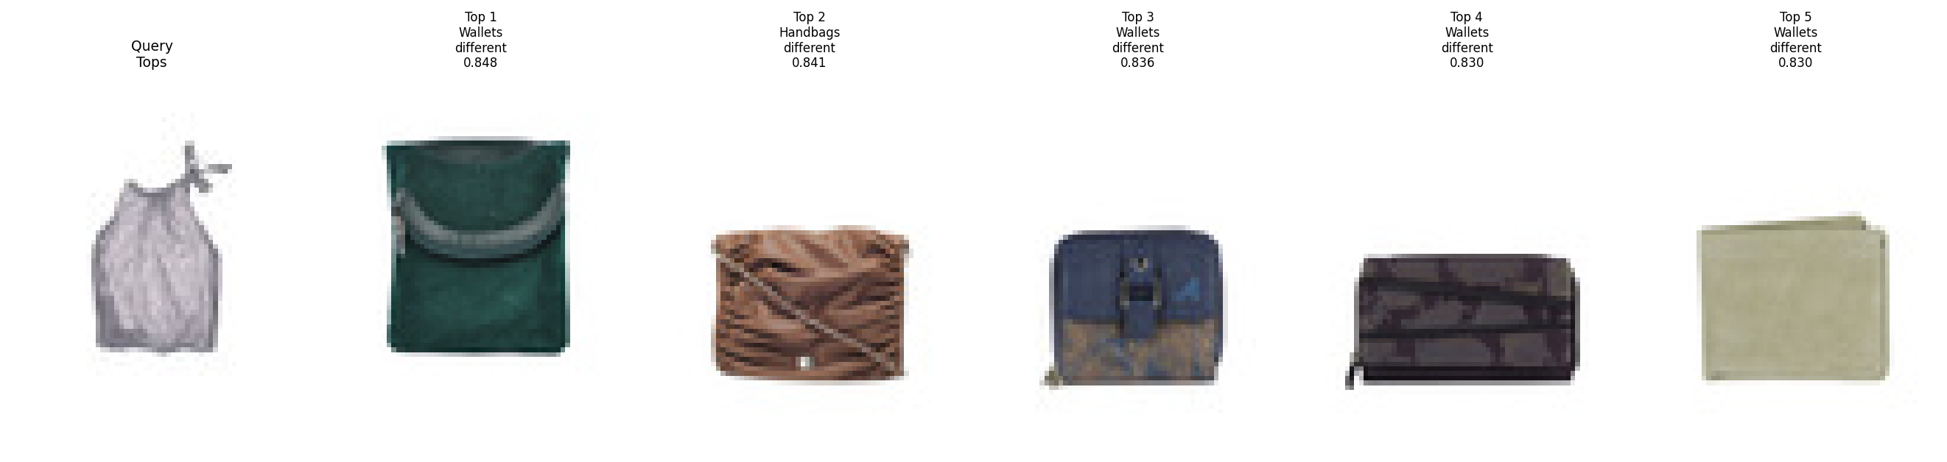
Figure 6. CLIP retrieval example.
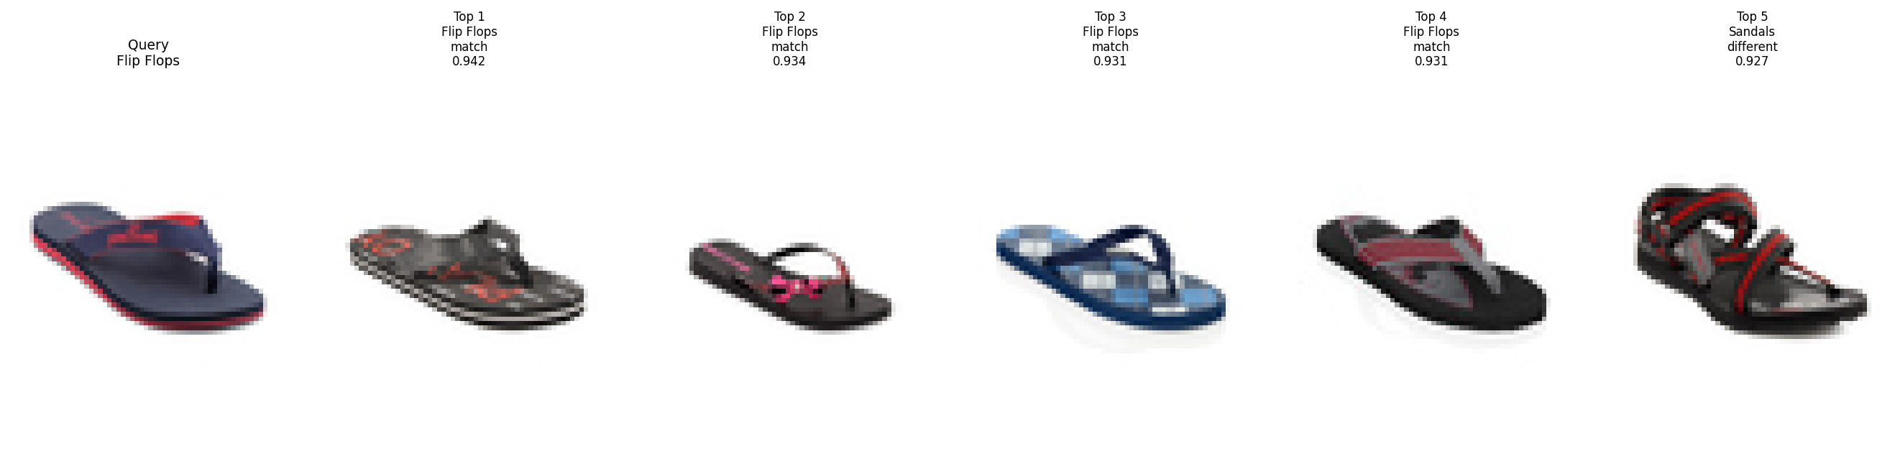
Figure 7. CLIP retrieval example.
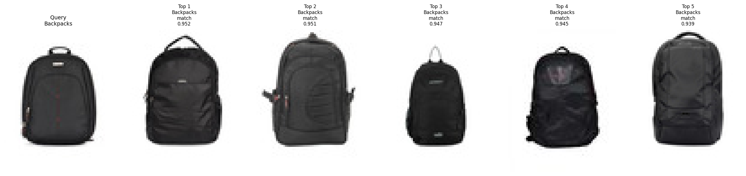
Figure 8. CLIP retrieval example.
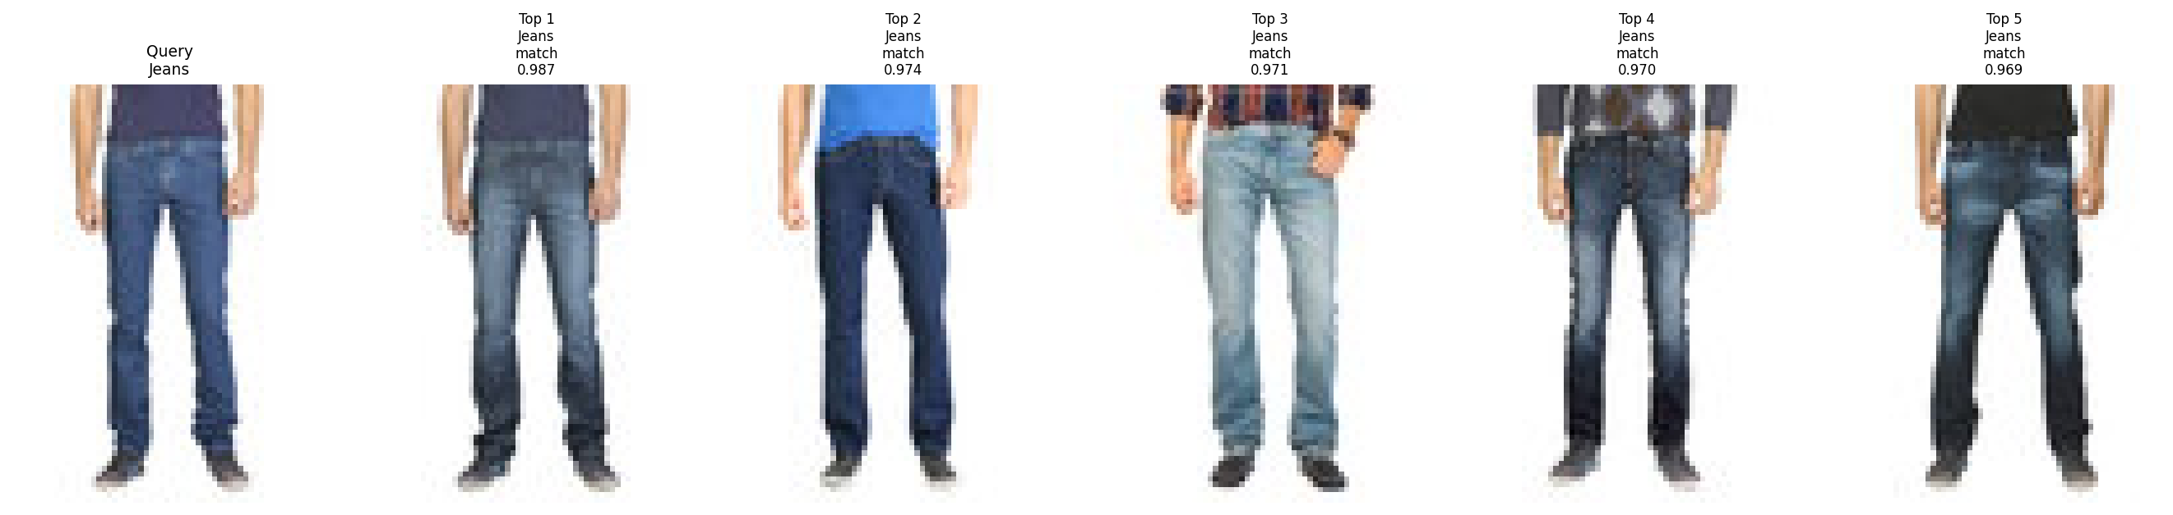
Figure 9. CLIP retrieval example.

Product Demo
The Streamlit app turns the experiment into an interactive product demo. Users can upload a product image or select a random sample query from the full test split. The app then retrieves visually similar products from the selected model's train-gallery index. Each result card displays the rank, product image, articleType, cosine similarity score, and image id.
The app supports switching between CLIP ViT-B/32 and ResNet18 Full Dataset. Both modes now use the same full train/test split: random sample queries come from the full test split, while retrieval searches a full train-gallery index. This prevents the confusing situation where a query image is treated as test for one model but gallery for another model.
In a real product deployment, this Streamlit app would correspond to the visual search frontend. A production version would likely move embedding extraction and vector search to a backend service, use FAISS or another approximate nearest-neighbor index, and combine visual similarity with business ranking signals such as price, brand, inventory, click-through rate, and personalization.

Discussion
The experiments highlight a useful distinction between supervised category learning and pretrained visual-semantic retrieval. ResNet18 is trained directly on articleType labels, so it learns dataset-specific category boundaries. This helps it achieve strong classification accuracy and strong Recall@1 in the full dataset setting. However, because it is trained to separate articleType classes, it may emphasize category-discriminative features more than broader style or semantic similarity.
CLIP is not trained on the local dataset, but it is pretrained on broad image-text pairs. Its full-dataset Recall@5 and Recall@10 are higher than ResNet18 full, suggesting that CLIP is especially strong as a candidate recall model. In product search, this is valuable because the ranking system often needs a good short list of candidates before applying business logic or personalization.
The results also show why classification accuracy alone is insufficient. ResNet18 full has strong Top-1 and Top-5 classification accuracy, but the product demo ultimately depends on retrieval behavior. A user does not only care whether the system says 'Flip Flops'; the user wants to see visually similar flip flops, ranked near the top.

Business Interpretation
From a business perspective, this system can be interpreted as the recall layer of a visual product search engine. When a user uploads an image, the system quickly retrieves a set of visually related catalog items. These items could then be re-ranked using structured metadata, user preferences, price, availability, and engagement signals.
The same embedding infrastructure can support several product features. It can power image-based product discovery, similar item recommendation, automatic product categorization, merchant listing quality checks, and duplicate or near-duplicate detection. On content platforms, it could help connect user-generated images or videos to purchasable products.
The model comparison suggests a practical hybrid strategy. ResNet18 is useful when the platform has labeled product data and wants a lightweight supervised model. CLIP is useful when broad generalization and strong Top-K candidate recall are important, especially before task-specific fine-tuning is available.

Limitations
- The relevance signal is articleType-level, not exact SKU-level matching.
- The debug CLIP result remains useful for the original notebook comparison, while the product demo now uses the full CLIP train-gallery index.
- The system does not yet use FAISS, metadata ranking, or a production backend.
- Category imbalance and dataset bias remain important limitations.
- The current app is a local Streamlit prototype rather than a deployed service.
- The retrieval evaluation does not consider brand, color, gender, season, price, or exact product identity.

Future Work
- Scale the full CLIP index with FAISS.
- Add FAISS approximate nearest-neighbor search.
- Fine-tune CLIP on product data.
- Use product metadata such as brand, color, price, and gender for ranking.
- Deploy with FastAPI and React and add a user feedback loop.
- Evaluate exact-product or SKU-level retrieval if product identity labels become available.
- Add qualitative failure analysis for visually similar but label-mismatched retrievals.

Conclusion
The project successfully builds a product visual search pipeline from dataset preparation through model training, retrieval evaluation, index construction, and an interactive frontend demo. The ResNet18 debug and CLIP debug experiments validate the end-to-end workflow. The full ResNet18 experiment extends the project to 44,405 valid images and 132 articleType classes. The synchronized full CLIP and ResNet18 indexes make the Streamlit demo easier to interpret and more realistic.
Overall, the project demonstrates that product recognition and visual retrieval are complementary. Supervised ResNet18 provides strong dataset-specific classification and Recall@1, while CLIP provides strong Top-K candidate recall without local supervised training. Together, these models form a solid foundation for a product visual search system that could later be scaled with FAISS, fine-tuned multimodal embeddings, metadata-aware ranking, and a production web application.

