Product Visual Search and Retrieval Using ResNet18 and CLIP
Course Project Report
Date: April 26, 2026
Author: Student Name

Abstract
This project builds a product visual search system using the Kaggle Fashion Product Images Small dataset. It compares a supervised ResNet18 baseline with a frozen CLIP ViT-B/32 visual-semantic embedding model. Retrieval is evaluated using Recall@K, which is more aligned with visual search than classification accuracy. On the debug subset, CLIP achieves stronger Recall@5 and Recall@10 than ResNet18.

Introduction
Product visual search allows users to find visually similar products using an image as the query. E-commerce and content platforms benefit from this capability because users often search by appearance, style, or visual intent rather than exact product names. Classification accuracy alone is insufficient because a visual search system needs to return a ranked list of relevant candidate products.

Dataset and Preprocessing
- Total scanned images: 44,441.
- Label source: articleType from styles.csv.
- Debug subset: 20 classes, up to 50 images per class, about 1,000 images.
- Train/gallery size: 725; validation size: 126; test/query size: 149.
- Images are resized and normalized before model inference or training.
- Duplicate extracted image folders were handled by prioritizing data/raw/images/ to avoid train/test leakage.

Methodology

ResNet18 Supervised Baseline
ResNet18 is a residual network. Residual connections help train deeper networks by allowing layers to learn corrections to earlier representations. The model is trained using articleType labels, then its final classification layer is removed so the penultimate 512-dimensional feature vector can be used as an image embedding.

CLIP-based Retrieval
CLIP stands for Contrastive Language-Image Pre-training. It is a vision-language pretrained model. This project uses only the frozen CLIP image encoder from the local checkpoint models/huggingface/timm_vit_base_patch32_clip_224_openai/open_clip_model.safetensors. CLIP is not fine-tuned on the current dataset.

Image Retrieval Pipeline
The retrieval pipeline embeds query and gallery images, computes cosine similarity, retrieves Top-K nearest images, and evaluates Recall@1, Recall@5, and Recall@10.

Experimental Setup
The experiments use DEBUG_MODE = True, 20 classes, at most 50 images per class, a gallery size of 725, and a query size of 149. Both ResNet18 and CLIP produce 512-dimensional embeddings. CUDA/GPU was used. The full 44,441-image dataset was not trained in this report.

Results
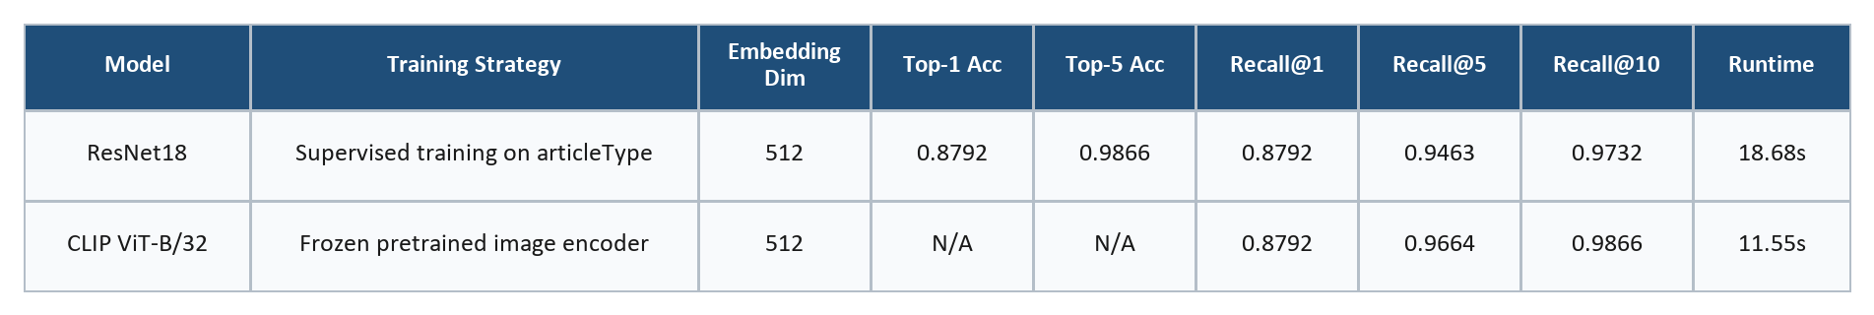
Table 1. ResNet18 and CLIP debug retrieval results.
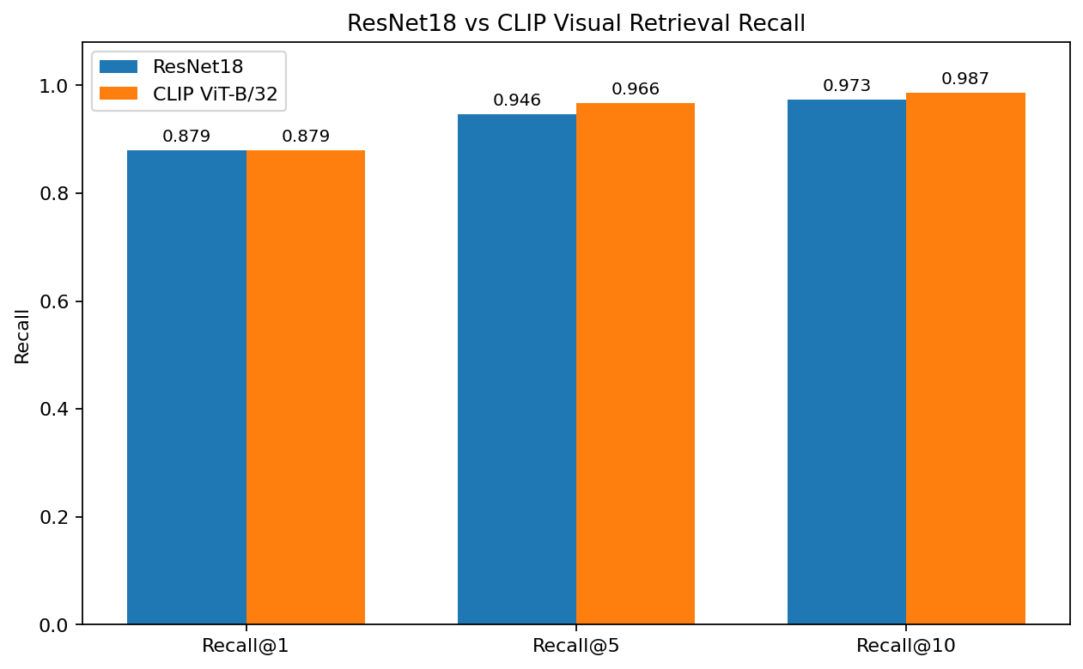
Figure 1. ResNet18 vs CLIP Recall@K comparison.

CLIP Retrieval Examples
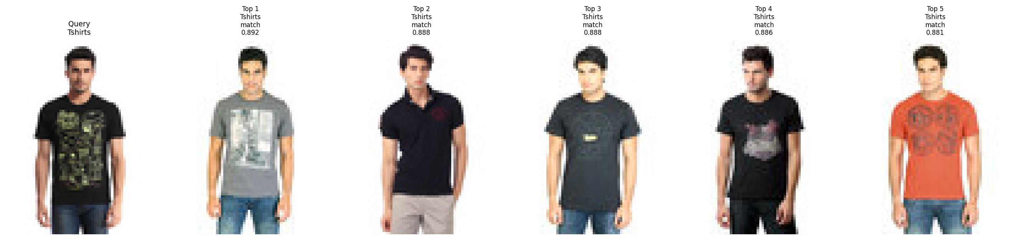
Figure 2. CLIP Top-5 retrieval example.
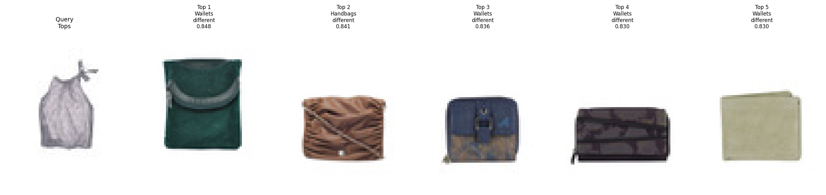
Figure 3. CLIP Top-5 retrieval example.
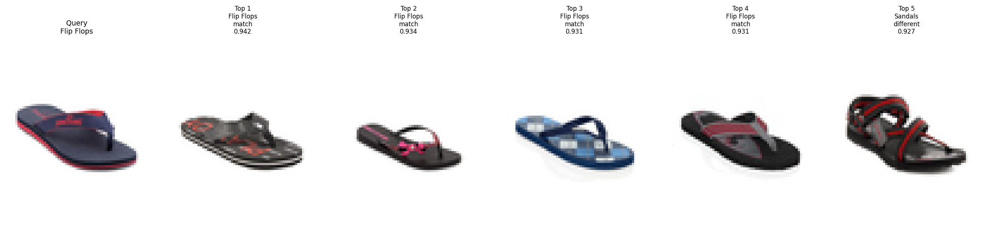
Figure 4. CLIP Top-5 retrieval example.
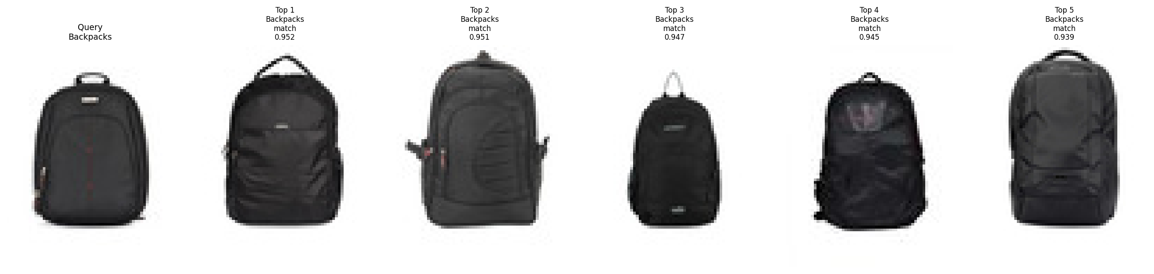
Figure 5. CLIP Top-5 retrieval example.
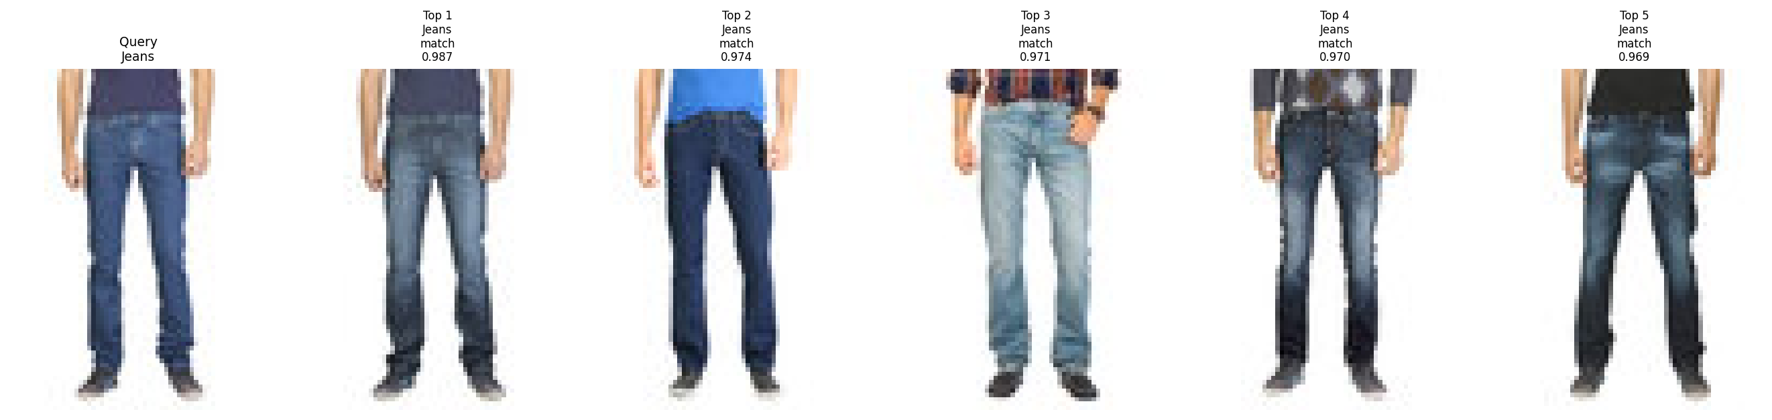
Figure 6. CLIP Top-5 retrieval example.

Discussion
ResNet18 and CLIP have nearly identical Recall@1, while CLIP has higher Recall@5 and Recall@10. This suggests that CLIP provides a stronger candidate set for Top-K retrieval. ResNet18 is a dataset-specific supervised baseline, while CLIP is a general-purpose pretrained visual-semantic representation. For visual search, Top-K retrieval is more important than a single class prediction because users usually expect a set of similar products.

Business Interpretation
Product visual search helps users find similar products from images. Higher Recall@K means the system is more likely to return relevant products near the top of the ranking. CLIP's strong performance without training suggests that pretrained foundation models can reduce training cost. ResNet18 remains useful as a lightweight supervised baseline or local customized model.

Limitations
- The experiment uses a debug subset rather than the full dataset.
- articleType is a category-level label, not a fine-grained product identity label.
- Debug subset results may not fully represent large-scale production behavior.
- CLIP is not fine-tuned on the current dataset.
- The retrieval metric does not consider color, brand, style, gender, season, or usage.

Future Work
- Run medium-scale and full-dataset evaluation.
- Fine-tune CLIP on fashion product data.
- Use attributes such as color, gender, season, and usage.
- Add FAISS for approximate nearest-neighbor search.
- Improve fine-grained retrieval beyond articleType.
- Deploy the pipeline as a simple visual search demo.

Conclusion
The project successfully constructs an end-to-end product visual search pipeline. ResNet18 validates supervised learning for product recognition and retrieval, while CLIP demonstrates that pretrained vision-language models can provide strong retrieval embeddings without dataset-specific training. CLIP's better Recall@5 and Recall@10 indicates strong practical value for product visual retrieval.

