Assignment-1 WEB Development

Submission date: 09/04/2017

Name: Bisesh Heyojoo, UN ID:17439847,

<https://sakuragi19.github.io/csy1018-assign1/>

Contents

Getting started……………………………………………………2

Wireframes……………………………………………………..2

This is my index page wireframe…………………..3

This is my Bio page wireframe………………………3

This is my CV page wireframe……………………….3

This is my Contact page wireframe………………4

Sketches index page……………………………………5

Sketches Bio page……………………………………….5,6

Sketches CV page……………………………………….6,7

Sketches contact page………………………………..9,10

Evidence of how I have used models for

good practice…………………………………………….11,12

Final draft…………………………………………………,13,14,15

Html validation………………………………………..16

Css validation…………………………………………..16

Time for completion………………………………..17

Getting Started

In between these 12 weeks I constantly kept changing my designs unsatisfied with myself. I got some ideas going through other people’s portfolio. This gave me a brief knowledge of what I had to do. I looked up for the codes from <https://www.w3schools.com/>. I have used HTML5 and Css to code my website.

Designs

Wireframes:

This is my index page wireframe:

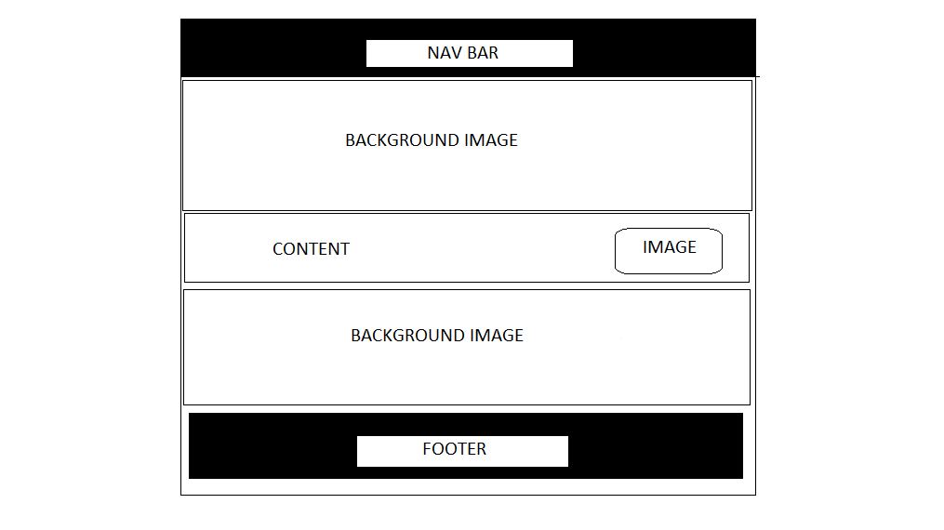

This is my bio page wireframe:

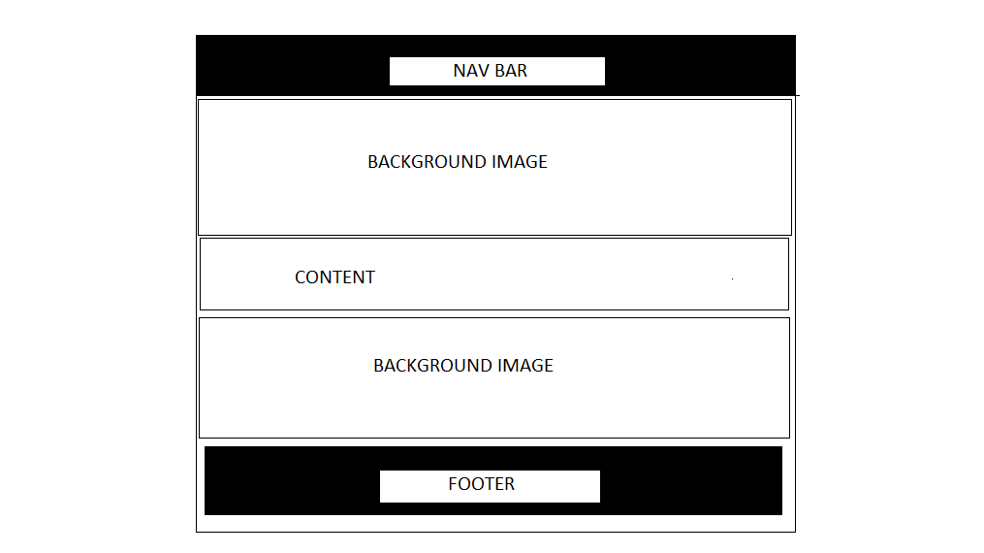

This is my CV page wireframe:

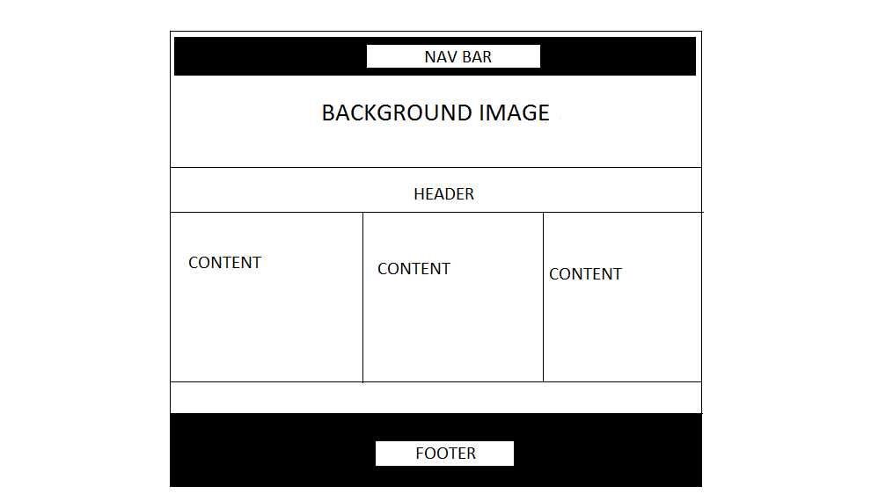

This is my contact page wireframe:

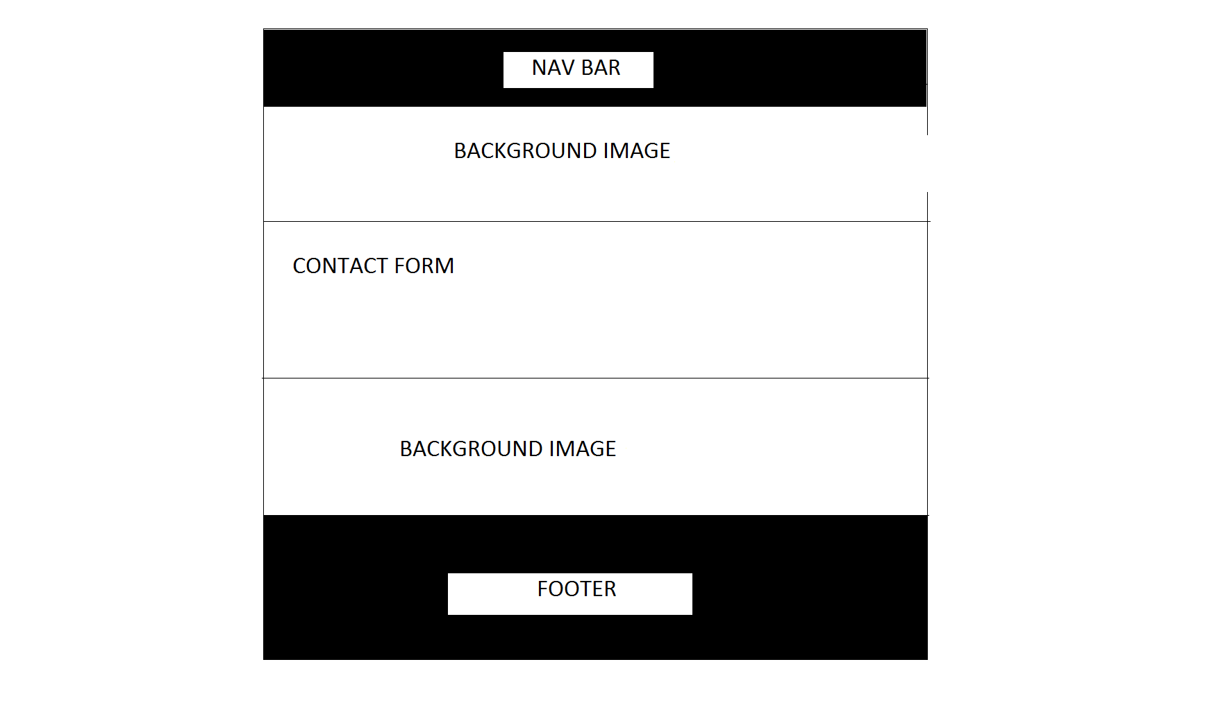

Sketches:

INDEX PAGE:

For my homepage, I wanted it to be very simple and very easy to navigate across other pages. So, I made the navigation bar at the top. The navigation bar will have black background color and the text color will be white. As we hover through the links the background color will change to grey and text color will change to black. I will add background images for the body part and will use parallax scrolling effect. I will have a small introduction of myself and a small picture of me beside the introduction. At the bottom I have a footer section which will contain links towards my social media accounts.

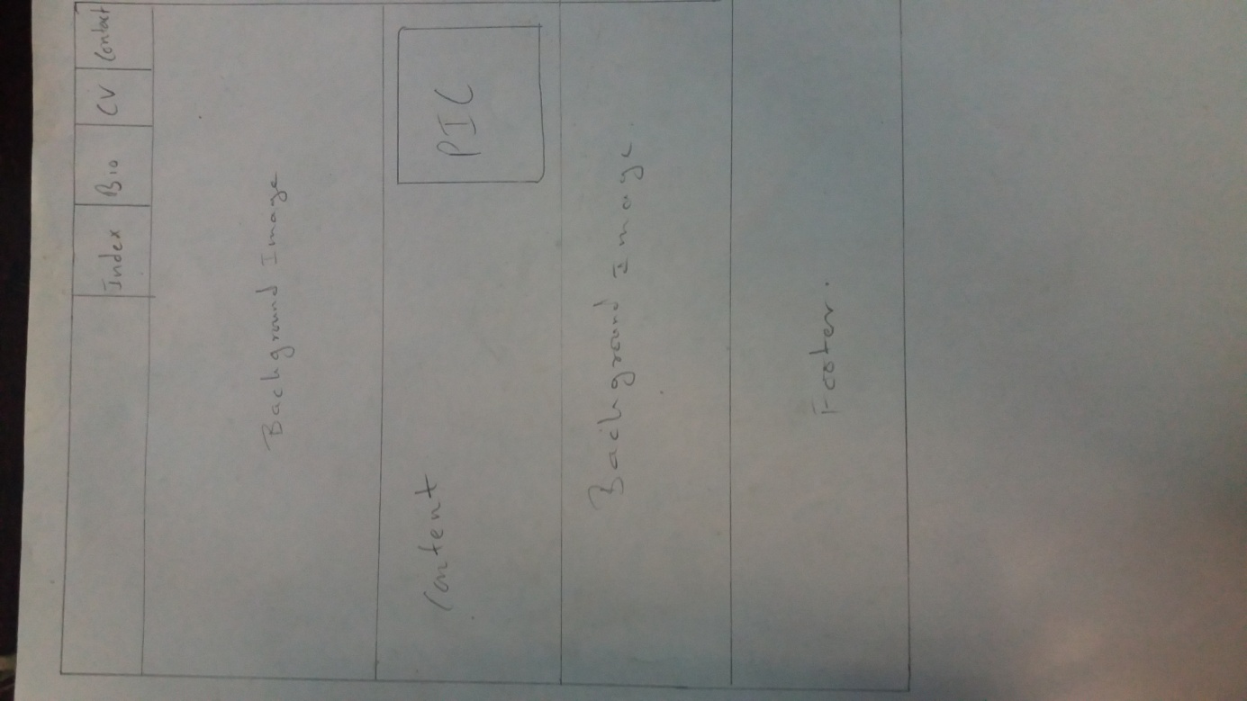

BIO PAGE:

For my bio page everything will be basically the same but I will not have my picture in it.

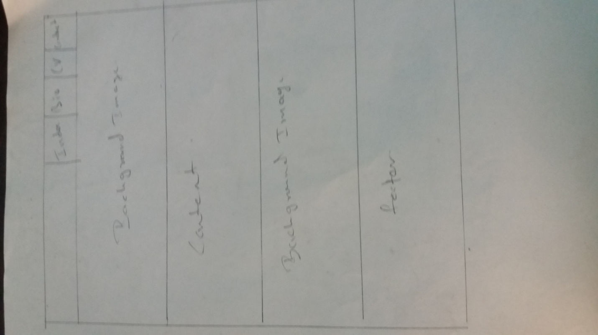

CV PAGE:

In my CV page I will be using the same layout structure but in the body part I will have a header section and below that three column sections that will have my skills and experience written. Below that will be section where I my educational information will be written. I will not put the second background image in this page. That part will be covered by my educational information section. This page will still have the parallax scrolling effect. The footer part will be the same.

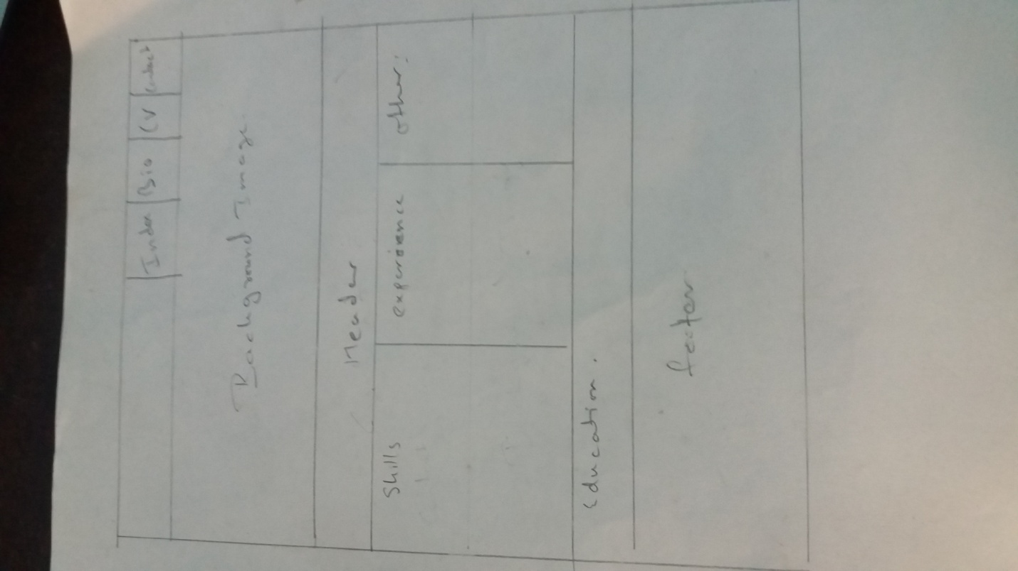

CONTACT PAGE:

Everything will be same in the contact page, but only the body part will be changed. There will be a contact form where users have to fill their name and email address and write the message they want to send to me. This page will have both background images and will have the parallax scrolling effect.

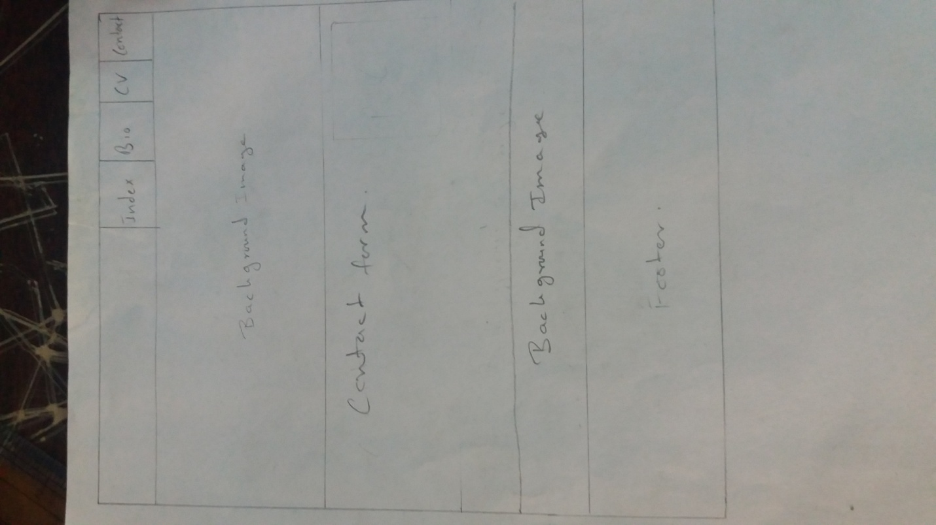

Evidence of how I have used models for good practice:

Navigation:

One of the most important models for good practices is that the navigation system of the website must have links towards all the pages of the website and should be user friendly so that the user can easily navigate throughout the website. If you don’t want to lose your website visitors then your website should have good page flow. This makes your website better. Also making sure that you don’t have endless trees of directories is a must. So in my website I have made sure to make my navigation bar as simple as possible also making sure that all the pages are linked together and I don’t have infinite tree directory.

Image Quality:

I have used images that were photographed by me so that I won’t have to deal with any copyright issues and the quality of the images will also be the best.

Visual Appeal:

While trying to create my own website I looked upon other famous portfolios that were around the internet, and from there I noticed that many popular portfolios had attractive colors and was visually appealing. So I also tried to do the same thing. I asked for my family and friends to give their opinions on which colors I should use for my websites.

Page load speed:

One of the most important things a web developer should keep in mind whilst creating a website is speed. Making sure the speed is high is one of the best models for good practice that can be used in web designing. I tested my website on pingdom.com. The load time for my website is 398ms which is a staggering 98% which is pretty good.

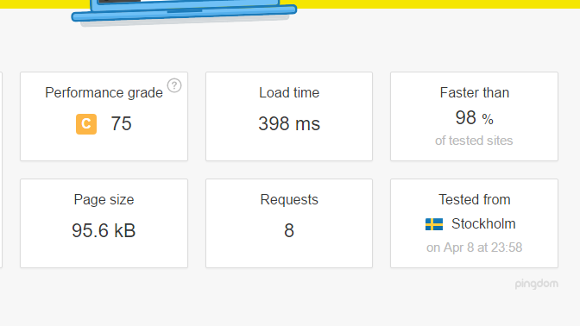

Final Draft:

Index page:

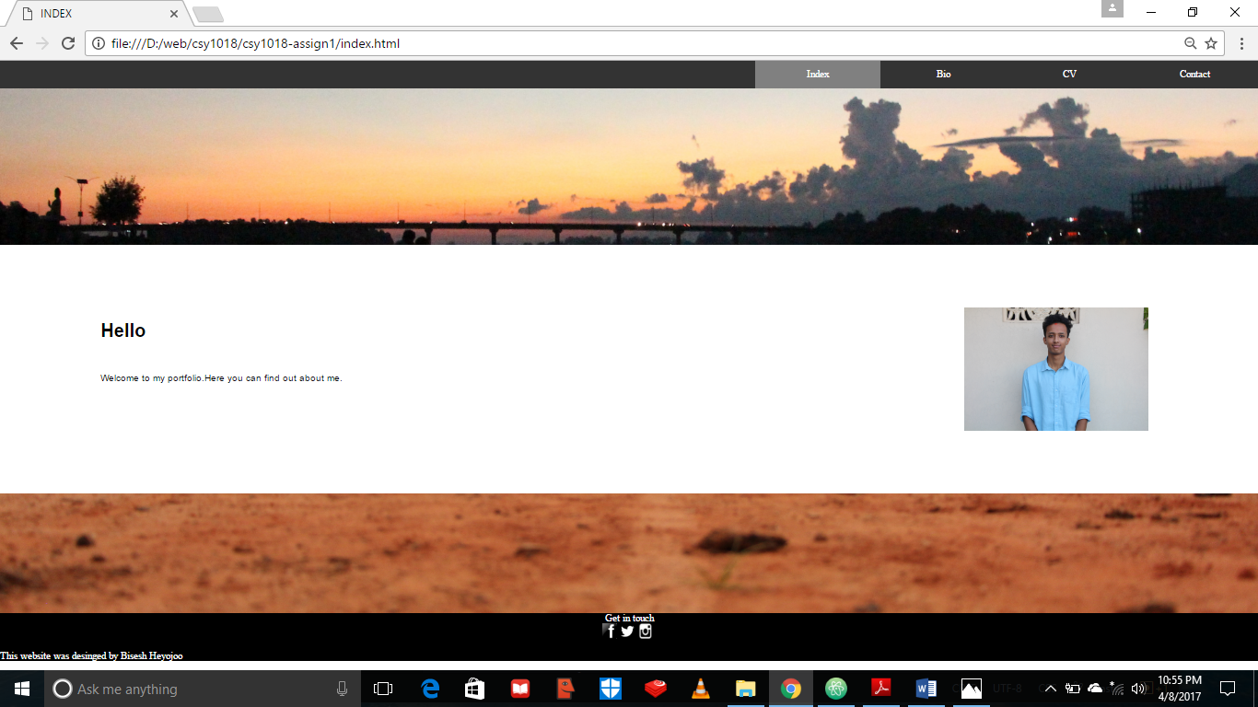

Bio page:

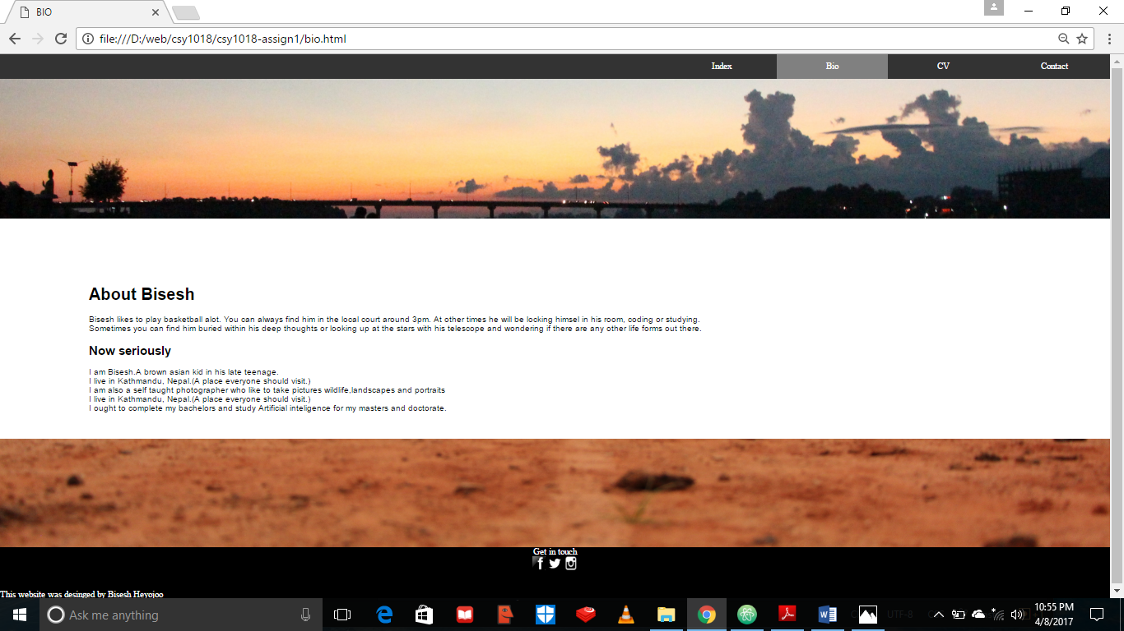

CV page:

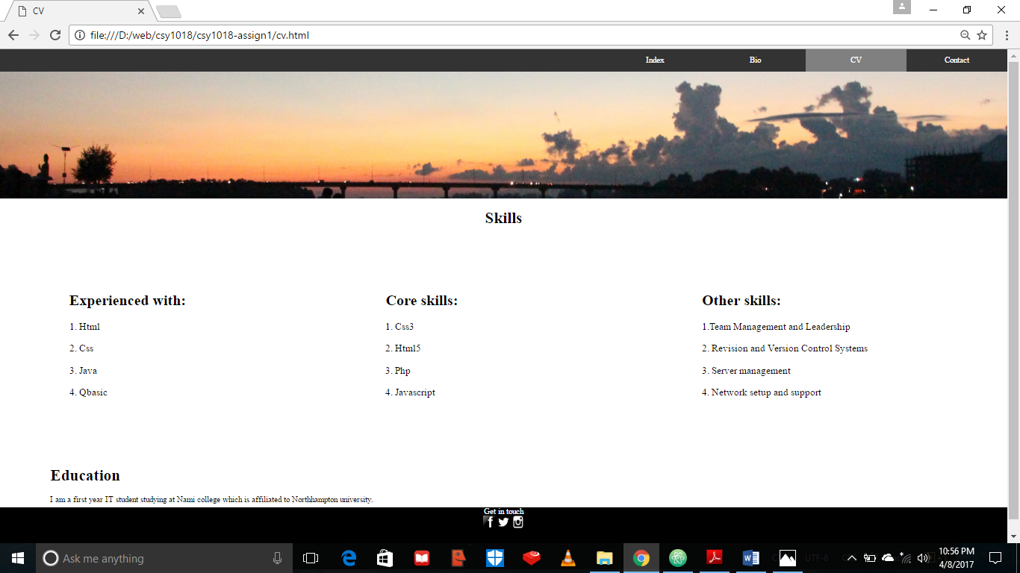

Contact page:

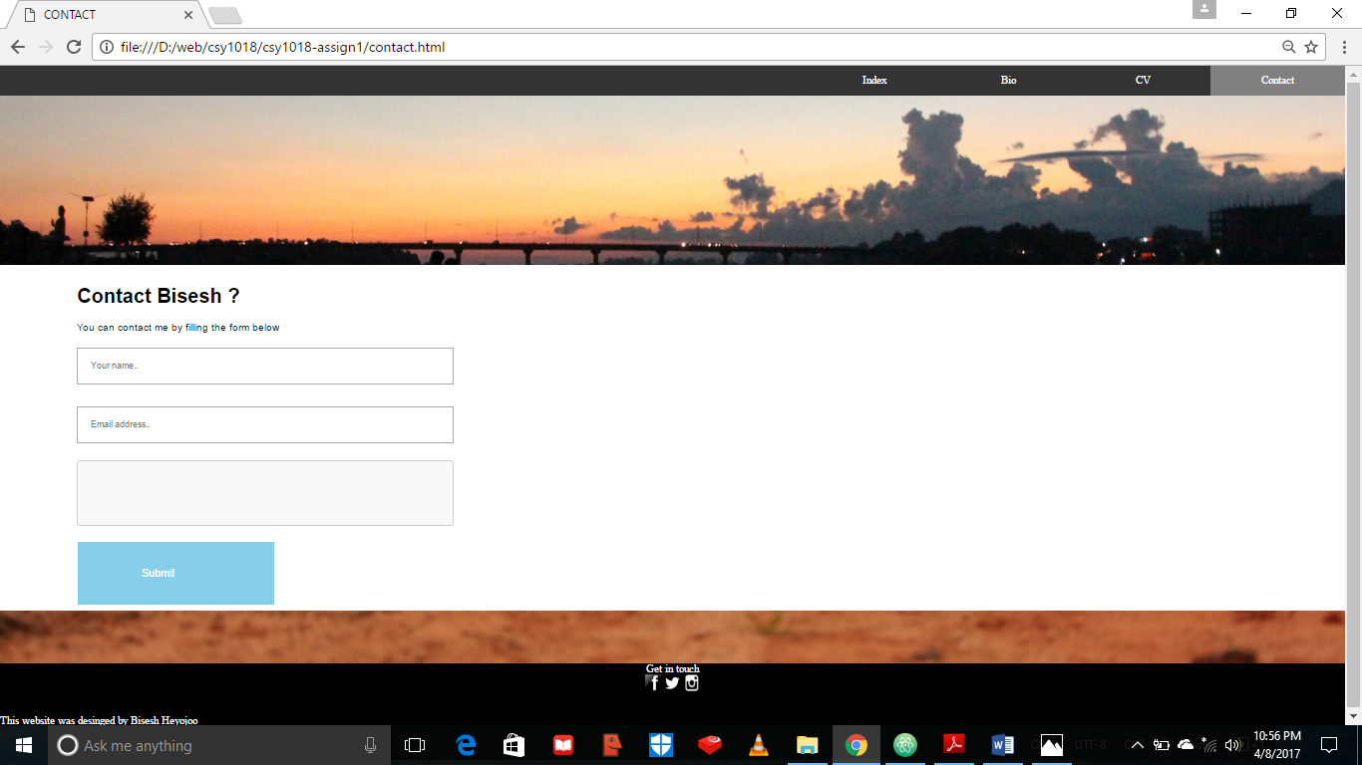

HTML validation:

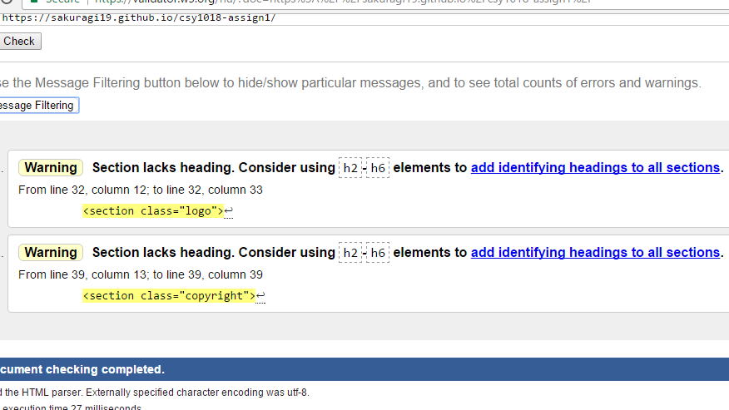

Css validation:

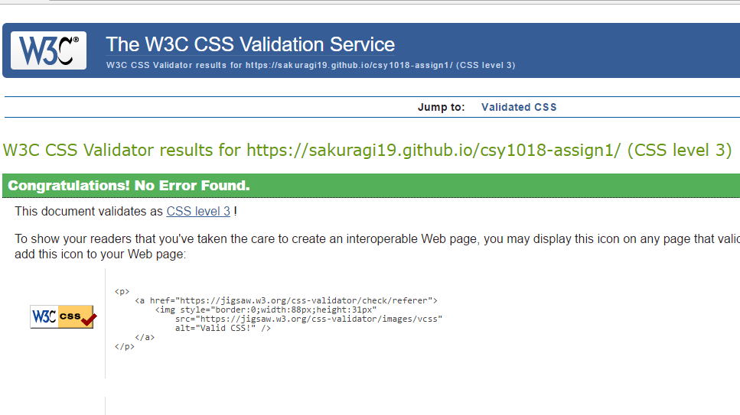

Time for completion:

The approximate time taken for me to complete the webpage was 23 hours. And for the completion of the assignment was over 74 hours.