UI/UX Case Study– Music Player App

Ananya Rakhi Singh

22BCE11485

ananyarakhisingh@vitbhopal.ac.in

+91 8107377058

**1. Project Overview**

* What is the project?

Music Player App UI

* Why are you designing it?

To create a personalized music experience for Music Enthusiasts.

* Who is it for?

Everyone who is pationate about music and wants to find an escape from the reality.

**2. Problem Statement**

Users who enjoy listening to music often struggle to find a music app that feels truly personalized, visually soothing, and easy to navigate.

Most existing music apps are packed with features but lack emotional connection and intuitive design. They tend to focus on algorithmic recommendations and generic playlists, overlooking how people connect with music based on mood, moments, or personal vibes. This makes it harder for users to feel engaged, especially when they want a more meaningful, mood-driven listening experience.

**3. User Research**

To understand user behaviors and expectations around music streaming apps, I conducted a mix of informal interviews, online surveys, and secondary research.

* **Users want personalization:** 80% of participants said they rely on music to match their moods but felt current apps don’t understand or reflect their emotional state.
* **Overwhelming UI is a turn-off:** Many users felt overwhelmed by cluttered interfaces and too many options. They prefer clean, minimal layouts with easy navigation.
* **Mood-based discovery is underutilized:** While users often choose music based on feelings (e.g., “happy,” “chill,” “heartbroken”), most apps only recommend music based on past listens, not emotions.
* **Visual aesthetics matter:** Soft, aesthetically pleasing visuals were mentioned as something that could enhance the emotional connection with the app.
* **Favorites & quick access matter:** Users want faster access to their liked songs and playlists without digging through multiple layers.

**User Types Identified:**

1. **The Mood Listener:** Selects music based on feelings, not genre.
2. **The Minimalist:** Wants a clean, distraction-free experience.
3. **The Curator:** Loves making playlists and sharing them.
4. **The Passive Listener:** Plays music in the background while working or commuting, prefers smart suggestions.

**4. Personas**

**👨‍💻 Persona 1: Mrityunjay Kumar- Studyholic**

* Age: 25
* Occupation: Teacher
* Location: Patna, Bihar

🎯 Goals:

* To quickly access focus-friendly music during work sessions
* To have a minimal, distraction-free music player
* To listen based on vibes/moods instead of genres

💭 Frustrations:

* Gets distracted by endless recommendations
* Feels most music apps look too corporate or lack personality
* Wants to build custom playlists but finds it clunky on most apps

🎧 Music Habits:

* Plays ambient, chill, or cinematic tracks while working
* Uses music to get into a creative flow
* Switches moods between mellow mornings and energized evenings
* Prefers apps with a sleek, visual aesthetic that match his vibe

👩‍🎓 **Persona 2: Priyanshu Joshi– The Emotional Listener**

* Age: 21
* Occupation: University Student (computer science major)
* Location: Pune, Maharashtra

🎯 Goals:

* To find music that reflects his emotions (e.g., calm, happy, heartbroken)
* To discover new romantic or indie tracks
* To organize music into mood-based playlists

💭 Frustrations:

* Most apps push trending songs, not what he feels like listening to
* Cluttered UI with too many unnecessary features
* Can't easily create aesthetic playlists or share emotional moments through music

🎧 Music Habits:

* Listens to music while studying, journaling, or daydreaming
* Loves lo-fi, acoustic, and soft romantic songs
* Often uses music as emotional self-care
* Listens on Spotify but finds it too "algorithmic"

**5. Task Flow & Wireframes**

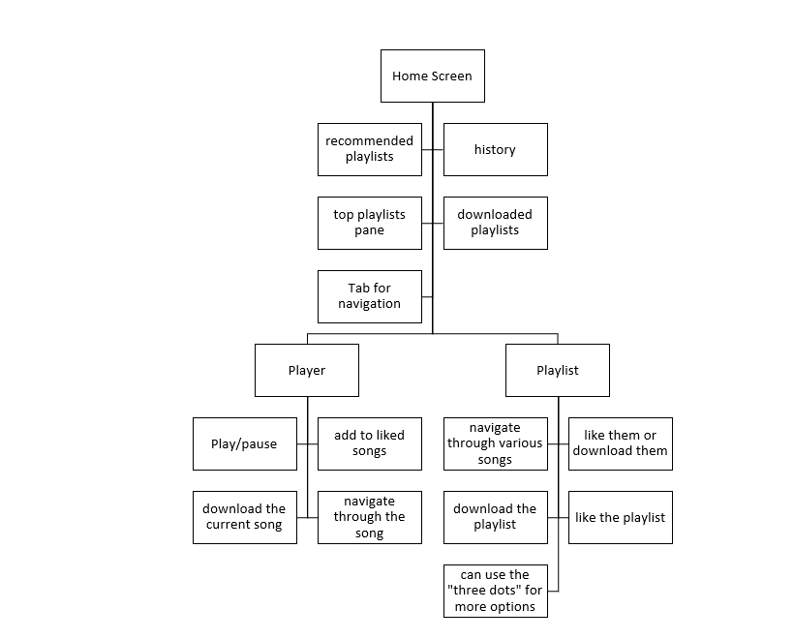

**6. Information Architecture**

These are low-fidelity outlines of your screens, describing their basic layout. Based on your design, here’s a breakdown of each key screen:

### Home Screen

* Background gradient (Soothing Mood)
* Playlist section with:
* Song card (image, title, artist)
* Scrollable list
* Bottom Nav bar  
  Home | Search | Favorites | Profile

1. **Now Playing Screen**

* Large Album Art (centered)
* Song Title + Artist (under image)
* Playback Controls:  
  Previous | Play/Pause | Next
* Progress Bar
* Heart Icon ❤️ to add to favorites
* Optional background animation (blur from album art)

1. **Playlist Detail Screen**

* Header with Playlist Title
* List of songs with play buttons
* Mini-album art and song info



**7. UI Design**

My prototype presents a mobile music application with a focus on personalization and user engagement.

Here's a breakdown of the design elements:

1. Home Screen:

* Personalized Greeting: Displays a friendly message like "Hello, Ananya.278," fostering a personal connection.
* Content Sections: Features categories such as "Recommended," "Look Back...," and "Downloaded," each likely showcasing curated playlists or tracks.
* Navigation Bar: Includes icons for Home, Search, Playlist, and Profile, facilitating easy navigation.​

1. Now Playing Screen:

* Album Art Display: Prominently features the current track's album art.
* Playback Controls: Provides standard controls like play/pause, next, previous, and a like (heart) button.
* Interactive Elements: Incorporates hover and click interactions for a dynamic user experience.​

1. Playlist Screen ("Songs I’ll Never Skip"):

* Track List: Displays a list of songs with details such as artist name, track title, and options to like or access more actions.
* Design Aesthetics: Utilizes a soft color palette with pastel tones, creating a soothing visual appeal.

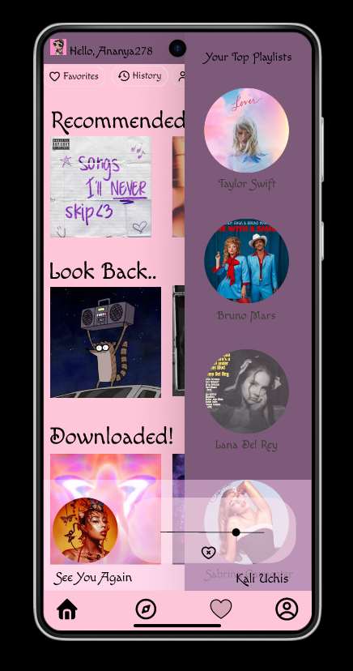 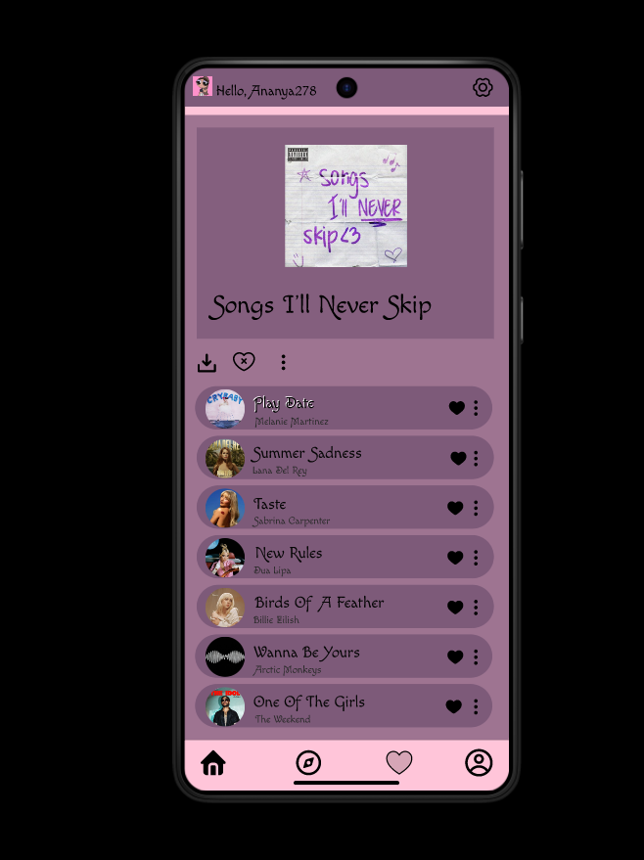

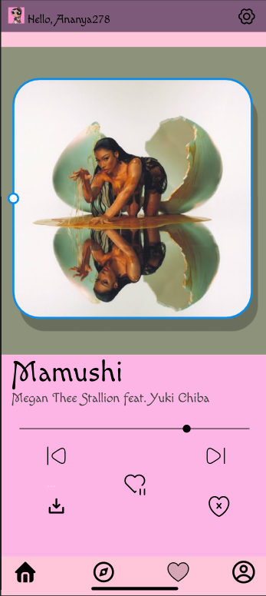

**8. Prototype**

Here is a link to the prototype :  
<https://www.figma.com/proto/JJLJKcuQaTa95eO7dwLrg1/final?node-id=1-362&t=CCFWuiMQt9SmrTiV-1&scaling=scale-down&content-scaling=fixed&page-id=0%3A1&starting-point-node-id=1%3A3>

**9. Usability Testing**

**Tasks Conducted:**

* Navigating through different music categories.
* Playing a song by tapping on the album art.
* Liking a song using the heart icon.
* Exploring the "Songs I’ll Never Skip" playlist.
* Using the bottom navigation bar to switch between screens.​

**Feedback Received:**

Positive:

* Users appreciated the personalized greeting and overall aesthetic.
* Navigation was intuitive, and the interactive elements enhanced engagement.

**Areas for Improvement:**

* Some users were uncertain about the functionality of certain icons (e.g., download icon).
* Hover effects were not evident in mobile view, leading to potential confusion.
* Swipe gestures in carousels lacked clear indicators.​

**Implemented Changes:**

* Enhanced icon clarity by increasing contrast and adding tooltips.
* Introduced animations to interactive elements for better feedback.
* Added visual cues for swipe gestures in carousels.
* Ensured all interactive elements are functional and responsive in mobile view.

**10. Final Thoughts & Learnings**

**What Went Well:**

* The personalized and aesthetic design resonated well with users.
* Navigation structure was clear and user-friendly.
* Interactive elements added depth to the user experience.​

**Areas for Improvement:**

* Need to ensure all functionalities are evident and accessible in mobile view.
* Consider adding onboarding or tooltips to guide new users.
* Evaluate the necessity and functionality of hover effects in a mobile context.​

**Key Learnings:**

* User Feedback is Crucial: Direct insights from users can highlight areas that designers might overlook.
* Consistency Matters: Maintaining a consistent design language enhances usability and aesthetics.
* Mobile-First Approach: Designing with mobile constraints in mind ensures broader accessibility and functionality