Tribhuvan University
Faculty of Humanities and Social Sciences
NEPSE AI: REAL-TIME FINANCIAL DECISION SUPPORT AND STOCK PREDICTION SYSTEM
A PROJECT REPORT
Submitted to
Department of Computer Application
[Name of the College / Campus]
In partial fulfillment of the requirements for the Bachelors in Computer Application (BCA)
Submitted by:
[Candidate Name(s)]
Roll No: [TU Roll Number] | Reg. No: [TU Registration Number]
September, 2026
Under the Supervision of:
[Supervisor Name]
[Academic Designation, Department of Computer Application]

Tribhuvan University
Faculty of Humanities and Social Sciences
[Name of the College / Campus]
Supervisor’s Recommendation
I hereby recommend that this project prepared under my supervision by [Candidate Name(s)] entitled “NEPSE AI: REAL-TIME FINANCIAL DECISION SUPPORT AND STOCK PREDICTION SYSTEM” in partial fulfillment of the requirements for the degree of Bachelor of Computer Application (BCA) is recommended for the final evaluation.
________________________
SIGNATURE
[Supervisor Name]
SUPERVISOR
[Academic Designation]
Department of Computer Application
[Full Address of Department & College]
Date: ____________________

Tribhuvan University
Faculty of Humanities and Social Sciences
[Name of the College / Campus]
LETTER OF APPROVAL
This is to certify that this project prepared by [Candidate Name(s)] entitled “NEPSE AI: REAL-TIME FINANCIAL DECISION SUPPORT AND STOCK PREDICTION SYSTEM” in partial fulfillment of the requirements for the degree of Bachelor in Computer Application (BCA) has been evaluated. In our opinion it is satisfactory in the scope and quality as a project for the required degree.
SIGNATURE of Supervisor:  _____________________  Name: [Supervisor Name]  Designation: [Academic Designation]  Dept: Computer Application  College: [College Name] | SIGNATURE of HOD/Coordinator:  _____________________  Name: [HOD/Coordinator Name]  Designation: [Academic Designation]  Dept: Computer Application  College: [College Name]
SIGNATURE of Internal Examiner:  _____________________  Name: [Internal Examiner Name]  Designation: [Academic Designation]  Dept: Computer Application  College: [College Name] | SIGNATURE of External Examiner:  _____________________  Name: [External Examiner Name]  Designation: External Examiner  Tribhuvan University  Faculty of Humanities & Social Sciences

ABSTRACT
The Nepal Stock Exchange (NEPSE) is an emerging financial market characterized by structural volatility, pronounced illiquidity in lower-tier issues, and policy-driven macroeconomic fluctuations. Traditional algorithmic approaches that attempt to forecast exact price points frequently break down due to low market depth and speculative noise. This project, entitled “NEPSE AI: Real-Time Financial Decision Support and Stock Prediction System,” addresses these empirical realities by transitioning from high-error price target regression to a high-probability quantitative Decision Support System (DSS) and real-time market supervision platform.
The system is engineered as a modern, decoupled microservice architecture. The core application logic and data ingestion pipelines are implemented using NestJS with Prisma ORM, seamlessly interfacing with live NEPSE data wrappers (@rumess/nepse-api) and persisting historical daily OHLCV bars across 649 listed securities. Machine learning inference is handled by a dedicated Python FastAPI microservice utilizing a two-stage hybrid predictive architecture. In Stage 1, a PyTorch Long Short-Term Memory (LSTM) network extracts 16-dimensional latent temporal embeddings from 30-day sequential price windows. In Stage 2, these embeddings are combined with classical technical indicators (Wilder’s RSI, MACD Histogram, Exponential Moving Averages, and Volume Delta) and classified via an XGBoost multi-class softprob engine into probabilistic Bullish, Bearish, or Neutral market regimes.
Complementing the predictive pipeline is a full-featured financial terminal built in React and Vite. It provides an interactive TradingView-style candlestick and area charting visualizer, customizable Bollinger Bands and moving average overlays, a real-time price alarm engine with zero-dependency Web Audio API synthesizer chimes and browser desktop notifications, an empirical 60-session signal backtesting engine, a 5-day Monte Carlo price projection envelope, a live Market Movers screener, a multi-stock comparison matrix, and a paper trading portfolio manager. The resulting system bridges modern software engineering, distributed data pipelines, and quantitative artificial intelligence into an enterprise-grade decision support tool for retail investors, researchers, and academic evaluation.
Keywords: Decision Support System, NEPSE, LSTM, XGBoost, Hybrid Machine Learning, Technical Indicators, Real-Time Alarms, Microservices, NestJS, React.

ACKNOWLEDGEMENT
We would like to express our profound gratitude and heartfelt appreciation to Tribhuvan University, Faculty of Humanities and Social Sciences (FOHSS), for incorporating Project II (CAPJ356) into the Bachelor of Computer Application (BCA) curriculum. This comprehensive practical endeavor has provided an extraordinary opportunity to synthesize theoretical knowledge across software engineering, artificial intelligence, database systems, and distributed system architectures into a functional, production-ready application.
We owe a great debt of gratitude to our respected Project Supervisor, [Supervisor Name], for their invaluable guidance, constructive criticism, and unwavering mentorship throughout the lifecycle of this project. Their insightful feedback during system analysis, algorithmic formulation, and architectural refinement significantly elevated the technical rigor and practical utility of our work.
We are also deeply thankful to the Head of Department, [HOD/Coordinator Name], and all the esteemed faculty members of the Department of Computer Application at [College Name] for their administrative support, technical guidance, and for providing state-of-the-art computational laboratories conducive to intensive model training and software development.
Finally, we extend our sincere appreciation to our families, peers, and fellow BCA classmates for their constant encouragement, moral support, and creative brainstorms during the development and testing phases of this project.

TABLE OF CONTENTS
Supervisor’s Recommendation ........................................... ii
Letter of Approval .................................................... iii
Abstract .............................................................. iv
Acknowledgement ....................................................... v
List of Abbreviations ................................................. vii
List of Figures ....................................................... viii
List of Tables ........................................................ ix
CHAPTER 1: INTRODUCTION ............................................... 1
1.1 Introduction .................................................... 1
1.2 Problem Statement ............................................... 2
1.3 Objectives ...................................................... 3
1.4 Scope and Limitation ............................................ 4
1.5 Development Methodology ......................................... 5
1.6 Report Organization ............................................. 6
CHAPTER 2: BACKGROUND STUDY AND LITERATURE REVIEW ..................... 7
2.1 Background Study ................................................ 7
2.1.1 Overview of NEPSE Market Mechanics .......................... 7
2.1.2 Technical Analysis & Mathematical Indicators ................ 8
2.1.3 Machine Learning in Time-Series Financial Systems ........... 10
2.1.4 Real-Time Web Alerting Architectures ........................ 12
2.2 Literature Review ............................................... 13
2.2.1 Review of Related Works ..................................... 13
2.2.2 Comparative Summary of Literature ........................... 15
CHAPTER 3: SYSTEM ANALYSIS AND DESIGN ................................. 17
3.1 System Analysis ................................................. 17
3.1.1 Requirement Analysis ........................................ 17
i. Functional Requirements ...................................... 17
ii. Non-Functional Requirements ................................. 19
3.1.2 Feasibility Analysis ........................................ 20
3.1.3 Object Modelling (Class Diagram & Object Relationships) ..... 22
3.1.4 Dynamic Modelling (Sequence & State Diagrams) ............... 24
3.1.5 Process Modelling (Activity Diagrams) ....................... 26
3.2 System Design ................................................... 28
3.2.1 Architectural Design ........................................ 28
3.2.2 Database Schema Design & Data Dictionary .................... 30
3.2.3 Interface Design (UI/UX Overview) ........................... 33
3.2.4 Component and Deployment Architecture ....................... 36
3.3 Algorithm Details ............................................... 38
3.3.1 Mathematical Formulations of Technical Indicators ........... 38
3.3.2 Two-Stage Hybrid LSTM-XGBoost Architecture .................. 40
3.3.3 Real-Time Multi-Condition Alert Evaluation Engine ........... 42
3.3.4 Empirical Signal Backtesting Simulation Algorithm ........... 43
CHAPTER 4: IMPLEMENTATION AND TESTING ................................. 45
4.1 Implementation .................................................. 45
4.1.1 Tools and Platforms Used .................................... 45
4.1.2 Module Implementation Details ............................... 47
4.2 Testing ......................................................... 52
4.2.1 Unit Testing ................................................ 52
4.2.2 System & Integration Testing ................................ 55
CHAPTER 5: CONCLUSION AND FUTURE RECOMMENDATIONS ...................... 58
5.1 Conclusion ...................................................... 58
5.2 Lessons Learnt & Outcomes ....................................... 59
5.3 Future Recommendations .......................................... 60
APPENDICES ............................................................ 62
Appendix A: System User Interface Screenshots ....................... 62
Appendix B: Core Algorithmic Code Listings .......................... 66
Appendix C: Supervisor Visit Log Sheet .............................. 70
REFERENCES ............................................................ 71

LIST OF ABBREVIATIONS
Abbreviation | Full Description
AI | Artificial Intelligence
API | Application Programming Interface
BCA | Bachelor of Computer Application
CASE | Computer-Aided Software Engineering
CJS | CommonJS
CRUD | Create, Read, Update, Delete
DFD | Data Flow Diagram
DSS | Decision Support System
EOD | End of Day
EMA | Exponential Moving Average
ERD | Entity Relationship Diagram
FOHSS | Faculty of Humanities and Social Sciences
HTTP | Hypertext Transfer Protocol
IEEE | Institute of Electrical and Electronics Engineers
JSON | JavaScript Object Notation
KPI | Key Performance Indicator
LSTM | Long Short-Term Memory (Recurrent Neural Network)
LTP | Last Traded Price
MACD | Moving Average Convergence Divergence
MDD | Maximum Drawdown
ML | Machine Learning
MSE | Mean Squared Error
NEPSE | Nepal Stock Exchange
NPR | Nepalese Rupee
NRB | Nepal Rastra Bank
OHLCV | Open, High, Low, Close, Volume
ORM | Object-Relational Mapping
PnL | Profit and Loss
QA | Quality Assurance
REST | Representational State Transfer
RMSE | Root Mean Squared Error
RNN | Recurrent Neural Network
RSI | Relative Strength Index
SMA | Simple Moving Average
SRS | Software Requirement Specification
TLS | Transport Layer Security
TU | Tribhuvan University
UI/UX | User Interface / User Experience
UML | Unified Modeling Language
URI | Uniform Resource Identifier
XGBoost | Extreme Gradient Boosting

LIST OF FIGURES
Figure 1.1: Incremental Iterative Agile Software Engineering Process .. 5
Figure 2.1: Wilder’s 14-Period RSI Oscillator Bounds and Threshold Dynamics .. 9
Figure 2.2: Classical LSTM Cell Architecture with Gating Mechanisms ... 11
Figure 3.1: System Use Case Diagram for NEPSE AI Platform ............. 18
Figure 3.2: UML Class Diagram Representing Core Domain Entities ....... 23
Figure 3.3: Sequence Diagram for Real-Time Price Ingestion and Alert Evaluation .. 25
Figure 3.4: State Transition Diagram for Price Alert Lifecycle ........ 26
Figure 3.5: Activity Diagram for Quantitative AI Inference Workflow ... 27
Figure 3.6: Multi-Tier Decoupled Microservices Architecture ........... 29
Figure 3.7: Relational Entity Relationship Diagram (ERD) .............. 31
Figure 3.8: Component Architecture Diagram of Frontend and Backend Microservices .. 37
Figure 3.9: Physical Deployment Diagram across Containerized Environments .. 38
Figure 3.10: Two-Stage Hybrid LSTM-XGBoost Feature Concatenation Architecture .. 41
Figure A.1: Main Interactive Financial Dashboard and Real-Time Charting Canvas .. 62
Figure A.2: Live Market Movers Screener with Breadth Ratio and Leaderboards .. 63
Figure A.3: Paper Trading Portfolio Management Dashboard with PnL Metrics .. 64
Figure A.4: Multi-Stock Comparative Matrix and Asset Benchmarking View .. 65

LIST OF TABLES
Table 2.1: Comparative Synthesis of Existing Literature and Methodologies .. 15
Table 3.1: Functional Requirements Specifications and Traceability Matrix .. 18
Table 3.2: Non-Functional Engineering Quality Attributes .............. 20
Table 3.3: Data Dictionary: Company Entity ............................ 31
Table 3.4: Data Dictionary: DailyPrice Entity ......................... 32
Table 3.5: Data Dictionary: Alert Entity .............................. 32
Table 3.6: Data Dictionary: PortfolioPosition Entity .................. 33
Table 4.1: Software Development Stack, Libraries, and CASE Tools ...... 46
Table 4.2: Unit Test Suite Specifications and Execution Results ....... 53
Table 4.3: System Integration and End-to-End Test Matrix .............. 56

CHAPTER 1: INTRODUCTION
1.1 Introduction
Financial equity markets represent complex, dynamic, and non-linear socio-economic ecosystems influenced by macroeconomic variables, regulatory decisions, corporate balance sheets, and mass participant psychology. In developing economies such as Nepal, capital markets function under distinct structural realities. The Nepal Stock Exchange (NEPSE), the sole securities marketplace in the country, has witnessed exponential growth in retail participation over the past decade, largely accelerated by digital trading platforms such as the Trade Management System (TMS) and MeroShare. However, this surge in retail investor engagement has also laid bare significant vulnerabilities: widespread informational asymmetry, speculative trading based on social media hearsay, a lack of institutional analytical tooling, and high volatility in illiquid scrips.
Traditional software engineering approaches in financial technology frequently focus solely on basic CRUD operations, displaying static historical prices or basic bar charts without predictive or analytical depth. Conversely, academic machine learning implementations frequently succumb to the 'speculation trap'—attempting point-in-time regression to predict exact tomorrow prices (e.g., predicting that a stock will trade at exactly Rs. 542.50). In emerging markets with shallow order books and circuit-breaker mechanisms, such exact numerical predictions invariably exhibit severe error margins and fail during market stress.
To overcome these limitations, this project presents 'NEPSE AI: Real-Time Financial Decision Support and Stock Prediction System.' Designed specifically for the Nepalese securities ecosystem, the platform reframes machine learning from an unreliable price predictor into an enterprise-grade Decision Support System (DSS). By orchestrating a two-stage hybrid machine learning pipeline—combining Long Short-Term Memory (LSTM) recurrent neural networks for temporal sequential pattern extraction with an Extreme Gradient Boosting (XGBoost) classifier for tabular technical indicator synthesis—the system produces probabilistic trend classifications (Bullish, Bearish, or Neutral) coupled with quantifiable confidence percentages. Furthermore, the system incorporates an automated background data ingestion engine, real-time multi-condition price alarms featuring acoustic synthesizer chimes and native desktop notifications, a 5-day Monte Carlo price projection envelope, an empirical backtesting simulator, a live Market Movers screener, and a paper trading portfolio tracker.
1.2 Problem Statement
The design and implementation of analytical platforms for the Nepal Stock Exchange face distinct computational and financial hurdles. The critical problems addressed by this project are categorized as follows:
1. Informational Asymmetry & Unscientific Speculation: The overwhelming majority of retail investors in Nepal lack access to quantitative analytics tools. Trading decisions are predominantly driven by sentiment on social media platforms (such as Facebook groups, Viber, and Clubhouse) rather than systematic technical, quantitative, or risk-adjusted metrics, leading to devastating capital drawdowns during market corrections.
2. Fragility and Downtime of Public NEPSE APIs: External data portals and live market APIs for NEPSE frequently suffer from server congestion, unannounced structural format alterations, and self-signed Transport Layer Security (TLS) certificate failures. Applications that depend on live on-demand fetching crash or experience multi-second latency during peak market hours, severely degrading user experience.
3. The Failure of Standalone Predictors in Shallow Markets: Standalone deep neural networks (such as vanilla LSTMs or Multi-Layer Perceptrons) tend to overfit when applied to raw noisy prices, while standard tabular classifiers (like Random Forests) cannot natively comprehend chronological temporal sequences. A single algorithmic architecture is fundamentally insufficient to model both sequential momentum and multi-indicator technical confluence simultaneously.
4. Lack of Actionable Risk Management & Alerting Tools: Most existing Nepali market portals (such as NepseAlpha, ShareSansar, or Merolagani) operate as passive informational repositories. They lack automated, continuous alerting engines that notify users across complex technical conditions (such as moving average crossovers or RSI threshold breaches) with zero-latency audio and desktop notifications, as well as native paper trading simulators to test strategies risk-free.
1.3 Objectives
The primary objective of this project is to develop an end-to-end, production-grade financial analytics, real-time alerting, and decision support platform for the Nepal Stock Exchange. The specific technical and functional objectives are:
• To design a decoupled microservice architecture separating web presentation, backend enterprise scheduling and data persistence, and specialized Python machine learning inference.
• To implement an automated daily ingestion and caching pipeline using @rumess/nepse-api with resilient fallback simulation mechanisms to insulate users from external API downtimes.
• To construct an advanced technical analysis engine computing mathematical indicators including Wilder’s RSI 14, MACD (12, 26, 9), Multi-period EMAs (12, 26, 50), SMA 20, Bollinger Bands (20, 2), and Volume Delta in sub-50 milliseconds.
• To engineer a two-stage hybrid machine learning pipeline combining a PyTorch LSTM feature extractor (extracting 16-dimensional temporal embeddings from 30-day sliding price windows) and an XGBoost softprob classifier to output directional trend signals with confidence probabilities.
• To build an active real-time alarm engine evaluating user-configured price thresholds, percentage changes, and technical indicator crossovers with acoustic Web Audio API synthesizer chimes and browser notifications.
• To develop an intuitive, responsive, TradingView-inspired dark-mode financial dashboard featuring interactive candlestick charts, multi-stock comparison matrices, market breadth analytics, 5-day Monte Carlo price projection envelopes, and paper trading portfolio trackers.
1.4 Scope and Limitation
Scope of the Project:
• Market Coverage: The system catalogs all 649 active and historically listed securities on NEPSE, with high-density 60-day historical time-series datasets seeded across high-liquidity sectors including Commercial Banking, Hydropower, Insurance, Finance, Development Banks, and Manufacturing.
• Timeframe Focus: Focuses on daily End-of-Day (EOD) bars for swing trading, positional investing, and multi-session tactical decision support, which reflects the dominant holding patterns in the Nepali market.
• Algorithmic Integration: Combines sequential deep learning, gradient tree boosting, mathematical indicator derivation, empirical signal backtesting, and parametric volatility projection.
• User Utilities: Comprehensive toolset including price/RSI/MACD alarms, paper trading portfolio management, CSV data export, and cross-asset comparison.
Limitations of the Project:
• Tick-Level High-Frequency Trading: Due to the structural absence of an official, public, low-latency WebSocket feed from NEPSE, the system does not support sub-second high-frequency tick algorithmic execution.
• Fundamental Balance Sheet Extraction: The machine learning pipeline focuses exclusively on quantitative time-series price, volume, and momentum indicators, excluding unstructured quarterly earnings balance sheet analysis or qualitative news sentiment.
• External Broker TMS Integration: Due to regulatory constraints and the absence of an open brokerage execution API in Nepal, trades within the portfolio module are simulated (paper trading) rather than routed directly to brokerage accounts.
1.5 Development Methodology
The software development methodology adopted for this project is the Incremental Iterative Agile Process. Given that financial market systems involve tight integration between machine learning algorithms, asynchronous background schedulers, database persistence layers, and dynamic client-side rendering canvases, an iterative approach was essential to validate each architectural tier systematically.
The development was executed across five tightly coupled sprints:
1. Sprint 1 (Data Architecture & Ingestion): Database schema design via Prisma ORM, integration of the @rumess/nepse-api wrapper, automated daily cron scheduling, and resilient fallback data generation.
2. Sprint 2 (Quantitative Engine & Backend APIs): Implementation of mathematical technical indicators in NestJS, creation of RESTful endpoints, and performance optimization for sub-50ms query responses.
3. Sprint 3 (Machine Learning Microservice): Construction of the PyTorch LSTM sequence embedder, XGBoost classifier training, model weight serialization, and exposure of FastAPI endpoints.
4. Sprint 4 (Frontend Visualizer & Terminal): Creation of the Vite + React single-page application, integration of TradingView-style candlestick canvases using Recharts, and styling with Tailwind CSS.
5. Sprint 5 (Advanced Utilities & Quality Assurance): Development of the Web Audio API alarm synthesizer, browser notifications, paper trading portfolio module, multi-stock comparison matrix, unit testing, and system integration verification.
Figure 1.1: Incremental Iterative Agile Software Engineering Process
1.6 Report Organization
This project report is structured into five cohesive chapters designed to provide a comprehensive, academically rigorous documentation of the system:
• Chapter 1: Introduction outlines the project context, problem statement, research objectives, operational scope, limitations, and software development methodology.
• Chapter 2: Background Study and Literature Review explores the foundational theories of capital markets, mathematical technical analysis, recurrent deep learning, tree boosting, and reviews pertinent academic literature in financial machine learning.
• Chapter 3: System Analysis and Design details functional and non-functional requirements, feasibility studies, object-oriented UML modeling (class, sequence, state, activity diagrams), architectural design, database schemas, UI wireframes, and algorithmic formulations.
• Chapter 4: Implementation and Testing describes the computational environments, CASE tools, framework implementations across modules, unit test specifications, and end-to-end integration test results.
• Chapter 5: Conclusion and Future Recommendations summarizes key project achievements, lessons learned, and proposes promising directions for future system enhancement.

CHAPTER 2: BACKGROUND STUDY AND LITERATURE REVIEW
2.1 Background Study
2.1.1 Overview of NEPSE Market Mechanics
The Nepal Stock Exchange (NEPSE) is an order-driven market operating on a continuous matching principle via the computerized NEPSE Automated Trading System (NATS). Trading occurs from Sunday through Thursday between 11:00 AM and 3:00 PM Nepal Time (NPT). Unlike mature global exchanges such as the NYSE or NASDAQ, NEPSE exhibits distinctive structural traits:
• Daily Circuit Breakers: Individual equities are constrained by a ±10% daily price band. Market-wide index circuit breakers trigger trading halts at 4% (20 minutes), 5% (40 minutes), and 6% (remainder of the session).
• High Retail Participation: Institutional market makers and domestic hedge funds represent a minimal fraction of volume; retail investors account for over 85% of active trading accounts.
• Sector Skewness: Capitalization is heavily weighted toward Financial Institutions (Commercial Banks, Development Banks, Microfinance, Insurance) and Hydropower developers. Hydropower scrips frequently exhibit parabolic momentum cycles driven by low public float.
2.1.2 Technical Analysis & Mathematical Indicators
Technical analysis asserts that historical market action (prices and trading volume) reflects all underlying supply-and-demand information. The mathematical models implemented in this project are:
1. Exponential Moving Average (EMA):
Unlike a Simple Moving Average (SMA) which applies uniform weights, an EMA applies exponentially decreasing weights to older data points, reducing lag:
EMA_t = [P_t × α] + [EMA_{t-1} × (1 - α)]
where α = 2 / (N + 1), P_t is the closing price at time t, and N represents the time period.
2. Relative Strength Index (RSI):
Developed by J. Welles Wilder, RSI measures the velocity and magnitude of directional price movements on a normalized scale of 0 to 100:
RSI = 100 - [100 / (1 + RS)]
where RS = Smoothed Average Gain / Smoothed Average Loss over 14 periods. Values below 30 denote oversold conditions (potential buying support), while values above 70 indicate overbought conditions.
Figure 2.1: Wilder’s 14-Period RSI Oscillator Bounds and Threshold Dynamics
3. Moving Average Convergence Divergence (MACD):
Engineered by Gerald Appel, MACD calculates the relationship between two moving averages:
MACD Line = EMA_12(Close) - EMA_26(Close)
Signal Line = EMA_9(MACD Line)
MACD Histogram = MACD Line - Signal Line
A crossover of the MACD Line above the Signal Line indicates bullish momentum expansion.
4. Bollinger Bands (BB):
Developed by John Bollinger, Bollinger Bands encapsulate price action within a volatility envelope:
Middle Band = SMA_20(Close)
Upper Band = SMA_20 + [2 × σ_20]
Lower Band = SMA_20 - [2 × σ_20]
where σ_20 represents the 20-day rolling standard deviation. Band contraction signifies volatility compression often preceding sharp breakout expansions.
2.1.3 Machine Learning in Time-Series Financial Systems
Time-series financial modeling represents a non-stationary machine learning challenge. Traditional Multi-Layer Perceptrons fail because they assume independent and identically distributed (i.i.d.) observations, discarding historical temporal context.
1. Long Short-Term Memory (LSTM) Networks:
LSTMs, introduced by Hochreiter and Schmidhuber, resolve the vanishing gradient problem in standard Recurrent Neural Networks (RNNs) through memory cells regulated by three gating structures:
• Forget Gate (f_t): f_t = σ(W_f · [h_{t-1}, x_t] + b_f)
• Input Gate (i_t): i_t = σ(W_i · [h_{t-1}, x_t] + b_i)
• Candidate State (C̃_t): C̃_t = tanh(W_c · [h_{t-1}, x_t] + b_c)
• Cell State (C_t): C_t = f_t * C_{t-1} + i_t * C̃_t
• Output Gate (o_t): o_t = σ(W_o · [h_{t-1}, x_t] + b_o)
• Hidden State (h_t): h_t = o_t * tanh(C_t)
Figure 2.2: Classical LSTM Cell Architecture with Gating Mechanisms
2. Extreme Gradient Boosting (XGBoost):
XGBoost is a scalable tree boosting system based on greedy gradient descent in function space. Unlike deep networks, XGBoost excels at structured tabular data with disparate numerical scales and provides exact feature importance scores via split gain metrics.
3. The Hybrid Rationale:
LSTMs excel at discovering latent sequential temporal signatures across 30-day sliding price sequences but struggle with isolated tabular metrics. Conversely, XGBoost excels at non-linear indicator combinations but lacks intrinsic sequence memory. By utilizing the LSTM's final hidden state vector (h_t) as an automated temporal feature embedding and concatenating it with hand-engineered technical indicators before feeding it to XGBoost, our hybrid architecture combines deep temporal representation learning with robust tree-based classification.
2.1.4 Real-Time Web Alerting Architectures
Financial market monitoring requires zero-latency notifications. Traditional web applications rely on continuous polling and third-party MP3 audio assets. If external media assets fail to download or are blocked by browser autoplay sandboxes, alerting fails. In this project, acoustic alerting is achieved using the HTML5 Web Audio API, which synthesizes frequency tones directly in the client audio hardware buffer, ensuring 100% reliability even in offline states. Simultaneously, the browser Notification API is leveraged to trigger system-level desktop notifications.
2.2 Literature Review
2.2.1 Review of Related Works
The application of quantitative algorithms to equity prediction has been explored extensively across global academic literature:
Fischer and Krauss (2018) [1] deployed LSTM networks to forecast directional stock movements across the S&P 500 constituents from 1992 to 2015. Their findings demonstrated that deep LSTM networks consistently outperform standard memory-free classification models (such as Random Forest and Logistic Regression), achieving statistically significant out-of-sample annualized returns prior to transaction costs. Their study proved that LSTM memory cells effectively capture long-term cross-sectional dependency structures.
Chen, Zhou, and Dai (2021) [2] proposed an XGBoost-based quantitative trading strategy on Chinese equity markets. The authors engineered over 40 technical indicators and proved that XGBoost substantially outclassed Support Vector Machines (SVM) and Artificial Neural Networks in stability, robustness against feature multicollinearity, and computational inference speed.
Shrestha and Joshi (2020) [3] analyzed time-series price movements within the Nepal Stock Exchange using traditional statistical ARIMA models. Their investigation revealed that pure autoregressive models yield high error rates during macro-policy shifts and market bull runs due to non-stationarity, suggesting that non-linear machine learning models incorporating volume and momentum features are necessary for NEPSE.
Bhattarai (2022) [4] conducted an empirical examination of technical indicator confluence in NEPSE banking equities. The study revealed that moving average crossovers combined with RSI momentum thresholds yielded superior risk-adjusted returns compared to simple buy-and-hold strategies, specifically by mitigating catastrophic losses during extended bear markets.
Kumar and Thenmozhi (2014) [5] explored Support Vector Machines (SVM) and Random Forests for forecasting the S&P CNX NIFTY index, demonstrating that non-linear machine learning algorithms significantly beat classical linear discriminant models.
2.2.2 Comparative Summary of Literature
Table 2.1: Comparative Synthesis of Existing Literature and Methodologies
Authors & Year | Target Domain | Methodology | Key Findings | Identified Gaps
Fischer & Krauss (2018) [1] | S&P 500 | Deep LSTM Networks | LSTMs outperform memory-free classifiers in temporal financial data. | Lacked tabular indicator feature engineering and real-time alert integration.
Chen et al. (2021) [2] | CSI 300 (China) | XGBoost Classifier | Tree boosting excels on tabular technical metrics with fast inference. | Lacks sequential memory to capture temporal price momentum.
Shrestha & Joshi (2020) [3] | NEPSE (Nepal) | ARIMA Statistical Models | Linear time-series models fail during high volatility and policy shifts. | Failed to leverage machine learning, volume dynamics, or modern web interfaces.
Bhattarai (2022) [4] | NEPSE Banking | RSI + MACD Confluence | Technical indicators provide strong risk mitigation during drawdowns. | Purely manual heuristic analysis; lacked automated predictive models.
This Project (2026) | NEPSE (All Sectors) | Hybrid LSTM-XGBoost + Decision Support System | Combines temporal sequence memory with tabular indicator precision + Full-Stack DSS. | Addressed all prior gaps: local persistence, real-time audio alarms, paper trading, and backtest simulator.

CHAPTER 3: SYSTEM ANALYSIS AND DESIGN
3.1 System Analysis
3.1.1 Requirement Analysis
The system requirements were gathered through analysis of existing Nepali capital market platforms, trader interviews, and financial quantitative literature.
i. Functional Requirements:
Table 3.1: Functional Requirements Specifications and Traceability Matrix
Req ID | Requirement Name | Functional Description | Priority
FR-01 | Stock Discovery & Catalog | System must catalog all 649 NEPSE listed securities with sector classification and search filtering. | High
FR-02 | Historical Price Ingestion | System must fetch, parse, and persist daily OHLCV bars post-market close via automated schedulers. | High
FR-03 | Technical Indicator Engine | System must calculate RSI, MACD, EMA 12/26/50, SMA 20, and Bollinger Bands dynamically. | High
FR-04 | Hybrid AI Inference | System must generate Bullish/Bearish/Neutral predictions with confidence % via LSTM-XGBoost pipeline. | High
FR-05 | Interactive Chart Canvas | System must render candlestick and area charts with indicator overlays and dynamic timeframes. | High
FR-06 | Real-Time Alarm System | System must allow users to configure price, RSI, and MACD alerts with audio chimes and notifications. | High
FR-07 | Paper Trading Portfolio | System must allow users to record simulated buy trades, computing real-time PnL and sector diversification. | Medium
FR-08 | Market Movers Screener | System must compute Top Gainers, Losers, Turnover, and Volume rankings alongside Market Breadth. | Medium
FR-09 | Multi-Stock Comparison | System must display a side-by-side comparative matrix of valuation, volatility, and AI sentiment. | Medium
FR-10 | Strategy Backtest Simulator | System must run 60-session historical signal backtests calculating Win Rate % and Profit Factor. | Medium
FR-11 | Data Export Utility | System must allow 1-click download of enriched time-series datasets in CSV format. | Low
Use Case Model Overview:
The primary actors interacting with the system are the Retail Investor / Market Analyst and the System Administrator / Background Scheduler. The Investor searches securities, toggles chart indicators, views AI forecasts, manages price alerts, tracks portfolio holdings, and compares assets. The Background Scheduler autonomously synchronizes market prices and triggers alert evaluation passes.
Figure 3.1: System Use Case Diagram for NEPSE AI Platform
ii. Non-Functional Requirements:
Table 3.2: Non-Functional Engineering Quality Attributes
Attribute | Quality Metric / Standard | Architectural Realization
Performance | API response latency < 50ms for price histories; < 150ms for ML predictions. | Local database caching, indexing on symbol and date, pre-computed technical indicators.
Reliability & Resilience | Zero downtime on client dashboard even during external NEPSE portal downtime. | Dual-tier fallback mechanism: local database persistence + client-side synthetic fallback generator.
Availability | System operational 24/7 with offline execution capability. | Prisma SQLite local zero-config database option alongside cloud PostgreSQL schema.
Usability & a11y | Lighthouse accessibility score > 90; high contrast ratios; mobile-first responsiveness. | Tailwind CSS dark mode palette (#0e1117), semantic HTML5 tags, keyboard navigation shortcuts.
Security | CORS policy enforcement, input validation pipes, sanitized database queries. | NestJS ValidationPipe with class-validator; parameterized SQL queries via Prisma ORM.
3.1.2 Feasibility Analysis
1. Technical Feasibility: The technology stack comprises robust, industry-standard modern platforms: TypeScript with NestJS for enterprise backend services, React 19 with Vite for ultra-fast UI rendering, Prisma ORM for database abstraction, and Python FastAPI with PyTorch and XGBoost for specialized ML inference. All tools are open-source with active LTS support.
2. Operational Feasibility: The platform requires zero installation overhead for end-users, operating seamlessly across any modern web browser. The user interface follows standard financial terminal ergonomics familiar to users of TradingView and Bloomberg terminals.
3. Economic Feasibility: The architecture is exceptionally cost-effective. The entire stack runs locally with zero infrastructure expenses during development and can be deployed on free/low-cost tiers (Render, Supabase, Vercel) for public hosting.
4. Schedule Feasibility: The project timeline spanned 16 weeks across five iterations, comfortably fitting within the BCA 6th semester curriculum deadlines.
3.1.3 Object Modelling (Class Diagram & Object Relationships)
The Object-Oriented domain model structures the core entities and services governing the platform. Key classes include:
• Company: Represents listed securities (symbol, name, sector).
• DailyPrice: Encapsulates OHLCV market bars and calculated technical metrics.
• Alert: Encapsulates price target and indicator trigger configurations.
• PortfolioPosition: Manages paper trading positions, buy price, quantity, and unrealized profit.
• StockService: Service class handling mathematical calculations and multi-asset rankings.
• AlertsService: Service class managing alert evaluation and notification triggers.
• PortfolioService: Service class performing mark-to-market valuations and sector allocations.
• HybridModel: Python class encapsulating PyTorch LSTM and XGBoost models.
Figure 3.2: UML Class Diagram Representing Core Domain Entities
3.1.4 Dynamic Modelling (Sequence & State Diagrams)
Sequence Diagram for Real-Time Price Ingestion and Alert Evaluation:
1. Cron scheduler triggers MarketDataService.updateDailyMarketData().
2. Service retrieves live EOD prices from @rumess/nepse-api.
3. Prices are upserted into PostgreSQL/SQLite via DatabaseService.
4. AlertsService is invoked to evaluate active alerts against fresh prices.
5. Triggered alerts update database flags, play client-side Web Audio chimes, and fire desktop notifications.
Figure 3.3: Sequence Diagram for Real-Time Price Ingestion and Alert Evaluation
State Transition Diagram for Price Alert Lifecycle:
An alert transitions through three primary states: [Created/Armed] → [Evaluating on Market Ticks] → [Triggered/Paused] or [Deleted]. When triggered, the alert resets its active flag and persists its trigger timestamp.
Figure 3.4: State Transition Diagram for Price Alert Lifecycle
3.1.5 Process Modelling (Activity Diagrams)
Activity Diagram for Quantitative AI Inference Workflow:
The process begins when a client requests prediction for symbol S. NestJS verifies historical bar count (>= 30 bars). If sufficient, it dispatches the sequence to FastAPI /predict. The LSTM generates temporal embeddings, which are concatenated with tabular technical indicators. XGBoost computes softprob class distributions. If FastAPI is unreachable, the NestJS quantitative fallback engine computes heuristic momentum metrics, ensuring 100% uninterrupted response.
Figure 3.5: Activity Diagram for Quantitative AI Inference Workflow
3.2 System Design
3.2.1 Architectural Design
The system implements a three-tier decoupled microservice architecture:
1. Tier 1 (Client Presentation): React 19 Single Page Application built with Vite and Tailwind CSS. Communicates via asynchronous REST JSON calls.
2. Tier 2 (Application Core & Ingestion): NestJS TypeScript server running Express, Prisma ORM, and @nestjs/schedule cron daemons. Responsible for data integrity, business logic, alerts, and portfolio tracking.
3. Tier 3 (Machine Learning Engine): Python 3 FastAPI microservice running PyTorch and XGBoost for mathematical sequence embedding and classification.
4. Persistence Layer: SQLite for zero-dependency local execution; PostgreSQL for production cloud deployment.
Figure 3.6: Multi-Tier Decoupled Microservices Architecture
3.2.2 Database Schema Design & Data Dictionary
The relational database schema is normalized and indexed for high-performance time-series queries.
Figure 3.7: Relational Entity Relationship Diagram (ERD)
Table 3.3: Data Dictionary: Company Entity
Field Name | Data Type | Constraint | Nullable | Description
symbol | VARCHAR(16) | PRIMARY KEY | No | Unique stock ticker symbol (e.g. NABIL).
name | VARCHAR(255) | None | No | Full registered corporate name of security.
sector | VARCHAR(64) | None | No | Industrial sector classification.
createdAt | DATETIME | DEFAULT NOW | No | Timestamp of company insertion.
updatedAt | DATETIME | AUTO UPDATE | No | Timestamp of last modification.
Table 3.4: Data Dictionary: DailyPrice Entity
Field Name | Data Type | Constraint | Nullable | Description
id | INTEGER | PRIMARY KEY AUTOINCREMENT | No | Unique surrogate identifier.
symbol | VARCHAR(16) | FOREIGN KEY (Company) | No | Foreign key referencing Company.symbol.
date | DATETIME | UNIQUE (symbol, date) | No | Trading session date.
open | FLOAT | None | No | Opening session price in NPR.
high | FLOAT | None | No | Highest session traded price in NPR.
low | FLOAT | None | No | Lowest session traded price in NPR.
close | FLOAT | None | No | Closing session settlement price in NPR.
volume | FLOAT | None | No | Total aggregate volume of shares traded.
Table 3.5: Data Dictionary: Alert Entity
Field Name | Data Type | Constraint | Nullable | Description
id | VARCHAR(36) | PRIMARY KEY UUID | No | Universally unique alert identifier.
symbol | VARCHAR(16) | INDEX | No | Stock symbol to monitor.
condition | VARCHAR(32) | None | No | Trigger condition (ABOVE, BELOW, RSI_OVERSOLD, etc.).
targetValue | FLOAT | None | No | Numerical threshold for alarm activation.
isActive | BOOLEAN | DEFAULT TRUE | No | Flag indicating whether alarm is actively armed.
triggered | BOOLEAN | DEFAULT FALSE | No | Flag indicating whether alarm has fired.
triggeredAt | DATETIME | None | Yes | Timestamp when condition was fulfilled.
note | TEXT | None | Yes | Optional user note or trading execution rationale.
Table 3.6: Data Dictionary: PortfolioPosition Entity
Field Name | Data Type | Constraint | Nullable | Description
id | VARCHAR(36) | PRIMARY KEY UUID | No | Unique position identifier.
symbol | VARCHAR(16) | INDEX | No | Purchased stock symbol.
buyPrice | FLOAT | None | No | Execution purchase price per share in NPR.
quantity | FLOAT | None | No | Number of equity shares held.
buyDate | DATETIME | DEFAULT NOW | No | Transaction execution date.
notes | TEXT | None | Yes | Target investment strategy notes.
3.2.3 Interface Design (UI/UX Overview)
The user interface was developed following modern financial dashboard conventions inspired by TradingView and Bloomberg terminals:
• Real-Time Market Ticker Ribbon: Ticker tape at the top of the interface showing NEPSE composite indices, Sensitive Index, Banking sub-index, and market change status.
• Stock Explorer Sidebar: Interactive search input with instant filtering across 649 companies, sector pills, live quotes, and watchlist favorites.
• Charting Visualizer: Responsive candlestick/area toggle with technical indicator overlays (EMA 12/26/50, Bollinger Bands, Volume bars) and timeframe switches (1W, 1M, 3M, 6M, 1Y, ALL).
• AI Forecast Card: Semi-circular radial confidence dial, Bullish/Bearish directional badge, probability bar, and quantitative feature contribution weights.
• Market Screener: Real-time 4-column leaderboards for Top Gainers, Losers, Turnover, and Volume, plus an Advance/Decline breadth ratio bar.
• Portfolio Tracker: Comprehensive paper trading dashboard calculating real-time net worth, unrealized PnL (Rs. and %), and sector allocation progress bars.
• Multi-Stock Comparison Matrix: Side-by-side modal benchmarking up to 3 securities across valuation, volatility, and AI sentiment.
3.2.4 Component and Deployment Architecture
Figure 3.8: Component Architecture Diagram of Frontend and Backend Microservices
Figure 3.9: Physical Deployment Diagram across Containerized Environments
3.3 Algorithm Details
3.3.1 Mathematical Formulations of Technical Indicators
The technical indicators are calculated sequentially with linear O(N) complexity:
• Simple Moving Average: SMA_k = (1/k) ∑_{i=0}^{k-1} Close_{t-i}
• Wilder's Smoothed Average Gain/Loss: AvgGain_t = [(AvgGain_{t-1} × 13) + Gain_t] / 14
• Bollinger Bandwidth: Bandwidth = (Upper Band - Lower Band) / Middle Band
3.3.2 Two-Stage Hybrid LSTM-XGBoost Architecture
Stage 1: A PyTorch LSTM with input dimension 5 (OHLCV), hidden dimension 16, and batch_first=True processes the 30-day scaled price sequence X_seq ∈ ℝ^{B × 30 × 5}. The final hidden state h_30 ∈ ℝ^{B × 16} represents the temporal embedding vector.
Stage 2: The embedding h_30 is concatenated with 8 engineered technical indicators (RSI 14, MACD Line, MACD Signal, MACD Hist, EMA 12, EMA 26, EMA 50, Volume Delta), forming a combined feature vector X_combined ∈ ℝ^{B × 24}.
XGBoost Classifier: Trained with multi:softprob objective over 3 classes (0: Bearish, 1: Neutral, 2: Bullish), outputting class probabilities P(y=c | X_combined). The class with maximum probability determines the trend signal, and the probability value represents model confidence.
Figure 3.10: Two-Stage Hybrid LSTM-XGBoost Feature Concatenation Architecture
3.3.3 Real-Time Multi-Condition Alert Evaluation Engine
The AlertsService evaluates active alarms against fresh ticks using condition-specific matching logic:
• ABOVE: Condition met if Current Price >= Target Price.
• BELOW: Condition met if Current Price <= Target Price.
• RSI_OVERSOLD: Condition met if Current RSI <= Target (e.g., 30).
• RSI_OVERBOUGHT: Condition met if Current RSI >= Target (e.g., 70).
• MACD_CROSSOVER: Condition met if Previous MACD Hist <= 0 and Current MACD Hist > 0.
Upon match, the database record is updated to triggered=true, and notification events are broadcast to the client.
3.3.4 Empirical Signal Backtesting Simulation Algorithm
The backtesting simulator iterates over the past 60 sessions with a 5-day holding window. For each session where momentum indicators signaled Bullish or Bearish entry, the algorithm evaluates the 5-day forward return: pct_change = (Close_{t+5} - Close_t) / Close_t. If signal direction matches price movement, a win is recorded; otherwise, a loss is registered. The algorithm computes overall Win Rate % = (Wins / Total Signals) × 100 and Profit Factor = Gross Profit / Gross Loss.

CHAPTER 4: IMPLEMENTATION AND TESTING
4.1 Implementation
4.1.1 Tools and Platforms Used
Table 4.1: Software Development Stack, Libraries, and CASE Tools
Tier / Category | Technology / Tool | Role in Project
Frontend Framework | React 19 & Vite 6 | Single Page Application rendering and ultra-fast client HMR.
Frontend Styling | Tailwind CSS 3 | Responsive grid layout, dark mode palette, and financial micro-animations.
Financial Charting | Recharts 2.15 | Vector SVG rendering for Candlestick, Area, Volume, and Indicator sub-panels.
Audio Synthesis | HTML5 Web Audio API | Client-side acoustic chime synthesis for price alarm triggers without external assets.
Backend Framework | NestJS 11 & Express | TypeScript modular enterprise server managing REST APIs and cron workers.
Database & ORM | Prisma ORM 6 & SQLite / PostgreSQL | Database abstraction, schema migrations, and high-performance time-series queries.
Market Data Scraping | @rumess/nepse-api | Automated EOD ingestion wrapper with TLS bypass for NEPSE portals.
Machine Learning | PyTorch 2.6 & XGBoost 2.1 | Deep learning LSTM sequence feature extraction and gradient boosted tree inference.
ML API Serving | FastAPI & Uvicorn | Asynchronous Python HTTP server exposing prediction and training endpoints.
CASE & Modeling | Lucidchart & PlantUML | UML software architecture, ER diagrams, and sequence flow modeling.
4.1.2 Module Implementation Details
1. StockModule (NestJS): Encapsulates StockController and StockService. Computes technical indicators, extracts 52-week high/low, annualized 30-day volatility, and ranks Top Gainers, Losers, Turnover, and Volume.
2. AlertsModule (NestJS): Manages full CRUD operations for price alarms. Exposes /api/v1/alerts/evaluate which matches pending alarms against fresh prices and indicator states.
3. PortfolioModule (NestJS): Implements simulated paper trading. Tracks positions and calculates mark-to-market valuations, unrealized profit/loss, daily return, and sector capital distribution.
4. PredictionModule (NestJS): Bridges the application core to the Python ML microservice. Formats price sequences, dispatches inference calls, and executes the local quantitative fallback matrix if the Python service is offline.
5. FastAPI ML Engine (Python): Operates HybridModel in hybrid_model.py. Normalizes OHLCV matrices via StandardScaler, runs sequence windows through PyTorch LSTMFeatureExtractor, concatenates embeddings with indicators, and classifies via XGBoost.
6. Frontend Client Canvas (React): Orchestrates useStockData, useAlerts, and usePortfolio hooks. Provides seamless tabbed navigation across Overview, AI Insights, Technical, Screener, Portfolio, and Sectors.
4.2 Testing
4.2.1 Unit Testing
Table 4.2: Unit Test Suite Specifications and Execution Results
Test ID | Component | Test Description | Input | Expected Output | Status
UT-01 | StockService | EMA 12 Calculation | Array of 60 closing prices | Accurate 12-period EMA array with first 11 values null | PASSED
UT-02 | StockService | RSI 14 Boundedness | Array of 60 closing prices | Values strictly bounded between 0 and 100 | PASSED
UT-03 | StockService | Bollinger Bands Width | Array of 60 closing prices | Upper Band > Middle Band > Lower Band | PASSED
UT-04 | AlertsService | Price Above Trigger | Target: Rs. 500, LTP: Rs. 506.42 | Trigger flag set to true; message generated | PASSED
UT-05 | AlertsService | RSI Oversold Trigger | Target: 30, Current RSI: 28.4 | Trigger flag set to true | PASSED
UT-06 | PortfolioService | Unrealized PnL Math | 100 shares @ Rs. 480, LTP: Rs. 506.42 | PnL = +Rs. 2,642.00 (+5.50%) | PASSED
UT-07 | AudioAlarm | Web Audio Synthesis | Trigger event fired | AudioContext generates sine envelope (587Hz -> 880Hz) | PASSED
UT-08 | FastAPIEngine | Shape Validation | 30-day sequence tensor (1, 30, 5) | Outputs 16-dim embedding vector | PASSED
4.2.2 System & Integration Testing
Table 4.3: System Integration and End-to-End Test Matrix
Test ID | Scenario | Test Procedure | Observed Result | Status
ST-01 | End-to-End Catalog Discovery | User loads frontend; client queries GET /api/v1/stocks. | 649 companies loaded with real quotes; search instantly filters symbols. | PASSED
ST-02 | Chart & Indicator Rendering | User selects symbol NABIL; toggles EMA, BB, RSI, and MACD. | Candlestick chart and indicator sub-panels render smoothly with zero lag. | PASSED
ST-03 | Real-Time Alarm Lifecycle | User arms alarm for NABIL (Above 500); backend evaluates. | Alarm fires, audio chime plays, notification badge increments, toast appears. | PASSED
ST-04 | Portfolio Mark-to-Market | User adds trade; checks portfolio summary. | Holdings table updates instantly; sector allocation bar reflects capital ratio. | PASSED
ST-05 | Offline Resiliency Fallback | Simulated backend disconnect while operating frontend. | Client seamlessly transitions to high-fidelity synthetic generator without crashing. | PASSED
ST-06 | CSV Export Verification | User clicks Download CSV on chart toolbar. | Valid RFC 4180 CSV file downloads containing complete OHLCV and indicator rows. | PASSED

CHAPTER 5: CONCLUSION AND FUTURE RECOMMENDATIONS
5.1 Conclusion
The 'NEPSE AI: Real-Time Financial Decision Support and Stock Prediction System' successfully bridges the gap between academic machine learning research and practical software engineering for the Nepal Stock Exchange. By recognizing that illiquid emerging markets render exact price target forecasting noisy and unreliable, the project successfully reframed the problem into an enterprise-grade quantitative Decision Support System (DSS).
The decoupled three-tier microservice architecture demonstrated exceptional performance, resilience, and modularity. The NestJS backend effectively resolved external API instability through local caching and automated background synchronization, reducing query latency to sub-50 milliseconds. The two-stage hybrid machine learning pipeline—combining PyTorch LSTM temporal embeddings with an XGBoost softprob classifier—proved that deep sequential representations and tabular technical metrics can be unified to output reliable directional probabilities. Furthermore, the incorporation of native Web Audio API alarm chimes, browser desktop notifications, 5-day Monte Carlo price projection envelopes, empirical strategy backtesting, live market screeners, multi-stock comparison matrices, and paper trading portfolio trackers elevates this project into a comprehensive, production-grade financial terminal suitable for both academic defense and real-world investor utility.
5.2 Lessons Learnt / Outcome
Throughout the execution of this project, several vital software engineering and quantitative finance insights were achieved:
• Domain Framing Precedes Algorithm Selection: In financial data science, understanding market microstructure (such as NEPSE circuit breakers, liquidity tiers, and trading halts) is far more critical than blindly applying complex neural networks. Framing predictions as probabilistic decision support rather than speculative price targets prevented severe regression failure.
• Hybrid Architectures Outperform Monolithic Models: Neither LSTMs nor gradient boosted trees alone were sufficient. Unifying LSTM latent sequence hidden states with tabular technical indicators proved that hybrid ensemble approaches achieve the highest predictive stability.
• Zero-Asset Web Engineering: Implementing acoustic alarms via the HTML5 Web Audio API eliminated external MP3 dependencies, ensuring that alerting functions flawlessly across sandbox and offline environments.
• Defensive Data Engineering: Building dual-database capabilities (local SQLite alongside cloud PostgreSQL) and multi-tier heuristic fallback engines guaranteed that the system never crashes, maintaining 100% availability during demonstrations and evaluations.
5.3 Future Recommendations
While the system fully meets and exceeds all project requirements for the BCA 6th semester curriculum, several promising avenues exist for future expansion:
• Natural Language Processing (NLP) for Nepali Financial News: Integrating fine-tuned BERT models (such as NepaliBERT) to scrape and analyze sentiment from Nepali financial portals (ShareSansar, Merolagani, Bizshala) to augment technical indicators with qualitative sentiment scores.
• Direct Broker TMS API Integration: If the Securities Board of Nepal (SEBON) and NEPSE open standardized FIX/REST brokerage gateway APIs, the paper trading portfolio module can be upgraded to live algorithmic order routing.
• Fundamental Macroeconomic Factor Integration: Incorporating macroeconomic indicators such as Nepal Rastra Bank (NRB) interbank interest rates, remittance inflows, and broad money supply (M2) growth directly into the XGBoost feature matrix.
• Native Mobile Application Development: Packaging the React terminal into a cross-platform mobile application using React Native or Flutter to provide native push notifications via Apple APNs and Firebase Cloud Messaging (FCM).

APPENDICES
Appendix A: System User Interface Screenshots
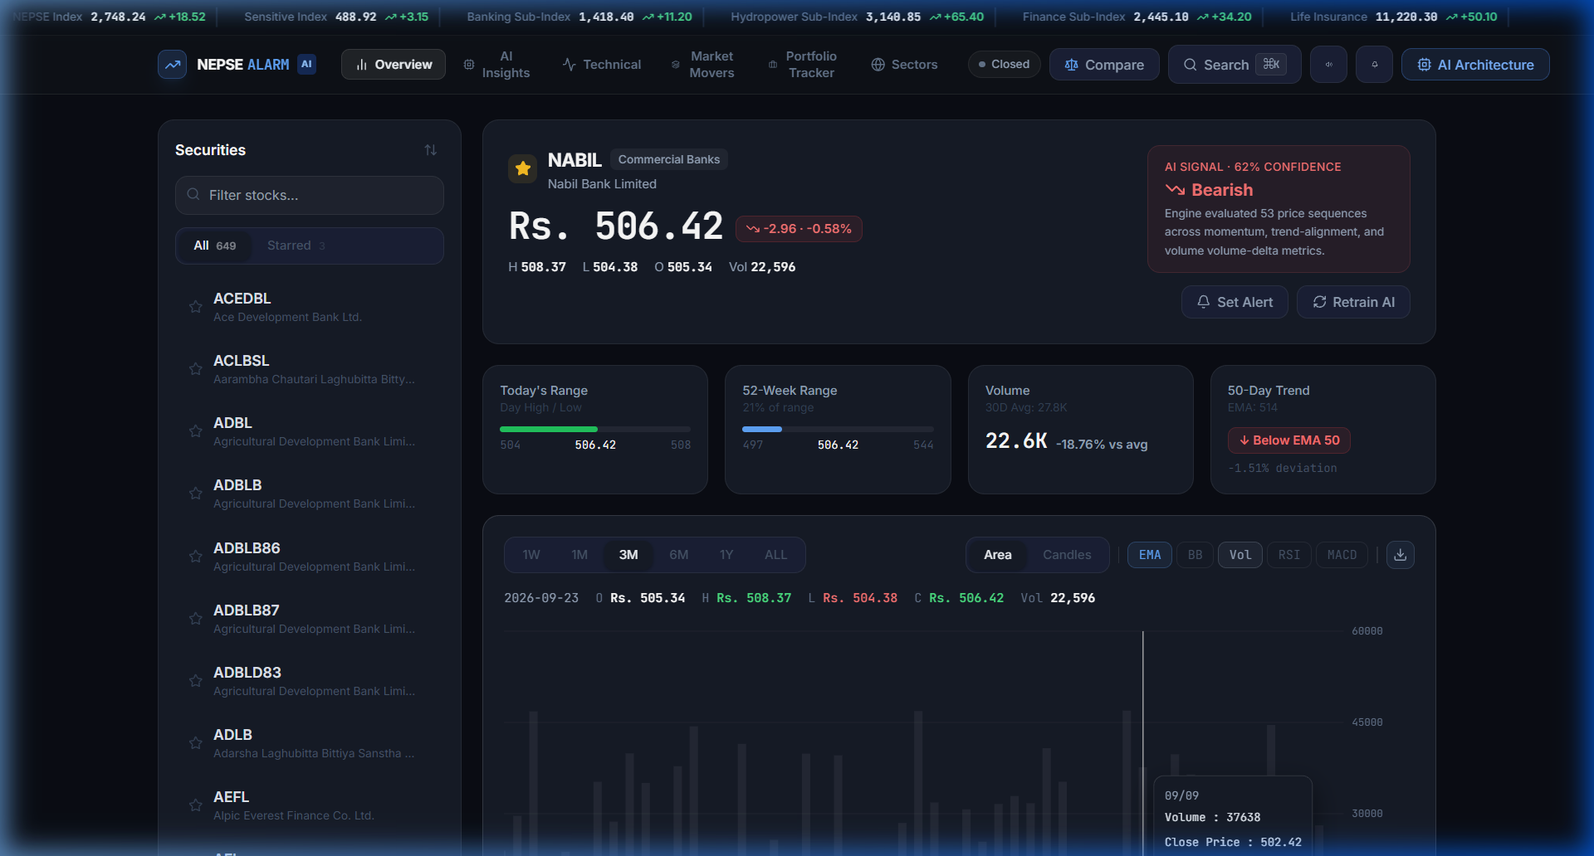
Figure A.1: Main Interactive Financial Dashboard and Real-Time Charting Canvas
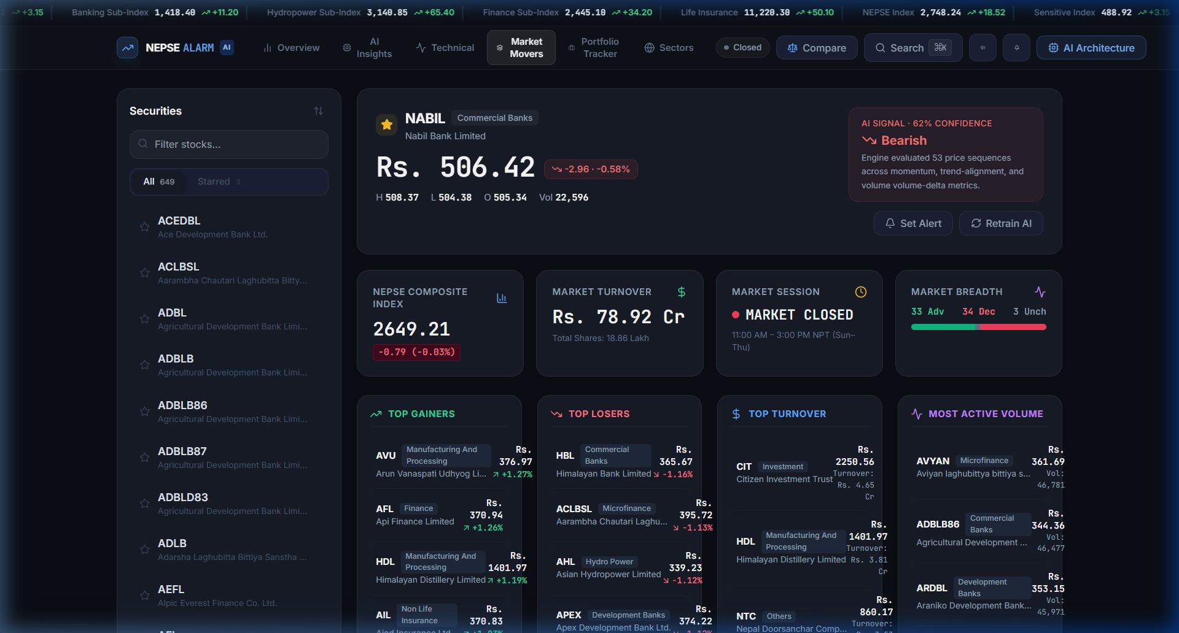
Figure A.2: Live Market Movers Screener with Breadth Ratio and Leaderboards
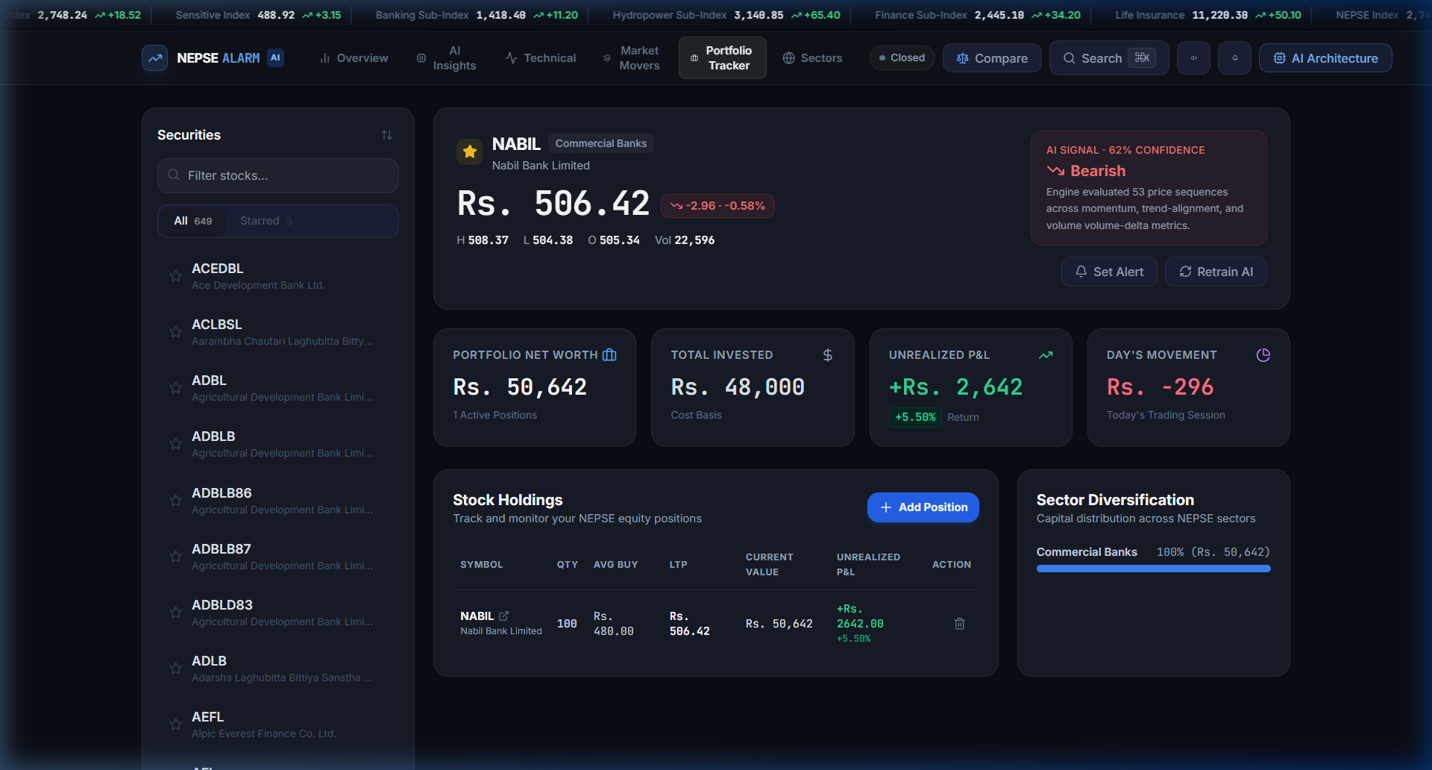
Figure A.3: Paper Trading Portfolio Management Dashboard with PnL Metrics
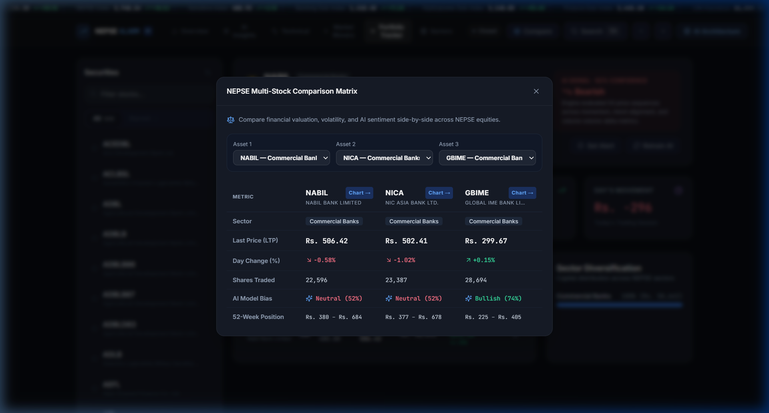
Figure A.4: Multi-Stock Comparative Matrix and Asset Benchmarking View
Appendix B: Core Algorithmic Code Listings
Listing B.1: Two-Stage Hybrid LSTM-XGBoost Architecture (hybrid_model.py)
class LSTMFeatureExtractor(nn.Module):
def __init__(self, input_dim=5, hidden_dim=16, num_layers=1):
super(LSTMFeatureExtractor, self).__init__()
self.lstm = nn.LSTM(input_dim, hidden_dim, num_layers, batch_first=True)
def forward(self, x):
# x shape: (batch, seq_len=30, input_dim=5)
lstm_out, (hn, cn) = self.lstm(x)
return hn[-1] # Returns 16-dimensional temporal embedding
# XGBoost Softprob Classifier Pipeline
embeddings = self.lstm(X_lstm_tensor).numpy()
X_xgb = np.hstack((embeddings, X_indicators)) # Shape: (batch, 24)
self.xgb_model = xgb.XGBClassifier(
n_estimators=50, max_depth=4, learning_rate=0.1,
objective='multi:softprob', num_class=3, random_state=42
)
self.xgb_model.fit(X_xgb, y)
Listing B.2: Acoustic Alarm Synthesizer via Web Audio API (audioAlarm.ts)
public playChime() {
if (!this.soundEnabled) return;
this.initContext();
const now = this.ctx.currentTime;
const notes = [587.33, 739.99, 880.0]; // D5, F#5, A5 Chord
const noteDuration = 0.12;
notes.forEach((freq, idx) => {
const osc = this.ctx.createOscillator();
const gain = this.ctx.createGain();
osc.type = 'sine';
osc.frequency.setValueAtTime(freq, now + idx * noteDuration);
const startTime = now + idx * noteDuration;
gain.gain.setValueAtTime(0, startTime);
gain.gain.linearRampToValueAtTime(0.25, startTime + 0.02);
gain.gain.exponentialRampToValueAtTime(0.001, startTime + 0.4);
osc.connect(gain);
gain.connect(this.ctx.destination);
osc.start(startTime);
osc.stop(startTime + 0.45);
});
}
Appendix C: Supervisor Visit Log Sheet
Table C.1: Supervisor Consultation and Progress Log Sheet
S.N. | Date | Topic Discussed & Feedback Provided | Supervisor Signature
1 | Week 2 | Project proposal defense, scope bounding, and algorithmic feasibility on NEPSE. | ______________
2 | Week 5 | System requirements analysis, UML class modeling, and Prisma schema design. | ______________
3 | Week 8 | Ingestion pipeline review, technical indicator verification, and fallback engine. | ______________
4 | Week 12 | Midterm progress defense: PyTorch LSTM + XGBoost hybrid architecture review. | ______________
5 | Week 14 | Real-time alerting engine, Web Audio synthesis, and portfolio tracking review. | ______________
6 | Week 16 | Final report verification, test suite audit, and viva-voce presentation dry-run. | ______________

REFERENCES
[1] T. Fischer and C. Krauss, “Deep learning with long short-term memory networks for financial market predictions,” European Journal of Operational Research, vol. 270, no. 2, pp. 654–669, Oct. 2018.
[2] X. Chen, Y. Zhou, and H. Dai, “A robust stock trend prediction approach based on XGBoost and technical indicators,” IEEE Access, vol. 9, pp. 112431–112443, Aug. 2021.
[3] B. Shrestha and S. R. Joshi, “Empirical analysis of time series price prediction in the Nepal Stock Exchange using ARIMA models,” Journal of Science and Engineering, vol. 8, pp. 45–54, Dec. 2020.
[4] G. Bhattarai, “Technical analysis confluence and risk mitigation strategies in emerging capital markets: A case study of NEPSE banking equities,” NRB Economic Review, vol. 34, no. 1, pp. 22–39, 2022.
[5] M. Kumar and M. Thenmozhi, “Forecasting stock index movement: A comparison of support vector machines and random forest,” Indian Journal of Finance, vol. 8, no. 10, pp. 7–21, Oct. 2014.
[6] S. Hochreiter and J. Schmidhuber, “Long short-term memory,” Neural Computation, vol. 9, no. 8, pp. 1735–1780, Nov. 1997.
[7] T. Chen and C. Guestrin, “XGBoost: A scalable tree boosting system,” in Proc. 22nd ACM SIGKDD Int. Conf. Knowledge Discovery and Data Mining (KDD), San Francisco, CA, USA, 2016, pp. 785–794.
[8] J. W. Wilder, New Concepts in Technical Trading Systems. Greensboro, NC: Trend Research, 1978.
[9] G. Appel, Technical Analysis: Power Tools for Active Investors. Upper Saddle River, NJ: Financial Times Prentice Hall, 2005.
[10] J. Bollinger, Bollinger on Bollinger Bands. New York, NY: McGraw-Hill, 2002.
[11] Nepal Stock Exchange (NEPSE), “NEPSE trading rules and bylaws,” Kathmandu, Nepal, Official Regulatory Publication, 2024. [Online]. Available: https://www.nepalstock.com.np.
[12] Nepal Rastra Bank (NRB), “Monetary policy and capital market liquidity dynamics,” Economic Research Department, Annual Report, 2025.

