# Workplan

### 2019-09-16

### Salar Mohammed

### 073-920 67 71

### [salar.mohammed@stud.ki.se](mailto:salar.mohammed@stud.ki.se)

Supervisor: Martin Gerdin Wärnberg

[Martin.gerdin@ki.se](mailto:Martin.gerdin@ki.se)

+46708539598

**How do transfers and updating of clinical prediction models for trauma triage affect mistriage rates?**

# Introduction

Trauma accounts for 10% of global mortality (1). More than 4.8 million people die anually due to trauma and it is one of the leading causes of mortality in individuals under 44 years old (1,2). Prediction models used in trauma care seek to facilitate when prioritizing patients but also to guide treatment decisions, for example massive transfusion. Models have and are still being developed to predict death or survival rates in patients. Many models are built on vital-parameters such as systolic blood pressure (SBP) and respiratory rate (RR) and other variables such as Glascow Coma Scale (GCS) (3). The variables are later put in a system to determine the level of trauma. Development of these models are in many cases being made limited to a specified location or setting and are later being used in other circumstances. Also, they are developed on a national level using databases for that specific country and is being used in other parts of the world. This study seeks to answer if transferring prediction models from a country and applying it in another country affects mistriage rates. Mistriage rates is measured as either over- or undertriage. Updating the prediction models may have an impact on mistriage rates also.

# Aim

To asses how transfers of prediction models for trauma triage between different settings affect mistriage rates and to assess how model updating affect these rates compared with no updating.

# Material and methods

## Study design

This is a registry-based cohort study with data from the Swedish trauma registry (SweTrau), the US national trauma data bank (NTDB) and the Towards Improved Trauma Care Outcomes in India cohort (TITCO).

Each dataset will be divided into samples of three; development, updating and validation samples. Logistic regression will be used to develop the models in the development samples. An estimation will be made of the mistriage rates in the validation samples models and will be compared to it self and to the other validation sample from the other databases. The updating samples will be tested in different settings and compared to see how model updating affect the mistriage rates.

Setting

95.5% of all Swedish hospitals are connected to SweTrau, making it 52 out of 55 hospitals. It holds approximately 55 000 cases. The NTDB holds data from pediatric and adult patients from different levels of trauma centers, including undesignated trauma centers from 2007 to 2017. TITCO collects information from designated trauma centres in India from four centres. These centres are based in large cities in urban India. Kolkata, Mumbai (2-centres) and Delhi (4-6)

## Participants

The **inclusion** criteria in patients registered in SweTrau are:

* All patient that have experienced a traumatic event in which a trauma protocol has been activated in a hospital
* Admitted patients with or without trauma protocol activation
* Patients transferred to the hospital <7 days after the traumatic event and with a NISS score of >15.

**Exclusion** criteria for SweTrau:

* Patients whose only traumatic injury is chronic subdural hematoma
* Trauma protocol activation without an underlying traumatic event(4)

**Exclusion- and inclusioncriterias** for NTDB(7):

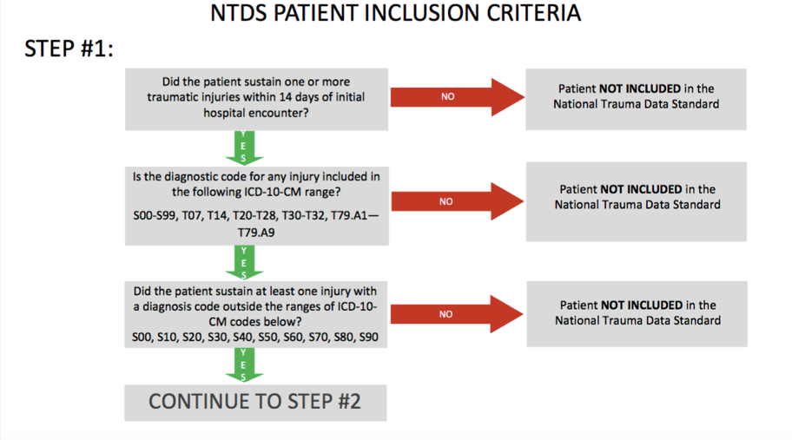

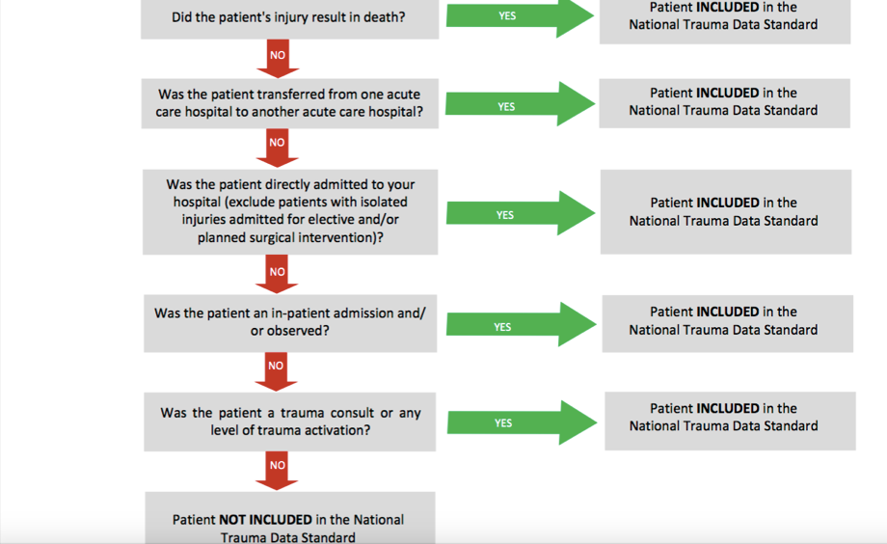

**Inclusion** criteria for TITCO:

* Patients presenting to the casualty department with injury sustained from road traffic, railway, assault or burns admitted to hospital for treatment
* Patients who died after arrival but before admission

**Exclusion** criteria for TITCO:

* Patients who were dead on arrival (5)

Individuals 15 years or older registered in all three registers, SweTrau, NTDB and TITCO cohort. We will use >15 years as the cut off because everything below that activates trauma team for pediatrics in many cases but mainly it is because of the physiology difference between children and adults. (8).

## Data sources/measurement

Every parameter will be obtained from NTDB, SweTrau and TITCO. SBP, RR, GCS, ASA, NISS and ISS sex and age have been registered or calculated by workers in hospitals (physicians, nurses, assistant nurse).

## Bias

Possible when coding. The programming will be double checked by an experienced colleague. Confirmation bias is also a risk when conducting data to the analysis program.

## Study size

All patients in SweTrau, NTDB and TITCO over 15 years of age and that fits the inclusion criteria to be in the register.

## Patient cohort

Age, sex, ASA(American Society of Anaesthesiologist physical status classification system), ISS(Injury Severity Score) and NISS(New ISS).

## Variables

### Study outcome

ISS >15 major trauma. ISS ≤15 minor trauma. Overtriage will be defined as the event when major trauma is ISS ≤15 calculated by the prediction model. Undertriage will be when ISS > 15 is considered minor trauma by the prediction model. The overtriage rate will be calculated by dividing the amount of overtriaged patients with all patients. The undertriage rate will be the number of undertriaged patients divided by all patients. The mistriage rate will be the sum of the overtriage and undertriage rate.

### Model outcome

Mortality within 30 days of the traumatic event. For NTDB and TITCO mortality will be in-hospital mortality. For SweTrau mortality includes out of hospital mortality too.

### Model predictors

SBP, RR and GCS will be used as quantitive variables to develop the models.

## Statistical methods

We will use data from three sources: SweTrau, NTDB and TITCO. Each dataset will be split temporally into three samples: one development, one updating, and one validation sample. We will develop one model per development sample, resulting in three models. The performance of each model will be evaluated by testing the model in all three validation samples. Local performance will be defined as a model’s performance in the validation sample from the same dataset as the development sample, for example the SweTrau model’s performance in the SweTrau validation sample. Transferred performance will be defined as a model’s performance in a validation sample from a different dataset compared to the sample in which the model was developed, for example the SweTrau model’s performance in the NTDB and TITCO validation samples. To assess how model transfer affect mistriage rates the local and transferred performances will be compared by subtracting the transferred performance from the local performance in a pair-wise manner. For example, the SweTrau model’s performance in the NTDB validation sample will be subtracted from the SweTrau model’s performance in the SweTrau validation sample. A negative difference then means that the performance declined when the model was transferred. Then, each model will be updated in updating samples from datasets in which the model was not developed, the SweTrau model will for example be updated in the NTDB and TITCO updating samples. Updated performance will then be defined as an updated model’s performance in the validation sample from the same dataset as the updating sample, for example the SweTrau model’s performance in the NTDB validation sample after having been updated in the NTDB updating sample. To assess how model updating affect mistriage rates compared to no updating the updated performance will be compared with the transferred performance by subtracting the transferred performance from the updated performance. A positive difference means that the updating improved performance compared to no updating. Models will be developed using logistic regression. Predictors will be treated as continuous variables with linear associations with mortality. The entire process will be repeated 1000 times and results presented as medians and values at the 2.5th and 97.5th percentiles. Observations with missing data will be excluded.

**Ethical considerations**

## Autonomy-respect

The patients can withdraw from the register if they choose to do so. They are not in all cases informed that the information can be used in a study. In that case, we have a responsibility to treat the data with respect like we will do with all data used in this study.

## The principle of beneficence

The study will hopefully improve the management of trauma care and contribute to better healthcare for patients.

## The principle of nonmaleficence

No intervention is being made so there is no risk for physical harm. Data leakage will be the biggest risk for harm and integrity.

## The principle of justice

All patients are depersonalized and anonymous when the data is being obtained. The information gained from the registry will either way be treated equal.

## Ethical Permit

2015/426-31 and 2016/461-32

# Time plan

3-15 September: Write study plan. 16-28 September: Write analysis plan. 29 September - 28 October: Initial analysis and prepare half time report. 29 October - 30 November: Complete analysis and write results. 1 December - 2 January: Write discussion and finalise thesis.

# Backup plan

All the data exist and there is minimal risk that the data can not be used. One potential problem is that the programming takes longer than usual. In this case there will be experienced (supervisor or other) people that will guide me along the way.

**References**

1. World Health Organization. Injuries and violence: The facts. Geneva: World Health Organization; 2014
2. Haagsma J. The global burden of injury: incidence, mortality, disability-adjusted life years and time trends from the Global Burden of Disease study 2013 [Internet]. Institute for Health Metrics and Evaluation. 2019 [cited 15 September 2019]. Available from: http://www.healthdata.org/research-article/global-burden-injury-incidence-mortality-disability-adjusted-life-years-and-time
3. J.M.JONES. (2019). Norwegian survival prediction model in trauma: modelling effects of anatomic injury, acute physiology, age, and co-morbidity. Wiley Online Library [online] available at: https://onlinelibrary.wiley.com/doi/full/10.1111/aas.12256
4. Rcsyd.se. (2019). Om SweTrau | SweTrau. [online] Available at: http://rcsyd.se/swetrau/om-rc-syd [Accessed 13 Sep. 2019]
5. Sites.google.com. (2019). About TITCO - India - TITCO-India. [online] Available at: https://www.sites.google.com/site/titcoindia/about-titco [Accessed 13 Sep. 2019]
6. Trauma Quality Programs Participant Use File [Internet]. American College of Surgeons. 2019 [cited 16 September 2019]. Available from: https://www.facs.org/quality-programs/trauma/tqp/center-programs/ntdb/datasets
7. [Internet]. Facs.org. 2019 page 5 [cited 16 September 2019]. Available from: https://www.facs.org/-/media/files/quality-programs/trauma/ntdb/ntds/data-dictionaries/ntds_data_dictionary_2020.ashx?la=en
8. School, M. (2019). Trauma Team Activation for Pediatrics (age 15 years and below) | Department of Surgery | McGovern Medical School. [online] Med.uth.edu. Available at: https://med.uth.edu/surgery/trauma-team-activation-for-pediatrics-age-15-years-and-below/ [Accessed 13 Sep. 2019].