Executive Summary
This report presents a comprehensive analysis of sales, profitability, and operational performance across the business, using data visualisation in Tableau to uncover key insights. The analysis covers five key areas: overall sales trends, product performance, customer segmentation, geographic insights, and operational efficiency.
Sales and profit have grown steadily from 2021 to 2025, though profitability has not always matched revenue increases. The company maintains a relatively low average profit margin of 10.6%, which may be affected by discounting and shipping costs. Technology products consistently deliver the strongest returns, while Furniture shows inconsistent performance.
Product-level analysis revealed that not all best-selling items are profitable. Discounting has a clear negative impact on profit, particularly in categories like Furniture and Office Supplies. The business should consider reducing discounts on low-margin products and focusing more on high-margin categories such as Phones and Copiers.
Customer segmentation showed that Corporate and Consumer customers contribute most to revenue. However, some high-spending customers generate little or no profit, while some mid-tier customers offer better returns. Targeted retention and pricing strategies are recommended.
Geographic analysis revealed that top-performing regions include California and New York, while some high-sales states like Florida and Arizona underperform on profit. Tailoring pricing and product strategy by region is advised.
Operational analysis found that standard shipping is widely used but not always efficient. High shipping costs often reduce profit, and no clear link was found between order priority and profitability. Better logistics and fulfilment tracking is recommended.
In summary, the business has strong areas of performance but also clear opportunities to improve margins by refining pricing, product focus, and operational efficiency.

Table of Contents
Executive Summary 1
Dashboard 1: Sales & Profit Overview 3
Dashboard 3: Customer Segmentation 5
Dashboard 4: Geographic Insights 6
Dashboard 5: Operational Performance 7
Conclusion 8

Dashboard 1: Sales & Profit Overview 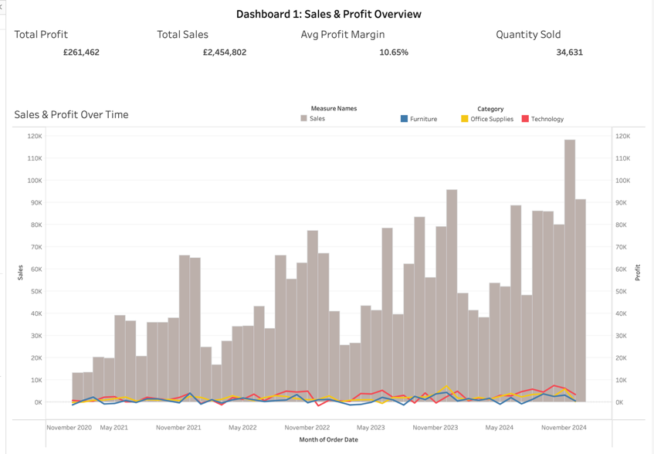
This dashboard provides a high-level summary of the company’s financial performance from 2021 to 2025, showing how sales and profit trends have changed over time. It includes headline figures such as total sales, total profit, average profit margin, and total quantity sold.

Key Insights:
- Sales Growth: Sales increased steadily, with a notable peak in late 2024 exceeding £120,000 in monthly revenue, indicating strong market demand or improved sales execution.
- Profit Fluctuations: Despite higher sales, profit did not increase consistently. Several high-sales months delivered low profit, suggesting rising costs or discounting issues.
- Average Profit Margin: The overall profit margin is approximately 10.6%, which is relatively low and may reflect high operating costs or overly aggressive discounting.
- Product Category Impact: Technology was the most consistently profitable category, while Furniture showed more volatility in profitability, likely due to cost structure or pricing pressure.
- Performance Summary:
  - Total Sales: £2.45 million
  - Total Profit: £261,462
  - Units Sold: 34,631
  - Avg. Profit Margin: 10.6%

Recommendations:
- Review Low-Profit Periods: Analyse high-sales, low-profit months to identify cost inefficiencies or pricing issues.
- Focus on High-Margin Products: Prioritise promotion and stock of categories like Technology, which offer better returns.
- Track Profit Margin Regularly: Include margin as a core KPI in future reporting to better manage overall profitability.
Dashboard 2: Product Performance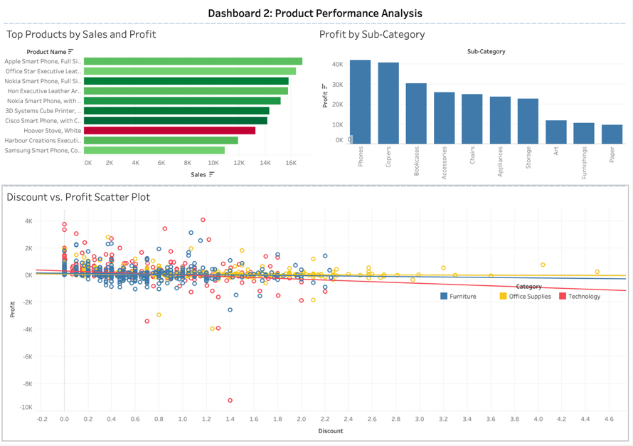
This section analyses which products and categories contribute most to sales and profit. It also examines how discounting impacts profitability.

Key Insights:
- Sales ≠ Profit: Some top-selling products show weak or negative profitability. For example, certain smartphones and office furniture items generate high sales but inconsistent margins.
- Sub-Category Profitability Varies: Categories like Phones, Chairs, and Copiers consistently produce strong profits. In contrast, Tables and Binders often underperform or operate at a loss, possibly due to pricing or cost structure issues.
- Discounting Hurts Profit: Products with higher discounts frequently show lower or negative profit. In some cases, items with discounts above 40% resulted in losses exceeding £5,000.
- Category-Specific Discount Trends: Technology products tolerate discounting better than Furniture or Office Supplies, which tend to suffer larger losses at higher discount levels.

Recommendations:
- Review Discounting Strategy: Identify high-discount, low-profit products and reduce discount levels or adjust pricing to protect margins.
- Promote High-Margin Categories: Focus marketing efforts on profitable sub-categories such as Phones and Chairs.
- Reconsider Underperforming Products: Review or discontinue products that consistently lose money.
- Tailor Discounts by Category: Apply discount strategies selectively based on how different product categories respond.

Dashboard 3: Customer Segmentation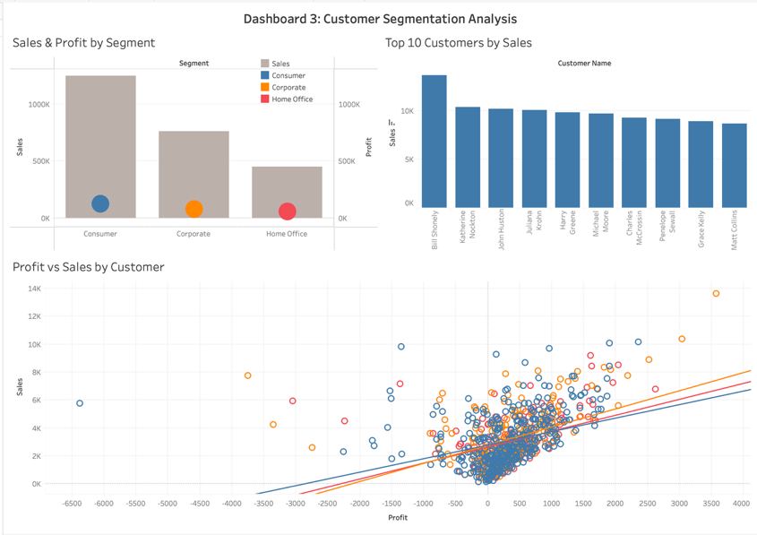
This dashboard analyses how different customer groups contribute to overall revenue and profit. It highlights key segments, identifies top customers, and explores the relationship between spending and profitability.

Key Insights:
- Consumer and Corporate Lead Performance: These two segments account for the bulk of sales. Consumer leads in total revenue, while Corporate shows more consistent profitability per order.
- Home Office Lags Behind: This segment generates the lowest sales and profit, possibly due to a smaller customer base or lower purchase frequency.
- Top Customers Drive a Large Share: The top 10 customers significantly impact total revenue. The highest-spending customer alone contributes over £18,000. However, not all high spenders deliver strong profit — some have low or even negative returns.
- No Clear Link Between Spend and Profit: The scatter plot reveals that high-spend customers aren’t always profitable, often due to high fulfilment costs or discounts. Conversely, some mid-level customers deliver strong profits with moderate spending.
- Profitability Varies by Segment: Corporate customers are generally more reliable in terms of profit. Home Office and Consumer segments show more variability and include several loss-making accounts.

Recommendations:
- Prioritise Corporate Accounts: Retain and grow relationships with high-performing corporate clients through loyalty incentives or personalised service.
- Optimise Pricing for High-Spend, Low-Profit Customers: Reassess discounts or service costs for customers who spend a lot but generate low returns.
- Expand Mid-Tier Profit Pools: Focus on profitable mid-range customers who may offer better ROI with lower servicing costs.
- Revisit Home Office Strategy: Either improve the value proposition for this segment or shift focus toward more profitable customer groups.

Dashboard 4: Geographic Insights 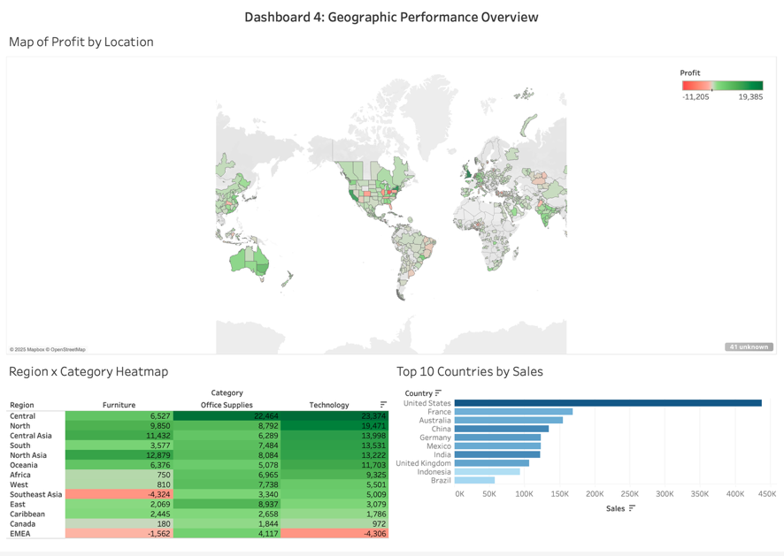
This dashboard explores the company’s performance across different locations, highlighting areas of strength, inefficiency, and opportunity. It focuses on country-level sales, profit, and patterns across product categories.

Key Insights:
- Revenue Concentrated in Key Countries: Locations such as California, New York, and Texas generate a significant share of sales. California leads overall, likely due to high customer density and strong brand presence.
- Profitability Doesn’t Always Follow Sales: While Texas and New York deliver both strong sales and profit, states like Florida and Arizona show high sales but weak or negative profit. This may be due to high operating costs, returns, or discounting.
- Regional Category Differences: The heatmap shows Technology performs best in the West and East, while Furniture struggles in the South and Central regions. This reflects differences in demand, pricing sensitivity, or logistics.
- Unprofitable Areas Identified: Several regions show negative profit despite moderate sales. These should be flagged for further analysis to assess fulfilment costs, product mix, or customer service challenges.

Recommendations:
- Focus on High-Performing Regions: Continue prioritising sales and marketing efforts in states like California and New York, which generate strong profit and volume.
- Investigate Low-Margin Markets: Review cost structures in regions where sales are high but margins are poor. Adjust pricing, product availability, or operations accordingly.
- Adjust Product Strategy by Region: Align inventory and promotion with regional performance. For example, expand Technology offerings in the West and reduce underperforming Furniture lines in low-profit regions.
- Use Regional Profit Data for Expansion Decisions: Future geographic growth should be guided not just by revenue potential, but also by profit history.

Dashboard 5: Operational Performance 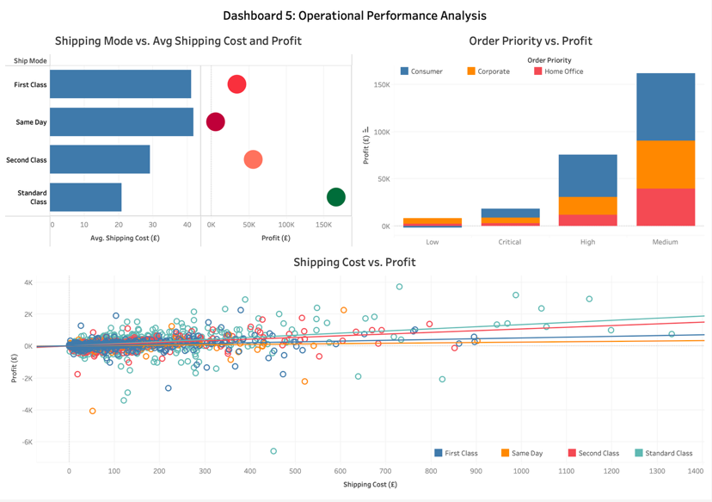
This dashboard looks at how the company’s logistics and fulfilment processes affect profitability. It focuses on shipping modes, shipping costs, and order priorities, helping to highlight potential cost inefficiencies.

Key Insights:
- Standard Class is Most Used, but Less Efficient: Standard Class handles the majority of orders and sales, but isn’t the most profitable. First and Second Class options, although less frequent, deliver better balance between cost and profit.
- High Shipping Costs Reduce Profit: The scatter plot shows a clear trend — orders with higher shipping costs often yield lower or negative profit. This suggests that some delivery expenses aren’t being recovered through pricing.
- Trend Confirms Cost-Profit Link: The trend line reinforces that increased shipping costs are usually linked to reduced profitability, highlighting logistics as a key cost driver.
- Low-Priority Orders Drive Volume: Surprisingly, Low-priority orders account for the highest sales, likely from frequent, lower-urgency customers. High and Critical priority orders, while fewer, often incur higher fulfilment costs.
- Order Priority Doesn’t Predict Profit: There’s no strong correlation between urgency and profitability. Some critical orders are loss-making due to expensive, rushed fulfilment.

Recommendations:
- Improve Cost Recovery: Consider adjusting pricing or adding surcharges for high-shipping-cost orders to protect margins.
- Encourage Efficient Shipping Modes: Promote ship modes like Second Class, which appear more cost-effective while maintaining reliability.
- Review Loss-Making Orders: Identify patterns in orders with high shipping costs and low profit. Explore packaging, fulfilment, or delivery partners for efficiency gains.
- Balance Speed vs. Cost in Fulfilment: Track costs associated with high-priority orders to ensure service levels aren’t reducing profitability unnecessarily.

Conclusion

This analysis has provided a clear view of the company's commercial performance across five key areas: sales trends, product performance, customer segmentation, geographic variation, and operational efficiency. Using Tableau to visualise patterns in the data has revealed several areas where profitability can be improved.
The insights suggest that stronger performance could be achieved by refining discounting practices, focusing on high-margin products and customers, and addressing underperforming regions and shipping inefficiencies. While some segments and product categories consistently deliver strong results, others operate with narrow or negative margins — often due to high shipping costs or aggressive discounting.
Going forward, the business should regularly monitor both revenue and profit at a more granular level. A deeper focus on logistics, customer profitability, and regional differences will help drive more sustainable growth. Finally, adopting data visualisation tools like Tableau across teams could support ongoing decision-making and improve transparency.

Word Count: 1206
Data Sampled: 10000

