Asset Log

Styles

* Google Fonts url('https://fonts.googleapis.com/css2?family=Playfair+Display:wght@600&family=Poppins:wght@300;400&family=Quicksand:wght@500&display=swap');

APIs

* Google OAuth
* Google Maps Geolocation API: <https://maps.googleapis.com/maps/api/geocode/json?address>
* OpenChargeMaps API: https://api.openchargemap.io/v3/poi/

Images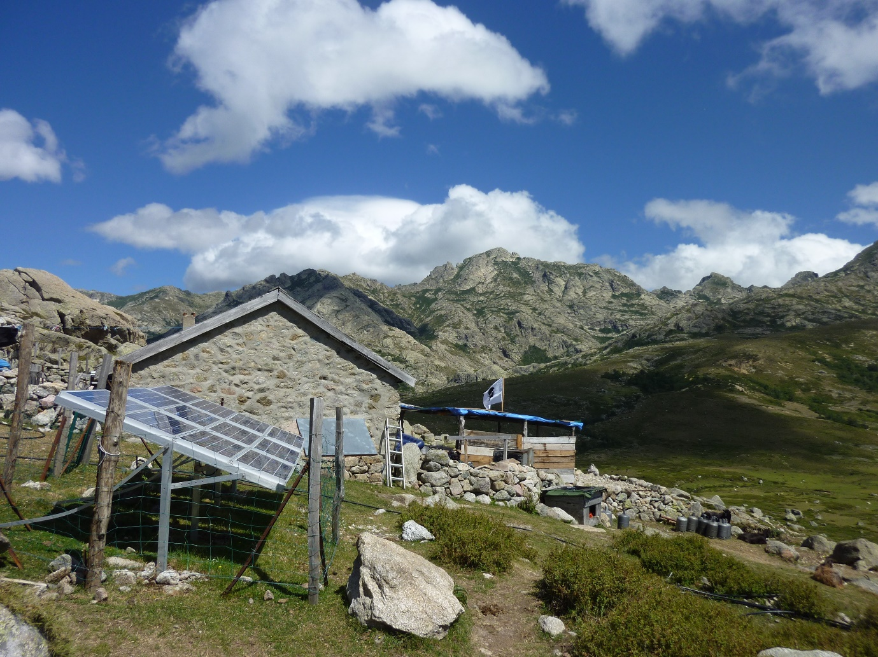

Frontend Dependencies:

1. axios: ^1.7.9, ^1.8.4
2. cra-template: 1.2.0
3. jwt-decode: ^4.0.0
4. leaflet: ^1.9.4
5. lucide-react: ^0.486.0
6. react: ^18.3.1, ^19.0.0
7. react-calendar: ^5.1.0
8. react-dom: ^18.3.1, ^18.2.0
9. react-leaflet: ^5.0.0
10. react-router-dom: ^7.1.5, ^7.4.1
11. react-scripts: ^5.0.1
12. recharts: ^2.15.1
13. web-vitals: ^4.2.4

Backend Dependencies:

1. axios: ^1.7.9
2. bcrypt: ^5.1.1
3. bcryptjs: ^2.4.3
4. body-parser: ^1.20.3
5. cors: ^2.8.5
6. dotenv: ^16.4.7
7. express: ^4.21.2
8. google-auth-library: ^9.15.1
9. i18next-browser-languagedetector: ^8.0.4
10. jsonwebtoken: ^9.0.2
11. leaflet: ^1.9.4
12. mongoose: ^8.9.5
13. pg: ^8.13.1
14. pg-hstore: ^2.3.4
15. react: ^18.3.1
16. react-dom: ^18.3.1
17. react-leaflet: ^5.0.0
18. react-router-dom: ^7.1.5
19. react-scripts: ^5.0.1
20. sequelize: ^6.37.5
21. sqlite3: ^5.1.7