Lab 10:

Classification and Prediction:
- Classification: The process of identifying the category or class of a new observation based on a training dataset.
- Prediction: Using the classification model to forecast outcomes for unseen data.
Decision Tree:
- A classification tool that represents data as a hierarchical structure of nodes:
  - Root Node: Represents the initial feature for splitting data.
  - Internal Nodes: Represent features and decisions at each step.
  - Leaf Nodes (External Nodes): Represent the final class or prediction outcome.
- Decision trees also include rules derived from training data. These rules help classify new data based on the values of attributes.

Steps to Create the Weather Dataset
- Open Notepad:
  - Navigate to Start → Programs → Accessories → Notepad.
- Enter the Training Data: Paste the following content into Notepad:
- @relation weather
- @attribute outlook {sunny, rainy, overcast}
- @attribute temperature numeric
- @attribute humidity numeric
- @attribute windy {TRUE, FALSE}
- @attribute play {yes, no}

- @data
- sunny,85,85,FALSE,no
- sunny,80,90,TRUE,no
- overcast,83,86,FALSE,yes
- rainy,70,96,FALSE,yes
- rainy,68,80,FALSE,yes
- rainy,65,70,TRUE,no
- overcast,64,65,TRUE,yes
- sunny,72,95,FALSE,no
- sunny,69,70,FALSE,yes
- rainy,75,80,FALSE,yes
- sunny,75,70,TRUE,yes
- overcast,72,90,TRUE,yes
- overcast,81,75,FALSE,yes
- rainy,71,91,TRUE,no
- Save the File:
  - Save the file as weather.arff.
- Open Weka:
  - Navigate to Start → Programs → Weka-3-4 → Weka-3-4.
- Load Dataset in Weka:
  - Click Explorer and open the weather.arff file.
- View Dataset:
  - Click Edit to confirm that the weather table is displayed correctly.

Steps to Build a Decision Tree
- Open Weka Explorer:
  - Navigate to Start → Programs → Weka-3-4 → Weka-3-4.
- Load Dataset:
  - Click Open File and select weather.arff.
- Select Classifier:
  - On the top menu, click Classifier.
- Choose J48 Algorithm:
  - Click Choose, navigate to Trees, and select J48 (an implementation of the C4.5 algorithm).
- Build the Decision Tree:
  - Click Start to train the model. The output is displayed in the results pane on the right.
- Visualize the Tree:
  - Right-click on the result list and select Visualize Tree. The decision tree will appear in a new window.
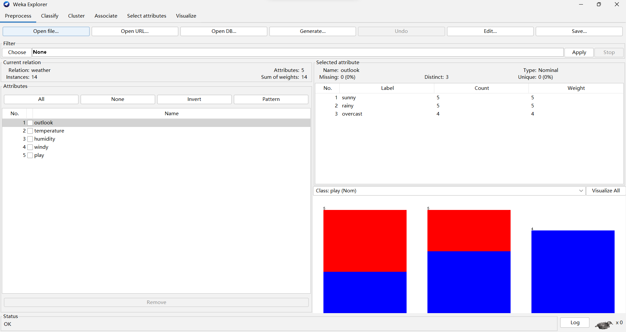
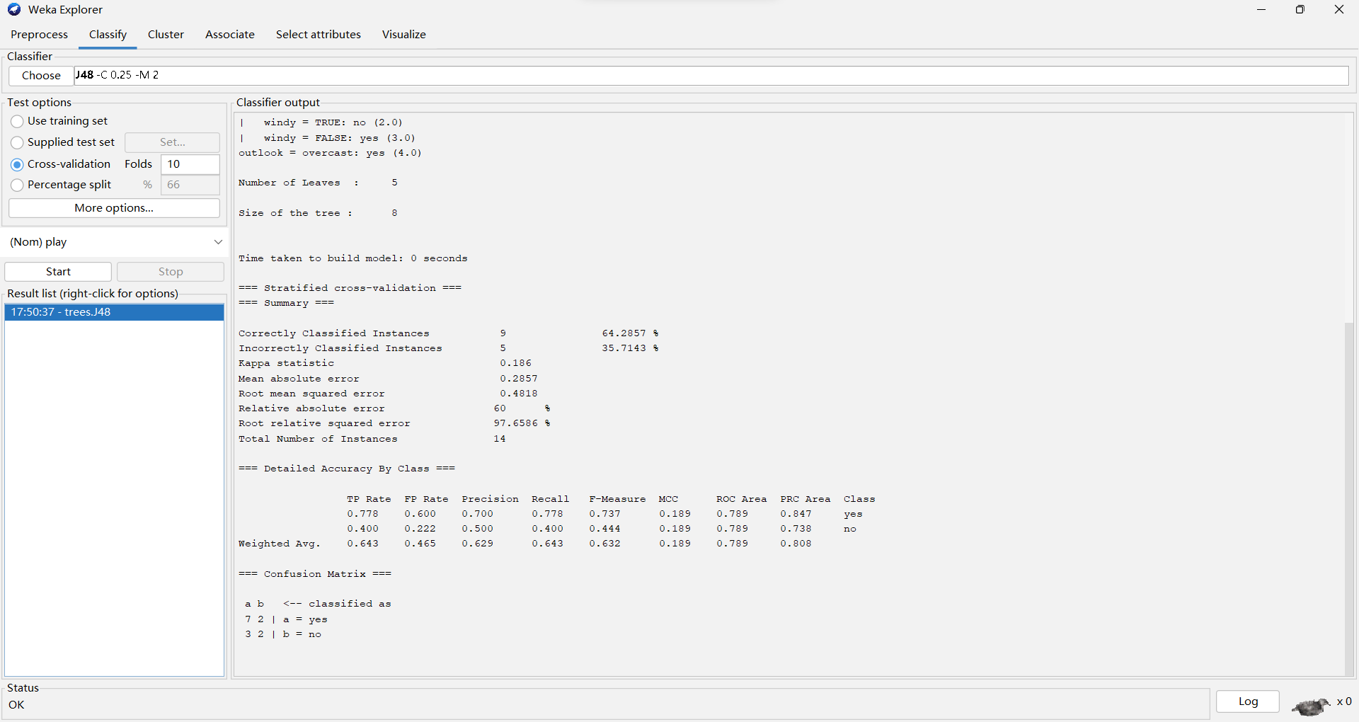
Output
Example Decision Tree:
- Root Node: Splits data based on outlook.
- Internal Nodes: Use attributes like humidity and windy for further splits.
- Leaf Nodes: Contain the predicted class (yes or no).
Example rules derived from the tree:
- If outlook = sunny and humidity > 80, then play = no.
- If outlook = overcast, then play = yes.
- If outlook = rainy and windy = FALSE, then play = yes.

