Lab 2-3 Talapkan Salauat

1. Create a data file:
plaintext
@relation employee
@attribute name {x,y,z,a,b}
@attribute id numeric
@attribute salary {low,medium,high}
@attribute exp numeric
@attribute gender {male,female}
@attribute phone numeric
@data
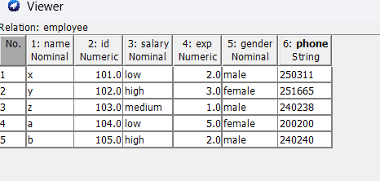
2. Saving the file:
- Save the file with the .arff extension.
3. Opening a file in WEKA:
- Open WEKA (Start -> Programs -> weka-3-4).
- In the WEKA window, select the *Explorer* mode.
- In the *Explorer*, select open file, find and select your .arff file.
- Click edit to view the employee table in WEKA.
Result:
The employee table has been successfully created and displayed in WEKA.
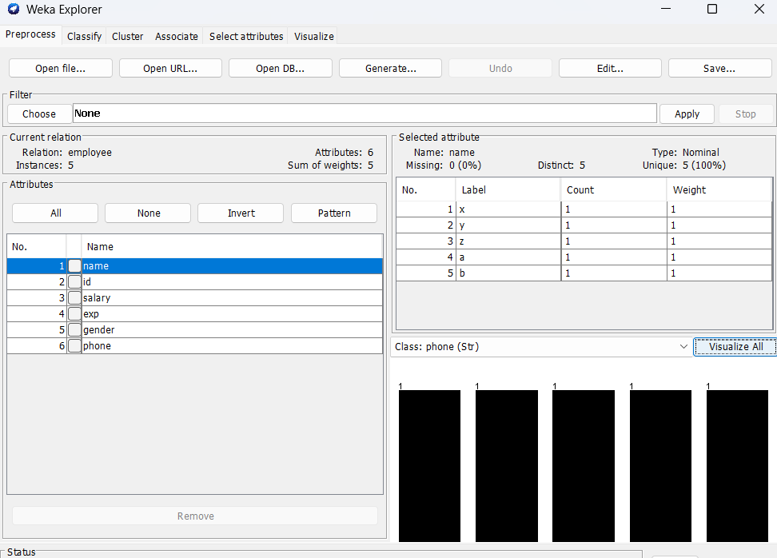

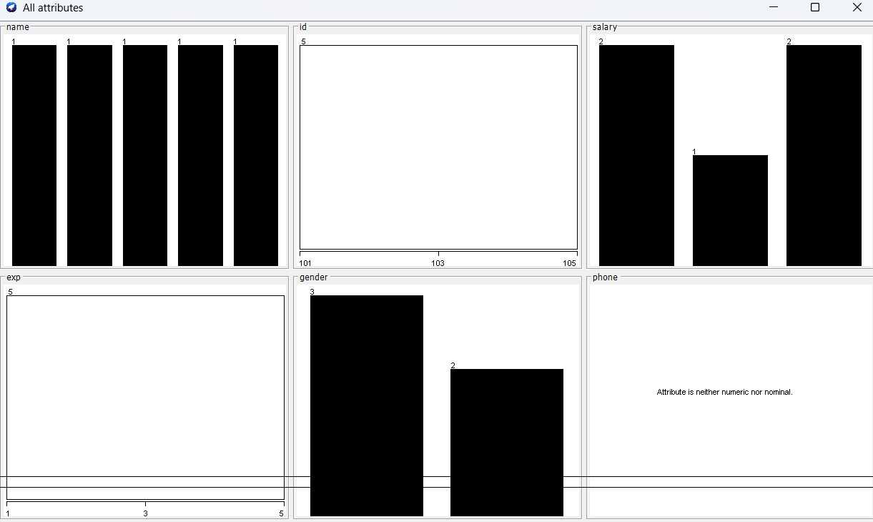
The weatherlab file contains a dataset on weather conditions, used to make decisions about whether it’s suitable to play outside on a given day. This file consists of several attributes, each describing a specific aspect of the weather or decision. Below is a detailed description of each attribute and some sample data.
- Outlook:
Data Type: Categorical (nominal).
Possible Values: sunny, rainy, overcast
Description: This attribute indicates the weather forecast, defining whether the day is sunny, rainy, or overcast. Weather outlook can significantly affect the comfort of being outdoors and the likelihood of playing outdoor games.
- Temperature:
Data Type: Numeric.
Description: This attribute shows the air temperature on the given day. Higher numerical values indicate warmer weather. For example, a value of 85 represents a warm day, whereas lower values suggest cooler conditions. Temperature serves as an indicator of how comfortable it might be for physical activities outdoors.
- Humidity:
Data Type: Numeric.
Description: This attribute displays the air humidity level as a percentage. High humidity can make outdoor conditions less comfortable and affect the decision to play. For instance, a humidity level of 85 indicates a significant amount of moisture in the air, which can make outdoor activities challenging.
- Windy:
Data Type: Categorical
Possible Values: true, false.
Description: This attribute indicates the presence or absence of wind. A value of true means it is windy, while false indicates no wind. Wind can both provide relief in hot weather and complicate games, especially with strong gusts.
- Play:
Data Type: Categorical.
Possible Values: yes, no.
Description: This is the target attribute, determining whether it is recommended to play outside on a particular day based on the weather conditions. A value of yes indicates that conditions are suitable for playing, while no means that conditions are not favorable for playing.
@relation employee
@attribute name {x,y,z,a,b}
@attribute id numeric
@attribute salary {low,medium,high}
@attribute exp numeric
@attribute gender {male,female}
@attribute phone numeric

@data x,101,low,2,male,250311 y,102,high,3,female,251665 z,103,medium,1,male,240238 a,104,low,5,female,200200 b,105,high,2,male,240240

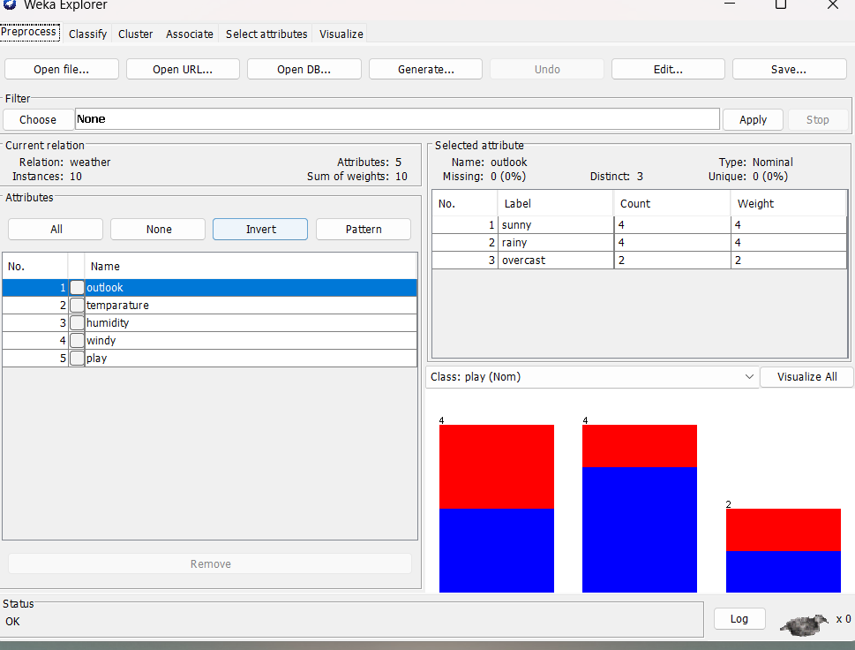

Each row in the table represents specific weather conditions and the decision about playing. For example, in the first case, with sunny weather, a temperature of 85, humidity at 85, and no wind, the decision was that the day was not suitable for playing (No). In the second case, despite an overcast sky, a temperature of 80, high humidity at 90, and wind present, it was also decided not to play (No). The third row shows favorable conditions for playing with sunny weather, a temperature of 83, humidity at 86, and no wind, resulting in a Yes.
The weatherLab.arff file is useful for studying how different combinations of weather factors can influence the final decision on whether it is suitable to play outside.

