Lab Work 7-Data Processing
Student Work

1. Create a Buying Table:
- Open Notepad (Start > Programs > Accessories > Notepad).
- Enter the dataset.
- In Weka, click Explorer and open the buying.arff file.
- View the dataset using the Edit button.
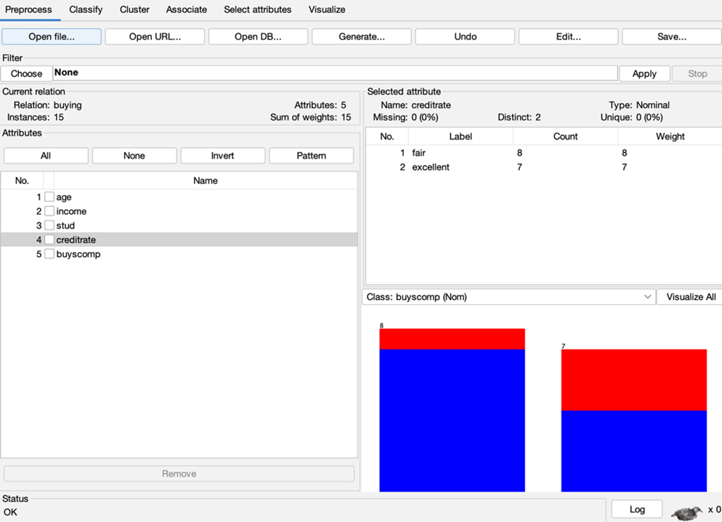

2. Generate Association Rules:
- Open Weka (Start > Programs > Weka-3-4).
- In Explorer, open the buying.arff file.
- Select the Associate tab in the top menu bar.
- Click on the Choose button and select the Apriori Algorithm.
- Click Start to run the Apriori algorithm.
- The output, showing association rules, will appear on the right side of the Weka window.

Step 3: Run the Apriori Algorithm
To perform association rule mining:
- Click on the Associate tab at the top of the Weka window.
- Select the Apriori Algorithm, a powerful tool for discovering frequent item sets and generating association rules.
- Click the Start button to run the algorithm.
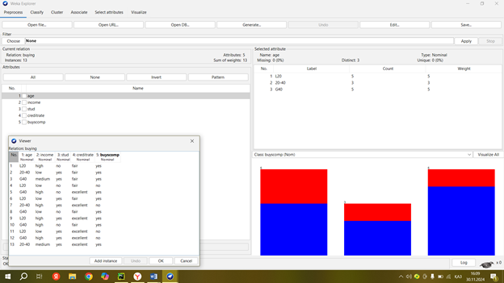

Result:
The association rules have been successfully discovered and displayed using Weka.

