Lab Work #8-Data Processing
Student Work

1: Convert the Bank Table to .arff Format
First, we need to convert the Bank Table into a .arff (Attribute-Relation File Format) file. This format is essential for loading the data into Weka. Once the conversion is complete, we open the .arff file in Weka by selecting the Explorer option.

2: Explore the Dataset
After opening the file, Weka presents the data in a structured format. We can see:
- Attributes and values representing the columns of the Bank Table.
- Visual summaries and bar charts that provide insights into the data distribution for each attribute.

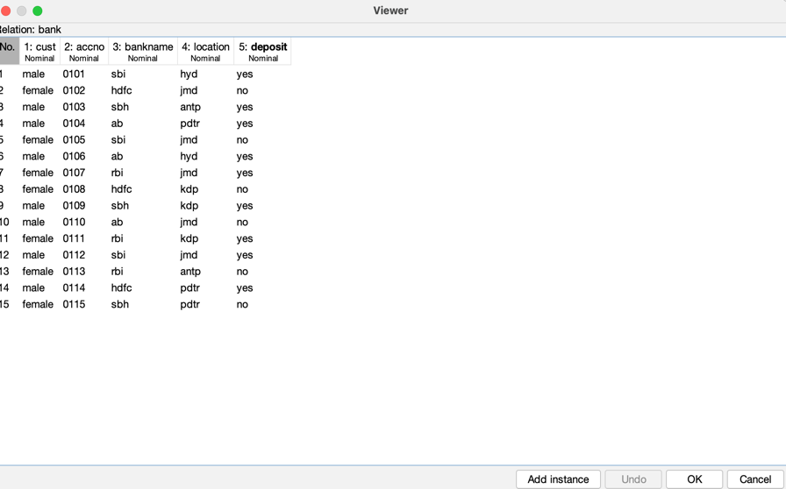

3: Apply the Apriori Algorithm
To perform association rule mining, we follow these steps:
- Click the Associate tab at the top of the Weka interface.
- Click the Choose button and select Apriori from the list of available algorithms.
- Finally, click the Start button to run the algorithm.

4: Analyze the Output
Once the Apriori algorithm finishes running, the results appear on the right side of the window. These results include:
- Frequent item sets: Sets of items that commonly occur together.
- Association rules: Patterns such as "If attribute X occurs, then attribute Y is likely to occur."
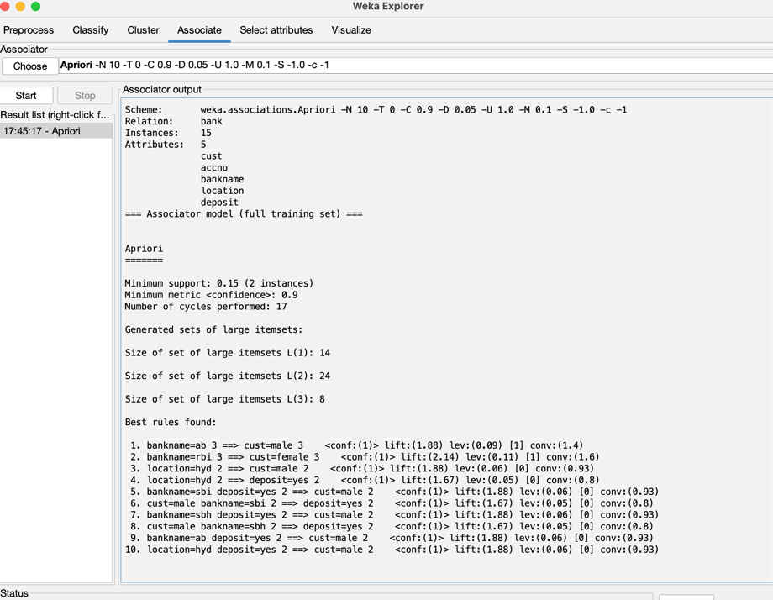

Result
After reviewing the output, we successfully completed the lab. This exercise demonstrates how we can extract meaningful patterns and relationships from data using Weka's Apriori algorithm, making it a valuable tool for data mining and analysis.

