Lab 9:
1. Open Notepad:
- Navigate to Start → Programs → Accessories → Notepad.
2. Enter the Training Dataset: Paste the following data into Notepad:
@relation employee-1
@attribute age {youth, middle, senior}
@attribute income {high, medium, low}
@attribute class {A, B, C}

@data
youth, high, A
youth, medium, B
youth, low, C
middle, low, C
middle, medium, C
middle, high, A
senior, low, C
senior, medium, B
senior, high, B
middle, high, B

3. Save the File:
- Save the file with the extension .arff (e.g., employee-1.arff).
4. Open Weka:
- Navigate to Start → Programs → Weka-3-4 → Weka-3-4.
5. Load Dataset in Weka:
- In Weka's dialog box, click Explorer.
- Select Open File, locate employee-1.arff, and load the dataset.
View Dataset:
- Click Edit in Weka to view the employee table.

Steps to Generate Association Rules
- Open Weka Explorer:
  - Navigate to Start → Programs → Weka-3-4 → Weka-3-4 and open the Explorer.
- Load Dataset:
  - Click Open File and select employee-1.arff.
- Select Association Mode:
  - On the top menu, click Associate.
- Choose the Apriori Algorithm:
  - Click the Choose button and select Apriori from the list of algorithms.
- Generate Rules:
  - Click Start to execute the algorithm.
  - The association rules will be displayed on the right side of the window.
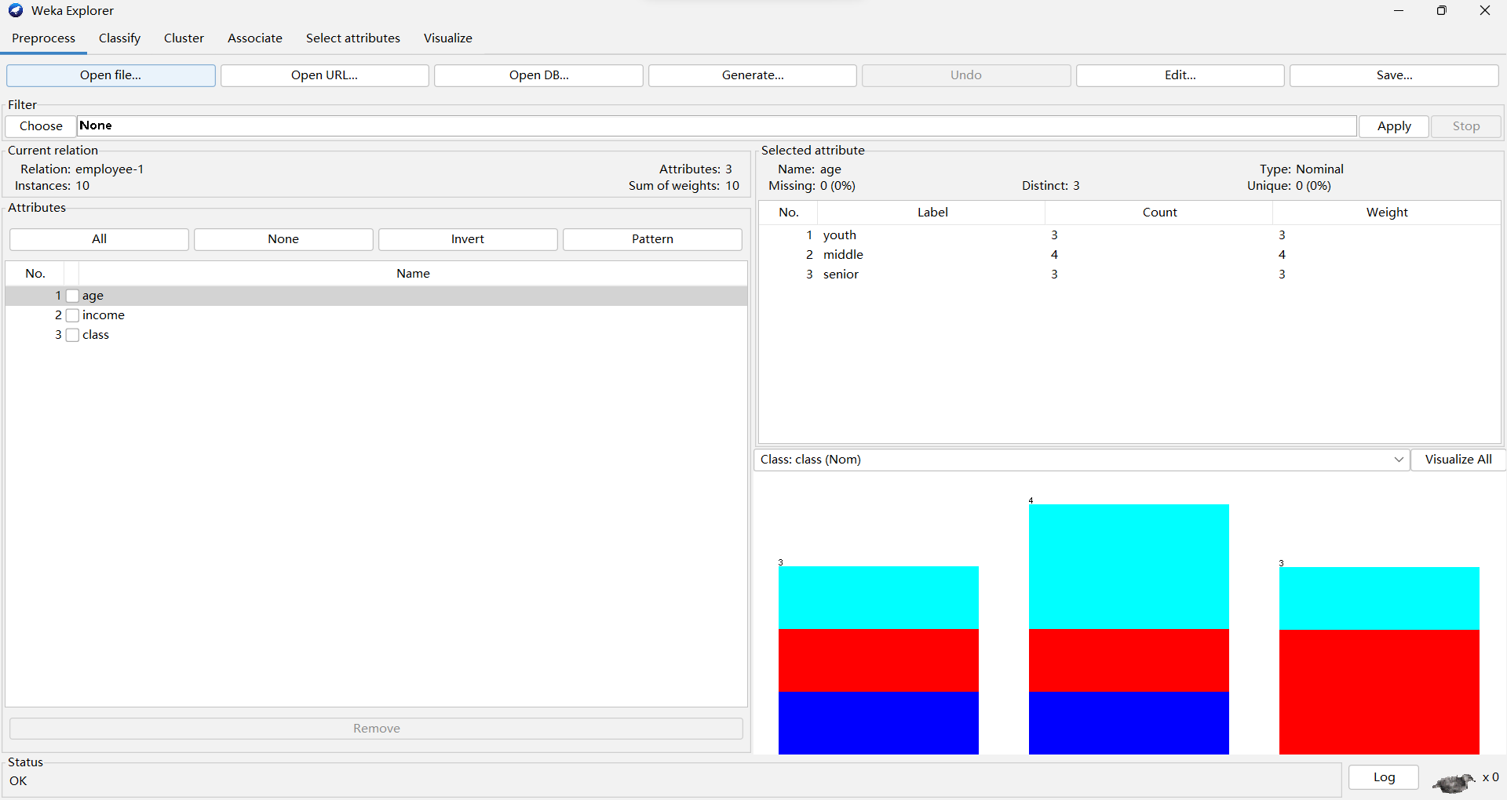
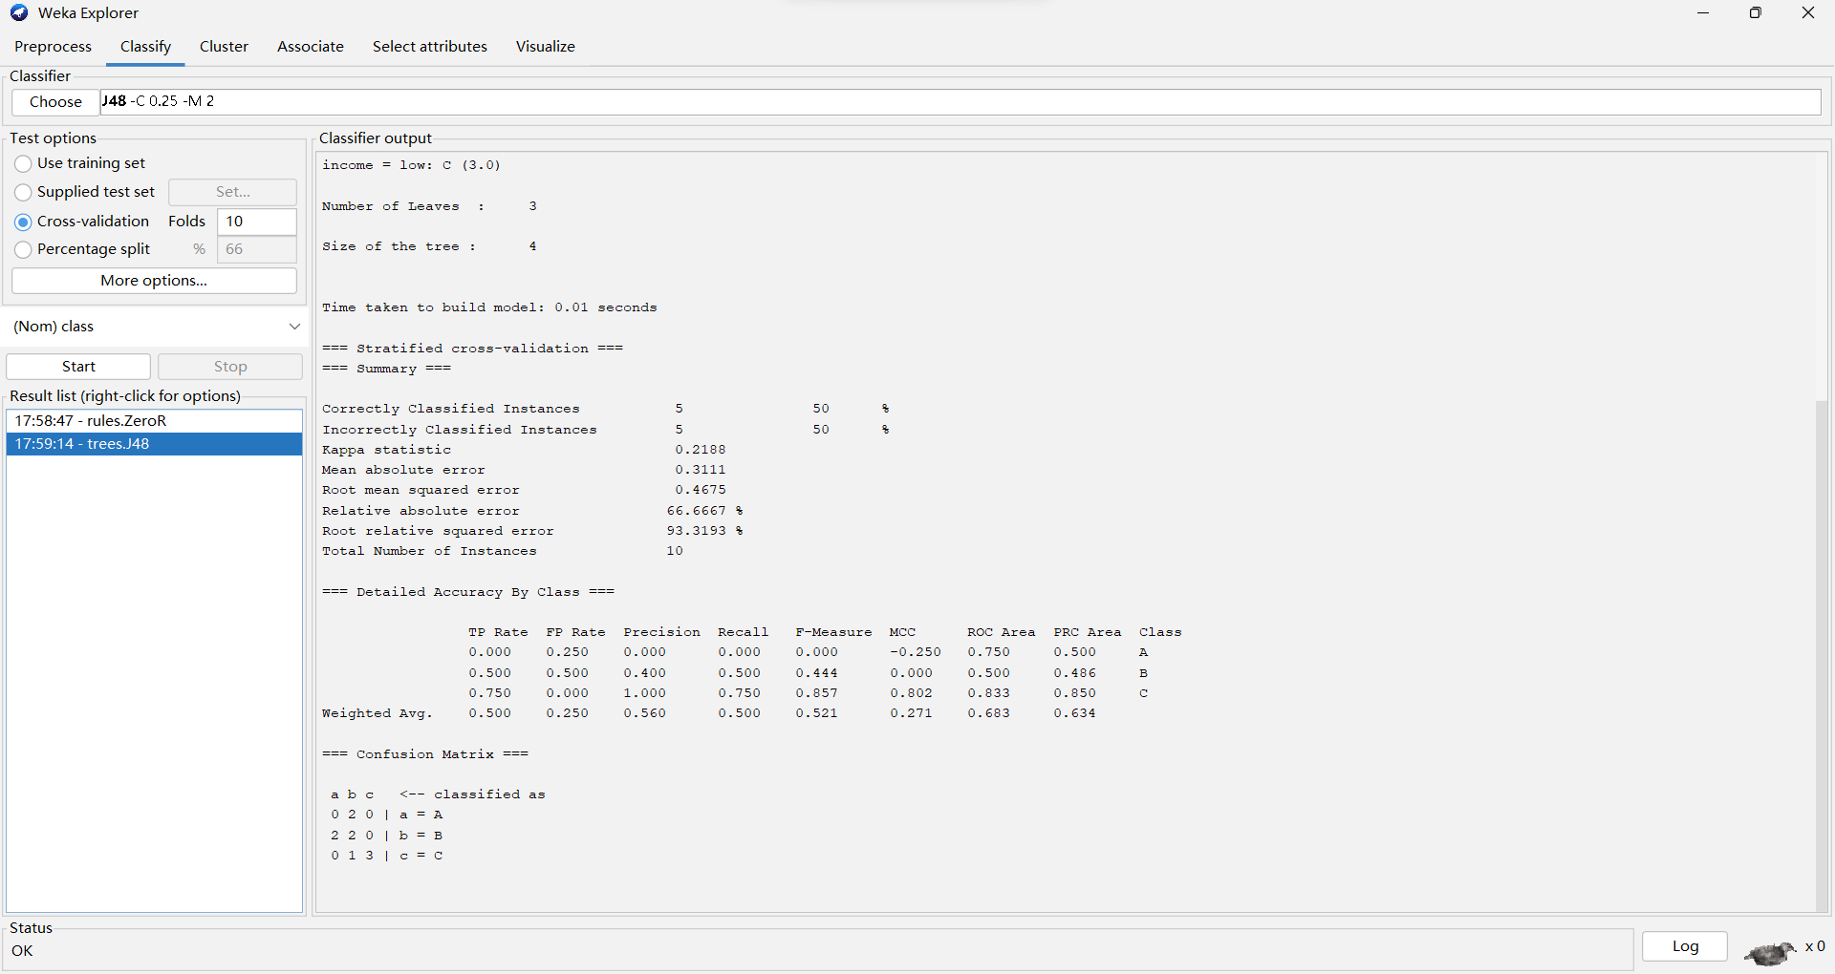

Output:
The generated association rules from Weka may include examples like:
- Rule 1:
If age = youth and income = high, then class = A.
Confidence: 80%, Support: 30%
- Rule 2:
If age = senior and income = medium, then class = B.
Confidence: 70%, Support: 25%
- Rule 3:
If income = low, then class = C.
Confidence: 90%, Support: 40%

