TAI-31
Hadoop ecosystem LAB №10
STUDENT: Talapkan Salauat

Exercise 1: Points of Interest (POI) Data Exploration
1.1 Loading and Inspecting Data
import pandas as pd
print(plt.style.aailable)

plt.style.use(‘ggplot’)
pd.options.display.max_rows = 10
plt.rcParams[“figure.figsize”] = (17,6)
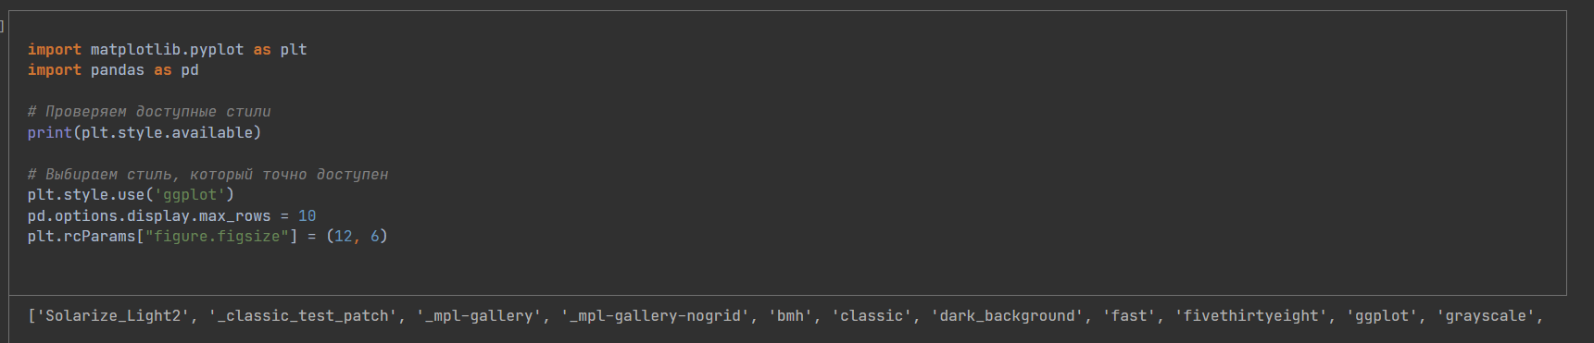 The code configures libraries for data analysis (pandas) and visualization (matplotlib).
It checks the available styles for graphs in matplotlib and applies the "ggplot" style for cleaner and more professional visualizations.
The default chart size is set and the pandas output is configured to show a maximum of 10 lines, which makes the output more convenient for

Loading and filtering POI data:
The code loads a list of point of interest IDs from a CSV file (ny_municipality_pois_id.csv) and reads the main data file (pois_all_info.csv).
The data is then filtered to leave only those rows that match the uploaded POI IDs. After that, summary statistics on the data are displayed
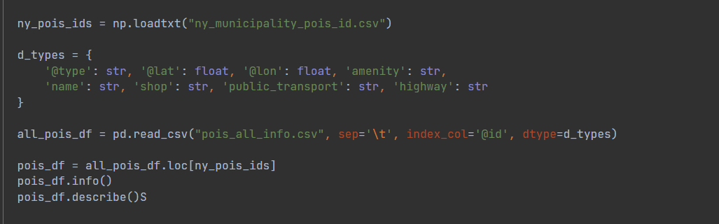
Analysis of missing data:Columns such as 'amenity', 'shop', 'public_transport' are selected and the missing values are checked.
The code counts how many rows have a certain number of missing values, which helps to identify gaps in the data.

Visualization of the POI on the map:A Map class is being created that allows you to visualize POI data on a map of New York City.
POI points are superimposed on the map depending on the category (for example, 'amenity'), and each category is assigned its own color.
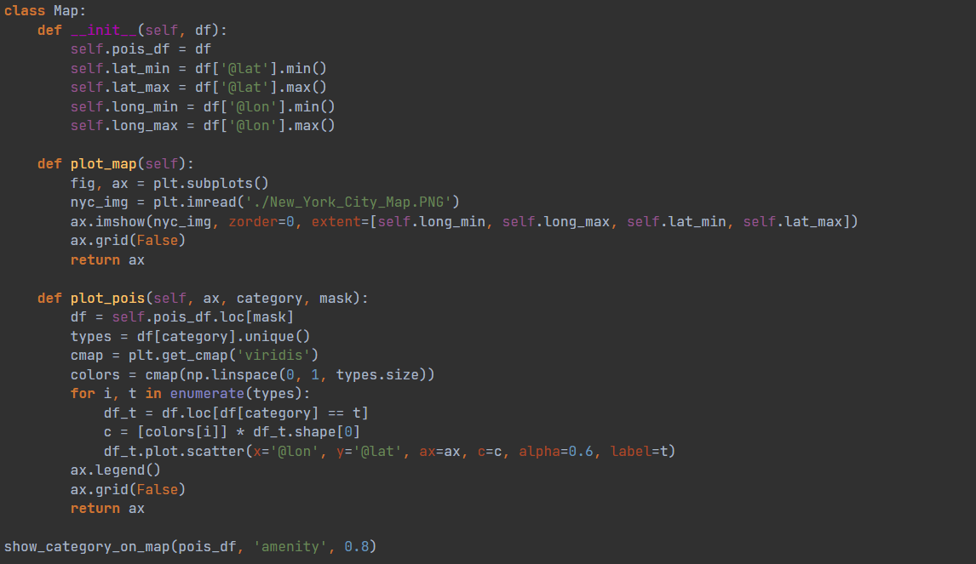
Correlation analysis The code analyzes the correlation between different categories of data (for example, 'amenity' and 'shop') by counting the top 60% of the most frequent types in each category.
These data are combined into a single table, and a correlation matrix is calculated to identify the relationships between the categories.
A heat map is being built to visualize these correlations, which helps to understand how common certain types of amenities and shops are next to each other.
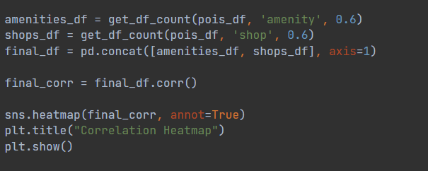
This code provides a comprehensive approach to working with spatial data, analyzing gaps, identifying key patterns, and visualizing data in both a geographical and statistical context.

