Exercise 1:
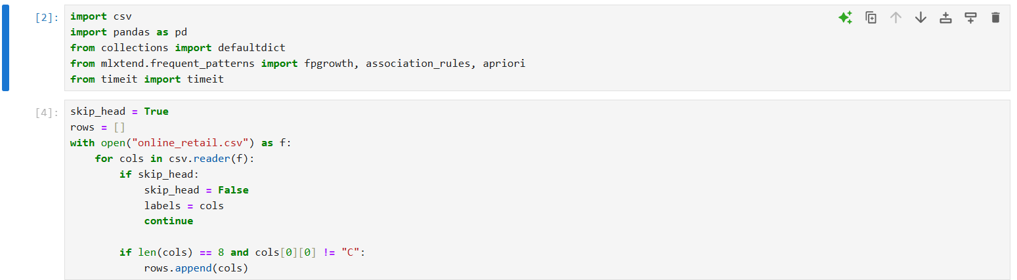
This code reads data from a CSV file called "online_retail.csv" and filters it. It starts by skipping the first row, which is assumed to contain headers, and saves these headers as labels. Then, it reads each row in the CSV file. If a row has exactly eight columns and its first value does not start with the letter "C," the code adds this row to a list called rows. In the end, rows will contain only the filtered rows that meet these conditions.
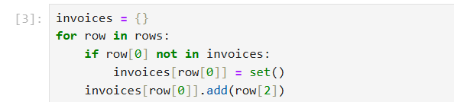

This code creates a dictionary called invoices that groups items by their invoice IDs. For each row in rows, it checks if the invoice ID (the first element, row[0]) is already in invoices. If not, it adds this ID as a key in the dictionary and assigns it an empty set. Then, it adds the item (the third element, row[2]) to the set for that invoice ID. This way, each invoice ID in invoices is associated with a set of unique items, effectively grouping items by their invoices.
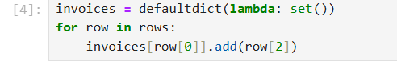
This code is a simplified version of the previous one, using defaultdict to create the invoices dictionary. Here, invoices is a defaultdict with a default value of an empty set for each new key. For each row in rows, it directly adds the item (the third element, row[2]) to the set of items associated with the invoice ID (the first element, row[0]). Using defaultdict removes the need to check if the invoice ID already exists in the dictionary, making the code shorter and more efficient.
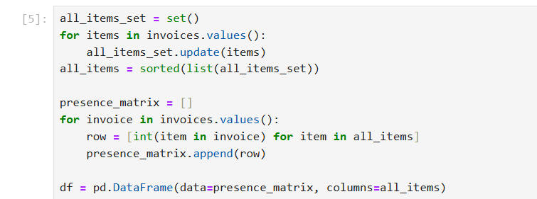
This code creates a "presence matrix" that indicates which items appear in each invoice, then converts it into a DataFrame.
- Unique Items: It first collects all unique items from all invoices by updating all_items_set with the items from each invoice. Then, it sorts this set into a list called all_items.
- Presence Matrix: For each invoice in invoices, it creates a row where each element is 1 if the item from all_items is in the invoice, and 0 otherwise. These rows are stored in presence_matrix.
- DataFrame Creation: Finally, it creates a pandas DataFrame df from presence_matrix, with columns labeled by all_items. Each row represents an invoice, and each column shows if a specific item is present in that invoice (1 for present, 0 for absent). This DataFrame makes it easy to analyze item presence across invoices.

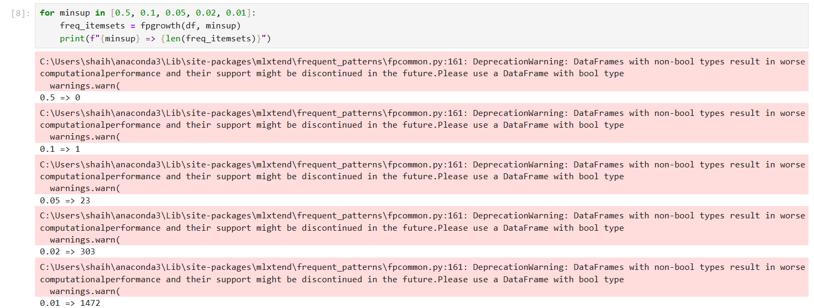
This code is testing different minimum support values (minsup) for finding frequent itemsets using the fpgrowth function from the mlxtend library. For each minsup value, it calculates the number of frequent itemsets and prints the result. The warnings shown indicate that the data type used may reduce performance and that the code should use a DataFrame with boolean types instead. The results show that as minsup decreases, the number of frequent itemsets found increases (e.g., minsup = 0.5 finds 0 itemsets, while minsup = 0.01 finds 1472 itemsets).
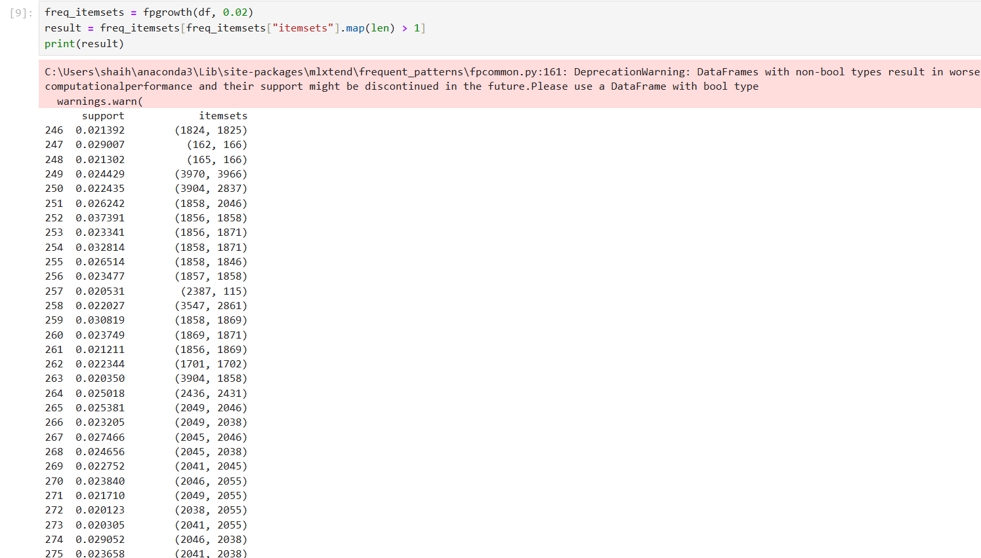
This code uses the fpgrowth algorithm with a minimum support threshold of 0.02 to find frequent itemsets from the data. It then filters the results to only include itemsets that have more than one item (by checking the length of each itemset). Finally, it displays these filtered itemsets along with their support values. The warning message advises using a DataFrame with boolean types to improve performance. The output shows pairs of items along with their support, indicating how frequently these item combinations appear in the dataset.
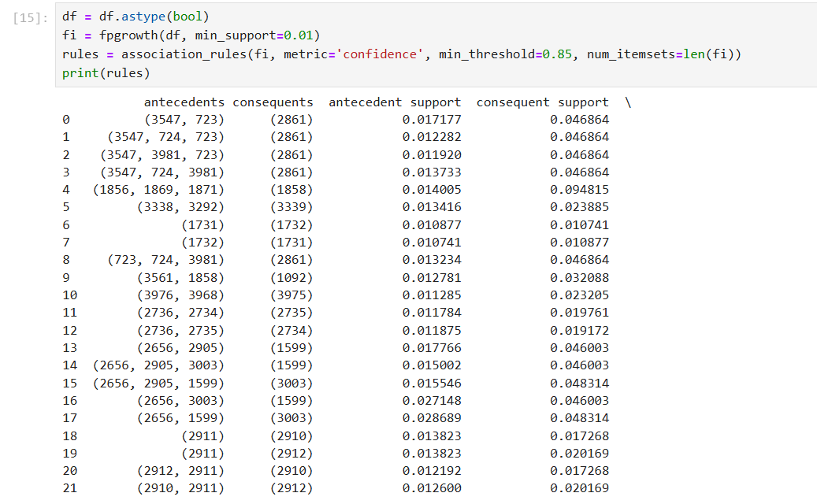
This code converts the df DataFrame to a boolean type for better performance in calculations. It then uses the fpgrowth algorithm to find frequent itemsets with a minimum support of 0.01. After finding these itemsets, it applies the association_rules function to generate association rules based on confidence. The rules are filtered to include only those with a confidence of at least 0.85. The result displays the rules, showing the antecedents (items that lead to other items), consequents (items that follow), and their support values, which indicate how frequently these item combinations appear together. This table helps in understanding which items are likely to be bought together based on confidence and support.

EXERCISE 2:

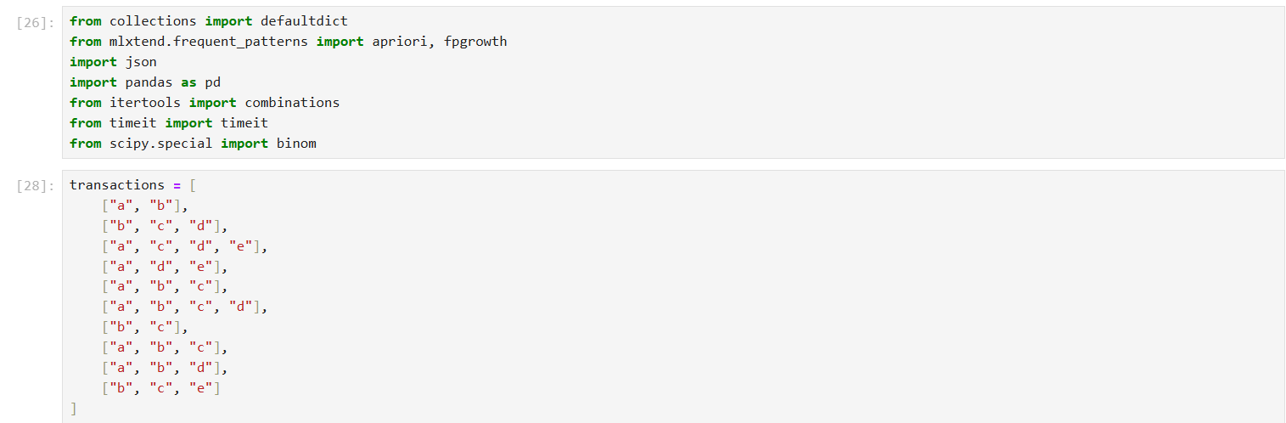
This code imports various libraries and prepares a list of transactions for frequent itemset mining. It imports pandas for data handling, combinations from itertools for generating item combinations, timeit for measuring execution time, and binom from scipy.special for mathematical calculations. From mlxtend.frequent_patterns, it imports apriori and fpgrowth, two algorithms used for finding frequent itemsets. defaultdict is used to simplify dictionary-based data handling, and json allows JSON formatting if needed. The list transactions contains multiple transactions, where each transaction is a list of items (like "a", "b", "c", etc.). This list is the sample data on which Apriori or FP-growth algorithms can be applied to identify frequent item combinations within transactions, providing the foundation for association rule mining analysis.
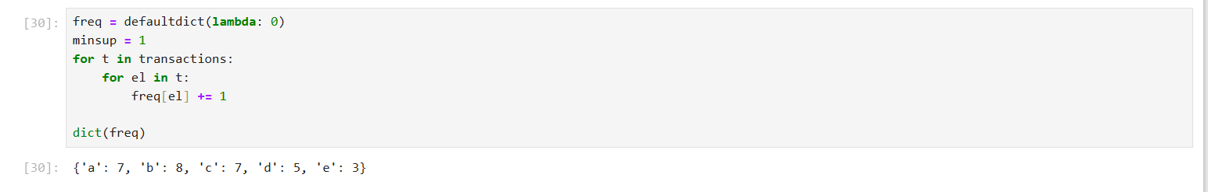
This code counts the frequency of each item in the transactions list and displays the results as a dictionary. It creates a defaultdict called freq to store the counts, initializing each item’s count to 0. Then, for each transaction in transactions, it iterates over each item and increases its count in freq. Finally, it converts freq to a regular dictionary and prints it. The output shows how many times each item appears in all transactions: for example, 'a' appears 7 times, 'b' appears 8 times, 'c' appears 7 times, 'd' appears 5 times, and 'e' appears 3 times. This gives a summary of item frequencies across all transactions.
This code filters items in freq based on a minimum support threshold (minsup) and stores the result in a list called L. It uses a dictionary comprehension to include only items with a frequency (v) greater than or equal to minsup, representing each item as a tuple (k,) for consistency in format. The filtered dictionary is then added as the first element of list L. The output, L[0], shows this filtered dictionary, which includes only the items that meet or exceed the minimum support, such as {('a',): 7, ('b',): 8, ('c',): 7, ('d',): 5, ('e',): 3}, indicating these items are frequent based on the threshold.
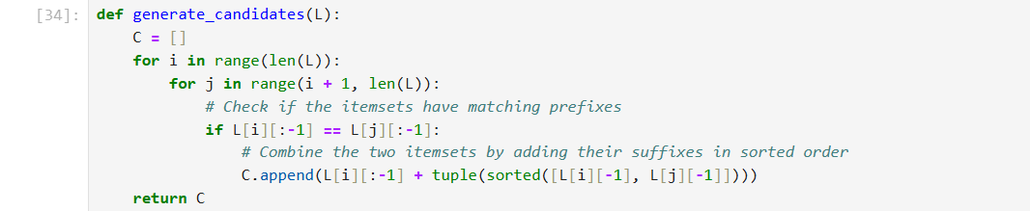
This code defines a function generate_candidates(L) that generates candidate itemsets for the next level of a frequent itemset mining algorithm.
- Initialization: It creates an empty list C to store candidate itemsets.
- Looping through pairs: For each itemset pair (i, j) in the list L, it checks if the itemsets have matching prefixes (all elements except the last one are the same).
- Combining itemsets: If the prefixes match, the function combines the two itemsets by adding their last elements in sorted order to form a new itemset. This new itemset is added to C.
- Return: It returns C, a list of candidate itemsets.
This function is used in algorithms like Apriori to generate larger candidate itemsets based on frequent itemsets from the previous iteration.

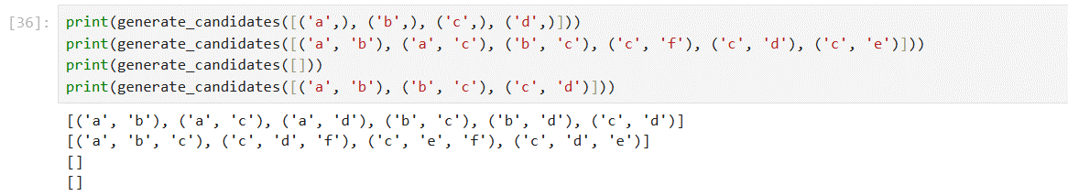
This code tests the generate_candidates function with different sets of input itemsets.
- First Test: The input [(‘a’,), (‘b’,), (‘c’,), (‘d’,)] generates pairs of these single-item sets, producing [('a', 'b'), ('a', 'c'), ('a', 'd'), ('b', 'c'), ('b', 'd'), ('c', 'd')].
- Second Test: The input includes more items and pairs of items, like [(‘a’, ‘b’), (‘a’, ‘c’), (‘b’, ‘c’), (‘c’, ‘f’), (‘c’, ‘d’), (‘c’, ‘e’)]. The output combines these items by matching prefixes, resulting in [('a', 'b', 'c'), ('c', 'd', 'f'), ('c', 'e', 'f'), ('c', 'd', 'e')].
- Third and Fourth Tests: These inputs are empty or contain no matchable prefixes, so they return empty lists ([]), as no candidates can be generated.
The results demonstrate how generate_candidates forms larger itemsets by combining items with matching prefixes, which is useful for generating candidate itemsets in algorithms like Apriori.
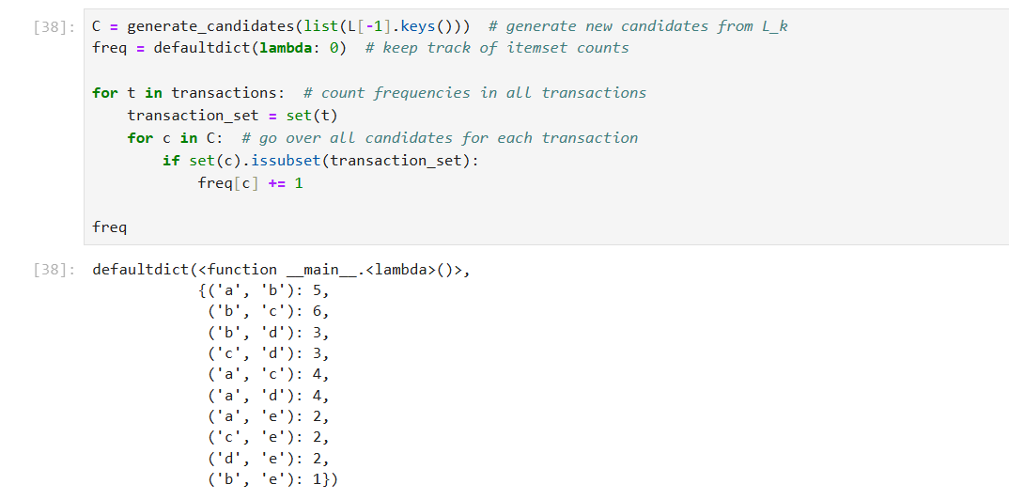
This code counts how often candidate itemsets appear in a list of transactions. It first generates new candidate itemsets, `C`, from the previous level's frequent itemsets (`L[-1]`) using `generate_candidates`. It initializes a frequency dictionary, `freq`, to store counts of each candidate, starting from 0. For each transaction, it creates a set `transaction_set` to check for subsets efficiently. Then, it goes through each candidate `c` in `C` and checks if `c` is a subset of `transaction_set`; if it is, the count for `c` in `freq` is increased by 1. Finally, it prints `freq`, showing how many times each candidate itemset (like `('a', 'b')`, `('b', 'c')`) appears in the transactions. This helps identify itemsets that are frequent across transactions for use in association rule mining.
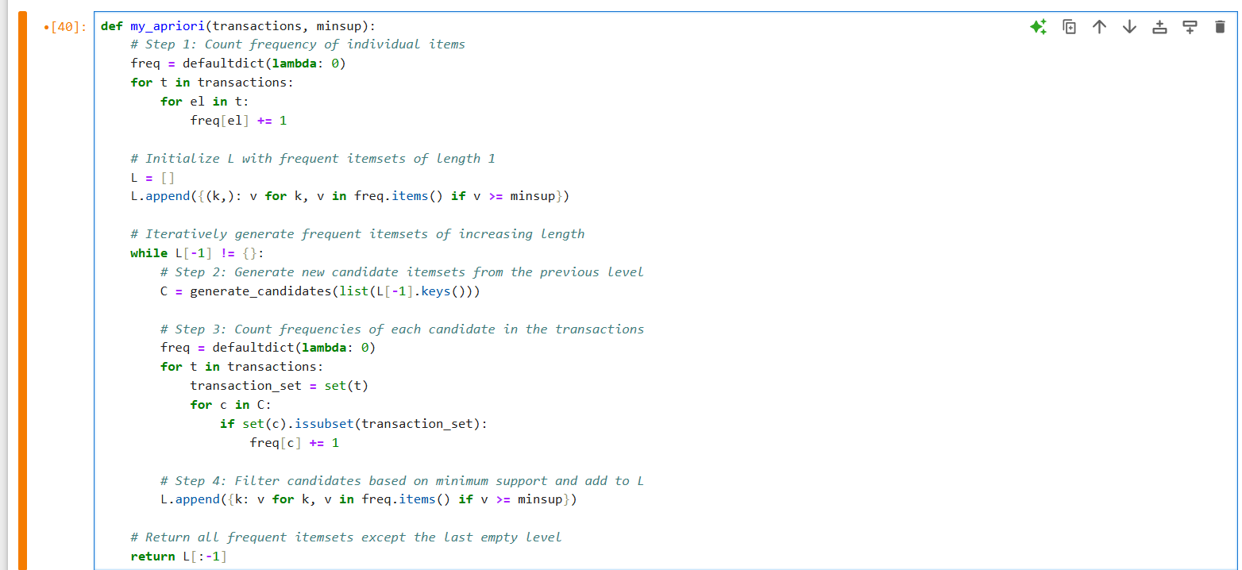
This code defines a function `my_apriori` that implements the Apriori algorithm to find frequent itemsets in a list of transactions, given a minimum support threshold (`minsup`). It starts by counting the frequency of individual items and adds itemsets with frequency greater than or equal to `minsup` to a list `L`. Then, it iteratively generates candidate itemsets of increasing length using `generate_candidates`, counts their frequencies across transactions, and filters them based on `minsup`, adding the filtered itemsets to `L`. The process continues until no more frequent itemsets can be generated. Finally, the function returns all frequent itemsets found except the last empty level. This implementation systematically identifies frequent item combinations, useful for association rule mining.

The code runs the `my_apriori` function with a minimum support of 2 on a list of transactions, storing the results in `results`. It then prints `results`, which contains frequent itemsets identified by the algorithm. Each dictionary in `results` shows itemsets with their counts that meet or exceed the minimum support. For example, `{('a',): 7, ('b',): 8, ('c',): 7}` shows single items and their counts, while `{('a', 'b'): 5, ('b', 'c'): 6}` shows pairs of items with their counts. This output shows all frequent itemsets of different lengths that appear often enough in the transactions based on the specified support.\
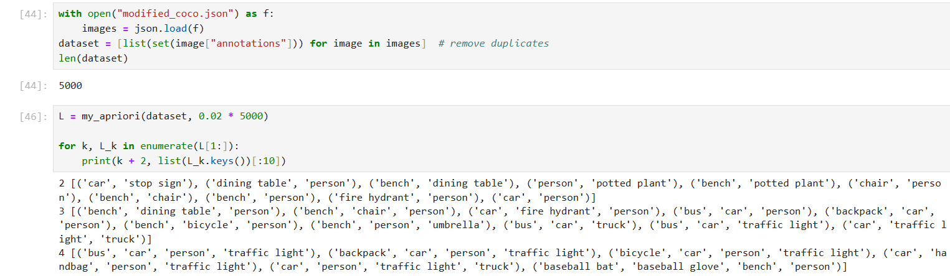
This code reads a JSON file called `"modified_coco.json"` to extract image annotations, creating a list called `dataset` with unique annotations for each image. It confirms the dataset contains 5000 entries. Then, it applies the `my_apriori` function on `dataset` with a minimum support threshold of `0.02 * 5000` (meaning itemsets must appear at least 2% of the time). The result, `L`, contains frequent itemsets at different lengths. A loop iterates through `L`, displaying frequent itemsets for levels starting from 2-item combinations. Each level shows common item combinations like `("car", "stop sign")`, `("bench", "person")`, indicating frequently co-occurring objects in the images based on the specified support threshold. This helps identify frequent item groupings in the dataset.

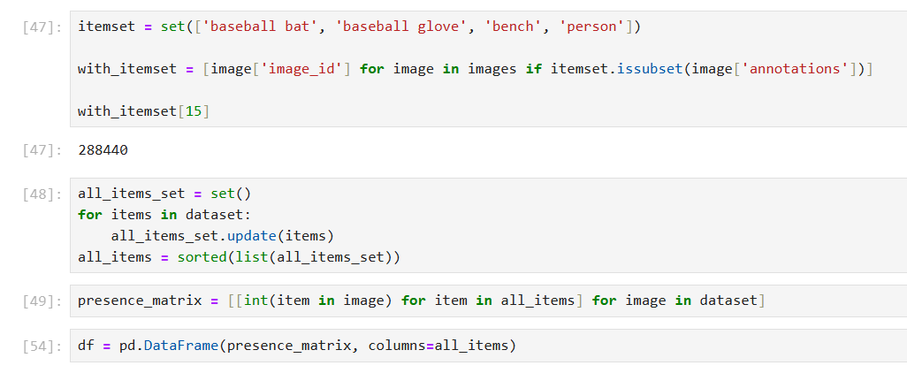
This code identifies images containing a specific set of items and creates a presence matrix for all unique items across the dataset.
1. Filtering Images with a Specific Itemset: It defines `itemset` with items `["baseball bat", "baseball glove", "bench", "person"]` and finds all image IDs (`with_itemset`) where this itemset appears as a subset of the annotations. The result `with_itemset[15]` displays the 16th image ID that matches this itemset. The length, `288440`, shows the number of images containing this itemset.
2. Creating Unique Item List It gathers all unique items across `dataset` into `all_items_set`, sorts them into a list `all_items`.
3. Building Presence Matrix: It creates a matrix (`presence_matrix`) where each row represents an image, and each column (0 or 1) indicates the presence of a specific item in `all_items` within that image.
4. DataFrame Creation: It converts `presence_matrix` into a DataFrame `df` with columns labeled by `all_items`, allowing for easy analysis of item presence across images.
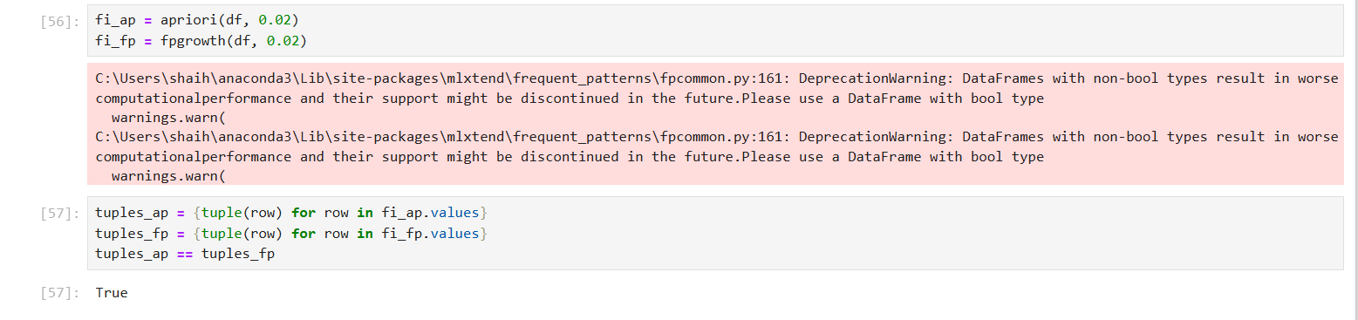
This code compares the results of two frequent itemset mining algorithms, Apriori and FP-growth, on the DataFrame `df` with a minimum support threshold of `0.02`.
1. Running Algorithms: It runs both the `apriori` and `fpgrowth` algorithms from `mlxtend.frequent_patterns`, storing the results in `fi_ap` and `fi_fp` respectively. The warnings indicate that using non-boolean types may reduce performance, and suggest using a DataFrame with boolean types.
2. Converting Results to Tuples: It converts each row in the results (`fi_ap.values` and `fi_fp.values`) into a tuple and stores these tuples in sets `tuples_ap` and `tuples_fp` for easy comparison.
3. Comparison: It checks if the sets `tuples_ap` and `tuples_fp` are equal. The result `True` indicates that both algorithms produced identical sets of frequent itemsets, confirming consistency between Apriori and FP-growth on this dataset with the given support threshold.
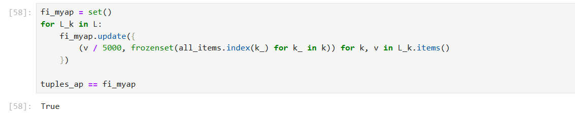
This code verifies that the custom `my_apriori` algorithm produces the same frequent itemsets as the standard Apriori implementation. It initializes a set `fi_myap` to store the itemsets generated by `my_apriori`, where each itemset is represented by its relative support (`v / 5000`) and a `frozenset` of item indices from `all_items`. For each level in `L`, it updates `fi_myap` with these transformed itemsets. Finally, it compares `fi_myap` to `tuples_ap`, the itemsets from the standard Apriori, and the result `True` confirms that both implementations yield identical frequent itemsets, validating the accuracy of the custom algorithm.
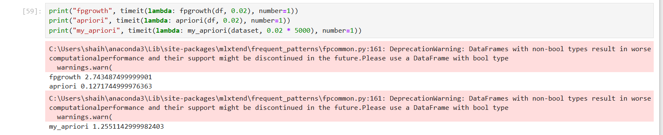
This code measures the execution time of three frequent itemset mining algorithms—FP-growth, Apriori, and a custom `my_apriori`—using the `timeit` function. Each algorithm is applied to the dataset with a minimum support threshold of 0.02, and the time taken (in seconds) is printed. The results show that FP-growth took about 2.74 seconds, Apriori took about 0.13 seconds, and the custom `my_apriori` took about 1.25 seconds. The warnings indicate that using non-boolean DataFrames may reduce performance, suggesting a boolean DataFrame would be more efficient. This timing comparison helps to evaluate the relative efficiency of each algorithm.
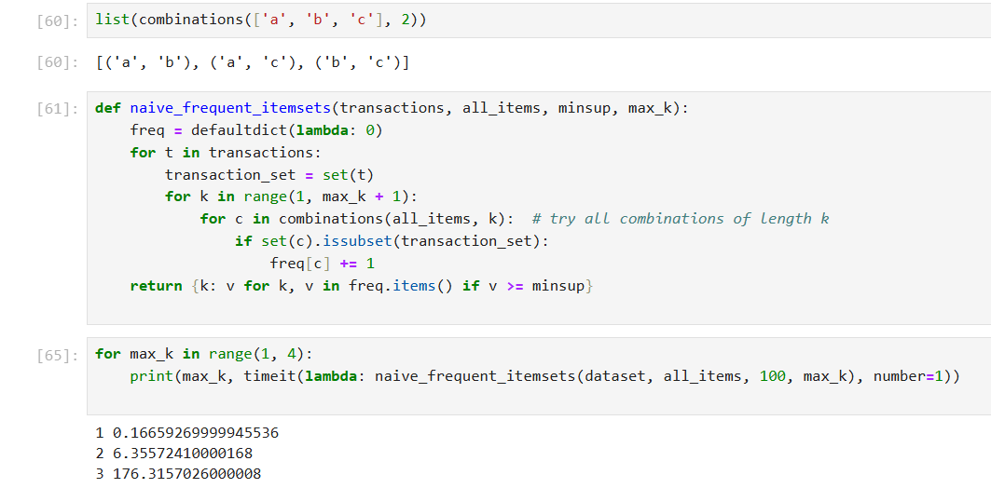
This code defines and tests a naive algorithm for finding frequent itemsets up to a given length (max_k), then measures its performance.
- Combinations Example: It shows how combinations(['a', 'b', 'c'], 2) generates pairs like ('a', 'b'), ('a', 'c'), and ('b', 'c').
- Naive Algorithm: The naive_frequent_itemsets function finds frequent itemsets by counting each combination up to length max_k in transactions.
  - It initializes a frequency dictionary freq.
  - For each transaction, it converts the items to a set and checks all combinations of items (from length 1 up to max_k).
  - If a combination c is a subset of the transaction, it increments its count in freq.
  - Finally, it returns only the itemsets in freq that meet or exceed the minimum support (minsup).
- Timing Test: The timeit function measures the time taken for different values of max_k (1 to 3) on the dataset with a minimum support of 100.
  - Results show that execution time increases significantly with higher max_k: 0.17s for max_k=1, 6.36s for max_k=2, and 176.32s for max_k=3, illustrating the exponential growth in time due to the increased number of combinations.
This demonstrates the computational intensity of the naive approach as max_k grows.

