Lab 6 1-2:Salauat Talapkan

Exercise 1:
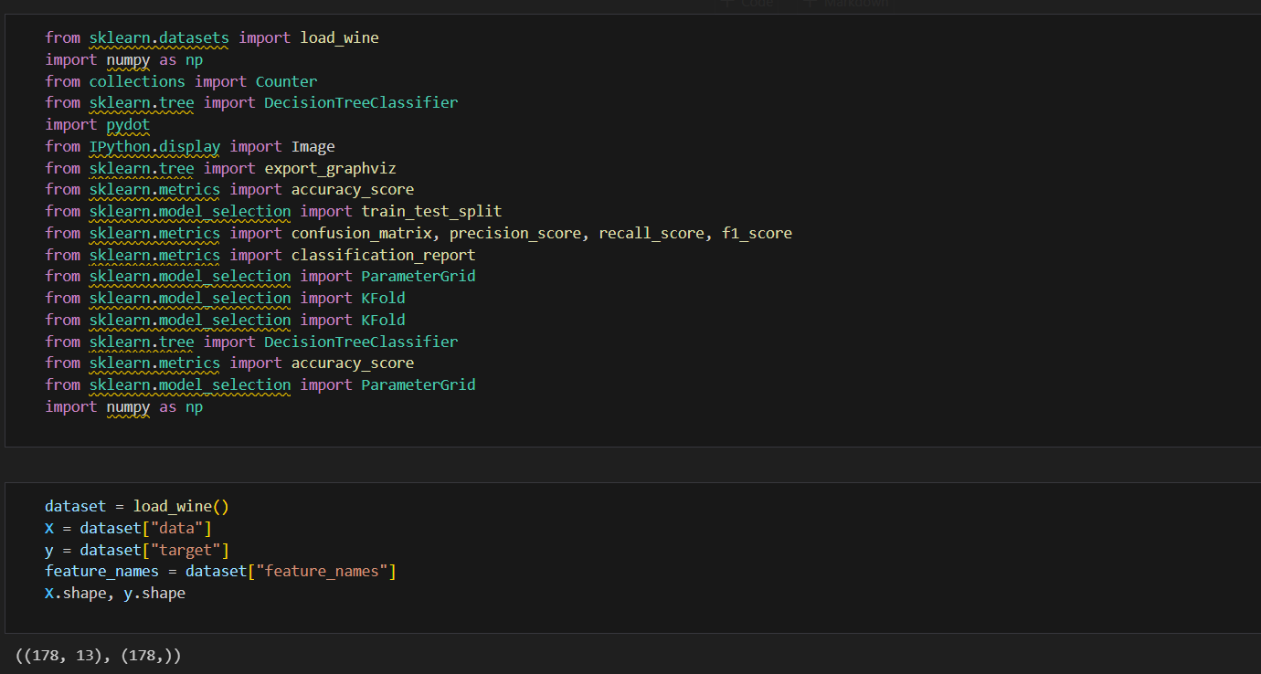
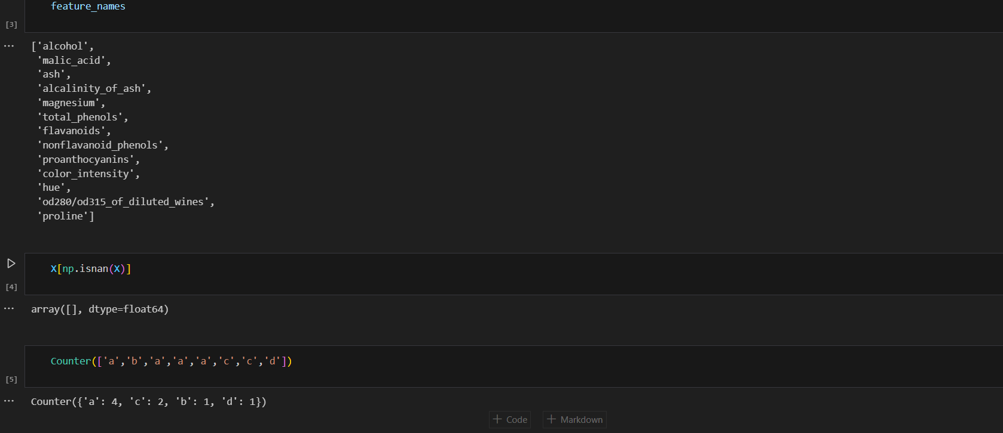
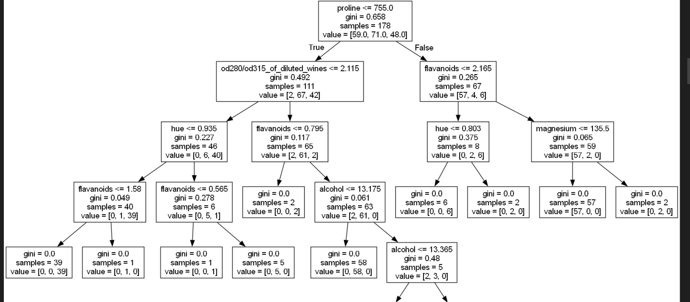
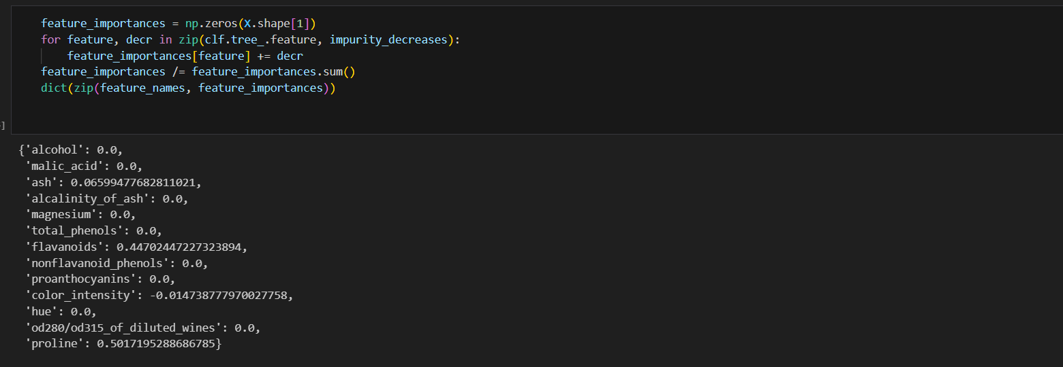1.Library imports:
import pandas as pd
import matplotlib.pyplot as plt
- These libraries are used to work with data and visualization.
2.Loading data:
df = pd.read_csv("synth.csv")
df.head()
- Reads the synth.csv CSV file, outputs the data for inspection.
3.Visualizing data:
X = df.values[:, :2]
y = df.values[:, 2]
plt.scatter(X[:, 0], X[:, 1], c=y)
plt.xlabel("x0")
plt.ylabel("x1")
- X — coordinates of points (first 2 columns).
- y — class labels (3rd column).
- Points are displayed as a color graph.
4. Building a decision tree:
from sklearn.tree import DecisionTreeClassifier
from sklearn.tree import export_graphviz
import pydot
from IPython.display import Image
clf = DecisionTreeClassifier()
clf.fit(X, y)
dot_code = export_graphviz(clf, feature_names=["x0", "x1"])
graph = pydot.graph_from_dot_data(dot_code)
Image(graph[0].create_png())
- A decision tree is created based on data X and y.
- Save its visualization.
5.Modified data:
X_ = (X[:, 0] + X[:, 1]).reshape(500, 1)
clf_ = DecisionTreeClassifier()
clf_.fit(X_, y)
dot_code = export_graphviz(clf_, feature_names=["x0 + x1"])
graph = pydot.graph_from_dot_data(dot_code)
Image(graph[0].create_png())
- A new feature is used: the sum of coordinates x0 + x1.
6.Splitting the space:
def draw_split(features, thresholds, i, x0_min, x0_max, x1_min, x1_max):
plt.scatter(X[:, 0], X[:, 1], c=y)
plt.xlim(0, 10)
plt.ylim(0, 10)
draw_split(clf.tree_.feature, clf.tree_.threshold, 0, 0, 10, 0, 10)
plt.show()
The function visualizes the splitting of the feature space based on the decision tree parameters.

Exercise 2:
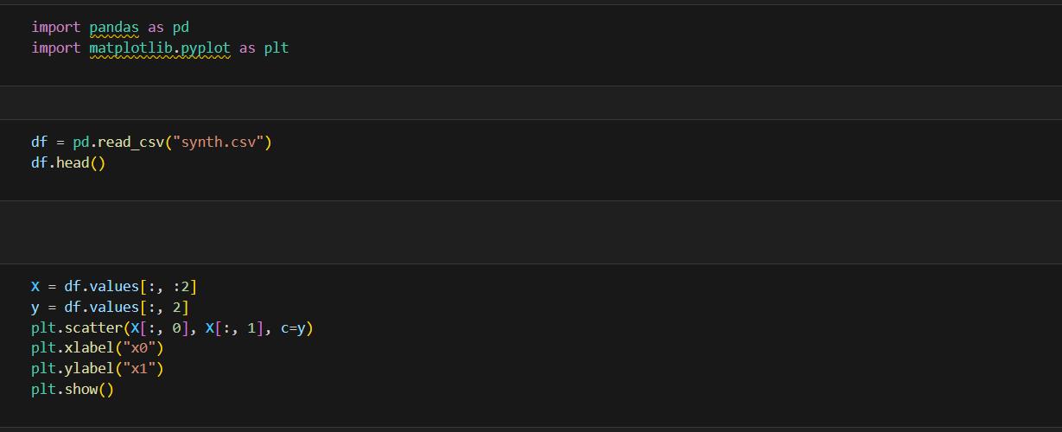

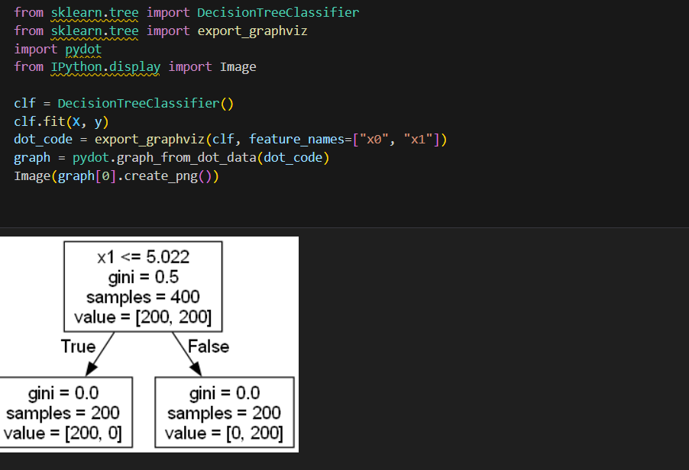
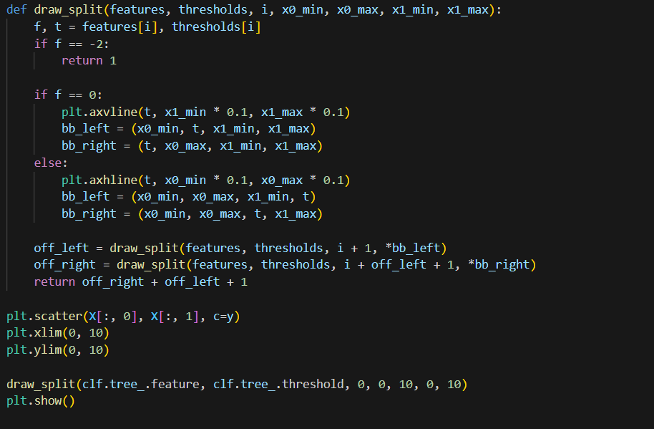

1.Library imports:
from sklearn.datasets import load_wine
from sklearn.tree import DecisionTreeClassifier
from sklearn.metrics import accuracy_score
- These libraries load the wine dataset, build a decision tree, and evaluate the accuracy of the model.
2.Build and train the model:
clf = DecisionTreeClassifier()
clf.fit(X, y)
- Build and train the decision tree model.
3.Data splitting:
from sklearn.model_selection import train_test_split
X_train, X_test, y_train, y_test = train_test_split(X, y, test_size=0.2, stratify=y)
- The data is split into training and testing sets with equal class distribution.
4.Quality metrics:
y_pred = clf.predict(X_test)
print(confusion_matrix(y_test, y_pred))
print(precision_score(y_test, y_pred, average=None))
print(recall_score(y_test, y_pred, average=None))
print(f1_score(y_test, y_pred, average=None))
- The main metrics are calculated: confusion matrix, precision, recall, F1-score.
5.Hyperparameter optimization:
from sklearn.model_selection import ParameterGrid
params = {
"max_depth": [None, 2, 3, 4, 5],
" &#8203;:contentReference[oaicite:0]{index=0}&#8203;

