CUSTOMER SEGMENTATION AND
TARGETING ANALYSIS
Data-Driven Digital Marketing Analysis Using Python and K-Means Clustering
Week 3 Internship Project

1. Executive Summary
This project presents an end-to-end customer segmentation and targeting analysis for digital marketing. A simulated hypothetical market dataset containing 200 customer records was analyzed using Python. Demographic and behavioral variables—age, annual income, spending score, purchase frequency, and online engagement—were used to identify groups of customers with similar characteristics. The workflow includes data preparation, feature standardization, K-Means clustering, cluster evaluation, visualization, segment profiling, and targeted marketing recommendations. Four distinct customer segments were identified: Low Engagement, Value Seekers, Growth Customers, and Premium Loyalists. Each segment is described using its average customer characteristics and connected to an appropriate marketing objective. The project demonstrates how data analysis and machine learning can support more personalized digital marketing decisions.

2. Introduction
Customer segmentation is the process of dividing a broad customer population into smaller groups that share meaningful characteristics or behaviors. In digital marketing, segmentation can support personalization, campaign planning, customer retention, and more efficient allocation of marketing resources. This project focuses on demographic and behavioral segmentation and demonstrates the process using a hypothetical market dataset.
The dataset is simulated for educational purposes. It does not represent a real company's customers or contain real personal information. The purpose is to demonstrate a reproducible analytical method that could later be applied to a validated business dataset.

3. Objectives
- Analyze customer demographic and behavioral characteristics.
- Prepare data for machine-learning-based segmentation.
- Identify and justify at least three distinct customer segments.
- Create visualizations that clearly communicate the segments.
- Develop targeted digital marketing strategies for each segment.
- Demonstrate a reproducible Python data-analysis workflow.

4. Dataset and Variables
The dataset contains 200 simulated customer records. CustomerID is used only as an identifier and is excluded from clustering.
Variable | Type | Purpose
Age | Numerical | Demographic profile
AnnualIncome | Numerical | Income-based differentiation
SpendingScore | Numerical | Relative spending behavior
PurchaseFrequency | Numerical | Purchase activity
OnlineEngagement | Numerical | Digital engagement level

5. Methodology

5.1 Data Preparation
The customer data was stored in CSV format and loaded using Pandas. The numerical variables were checked for reasonable values. CustomerID was not used as a predictive feature because it has no behavioral meaning.

5.2 Feature Selection
Age, AnnualIncome, SpendingScore, PurchaseFrequency, and OnlineEngagement were selected because they combine demographic and behavioral information relevant to customer profiling.

5.3 Standardization
The selected features were standardized with StandardScaler. This is important because annual income has a much larger numerical scale than variables such as spending score or purchase frequency.

5.4 K-Means Clustering
K-Means clustering was applied with four clusters. The algorithm groups observations by minimizing the distance between customers and their assigned cluster centers.

5.5 Evaluation
The resulting clustering produced a silhouette score of 0.548. This indicates the degree of separation within this simulated sample. Since the data is educational and simulated, the score should not be interpreted as a guarantee of real-world campaign performance.

6. Data Visualizations
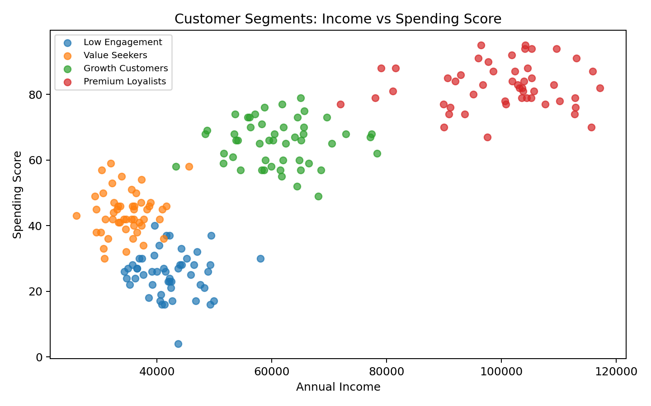
Figure 1. Income and spending relationship across customer segments.
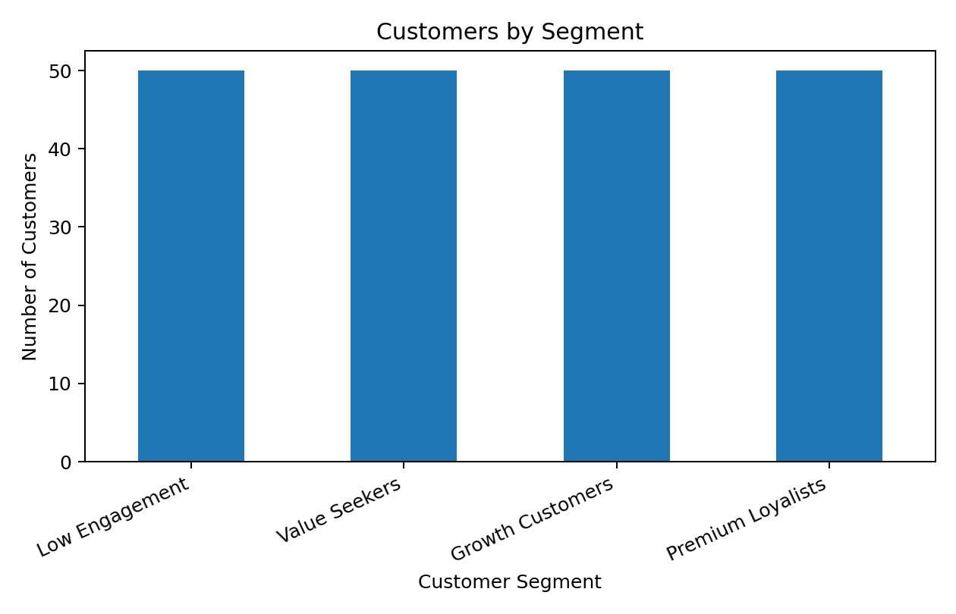
Figure 2. Number of customers in each identified segment.
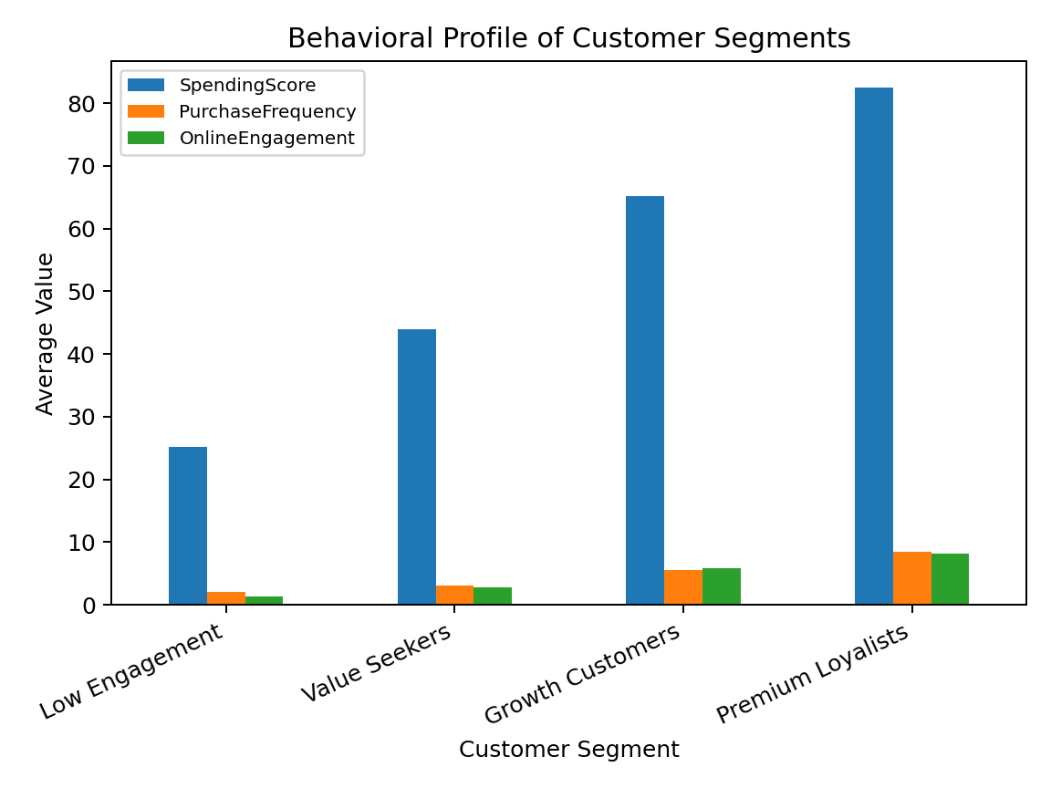
Figure 3. Comparison of key behavioral characteristics.

7. Customer Segment Identification and Justification

Low Engagement
This segment contains 50 customers. Its average age is 47.4 years, annual income is approximately ₹42,155, spending score is 25.2, purchase frequency is 2.0, and online engagement is 1.4.
The combination of comparatively low spending, purchase frequency, and online engagement indicates a group that requires awareness and re-engagement efforts.

Value Seekers
This segment contains 50 customers. Its average age is 23.6 years, annual income is approximately ₹34,759, spending score is 43.9, purchase frequency is 3.1, and online engagement is 2.8.
This group displays moderate spending behavior and can be approached through clear value propositions, bundles, and practical offers.

Growth Customers
This segment contains 50 customers. Its average age is 28.7 years, annual income is approximately ₹61,045, spending score is 65.2, purchase frequency is 5.5, and online engagement is 5.8.
This group has stronger purchase activity and spending than the value-oriented group, creating an opportunity for cross-selling, personalization, and frequency-building campaigns.

Premium Loyalists
This segment contains 50 customers. Its average age is 38.2 years, annual income is approximately ₹100,103, spending score is 82.5, purchase frequency is 8.4, and online engagement is 8.1.
This group combines relatively high spending, purchase frequency, and digital engagement, making retention and loyalty-oriented communication relevant.

8. Targeted Marketing Strategies
Segment | Campaign Focus | Example Tactics | Key Metrics
Low Engagement | Re-engagement | Reminder messages, useful content, return-purchase incentives | Reactivation rate, engagement, conversion
Value Seekers | Value and conversion | Discount bundles, price-value messaging, limited-time offers | CTR, conversion, revenue
Growth Customers | Growth and cross-selling | Personalized recommendations, bundles, complementary products | AOV, frequency, conversion
Premium Loyalists | Retention and loyalty | Loyalty rewards, early access, personalized premium offers | Retention, repeat rate, customer value

9. Campaign Implementation
- Create separate audience groups using the segment labels.
- Develop segment-specific messages and creative assets.
- Run controlled A/B tests for offers and calls to action.
- Measure campaign results separately by segment.
- Review customer segments periodically as behavior changes.
- Use appropriate privacy controls and avoid sensitive or discriminatory criteria.

10. Technical Implementation
Python is the primary language used in the project. Pandas handles data loading, grouping, profiling, and export. NumPy supports numerical processing. Matplotlib is used for the report charts, while Scikit-learn provides feature standardization, K-Means clustering, and silhouette evaluation. The project includes the dataset, Python script, segmented output, and visualization files so the analysis can be reproduced.

11. Key Findings
- Customer behavior can be separated into multiple interpretable groups.
- Combining demographic and behavioral variables provides a richer profile than income or age alone.
- Different segments require different campaign objectives and messages.
- Visualizations make segment differences easier to communicate to marketing stakeholders.
- Segmentation should be combined with campaign testing and business context before operational decisions are made.

12. Limitations
The dataset is simulated and therefore does not represent actual customer behavior. The analysis uses a limited set of numerical variables and does not include geographic, product-category, channel, or psychographic information. K-Means clustering also requires careful selection of features and cluster count. A real deployment would require validated business data, stronger model selection, privacy review, monitoring, and periodic re-segmentation.

13. Conclusion
This project demonstrates an end-to-end customer segmentation and targeting workflow. Using demographic and behavioral data, K-Means clustering produced four interpretable groups: Low Engagement, Value Seekers, Growth Customers, and Premium Loyalists. Each segment was linked to a different digital marketing strategy. The project shows how Python, data analysis, visualization, and machine learning can convert customer data into structured insights that support personalized marketing planning.

14. Tools and Technologies
Python | Pandas | NumPy | Matplotlib | Scikit-learn | Microsoft Word

15. Project Files
- customer_segmentation_data.csv
- customer_segmentation.py
- segmented_customers.csv
- charts/income_vs_spending.png
- charts/segment_counts.png
- charts/segment_profiles.png

