DATA ANALYSIS AND VISUALIZATION
FOR CAMPAIGN PERFORMANCE
Digital Marketing Campaign Performance Analysis
Internship Week 2 Project Report
Dataset: Simulated sample digital marketing data

1. Executive Summary
This report analyzes 120 simulated campaign-day records covering four campaigns and four digital platforms over 30 days. The analysis uses impressions, clicks, conversions, engagements and spend, with derived metrics including CTR, conversion rate, engagement rate, CPC and CPA. The simulated campaigns generated 1,066,801 impressions, 34,145 clicks and 2,444 conversions. Overall CTR was 3.20%, overall conversion rate was 7.16%, and overall engagement rate was 4.40%. The purpose is to demonstrate a reproducible marketing-analysis workflow; the values are synthetic and do not represent a real company.

2. Introduction
Digital marketing produces measurable data about audience reach and interaction. This project demonstrates how campaign data can be organized, analyzed and visualized to identify patterns, differences and potential investigation points. Python is used for data preparation, metric calculation and visualization.

3. Objectives
- Analyze campaign performance using impressions, clicks, conversions, engagements and spend.
- Calculate CTR, conversion rate, engagement rate, CPC and CPA.
- Compare campaigns and advertising platforms.
- Create at least five visualizations.
- Identify trends, patterns and potential anomalies.
- Document methods, tools and limitations.

4. Dataset and Data Collection
The dataset is a simulated sample created for this internship task. It contains daily observations from 1 August 2026 to 30 August 2026 for Summer Sale, Product Launch, Brand Awareness and Retargeting campaigns across Instagram, Facebook, Google Ads and YouTube. The values were generated to resemble plausible marketing measurements while remaining synthetic. This is explicitly labelled as simulated data and should not be presented as real advertising-account performance.

5. Data Dictionary
Field | Meaning | Type
Date | Observation date | Date
Campaign | Campaign name | Categorical
Platform | Advertising platform | Categorical
Impressions | Times content was displayed | Integer
Clicks | Recorded clicks | Integer
Conversions | Desired actions after interaction | Integer
Engagements | Audience interactions | Integer
Spend | Simulated ad expenditure | Numeric
CTR (%) | Clicks / impressions × 100 | Derived
Conversion Rate (%) | Conversions / clicks × 100 | Derived
Engagement Rate (%) | Engagements / impressions × 100 | Derived
CPC | Spend / clicks | Derived
CPA | Spend / conversions | Derived

6. Methodology
- Create and organize simulated campaign observations in a Pandas DataFrame.
- Validate numeric fields and calculate derived KPIs.
- Aggregate by campaign, platform and date.
- Use bar charts for category comparisons and line charts for time trends.
- Use a correlation matrix as an exploratory view of relationships.
- Interpret findings while recognizing that the data is synthetic.

7. Key Metric Formulas
CTR (%) = (Clicks / Impressions) × 100
Conversion Rate (%) = (Conversions / Clicks) × 100
Engagement Rate (%) = (Engagements / Impressions) × 100
CPC = Spend / Clicks
CPA = Spend / Conversions

8. Overall Performance
Metric | Result
Total impressions | 1,066,801
Total clicks | 34,145
Total conversions | 2,444
Total engagements | 46,960
Total spend | 53,526.59
Overall CTR | 3.20%
Overall conversion rate | 7.16%
Overall engagement rate | 4.40%

9. Visual Analysis

9.1 Impressions by Campaign
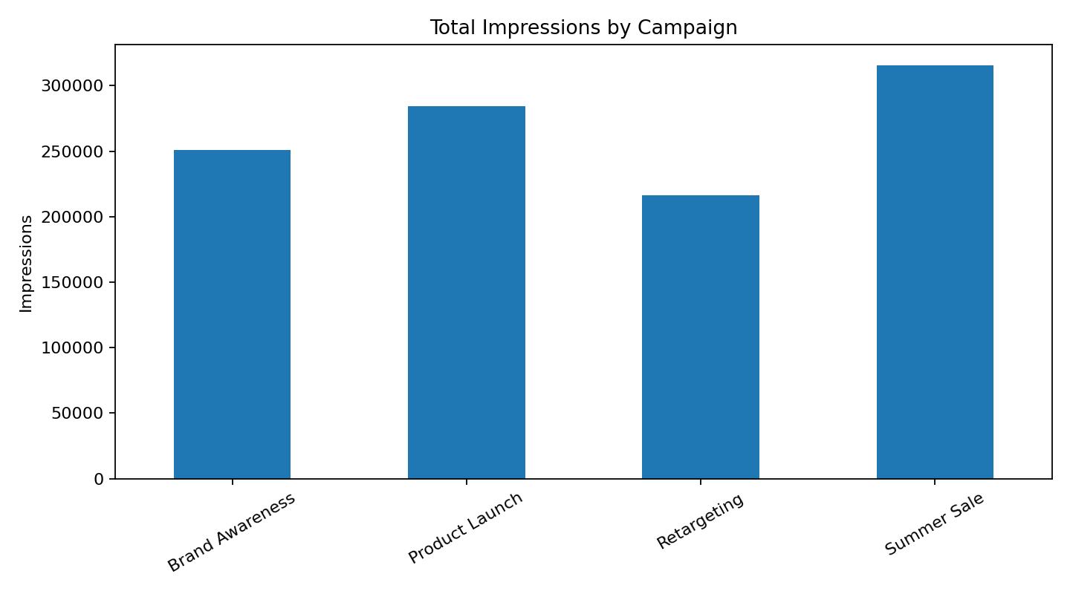
Figure: 9.1 Impressions by Campaign
Summer Sale has the highest simulated impression volume, while Retargeting has the lowest. Reach should be interpreted together with clicks and conversions.

9.2 Daily Click Trend
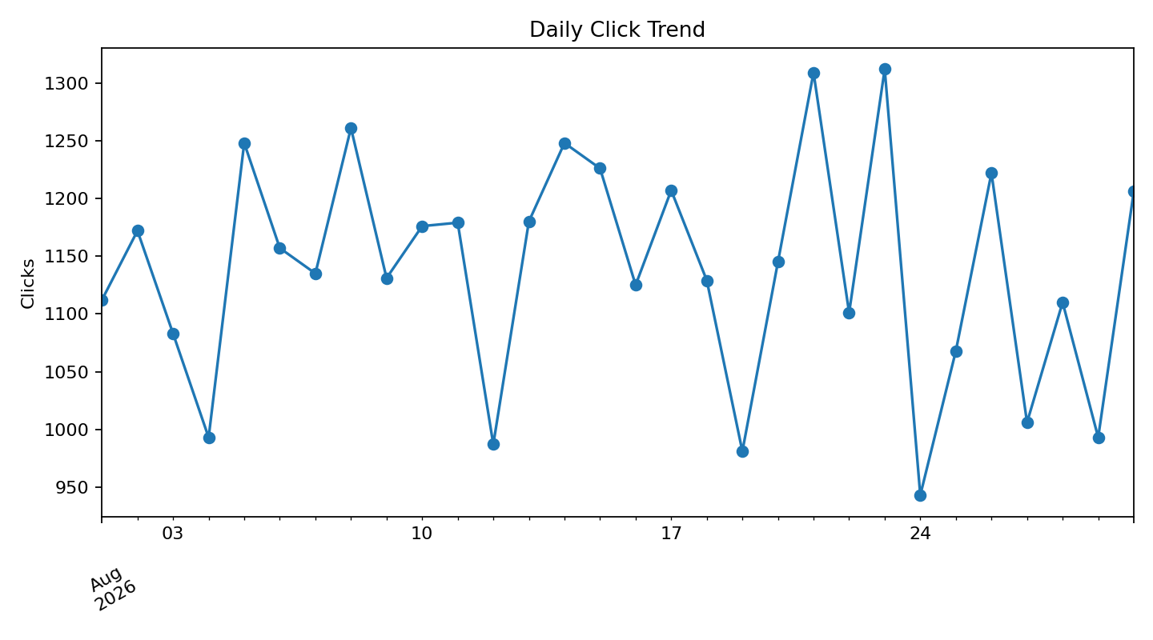
Figure: 9.2 Daily Click Trend
Daily clicks fluctuate. The highest simulated daily click volume occurs on 23 August 2026; the lowest occurs on 24 August 2026.

9.3 Conversions by Campaign
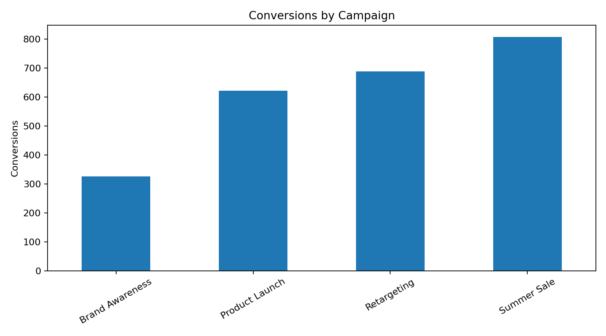
Figure: 9.3 Conversions by Campaign
Summer Sale has the highest total simulated conversions. Conversion counts reflect both traffic volume and post-click conversion rate.

9.4 CTR by Platform
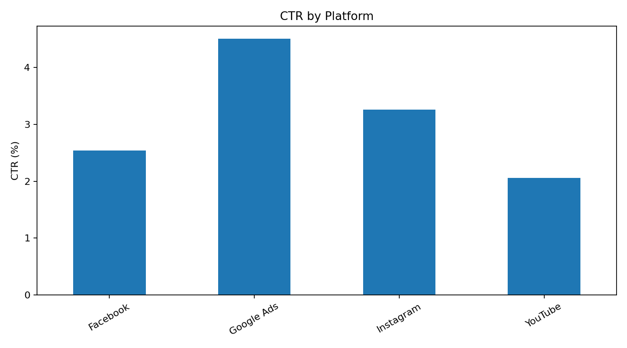
Figure: 9.4 CTR by Platform
Google Ads has the highest simulated CTR. CTR measures the share of impressions that generated clicks and does not by itself measure final business success.

9.5 Engagement Rate by Platform
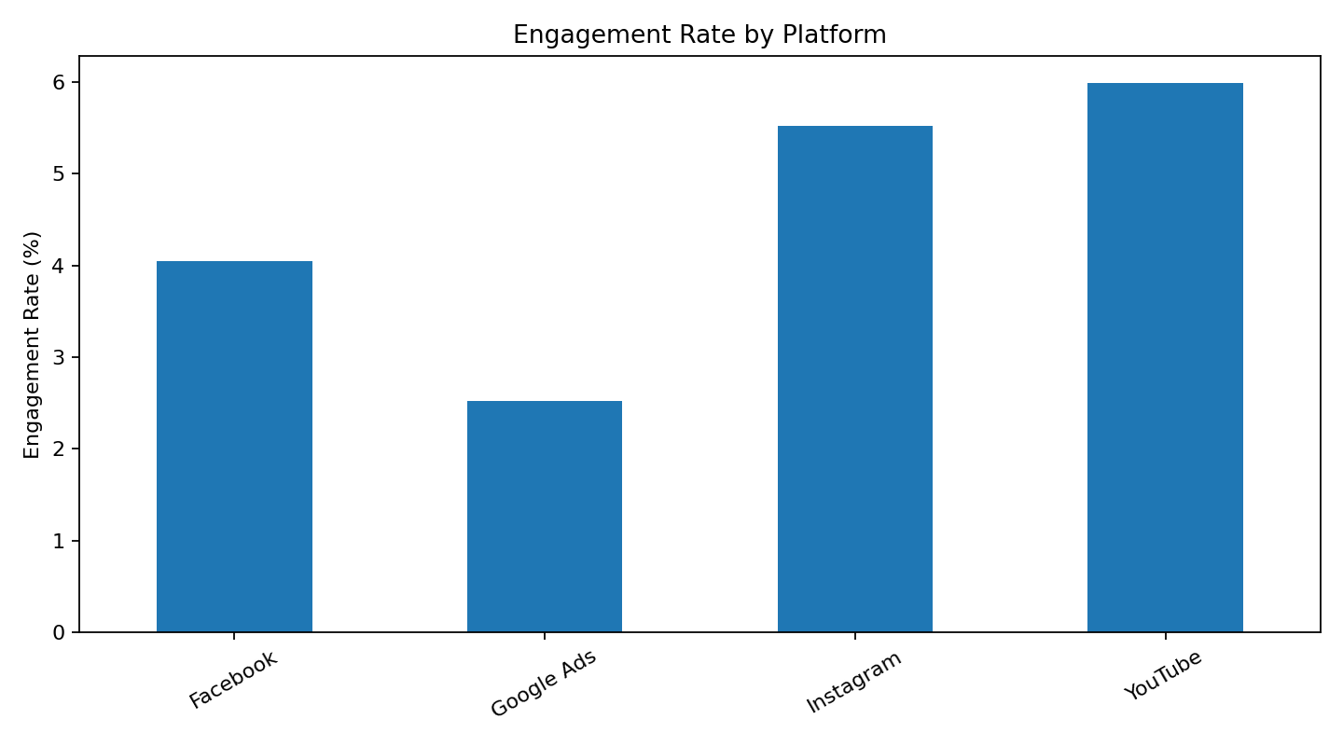
Figure: 9.5 Engagement Rate by Platform
YouTube has the highest simulated engagement rate. Real platform comparisons require consistent engagement definitions.

9.6 Daily Conversion Rate
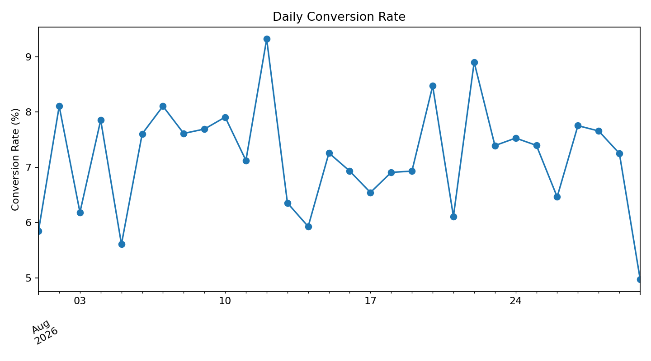
Figure: 9.6 Daily Conversion Rate
The daily conversion-rate chart shows variation in the proportion of clicks that become conversions. Large changes in real campaigns should be investigated against budget, audience, landing-page and tracking changes.

9.7 Correlation Matrix
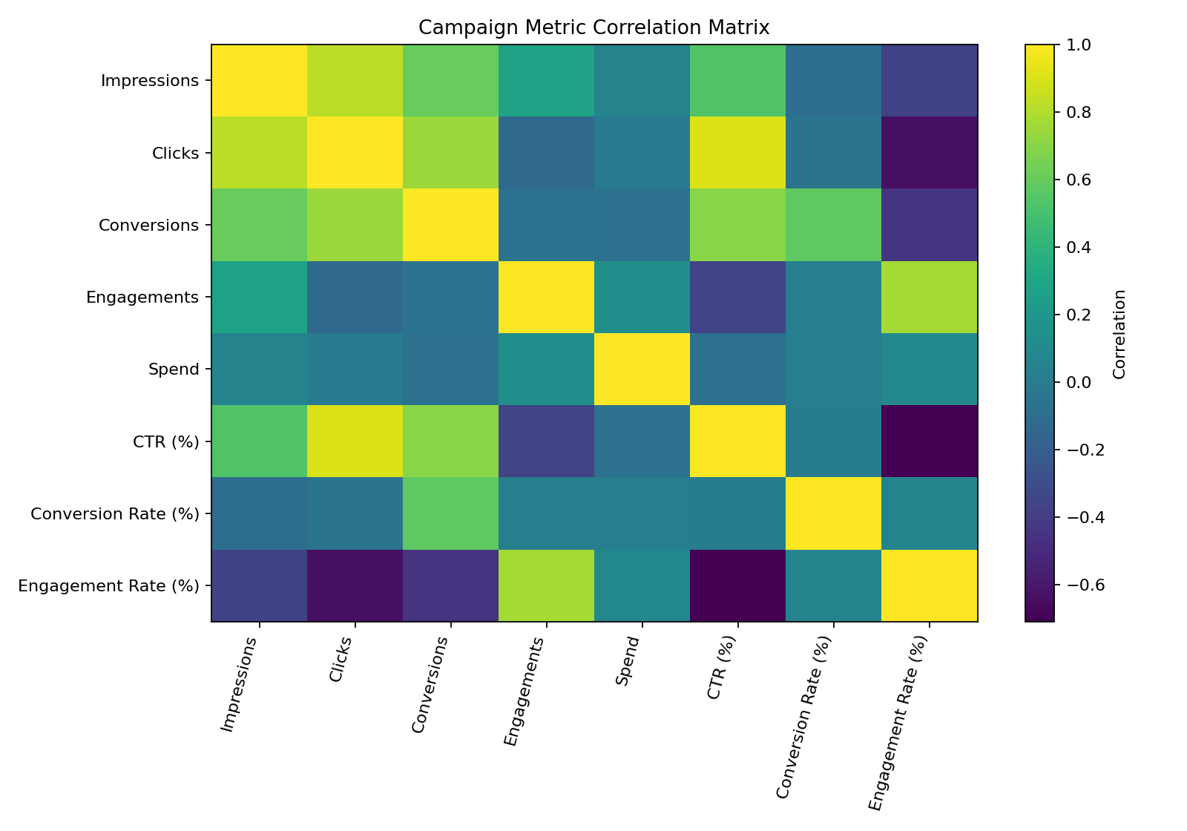
Figure: 9.7 Correlation Matrix
The correlation matrix is exploratory. Correlation does not prove causation, and volume metrics can naturally move together when campaign exposure changes.

10. Trends and Patterns
- Product Launch has the highest campaign-level CTR in the simulated data.
- Summer Sale records the largest number of simulated conversions.
- Google Ads has the highest platform-level CTR.
- YouTube has the highest engagement rate.
- Daily metrics vary, showing why time-based analysis is useful.
- Absolute totals should be interpreted alongside rates because high-volume campaigns can naturally produce larger counts.

11. Potential Anomalies and Investigation Points
Unusually high or low daily values are treated as investigation points rather than automatically being labelled errors. In a real campaign, an analyst would check budget changes, platform delivery, creative changes, audience targeting, website availability and tracking quality.

12. Key Insights
- Reach and engagement are different concepts.
- CTR describes click response, while conversion rate describes post-click outcomes.
- Platform comparisons require consistent metric definitions and time windows.
- Multiple KPIs provide a more complete picture than one metric.
- Time-series charts can reveal fluctuations hidden by overall totals.

13. Tools Used
- Python
- Pandas
- NumPy
- Matplotlib
- python-docx
- CSV
- GitHub

14. Limitations
- The dataset is simulated.
- No real advertising-platform API or customer-level data is used.
- Platform engagement definitions can differ.
- Correlation does not establish causation.
- The 30-day period is limited for seasonal analysis.
- Audience, creative, landing-page and attribution details are not included.

15. Conclusion
This project demonstrates a complete campaign-performance workflow from structured data through KPI calculation, visualization and interpretation. The analysis shows why campaign performance should be assessed using several related measures rather than a single number. The same workflow could be extended with verified platform data, audience and creative attributes, longer time periods and validated business outcomes.

16. Project Files
- campaign_data.csv – simulated dataset with calculated metrics.
- campaign_analysis.py – reusable analysis script.
- charts/ – seven visualizations.
- README.md – GitHub documentation.

17. Submission Note
Upload this Word document to the internship portal. Because the portal states that GitHub is compulsory for technical tasks, publish the project files in a GitHub repository and paste that repository URL into the submission form. The separate portal description should be at least 200 words and should accurately describe this project as a simulated campaign-performance analysis.

