

MR. SALAH AHMED SAEEDI (1395309)

MR. ABDUL HADI (1395308)

MR. MUHAMMAD MUSHARRAF

MR. SHAMEER BAKAR

PROJECT BY:

EXCELLENT

COACHING

SUBMITTED TO: MISS SAHIA JAMAL

­



Table of Contents

Acknowledgment 2

Synopsis 3

Problem Definition 4

Requirement 4

Scope 5

Design of the System 6

# **Acknowledgment**

I would like to acknowledge all those who have given me moral support and helped me make the project a success.

I wish to express my gratitude to the E-projects team at the Head Office, who guided and helped me. I would also like to express my gratitude to all the staff members of my center for not only providing me with the opportunity to work with them on this project but also for their support and encouragement throughout the process.

I also express my sincere gratitude to the E-projects team at the Aptech Head Office and my project guide at the organization, for her valuable guidance and support for the completion of this project.

And finally, I would like to offer many thanks to all my colleagues for their valuable suggestions and constructive feedback.

# **Synopsis**

Excellent Coaching is a Website that provides an educational institution designed to provide learning spaces and learning environments for the teaching of students under the direction of teachers.

Excellent Coaching manages all this by hiring professional, well-experienced Teachers who are able to convey their knowledge to students easily.

Excellent Coaching is beneficial in the following ways :

* Allows students to overcome their studies with fun and joy
* Allows students to quickly view the details of their desired courses and enroll
* Allows students to contact us for any further queries
* Will be visually appealing

# **Problem Definition**

Excellent Coaching is into business for more than a decade. They have been

advertising about their coaching classes through newspapers, pamphlets, and television.

Now with changing times, they have decided to go online as most of the students

Today are frequent users of the Internet. They have planned for a website with complete

details about the Coaching classes.

# **Requirement**

The Web site is to be created based on the following requirements.

1) The Home Page should have a suitable logo and a decent color combination.

2) Information should be neatly placed at a suitable location.

3) Various pages having information about different courses/subjects taught at

the classes, Faculty/Teachers complete information, and previous year

Success stories should be listed.

4) The site should display a menu that will contain the options for brief

introduction about the above-mentioned information, location/address of the

coaching classes and any other information if required.

5) The information should be categorized according to different subjects like if a

The user wants to see details of ‘Commerce’ then he clicks on a Link/button/menu

etc and he will see details of the course structure of commerce. Similarly, for

‘Mathematics’, ‘Languages’ and other subjects.

6) When a user selects any course stream, a complete list of subjects for that

course stream will be displayed.

7) Details of the courses should be displayed on the Web Page along with the

title and it should be stored in Individual Word documents which can be

downloaded or viewed by the User who wishes to see the same.

8) Price Lists for all courses should be available for download.

9) There should be a “Contact Us” page which will have the Address of the

Coaching Classes and the mail address which when clicked will invoke the

local mail client from where they can send an email.

# **Scope**

A paragraph is a series of sentences that are organized and coherent, and are all related to a single topic. Almost every piece of writing you do that is longer than a few sentences should be organized into paragraphs. This is because paragraphs show a reader where the subdivisions of an essay begin and end, and thus help the reader see the organization of the essay and grasp its main points.

Paragraphs can contain many different kinds of information. A paragraph could contain a series of brief examples or a single long illustration of a general point. It might describe a place, character, or process; narrate a series of events; compare or contrast two or more things; classify items into categories; or describe causes and effects. Regardless of the kind of information they contain, all paragraphs share certain characteristics. One of the most important of these is a topic sentence.

# **Design of the System**







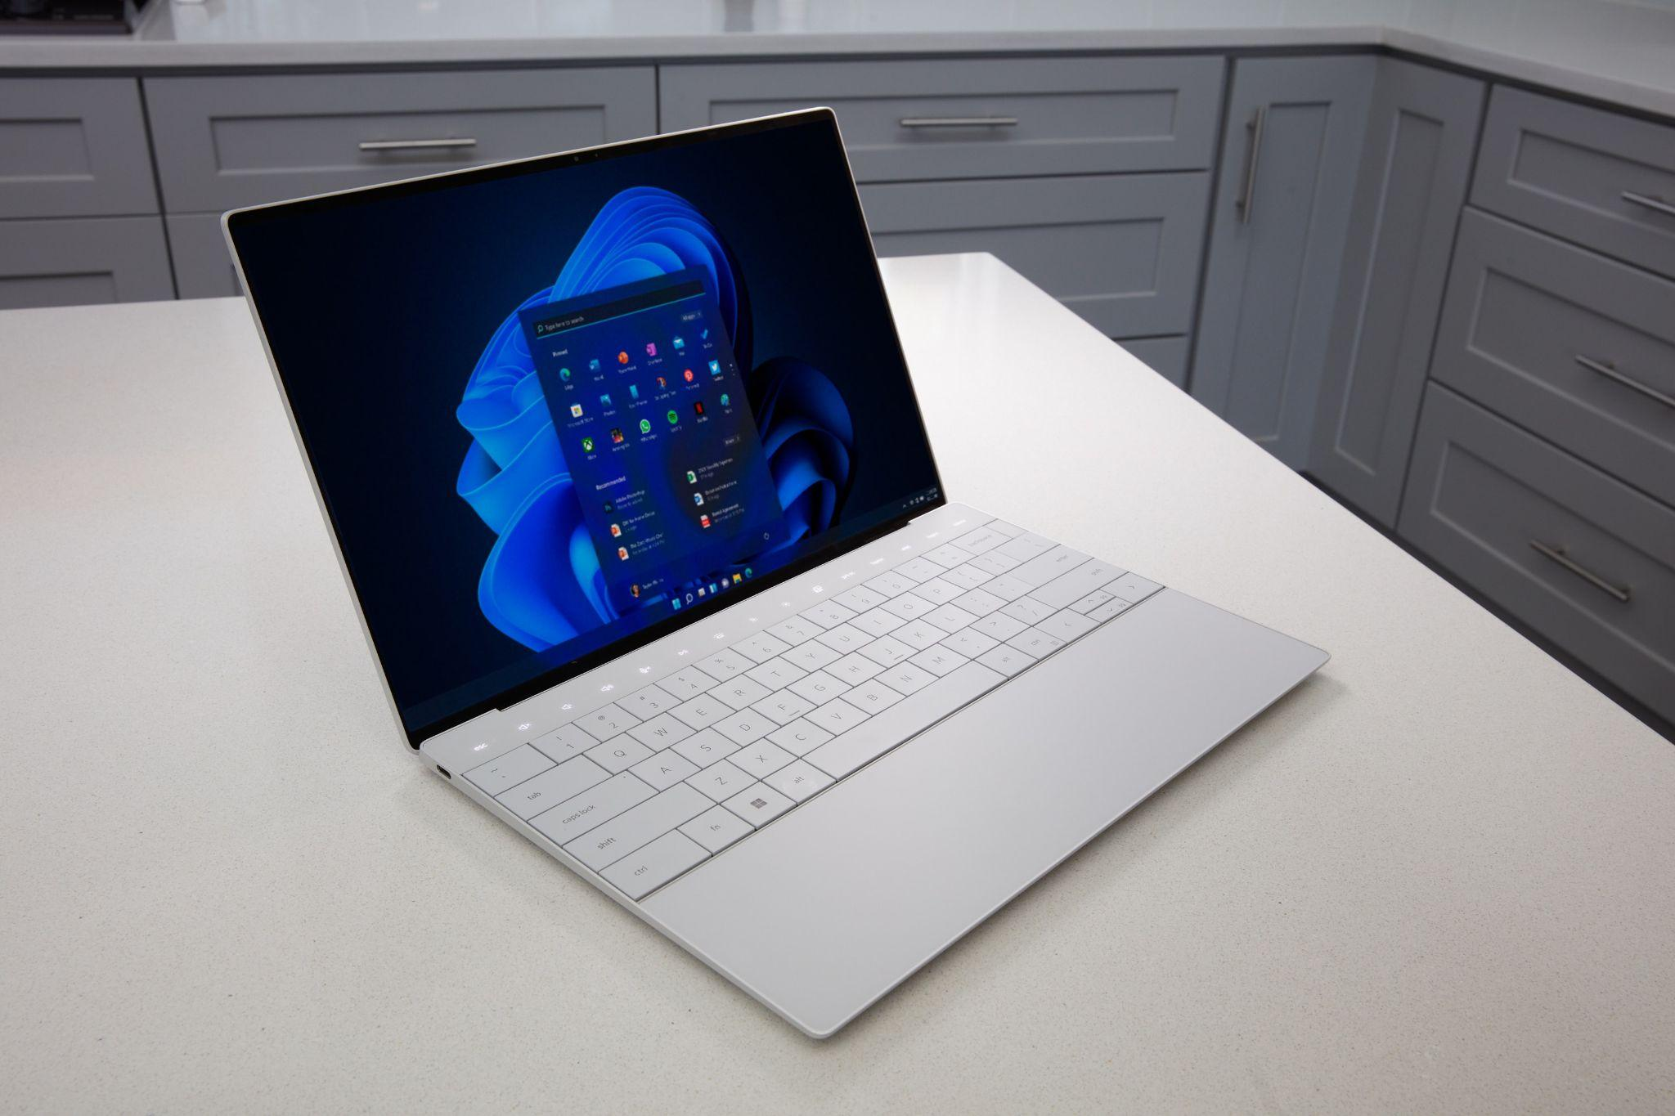

**Sitemap**

Home =====> Course ===>Pre-Medical

===>Pre-Engineer

===>Commerce

===>Computer

Home ====> Faculty ====> Faculty

Home ====>Success Stories ====>Success Stories

Home ====> Contact Us ====> Contact Us

Home ====> About Us ====> About Us

**Task Sheet**

|  |  |  |  |  |  |  |  |
| --- | --- | --- | --- | --- | --- | --- | --- |
| **Project Ref. No:** | | **Project Title:** | **Activity Plan By:** | **Date Of Preparation Of Activity Plan:** | | | |
| **Sr. No** | **Task** | **Actual Start Date** | **Actual Days** | **Team Mate Names** | **Status** |
| 1 | Home page design and coding | Excellent Coaching | Salah Ahmed Saeedi | 5/Nov/2022 | 30 days | Zohaib, Shahveer, Abdul-Hadi | Completed |
| 2 | Contact Us page | Excellent Coaching | Salah Ahmed Saeedi | 5/Nov/2022 | 30 days | Zohaib, Shahveer, Abdul-Hadi | Completed |
| 3 |  | Excellent Coaching | Salah Ahmed Saeedi | 5/Nov/2022 | 30 days | Zohaib, Shahveer, Abdul-Hadi | Completed |
| 4 |  | Excellent Coaching | Salah Ahmed Saeedi | 5/Nov/2022 | 30 days | Zohaib, Shahveer, Abdul-Hadi | Completed |

**Checklist of Validations**

|  |  |
| --- | --- |
| **Option** | **Validated** |
| Do all the text links lead to the appropriate Web pages? | Yes |
| Do all the image links lead to the appropriate Web pages? | Yes |
| Are all the images and links clearly visible on the page? | Yes |
| Is the Web page opening properly in all the tested Web browsers? | Yes |
| Are the animations loading well? | Yes |
| Is the Website responsive? | Yes |
| Is the Web page taking too long to load? | No |
| Is the navigation sequence correct through all the Web pages on the site? | Yes |
| Is the JavaScript code working as expected in all click events? | Yes |

**Submission Checklist**

|  |  |  |  |  |  |
| --- | --- | --- | --- | --- | --- |
| **Sr. No** | **Particulars** | **Yes** | **No** | **NA** | **Comments** |
| 1. | Are all users able to view images and links? | Yes | No |  |  |
| 2. | Have all components of the website been integrated and do they load as expected? | Yes | No |  |  |
| 3. | Is the portal user-friendly? | Yes | No |  |  |
| 4. | Is the website launching correctly in the browser? | Yes | No |  |  |
| 5. | Are the GUI contents devoid of spelling mistakes? | Yes | No |  |  |

**User Guide**

|  |  |  |
| --- | --- | --- |
| **No.** | **Items** | **Description** |
| **1.** | Operating System | Windows 8, 10 or higher |
| **2.** | Software | Bootstrap 5 or higher libraries from bootstrap.com, jQuery plugins and owl plugins, VS code or other HTML editor |