Network Details Visually

# Security

To accommodate for different roles in the system, user have two different types of access:

* User: has the authority to access network details information
* Administrator: in addition to user actions, admins can also use the ‘ping’ command from the interface.

The implementation of the security check is done through a text file that includes the username, password and the role of the login [user or admin]

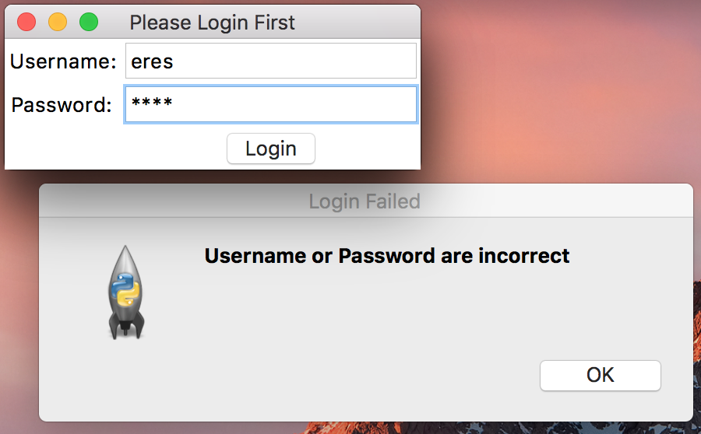

Failed login message

# User Interface:

User interface (UI) is the interaction between the user and the program with the focus on maximising usability; I opted for a clean user interface that utilises similar widgets to native desktop applications. Buttons get highlighted when clicked, textboxes have a surrounding frame and different colours to indicate the possibility to edit their content. An example for good user interface is the ‘ping’ command which includes an example entered in the box ‘127.0.0.1’ that points to the machine itself to test the ‘ping’ functionality and give the user an example to follow. Password textbox is encrypted with asterisks ‘*’.

To maximise user navigation and glance-ability, each window in the program has an appropriate header that lets the user know quickly the purpose of the window.

To keep the user efficiency high while using the system, I had opted from disabling inaccessible items, to hiding them from the user. Two examples are described:

1. At the first version of the software, I showed the user the ping button, but it was disabled until the user logs in as an admin. The current version hides the feature to begin with as to reduce user confusion.

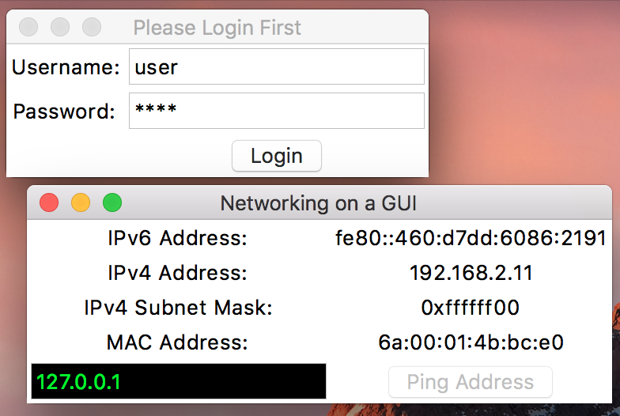

Old version: disables ping option if user is not authorised.

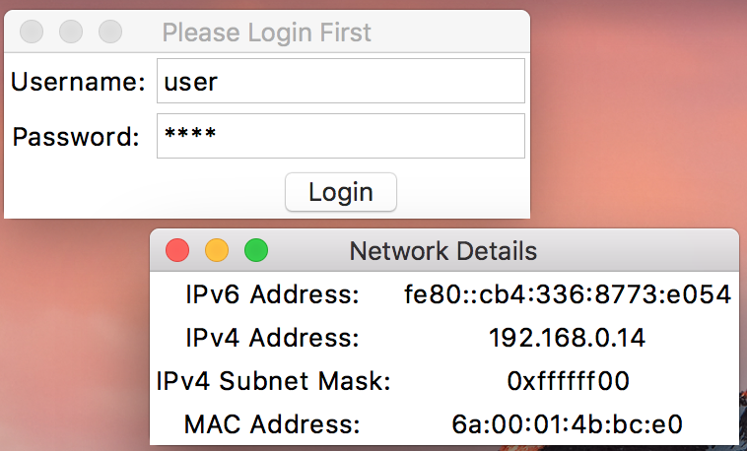

Current version: user doesn’t see disabled elements

1. If connection is not available to user, the login page is not displayed, but a message saying that ‘no active connection was found’ is displayed.

## Windows vs. MacOS

### Internet Information Command

Windows command to access the network information through the command-line is ‘ipconfig’ which stands for ‘**I**nternet **P**rotocol **Config**uration’ through ipconfig, it’s a console application where users can:

* Display TCP/IP data such as IPv4, IPv6 and MAC address
* Change Dynamic Host Configuration Protocol [DHCP] and Domain Name System [DNS] settings

Mac ‘ifconfig’ which is an abbreviation for ‘**I**nter**f**ace **P**rotocol’ and it’s a system utility which provides similar options to ‘ipconfig’

### Setting up network

Windows allows setting up networks via a setup wizard that is useful for inexperienced users or an interface allowing setting up with default options quickly. Another way is using an interface to modify the settings manually that allows using configuration files, but configuration files might not include all the data since some of networking information might be stored in the registry and cannot be exported.

MacOS on the other hand [which is a Unix-based system] allows configuring network settings via command-line which are simple enough for novice users to use. But allow multiple options for advanced users

While MacOS runs with much more expenses as a networking device, the stability it provides gives a high advantage for running networking tasks e.g. server. The main cause of stability is the targeted hardware which minimises the crashes caused by the interactions between hardware and kernel.

Windows on the other hand can run on multitude of devices and this allows to bring the cost of hardware down making it more valuable for cutting costs for enterprises trying to host on the network. Windows has the system roles as well, but can still hide files/options from the Administrator.

MacOS is based on Unix which was built with multi-users in mind; only admin/root users have access to change options and change sensitive configurations, while other users can only access specific options. This modularity brings more security to MacOS than Windows.

MacOS gets attacked much less than windows as well.

### Ping

One of the differences in MacOS vs Windows is the ping command; windows uses ‘-n’ option to specify the number of packets to end on the ping command (Microsoft), whereas MacOS uses ‘-c’ for the sent packet count. (Apple Inc, 2013)

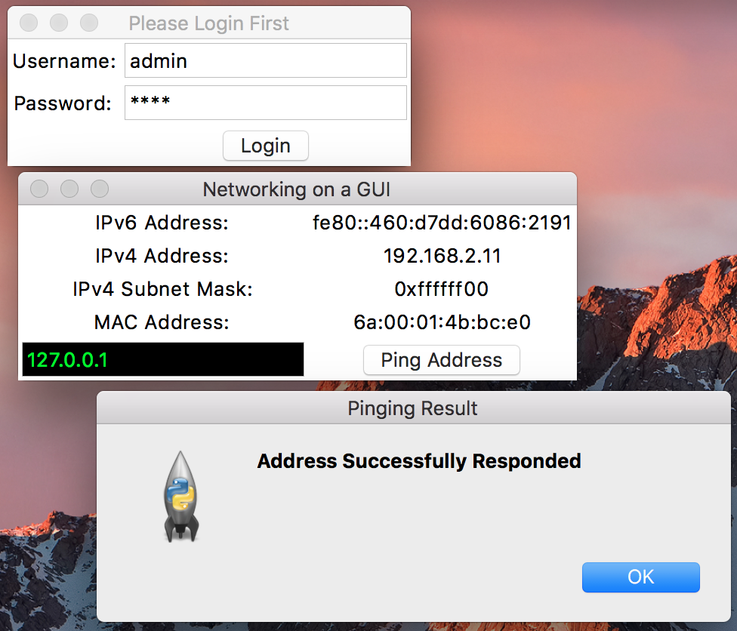

Ping option is available if user is ‘admin’

# Works Cited

Apple Inc. (2013, 3 29). *Mac OS X Manual.* Retrieved from MacOS Developers: https://developer.apple.com/legacy/library/documentation/Darwin/Reference/ManPages/man8/ping.8.html

Microsoft. (n.d.). *Windows XP Documentation Ping.* Retrieved from Microsoft Documentation: https://www.microsoft.com/resources/documentation/windows/xp/all/proddocs/en-us/ping.mspx?mfr=true