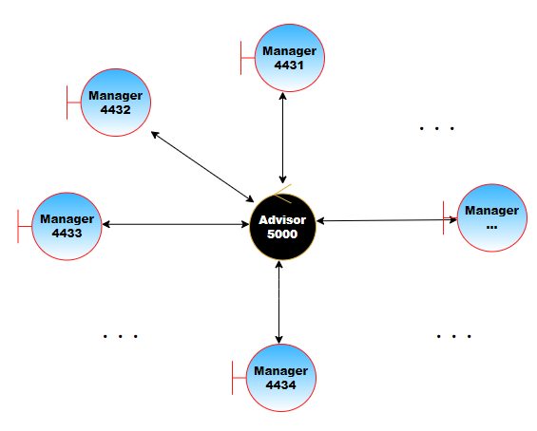

**Topology of the Blockchain Network**

**Demonstration**

**25/26**

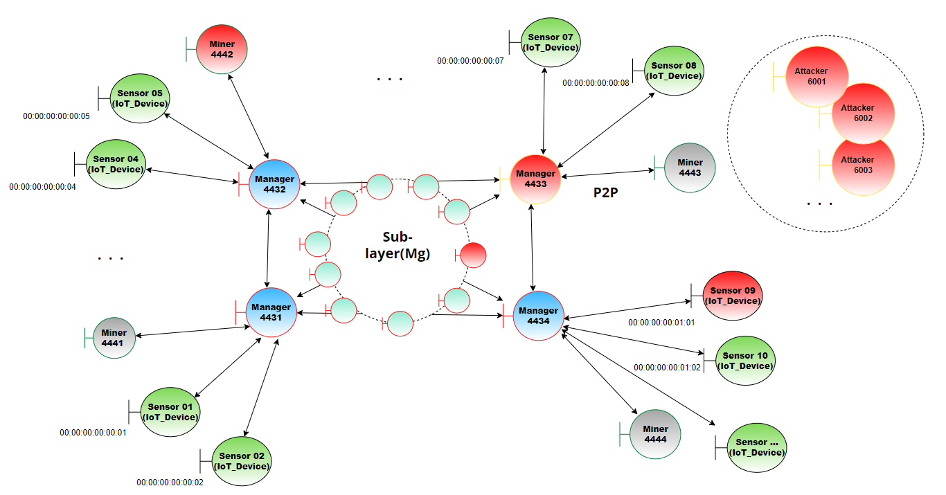

**In demonstration section we will see in details :**

* + **Networking Configuration**
    - The manager connection cases.
    - The registration and authentication scenarios.
* So in the same way we add 4 manger and 4 miners and at least for each one 2 Sensor
  + - Scenario of block creation.
* **I will add more block 🡺 we have 7 block in dominant BC**
  + **Spoofing and sniffing attacks**
    - Private key theft. 🡺 as we saw everything its hashed
    - Monitoring and get plaintext. 🡺 all data and block added its hashed
* **When we useing Wirshark**
  + **Threat against data integrity : (**VTA Cases**)**
    - The normal case.
    - Damaging the manager. 🡺 as attacker
    - Adding a malicious device. 🡺 for this attacker 🡺 as we saw the block its rejected and the number of Block still the same 🡺 now we will details about VTA case

*********************

Am use:

IoT devices **13**(00:00:00:00:00:1A) 🡪 Attackers1 (**6001**) & MinerPort = 4445

IoT devices **14**(00:00:00:00:00:1B) 🡪 Attackers2 (**6002**) & MinerPort = 4445

…

IoT devices **17**(00:00:00:00:00:1F) 🡪 Attackers1 (**6005**) & MinerPort = 4445

*********************

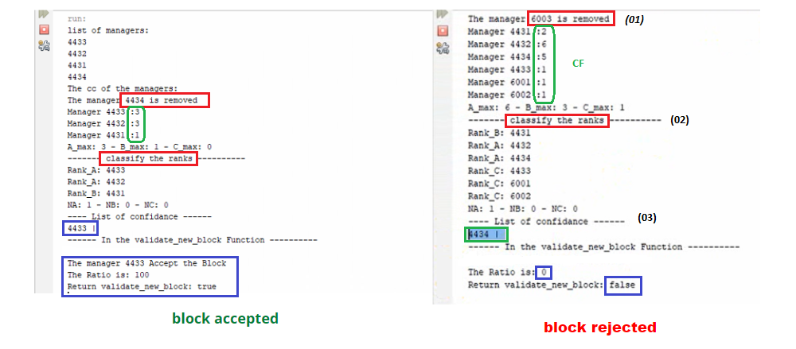

* + **Double spend attack (51% attack)**
    - Adding More malicious device (Nb of attacker > Nb of legitime managers). 🡺 and see the interaction from VTA process
      * We have 4 manager we need 5 attckers
* If we add 20 attacker or more 🡺 we stiil use the ligtime mangers using VTA process