Training a neural network using simulink and matlab gives logs that are idealistic.
By integrating ROS, it makes the situation more realistic and present the slightest error that can help with the problem of overfitting so we mimic a real worold scenario. Even though we are using during a simulatio sme simple integration method to represent the simulation, we are actually openning the door to use the base we built to be implemented on a real robot. So we can feed the neural enetwork with real log that are provided by a real expert

some of the technical problems hat we stumbled on :
- the communcation between ros2 and matlab
- choosing the right sampling time (Ts), communication time (tc), buffer, step size(h), simulation suration size, …
- getting the best performance out of the communication
- the problem of communication beween nodes due to the memory leak and other related problems
- how to automotize the parameters generation
- how to obtain the logs in a organized way that can be used for trace
- transfering the bags to csv files for matlab
- obtaining the desired information
- trying to impelement a neural network in C++ using pytorch
- launching ros2 outside of matlab from within matlab
- study the loss function to find the optimal one ( adam)

so why choose a neural netwrok as a controller instead of the normal controller.
The normal controller can be be computationally expensive, slow or enegy intensive. A well trained NN can gives us similar control results much faster and implemented on cheap and energy-efficient embeded platform. MPC is one of those controllers

concerning the way we proceed with the optimization of the neural network performance,
after we train the neural network we need to find good training sample that can gives the variety of response that will be performed by the NN controller now we search for the sample where the results does not satisfy the STL requirements, and this is called falsification and it is done by the breach tool, now we can explore those parameters with the real controller to obtain new valuable reslut that will be fed to the neural network

second objectif:
using 2 PID controller, one of them is fast but with oershoot, in the other hand we have one who is swithout ovweshoot but slow. Our objective here was focused on how to alternante between the 2 controllers in a way that will gives us the best performance, by that we mean that the system will be fast and without overshoot at the same time, and then by the results we obtain we can train a neural network that can replace those 2 controllers and be less cost on computation.
using the breach tool to make sure the pid is working well, I noticed that the evaluation value gave that robust even though it had a big overshoot and it was close to be out of the the criteria wanted
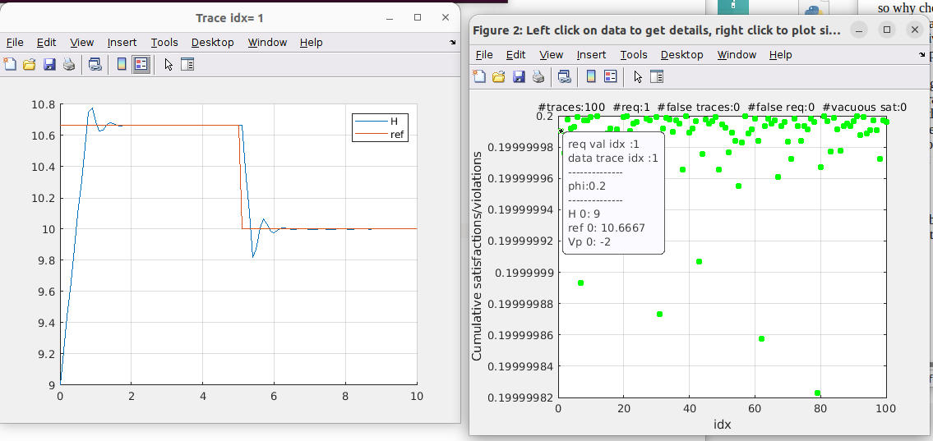
concerning the neural network structure and training :

the optimizer used during training , we used the ‘adam’ optimizer, adaptive momemnt estimation, it computes adaptive learning rates for each parameter and is know for its efficiency and good performance in deep leaning tasks
size of batch is 512
initital learning rate is set to 0.001
hardware used for training is the cpu
gradient threshold is 10
mx epochs is 40

those settings are intended to configure a stable and efficient training process

work done:
doing the simulation using ROS2 to siulate a real scenario. For example if I want to use it with gazeebo.
Started with the main code of the simulation where I was supposed to recreate the smulation done in simulink by one that is simulated in c++ using ROS2 . Since the simulation is not given by a real y=system or on gazeebo I had to do the intergration by Runge kutta. And I had to change to work on the intergration time and the time of communication . And this resulted on different behaviour because of the effect we have on the pc, such as the computational time and the continuity of the simulation , and the respons between nodes that puts a delay for the simulation to receive the commande from the controller ….

Idea that I tried

to generate different launch different simulation with different parameters each time I tried to create a script that each time generates a .yaml file for each parameter given but I face a problem with something that I don’t recall what it was .

