Data Analytics Program : DataScience Track

Capstone Project : Prediction of the Customer Churn Dataset
Student Name : Salahaldin Ahmad Hameed
Date : 13th Jan 2025

- Introduction

The Customer Churn dataset provides insights into the patterns and behaviors associated with customer attrition in a company. Customer churn occurs when individuals decide to terminate their relationship or subscription with a service provider, which is a critical concern for businesses as it directly affects their revenue, growth, and customer retention strategies. The dataset contains various features and indicators that help identify whether a customer has churned or not, allowing businesses to analyze and understand the underlying factors influencing customer retention.

- Problem

The primary challenge addressed by the Customer Churn dataset is the identification and prediction of customer churn. Companies need to determine which factors contribute to customer attrition and how they can intervene to retain at-risk customers. By leveraging this dataset, businesses aim to develop predictive models that can accurately forecast customer churn, enabling them to take proactive measures to improve customer satisfaction, enhance retention rates, and ultimately minimize revenue loss caused by customer turnover.

- Data set

Source : Kaggle
Link : Customer Churn Dataset

Attribute Information
- CustomerID: unique identifier for each customer
- Age: age of the customer
- Gender: gender of the customer (Male, Female)
- Tenure: duration of customer relationship in months
- Usage Frequency: average usage frequency of the service
- Support Calls: number of support calls made by the customer
- Payment Delay: average delay in payment (in days)
- Subscription Type: type of subscription the customer has (Standard, Premium, Basic)
- Contract Length: length of the customer’s contract (Annual, Quarterly, Monthly)
- Total Spend: total amount spent by the customer
- Last Interaction: time since the last interaction with the customer (in days)
- Churn: whether the customer has churned (1: churned, 0: not churned)

- Data visualization
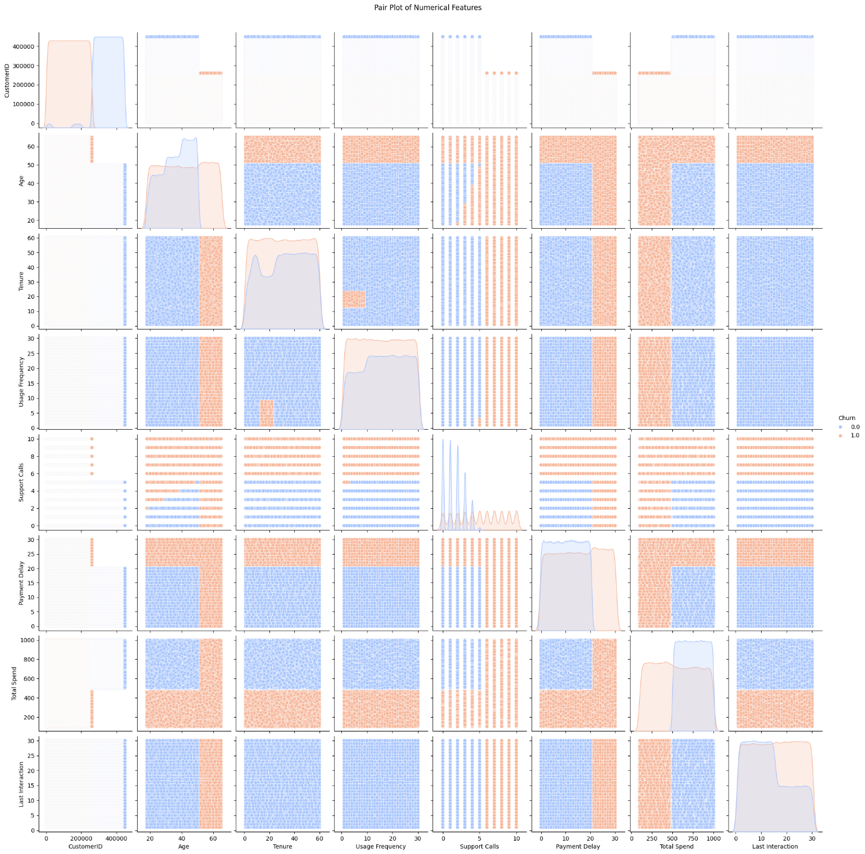

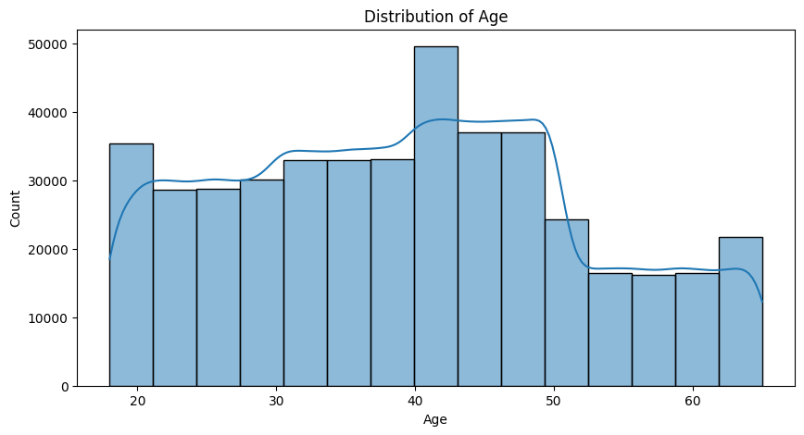

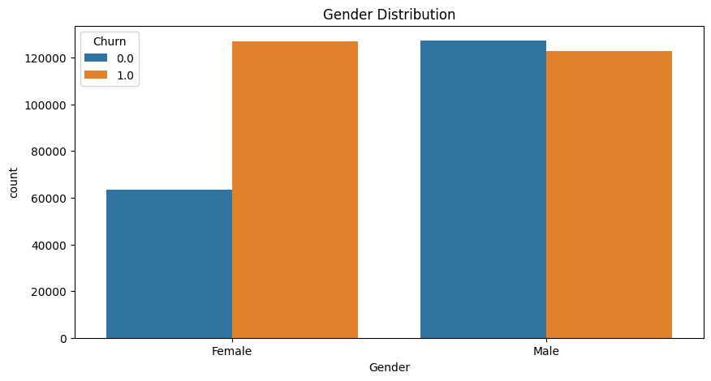

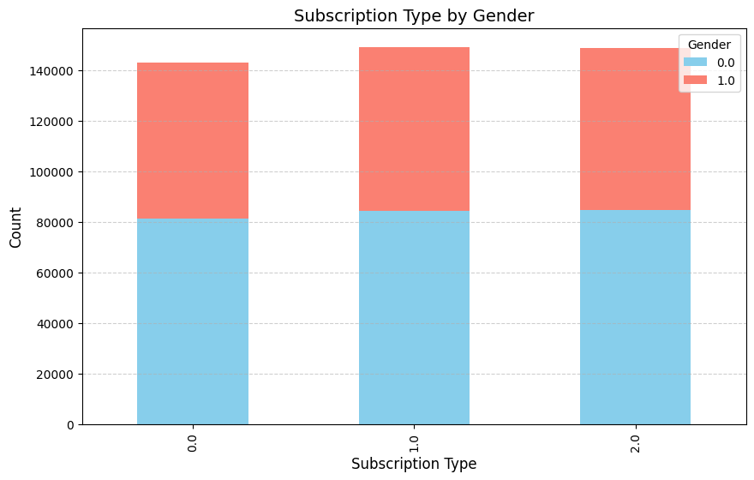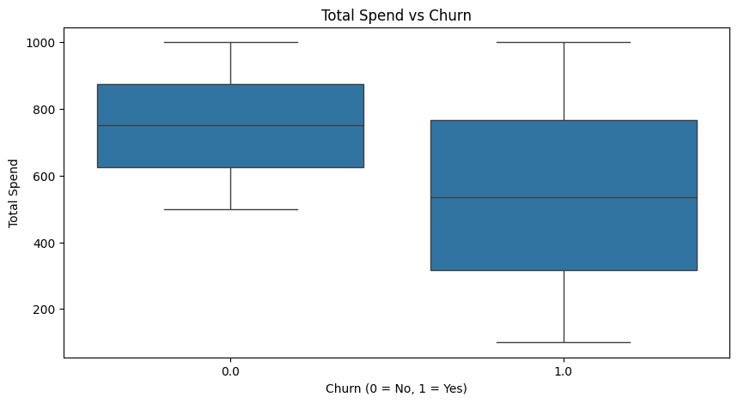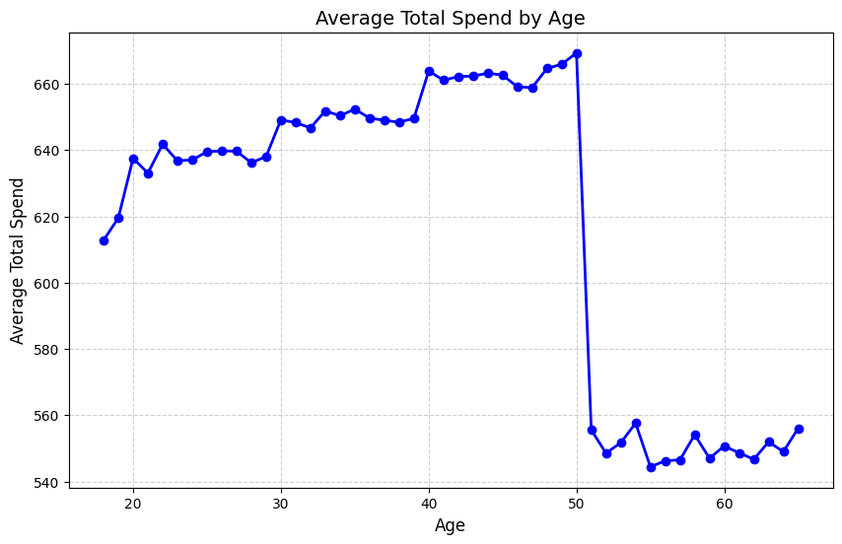

- Model
  - Linear Regression

K-nearest neighbors (KNN)

- Results
  - Mean Squared Error: 0.053858359328303435
  - R-squared: 0.780635232111961

  - Mean Squared Error: 0.010117164018283486
  - R-squared: 0.9587928528786492

- Github:
Repositorie in GitHub for model and code

