CascadableNbitComparator
Objectif
Ce composant est un comparateur de magnitude cascadable sur N bits. Il permet de comparer deux nombres en les découpant en tranches (slices) qui se chaînent, un peu comme on pose une comparaison à la main en commençant par les bits de poids faible.
🔌 Interface
Entrées
- a, b : Les deux nombres à comparer sur N bits (cette tranche)
- eq_in, gt_in, lt_in : Signaux provenant de la tranche de poids inférieur, indiquant le résultat de la comparaison des bits plus faibles
Sorties
- eq_out, gt_out, lt_out : Résultat combiné de cette tranche ET des tranches inférieures
Logique interne
1. Comparaison locale (eq_self, gt_self, lt_self)
Le composant compare d'abord les N bits de cette tranche uniquement :
vhdl
eq_self <= '1' quand a_unsigned = b_unsigned
gt_self <= '1' quand a_unsigned > b_unsigned
lt_self <= '1' quand a_unsigned < b_unsigned
2. Logique de cascade (le cœur du composant)
C'est là que la magie opère :
vhdl
eq_out <= eq_in AND eq_self
On est globalement égal seulement si cette tranche est égale ET toutes les tranches inférieures étaient égales.
vhdl
gt_out <= gt_self OR (eq_self AND gt_in)
On est globalement plus grand si :
- Soit cette tranche est strictement plus grande (prioritaire)
- Soit cette tranche est égale ET les bits inférieurs étaient plus grands
vhdl
lt_out <= lt_self OR (eq_self AND lt_in)

LIBRARY ieee;
USE ieee.std_logic_1164.ALL;
USE ieee.numeric_std.ALL;

ENTITY CascadableNbitComparator IS
GENERIC (
N : INTEGER := 8 -- width of this slice
);
PORT (
a, b : IN STD_LOGIC_VECTOR(N - 1 DOWNTO 0);
eq_in : IN STD_LOGIC; -- from lower bits
gt_in : IN STD_LOGIC;
lt_in : IN STD_LOGIC;
eq_out : OUT STD_LOGIC; -- to higher bits
gt_out : OUT STD_LOGIC;
lt_out : OUT STD_LOGIC
);
END CascadableNbitComparator;

ARCHITECTURE Behavioral OF CascadableNbitComparator IS
SIGNAL a_unsigned : unsigned(N - 1 DOWNTO 0);
SIGNAL b_unsigned : unsigned(N - 1 DOWNTO 0);
SIGNAL eq_self : STD_LOGIC;
SIGNAL gt_self : STD_LOGIC;
SIGNAL lt_self : STD_LOGIC;
BEGIN

a_unsigned <= unsigned(a);
b_unsigned <= unsigned(b);

-- Compare within this slice
eq_self <= '1' WHEN a_unsigned = b_unsigned ELSE
'0';
gt_self <= '1' WHEN a_unsigned > b_unsigned ELSE
'0';
lt_self <= '1' WHEN a_unsigned < b_unsigned ELSE
'0';

-- Cascade logic
eq_out <= eq_in AND eq_self; -- only equal if self-equal AND lower bits equal
gt_out <= gt_self OR (eq_self AND gt_in); -- greater if self-greater, or self-equal and lower greater
lt_out <= lt_self OR (eq_self AND lt_in); -- same for less

END Behavioral;
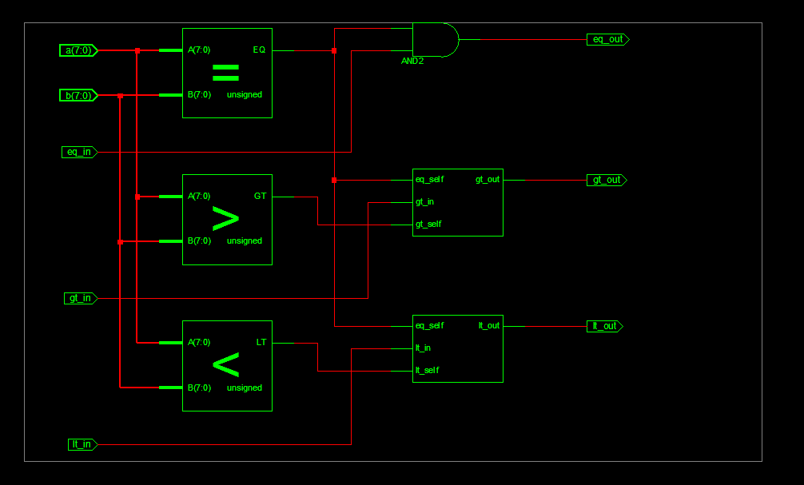

LIBRARY ieee;
USE ieee.std_logic_1164.ALL;
USE ieee.numeric_std.ALL;

ENTITY CascadableNbitComparator_tb IS
GENERIC (
N : INTEGER := 8
);
END CascadableNbitComparator_tb;

ARCHITECTURE Behavioral OF CascadableNbitComparator_tb IS

-- Component declaration
COMPONENT CascadableNbitComparator IS
GENERIC (
N : INTEGER := 8
);
PORT (
a, b : IN STD_LOGIC_VECTOR(N - 1 DOWNTO 0);
eq_in : IN STD_LOGIC;
gt_in : IN STD_LOGIC;
lt_in : IN STD_LOGIC;
eq_out : OUT STD_LOGIC;
gt_out : OUT STD_LOGIC;
lt_out : OUT STD_LOGIC
);
END COMPONENT;

-- Test signals
SIGNAL a_tb, b_tb : STD_LOGIC_VECTOR(N - 1 DOWNTO 0);
SIGNAL eq_in_tb : STD_LOGIC;
SIGNAL gt_in_tb : STD_LOGIC;
SIGNAL lt_in_tb : STD_LOGIC;
SIGNAL eq_out_tb : STD_LOGIC;
SIGNAL gt_out_tb : STD_LOGIC;
SIGNAL lt_out_tb : STD_LOGIC;

BEGIN

-- Unit Under Test instantiation
UUT : CascadableNbitComparator
GENERIC MAP(
N => N
)
PORT MAP(
a => a_tb,
b => b_tb,
eq_in => eq_in_tb,
gt_in => gt_in_tb,
lt_in => lt_in_tb,
eq_out => eq_out_tb,
gt_out => gt_out_tb,
lt_out => lt_out_tb
);

-- Stimulus process
stim_proc : PROCESS
BEGIN
-- Initialize inputs from lower bits (LSB slice: eq_in=1, others=0)
eq_in_tb <= '1';
gt_in_tb <= '0';
lt_in_tb <= '0';

-- Test 1: a = b (equal values)
a_tb <= std_logic_vector(to_unsigned(85, N));
b_tb <= std_logic_vector(to_unsigned(85, N));
WAIT FOR 10 ns;
ASSERT (eq_out_tb = '1' AND gt_out_tb = '0' AND lt_out_tb = '0')
REPORT "Test 1 (a=b) failed"
SEVERITY ERROR;

-- Test 2: a > b
a_tb <= std_logic_vector(to_unsigned(200, N));
b_tb <= std_logic_vector(to_unsigned(150, N));
WAIT FOR 10 ns;
ASSERT (eq_out_tb = '0' AND gt_out_tb = '1' AND lt_out_tb = '0')
REPORT "Test 2 (a>b) failed"
SEVERITY ERROR;

-- Test 3: a < b
a_tb <= std_logic_vector(to_unsigned(50, N));
b_tb <= std_logic_vector(to_unsigned(175, N));
WAIT FOR 10 ns;
ASSERT (eq_out_tb = '0' AND gt_out_tb = '0' AND lt_out_tb = '1')
REPORT "Test 3 (a<b) failed"
SEVERITY ERROR;

-- Test 4: a = b but lower bits say greater (cascade test)
a_tb <= std_logic_vector(to_unsigned(100, N));
b_tb <= std_logic_vector(to_unsigned(100, N));
eq_in_tb <= '1'; -- lower bits equal
gt_in_tb <= '1'; -- but lower slice had a>b
lt_in_tb <= '0';
WAIT FOR 10 ns;
ASSERT (eq_out_tb = '1' AND gt_out_tb = '1' AND lt_out_tb = '0')
REPORT "Test 4 (a=b, lower gt) failed"
SEVERITY ERROR;

-- Test 5: a = b but lower bits say less (cascade test)
a_tb <= std_logic_vector(to_unsigned(100, N));
b_tb <= std_logic_vector(to_unsigned(100, N));
eq_in_tb <= '1';
gt_in_tb <= '0';
lt_in_tb <= '1'; -- lower slice had a<b
WAIT FOR 10 ns;
ASSERT (eq_out_tb = '1' AND gt_out_tb = '0' AND lt_out_tb = '1')
REPORT "Test 5 (a=b, lower lt) failed"
SEVERITY ERROR;

-- Test 6: a > b regardless of lower bits
a_tb <= std_logic_vector(to_unsigned(255, N));
b_tb <= std_logic_vector(to_unsigned(128, N));
eq_in_tb <= '1';
gt_in_tb <= '1';
lt_in_tb <= '1';
WAIT FOR 10 ns;
ASSERT (eq_out_tb = '0' AND gt_out_tb = '1' AND lt_out_tb = '0')
REPORT "Test 6 (a>b, irrelevant lower) failed"
SEVERITY ERROR;

-- Test 7: Boundary values (max vs min for 8-bit)
a_tb <= (OTHERS => '1'); -- 255
b_tb <= (OTHERS => '0'); -- 0
eq_in_tb <= '1';
gt_in_tb <= '0';
lt_in_tb <= '0';
WAIT FOR 10 ns;
ASSERT (eq_out_tb = '0' AND gt_out_tb = '1' AND lt_out_tb = '0')
REPORT "Test 7 (boundary max>min) failed"
SEVERITY ERROR;

-- Test 8: Test with all zeros and eq_in=0 (should propagate)
a_tb <= (OTHERS => '0');
b_tb <= (OTHERS => '0');
eq_in_tb <= '0';
gt_in_tb <= '0';
lt_in_tb <= '0';
WAIT FOR 10 ns;
ASSERT (eq_out_tb = '0' AND gt_out_tb = '0' AND lt_out_tb = '0')
REPORT "Test 8 (all zeros, eq_in=0) failed"
SEVERITY ERROR;

-- End of simulation
REPORT "All tests completed successfully"
SEVERITY NOTE;
WAIT;
END PROCESS;

END Behavioral;
