

Summer Internship 2026
Final Project – Team B
Project Report

Prepared by:
Adel Ahmed Elduhemy
Andrew Hany
Ayham Sameh Ahmed
Basem Walid Talaat Mansour
Mohamed Essam
Mohamed Morsi Genena
Omar Ahmed Abdelaty Abdo
Salah Mohamed Salah
Salem Mamdouh Salem

GitHub Repo:
https://github.com/Salahmohameds/documind-ai/

Contents
Introduction 6
Responsibilities 6
Design and Architecture 7
1. Upload and Index (async) 8
2. Query and Answer (sync) 9
3. Architecture Diagram 9
Cloud Infrastructure 10
1. Network Architecture 10
2. IaC Terraform Module Architecture 11
3. OKE Cluster and Workload Architecture 12
4. IAM and Workload Identity 13
5. Cloud-Level Observability 14
6. CI/CD Pipeline Architecture 14
7. Security Posture and Policy Enforcement 15
API Gateway 16
1. Role and Scope 16
2. Service Surface 17
3. Authentication 17
4. Request Proxying and Identity Propagation 18
5. Question and Answer Orchestration 18
Document Service 19
1. Role and Scope 19
2. Service Surface 20
3. Upload Validation and Storage 20
4. Handoff to Processing 21
5. Reprocessing 22
Processing Service 22
1. Role and Scope 23
2. Entry Point and Health 23
3. Consuming the Queue 23
4. Pipeline Order 23
5. Calling Downstream Services 24
6. Storage Backend 25
7. Current Implementation Notes 25
Search Service 25
1. Role and Scope 26
2. Search Service Overview and API 26
3. Indexing and Retrieval Pipeline 26
4. Document Chunking 27
5. Embeddings and Vector Representation 28
6. PostgreSQL and pgvector Storage 28
7. Problem Discovered: Incomplete Vector Search Results 28
8. Diagnosing the Root Cause 29
9. The Fix 29
10. What wasn’t changed 30
11. Testing and Verification 30
12. JWT Authentication 30
13. Observability Integration 30
AI Service 31
1. Scope and Ownership 31
2. Service Surface 32
3. Provider Abstraction 33
3.1 Why the offline backend is the default 33
3.2 OCI Generative AI — region finding 34
4. Deterministic Analysis Engines 35
4.1 Risk scoring is not asked of a model 35
4.2 Extraction cannot invent a value 35
5. Reliability Engineering 36
5.1 Two failures found by measurement, not by review 37
6. Security — PII Redaction at the Egress Boundary 37
6.1 A misclassification reported by the team 38
7. Evaluation and Results 39
8. Defects Found and Fixed 40
9. Integration Guide 41
Observability & Monitoring 42
1. Observability Design 42
2. Request Correlation 44
3. Structured Logging 44
4. Distributed Tracing 45
5. Metrics Collection 45
7. Integration Guide 46
Frontend Engineering 48
1. Technology Stack 48
2. Design System 48
3. Application Screens 49
4. Component Architecture 50
5. Authentication and Session Handling 50
6. Asynchronous Processing in the Interface 51
7. Environment-Driven Configuration 51
8. Containerisation and Health Probes 51
Quality Assurance Strategy 52
1. Approach 52
2. Test Levels and Tooling 52
3. Test Environments and Portability 52
4. Test Case Catalogue 53
Test Data Engineering 54
1. The Problem 54
2. Generating Documents From Ground Truth 54
3. Reproducibility 55
4. Verification of the Ground Truth 55
5. Edge Case Fixtures 56
Continuous Integration 57
1. The Gap 57
2. Auto-Discovering Test Suites 57
3. Outcome 57
Contract and Integration Testing 58
1. Coverage by Service 58
2. Assertions That Earn Their Place 58
3. Test Isolation 59
End-to-End Verification 60
1. The Complete Path 60
2. Measured Behaviour 60
3. Failure and Recovery Testing 61
Result Accuracy Measurement 62
1. Method 62
2. Results 62
3. A Measurement Artefact Worth Recording 62
4. Classification Discrimination 62
Performance Engineering 63
1. Scenario Suite 63
2. Measuring Asynchronous Work 63
3. Cluster Metrics Collection 64
4. Comparison Protocol 64
Post-Deployment Smoke Testing 65
1. Design Constraints 65
2. Checks 65

Introduction
This technical report presents DocuMind AI, a document intelligence platform built to process contracts and other business documents: classifying them, extracting structured fields, scoring contract risk, and answering natural-language questions about their contents with page-level citations. This report documents the system's architecture, implementation, and verification, covering the platform end to end, from cloud infrastructure through to the individual microservices, the observability stack, and the testing strategy used to validate the result.
Beyond the architecture, this report also documents observability, monitoring and the quality assurance approach taken across the project: test levels and tooling, test data engineering, continuous integration, contract and integration testing, end-to-end verification, result accuracy measurement, performance engineering, and post-deployment smoke testing. Several chapters additionally document specific defects discovered during development, how each was diagnosed, and how it was resolved, reflecting the project's engineering process rather than only its final state.

Responsibilities
# | Role | Name
1 | OCI Infrastructure Lead & Deployment Engineer | Salah Mohamed Salah
2 | OCI Infrastructure Lead & IaC Lead | Ayham Sameh Ahmed
3 | Frontend, QA & Performance Engineer | Salem Mamdouh Salem
4 | Backend Lead | Adel Ahmed Elduhemy
5 | AI Engineer | Andrew Hany
6 | Distributed Systems Engineer | Basem Walid Talaat
7 | Data & Search Engineer | Mohamed Essam
8 | Security & DevSecOps Engineer | Omar Ahmed Abdelaty
9 | Observability, Monitoring & Documentation Lead | Mohamed Morsi Genena

Design and Architecture
The platform is built as a set of independently deployable microservices. An API Gateway handles authentication, routing, and rate limiting for every incoming request. A Document Service manages upload, metadata, and storage. A Processing Service consumes uploaded documents asynchronously, coordinating classification, extraction, and PII detection. An AI Service is the platform's sole point of contact with the underlying generative model, providing classification, extraction, risk scoring, embeddings, summarization, and cited answers to every other service that needs them. A Search Service owns document chunking, vector storage, and retrieval, and supplies the AI Service with the context it needs to answer a question.
These services interact through two distinct flows:
- An asynchronous upload and indexing pipeline that runs when a document is added.
- A synchronous query pipeline, orchestrated by the API Gateway, that runs when a user asks a question.

1. Upload and Index (async)
When a document is uploaded, the API Gateway hands it to the Document Service, which stores it and queues a background job rather than processing it inline. The Processing Service consumes that job and calls the AI Service and Search Service independently, generating embeddings and indexing them so the document becomes searchable.
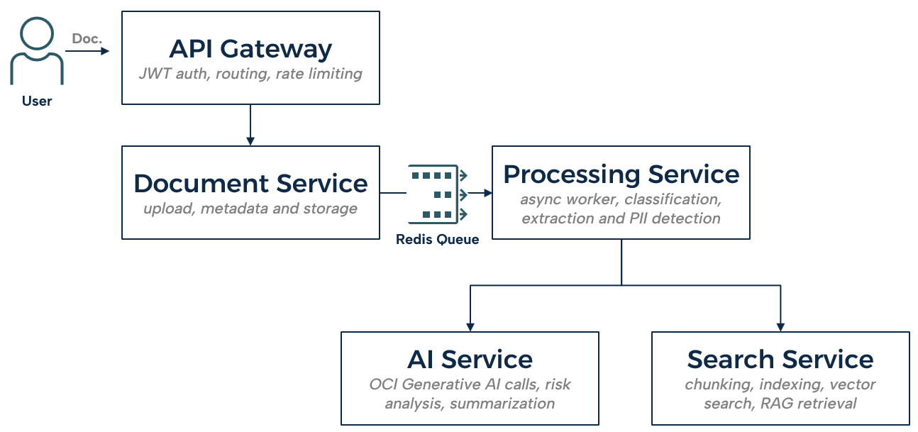

2. Query and Answer (sync)
When a user asks a question, the API Gateway orchestrates the response directly: it first queries the Search Service for the most relevant indexed chunks, then passes those chunks to the AI Service to generate a cited answer, which it returns to the client. Search and AI never call each other; the Gateway sequences both.
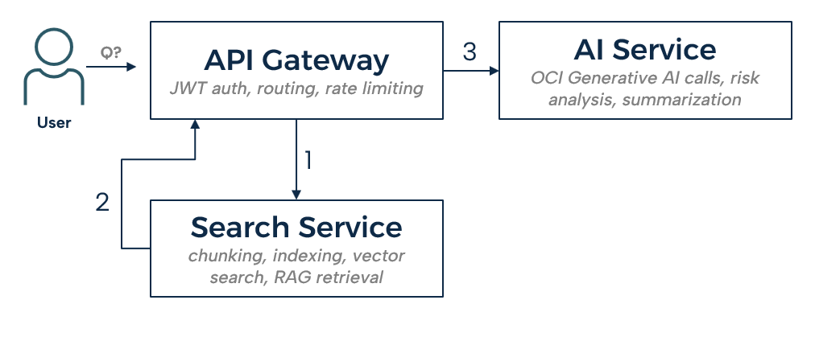

3. Architecture Diagram
The following architecture diagram shows the full cloud-native deployment of DocuMind on Oracle Cloud Infrastructure, end to end: how a user request enters through the internet gateway and load balancer, flows into an OKE Kubernetes cluster running the five microservices with autoscaling, how those services reach a private database and Redis queue, and how supporting regional services (Vault, OCIR, IAM, Object Storage, Generative AI, monitoring) tie in around them. It also lays out the network security boundaries (VCN, public/private subnets, NSGs), and the CI/CD pipeline that builds, scans, and deploys everything into that infrastructure.

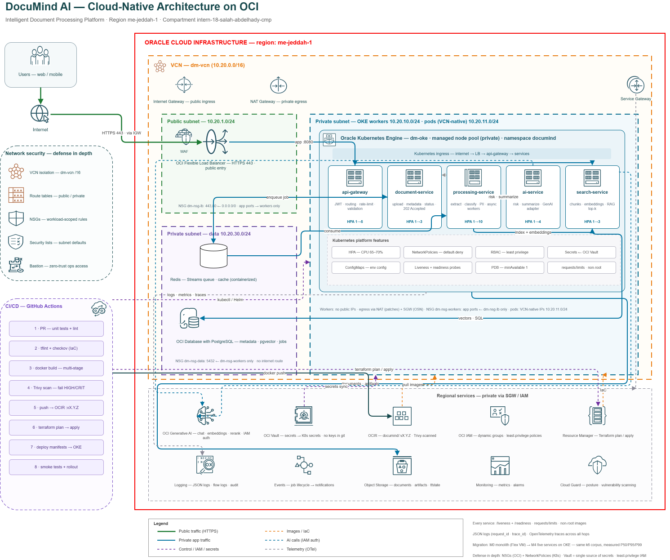

API Gateway
This chapter documents the api-gateway microservice: the single authenticated entry point for the platform. It terminates every client JWT, derives trusted identity from it, and is the only service a client talks to directly. It holds no business logic of its own; its job is authentication, routing, and orchestration, not analysis.

1. Role and Scope
Every request from a client passes through the gateway first, and no other service is reachable from outside the cluster. The gateway performs three jobs and only three: it verifies who is calling, it decides where the request should go, and, in exactly one case, it sequences two downstream calls into a single response. It does not classify, extract, score risk, chunk a document, or generate an embedding. Those responsibilities are deliberately kept out of the gateway so that a change to how a document is analyzed never requires touching the one component every request depends on.

2. Service Surface
Endpoint group | Purpose | Downstream service
auth | Login and registration | Internal, in-memory
documents | Proxies document upload, listing, status, deletion | document-service
search | Proxies indexing and query calls | search-service
/embed,  /classify,  /extract,  /analysis/risk,  /summarize,  /pii,  /answer | Verbatim proxy to individual AI capabilities | ai-service
POST /qa | Gateway-orchestrated question answering | search-service, then ai-service
health | Liveness and readiness | Internal

3. Authentication
The gateway issues and verifies JSON Web Tokens using HS256, with the signing secret read from configuration rather than hardcoded. Each token carries a subject, a role claim, and a 24 hour expiry; there is no issuer or audience claim, since the gateway is currently the only party that both issues and consumes its own tokens. A dependency enforces authentication on every protected route by reading the bearer token from the request, decoding it, and rejecting the request if it is missing, expired, or invalid.
The user store backing login is in-memory, seeded with a single administrator account whose password is stored bcrypt-hashed rather than in plaintext. This is an interim implementation rather than a production design: restarting the gateway resets the user list to that one seeded account, and there is no persistence layer behind it yet. This is recorded here as the current state of the system rather than glossed over, since it directly affects how the platform should be read during a demo versus how it should be read as production-ready.

4. Request Proxying and Identity Propagation
Individual AI capabilities are exposed by proxying verbatim to the AI Service: embedding, classification, extraction, risk analysis, summarization, PII detection, and answer generation each have a corresponding gateway route that forwards the request body unchanged and returns the downstream response unchanged. This keeps the gateway from needing to know anything about the shape of an AI request or response; if the AI Service's contract changes, the gateway does not need to change with it.
The proxy layer is built on a single pooled HTTP client shared across requests rather than opening a new connection per call, which keeps latency down under load. Before a request leaves the gateway, any identity headers a client attempts to set on their own request are stripped, and the gateway injects its own derived X-User-Email and X-User-Role headers instead. This exists specifically to prevent a caller from spoofing another user's identity by simply setting a header themselves; every downstream service trusts these headers precisely because only the gateway is permitted to set them. The request identifier used for tracing is propagated the same way, so a single request can be followed across every service it touches.

5. Question and Answer Orchestration
The one route where the gateway does more than proxy is /qa. Rather than forwarding a question to a single downstream service, the gateway calls the Search Service first to retrieve the top matching chunks for the question, reshapes that response into the format the AI Service expects, and then calls the AI Service to generate a cited answer from those chunks. The Search Service and AI Service never call each other directly in this flow; the gateway is the sole orchestrator of the sequence, and it is the only place in the platform where the output of one AI-adjacent service is deliberately fed into another before a client sees a result.
This placement was a deliberate choice rather than a default: keeping the orchestration at the gateway, rather than inside either Search Service or AI Service, keeps both of those services simpler and independently callable. A client that only needs retrieval can call search directly; a client that already has the relevant text can call /answer directly without going through search at all. Only the combined question-answering experience needs both, and only the gateway needs to know that.

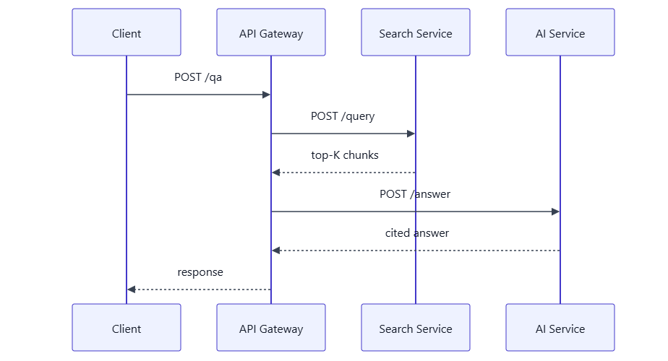

Document Service
This chapter documents the document-service microservice: the owner of document ingestion. It validates and persists every uploaded file, tracks its lifecycle, and hands off further work by publishing to a queue. It performs no analysis of a document's contents itself; that responsibility belongs entirely to the processing service and the services it calls.

1. Role and Scope
The document service is the first stop for an uploaded file after the gateway, and its responsibility ends where analysis begins. It answers three questions and three only: is this file valid, where is it stored, and what is its current status. It does not read a document's text, does not classify it, and does not decide what should happen to it beyond publishing that it has arrived.

2. Service Surface
Endpoint | Method | Purpose
/documents | POST | Accepts an upload, validates it, stores it, publishes a processing job
/documents | GET | Paginated listing of stored documents
/documents/{id} | GET | Retrieve a single document's record
/documents/{id}/status | GET | Retrieve a document's current lifecycle status
/documents | DELETE | Bulk delete by a list of document identifiers
/documents/reprocess | POST | Bulk re-queue previously uploaded documents
Upload is intentionally asynchronous at the API boundary: the endpoint returns as soon as the file is validated and stored, without waiting for classification, extraction, embedding, or indexing to complete. A client polls the status endpoint, or is notified separately, to learn when processing has actually finished.

3. Upload Validation and Storage
An uploaded file is written to a temporary location first and only made visible under its final name once the write succeeds in full, so that a reader can never observe a partially written file. Before a file is accepted, its path is checked to reject any attempt at path traversal, its leading bytes are checked against the expected PDF signature rather than trusting the client-supplied content type, and a fixed size limit is enforced. A file that fails any of these checks is rejected before it is ever written to storage, not cleaned up afterward.
The service is designed to support more than one storage backend, selected by configuration; a local filesystem backend is the one currently backing every deployment path exercised in this project. An object-storage backend is declared in configuration as a supported option, and treating it as fully implemented and verified would overstate the current state of the service; it is recorded here as declared rather than confirmed, so the report does not claim more than what has actually been exercised.

4. Handoff to Processing
Once a file is stored, the service publishes an event to a Redis stream, carrying the document identifier, its storage location, filename, content type, size, and upload timestamp.
{
"event_version": 1,
"document_id": "d3f1...",
"storage_key": "documents/d3f1....pdf",
"filename": "contract.pdf",
"content_type": "application/pdf",
"size_bytes": 482113,
"uploaded_at": "2026-08-27T10:15:00Z"
}
This publish is the only connection between the document service and the processing service; there is no direct HTTP call between them in either direction. Decoupling the two services through a queue rather than a direct call means a slow or temporarily unavailable processing service cannot block an upload, and multiple processing workers can consume from the same stream without the document service needing to know how many exist.
If the publish itself fails, the document is not left in an ambiguous "uploaded but maybe queued" state: it is explicitly marked failed, and a retryable error is returned to the caller so the failure is visible immediately rather than discovered later when a status check never advances.

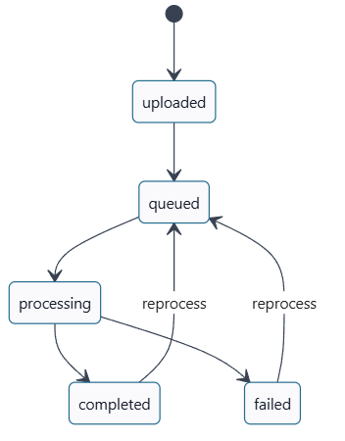

5. Reprocessing
A document can be reset to a queued state and the identical event contract republished, without requiring a new file upload. This exists so that a document affected by a defect in a downstream analysis step, rather than a defect in the document itself, can be re-run through the pipeline once the underlying issue is fixed, instead of asking a user to upload the same file again.
The document service does not verify the caller's identity itself; there is no JWT dependency on its routes. It trusts that the gateway has already authenticated the request before it arrives, which is consistent with the platform's overall boundary that only the gateway is exposed to clients directly, but it does mean the document service, taken in isolation and called directly rather than through the gateway, would not enforce authentication on its own.

Processing Service
This chapter documents the processing-service microservice: the background worker that drives a document through the analysis pipeline. It has no public API for a client to call; it is triggered entirely by messages on a queue, and it calls out to the AI Service and Search Service to do the actual work rather than performing any analysis itself.

1. Role and Scope
The processing service owns orchestration, not intelligence. It decides what needs to happen to a document and in what order, and it calls the AI Service and Search Service to make each step happen. No prompt, no model call, and no scoring rule lives in this service; if a result looks wrong, the defect is in the service that produced it, not in the worker that requested it.

2. Entry Point and Health
The service exposes only a liveness and readiness endpoint over HTTP; there is no route a client or another service calls directly to submit work. Every unit of work arrives as a message already sitting on a queue, which means the processing service's throughput scales by adding worker instances that all read from the same stream, rather than by scaling an API.

3. Consuming the Queue
The service consumes the same Redis stream the document service publishes to, using a consumer group so that work can be shared across multiple worker instances without two workers processing the same document twice. A message that goes unacknowledged for longer than a configured idle threshold is reclaimed from whichever worker was holding it and made available again, so a worker that crashes mid-job does not silently strand that job forever.
A message is only acknowledged once its outcome has been committed to the database, never on receipt. This ordering matters: if acknowledgment happened on receipt, a crash between receiving a message and finishing the work would lose that job permanently, since the queue would have no record that it was never completed. A message that fails repeatedly beyond a configured attempt limit is moved to a separate dead-letter stream with a bounded size, rather than being retried indefinitely or dropped silently.

4. Pipeline Order
Stage | Category | Failure behaviour
Fetch document | Spine | Fails the entire job
Extract text | Spine | Fails the entire job
Classify | Enrichment | Recorded and skipped on failure
Extract fields | Enrichment | Recorded and skipped on failure
Summarize | Enrichment | Recorded and skipped on failure
Risk analysis | Enrichment | Recorded and skipped on failure
Index | Spine | Fails the entire job
Classification runs first, since its result steers how the remaining enrichment stages are interpreted. Extraction, summarization, and risk analysis then run concurrently rather than sequentially, since none of the three depends on another's output, which shortens the total time a document spends in the pipeline. The distinction between spine and enrichment stages exists so that a failure in one optional analysis step, for example a summarization call that times out, does not discard the classification and extraction results that already succeeded; a document only fails outright if a step it cannot function without, like fetching or indexing, fails.

The following mermaid diagram shows a simple illustration of the process.
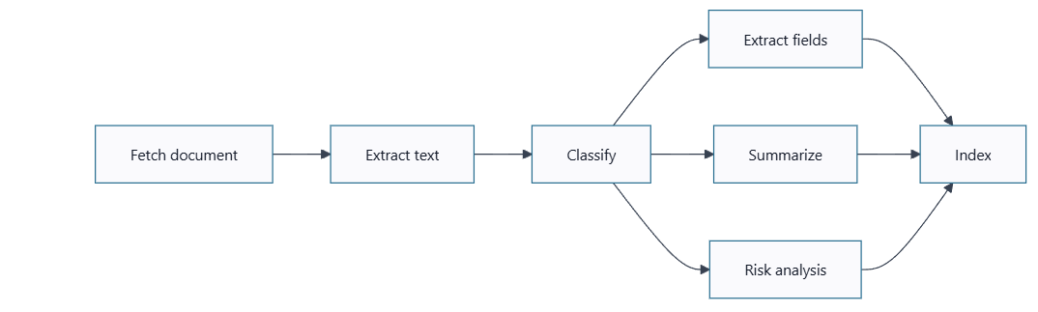

5. Calling Downstream Services
Calls to the AI Service and Search Service go through a shared client rather than ad hoc HTTP calls scattered through the pipeline code. That client maintains a bounded connection pool per dependency, a circuit breaker per dependency so a struggling service is not hammered with repeated requests once it has already started failing, and bounded retries with backoff. An overall deadline caps the entire retry chain, not just a single attempt, so a dependency that is slow rather than fully down cannot stall a worker indefinitely while still technically "retrying." Retries are limited to failures that are safe to retry, such as rate limiting or a server error; a client error is treated as final and is not retried.

6. Storage Backend
The service supports both a local filesystem backend and OCI Object Storage, selected by configuration. The OCI backend supports three authentication modes depending on where the service is running: workload identity in production, instance principal authentication as an alternative cluster-level credential, and a local configuration file for development outside the cluster. Unlike the document service, the OCI Object Storage backend here is a real, implemented backend rather than a declared-but-unconfirmed option, since the processing service is the component that reads a document's content directly during the fetch stage of the pipeline.

7. Current Implementation Notes
The processing service has no HTTP API for clients and no direct exposure to end users; every interaction with it happens through the queue, which is a deliberate consequence of its role rather than a limitation. Authentication to downstream services is conditional: a bearer token is only attached to a call to the AI Service or Search Service if one is configured; where authentication is disabled downstream for local development, no header is sent, and the two configurations are expected to match rather than silently diverge.

Search Service
This chapter documents the search-service microservice: the component that executes semantic search/RAG retrieval layer for DocuMind AI. Chunks document text, embeds it, stores vectors, and serves top-K similarity search so the AI Service can generate cited answers.

1. Role and Scope
This service is responsible for the turning document content into searchable chunks and vectors, storing them, and retrieving the most relevant chunks when a query is received. The following sections describe what was implemented, why each piece was needed, a retrieval problem that was investigated and fixed, and how the fix was verified.

2. Search Service Overview and API
The Search Service is a FastAPI microservice responsible for indexing document content and retrieving relevant document chunks using vector similarity search. It exposes the following endpoints:

Endpoint | Purpose
POST /index | Receives document content and indexes it for later retrieval.
POST /query | Receives a question and performs semantic retrieval over the indexed chunks.
GET /search | Provides a convenient query interface for search and testing.
GET /liveness | Checks whether the service process is alive.
GET /readiness | Checks whether the service is ready and its embedding/vector-store dependencies can initialize.

The service also validates JWT tokens for its protected endpoints; this is described in more detail in Section 12.

3. Indexing and Retrieval Pipeline
Within the service, the indexing and retrieval flow were implemented as two complementary pipelines rather than a single search-everything operation.
On the indexing side, document content is chunked, each chunk is turned into a
384-dimensional embedding, and the chunk together with its embedding is stored in PostgreSQL using the pgvector extension.
On the query side, an incoming question is converted into a query embedding, that embedding is compared against the stored chunk embeddings using vector similarity search, and the top-K most relevant chunks are returned to the consuming layer, such as the RAG/AI service.
The value of this pipeline is that it turns free-form document text into something a downstream AI layer can actually query semantically, chunk by chunk, instead of only matching exact keywords.

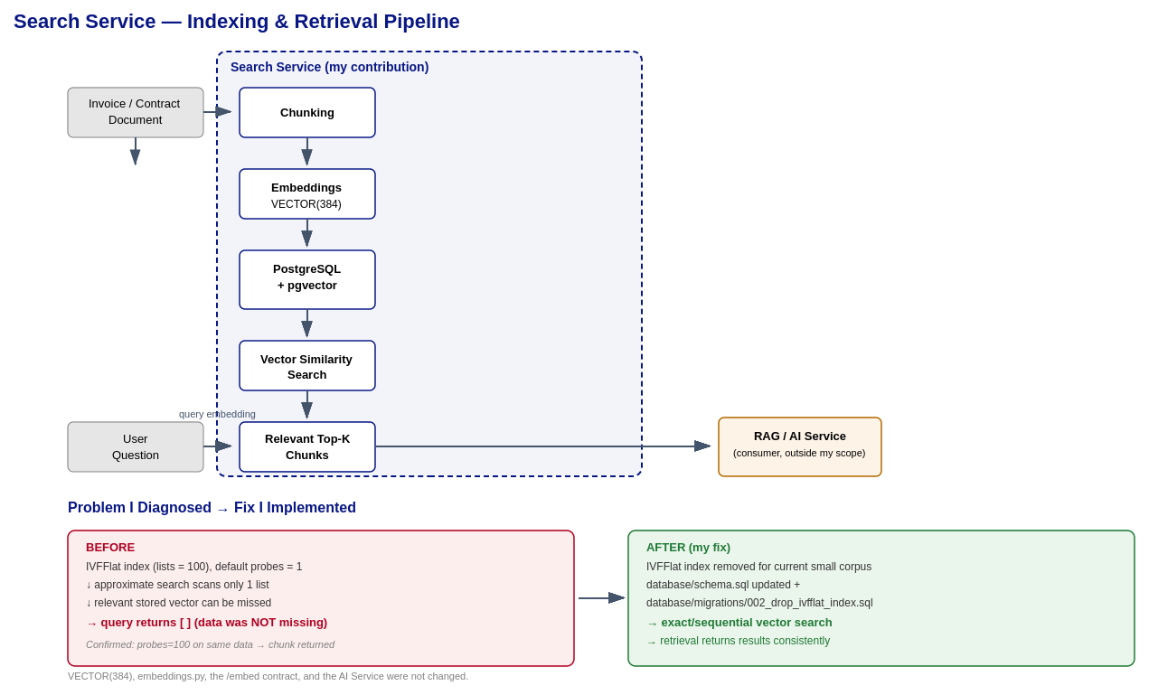

4. Document Chunking
The Search Service works with document chunks rather than treating an entire document as a single searchable unit. Large documents are divided into smaller pieces, and each chunk can be independently represented by its own embedding. This matters for two reasons: first, similarity search can then identify the specific part of a document that is actually relevant to a query, instead of returning an entire document indiscriminately; second, the retrieved chunks are a better fit for downstream RAG/AI processing, since the AI layer receives focused, relevant context rather than an oversized block of text.

5. Embeddings and Vector Representation
The Search Service represents text as numerical vectors, i.e. embeddings, so that semantically similar content can be found even when the wording differs. The current vector dimension used throughout the service and the database is 384, stored as VECTOR(384). The flow is: text is converted into a numerical vector representation, that vector is stored in PostgreSQL, and at query time the incoming question is converted into a vector in the same space so that similarity between vectors can be used to retrieve relevant chunks.
The service supports configurable embedding backends. For local plumbing and integration testing, mock embeddings were used. To be explicit about what that does and does not demonstrate: mock embeddings allow verifying that indexing, storage, retrieval, and service integration all worked correctly end to end, they are not evidence of semantic search quality, and we are not presenting them as an AI-quality benchmark.

6. PostgreSQL and pgvector Storage
The Search Service uses PostgreSQL with the pgvector extension to store document and chunk information together, including document ID, chunk ID, chunk index, page, text, embedding, and timestamps. The embedding column uses VECTOR(384). I used this design because it keeps document metadata and vector representations in the same place and lets the service perform vector similarity retrieval directly from PostgreSQL, without needing a separate vector database.

7. Problem Discovered: Incomplete Vector Search Results
A major contribution was the identifying and fixing of a particular retrieval problem.
The PostgreSQL vector search initially used an IVFFlat index configured with
lists = 100 (idx_document_chunks_embedding). IVFFlat is an approximate nearest-neighbor index, and with the default setting of ivfflat.probes = 1, a query only scans a limited number of lists. Because the corpus being tested was small, the list containing the relevant vector was not always the list being scanned.
The critical point is that the data itself was never the problem: indexing succeeded and the rows were stored correctly in PostgreSQL. Despite that, a vector search could return an empty result, [], even though a relevant chunk existed in the database. This mattered for the overall system because if vector retrieval returns no relevant chunks, the downstream RAG/AI layer receives no useful context and can behave as if the document contains no relevant information at all, even though it does.

8. Diagnosing the Root Cause
We avoided simply removing the index without understanding why it was failing. To diagnose the issue, We tested same query embedding against the same stored data while varying the search configuration:

Configuration | Observed Result
Default: probes = 1 | Search returned [] (no results)
Higher setting: probes = 100 | The relevant chunk was returned

This comparison was the key evidence in the investigation. It demonstrated, in order, that the document had been indexed, that the vector existed in PostgreSQL, that the query embedding itself was valid, and that the retrieval failure was caused specifically by the approximate IVFFlat search configuration, not by missing or corrupted data.

9. The Fix
After confirming the root cause, the database configuration was changed rather than the embedding or AI layers. We removed the IVFFlat index creation from database/schema.sql, and added a migration, 002_drop_ivfflat_index.sql, to remove the existing IVFFlat index from any database that already had it created.
database/schema.sql
-removed: CREATE INDEX idx_document_chunks_embedding USING ivfflat (lists = 100)

database/migrations/002_drop_ivfflat_index.sql
-drops idx_document_chunks_embedding on databases created before the fix
The design decision behind this fix is that, for the current small corpus, exact/sequential vector search is more reliable than an approximate index that was not correctly tuned for that data size. This is not a claim that IVFFlat is inherently a bad choice: approximate indexing can become valuable again once the dataset grows large enough that exact search becomes too slow, provided the index parameters (such as lists and probes) are chosen appropriately for that larger dataset.

10. What wasn’t changed
The fix was intentionally narrow in scope. We did not change VECTOR(384), embeddings.py, the embedding contract, the /embed contract, the AI Service, or the local/memory embedding backends. The fix targeted the vector retrieval and index configuration specifically, rather than the embedding system or the AI layer, because the diagnosis had already shown that those components were working correctly.

11. Testing and Verification
Before the fix, IVFFlat with lists = 100 and the default probes = 1 could return [] on a query even though relevant data existed. After removing the IVFFlat index, the same kind of query used exact/sequential vector search and returned results consistently. The PostgreSQL vector-store end-to-end verification confirmed that documents could be indexed, chunks were stored, similarity queries could be executed, and results were returned correctly after the fix. Search Service unit tests also passed.

12. JWT Authentication
The Search Service includes JWT authentication middleware for its protected endpoints. The health endpoints, /liveness and /readiness, are public. All other endpoints require a Bearer token unless authentication is explicitly disabled for local development or testing. For local integration testing, the Search Service and the API Gateway share the same development JWT secret, dev-secret-change-me, so that tokens issued by the Gateway can be validated by the Search Service. This is strictly a development/local value and should not be treated as, or mistaken for, a production secret.

13. Observability Integration
The Search Service was integrated into the project's shared observability setup, under /monitoring/app_instrumentation/. This integration includes OpenTelemetry tracing, Prometheus metrics, structured JSON logging, request/trace ID correlation, FastAPI instrumentation, and a /metrics endpoint. The service uses the shared configure_logging(), setup_tracing(), setup_metrics(), and RequestIDMiddleware functions.
The purpose of this work is to make the Search Service visible in the monitoring stack, so engineers can understand incoming requests, request duration, service behavior, traces, and errors/logs, and can correlate a given request with its corresponding trace. The Kubernetes deployment configuration also integrates the service with the OpenTelemetry Collector and ServiceMonitor-based metrics collection.

AI Service
This chapter documents the ai-service microservice: the sole owner of the platform's model access. It holds the OCI Generative AI credentials and token budget, and is the only service permitted to call the underlying model. Every AI-driven capability in the platform (classification, extraction, risk scoring, embeddings, summarization, PII detection, and cited Q&A) goes through it. It does not chunk, store, or retrieve anything; it turns text in, returns a result, and forgets it.

1. Scope and Ownership
Two ownership boundaries in the team's role definitions were ambiguous and would have produced a merge conflict. Both were resolved in writing before any integration code was written and recorded in docs/architecture/ai-service-contract.md.
Owned by ai-service | Deliberately NOT owned
The model client, provider credentials and the token budget | Chunking, vector storage, indexing and retrieval (search-service)
Classification, field extraction, risk scoring, summarisation | Text extraction from PDF or Word files (processing-service)
RAG answer generation and citation resolution | Retrieval quality metrics — hit rate, MRR (search-service)
PII detection and redaction at the egress boundary | Job orchestration, retries and dead-lettering (processing-service)
Generation quality metrics and the evaluation harness | Request routing and JWT validation (api-gateway)

The single most important consequence: ai-service performs no retrieval. The caller supplies the passages, and ai-service turns them into a cited answer. This keeps retrieval quality and answer quality separately measurable so that neither can hide behind the other, and it avoids a circular service dependency — search-service already calls ai-service for embeddings, so the reverse direction would close a cycle that self-deadlocks under load when both thread pools are saturated.

2. Service Surface
Nine HTTP endpoints, all at the service root on port 8080. The authoritative schema is served live at GET /openapi.json.
Endpoint | Purpose | Primary consumer
POST /embed | Batch text to vectors | search-service
POST /classify | invoice | contract | unknown | processing-service
POST /extract | Structured fields with source evidence | processing-service
POST /analysis/risk | Deterministic risk score plus explanation | processing-service
POST /summarize | Prose summary and key points | processing-service
POST /answer | RAG answer with page-level citations | api-gateway
POST /pii | PII detection and redaction | Security / QA
GET /liveness, /readiness | Kubernetes probes | Platform
GET /metrics | Prometheus scrape | Observability

Every provider call travels the same path, enforced in one module so that a route author cannot omit a step they never write:
Redact
Strip PII
Account
Token count, latency histogram, logs
Call
Provider adapter (mock/OCI/Openaicompat.)
Resilience
Timeout, retry, circuit breaker, deadlines
Budget
Reject oversized payloads

A security guarantee is only true if it is impossible to forget. Putting redaction in the shared pipeline rather than in each route is what makes the claim hold.

3. Provider Abstraction
Three backends implement one interface. Which one is live is an environment variable; no code changes and no rebuild. This is what makes ADR-006's claim that "a provider swap is a config change" true rather than aspirational.
Backend | Authentication | Status
mock | None — runs entirely in-process | Default. Ships in every image
oci — OCI Generative AI | IAM workload identity, no API key | Implemented, not yet verified live
openai_compat — Gemini / OpenAI | API key from a Kubernetes Secret | Implemented and verified against Gemini

3.1 Why the offline backend is the default
The whole platform had to be buildable while the AI provider decision was still open, and four other roles were blocked behind it. So the default backend is mock, and it is a working implementation rather than a stub: the service starts, serves every endpoint and passes its entire test suite with no credential and no network.
– Embeddings carry real lexical signal. Signed feature hashing over word unigrams and bigrams, L2-normalised, so related texts score measurably closer than unrelated ones and retrieval can genuinely be smoke-tested.
– Answers are extractive and truly grounded. The most lexically relevant sentence is selected and the passage it came from is cited, using the same [n] marker format a real model is prompted to emit — so one citation parser serves both paths.
– Classification, extraction and risk scoring are identical on every backend. They are deterministic engines, so their offline output is their production output.
Three further reasons it is retained rather than removed. The load test is impossible without it — the free Gemini tier was measured at 15 requests per minute, while a k6 run issues hundreds per second. Continuous integration has no API key and must not have one. And if connectivity fails during the demo, the system still runs.
What it is not is a language model, and the evaluation harness enforces that in code: it refuses to write a results file when the backend is mock, because a note in a README does not survive a deadline.

3.2 OCI Generative AI — region finding
A finding that changed the team's AI plan. The project's home region, me-jeddah-1, does not host OCI Generative AI at all — verified against Oracle's published region list, where it does not appear. The service runs in eleven commercial regions, the nearest being me-riyadh-1.
This is not fatal, and the reason is easy to miss: compartments in OCI are global, while the SDK client is pointed at a regional endpoint, and the two are independent. A compartment in Jeddah can therefore call Generative AI in Riyadh with the dynamic group and IAM policy unchanged and no data leaving the tenancy. The adapter is built for exactly this: OCI_REGION and OCI_COMPARTMENT_ID are separate settings and neither is derived from the other.
Verification is blocked on a tenancy permission the AI Engineer does not hold: listing region subscriptions requires inspect tenancies, and the request returns NotAuthorizedOrNotFound. The adapter is complete and reviewable; the call sites needing confirmation against the live SDK are marked in the source.

4. Deterministic Analysis Engines
Classification, field extraction and risk scoring are not model calls. They are versioned rule engines. This is a deliberate design choice, and the risk score is the clearest case.

4.1 Risk scoring is not asked of a model
Asking a language model for "72 out of 100" produces a number that cannot be validated, reproduced, or defended when a reviewer asks how it was checked. Here the score is a weighted sum over fifteen fixed rules. Every point is attributable to a named rule and a quoted span from the source document, the same document always scores the same, and the arithmetic is unit-tested. The language model's only job is to write the narrative; it cannot move the number.

"score": 38,
"band": "medium",
"categories": { "financial": "low", "legal": "low", "operational": "medium" },
"scoring": {
"method": "deterministic-rules",
"rules_version": "risk-1.0",
"points_scored": 23,
"rules_evaluated": 15,
"rules_fired": 3
}

The rule set distinguishes two kinds of finding. Presence rules match risky language that is there — an automatic renewal clause. Absence rules fire because protective language is missing — no liability cap, no governing law, no data-protection provision. Absence rules matter more in practice and are exactly what a keyword-spotting demonstration misses.

4.2 Extraction cannot invent a value
The governing rule is that a value which cannot be located in the source document is not a value. Every extracted field carries a character offset and a quoted snippet. That applies to model-produced values too: whatever the model returns is searched for in the original text, and discarded if it is not there. One string search per field, and it is the cheapest effective guard against a model inventing an invoice total.
On the sample invoice the engine returns ten of eleven fields correctly, and reports the eleventh — invoice_date — as null, because that document genuinely carries only a due date. An honest null is more useful than a confident wrong value, and an earlier version of the pattern did report the due date as the invoice date.

5. Reliability Engineering
ai-service sits in the middle of the asynchronous pipeline. If it hangs, the processing workers block, the Redis stream backs up, queue depth drives the autoscaler into adding workers that are all stuck on the same dead dependency, and the demonstration stalls in the most visible way possible. Failing fast is a feature, not a shortcut.
Control | Behaviour | Why it exists
Per-attempt timeout | REQUEST_TIMEOUT_S, enforced at the socket | A slow provider must not become an unbounded wait
Bounded retry with full jitter | Delay is uniform(0, exponential cap) | Fixed backoff sends every pod back in one synchronised wave
Circuit breaker | Opens after N consecutive failures; one trial call on reset | Stop hammering a dependency that is already down
Total deadline | REQUEST_DEADLINE_S caps the whole call, retries included | A per-attempt timeout does not bound a retrying call
Model rotation | Rate-limited models are parked for a cooldown | Rate limits are per model, so rotating buys real headroom
Token budget | Oversized payloads rejected before any provider call | A runaway prompt is a cost incident on a shared tenancy

The circuit breaker is deliberately per pod and in-process. A shared breaker would need a coordination backend and would make one pod's network problem everybody's outage. Each replica discovering the provider is down independently is correct behaviour, and it keeps the service stateless in the sense that matters: no pod holds data another pod needs.

5.1 Two failures found by measurement, not by review
Both were discovered by running the service against a live provider, and neither would have been visible in a code review.
Rate limiting. The evaluation harness sent twelve questions in roughly ten seconds and was cut off with HTTP 429, sixteen questions still to run. The provider dashboard confirmed 18 requests against a 15-per-minute limit. Retrying harder cannot help because the limit is per model, so model rotation was added: a rate-limited model is parked for a cooldown and the next one is tried. Two Flash-Lite models together give 30 requests per minute and 1,000 per day for one line of configuration.
An unbounded retry budget. A single request was measured at 241 seconds. Three retries against a 60-second socket timeout is a four-minute worst case, and nothing capped the total — a per-attempt timeout does not bound a call that retries. One slow question would have blocked a worker thread for four minutes with the queue backing up behind it. A total wall-clock deadline was added, with a regression test that asserts the exact number of attempts a deadline permits.

6. Security — PII Redaction at the Egress Boundary
Redaction runs in the shared pipeline before every call that leaves the cluster, which converts a product feature into a security control. The claim it supports is narrow and precise: when an external provider is configured, document text leaves the cluster with personal identifiers replaced by placeholders. It is not a claim that no data leaves.
Redacted | Deliberately not redacted
Email addresses, phone numbers | Invoice numbers and purchase orders
IBANs and payment card numbers | Amounts, subtotals, tax and totals
National IDs (Egyptian and Saudi) | Dates — issue, due, effective, expiry
Government IDs and IP addresses | Party names in a contract's operative text

The second column is the important one. Redacting business fields would destroy the extraction the product exists to perform, and those fields are not personal data. The line is a decision, and it is written down in the source so that it can be argued with rather than discovered.
Redaction is also not applied to the embedding path. Vectors never leave the platform as readable text, and redacting first would change the vector for a document the tenant already owns — degrading their own retrieval in order to protect them from themselves.
Verified in practice: during the live evaluation run against Gemini, every single request logged a redacted email address. The invoice's contact address never left the cluster.

6.1 A misclassification reported by the team
A team member reported that national ID numbers were sometimes being labelled as credit cards. The cause was precise and the intermittency was the clue: a fourteen-digit Egyptian national ID passes the Luhn checksum roughly one time in ten, and the card pattern was evaluated first, so those particular IDs were claimed as card numbers.
Luhn was the wrong instrument. It is a transcription-error checksum and was never designed to identify what a number is. It was replaced with structural validation: an Egyptian national ID is checked for a valid century digit, a real calendar date of birth and a real governorate code, while card detection now requires both a Luhn pass and a genuine issuer prefix.
Tightening the validators fixed the labels but opened a subtler hole: a malformed or foreign identifier now matched nothing at all and would have left the cluster unredacted. Since the module's stated bias is that a false positive costs a slightly worse prompt while a false negative leaks someone's identifier, an unclassified long digit run is now redacted anyway under a generic label. Both the original defect and the regression it would have introduced are covered by tests.

7. Evaluation and Results
The project already had a retrieval harness measuring whether search-service put the right chunk in the top-k. Nothing measured whether the answer built from those chunks was correct, grounded, or honest about not knowing. That harness was written as part of this work.

Twenty answerable questions with a known expected page, plus eight questions the corpus genuinely cannot answer — a headcount that appears nowhere, a penalty clause the contract does not contain, an invoice number that does not exist. The whole corpus is passed as context rather than a retrieved subset, which makes the task strictly harder than production, so the figures are a floor rather than a best case.
Metric | Offline (mock) | Gemini Flash-Lite
Citation page accuracy | 70.0 % | 100.0 %
Citation document accuracy | 70.0 % | 100.0 %
Grounded rate | 100.0 % | 100.0 %
Unsupported answer rate | 0.0 % | 0.0 %
Refusal precision | 12.5 % | 100.0 %
Answer F1 (token overlap) | 0.358 | 0.641
Refusal precision is the metric that keeps the others honest. A system that answers everything scores well on nothing, and a system that refuses everything scores 100 % on groundedness. Measuring refusals against questions with no possible answer catches both.
It is also the clearest evidence that the language model earns its place. The offline engine invented answers to seven of the eight unanswerable questions, because lexical matching always finds some sentence with overlapping words. The model declined all eight. Everything else in the pipeline already worked; that column is the difference between a demonstration and a system a person could rely on.
Answer F1 of 0.641 is expected and is not a weakness. It is blunt token overlap against a single reference phrasing, so a correct answer worded differently is penalised. It is reported next to citation accuracy precisely because neither number is sufficient alone.

8. Defects Found and Fixed
Recorded because the debugging is a substantial part of the engineering, and each one carries a regression test.
Defect | Consequence had it shipped
Sentence splitter dropped soft-wrapped lines | The one sentence stating the liability cap was invisible; that question was answered from the wrong page
Possessives tokenised with the apostrophe | "Provider's" never matched "Provider", so questions about the Provider missed their own answer
Risk rule required adjacent wording | Reported "no limitation of liability" on a contract that plainly had one
Interest-rate rule matched the digit after a decimal point | Read the 5 in 1.5 % as a 5 % rate and flagged a market-standard clause as punitive
Money pattern accepted only a leading currency symbol | Every amount on the sample invoice came back empty — 980 EGP is the regional norm
Phone pattern matched ISO dates | Every date on every document was redacted as a phone number, destroying extraction
Readiness probe accepted any status below 500 | An expired API key would have reported the pod as ready to serve traffic it could not serve
National ID claimed by the credit-card pattern | Government IDs mislabelled as payment cards in the PII report
Evaluation harness aborted on the first error | A single rate-limited question discarded twenty-seven completed results

9. Integration Guide
The API contract was written before the consumers wrote their integration code, and lives at docs/architecture/ai-service-contract.md. Every error response carries a retryable boolean, and that flag is the contract with the worker: true means re-queue, false means dead-letter because the same request will fail identically.
Consumer | What they need from ai-service
processing-service | Calls classify, extract, risk and summarize per document. Must supply text with page markers preserved, or page-level citations are impossible
search-service | Calls POST /embed, batch-first. The network hop is optional and selected by configuration
api-gateway | Composes /qa: search first, then answer. Must not blind-proxy the AI endpoints to the internet — they accept arbitrary text and spend tokens
QA / performance | Runs load tests against the offline backend. A real provider fails within seconds at 15 requests per minute
Observability | Scrapes token spend, circuit-breaker state, latency histogram and PII redaction counters

Two schema conflicts were found by reading the database definition rather than waiting for an integration failure. The classifier originally returned five labels while the documents table permits three, which would have thrown a constraint violation on the first insert; and the risk response returned a single band while the risk_assessments table stores financial, legal and operational separately. Both were corrected in ai-service before the consuming service was written.

Observability & Monitoring
This chapter documents the observability module integrated throughout the project’s implementation. This component is responsible for individual service-level middleware, structured logging, traceability, metric collection and visual representation using a dashboard.
For every existing microservice that exposes API endpoints, custom-built application instrumentation was attached to each application to ensure complete observability.

1. Observability Design
The observability stack is deployed as a dedicated set of components within an isolated Kubernetes namespace, separate from application workloads. It is built around three signals:
- Traces
- Metrics
- Logs
Each produced by application services and consumed by a purpose-built backend. Traces and metrics follow two distinct collection models.
Traces are push-based. Each instrumented service creates a span per request and pushes it over OTLP (gRPC) to a central OpenTelemetry Collector. The Collector is the single ingestion point for tracing data in the cluster; services never talk to the tracing backend directly. On receipt, the Collector enriches each trace with Kubernetes context: pod, namespace, node, and deployment name, batches it, and forwards it to Jaeger, which provides trace storage and the query UI used to inspect a request end-to-end across services.
Metrics are pull-based. Rather than pushing metrics over OTLP, each service exposes its own /metrics endpoint directly, and Prometheus actively scrapes that endpoint on a fixed interval (15 seconds). Prometheus discovers which endpoints to scrape through a Kubernetes custom resource that each service registers, rather than through any push from the application. Alongside application metrics, Prometheus also scrapes cluster-level exporters reporting node and pod resource usage and Kubernetes object state, extending observability beyond the application layer to overall cluster health using the kube-prom-stack helm in Kubernetes.
Logs are application-based. They are written as structured JSON to standard output by each service and are tagged with the same trace identifier used for tracing, allowing a log line and a trace to be cross-referenced directly.
Grafana sits on top of Prometheus as the visualization layer, with a dashboard covering the platform's main metrics.

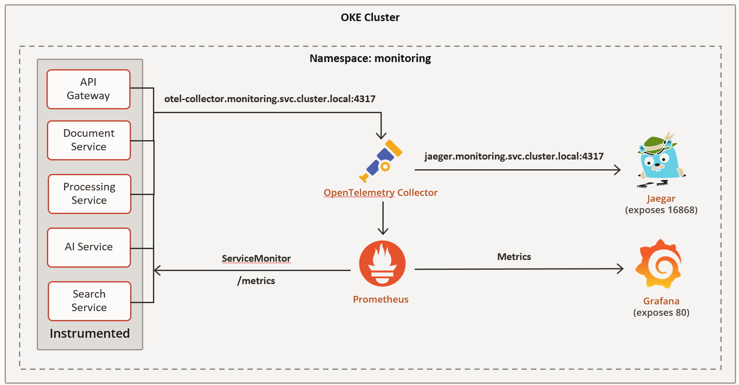

This design keeps each service's only responsibility toward observability infrastructure limited to emitting standardized traces, metrics, and logs. All storage, correlation, and visualization concerns are centralized and managed independently of application code.

2. Request Correlation
Each instrumented service runs a middleware component that derives a correlation identifier from the currently active trace span, rather than generating an independent one:
if span_context.trace_id != 0:
request_id = format(span_context.trace_id, "032x")
else:
request_id = "-"

response.headers["X-Trace-ID"] = request_id
Because this identifier is OpenTelemetry’s own trace ID, the value returned to a client, the value attached to every log line for that request, and the value searchable in the tracing backend are always identical. This removes the need to correlate logs and traces manually. A request ID reported by a client can be pasted directly into the tracing UI to retrieve the full trace, and vice versa. When no span is active (for example, during application startup or on a route excluded from instrumentation), the identifier falls back to a placeholder rather than fabricating a disconnected value.

3. Structured Logging
Logging is standardized across services through a shared configuration that produces a JSON-formatted logger writing to standard output. A logging filter attaches the current request's trace ID to every log record automatically:
class RequestIDLogFilter(logging.Filter):
def filter(self, record):
record.request_id = get_request_id()
return True
Log fields are normalized across services (timestamp, level, service name, request ID, message), which allows uniform querying and cross-service log aggregation regardless of which team authored the service. Application code interacts with this logger the same way across all services:
logger.info("order created", extra={"order_id": order_id, "user_id": user_id})

logger.error("payment failed", extra={"order_id": order_id, "reason": str(e)})

4. Distributed Tracing
Tracing setup establishes a tracer tagged with the service's name and exports spans over OTLP to the Collector:
provider = TracerProvider(resource=Resource.create({"service.name": service_name}))

provider.add_span_processor(BatchSpanProcessor(OTLPSpanExporter(endpoint=OTEL_ENDPOINT, insecure=True)))

trace.set_tracer_provider(provider)

FastAPIInstrumentor.instrument_app(app)
Automatic FastAPI instrumentation generates a span per request, capturing method, path, status code, and duration without additional code in individual route handlers. Outbound HTTP calls made by a service are instrumented separately, so that trace context propagates when one service calls another, preserving a single continuous trace across service boundaries.

5. Metrics Collection
Each service exposes its own metrics endpoint, populated with request-count and request-duration histograms:
Instrumentator(
should_group_status_codes=False,
excluded_handlers=["/metrics", "/health"],
).instrument(app).expose(app, endpoint="/metrics")
This endpoint is scraped directly by Prometheus rather than routed through the Collector, as described in the architecture overview above.

7. Integration Guide
Onboarding a new service into the observability stack follows a fixed sequence.
Step 1: Dependencies. Add the shared observability dependencies to the service's requirements.
Step 2: Application wiring. In the service's entry point, configure logging, tracing, metrics, and request correlation, then instrument outbound HTTP calls:
logger = configure_logging(service_name=SERVICE_NAME)
setup_tracing(app, service_name=SERVICE_NAME)
setup_metrics(app)
app.add_middleware(RequestIDMiddleware)
RequestsInstrumentor().instrument()
Step 3: Deployment configuration. Add the Collector's address as an environment variable so the service knows where to push traces:
- name: OTEL_EXPORTER_OTLP_ENDPOINT
value: "otel-collector.monitoring.svc.cluster.local:4317"
Step 4: Metric discovery. Register a ServiceMonitor so Prometheus knows to scrape the service's metrics endpoint:
apiVersion: monitoring.coreos.com/v1
kind: ServiceMonitor
metadata:
name: <service-name>
namespace: <service-namespace>
labels:
release: kube-prom-stack
spec:
selector:
matchLabels:
app: <service-name>
endpoints:
- port: <named-service-port>
path: /metrics
interval: 15s
The release label must match the Prometheus stack's Helm release name, as this is what causes the Prometheus Operator to pick up the resource; the port must be referenced by name, not number, requiring the service's container port to be named accordingly.

Frontend Engineering
The frontend was required to be functionally complete before deployment began. It is a Next.js application that talks to the platform entirely through configuration — no service URL appears anywhere in the source, so moving from a local stack to OCI is an environment change rather than a code change.

1. Technology Stack
Concern | Choice | Reason
Framework | Next.js (App Router), TypeScript | Server route handlers keep the JWT out of browser JavaScript
Styling | Tailwind CSS with a fixed token set | Constrains the palette; prevents drift between screens
Components | shadcn/ui primitives | Accessible defaults without adopting a whole design framework
Data fetching | TanStack Query | Polling with a stop condition is a first-class feature
Forms | react-hook-form with zod | One schema validates the form and types the payload
Charts | Recharts | Sufficient for the metrics views
PDF | react-pdf, dynamically imported | The viewer cannot render server-side

2. Design System
A restrained token set was fixed before any screen was drawn, so that consistency was a property of the system rather than something enforced by review. The palette is a neutral slate scale with a single accent reserved for primary actions — an accent used everywhere stops signalling anything.
Token group | Definition
Neutrals | Slate 50 through 900
Accent | Deep red #C74634, primary actions only
Status | Green completed, amber processing, red failed, grey queued
Risk bands | Green 0–33, amber 34–66, red 67–100
Typography | Inter for interface text, JetBrains Mono for identifiers, JSON and metric values
Radius | A single 8px value used everywhere
Spacing | 4px base scale, no arbitrary values
Elevation | 1px borders rather than shadows

Design rule. Four states were designed for every list and table before any of them was built: loading skeleton, empty, error, and populated. Missing empty states is the most common reason an otherwise finished interface feels unfinished.

3. Application Screens
Ten screens were specified. Six were treated as core and completed first because they carry the product demonstration end to end; the remainder reuse the same components and were built afterwards.
# | Screen | Purpose | Priority
1 | Login | Credentials, validation errors, auth failure | Core
2 | Upload | Dropzone with four states, per-file processing stepper | Core
3 | Documents list | Filterable table with status and risk badges | Core
4 | Document detail | Overview, extracted data, PII, risk, preview | Core
5 | Document Q&A | Split-screen chat with citation-linked PDF | Core
6 | States sheet | Skeletons, empty, error, toasts, responsive | Core
7 | Dashboard | Counts, status breakdown, recent uploads | Secondary
8 | Search | Semantic search across the corpus | Secondary
9 | Jobs | Queue view: pending, retrying, failed | Secondary
10 | System | Pods, HPA replicas, queue depth, latency | Secondary

The document detail screen
This is the screen the product is judged on, and it carries the most information density. It is organised as a header plus five tabs so that risk — the flagship feature — is visible immediately rather than buried behind navigation.
Tab | Contents
Overview | Metadata grid, classification with a confidence bar, vertical processing timeline with timestamps
Extracted Data | Structured fields with per-field confidence indicators and an inline edit affordance
PII | Detected entities: type, value masked by default with a reveal toggle, page number, confidence
Risk | Overall score, three category bars, findings list where each finding links to its source page
Preview | PDF viewer with page thumbnails, navigation and zoom

The question-and-answer screen
A split layout: conversation on the left, source document on the right. Each answer carries citation chips of the form contract.pdf · page 4. Clicking a chip moves the viewer to that page and highlights the cited passage, using the same accent treatment on both so the link between them is visually obvious. This single interaction is what makes the retrieval feature legible to a reviewer — an answer without a resolvable citation is indistinguishable from a fabricated one.

4. Component Architecture
Group | Components
Layout | Sidebar, Topbar, Breadcrumbs, UserMenu, ThemeToggle
Upload | UploadDropzone, FileCard, UploadProgressBar
Documents | DocumentTable, StatusBadge, DocTypeBadge, FilterBar, Pagination, EmptyState
Processing | ProcessingStepper, JobStatusPoller
Viewer | PdfViewer, PageHighlight
Results | ExtractedFieldsPanel, ConfidenceBar, PiiTable, RiskGauge, RiskCategoryBars, FindingsList
RAG | ChatPanel, MessageBubble, CitationChip, SourcePreviewPopover, StreamingText
Metrics | MetricCard, LatencyChart, QueueDepthChart, PodCountChart
Shared | Skeleton, Toast, ConfirmDialog, ErrorBoundary, Tabs, Modal

5. Authentication and Session Handling
The access token is never exposed to browser JavaScript. Login posts to a Next.js route handler, which calls the gateway and stores the returned JWT in an httpOnly cookie. Every subsequent request goes to a proxy route under the application's own origin, and the token is attached server-side.

Browser ──POST /api/auth/login──▶ Next route handler
│
├─▶ gateway /auth/login
│
Set-Cookie: httpOnly
Browser ──GET /api/proxy/documents──▶ Next route handler
│ reads cookie
├─▶ Authorization: Bearer …
└─▶ document-service

Route protection is enforced in middleware rather than per page, so a new authenticated route cannot be added without it. Seven route handlers exist, covering documents, document detail, status, counts, dashboard, search and health.

6. Asynchronous Processing in the Interface
Upload returns 202 Accepted with an identifier; the document is not processed yet. The interface polls for status and stops polling on a terminal state.
useQuery({
queryKey: ['job', documentId],
queryFn: () => api.getStatus(documentId),
refetchInterval: (q) =>
isTerminal(q.state.data?.status) ? false : 2000,
})
Design decision. The processing stepper is driven by the reported status, not by a timer. If the pipeline stalls, the interface visibly stalls with it. An animation that advances on its own would hide exactly the failure the user most needs to see.

7. Environment-Driven Configuration
No service URL is hardcoded anywhere in the frontend. A single module resolves every downstream address from the environment, and it is the only file in the application that knows a service exists at a particular host.
Variable | Local value | Deployed value
API_BASE_URL | http://localhost:8000 | https://<gateway-host>
DOCUMENT_SERVICE_URL | http://localhost:8081 | Cluster service DNS
SEARCH_SERVICE_URL | http://localhost:8090 | Cluster service DNS

8. Containerisation and Health Probes
The frontend runs in the cluster like any other workload, so it was built to the same operational standard as the services.
- Multi-stage Dockerfile with Next.js standalone output, so the final image carries only the server bundle, static assets and public files.
- Runs as a non-root user.
- Exposes /api/health/live and /api/health/ready, because a workload Kubernetes cannot probe is a workload Kubernetes cannot manage.
- The readiness route aggregates the readiness of the services it depends on and reports degraded rather than failing outright, so a partial outage is visible without taking the interface down.

Quality Assurance Strategy

1. Approach
The brief for this role is to prove the project works. That phrasing matters: proving a system works is not the same as exercising it. Each test in this suite is written to fail for one identifiable reason, and where a behaviour could not be verified, that is stated rather than papered over.
Two principles governed the work. First, no test asserts a behaviour the system was not designed to have — several apparent defects turned out to be correct behaviour that the test had misunderstood, and those tests were corrected rather than filed as bugs. Second, no number is reported without the conditions that produced it, because a measurement without its context is not evidence.

2. Test Levels and Tooling
Level | Tool | Scope
Unit | pytest | Owned by each service; wired into CI by this role
Contract | pytest + httpx | HTTP surface of each service in isolation
Integration | pytest + httpx | Cross-service paths through the queue
End-to-end | pytest + httpx | Upload through to indexed and retrievable
Failure | pytest + docker + redis-py | Dependency loss, restart, redelivery
Accuracy | pytest + generated corpus | Result correctness against ground truth
Load | k6 | Throughput, latency distribution, autoscaling
Smoke | pytest + httpx | Post-deployment verification

3. Test Environments and Portability
Every suite resolves its target from an environment variable and skips itself when that target is unreachable. This matters more than it sounds: it means any subset of the suite runs anywhere — a developer machine with two services up, a full compose stack, or the deployed cluster — without configuration and without false failures.
SEARCH_SERVICE_URL=https://search.dev.example pytest tests/integration
# unreachable target → SKIPPED, not FAILED
Tests that mutate system state — stopping containers, publishing directly to Redis — are marked disruptive and excluded from the default run. Accuracy runs, which upload the entire corpus, are marked separately for the same reason. Somebody running pytest should not have their Redis stopped underneath them.

4. Test Case Catalogue
A catalogue of 150 functional test cases was derived from the project specification and maintained as the authoritative list of what needs testing, independent of what has been automated. Each case carries a status: automated and passing, automated and failing as a recorded finding, blocked on something that does not yet exist, or specified but not yet automated.
Section | Cases | Coverage
Document upload | 15 | Complete
Status and listing | 11 | 9 of 11; 2 are recorded findings
Classification | 10 | 9 of 10
Information extraction | 8 | 7 of 8
PII detection | 11 | 8 of 11; 1 is a recorded finding
Risk analysis | 9 | 8 of 9
Search and RAG | 15 | 11 of 15; 3 need a real embedding model
Health and resilience | 15 | 12 of 15; 3 need a cluster
Authentication | 34 | Complete
End-to-end and failure | 19 | 17 of 19
Performance | 8 | 1 of 8; 7 blocked on the monolith

Test Data Engineering

1. The Problem
The repository contained two plain-text sample files totalling 2.6 kilobytes. The load-testing protocol called for roughly fifty documents, the retrieval evaluation set referenced page four of a file shorter than a single page, and neither sample was a PDF — which the upload service is the only format it accepts.
The consequences were not subtle. Retrieval hit rate was reported at 100 percent, but with two documents and seven chunks a top-five query returns most of the corpus by construction; the metric could not have produced any other number. Citation page accuracy was likewise reported at 100 percent across four pages of one contract. Both figures were structurally guaranteed and described nothing about the system.
Why this mattered. A metric that cannot fail is not a measurement. Quoting either of those figures in a final report would have presented a number with no information content as evidence of quality.

2. Generating Documents From Ground Truth
The solution was a generator that inverts the usual relationship between a document and its annotations. Rather than writing documents and then recording what they contain, the generator decides the ground truth first and renders a document from it.
1. choose values payment terms = 45 days
auto-renewal = present
national ID → page 4
2. render document text written from those values
3. emit ground truth the same values, as JSON

Because the document is written from the ground truth, the expected values cannot be wrong. With real documents, every expected value is a human transcription, and any transcription error surfaces later as an apparent model failure that costs days to trace.
Risk bands follow the same principle. The generator selects risk drivers — automatic renewal, termination notice period, liability cap, contract value, late-payment interest — before writing the text, then derives the expected band from them. The expected band is therefore explainable rather than asserted.
Output formats
Two ingest paths in the platform reject each other's format: the document service accepts PDF only and validates magic bytes; the search service indexes text and never touches a file. The generator emits both from the same source, so the two representations of a document are guaranteed identical.
Artifact | Format | Consumer
documents/*.pdf | Rendered PDF | document-service
text/*.txt | Text with `[PAGE n]` markers | search-service
ground-truth/*.json | Expected values | All test suites
manifest.json | Seed and corpus summary | Committed; reproducibility recor

3. Reproducibility
The corpus is generated from a fixed seed. The same seed produces byte-identical documents, which means any change in a measured metric is attributable to a code change and never to the data. Without this, a drop in retrieval accuracy is ambiguous between a regression and a different corpus, and the ambiguity is unresolvable after the fact.

cd tests/fixtures/generator
python generate.py --contracts 20 --invoices 30 --seed 42 --clean
python verify.py

4. Verification of the Ground Truth
A verification pass asserts that every expected value actually appears in the document text, and that every PII entity appears on the page the ground truth declares. This is not ceremony — it caught a real defect during development.
The first version of the PDF renderer drew each line without wrapping. Any line longer than the page width was silently truncated. The phrase "30 days written notice" existed in the ground truth but had been cut from the rendered document, so a retrieval test would have marked the system wrong for failing to find text that was never there. The renderer now wraps, and raises on overflow rather than dropping content.

Verified | Count
Documents | 50
Field values present in the text | 270
PII entities present and on the declared page | 250
RAG questions citing a page within the document | 270

5. Edge Case Fixtures
The corpus generator produces well-formed documents. A second generator produces the ones that break things. All are generated rather than committed — one is 28 mebibytes, and none of them belong in version control.
Fixture | What it is | Expected handling
empty.pdf | Zero bytes | Rejected at upload
not_a_pdf.pdf | Text file with a PDF extension | Rejected — no magic bytes
truncated.pdf | Valid header, body cut at 50% | Accepted, fails in processing
corrupt_body.pdf | Valid header and trailer, random middle | Accepted, fails in processing
no_text.pdf | Valid PDF, no text layer | Fails terminally, not silently indexed
long_100_pages.pdf | 100 pages | Processes to completion
oversized.pdf | 28 MiB, above the cap | Rejected at upload
traversal_name.pdf | Uploaded as `../../../etc/passwd.pdf | Filename sanitised
null_byte_name.pdf | Filename containing a null byte | Sanitised or rejected
unicode_name.pdf | Non-ASCII filename | Accepted, name preserved

A fixture bug worth recording. The size fixture was initially built at 26,000,000 bytes and was accepted, because the cap is 25 mebibytes — 26,214,400 bytes. The fixture was wrong, not the service, and correcting it incidentally confirmed that the service measures in the right units.

Continuous Integration

1. The Gap
The repository contained thirteen passing unit tests. The CI pipeline ran Terraform validation, container builds, image scanning and secret scanning — and did not run a single test. Thirteen tests existed and protected nothing.

2. Auto-Discovering Test Suites
Rather than enumerate the services, the CI job discovers any directory under services that contains a tests folder and runs pytest inside an isolated virtual environment for each. Per-service isolation matters because each service pins its own dependencies; installing them into one shared environment produces version conflicts that mask real failures.
- name: Discover services with tests
run: |
mapfile -t dirs < <(find services -maxdepth 2 -type d \
-name tests -printf '%h\n' | sort)
- name: Run pytest per service
run: |
for d in ${dirs[@]}; do
python -m venv "/tmp/venv-$(basename "$d")"
source "/tmp/venv-$(basename "$d")/bin/activate"
pip install -q -r "$d/requirements.txt" pytest
( cd "$d" && python -m pytest tests -q ) || failed=1
done
exit "$failed"

3. Outcome
The design proved itself within two days. A teammate landed the AI service with 136 tests of its own, and the job picked them up automatically with no change to the workflow. A later service did the same. Coverage went from thirteen tests running nowhere to 149 running on every pull request, then continued to grow without further intervention.
The loop is deliberately not fail-fast across services: if two suites are broken, both are reported in one run rather than discovered one after another across successive pushes.

Contract and Integration Testing
Each service received a suite exercising its HTTP surface against a live instance: status codes, response shapes, field types, validation boundaries and error envelopes. These assert the contract, not result quality — quality is measured separately, in Section 33.

1. Coverage by Service
Suite | Tests | Principal concerns
search-service | 18 | Index and search contract, both storage backends, chunking, ordering, round trip
document-service | 45 | Upload validation, listing, pagination bounds, error envelope, dependency failure, edge cases
api-gateway | 44 | Registration, login, JWT claims, protected routes, proxy transparency
ai-service | 38 | Classification, extraction, PII, risk, embeddings
end-to-end | 26 | Full pipeline, failure modes, corpus accuracy
smoke | 22 | Post-deployment checks against any environment

2. Assertions That Earn Their Place
A contract test that only checks for a 200 response verifies very little. The assertions below were chosen because each corresponds to a failure mode with real consequences.
Absent fields must be null, never invented
A model that returns a plausible value for a field not present in the document is worse than one that returns nothing, because nothing downstream can distinguish the two. The extraction suite asserts that unpopulated fields carry a null value, zero confidence and no evidence.
Every populated extraction carries evidence inside the document
Each extracted value is accompanied by a snippet and a character offset, and the tests assert that the offset falls within the input. An offset past the end of the document cannot point at anything, and an extraction that cannot be traced back to its source cannot be reviewed.

Failed logins must be indistinguishable
If a wrong password and an unknown account produce different responses, the login endpoint becomes an account enumerator. The suite asserts that both return an identical status and an identical message.
A rejection must be marked non-retryable
The processing worker branches on a retryable flag in the error envelope. A malformed file will still be malformed on the next attempt, so marking its rejection retryable places it in a retry loop. The suite asserts the flag is false for validation failures.
A token with a forged signature must be rejected
Anyone can construct JWT claims; only the issuer can sign them. The test mints a structurally valid token with an invalid signature and asserts a 401. Had it been accepted, a caller could grant themselves any identity or role and authentication would be decorative. Notably, the test never holds the signing secret — a test that needs the secret to pass is not testing a boundary.

3. Test Isolation
The in-memory vector store persists between runs and is written relative to the service's working directory, so no test can assume an empty store. Rather than fight this, each test namespaces its documents under a unique identifier. Tests are therefore independent of each other and of whatever ran before them.

End-to-End Verification

1. The Complete Path
Every component had coverage before anything verified that the components add up to a working system. The end-to-end suite exercises the whole path in one motion.
upload ──▶ 202 Accepted
│
└──▶ Redis stream ──▶ worker claims job
│
├──▶ PDF text extraction
├──▶ ai-service: classify
├──▶ ai-service: extract
├──▶ ai-service: risk
├──▶ search-service: index
│
└──▶ status: INDEXED

2. Measured Behaviour
A four-page contract completes in approximately 2.3 seconds with the degraded flag false, meaning no pipeline stage was skipped. The outcome was confirmed independently in the database rather than taken from the API alone: the job row reads COMPLETED, five chunks are present, and both the risk assessment and extracted fields are populated.
Verified behaviour | Result
Upload to terminal success across every service | Pass
Processing is genuinely asynchronous — 202 precedes the work | Pass
A contract is classified as a contract | Pass
An invoice is classified as an invoice | Pass
A completed document is retrievable by query | Pass
Four pages complete well inside 30 seconds | Pass
A truncated PDF reaches a terminal state | Pass
A textless PDF is not silently indexed empty | Pass

Why that case matters. The truncated-PDF case targets the worst available failure mode: a document that stalls in PROCESSING indefinitely. The user waits, no alert fires, and nothing marks the job as needing attention. A visible failure is strictly better than a silent stall.

3. Failure and Recovery Testing
The processing service documents specific reliability guarantees. Those claims were tested rather than trusted.
Claim under test | Method | Result
The consumer group exists | Inspect Redis stream groups | Pass
Completed jobs are acknowledged | Assert no lingering pending entries | Pass
A malformed event does not stall the stream | Publish garbage, then a valid job behind it | Pass
An unknown event version is rejected, not guessed | Publish version 42 | Pass
Readiness fails when Redis is unreachable | Stop the container | Pass
The worker recovers without a restart | Restart the container | Pass
Queued work survives a Redis restart | Restart mid-flight | Pass
Redelivery of the same message is not reprocessed | Inspect pending entries after completion | Pass
A terminal status is final | Republish for a completed document | Fail — recorded finding

The health probes were tested separately and behave correctly under dependency loss: readiness returns 503 and names which dependency failed, while liveness stays 200. The distinction is not cosmetic — if liveness also failed, the kubelet would restart a healthy container in a loop for as long as the outage lasted, instead of routing traffic away from it.
Uploading while the queue is unavailable returns 503 with a retryable error rather than 202. This was verified deliberately, because a 202 with no queue behind it stores the file and never processes it — a lost job the client believes succeeded.

Result Accuracy Measurement

1. Method
All fifty generated documents were uploaded through the complete pipeline and their results compared against the ground truth they were built from. This is the only suite that measures whether the answers are right rather than whether the interface is shaped correctly.

2. Results
Metric | Result | Rate
Documents reaching a terminal state | 50 / 50 | 100%
Documents completing successfully | 50 / 50 | 100%
Documents classified correctly | 50 / 50 | 100%
Classification producing more than one label | Yes | —
Completed documents indexed and retrievable | 50 / 50 | 100%

Required caveat. These figures measure the rule set, not a model. The backend under test is rules-based and deterministic rather than random, which makes the numbers real and repeatable — but they are not a claim about the production model provider. This caveat is printed by the test suite itself and should remain attached to any figure quoted from it.

3. A Measurement Artefact Worth Recording
Retrieval coverage was first measured with a single query and reported 94 percent — three documents appeared unretrievable. Direct inspection of the database showed all three were correctly indexed. The cause was the measurement: fifty documents produce roughly 150 chunks, and a single query capped at the top 200 results returns the best-matching chunks rather than every chunk, so a correctly indexed document can simply miss the cut.
Coverage is now measured as the union across six distinct queries, and reports 100 percent. The lesson generalises: retrieval coverage cannot be measured with one query, and anyone who does so will under-report it.

4. Classification Discrimination
A separate assertion checks that classification produces more than one label across the corpus. A classifier that always answers "contract" would score well on a contract-heavy corpus while being useless, and an accuracy figure alone would not reveal it.

Performance Engineering

1. Scenario Suite
Five k6 scenarios were written against a single shared journey definition, so that the monolith and the cluster deployment exercise identical work. The scenarios differ only in load profile.
Scenario | Profile | Question answered
smoke.js | 1 user, 10 iterations | Is the target up and correct before measuring?
baseline.js | Ramp, hold, ramp down | How does it perform under expected load?
stress.js | Step up to peak | Where is the ceiling, and what fails first?
spike.js | Calm, surge, calm | Does autoscaling react, and how quickly?
soak.js | Modest load, 60 minutes | Does anything leak over time?

The stress scenario deliberately carries no pass/fail thresholds. A stress run is expected to degrade; gating on that would suppress the very answer the scenario exists to produce.

2. Measuring Asynchronous Work
Upload returns 202 immediately, so end-to-end processing time does not appear in request latency at all. It is tracked separately by polling to a terminal state. Reporting only request duration for a write journey would claim a 95th-percentile latency of milliseconds for work that takes tens of seconds.
Each pipeline stage is tagged independently, so a slow run can be attributed to upload, to processing, or to the model call, rather than disappearing into a single aggregate.

3. Cluster Metrics Collection
k6 measures the client side only. CPU, memory, pod count and autoscaler replicas — all required by the comparison — appear nowhere in its output and must be sampled from the cluster while a run is in flight. A collector script does this on a fixed interval and writes CSV.

./tests/load/collect-metrics.sh baseline-oke documind 5
timestamp,pods_total,pods_ready,hpa_current,hpa_desired,
cpu_millicores,memory_mib,restarts_total
Operational note. Running the spike scenario without this collector proves nothing about autoscaling. The scaling event is the result, and it is entirely invisible from the client side.

The collector degrades gracefully: if the metrics server is absent, CPU and memory columns come back blank rather than failing the run, so the gap is discovered before the measured run rather than after it.

4. Comparison Protocol
For the comparison to mean anything, the two runs must differ in exactly one variable: the architecture.
Controlled variable | Requirement
Load script | The identical file, unedited between runs
Corpus | The same 50 documents, same seed
Load generator | The same machine for both runs
Request mix | Frozen alongside the API contract
Model backend | The same setting for both runs
Runs per configuration | Three; report the median

Thresholds currently in the configuration are placeholders. Per the test strategy, cluster thresholds are derived from the measured baseline rather than invented, so a passing threshold today is not evidence of anything.

Post-Deployment Smoke Testing

1. Design Constraints
A smoke suite runs against whatever was just deployed, which imposes two constraints. It must be read-only, because a suite that writes data pollutes the environment it is validating. And it must be fast — the current suite completes in about seven seconds — because a slow smoke suite gets skipped by exactly the people who most need it.

2. Checks
Check | Failure mode it catches
Liveness and readiness respond | The deployment came up but its dependencies did not resolve
Neither probe requires authentication | The kubelet cannot present a token; it would see 401, mark the pod unhealthy and restart it forever
A probe answers in under two seconds | Slow probes cause timeouts that restart merely-overloaded pods, turning a load problem into an outage
An unknown path returns a clean 404 | Framework debug pages expose file paths, versions and sometimes environment variables
The gateway rejects bad credentials | An authentication path broken in a way health probes cannot see
Document listing is reachable and readiness names its dependencies | A 503 that does not say what failed is not diagnosable
At least one service URL was configured | A run with the environment unset passes trivially, reporting success having verified nothing

The last check deserves emphasis. Without it, a misconfigured pipeline step produces a green smoke run that checked nothing at all — which is worse than a red one, because it actively creates confidence where none is warranted.
Every service is optional and skips when unconfigured, so the same suite works during a partial rollout. It is ready to wire into the delivery pipeline once application deployment exists; the current pipeline provisions infrastructure only.

