

Summer Internship 2026
Final Project – Team B
Visual Demonstration Document

Prepared by:
Adel Ahmed Elduhemy
Andrew Hany
Ayham Sameh Ahmed
Basem Walid Talaat Mansour
Mohamed Essam
Mohamed Morsi Genena
Omar Ahmed Abdelaty Abdo
Salah Mohamed Salah
Salem Mamdouh Salem

GitHub Repo:
https://github.com/Salahmohameds/documind-ai/

Contents
Introduction 3
Network 4
Instances 15
Block Volumes 17
Buckets 19
Containers 21
Oracle Kubernetes Engine 21
Kubernetes 24
Load Balancer 29
Application User Interface 34

Introduction
This document is a visual walkthrough of the DocuMind AI deployment on Oracle Cloud Infrastructure (OCI), provisioned via Terraform. Rather than a written architectural narrative, its purpose is to demonstrate the deployed system as it actually appears, through screenshots of the OCI console and terminal output, and to conclude with a look at the platform's final user-facing frontend.
The walkthrough proceeds service by service through the OCI console:
- Network: subnets, route tables, gateways, security lists, and network security groups
- Instances: provisioned virtual machines and their network attachments
- Block Volumes: attached persistent storage and backup configuration
- Buckets: buckets used for document ingestion and processing artifacts
- Containers: image repositories for the platform's microservices
- Oracle Kubernetes Engine: the managed cluster, node pools, workloads, and add-ons
- Load Balancers: the public-facing load balancer and its listener/backend configuration
The document closes with the DocuMind AI frontend, demonstrating the application running live on top of the infrastructure shown throughout.

Network
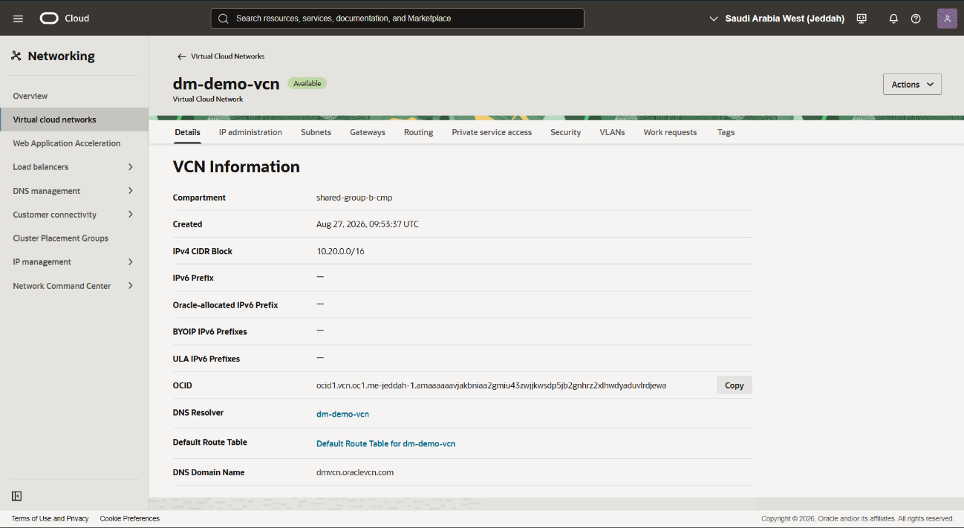
Displays the Virtual Cloud Network (VCN) topology.

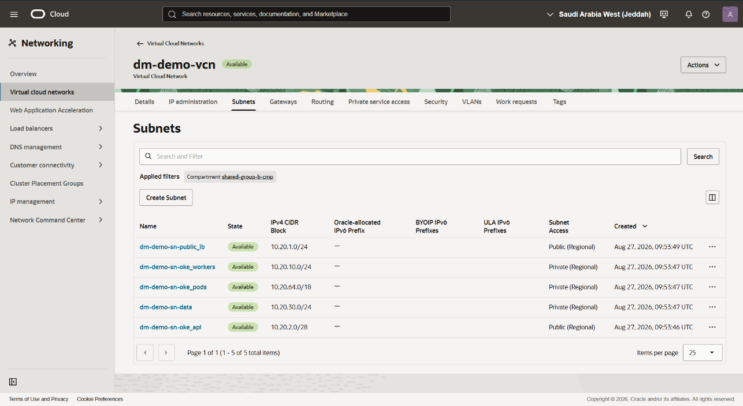
Shows the Subnets listing for the dm-demo-vcn compartment. It details each subnet's CIDR block, public/private access designation, and creation timestamp across the public LB, worker, pod, data, and API subnets.
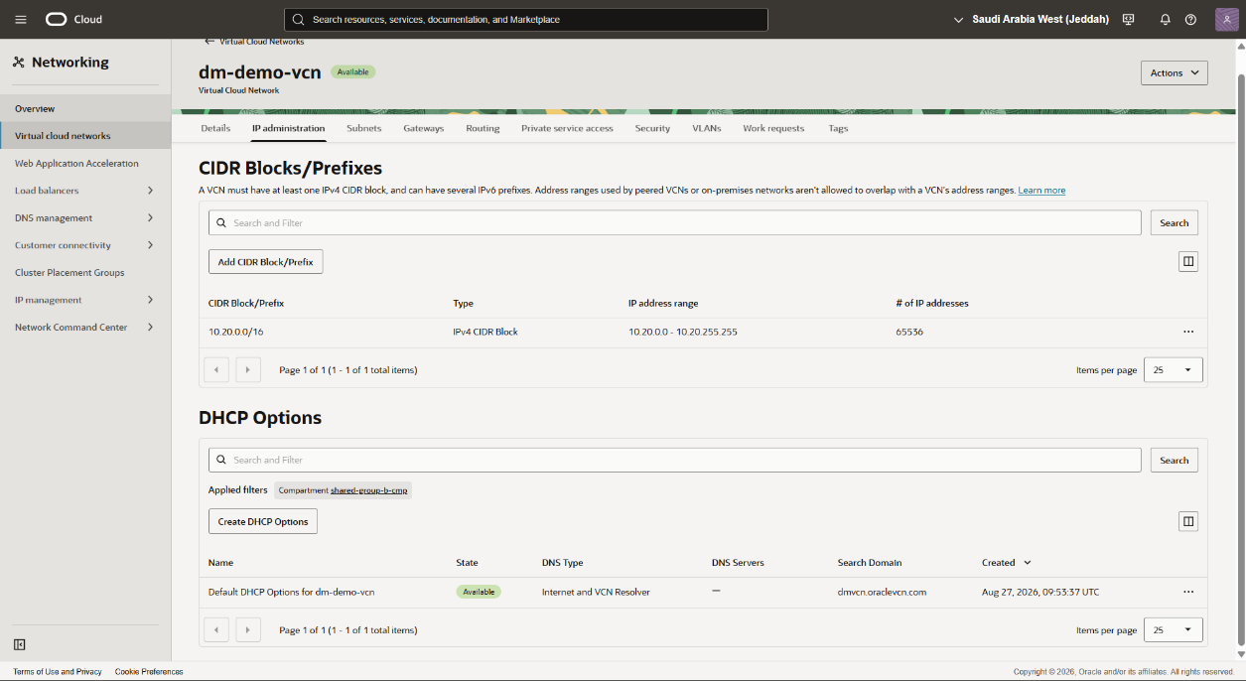
Presents the IP Administration view covering CIDR Blocks/Prefixes and DHCP Options for the VCN. It confirms the single IPv4 CIDR block allocation and the default DHCP configuration using Internet and VCN Resolver DNS types.

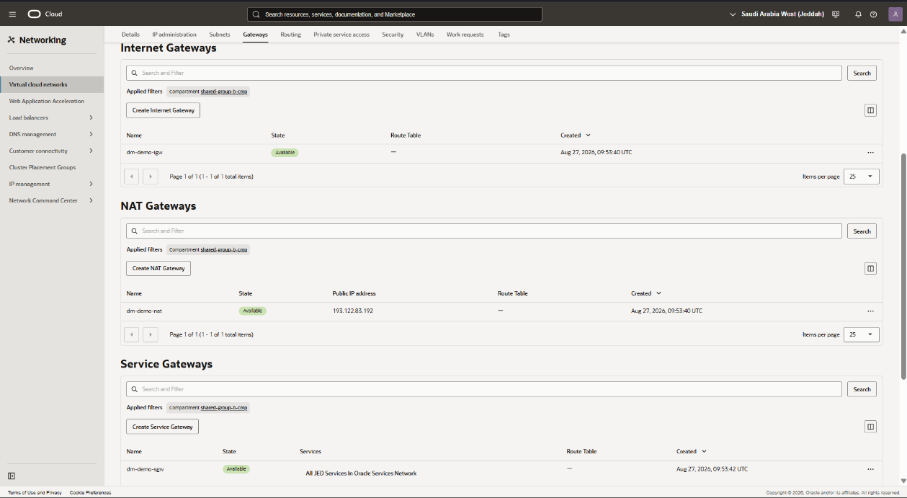
Displays the Gateways configuration, including Internet Gateway, NAT Gateway, and Service Gateway entries. It verifies public internet egress/ingress paths and Oracle Services Network connectivity for the VCN.
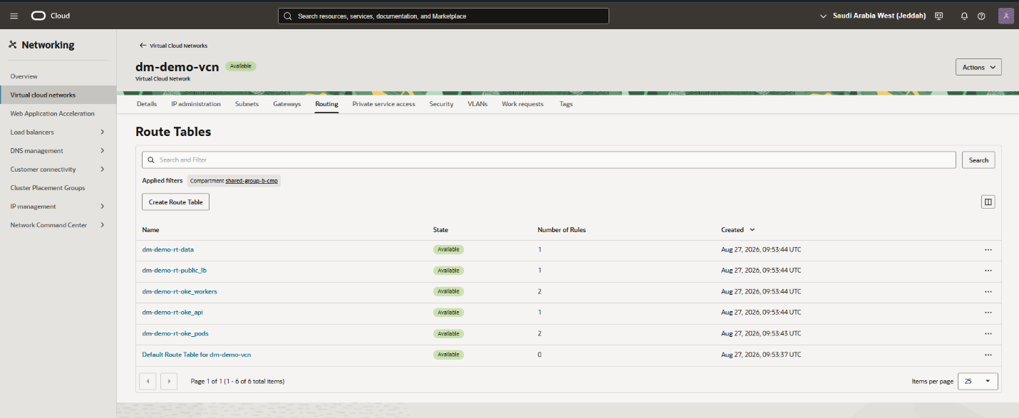
Shows the Route Tables listing across all subnets in the VCN. It highlights the number of routing rules configured per table for data, public LB, OKE worker, OKE API, and OKE pod subnets.

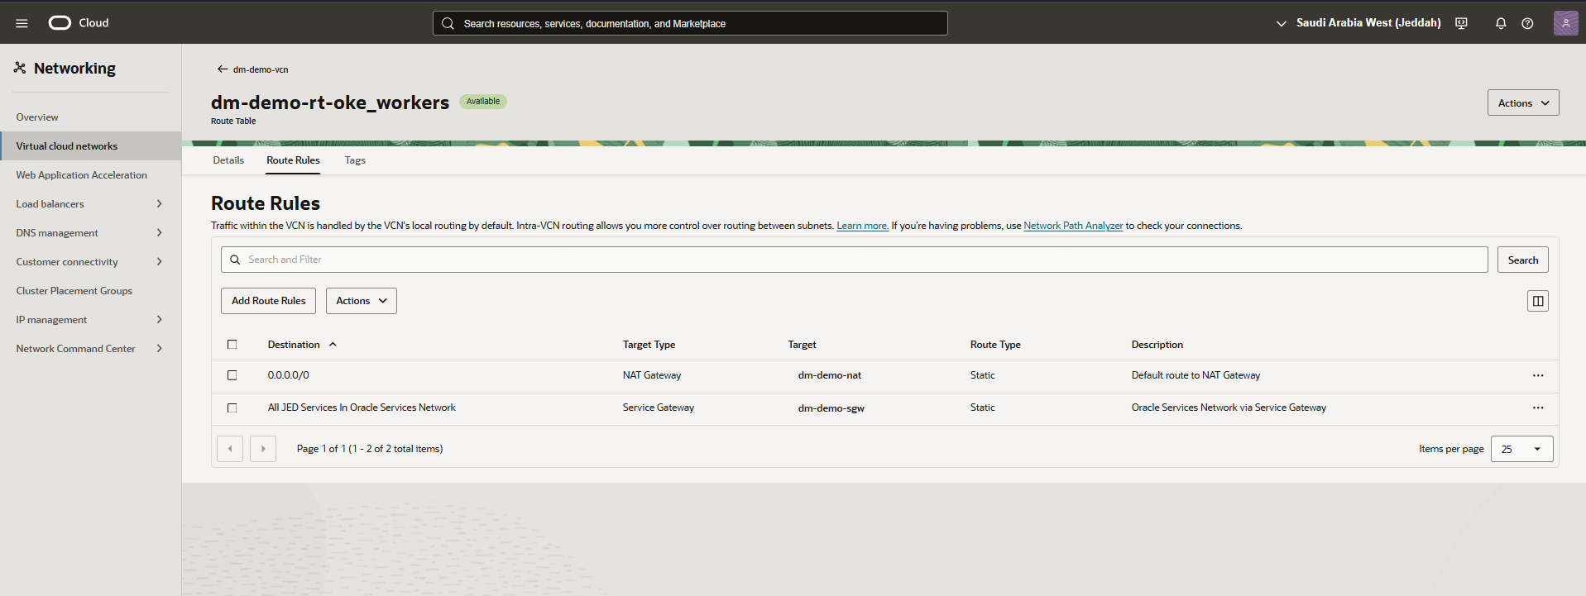
Presents the Route Rules for the dm-demo-rt-oke_workers route table. It confirms a default route to the NAT Gateway and a rule directing Oracle Services Network traffic through the Service Gateway.
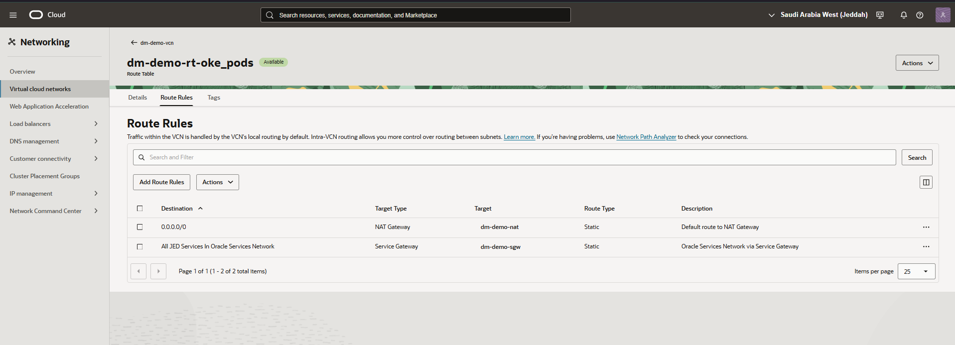
Shows the Route Rules for the dm-demo-rt-oke_pods route table. It mirrors the worker subnet configuration, routing default traffic through the NAT Gateway and services traffic through the Service Gateway.

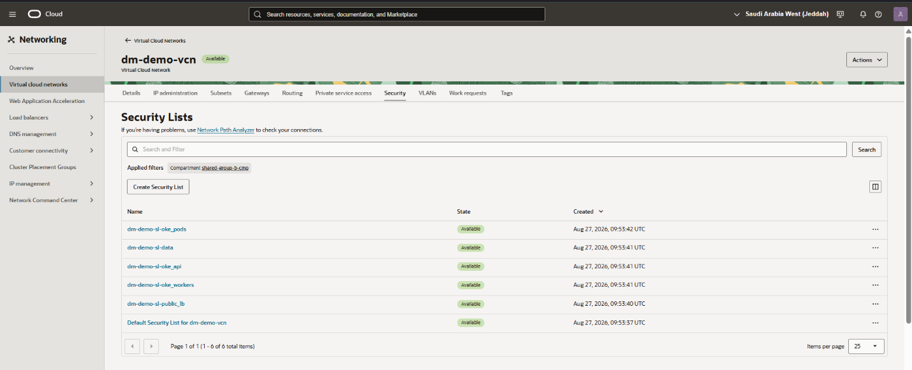
Displays the Security Lists overview for the VCN compartment. It lists security lists scoped to the OKE pods, data, API, workers, public LB subnets, and the VCN's default list.
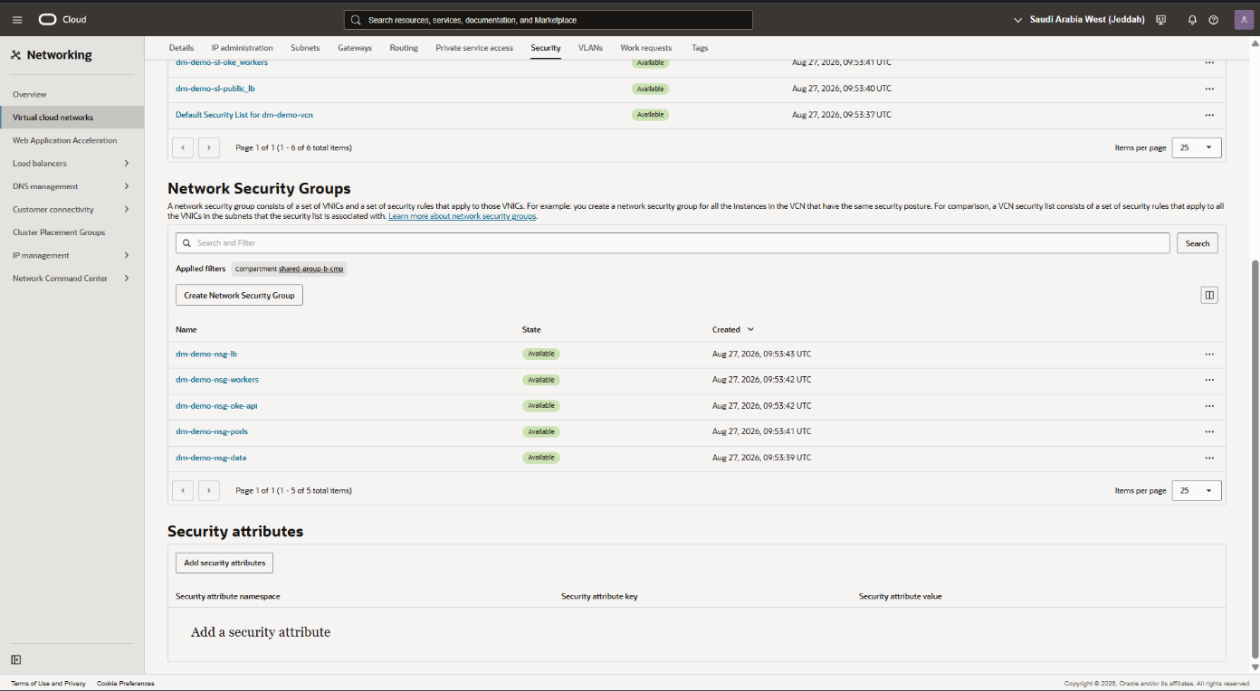
Shows the Network Security Groups overview alongside Security Attributes for the VCN. It lists NSGs for the load balancer, workers, OKE API and pods.

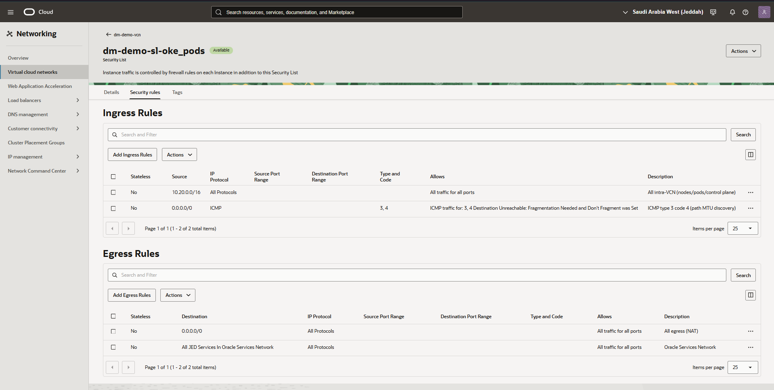
Presents the Security Rules for the dm-demo-sl-oke_pods security list. It shows ingress rules allowing intra-VCN traffic and path MTU discovery, alongside egress rules permitting all traffic and Oracle Services Network access.
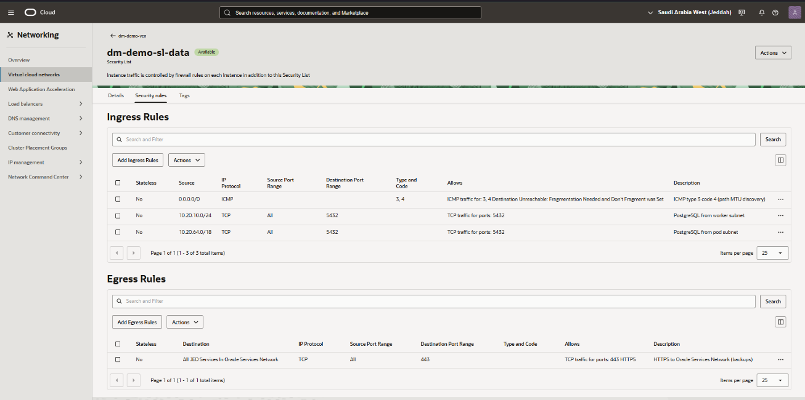
Displays the Security Rules for the dm-demo-sl-data security list. It confirms ingress rules restricting PostgreSQL access (port 5432) to the worker and pod subnets, with egress limited to HTTPS backup traffic over the Service Gateway.

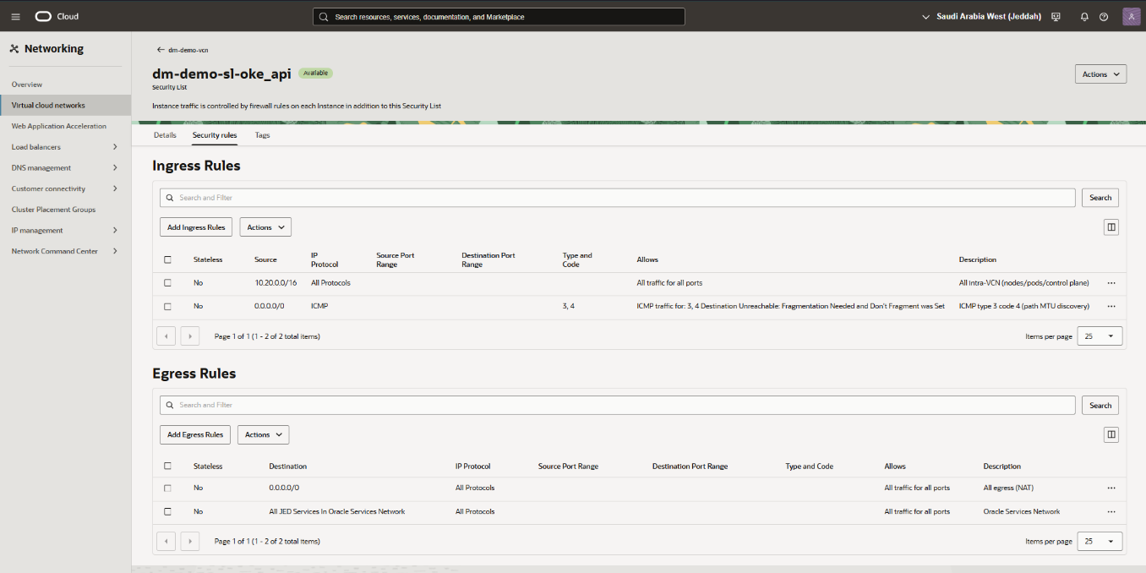
Shows the Security Rules for the dm-demo-sl-oke_api security list. It verifies ingress rules for intra-VCN traffic and path MTU discovery, plus egress rules covering NAT and Oracle Services Network traffic.
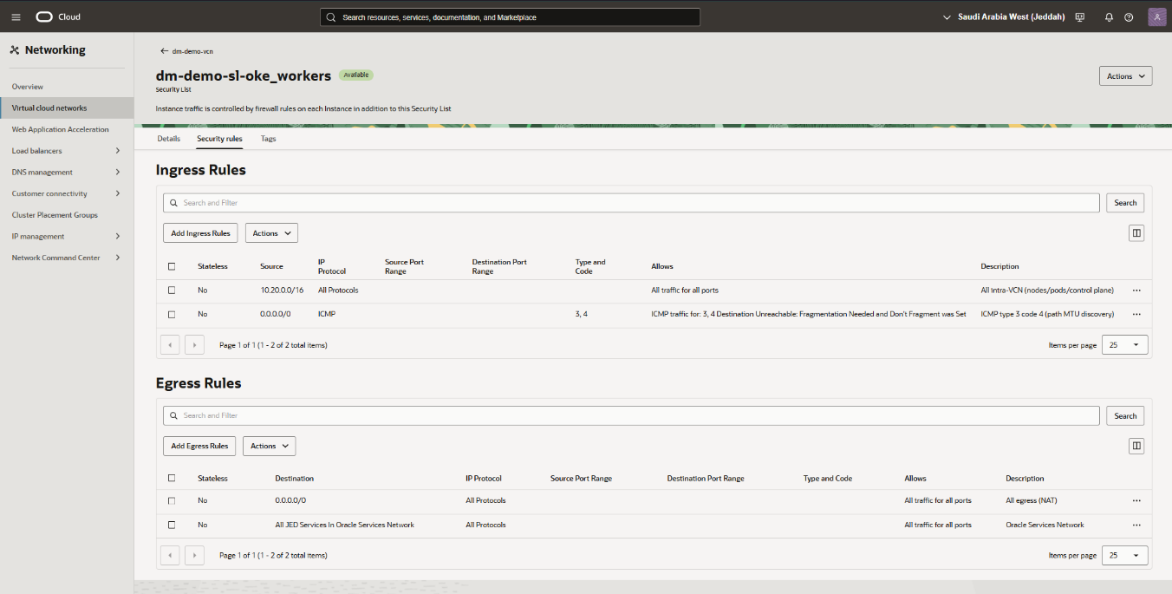
Presents the Security Rules for the dm-demo-sl-oke_workers security list. It confirms the same intra-VCN ingress pattern and NAT/Service Gateway egress rules as the API subnet's security list.

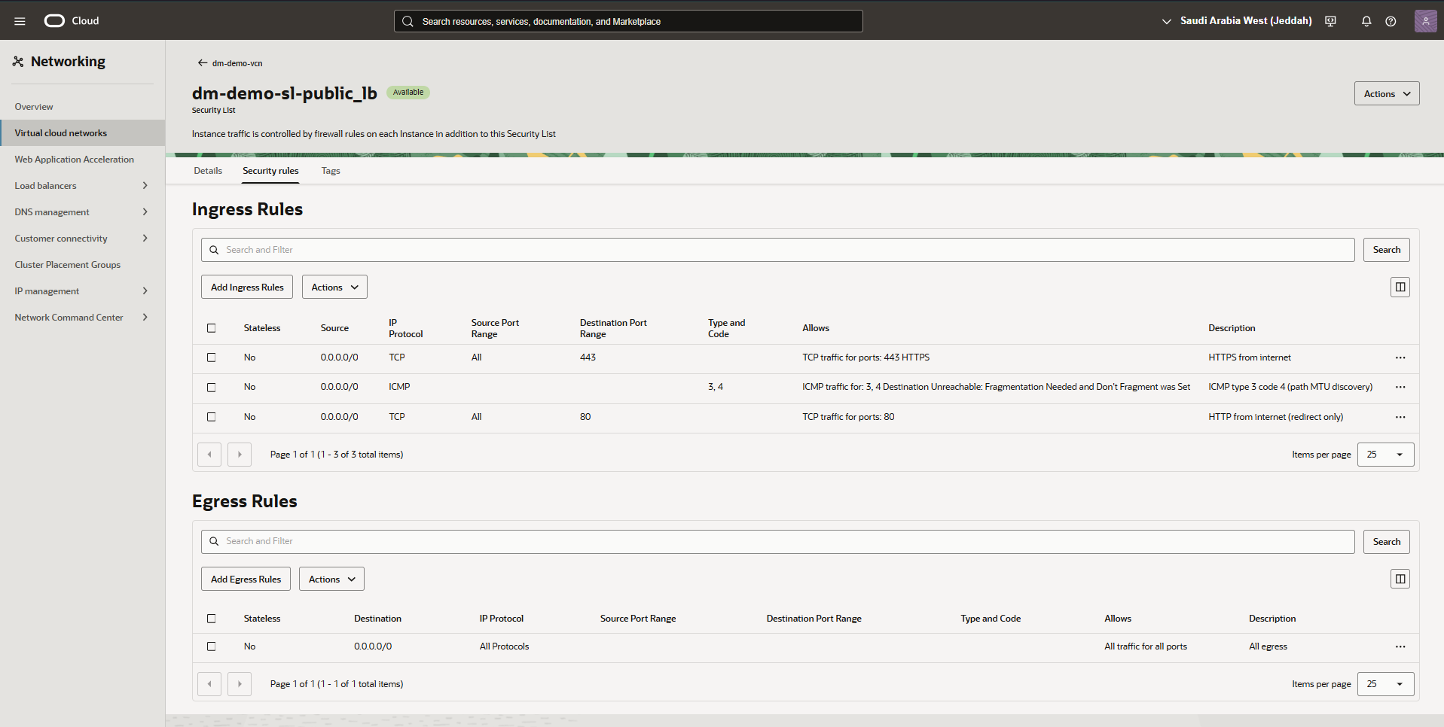
Displays the Security Rules for the dm-demo-sl-public_lb security list. It shows ingress rules allowing HTTPS (443) and HTTP redirect (80) traffic from the internet, with unrestricted egress for all protocols.
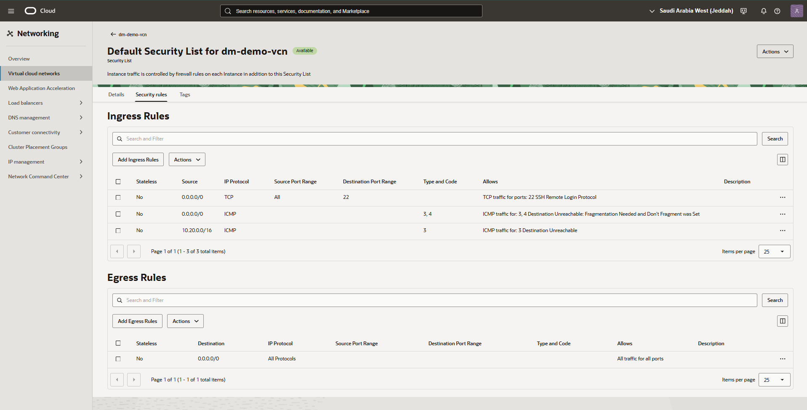
Shows the Default Security List rules for dm-demo-vcn. It details ingress rules for SSH (port 22) and ICMP path discovery, along with a fully open egress rule for all traffic.

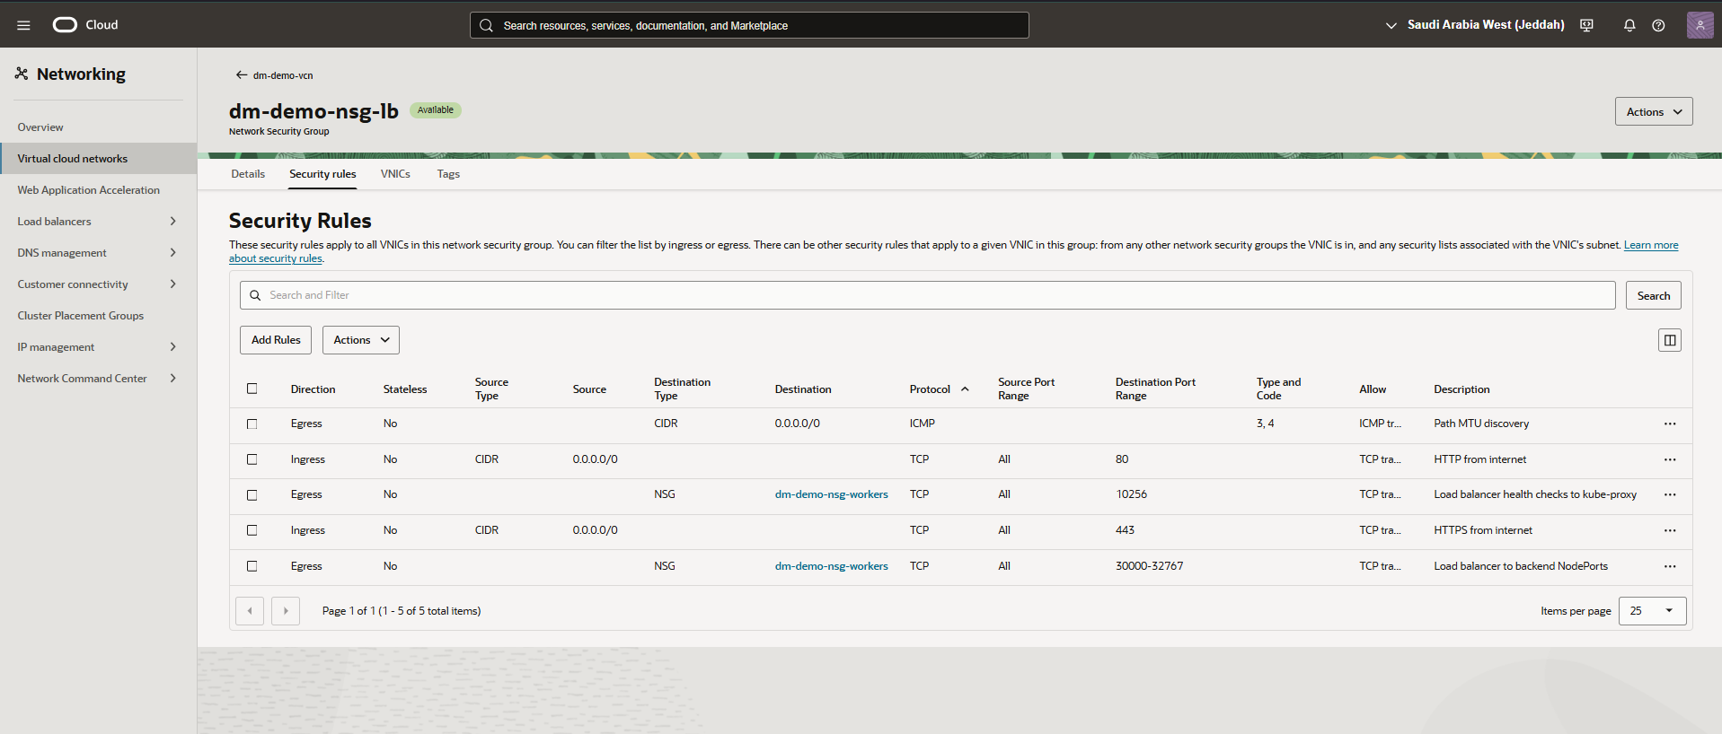
Presents the Security Rules for the dm-demo-nsg-lb network security group. It confirms ingress rules for HTTP/HTTPS from the internet and egress rules routing health checks and traffic to the worker node NSG.
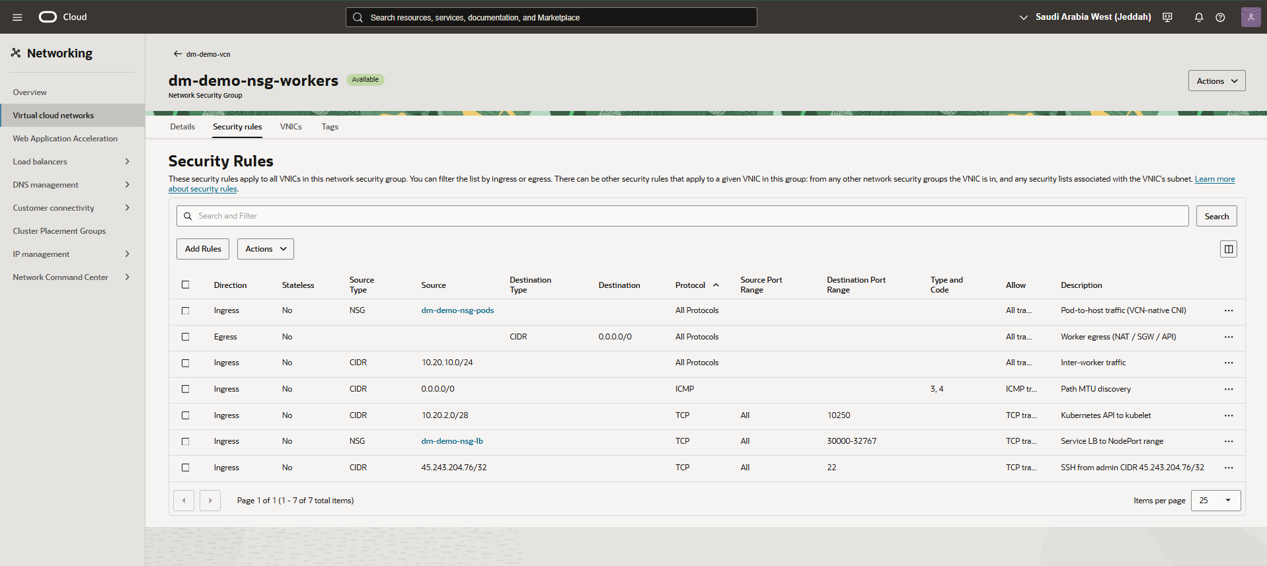
Displays the Security Rules for the dm-demo-nsg-workers network security group. It details ingress rules covering pod traffic, inter-worker communication, Kubernetes API access, load balancer NodePort routing, and admin SSH access.

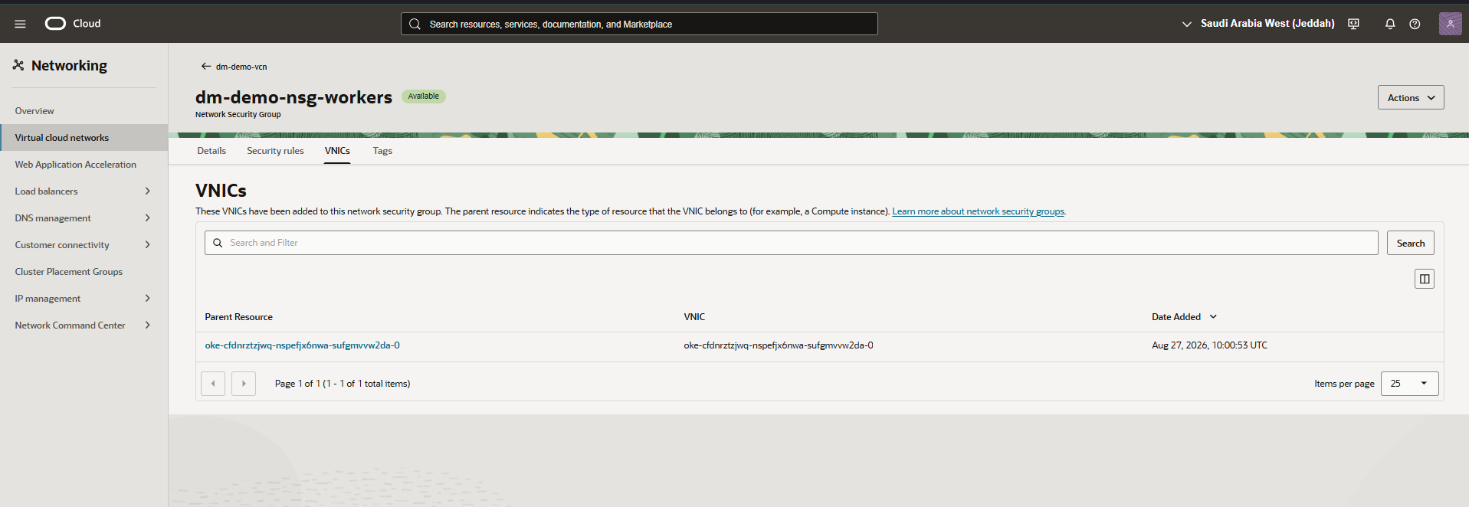
Shows the VNICs tab for the dm-demo-nsg-workers network security group. It confirms the OKE worker node's VNIC is attached to the group, validating correct security posture assignment for the cluster's compute resource.
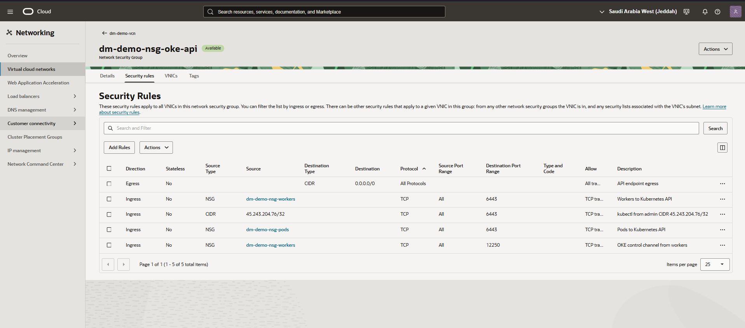
Shows the Security Rules for the dm-demo-nsg-oke-api network security group. It confirms ingress rules restricting Kubernetes API access (port 6443) to the worker NSG, pod NSG, and admin CIDR, alongside a control channel rule for OKE communication from workers.
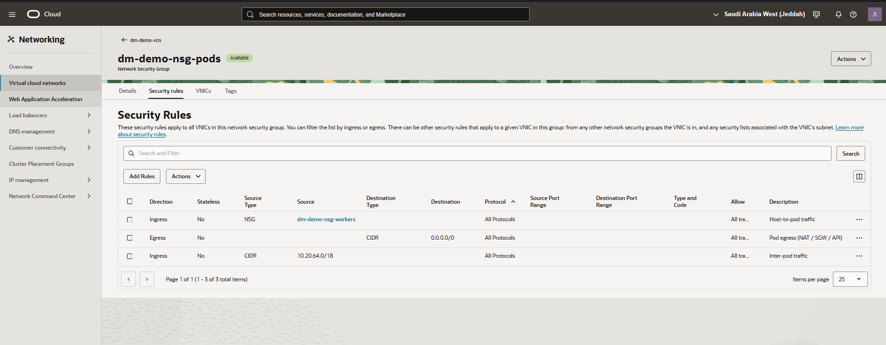
Shows the Security Rules for the dm-demo-nsg-pods network security group. It details ingress rules allowing host-to-pod and inter-pod traffic, alongside an egress rule permitting pod traffic out via NAT, Service Gateway, and API destinations.
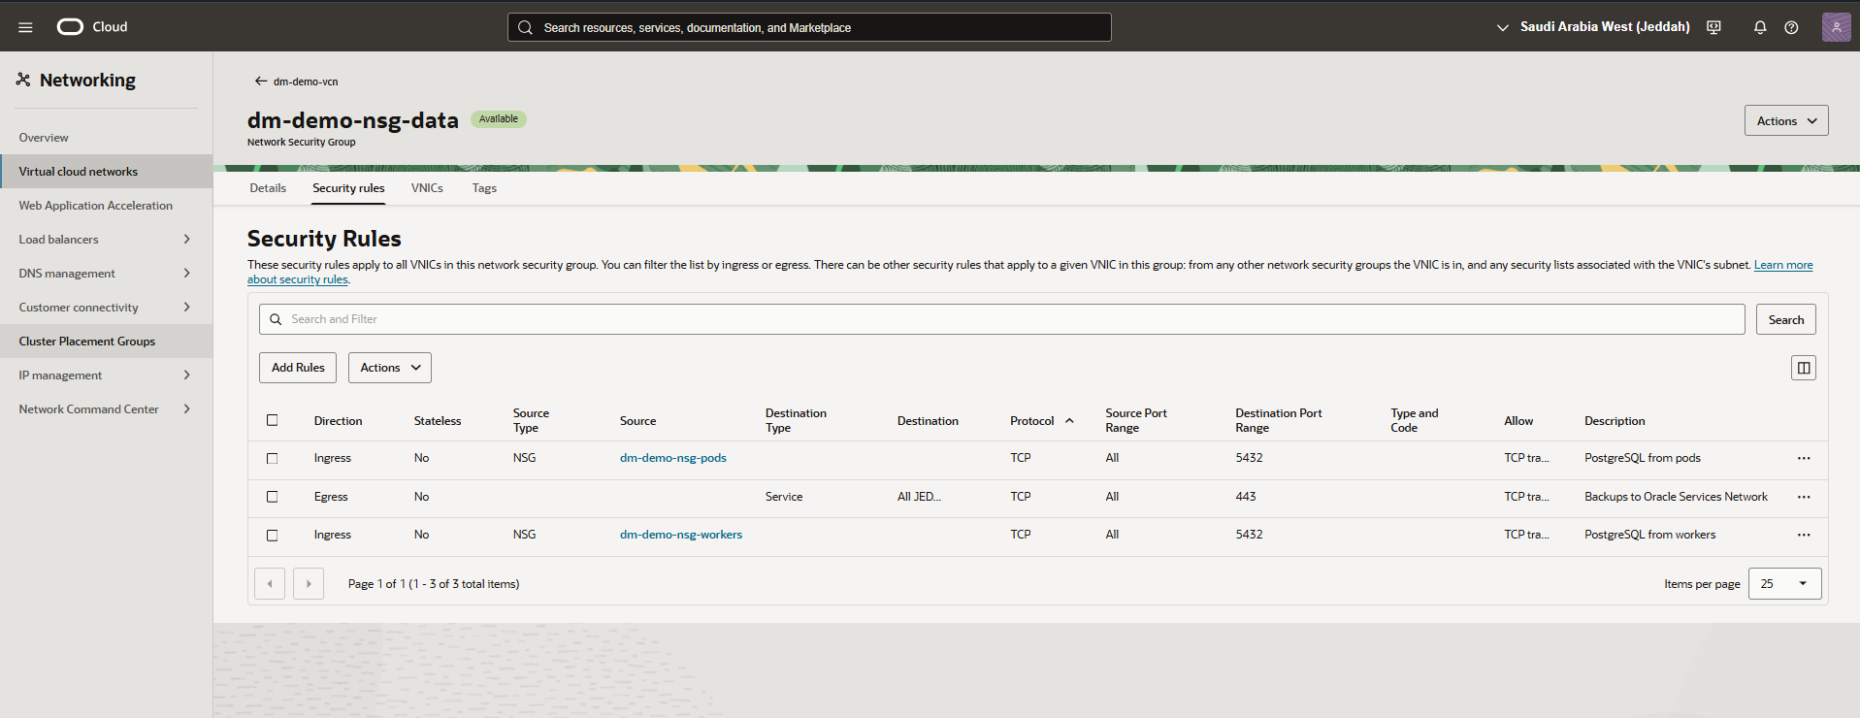
Displays the Security Rules for the dm-demo-nsg-data network security group. It confirms ingress rules allowing PostgreSQL (port 5432) from both the pods and workers NSGs, with egress restricted to HTTPS backup traffic over the Service Gateway.
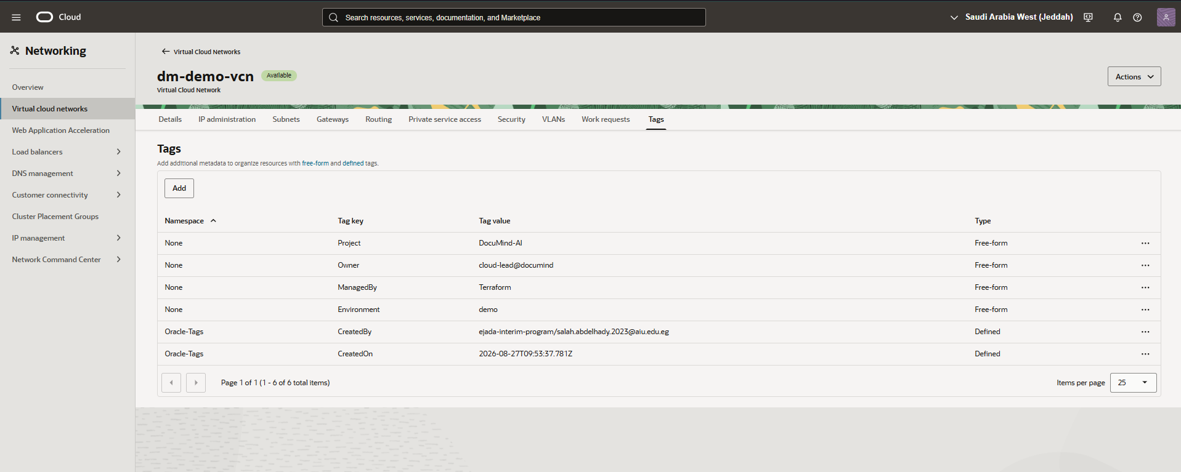
Presents the Tags assigned to the dm-demo-vcn resource. It lists free-form tags identifying the project, owner, and management tooling, alongside Oracle-defined tags recording the creator and creation timestamp.

Instances
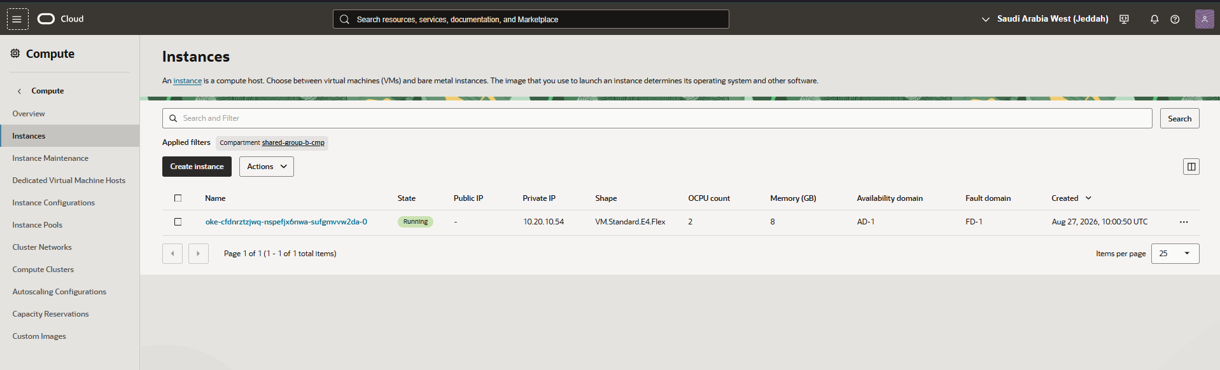
Shows the Compute Instances listing within the designated compartment. It highlights running virtual machine instances, shapes, fault domains, and private IP mappings.

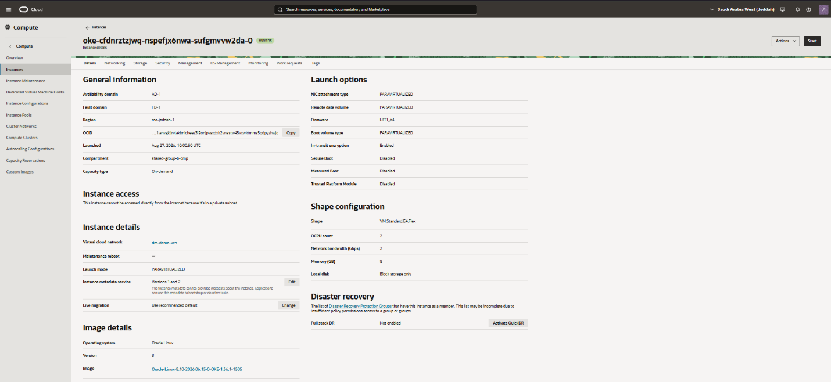
Displays the detailed resource page of an individual compute instance. It outlines OS image details, attached VNICs, and host-level metric monitoring.

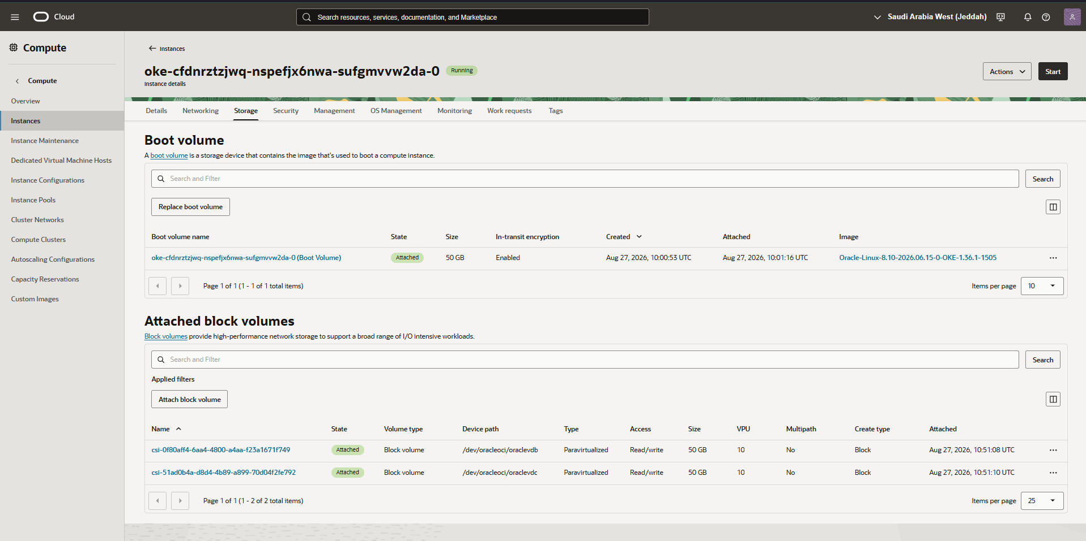
Shows compute instance lifecycle management and active boot volume attachment configurations. It confirms instance operational readiness and associated Network Security Group attachments.

Block Volumes
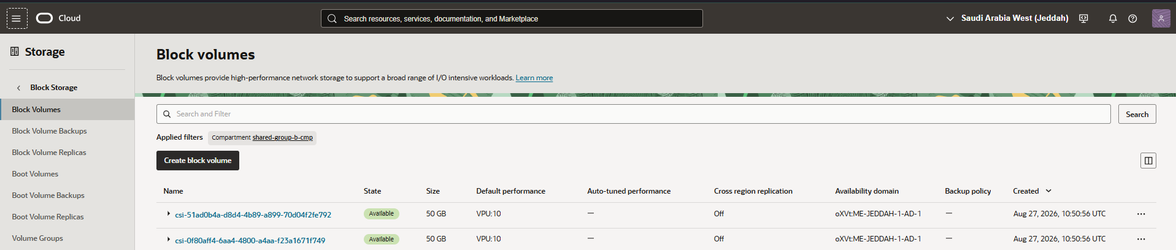
Displays the Block Volumes management console in the OCI tenancy, showing available storage volumes and their operational states. It provides core details such as compartment selection, provisioned size, and attachment status.

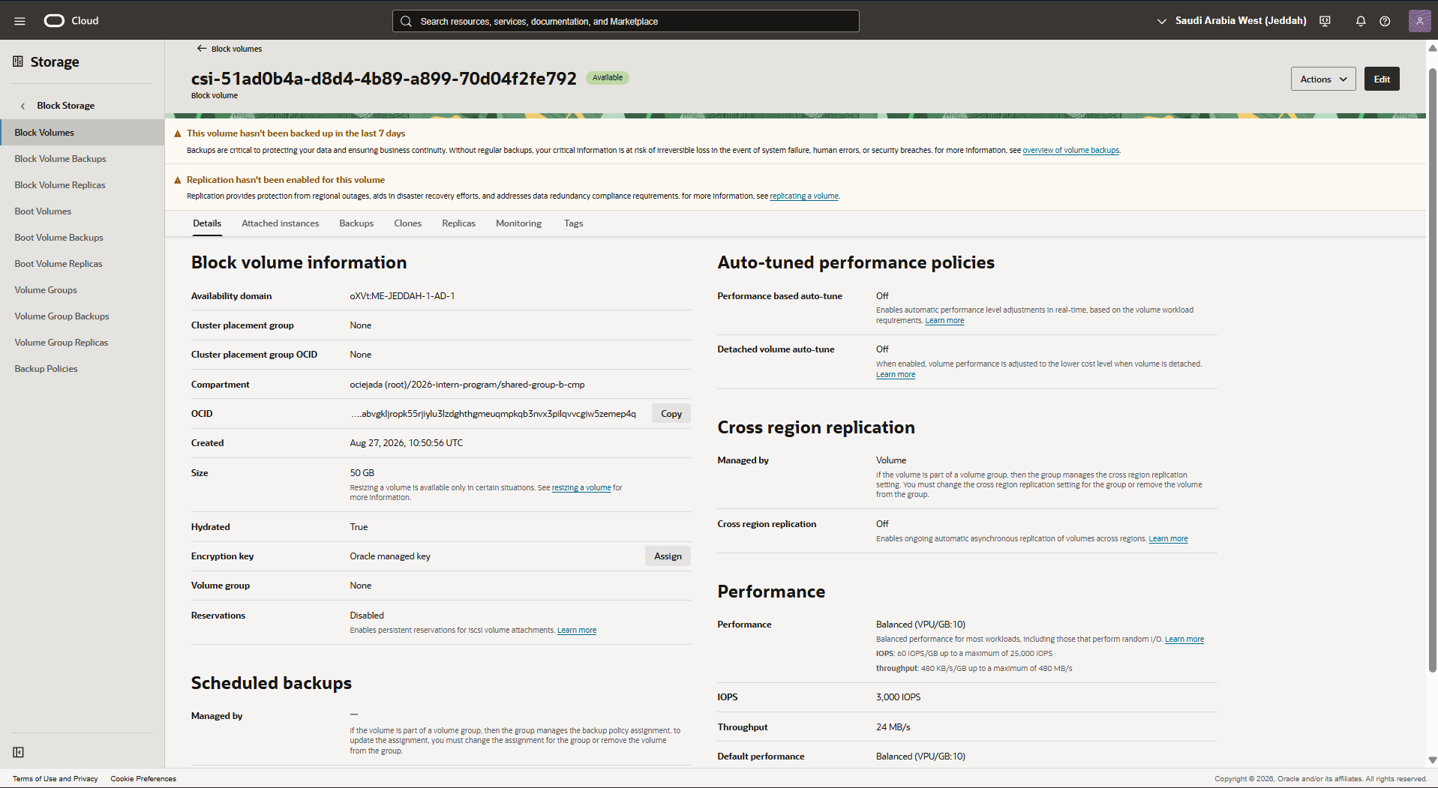
Highlights the block volume configuration details and performance metrics view. It outlines volume performance tiers (VPU/GB) and backup policy assignments.
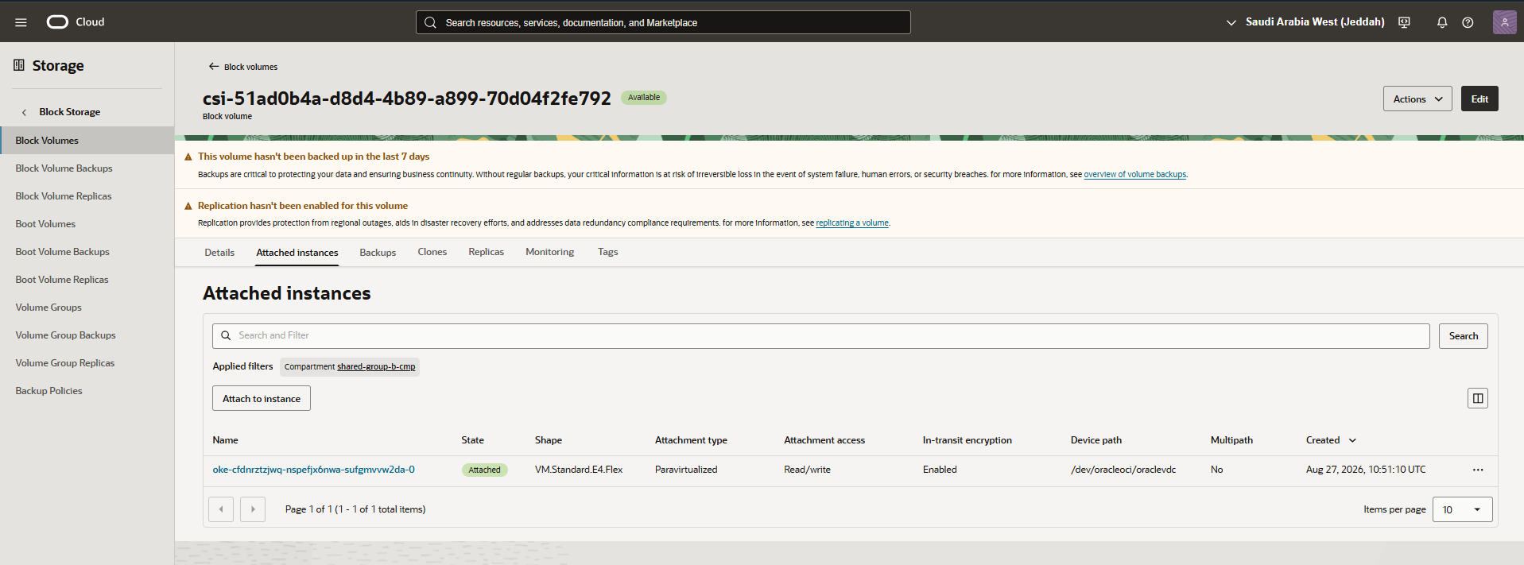
Shows the block volume attachment panel and storage assignment settings. It indicates the target compute instance, attachment type (iSCSI/Paravirtualized), and access mode.

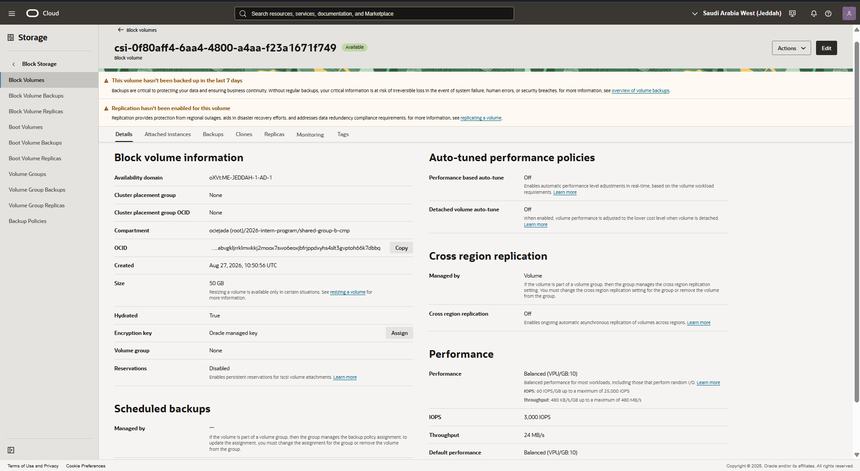
Presents block volume backup and replication status within the compartment. It details schedule executions, backup retention policies, and cross-region replication states.

Buckets
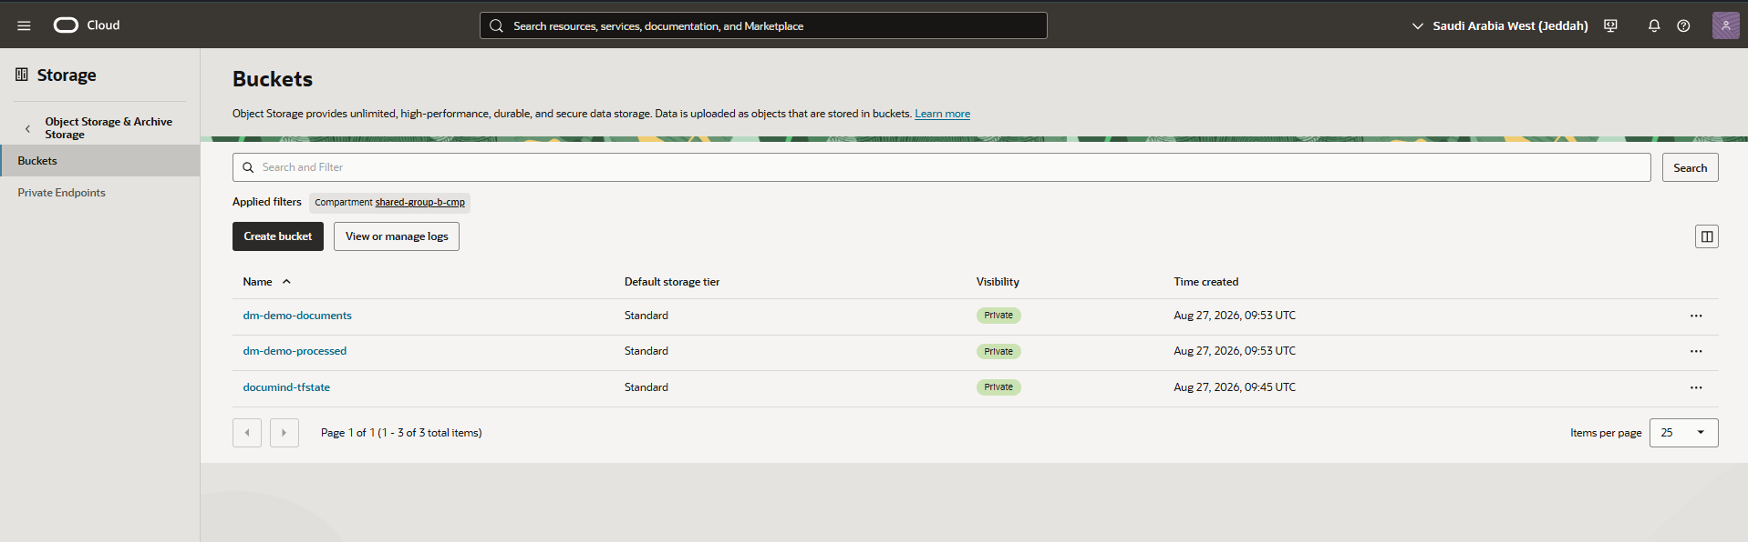
Displays the Object Storage Buckets overview within the selected compartment. It lists application buckets used for document ingestion and processing artifacts.

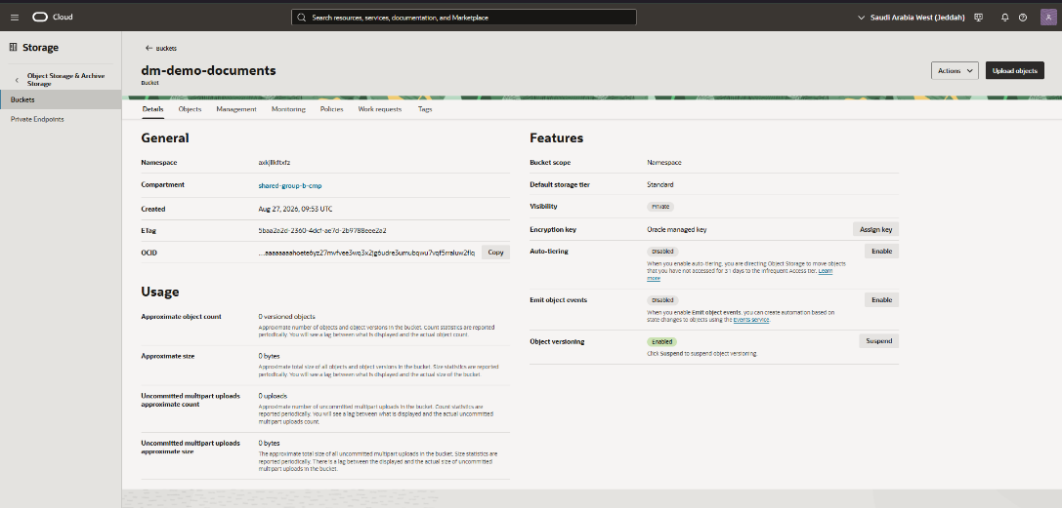
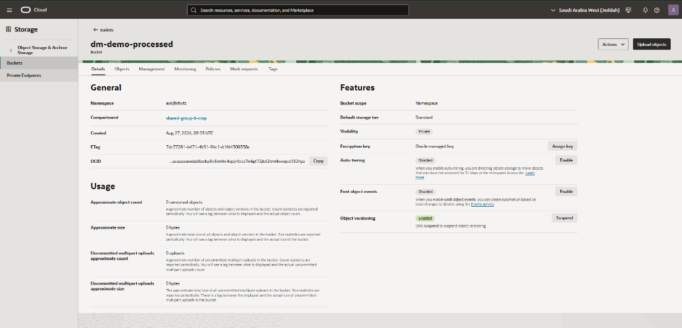
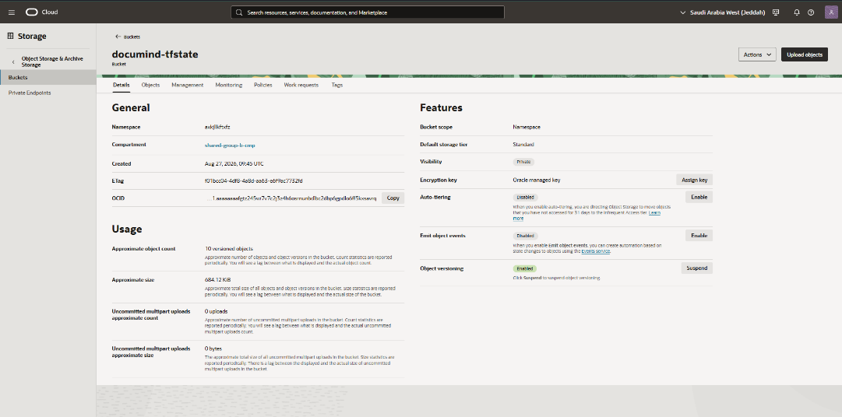
Displays the configuration, usage and features of all the created buckets for the deployment.

Containers
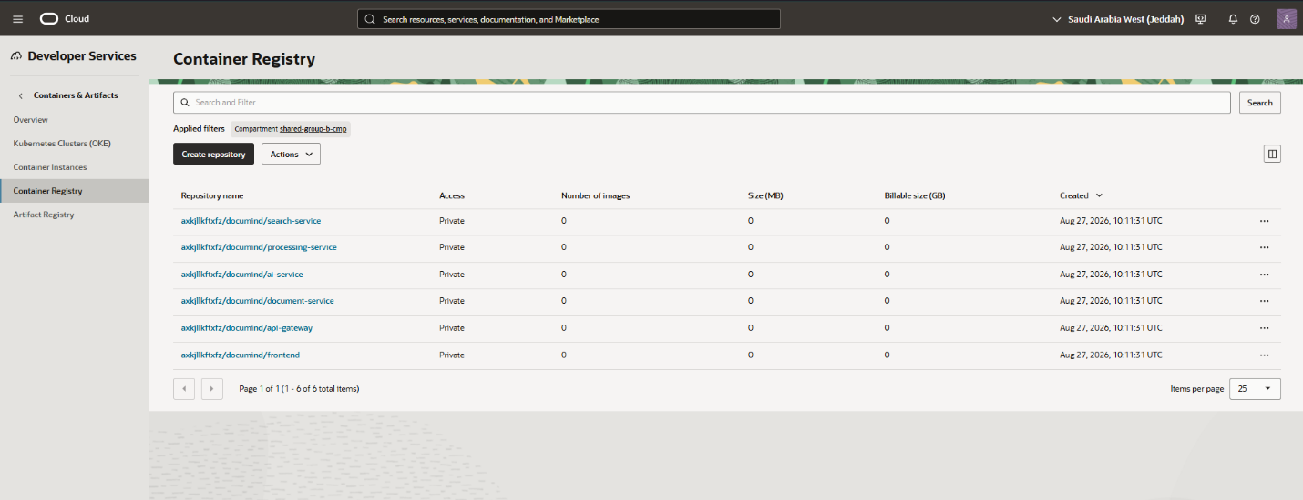
Presents the Oracle Cloud Infrastructure Registry (OCIR) container repository dashboard. It shows immutable image tags, scan statuses, and artifact repositories for microservice deployments.

Oracle Kubernetes Engine
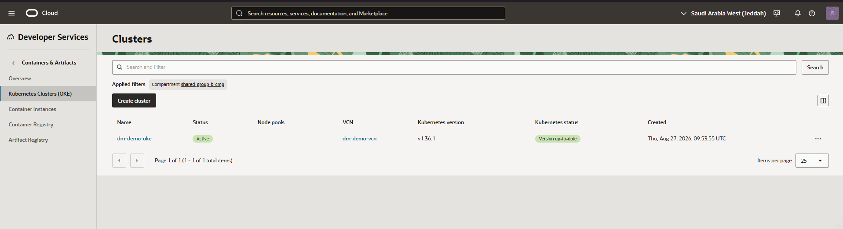
Displays the Oracle Kubernetes Engine (OKE) Clusters listing within the designated compartment. It shows the dm-demo-oke cluster in an Active state, running Kubernetes v1.36.1 and associated with the dm-demo-vcn.

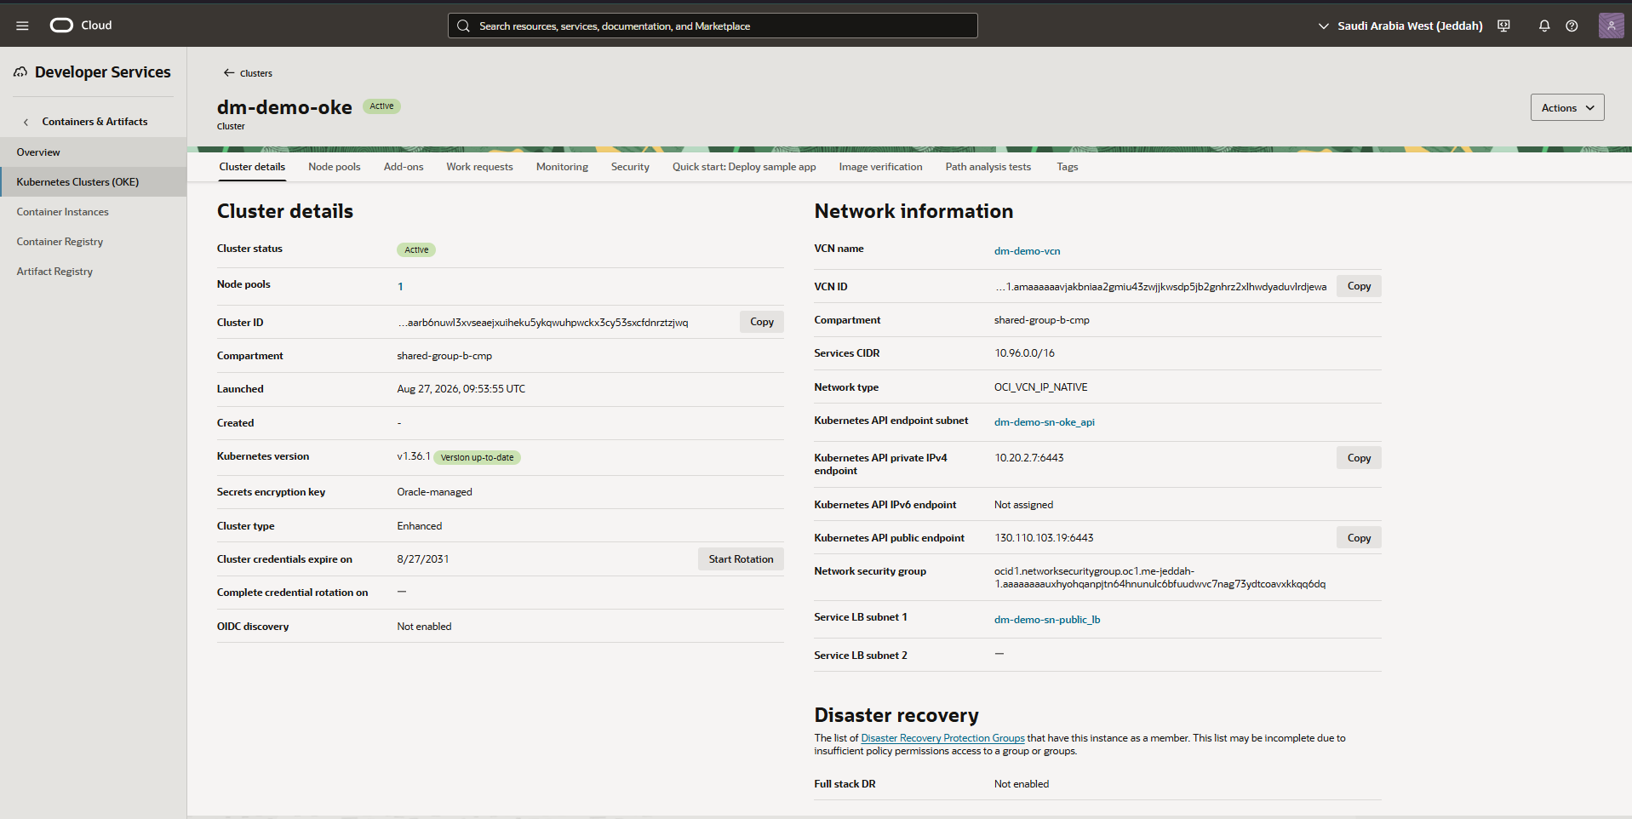
Shows the Cluster Details and Network Information for the dm-demo-oke cluster. It confirms the Kubernetes API endpoint configuration, Oracle-managed secrets encryption, and enhanced cluster type with associated network security groups and subnets.
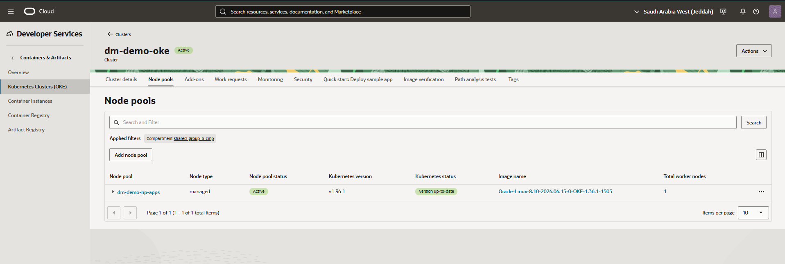
Presents the Node Pools listing for the dm-demo-oke cluster. It details the dm-demo-np-apps managed node pool running Kubernetes v1.36.1 with a single active worker node.

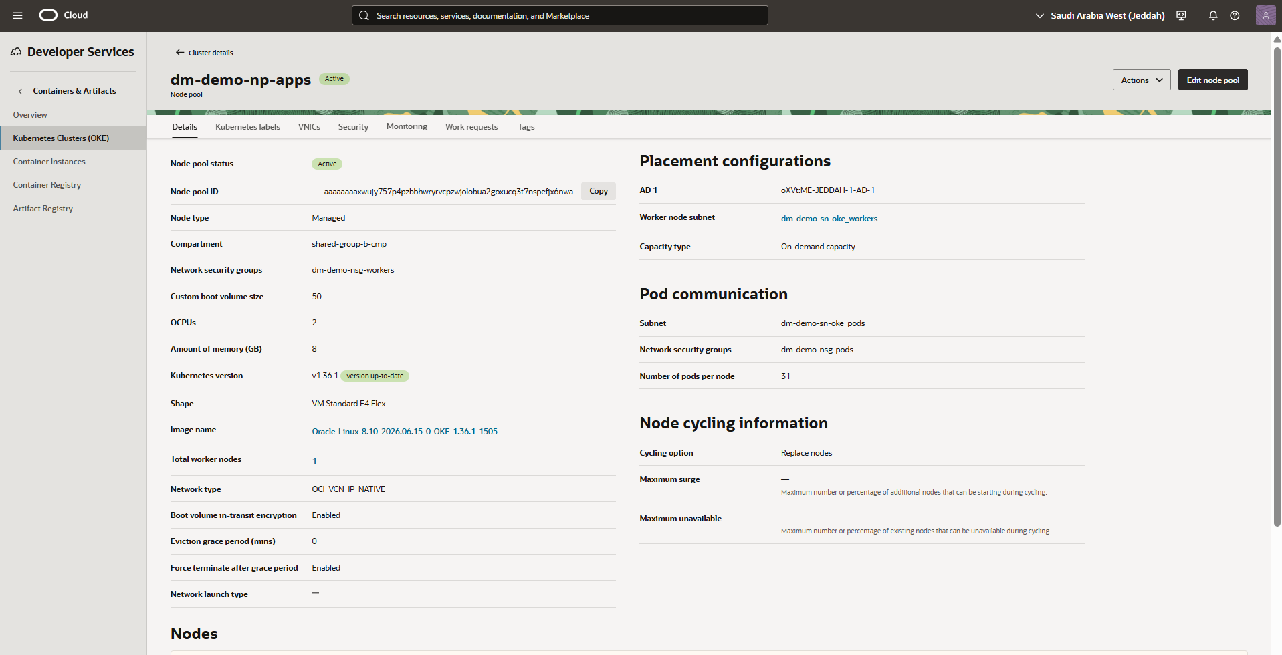
Displays the detailed configuration of the dm-demo-np-apps node pool, including placement, pod communication, and node cycling settings. It confirms the compute shape, associated subnets and NSGs for both worker nodes and pod communication, and node replacement cycling policy.
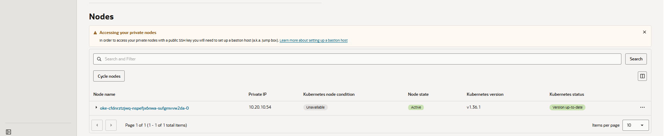
Shows the Nodes list for the dm-demo-np-apps node pool along with a bastion host advisory notice. It confirms the active worker node's private IP address and up-to-date Kubernetes version status.

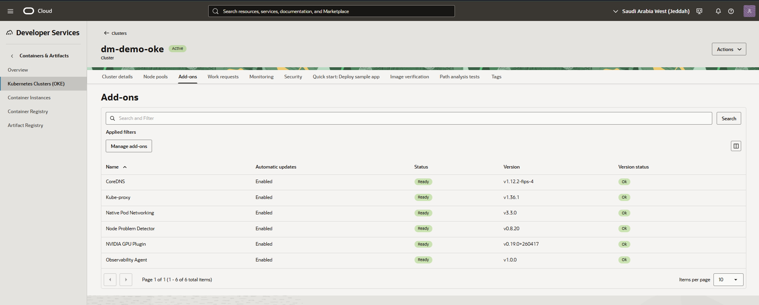
Presents the Add-ons management page for the dm-demo-oke cluster. It lists enabled add-ons including CoreDNS, Kube-proxy, Native Pod Networking, Node Problem Detector, NVIDIA GPU Plugin, and Observability Agent, all reporting a Ready status.

Kubernetes
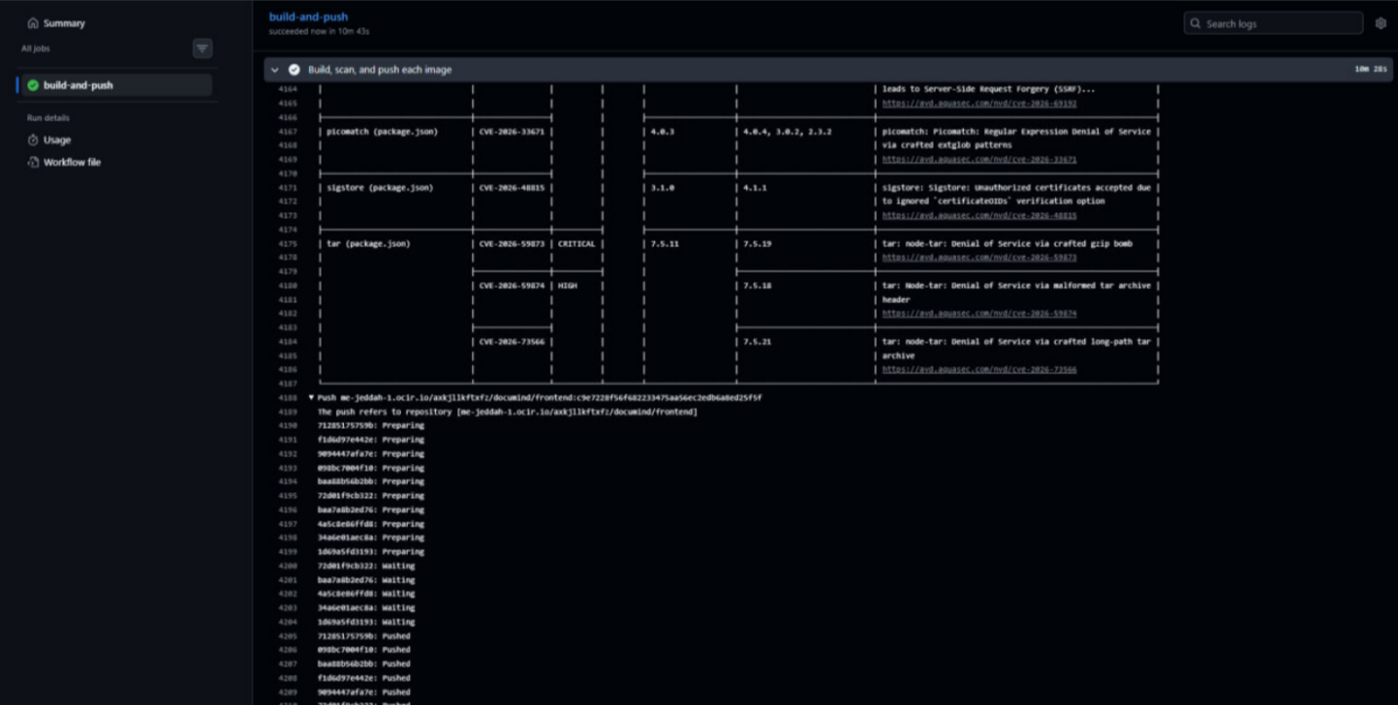
Displays the Oracle Kubernetes Engine (OKE) cluster summary dashboard. It details Kubernetes versioning, cluster state, and control plane endpoint configurations.

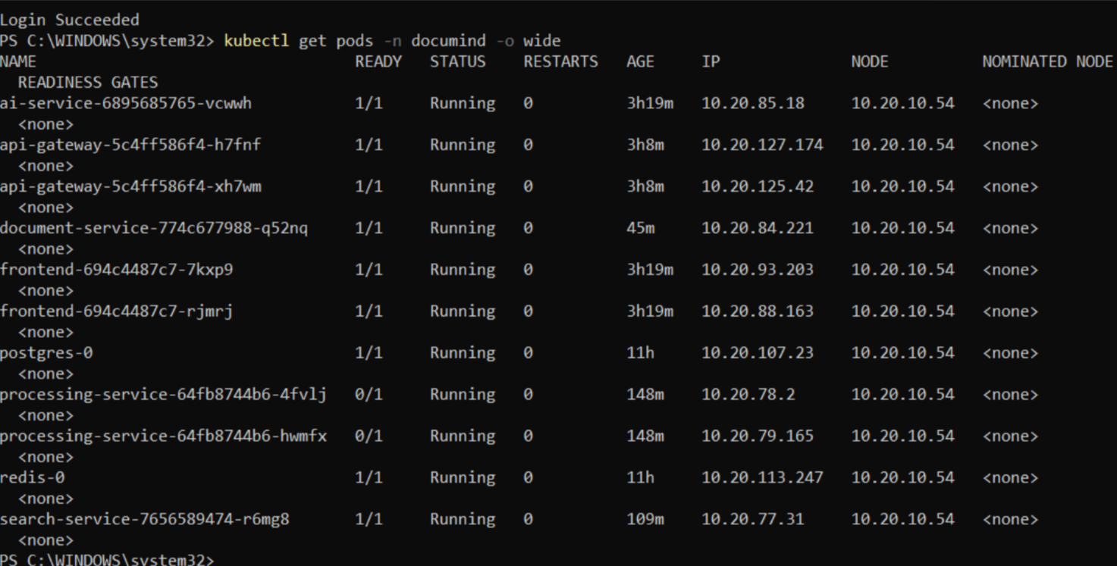
Shows the Node Pools configuration under the OKE cluster.
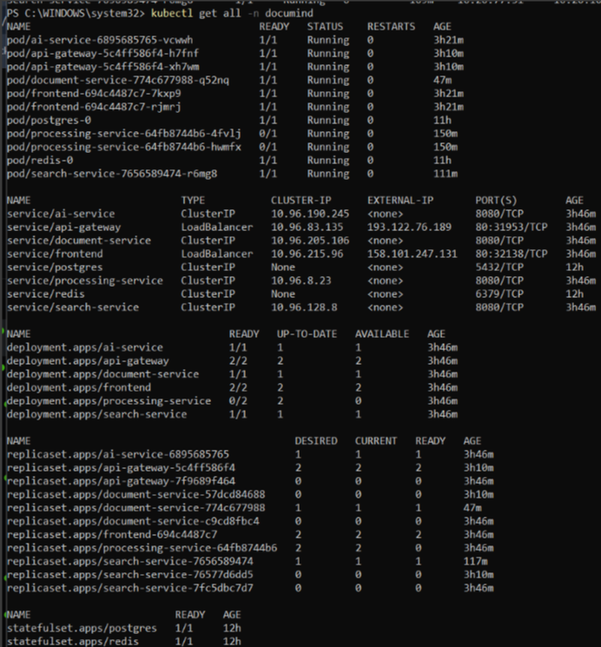
Presents the active deployments with health conditions and Kubernetes labels. It confirms private IP assignments and VCN-native CNI pod networking readiness.
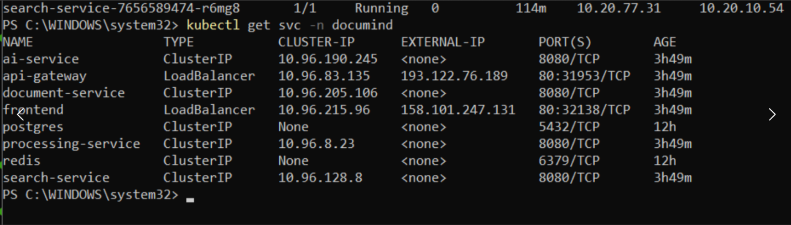
Displays deployed Kubernetes services the OKE cluster.

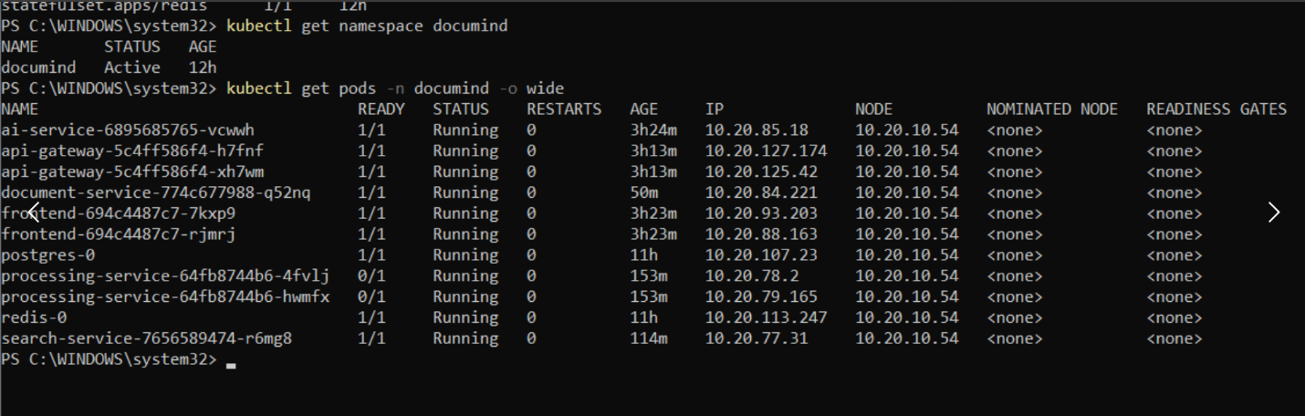
Shows Kubernetes pod health and container statuses.

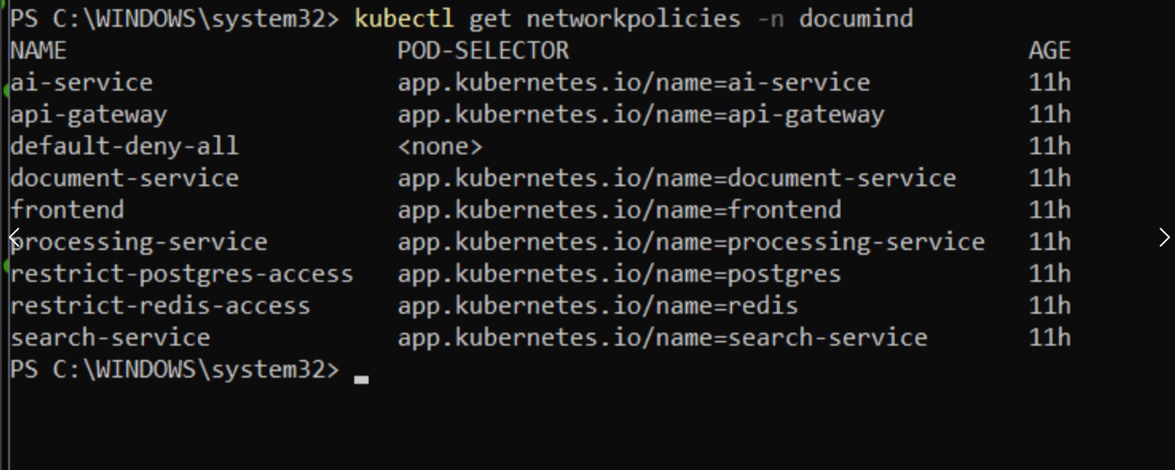
Highlights the Kubernetes Services and Ingress routing configuration. It demonstrates internal service networking and mapping to backend microservices.

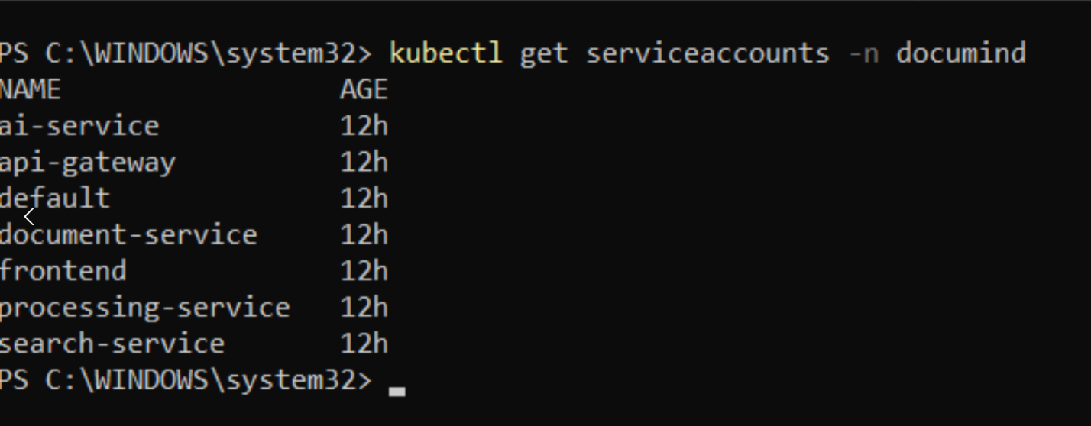
Presents all the ServiceAccounts in the namespace.

Load Balancer
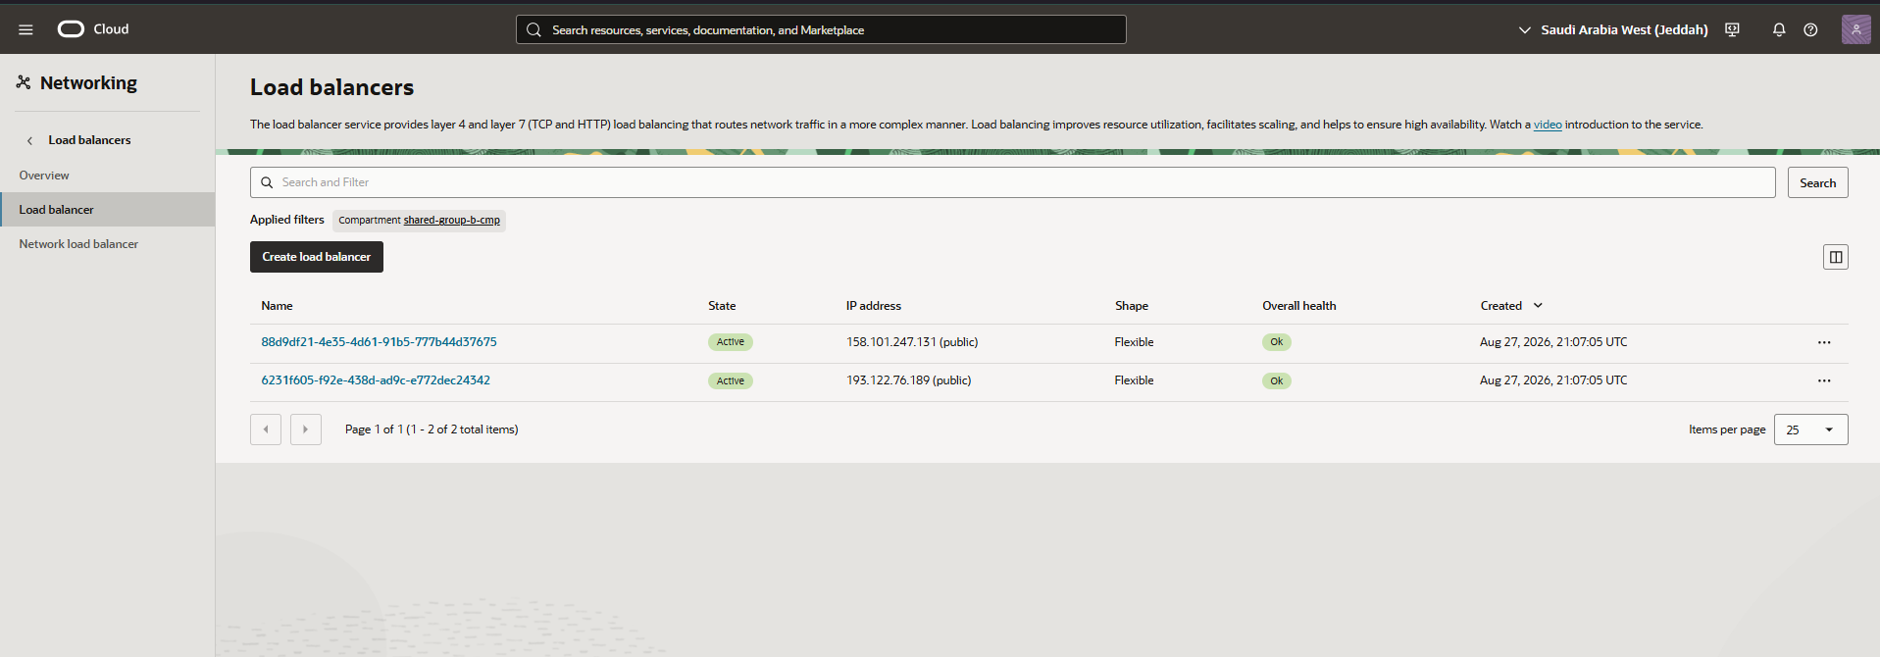
Displays the OCI Load Balancers overview dashboard. It outlines active flexible load balancer instances, provisioned bandwidth, and operational health.

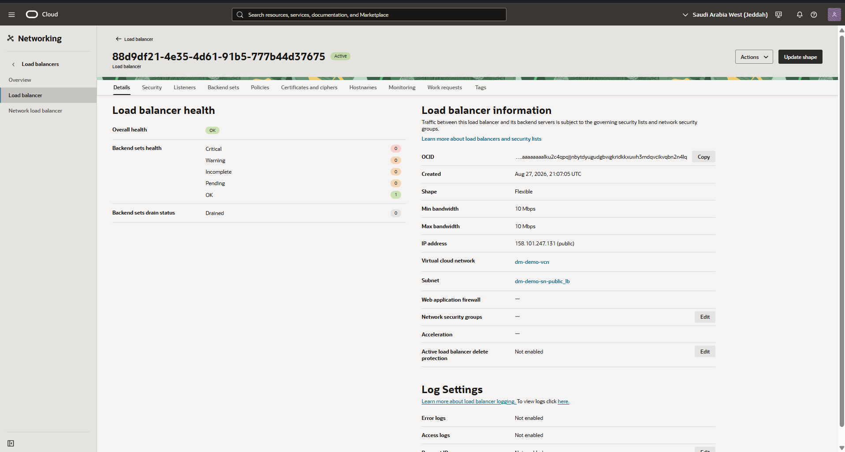
Shows the detailed view of the first application Load Balancer created via OKE Ingress. It displays public IP assignment, listener configurations, and port 443 HTTPS rules.

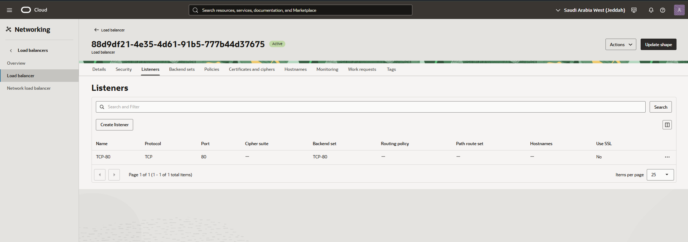
Shows the listener for the first load balancer.

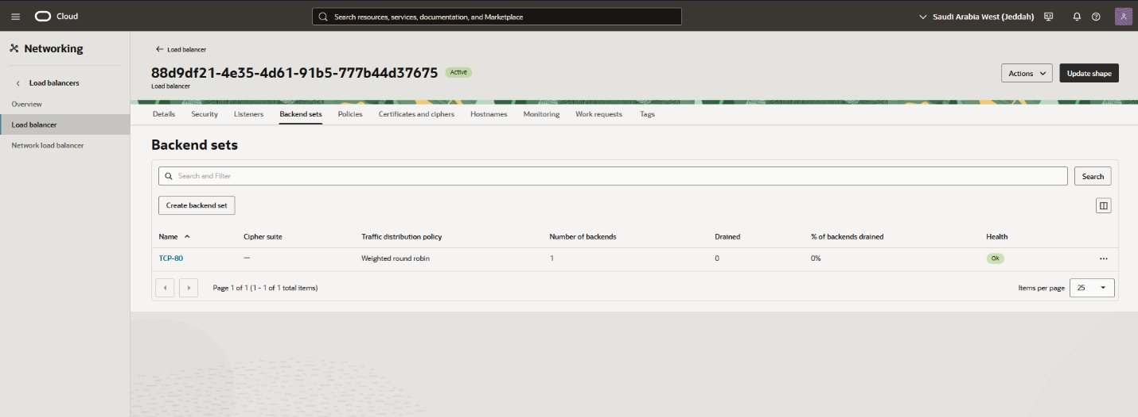
Presents backend sets for the first load balancer.

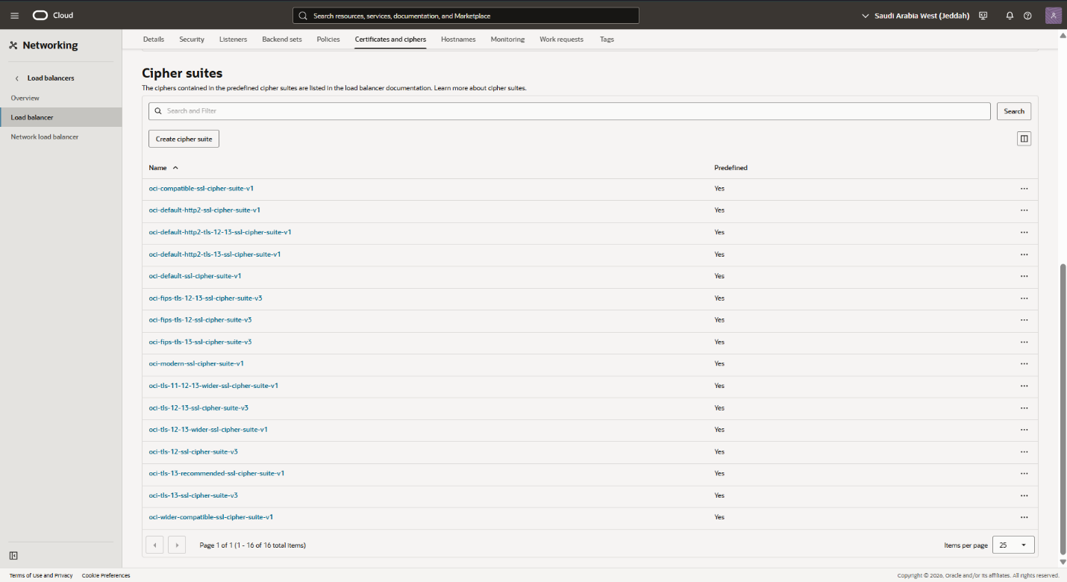
Shows the SSL/TLS cipher suites and certificate configuration on the load balancer listeners. It validates end-to-end transport security enforcement for public ingress.
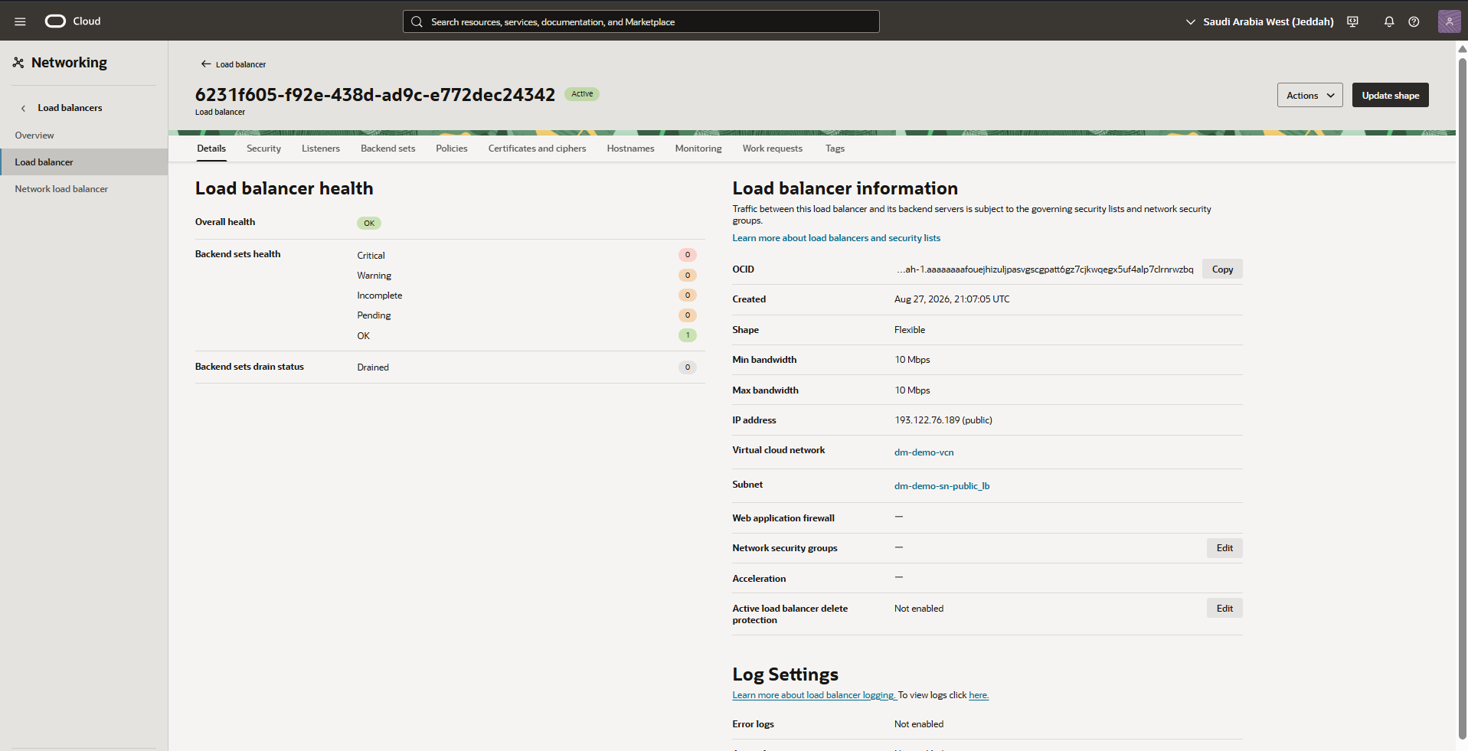
Shows the detailed view of the second application Load Balancer created via OKE Ingress. It displays public IP assignment, listener configurations, and port 443 HTTPS rules.

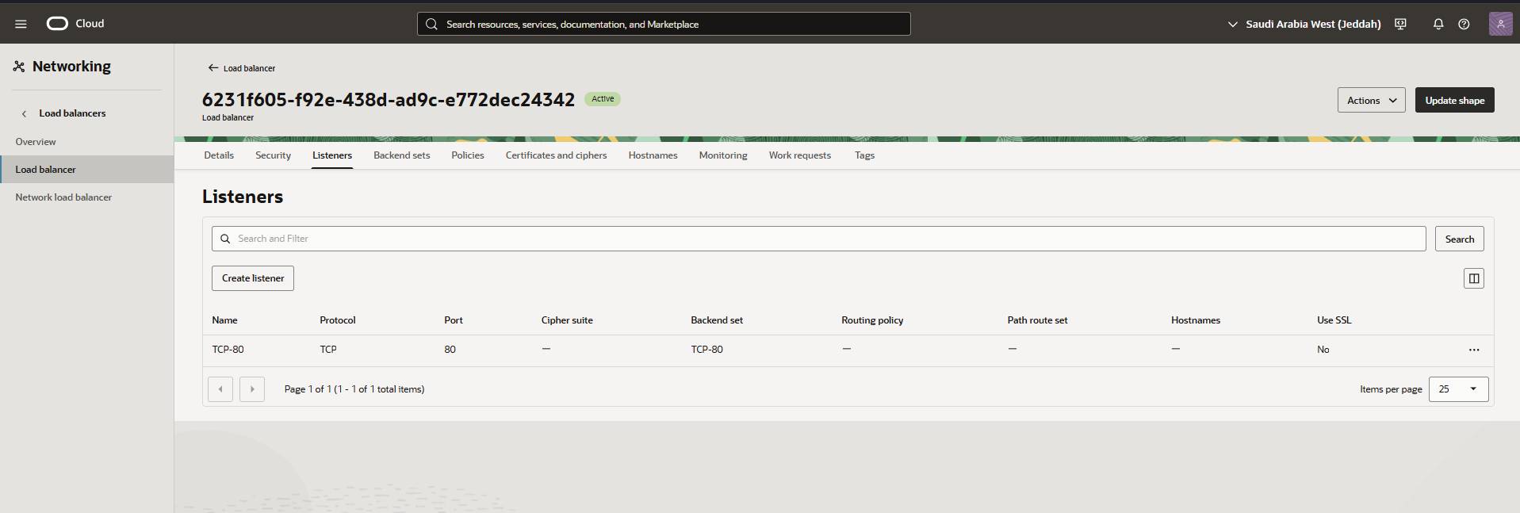
Shows the listener for the second load balancer.

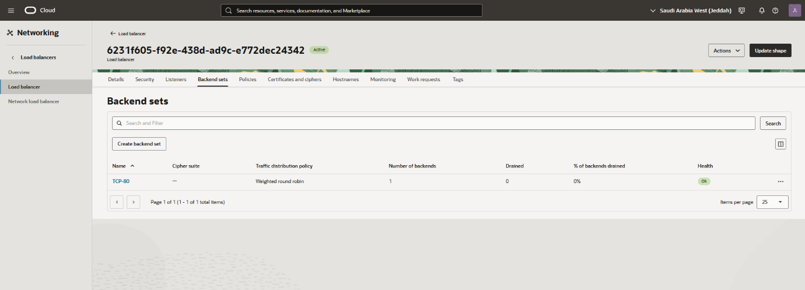
Presents backend sets for the second load balancer.

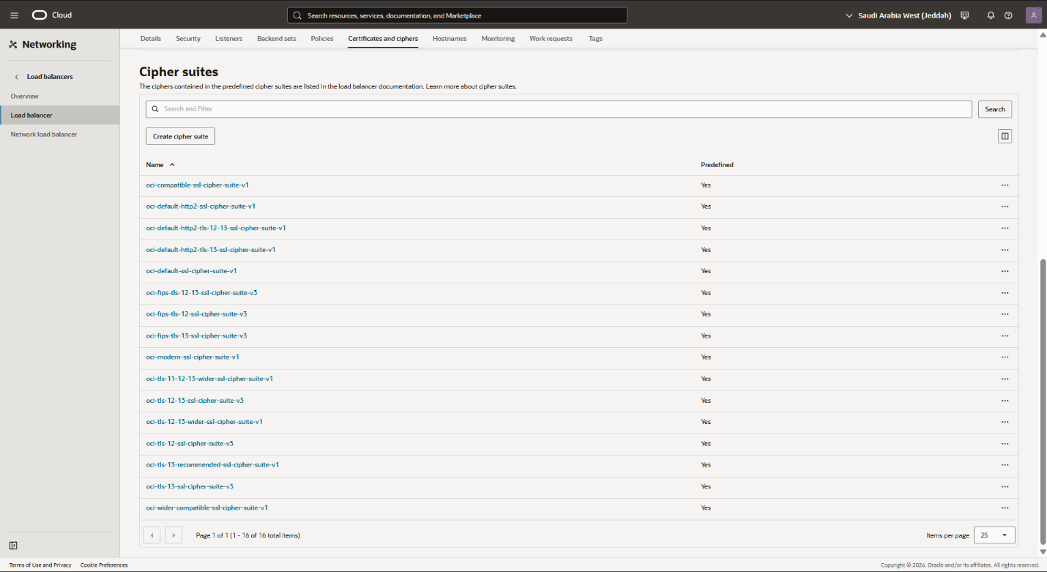
Shows the SSL/TLS cipher suites and certificate configuration on the load balancer listeners. It validates end-to-end transport security enforcement for public ingress.

Application User Interface
Login/register page:
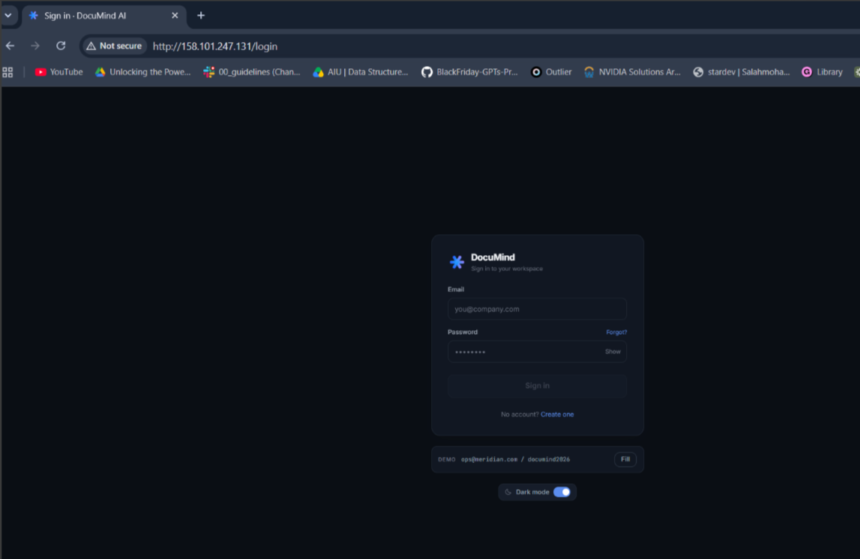
Dashboard:
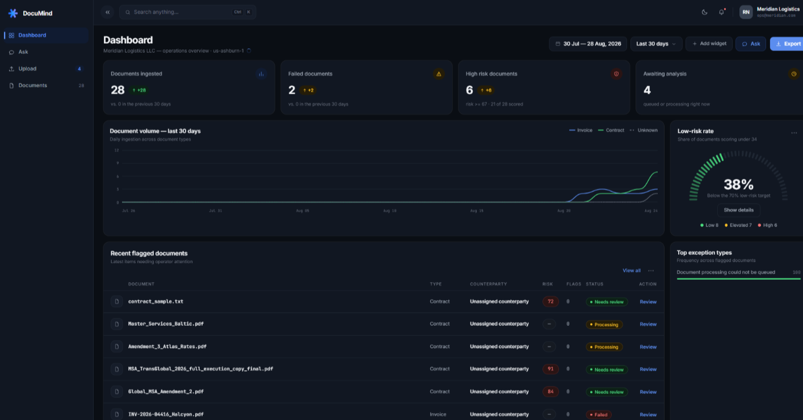
Document list:
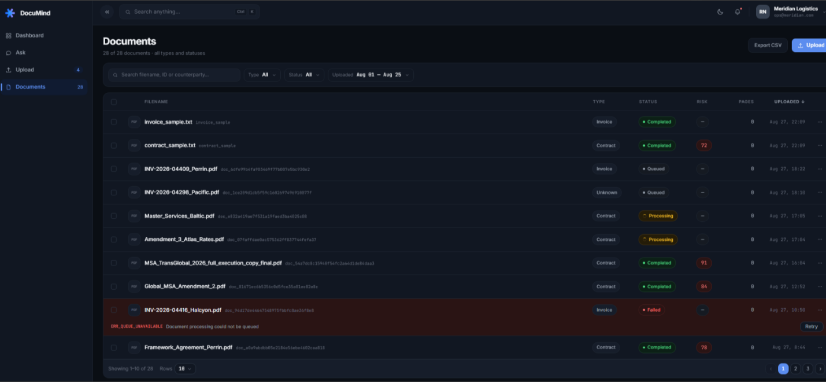

Document properties:
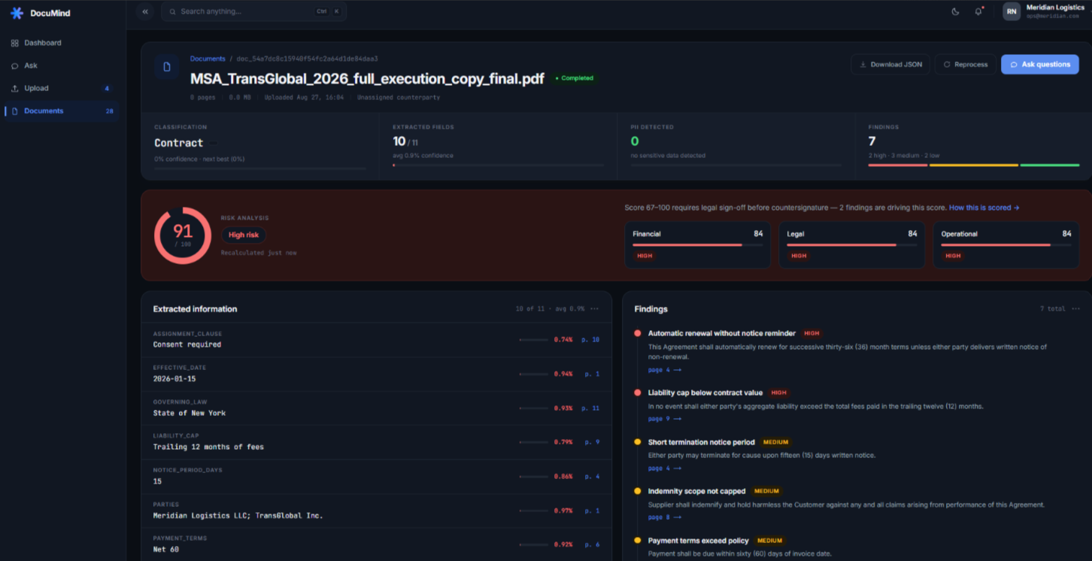

Question & Answer RAG:
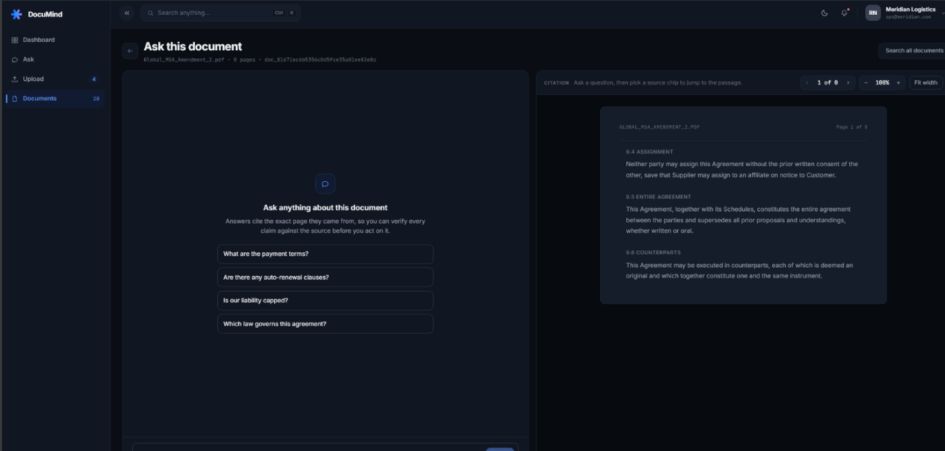

Light mode:
