# Salah Ud Din

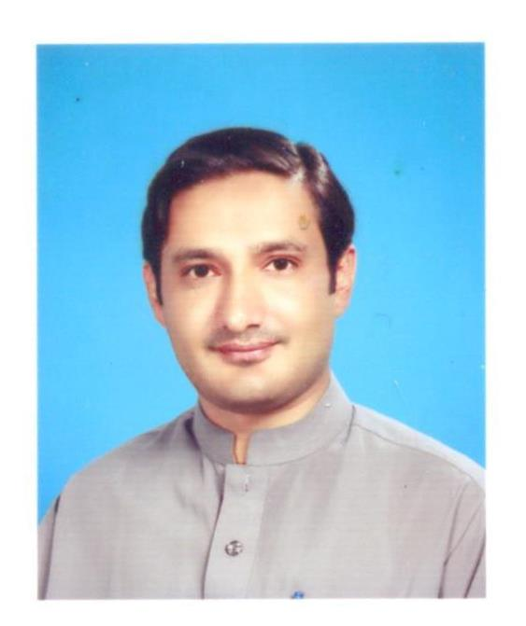

.

E-mail: salahuddin@ciit.net.pk

swati_pak2003@yahoo.com

Address: Village and P.O Guli Bagh Tehsil and District Mansehra (Pakistan).

Contact#: +923129680209

Nationality: Pakistani

NIC /Passport No: 13503-0525161-5 /AF5741612

Marital Status: Married

**OBJECTIVE:**

Seeking for the ideal professional environment in which to channel my creativity, innovation, enthusiasm and team spirit and to discover my qualities and capabilities that otherwise would remain dormant.

EDUCATION:

* **MS (CS) COMSATS** Institute of Information Technology Abbottabad, Pakistan

CGPA (3.69/4.0) 2013

* **M.Sc(Comp Sc)** Hazara University Mansehra, Pakistan 2006
* **B.Sc(Comp Sc)** University of Peshawar, Peshawar, Pakistan 2003

**PROFESSIONAL and RESEARCH EXPERIENCE***:*

* January 2014 to present: **Lecturer,** Department of Computer Science**, COMSATS** Institute of Information Technology Abbottabad, Pakistan.
* September 2013 to December 2014: **Secretary and member of Information Security and Image Processing Group(ISIP),** Department of Computer Science**, COMSATS** Institute of Information Technology Abbottabad, Pakistan.
* September 2013 to December 2013: **Visiting** **Lecturer,** Department of Computer Science**, COMSATS** Institute of Information Technology Abbottabad, Pakistan.
* September 2012 to June 2013: **Teaching Assistant,** Department of Computer Science**, COMSATS** Institute of Information Technology Abbottabad, Pakistan.
* June 2009 to May 2011: **Lecturer, Pakistan Group of Colleges Mansehra**, Pakistan.
* March 2006 to May 2009: **Lecturer, SAS College of Commerce Mansehra**, Pakistan.

**ADMINISTRATIVE EXPERIENCE:**

* Organizer of 12th and 13th International conference on Frontiers of Information Technology (FIT'14 and FIT15).
* September 2014 to September 2015: **Departmental Operating Officer (**Software Engineering Program), **COMSATS** Institute of Information Technology Abbottabad, Pakistan.

**Job Responsibilities:**

* Assist University administration in their administration work
* Supervision of all academic disciplines at every level.

**RESEARCH INTERESTS:**

* Image Processing, Computer Vision, Machine Learning, Document Image Analysis, Watermarking, Video Compression and Pattern Recognition.

**RESEARCH PUBLICATIONS:**

* **Salahuddin Swati**, Hayat K, Shahid Z (2014). “A Watermarking Scheme for High Efficiency Video Coding (HEVC)”. PLoS ONE 9(8): e105613. doi:10.1371/journal.pone. 0105613 (IF 3.73)
* Saeeda Naz, Arif I. Umar, Syed H. Shirazi, Muhammad M. Ajmal , **Salahuddin**. “The Optical Character Recognition for Cursive Scripts using HMM: A review". Research Journal of Applied Sciences, Engineering and Technology. 8(19): 2016-2025, 2014
* Saad Bin Ahmad, Saeeda Naz, **Salahuddin Swati**. “ UCOM a Offline dataset- a Urdu Handwritten dataset Generation”, The International Arab journal of Information Technology, Volume 14 ,Issue 2 , 2017. (IF 0.519)

**Conference/ Workshops Attended:**

* International conference on Frontiers of Information Technology (www.fit.edu.pk) from 2011 to 2015.
* Faculty Development workshop(FDW) from 24-28, Feb 2014 In COMSATS Institute of IT Abbottabd.
* Training workshop(iPakitan) of CS faculty in Serena Hotel Islamabad from 26-27, Nov 2016.

**Teaching:**

Fall 13:

1. Discrete Structures
2. Algorithms and Data Structures

Spring 14:

1. Introduction to computers and Programming
2. Design and Analysis of Algorithms
3. Professional Practices in IT

Fall 14:

1. Object Oriented Programming

Spring 15:

1. Object Oriented Programming

Fall 15:

1. Discrete Structures
2. Introduction to Computers and Programming
3. Operating System Concepts

Spring 16:

1. Discrete Structures
2. Algorithms and Data Structures

Fall 16:

1. Discrete Structures
2. Introduction to Computer Programming

**HONORS, AWARDS AND SCHOLARSHIPS:**

* COMSATS scholarship for MS at COMSATS Institute of Information Technology, Abbottabad, Pakistan, 2011.
* Best Teacher Award, Pakistan Group of Colleges Mansehra, Pakistan 2009 and 2010.
* Best Teacher Award, SAS College of commerce Mansehra, Pakistan 2008.
* Research Productivity Award, CIIT, Islamabad, Pakistan, 2015

**PROFESSIONAL PROFILE:**

* Young enthusiastic, energetic, devoted and motivated.
* Have excellent written and oral communication skills.
* Able to work under high pressure and tough environment.

**LANGUAGES:**

* English
* Urdu

**REFERENCES:**

|  |  |
| --- | --- |
| **Dr. Khizar Hayat**   * HoS & Associate professor * Mathematical and Physical Sciences - Computer Sciences Section College of Arts and Sciences (University of Nizwa Oman) * Telephone: (+968)25446297 * eMail: [khizar.hayat@unizwa.edu.om](mailto:khizar.hayat@unizwa.edu.om) | **Dr. Imran Ali Khan**   * Associate professor * COMSATS Institute of Information Technology Abbottabad, Pakistan * Telephone: (+92)3335483662 * eMail: [imran@ciit.net.pk](mailto:imran@ciit.net.pk) |