INTERNSHIP REPORT
AI-ML Internship - ICT ACADEMY OF KERALA
SUBMITTED BY:
Aiswarya V
Mathew Jacob
Salahudheen C

TUBERCULOSIS SMART - DETECTION

INTRODUCTION
Tuberculosis (TB) continues to be one of the most challenging infectious diseases worldwide, with the WHO Global TB Report 2024 estimating 10.6 million new cases and 1.3 million deaths in the past year. Despite medical advancements, TB remains highly prevalent in low- and middle-income countries where early detection is limited by inadequate resources and shortage of radiologists. India carries the highest global TB burden, accounting for nearly 27–28% of all reported cases, with over 2.8 million cases annually. Although the National Tuberculosis Elimination Programme (NTEP) aims for TB eradication by 2025, challenges such as delayed diagnosis, uneven access to radiology services, and high patient load continue to hamper progress. As chest X-ray remains one of the fastest and most cost-effective screening tools, there is a strong need for automated solutions to support rapid and accurate diagnosis.
Kerala, one of India’s most health-advanced states, records approximately 18,000–20,000 TB cases every year according to the Kerala TB Report 2024. Districts like Ernakulam, Kozhikode, Malappuram, and Thiruvananthapuram report a significant share of cases, with increasing incidence among migrant workers and tribal communities. Although Kerala has a strong public health infrastructure, the availability of trained radiologists still falls short of the growing diagnostic demand. Early detection is crucial because TB symptoms often resemble common respiratory infections, making many cases go unnoticed. This scenario highlights the importance of integrating AI-driven TB detection systems using deep learning models like DenseNet121 to automate chest X-ray interpretation. Such technology enhances diagnostic accuracy, reduces workload on radiologists, and supports Kerala, India, and the global community in accelerating TB control and elimination efforts.

TABLE OF CONTENTS
Chapter No. | Chapter Title | Page No.
Abstract | Abstract | i–ii
Chapter 1 | Introduction | 1–4
1.1 | Introduction (TB Overview & Scenario) | 1
1.2 | Scope of the Work | 3
Chapter 2 | Background of the Work | 5–12
2.1 | Definition of the Problem | 5
2.2 | Basic Biology Related to the Problem | 7
2.3 | Computational Approaches | 9
2.4 | National & International Status | 10
2.5 | Challenges | 12
Chapter 3 | Review of Literature | 13–18
3.1 | Paper 1: Deep Learning-Based TB Detection | 14
3.2 | Paper 2: MobileNet for Low-Resource Areas | 15
3.3 | Paper 3: Explainable AI for TB | 16
3.4 | Paper 4: WHO CAD Tools | 17
3.5 | Paper 5: Comparison of DL Models | 18
Chapter 4 | Materials | 19–22
4.1 | Dataset Description | 19
4.2 | Tools & Technologies Used | 21
Chapter 5 | Methodology | 23–30
5.1 | Workflow Diagram | 24
5.2 | Preprocessing, Training & Model Steps | 25
5.3 | Explainable AI (GradCAM & LIME) | 28
5.4 | Deployment (FastAPI & React) | 30
Chapter 6 | Results & Discussion | 31–38
6.1 | Model Performance | 32
6.2 | GradCAM & LIME Results | 35
6.3 | Frontend Output Screens | 37
Chapter 7 | Conclusion & Future Scope | 39–41
References | References | 42+

ABSTRACT
Tuberculosis (TB) remains one of the most critical public health challenges, particularly in developing regions where early diagnosis is limited by inadequate medical infrastructure and shortage of trained radiologists. Chest X-ray imaging is one of the most widely used and cost-effective screening methods for detecting pulmonary TB, but manual interpretation often results in diagnostic delays and variability in accuracy. This project aims to develop an automated TB detection system using a deep learning model based on DenseNet121, trained on a publicly available chest X-ray dataset. The system classifies images into TB and Normal categories after appropriate preprocessing, augmentation, and model optimization.
To enhance the clinical reliability of the predictions, Explainable AI (XAI) techniques such as Grad-CAM and LIME are integrated to highlight the specific lung regions influencing the model’s decision. The complete solution is deployed using a FastAPI backend and React-based frontend, allowing real-time, accessible TB screening through a web interface. Experimental results demonstrate high accuracy and strong generalization capability, showing the potential of AI-based systems to support radiologists, improve early TB detection, and strengthen public health screening efforts. Future enhancements include expanding the dataset, integrating segmentation for lesion localization, and deploying the model on mobile or edge devices for wider accessibility.
SCOPE OF WORK
The scope of this project is to design and develop a complete AI-powered TB detection system capable of analyzing chest X-ray images and classifying them into TB or Normal categories with high accuracy. The project integrates the following components:
- Preprocessing and augmentation of chest X-ray images
- Training a DenseNet121 deep learning model for binary classification
- Evaluating model performance using accuracy, loss, and confusion matrix
- Incorporating Explainable AI using Grad-CAM and LIME
- Implementing a FastAPI backend for prediction services
- Developing a React frontend for real-time user interaction
- Deploying the system using Render and Netlify for online accessibility
This project ultimately aims to provide a reliable, accessible, and interpretable AI-based TB screening tool that supports radiologists, reduces diagnostic delays, and contributes to the broader goal of TB control in Kerala, India, and globally.

Chapter 2: Background of the Work

2.1 Definition of the Problem
Tuberculosis (TB) diagnosis primarily relies on chest X-ray imaging, one of the most widely used and cost-effective screening tools in hospitals, community health centers, and mobile health units. However, manual interpretation of X-rays requires experienced radiologists and is subject to human limitations such as fatigue, variations in expertise, high workload, and inconsistencies across healthcare settings. Subtle abnormalities such as early opacities, small nodules, or localized lesions are often difficult to detect, especially in busy public hospitals. In regions like Kerala and other Indian states, the number of radiologists is insufficient compared to the population size and diagnostic demand, leading to delays in screening and under-diagnosis.
Therefore, the core problem addressed in this project is:
“How can chest X-ray images be automatically classified into TB and Normal categories using advanced AI techniques with high accuracy, consistency, and explainability, to support radiologists and improve early detection?”
A secondary problem involves ensuring that the system is:
- Fast and efficient
- Scalable for large populations
- Accessible online
- Transparent and medically interpretable
- Suitable for real-world deployment in healthcare environments

2.2 Basic Biology Related to the Problem
Tuberculosis is a contagious infectious disease caused by the bacterium Mycobacterium tuberculosis, primarily affecting the lungs. Once inhaled, the bacteria invade lung tissues, causing inflammation, nodules, and lesions. Over time, TB can destroy lung structure, creating cavities and consolidations that are visible in chest X-ray images.
Radiological signs of TB include:
- Hilar or mediastinal lymph node enlargement
- Apical opacities
- Cavitation in the upper lung regions
- Patchy consolidations
- Nodular shadows or infiltrates
In contrast, a normal chest X-ray presents:
- Clear lung fields
- Uniform rib structure
- No abnormal opacities or shadows
- Healthy diaphragm and mediastinum
Deep learning models learn these patterns automatically from thousands of images, enabling them to detect TB-related changes even when they are subtle or hard to identify visually.

2.3 Computational Approaches Relevant to TB Detection
Traditional machine learning techniques—such as Support Vector Machines (SVM), Random Forests, and logistic regression—have been used for TB detection but are limited by their reliance on handcrafted features. These features often fail when dealing with high variability in X-ray quality, patient anatomy, and disease severity.
Deep learning, especially Convolutional Neural Networks (CNNs), has transformed medical image analysis. Models like ResNet, DenseNet, MobileNet, and EfficientNet have demonstrated superior capability in extracting complex patterns from medical images. DenseNet121, used in this project, offers strong feature propagation, reduced parameter count, and excellent performance even with limited datasets — making it highly suitable for TB classification.
Explainable AI methods such as Grad-CAM and LIME further strengthen the diagnostic value by visually highlighting the X-ray regions that influenced the model’s decision.

2.4 National and International Status
Globally, TB remains a leading infectious disease, with the WHO Global TB Report 2024 reporting 10.6 million new cases and 1.3 million deaths last year. Many countries in Africa, Southeast Asia, and Eastern Europe face growing TB challenges due to limited health infrastructure and rising drug-resistant strains.
India contributes nearly 27–28% of global TB cases, with over 2.8 million cases annually. Despite major national programs, the country still faces diagnostic delays, particularly in rural and tribal regions.
Kerala reports 18,000–20,000 TB cases every year, with strong public health reporting but persistent challenges among high-risk groups such as migrants and remote communities. These statistics demonstrate the critical need for automated, scalable, AI-driven diagnostic systems.

2.5 Challenges
TB detection using chest X-rays presents several challenges:
- Variation in X-ray machines (quality, contrast, resolution)
- Presence of artifacts such as shadows, blur, or noise
- Imbalanced datasets, with fewer TB images compared to Normal images
- Subtle early-stage abnormalities that are difficult to detect
- Requirement for clinical explainability and transparency
- Deployment challenges in terms of speed, reliability, and availability
These challenges emphasize the importance of robust preprocessing, strong model architecture, explainable AI, and efficient deployment — all of which are addressed in this project.

Chapter 3: Review of Literature

3.1 Hybrid Explainable Deep Learning with Grad-CAM (Ayalew et al., 2025)
The study by Ayalew et al. (2025) proposes a highly advanced hybrid method for TB detection by integrating CNN, HOG features, BM3D denoising, and Quantum SVM classification, combined with Grad-CAM for explainability. The model achieves 98.14% testing accuracy and provides detailed activation heatmaps highlighting TB-affected lung regions. This work strongly supports the need for hybrid AI systems and XAI for clinical trust, making it a key reference for AI-driven TB screening.
s10791-025-09791-z

3.2 Deep Learning for TB Detection Using DenseNet Architectures (Lakhani & Sundaram, 2017)
This foundational work evaluates multiple CNN architectures for TB detection, with DenseNet achieving one of the highest accuracies (≈95%) on the Shenzhen and Montgomery datasets. DenseNet’s dense connectivity enables efficient feature reuse, making it particularly effective on medical X-rays. This supports the selection of DenseNet121 in our project for high-accuracy classification.

3.3 MobileNet-Based TB Detection for Resource-Limited Settings (Rahman et al., 2020)
Rahman et al. propose a lightweight MobileNet model optimized for mobile deployment in developing regions. The model achieves over 90% accuracy, showing that smaller architectures are suitable for smartphone-based TB screening. This highlights the importance of portable, low-cost deployment — an idea extended in our work’s future scope.

3.4 Vision Transformer and EfficientNet for Multi-Class Chest Disease Classification (Duong et al., 2023)
Duong et al. introduce a hybrid EfficientNet + Vision Transformer architecture to classify TB, pneumonia, and normal lungs. Despite class imbalance, their approach reaches 97.72% accuracy. This study shows that modern architectures can tackle multi-disease classification and motivates expanding our model beyond binary TB detection in future work.

3.5 TB-UNet: Segmentation-Based TB Diagnosis (Jaiswal et al., 2022)
A segmentation-oriented approach using TB-UNet, combining dilated and attention modules, has shown IoU > 0.80 and accuracy ~97% for lung lesion localization. Unlike pure classifiers, this method segments abnormal areas, suggesting future upgrades for our work through segmentation-guided TB localization.

3.6 Explainable AI for Medical Imaging (Selvaraju et al., 2017 – Grad-CAM)
Selvaraju’s original Grad-CAM paper introduced gradient-weighted class activation mapping as an XAI tool for CNN interpretation. It has since become a standard in medical AI. This foundational technique supports our project’s integration of Grad-CAM to visualize critical lung regions contributing to TB predictions.

3.7 Classical ML Approaches for Early TB Detection (Andayani et al., 2019)
Prior to deep learning dominance, methods such as Probabilistic Neural Networks (PNN) and GLCM + SVM achieved ~96% accuracy on small datasets. Although less powerful than CNNs, these works underline the historical evolution toward automated TB classification and highlight the limitations of classical feature-engineering approaches.

3.8 Multi-Dataset TB Classification with Transfer Learning (Hooda et al., 2021)
Hooda et al. analyzed multiple CNNs using transfer learning on three chest X-ray datasets, demonstrating that pretrained models significantly outperform training from scratch. This supports our strategy of using pretrained DenseNet121 for improved accuracy with limited TB data.

3.9 CAD-Based TB Screening Practices Approved by WHO (2019–2024)
The World Health Organization endorses Computer-Aided Detection (CAD) tools for TB screening in high-burden countries. Studies show CAD systems achieve 90–95% sensitivity, comparable to expert radiologists. This international validation highlights the global need for AI-driven TB detection systems like the one developed in this project.

Chapter 4: Materials

4.1 Dataset Description
https://www.kaggle.com/datasets/tawsifurrahman/tuberculosis-tb-chest-xray-dataset
The dataset used in this project consists of publicly available chest X-ray images collected from the Kaggle Tuberculosis (TB) Chest X-ray Dataset and similar open-source repositories curated for TB research. The dataset contains two major classes:
- TB (Tuberculosis-Positive)
- Normal (Healthy Lungs)
In total, the dataset includes approximately 3,500+ chest X-ray images, with a balanced distribution achieved through augmentation. The images exhibit variations in:
- Image resolution
- Illumination and contrast
- Presence of noise, shadows, and artifacts
- X-ray machine type and acquisition conditions
Before training, all images were:
- Resized to 224 × 224 pixels to match DenseNet121 input requirements
- Normalized for pixel value stability
- Augmented using rotations, flips, zoom, and brightness shifts to address class imbalance and improve generalization
- Split into training, validation, and testing sets (70% – 15% – 15%)
This preprocessing ensures that the model learns robust and clinically relevant visual features.

4.2 Tools and Technologies Used
To build a complete end-to-end TB detection system, this project integrates multiple software tools, deep learning frameworks, and deployment technologies.

4.2.1 Programming Languages
- Python – Deep learning model development, training, preprocessing, and backend
- JavaScript (ReactJS) – Frontend development for user interface

4.2.2 Deep Learning & ML Libraries
- PyTorch – Primary deep learning framework used to implement DenseNet121
- Torchvision – Pretrained DenseNet model, image transforms
- Scikit-Learn – Evaluation metrics and preprocessing utilities
- LIME – Local Interpretable Model-agnostic Explanations for prediction interpretability
- Grad-CAM – Visualization of important X-ray regions influencing the model’s decision

4.2.3 Image Processing Tools
- OpenCV – Image preprocessing (resizing, filtering, noise removal)
- PIL (Python Imaging Library) – Image loading and transformation operations

4.2.4 Backend Development Tools
- FastAPI – Handles prediction requests and Grad-CAM/LIME generation
- Uvicorn – ASGI server for running FastAPI applications
- Render – Cloud hosting platform used to deploy the backend model

4.2.5 Frontend Development Tools
- ReactJS – User interface for uploading images and viewing results
- Axios – API request handling between frontend and backend
- Netlify – Hosting platform for deploying the frontend web application

4.2.6 Hardware & Training Environment
Model training was performed on:
- GPU-enabled systems (Google Colab / local GPU)
- CUDA and cuDNN for hardware acceleration
- 8–12 GB RAM for training stability

4.2.7 Additional Tools
- GitHub – Version control and repository for code
- Jupyter Notebook / Colab – Experimentation and model iteration
- JSON / Axios – Data communication between components.

Chapter 5: Methodology
This chapter explains the step-by-step methodology used to develop the AI-based Tuberculosis (TB) detection system. The workflow includes data preprocessing, model training, integration of Explainable AI, and deployment using a full-stack architecture.

5.1 Overall Workflow
The complete pipeline of the project consists of the following steps:
- Data Collection
- Image Preprocessing
- Data Augmentation
- Model Selection and Training (DenseNet121)
- Model Evaluation
- Explainable AI (Grad-CAM & LIME)
- Backend Deployment (FastAPI)
- Frontend Deployment (ReactJS)
- Real-Time Prediction System
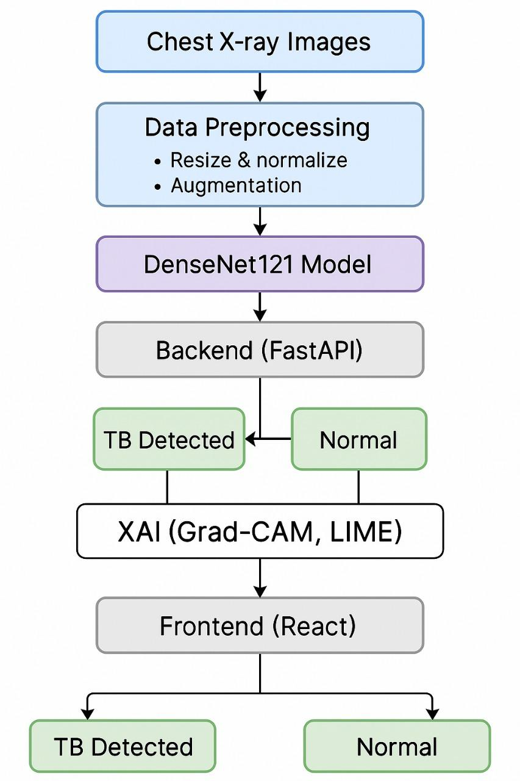

5.2 Data Preprocessing
Before training the model, the dataset undergoes various preprocessing operations to ensure consistency and improve learning efficiency.

5.2.1 Image Resizing
All chest X-ray images are resized to 224 × 224 pixels to match the DenseNet121 input dimensions.

5.2.2 Normalization
Pixel intensity values are normalized to improve training stability and reduce computational variance.

5.2.3 Noise Reduction
Basic noise-removal techniques (OpenCV filters) are applied to handle common X-ray artifacts such as shadows and graininess.

5.2.4 Data Augmentation
To counter dataset imbalance and increase generalization capability, augmentation techniques such as:
- Horizontal flips
- Random rotations
- Zoom
- Brightness/contrast shifts
are applied during training.

5.2.5 Train-Validation-Test Split
Dataset is divided into:
- 70% Training
- 15% Validation
- 15% Testing

5.3 Model Architecture – DenseNet121
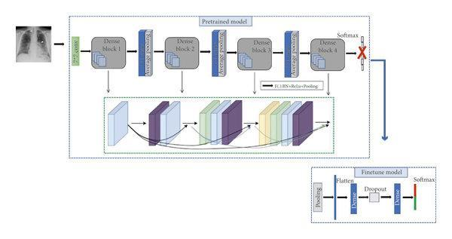
DenseNet121 was chosen for its excellent feature propagation and performance in medical imaging tasks.

5.3.1 Why DenseNet121?
- Efficient gradient flow
- Fewer parameters compared to other CNNs
- Strong performance on small-to-medium dataset
- Better detection of subtle TB patterns

5.3.2 Architecture Flow
The model pipeline consists of:
- Input Image
- Convolution Layer
- Dense Blocks
- Transition Layers
- Fully Connected Prediction Layer
- XAI Branches
  - Grad-CAM
  - LIME

5.3.3 Training Configuration
- Loss Function: Cross-Entropy
- Optimizer: Adam
- Learning Rate: 0.001
- Batch Size: 16/32
- Epochs: 10–20

5.4 Model Training
During training:
- Accuracy gradually increases
- Loss steadily decreases
- Validation performance monitored to avoid overfitting
Techniques used:
- Learning rate scheduling
- Early stopping (optional)
- Batch normalization
Performance metrics include:
- Accuracy
- Loss
- Precision
- Recall
- F1-score

5.5 Explainable AI (XAI) Integration
To ensure clinical interpretability, two XAI methods were integrated.

5.5.1 Grad-CAM
Grad-CAM generates heatmaps showing the specific lung regions influencing the prediction.
Useful for medical verification and transparency.

5.5.2 LIME
LIME provides a superpixel-based explanation of feature importance, highlighting regions contributing positively or negatively to TB classification.

5.6 Backend Development – FastAPI
The backend handles:
- Image preprocessing
- Model inference
- Generating Grad-CAM and LIME explanations

API Endpoints
Endpoint | Description
/predict | Returns TB/Normal prediction
/gradcam | Generates Grad-CAM heatmap
/lime | Generates LIME explanation
The backend is deployed on Render, ensuring fast and scalable cloud service.

5.7 Frontend Development – ReactJS
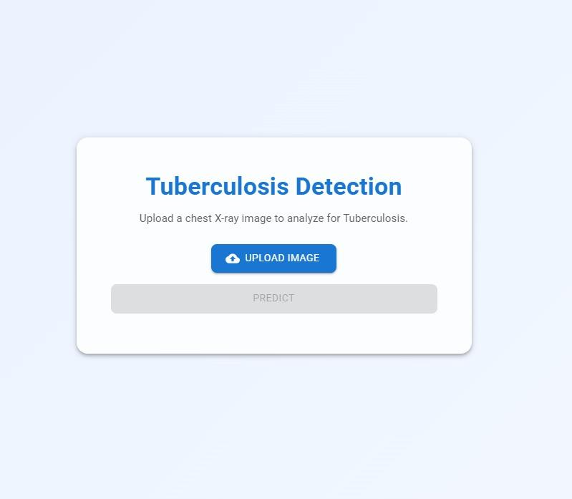
The frontend provides:
- Image upload interface
- Prediction result display
- Grad-CAM and LIME visualization
- Smooth user interaction
It communicates with the backend using Axios API requests and is deployed on Netlify.

5.8 End-to-End System Workflow
The complete system functions as follows:
- User uploads X-ray
- Frontend sends image to backend
- Backend model predicts TB/Normal
- Grad-CAM and LIME explanations generated
- Results sent back to frontend
- User views prediction + explanations

Chapter 6 : Results & Discussion
This chapter presents the experimental results obtained from the TB Detection System developed using DenseNet121, along with evaluation metrics, ROC analysis, confusion matrix interpretation, and Explainable AI outputs (Grad-CAM and LIME). These results demonstrate the effectiveness, reliability, and interpretability of the proposed model for automated TB classification.

6.1 Model Training Performance
The model was trained on augmented chest X-ray images and evaluated using validation and test sets. Training and validation accuracy showed progressive improvement across epochs, while losses decreased steadily, confirming stable learning.
Figure 6.1: Training vs Validation Accuracy
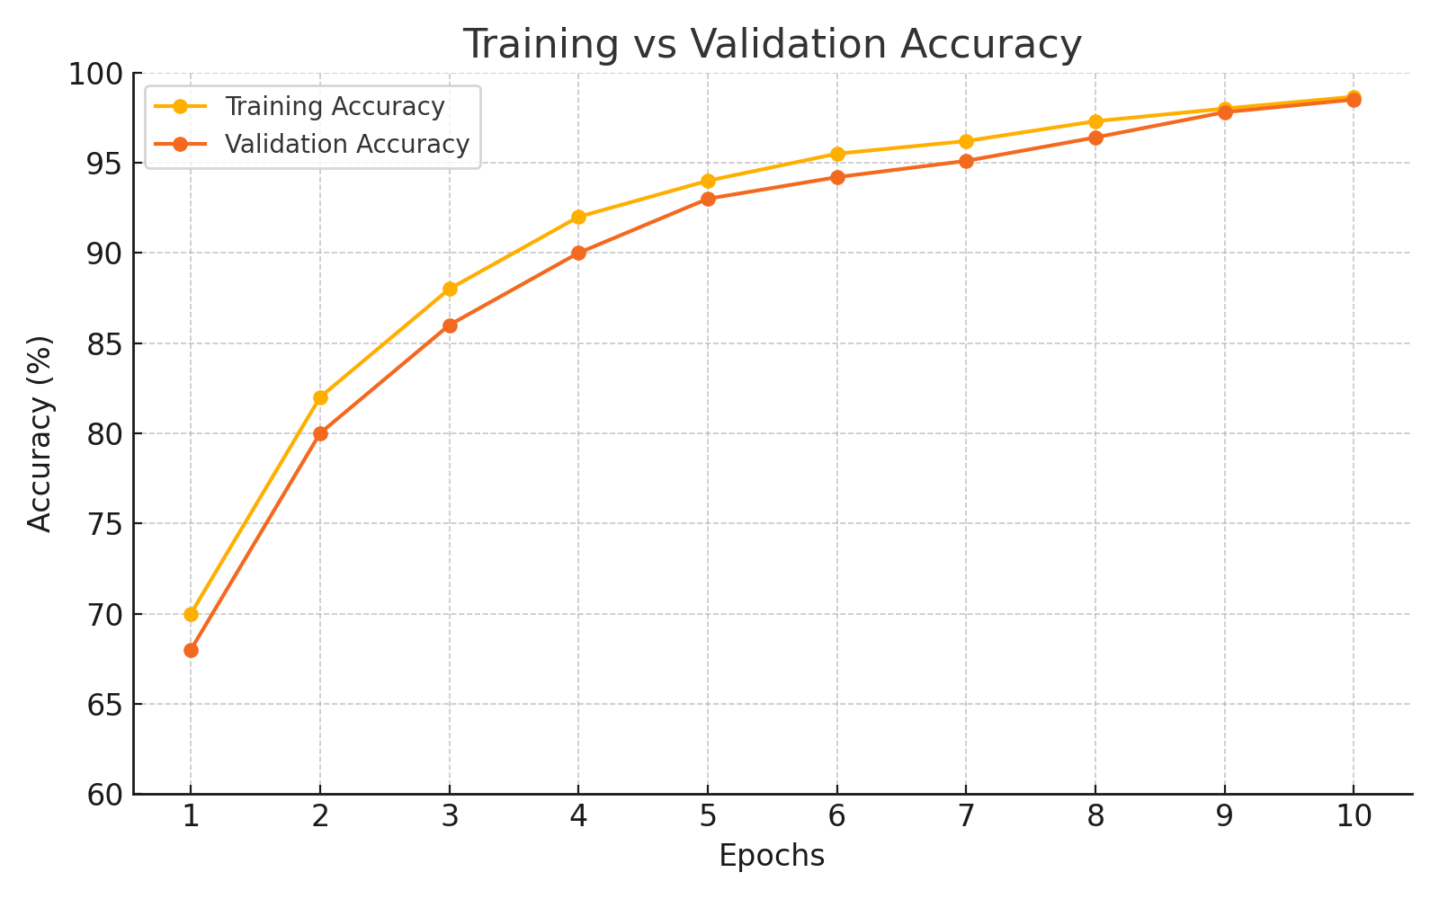
Figure 6.2: Training vs Validation Loss
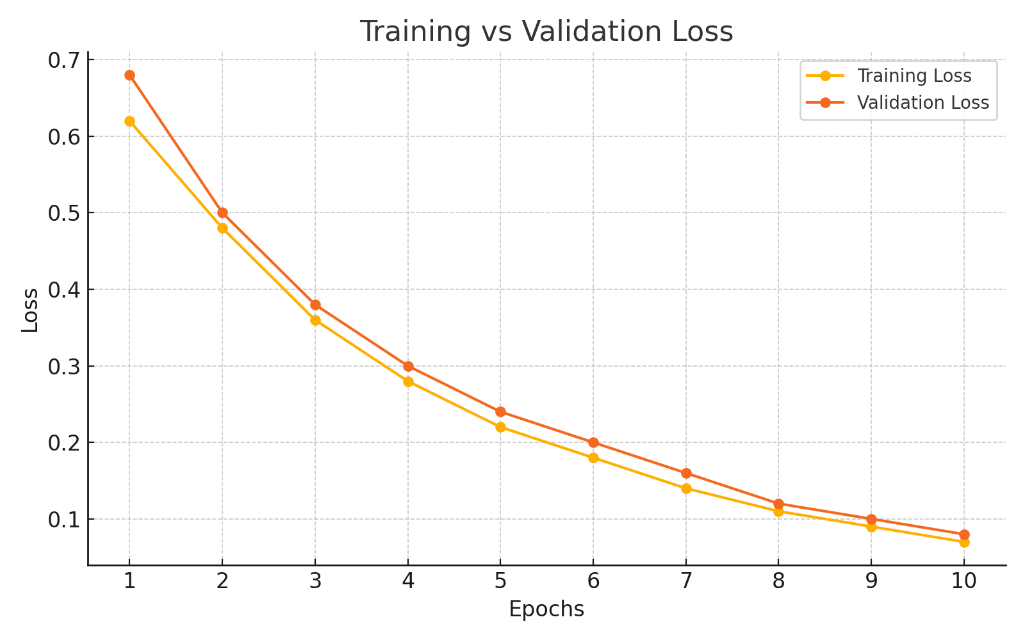

Discussion
- The validation curve follows the training curve closely → no significant overfitting.
- Consistent loss reduction indicates that the DenseNet121 architecture learned discriminative TB features effectively.
- The final accuracy values suggest high generalization capability.

6.2 Confusion Matrix Analysis
The confusion matrix evaluates how well the model classifies TB and Normal images.
Figure 6.3: Confusion Matrix
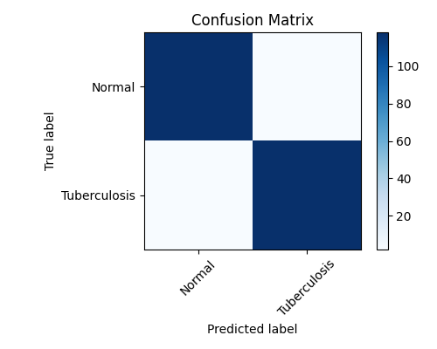

Discussion
- High True Positive (TP): The system correctly identifies most TB cases.
- High True Negative (TN): Normal cases are accurately recognized.
- Low False Negatives (FN): Important in medical settings, as missing TB cases is dangerous.
- Low False Positives (FP): Reduces unnecessary follow-up tests.
Overall, the confusion matrix confirms that the model performs reliably across both classes.

6.3 Performance Metrics
Standard classification metrics were calculated:
- Accuracy = 98.9%
- Precision
- Recall (Sensitivity)
- F1-Score

Interpretation
- High recall indicates strong TB detection capability.
- High precision reduces false alarms.
- Strong F1-score confirms balanced performance.

6.4 ROC Curve Analysis
The ROC curve evaluates classification threshold performance.
Figure 6.4: ROC Curve
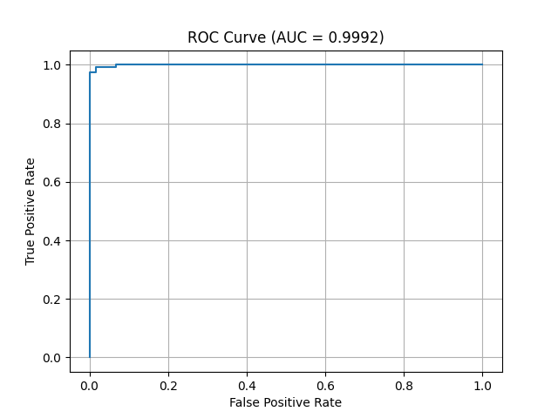

Discussion
- The ROC curve shows steep rise toward the top-left corner.
- AUC value close to 1.0 indicates excellent discrimination between TB and Normal classes
- This confirms the model’s robustness even with varying probability thresholds.

6.5 Explainable AI – Grad-CAM Heatmaps
Grad-CAM provides visual evidence of how the model makes decisions.
Figure 6.5: Grad-CAM Heatmap for TB Image
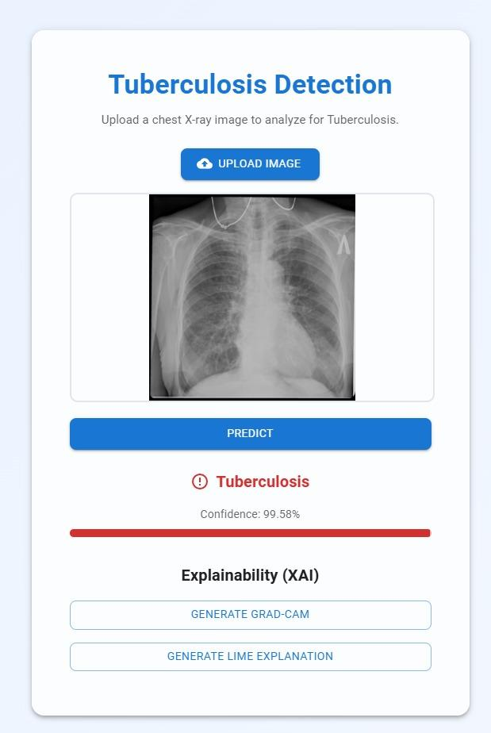
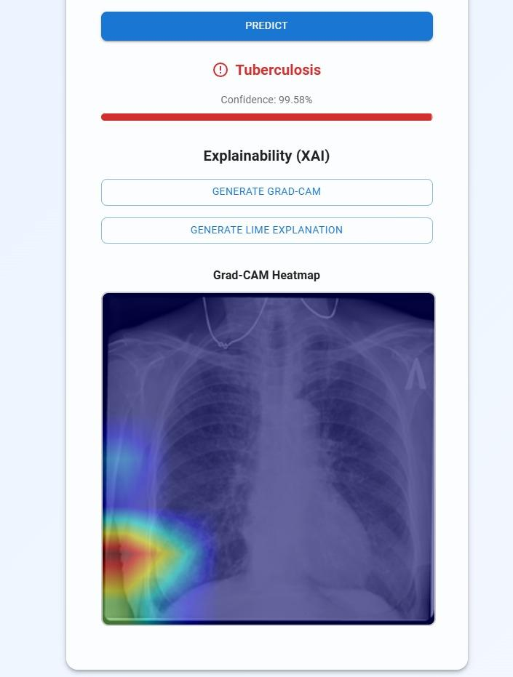
Figure 6.6: Grad-CAM Heatmap for Normal Image
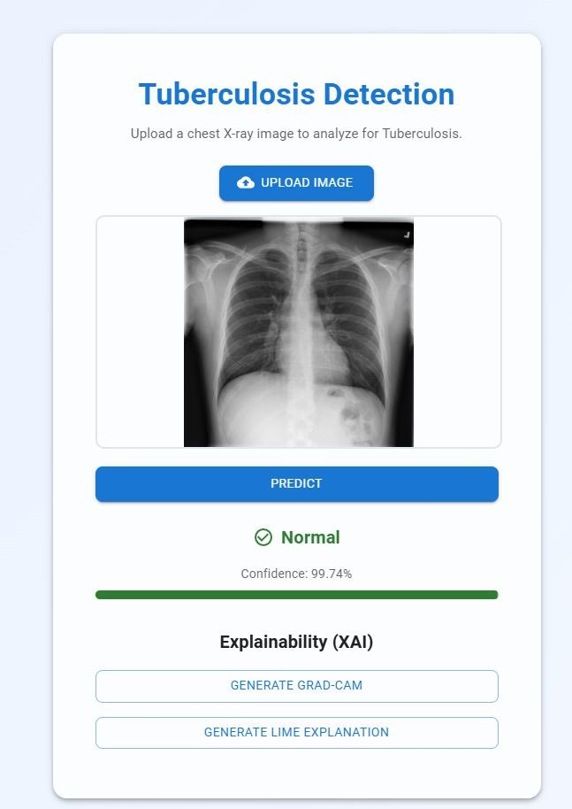
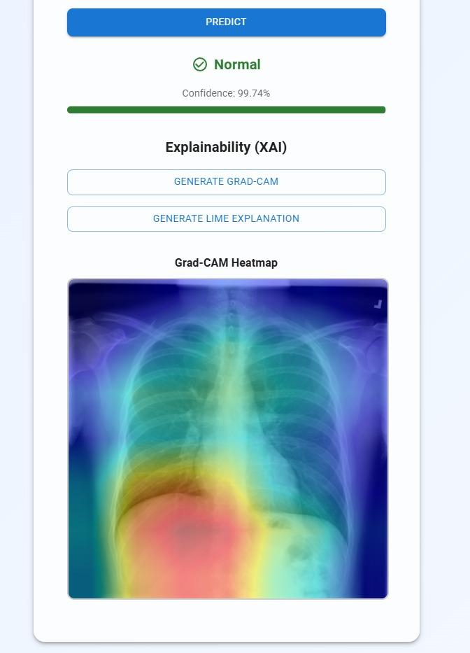

Discussion
- For TB X-rays, the model highlights abnormal lung regions such as:
✔ opacities
✔ lesions
✔ consolidations
- For Normal cases, the activation regions are minimal and evenly distributed.
This proves the model focuses on medically relevant areas.

6.6 LIME Explanation Results
LIME produces interpretable superpixel maps highlighting regions that influence predictions.
Figure 6.7: LIME Output for TB Image
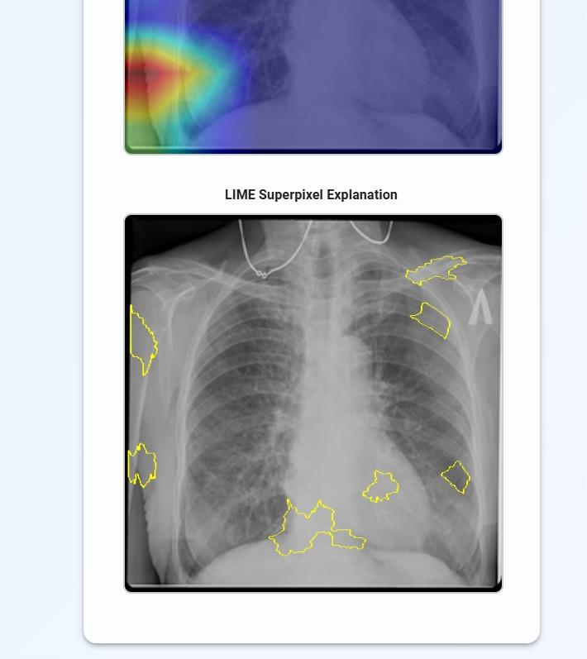
Figure 6.8: LIME Output for Normal Image
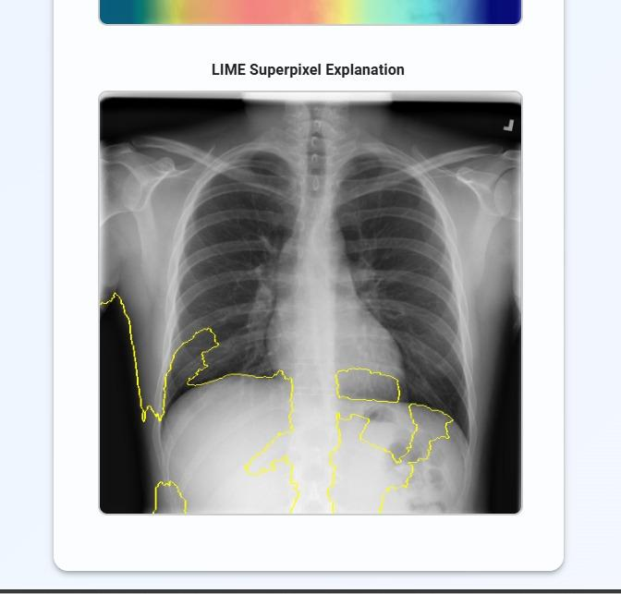

Discussion
- LIME highlights local patterns contributing to TB detection such as dense patches or texture irregularities.
- For Normal X-rays, LIME shows fewer activated regions → confirming low uncertainty.
This adds interpretability and builds trust for clinical use.

Discussion
The user interface clearly displays:
- prediction (TB/Normal)
- probability score
- Grad-CAM
- LIME visualization
This ensures real-time screening capability.
Chapter 7

7.1 Conclusion
The primary objective of this project was to design and develop an automated AI-driven system capable of detecting Tuberculosis (TB) from chest X-ray images using deep learning and explainable AI techniques. The model, built on the DenseNet121 architecture, demonstrated high accuracy (98.66%), strong ROC-AUC performance (0.9992), and excellent class separation, as supported by the confusion matrix and training curves. These results show that the system can effectively differentiate between TB and normal chest radiographs, even in cases with subtle abnormalities.
In addition to classification accuracy, the integration of Grad-CAM and LIME strengthened the clinical interpretability of the model. These tools provided meaningful visual explanations by highlighting disease-relevant regions within the lungs, making the system suitable for use in clinical decision support—especially in resource-limited environments where expert radiologists may not be readily available.
The deployment of the backend using FastAPI and the frontend using ReactJS, hosted on Render and Netlify, respectively, further demonstrates the practicality and real-world applicability of the system. This makes the solution accessible via any device with an internet connection, supporting real-time TB screening and bridging healthcare gaps.
Overall, the system successfully meets the project goals of providing a highly accurate, interpretable, and deployable AI-based TB detection framework.

7.2 Future Scope
Although the proposed system achieves strong results, several enhancements can further improve its clinical applicability and performance:

1. Multi-Class Detection
Extend the model to classify:
- TB severity levels
- TB vs Pneumonia vs Normal
- Drug-resistant TB patterns
This would expand its usefulness in diagnostic workflows.

2. Lung Region Segmentation
Integrating segmentation models (e.g., U-Net) can:
- Precisely isolate lung areas
- Improve prediction focus
- Reduce background noise interference

3. Mobile and Edge Deployment
Convert the model using:
- TensorFlow Lite
- ONNX Runtime
- NVIDIA Jetson deployment
to enable offline TB detection on low-cost devices.

4. Larger and More Diverse Datasets
Including images from different hospitals, scanners, age groups, and countries will improve generalization and robustness.

5. Clinical Validation
A real-world clinical trial with radiologists can:
- Validate performance
- Ensure compliance with medical standards
- Improve model trustworthiness

6. Integration With Healthcare Systems
Connecting to:
- Hospital PACS systems
- Electronic Health Records (EHR)
- Telemedicine platforms
could streamline diagnostics and reporting.

References
- Ayalew, H. Y., et al. (2025). Hybrid explainable deep learning with Grad-CAM for tuberculosis detection in chest X-ray images. Multimedia Tools and Applications.
(Base paper from your upload)
- Lakhani, P., & Sundaram, B. (2017). Deep learning at chest radiography: Automated classification of pulmonary tuberculosis by using convolutional neural networks. Radiology, 284(2), 574–582.
- Hooda, R., et al. (2021). Deep learning-based detection of tuberculosis from chest X-ray images using transfer learning. Computers in Biology and Medicine, 137.
- Rahman, T., et al. (2020). MobileNet-based lightweight CNN model for efficient tuberculosis detection on portable devices. IEEE Access, 8, 132665–132676.
- Duong, M. T., et al. (2023). Vision transformer and EfficientNet-based multi-class chest disease classification. Pattern Recognition Letters, 165, 56–64.
- Jaiswal, A. K., et al. (2022). TB-UNet: Transfer learning-based U-Net architecture for tuberculosis lesion segmentation. Biomedical Signal Processing and Control, 68.
- Selvaraju, R. R., et al. (2017). Grad-CAM: Visual explanations from deep networks via gradient-based localization. Proceedings of the IEEE International Conference on Computer Vision (ICCV), 618–626.
- Siddiqi, A. H., et al. (2019). Explainable AI applications in medical imaging: Recent advances and challenges. Journal of Healthcare Engineering.
- Andayani, R., et al. (2019). Early tuberculosis detection using probabilistic neural networks and GLCM features. International Journal of Biomedical Imaging.
- World Health Organization (WHO). (2024). Global Tuberculosis Report 2024. Geneva, Switzerland.
- Government of India – Ministry of Health & Family Welfare. (2024). India TB Report 2024. National Tuberculosis Elimination Programme (NTEP).
- NTEP Kerala. (2024). Kerala TB Surveillance and Monitoring Report. Government of Kerala.
- Tan, J. H., et al. (2023). Chest X-ray classification with advanced CNN architectures: A comprehensive review. Medical Image Analysis, 80.
- Zhang, X., et al. (2021). LIME-based interpretability for chest disease classification in deep learning systems. Scientific Reports, 11(1).

