Software Design Description (SDD)
Based on IEEE 1016 – Adapted for Student Projects
Project Title: InternSync – Cooperative Training Coordination and Tracking System
Team Name & Members: Group 3 (Section 5MA1)
Team Member | Student ID | Project Role
Salam Alsaour (Team Leader) | 2250009168 | Team leader; backend and AI services developer
Khalid Alajmi | 2250004309 | Frontend and backend developer
Ali Alghafly | 2250002460 | Frontend developer
Ahmed Kanaan | 2250009170 | AI services developer; deployment lead
Abdullah Abalhareth | 2250005266 | QA and documentation lead
Rakan Alzahrani | 2250000631 | UI/UX designer

Advisor: Dr. Sultan Al-Enezi
Version: 1.0
Date: 01-11-2026

Revision History
Version | Date | Description | Author
1.0 | Nov 1, 2026 | First version for Project 6 (SDD) on the course template (IEEE 1016 adapted), from System Design Document 1.7, API Specification 1.5, and the diagram pack; adds a class diagram of the report review module. | Group 3

Table of Contents
1. Introduction 4
1.1 Purpose 4
1.2 Scope 4
1.3 Intended Audience 4
1.4 References 5
2. System Overview 6
2.1 System Description 6
2.2 Design Strategy and Architectural Style 6
2.3 Users and Roles 7
3. Design Considerations 8
3.1 Assumptions and Dependencies 8
3.2 Constraints 8
3.3 Design Goals 9
3.4 Technology Choices 9
3.5 Trade-offs 10
4. Architectural Design 11
4.1 Overall Architecture 11
4.2 Components and Their Interactions 13
4.3 Request Pipeline 14
4.4 Synchronous and Background Work 14
4.5 Deployment 15
5. Detailed Design 16
5.1 Modules 16
5.2 Class Design: Report Review 17
5.3 State Machines 19
5.4 Key Interactions 22
5.5 Activities 26
5.6 Algorithms 28
5.6.1 Skill Extraction (FR-PRF-04) 28
5.6.2 Matching (FR-MAT-01 – 07) 29
5.6.3 Similarity Detection (FR-SIM-01 – 03) 29
5.6.4 Grade Computation (FR-WFL-02) 29
5.6.5 Deadlines (FR-CYC-01, FR-REP-04) 29
5.7 Scheduled Jobs 30
5.8 Security Design 30
5.9 User Interface Design 30
6. Data Design 32
6.1 Conventions 32
6.2 Entity-Relationship Diagrams 32
6.3 Tables by Area 37
6.4 Derived Values and Retention 37
7. External Interfaces 38
7.1 User Interface 38
7.2 REST API 38
7.3 External Services and Protocols 39
7.4 Libraries 39
8. Appendices 40
8.1 Glossary 40
8.2 Supporting Diagrams 40
8.3 Traceability 40
8.4 References 41
Evaluation 42

1. Introduction

1.1 Purpose
This Software Design Description (SDD) describes how InternSync is built: its components and how they interact, where they run, how data is stored, how the workflows behave, and how the security and privacy requirements are met. It turns the requirements of the SRS into decisions a developer can implement and a tester can check. It follows IEEE Std 1016 as adapted in the CSC 305 template.

1.2 Scope
InternSync is one web platform for cooperative and summer training. Universities and their colleges, training companies, and students take part. Students register and are verified, build a profile from their CV, apply to vacancies, and submit weekly and final reports; companies publish vacancies, review applicants, record attendance, and evaluate trainees; academic supervisors review reports and enter grades; one coordinator per college runs the training cycles and confirms placements; a Platform Admin approves coordinators and companies. AI services rank vacancies for a student, explain the match, and flag similar reports, always as advice. The interface is in Arabic (right to left) and English.
This document covers the whole system as built in Increments 1 to 5: the React web app (an installable PWA), the FastAPI backend with its in-process AI services and scheduler, the PostgreSQL database, the file storage, and the zero-cost reference deployment.

1.3 Intended Audience
Reader | What to read
Developers | Sections 4 to 7: components, modules, state machines, algorithms, data, and interfaces
Testers | Sections 5.3 (state machines and their guards), 5.6 (algorithms and thresholds), and 7.2 (API and error format); the STS uses them for its test cases
Instructor | Sections 2 and 3 for the design strategy and trade-offs, then the figures of Sections 4 and 5
Maintainers and the deployment lead | Sections 4.5 (deployment) and 7.3 (external services)

1.4 References
Document | Content
SRS 1.6 | The requirements this design implements; FR-… and NFR-… IDs refer to it
SPMP 1.7 | Process, schedule, roles, and risks
System Design Document 1.7 | The maintained design, including the full data dictionary of all 49 tables
API Specification 1.5 | Every endpoint, its roles, payloads, and error codes
Diagram pack 1.2 | The figures used in this document, with their sources
Interactive code diagrams | Architecture, workflow, sequence, data flow, lifecycle, and database diagrams traced from the code, in English and Arabic
Change requests | CR-01 to CR-11, the decisions that changed the design
IEEE Std 1016-1998 | IEEE Recommended Practice for Software Design Descriptions

2. System Overview

2.1 System Description
InternSync replaces the spreadsheets, emails, and paper forms that colleges and companies use to run cooperative training. One platform serves many organizations: a university has colleges, each college has one coordinator, its academic supervisors, and its students; a company has a Company Admin and optional further company supervisors. Every academic record is visible only inside its college, and every company record only inside its company.
The main flow is: a student registers and is verified by the college's coordinator, uploads a CV from which skills are extracted, sees vacancies ranked by fit, and applies; the company accepts the applicant; the coordinator confirms the placement, which creates the weekly report slots, the final report slot, and the grade; during the training the student submits reports, the company records attendance and evaluations, and the academic supervisor reviews reports; at the end the supervisor submits the grade, the coordinator approves it, and a certificate with a QR code can be issued.
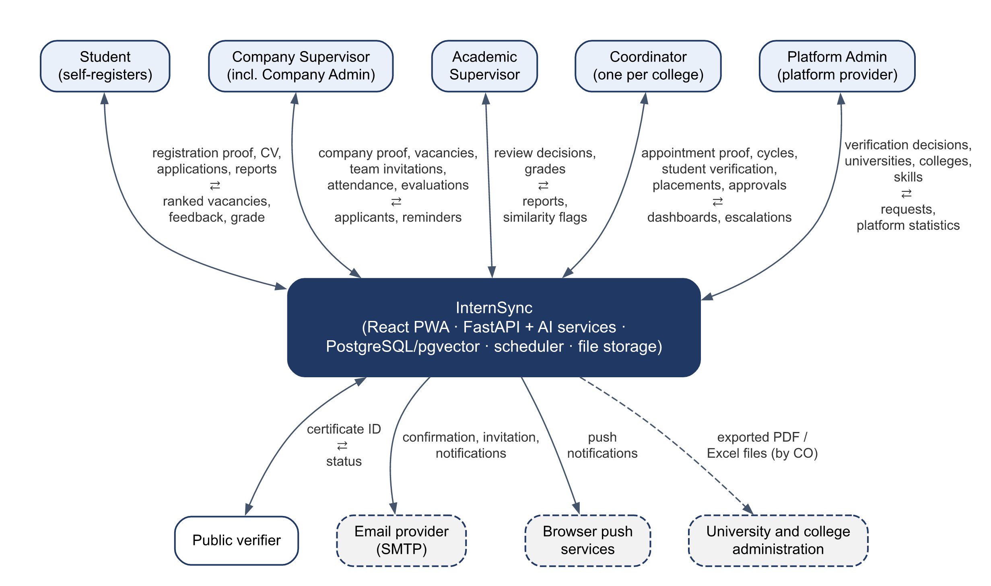
Figure 2.1 – Context diagram: the five roles, the public verifier, and the external services

2.2 Design Strategy and Architectural Style
- Client–server with a layered backend. The client is a static React PWA. The server is one FastAPI application organized in layers: routers (HTTP and validation), services (business rules and state transitions), and models (SQLAlchemy tables). Cross-cutting concerns (authentication, scope, audit, errors, language) sit in a shared core package.
- Modular monolith. One deployable backend holds the REST API, the AI services, and the scheduler. The modules are separated by package and by table ownership, not by network calls, so there is no message broker and no separate worker to run or pay for.
- Contract first. The API was specified before the code; FastAPI generates the OpenAPI document from the code, and the frontend's TypeScript client is generated from it. CI fails if either copy is out of date.
- Explicit state machines. Vacancies, applications, report slots, evaluations, grades, and certificates change state only through named transitions, each checked, audited, and tested.
- AI as advice. AI results are stored with their reason and model version and shown in an "Advisory" panel; no AI output changes a status.

2.3 Users and Roles
Role | Main tasks
Student (ST) | Registers, completes the profile and CV, applies, submits weekly and final reports, evaluates the company
Company supervisor (CS) and Company Admin (CA) | Publish vacancies, review applicants, record attendance, submit evaluations; the Company Admin also manages the company's team
Academic supervisor (AS) | Reviews reports, decides on similarity flags, enters and submits grades
Coordinator (CO), one per college | Verifies students, runs training cycles, confirms placements, approves grades, issues certificates, exports
Platform Admin (PA) | Approves coordinators and companies, manages universities, colleges, the skill vocabulary, and settings
Public verifier | Checks a certificate from its QR code, without signing in

3. Design Considerations

3.1 Assumptions and Dependencies
- Users have a current browser (Chrome, Edge, Safari, or Firefox) on a computer or phone; the app is installable as a PWA.
- Each college has one coordinator who verifies its students; companies are verified by the Platform Admin from their commercial registration.
- The demonstration uses synthetic data: 2 universities, 4 colleges, and about 400 students (SRS C-09).
- The reference deployment depends on free tiers (Vercel, Hugging Face Spaces, Supabase, Gmail SMTP). If one is unavailable, the same containers run with Docker Compose on a laptop.
- The embedding model intfloat/multilingual-e5-small is bundled in the API image, so the running system does not depend on the model hub.

3.2 Constraints
Constraint | Effect on the design
Python with FastAPI, React, and PostgreSQL (SRS C-03) | Backend, frontend, and database choices in Section 3.4
Zero cost (C-04, CR-01) | Free tiers only; one container holds API, AI, and scheduler; halfvec vectors to fit the 500 MB database
CPU-only hosting (C-10) | A small embedding model (384 dimensions) that runs on CPU in under a second per text
Privacy (NFR-PRV-02, NFR-PRV-03) | AI runs inside the API, so no text leaves it; push messages carry only a title and a link
Arabic and English (FR-LOC-01, NFR-L10N-01 – 04) | Every text is a translation key; logical CSS properties for right-to-left; PDF exports with Arabic shaping
Course schedule | Plan-driven, incremental delivery: Must functions first, then Should, then Could

3.3 Design Goals
Goal | What it means in the design | Requirements
One deployable backend | A single FastAPI container holds the REST API, the AI services, and the scheduler | C-03, C-10
Server-side authorization | Every endpoint declares its roles and record scope; queries are filtered by scope on the server, never by the client | FR-AUT-05
Organization isolation | Academic records are filtered by the caller's college, company records by the caller's company; the Platform Admin has no endpoint that returns academic records | FR-AUT-05, NFR-PRV-03
Correct workflows | State machines with guards; every change, its audit entry, and its notifications saved in one transaction | FR-WFL-01, FR-AUD-01, NFR-REL-04
AI is advisory and explainable | Matched and missing skills shown with every score; model version stored; rule-based fallback | NFR-AI-01 – 03, FR-MAT-04 – 07
Configurable defaults | Every "default" value of the SRS is a row in system_settings or a cycle field | NFR-MNT-03
Bilingual by construction | Dates stored in UTC and shown in Asia/Riyadh time; errors in the user's language | FR-LOC-02, NFR-L10N-02
Testable | Each acceptance test has a named automated test; a permission matrix covers every endpoint for every role | NFR-MNT-01

3.4 Technology Choices
Layer | Choice | Reason
Backend | Python, FastAPI, Pydantic v2 | Required by C-03; generates the OpenAPI document (NFR-MNT-02)
Database access | SQLAlchemy 2.0, psycopg 3, Alembic migrations | Mature and simple; synchronous endpoints in a thread pool are enough for the load (NFR-PER-01)
Database | PostgreSQL 16+ with pgvector (halfvec) and pg_trgm | Relational data and embeddings in one place; halfvec halves vector storage
Passwords and tokens | Argon2id; JWT (HS256) with a server-side session row | NFR-SEC-02; idle timeout and logout revocation (FR-AUT-03)
AI | multilingual-e5-small with sentence-transformers on CPU; pypdf and python-docx for text | Arabic and English (NFR-L10N-04); small enough for CPU hosting
Scheduler | APScheduler inside the API process, PostgreSQL advisory locks | NFR-REL-03 without a separate worker
Exports | fpdf2 with HarfBuzz shaping and Noto fonts; openpyxl; qrcode | Correct Arabic joining in PDFs (CR-09); Excel grade sheets; certificate QR codes
Email and push | smtplib over TLS; pywebpush with VAPID keys | FR-NOT-01, FR-PWA-02
Frontend | React 18, Vite, TypeScript, React Router, TanStack Query, react-i18next, Tailwind CSS | C-03; logical properties for right-to-left
Tests | pytest, httpx, Vitest, Playwright, Locust, OWASP ZAP | NFR-MNT-01, NFR-PER-01, NFR-SEC-05

3.5 Trade-offs
Decision | Alternative considered | Why this choice
Modular monolith in one container | Microservices, or a separate AI service and worker | One free container fits the API, the model, and the scheduler; no network calls between modules; simpler to test and deploy. Cost: the API and AI scale together, which is enough for about 400 students
Scheduler in the API process with advisory locks | A message broker and worker (Celery, Redis) | No extra service to host. Jobs select work by state, so a run missed during downtime catches up on the next one
Notification outbox table | Sending email inside the request | A notification exists exactly when its change was saved; delivery retries without slowing the request
Rule-based skill extraction with the student's confirmation | A trained extraction model | Fast, explainable, and the student confirms; recall measured on labelled CVs
Hybrid matching (semantic score plus required and preferred skills) | Embeddings only | Embeddings alone cannot say which skills are missing; the hybrid score explains itself and has a rule-based fallback
Similarity on sentence-sized passages with a lexical check | Whole-report comparison | Finds a copied paragraph inside an original report; the lexical check stops same-topic text from being flagged
Files streamed by the API after the permission check (CR-08) | Signed links to the bucket | No bucket link reaches a browser, so access always follows the record's permission rule
Hugging Face Spaces for the API (CR-01) | Railway or a VM | Free 2 vCPU and 16 GB RAM for a Docker container; Railway's free plan has 0.5 GB RAM, too little for the model
Status values as text with CHECK constraints | PostgreSQL enums | Easier to migrate when a state is added

4. Architectural Design

4.1 Overall Architecture
The React PWA is a static build. It calls the REST API under /api/v1 with a JWT bearer token. The API container holds the REST API modules, the AI services (text and skill extraction, matching, similarity detection, and one shared embedding model loaded once), and the scheduler. PostgreSQL stores all records and embeddings; a private object store keeps CVs, attachments, exports, and certificates. Email goes out through SMTP and push messages through the browser vendors' push services.
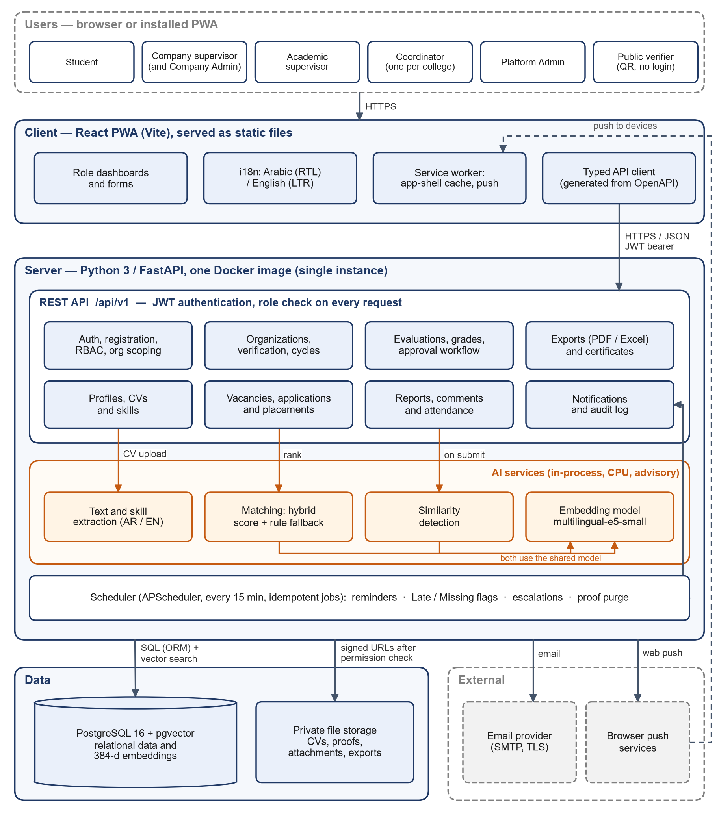
Figure 4.1 – Component diagram (diagram pack Figure 5). Since CR-08 the API streams files after the permission check instead of issuing signed links
Figure 4.2 shows the same system traced from the code for its main request, the submission of a weekly report, with the trust boundaries: the browser is not trusted, every request passes the authentication and scope gate, and only the API process holds the database and storage credentials.
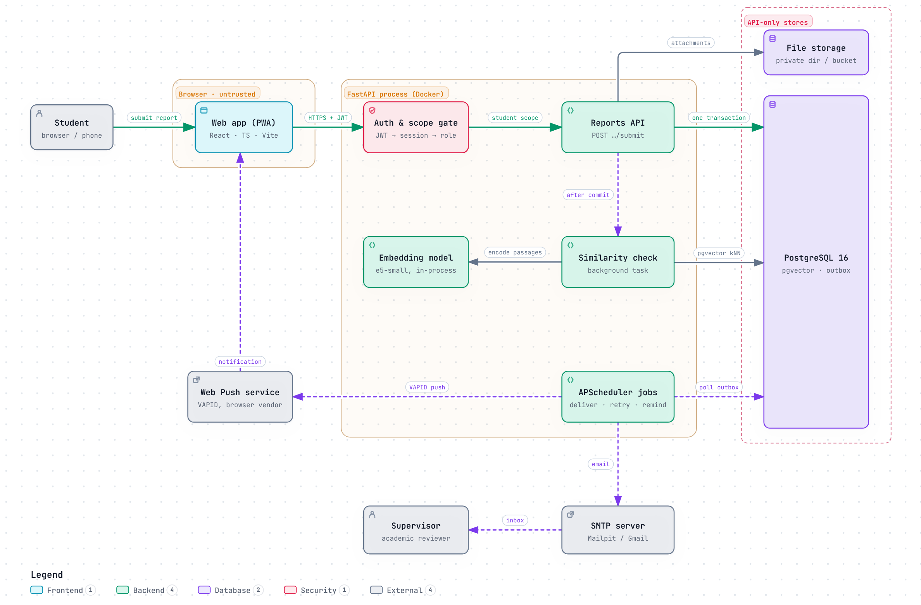
Figure 4.2 – Runtime components, the report submission path, and the trust boundaries

4.2 Components and Their Interactions
Component | Responsibility | Interacts with
Web app (React PWA) | Role dashboards and forms in Arabic and English; offline copy of opened pages and drafts; push notifications | REST API over HTTPS with a bearer token; service worker for the app shell
Auth and scope gate (core/deps.py, core/scope.py) | Checks the token, the session row and its idle limit, consent, verification, role, and record scope on every request | All routers; users, user_sessions
REST API modules (backend/app/<module>) | Business rules and state transitions per area (Section 5.1) | PostgreSQL, file storage, AI services, notification outbox
AI services (app/ai, matching, similarity) | Skill extraction, fit score and explanation, development plan, similarity detection | Embedding model in memory; pgvector search in PostgreSQL
Scheduler (app/jobs) | Reminders, missing flags, escalations, notification delivery, similarity retries, purges, clean-up | PostgreSQL (with advisory locks), SMTP, Web Push
PostgreSQL with pgvector | All records, embeddings, audit log, notification outbox | API and scheduler only
File storage (local volume or Supabase Storage) | CVs, report files, verification documents, exports, certificates | API only, under random keys
SMTP server and Web Push services | Deliver email in the user's language and push notifications | Called by the deliver job

4.3 Request Pipeline
1. Transport: HTTPS is terminated by the hosting provider; CORS allows only the configured web app origin.
2. Authentication: the JWT signature and expiry are checked, the session is loaded by its ID, and a session idle for more than 30 minutes is ended.
3. Consent gate: until the user accepts the privacy notice, only /me, consent, and logout answer; everything else returns 403 CONSENT_REQUIRED.
4. Verification gate: an account whose verification is pending or rejected reaches only its own pages; other endpoints return 403 VERIFICATION_REQUIRED.
5. Authorization: the route declares its roles; the service loads the record through a query that always includes the caller's college or company. A record outside the scope returns 403 FORBIDDEN.
6. Business rule and transition: the service checks the state machine and the limits, then writes the change.
7. Audit and notifications: the audit entry and any notifications are inserted in the same transaction as the change, so either all are saved or none.
8. Response: JSON, or application/problem+json with a stable code and a message in the user's language.

4.4 Synchronous and Background Work
Work | How it runs | Limit
CV text and skill extraction | In the upload request | ≤ 30 s (NFR-PER-03)
Profile and vacancy embedding | When skills are confirmed or a vacancy is published | < 1 s
Ranking of vacancies | One SQL query for eligible vacancies and their vectors, scoring in Python | ≤ 5 s for 300 vacancies (NFR-PER-02)
Similarity check | Created as pending with the submission, run in a background task after the response; a retry job picks up any check left pending | ≤ 2 min (NFR-PER-04)
Email and push | Written to the outbox in the business transaction; sent by the deliver job | Every minute
Exports | Built in the request and streamed as a file | ≤ 60 s for 100 students (NFR-PER-05)

4.5 Deployment
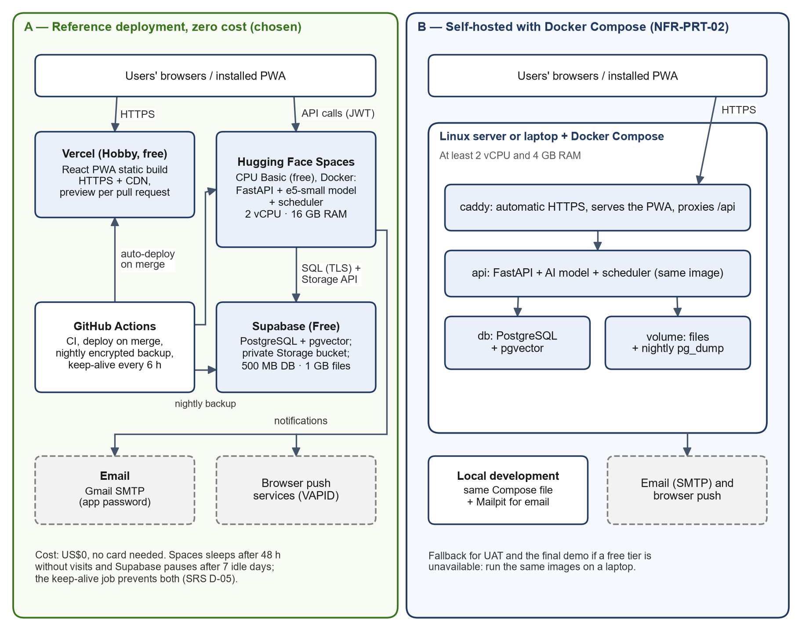
Figure 4.3 – Deployment diagram of the zero-cost reference deployment
Node | Service and plan | Runs
Web app | Vercel Hobby | The static build of frontend/ behind HTTPS and a CDN; the domain internsync.tech points at it
API container | Hugging Face Spaces, Docker, CPU Basic (2 vCPU, 16 GB RAM) | FastAPI, the embedding model baked into the image, and the scheduler; port 7860; no state on disk
Database | Supabase Free | PostgreSQL with vector and pg_trgm; the Data API is off and row level security is on as a second guard
File storage | Supabase Storage, one private bucket | Reached only by the API with the service key
Email | Gmail SMTP with an app password | About 500 emails a day
Operations | GitHub Actions | CI on every pull request, API deployment on merge, keep-alive every 6 hours, nightly encrypted backups

Locally and for the demonstrations, docker compose up runs the database, the API, the web app, and Mailpit (which catches every email). The same image runs in both places.

5. Detailed Design

5.1 Modules
Each backend module is a Python package under backend/app/ with a router (endpoints), schemas (Pydantic models), a service (rules and transitions), and models (tables).
Module Name | Responsibilities | Inputs/Outputs | Notes / Diagrams
core | Settings, database session, errors, language, audit helper, auth and scope dependencies, clock (UTC and Asia/Riyadh) | Input: every request. Output: Actor (user and session) or 401/403 | Section 4.3; NFR-MNT-03, FR-AUD
auth | Registration, email confirmation, invitations, login and logout, sessions, password reset, lockout, consent | Input: email and password, one-time link tokens. Output: access token, session, emails | FR-AUT-02 – 04, NFR-SEC-02/03; Section 5.8
orgs | Universities, colleges, companies, verification requests and documents, role transfer, deactivation | Input: registration forms and documents. Output: verified accounts and organizations, notifications | FR-ORG-01 – 09, FR-AUT-06
cycles | Training cycles, weeks and deadlines, grade components, rubric, enrolments; skill vocabulary and majors | Input: cycle settings. Output: weekly deadlines, enrolments | FR-CYC-01 – 05; Section 5.6.5
profiles | Student profile, CV upload, skill extraction and confirmation | Input: PDF or DOCX CV. Output: candidate skills with evidence, confirmed skills, profile embedding | FR-PRF-02 – 05; Figure 5.6
vacancies | Vacancies, applications, placements | Input: vacancy forms, applications, decisions. Output: placements, report slots, grade rows | FR-VAC-01 – 08; Figures 5.4, 5.5
matching | Eligibility, fit score, explanation, development plan | Input: student profile and vacancies. Output: ranked vacancies with matched and missing skills | FR-MAT-01 – 07; Section 5.6.2
reports | Report slots, versions, attachments, reviews, comments | Input: drafts, files, submit, accept, revision. Output: slot states, audit entries, notifications | FR-REP-01 – 07, FR-WFL-01; Figures 5.1, 5.2
similarity | Passages, similarity checks, supervisor decisions | Input: submitted version. Output: score, flag, passage pairs | FR-SIM-01 – 03; Section 5.6.3
attendance | Weekly attendance and unlocks | Input: attended days per week. Output: attendance rate | FR-ATT-01 – 04
evaluations | Periodic and final evaluations, evaluation of the company, outcome survey | Input: rubric scores and comments. Output: company evaluation component of the grade | FR-EVL-01 – 05
grades | Grade entry, computation, approval workflow | Input: component scores. Output: total, Final grade, completed placement | FR-WFL-02 – 07; Figure 5.3
dashboards | Pending actions, cycle and platform statistics, leniency alerts | Input: role and scope. Output: live counts | FR-DSH-01 – 05
exports, certificates | Grade sheet, term summary, training record; certificates with a QR code and public verification | Input: cycle or placement. Output: PDF and Excel files; certificate status | FR-EXP-01 – 03, FR-CER-01 – 03
notifications, jobs | Notification outbox, in-app list, email and push delivery; scheduled jobs | Input: events from the services. Output: emails, push messages, job runs | FR-NOT-01 – 06, NFR-REL-03; Section 5.7
files | Upload checks, storage adapter, permission-checked download | Input: uploaded bytes. Output: stored file under a random key; streamed download | NFR-SEC-04

5.2 Class Design: Report Review
Figure 5.1 shows the classes of the report review module. The model classes are SQLAlchemy tables; reports.service and similarity.service are Python modules of functions, drawn as utility classes. A report slot owns its versions and comments; a version owns its attachments and reviews; a similarity check refers to one submitted version.
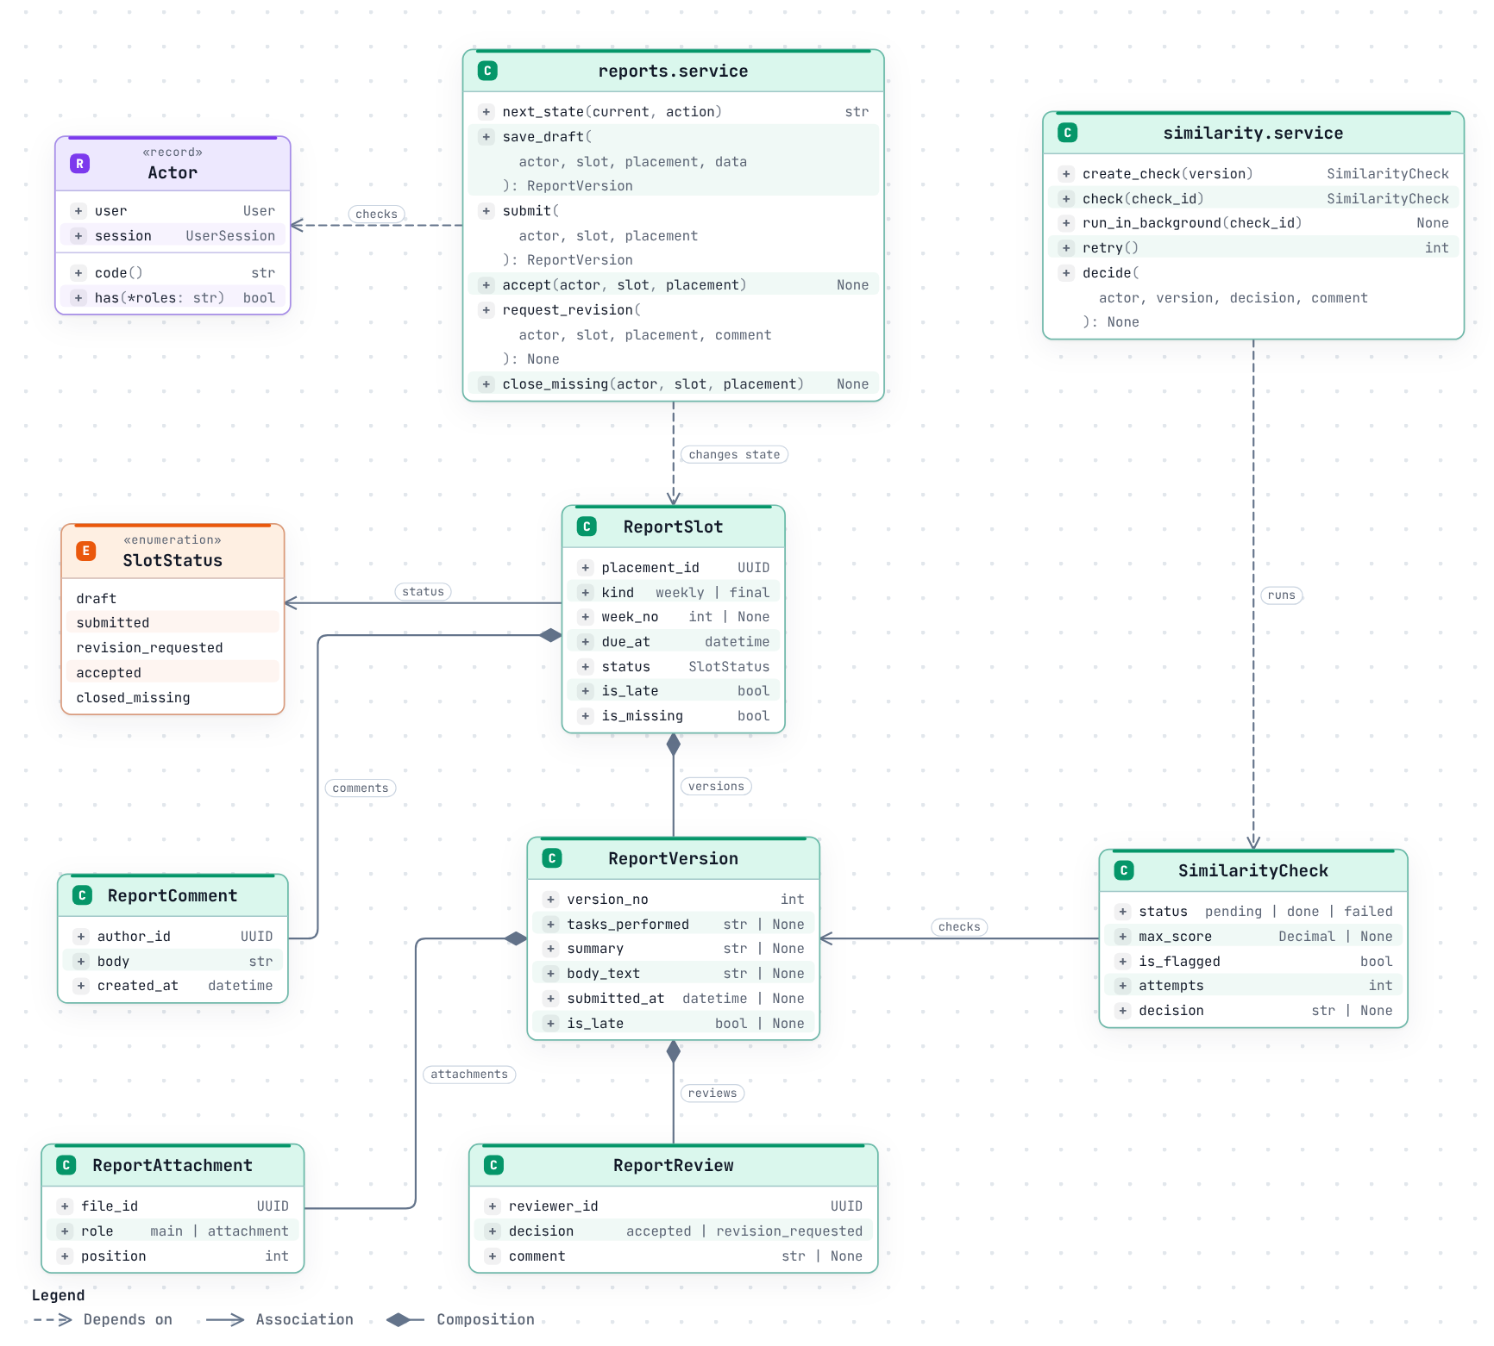
Figure 5.1 – Class diagram of the report review module, from backend/app/models and the two services
Function | Input | Output and rule
next_state(current, action) | Current slot status and an action | The new status from Table 5.1, or 409 INVALID_TRANSITION (SLOT_CLOSED for a closed slot)
save_draft(actor, slot, placement, data) | The student's text fields | Creates or updates the single draft version; the slot status does not change
submit(actor, slot, placement) | The draft | Checks the four text fields (weekly) or the main document (final) and the attachment limit, sets submitted_at and lateness, moves the slot to submitted, writes the audit entry and the report.submitted notification
accept(…), request_revision(…, comment) | The assigned academic supervisor's decision | A review row on the last version, the new status, an audit entry, and a notification to the student; a revision needs a comment
close_missing(actor, slot, placement) | A draft past its deadline with no submitted version | closed_missing and the missing flag
create_check(version), check(check_id) | A submitted version | A pending check in the same transaction; after the response, the score, the flag, and the passage pairs (Section 5.6.3)

5.3 State Machines
Every transition is one service function. It checks the actor's role and scope and the current state, writes the new state, adds one audit entry, and creates the listed notifications, all in one transaction. A transition that is not listed returns 409 INVALID_TRANSITION.
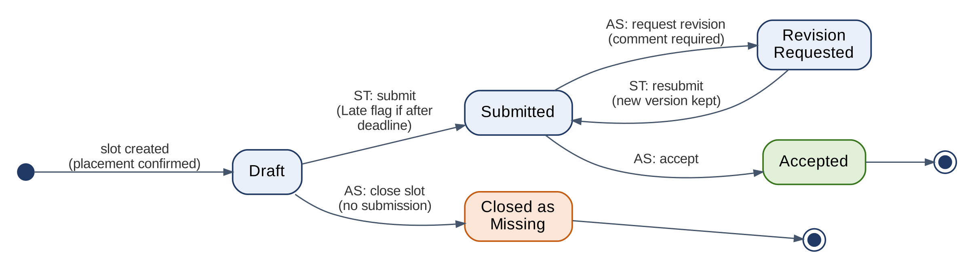
Figure 5.2 – Report slot states
Table 5.1 – Report slot transitions (FR-REP-01 – 07, FR-WFL-01)
From | Action | Actor | Guard | To | Notifications
draft | submit | ST | Required fields; attachment limits; slot not closed | submitted | AS: report to review
submitted | accept | AS (assigned) | – | accepted | ST: report accepted
submitted | request revision | AS (assigned) | Comment required | revision_requested | ST: revision requested
revision_requested | resubmit | ST | As for submit | submitted | AS: report to review
draft | close as missing | AS (assigned) | No submitted version; deadline passed | closed_missing | ST

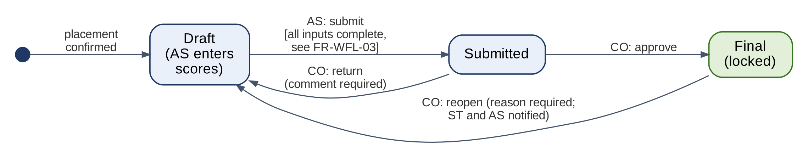
Figure 5.3 – Grade states
Table 5.2 – Grade transitions (FR-WFL-03 – 07)
From | Action | Actor | Guard | To
draft | submit | AS (assigned) | Final evaluation submitted; final report accepted; every weekly slot accepted or closed missing; every component entered. Otherwise 409 PRECONDITIONS_UNMET with the missing items | submitted
submitted | approve (single or bulk) | CO | – | final; the placement becomes completed
submitted | return | CO | Comment required | draft
final | reopen | CO | Reason required | draft; the placement is active again

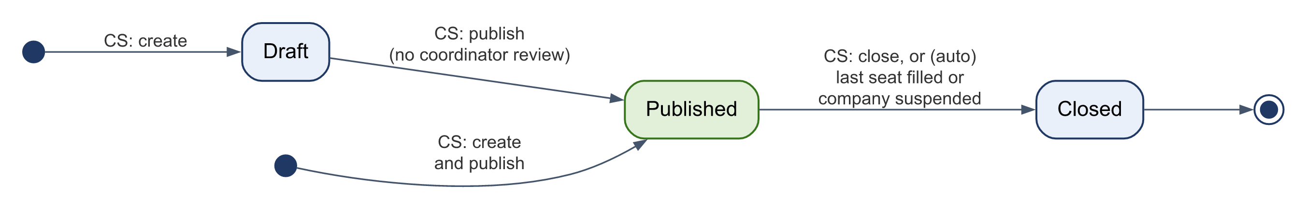
Figure 5.4 – Vacancy states: draft, published, closed (by the company, the last seat, or a company suspension)
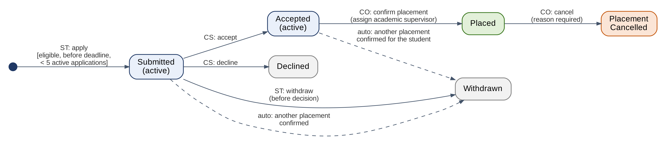
Figure 5.5 – Application states: submitted, accepted or declined, placed, withdrawn, placement cancelled
Other records follow the same pattern: an evaluation goes from draft to submitted and can be reopened once by the coordinator; a certificate is valid until revoked with a reason; a training cycle is open or closed, and while closed every write to its records returns 409 CYCLE_CLOSED; a verification request is approved or rejected with a reason.

5.4 Key Interactions
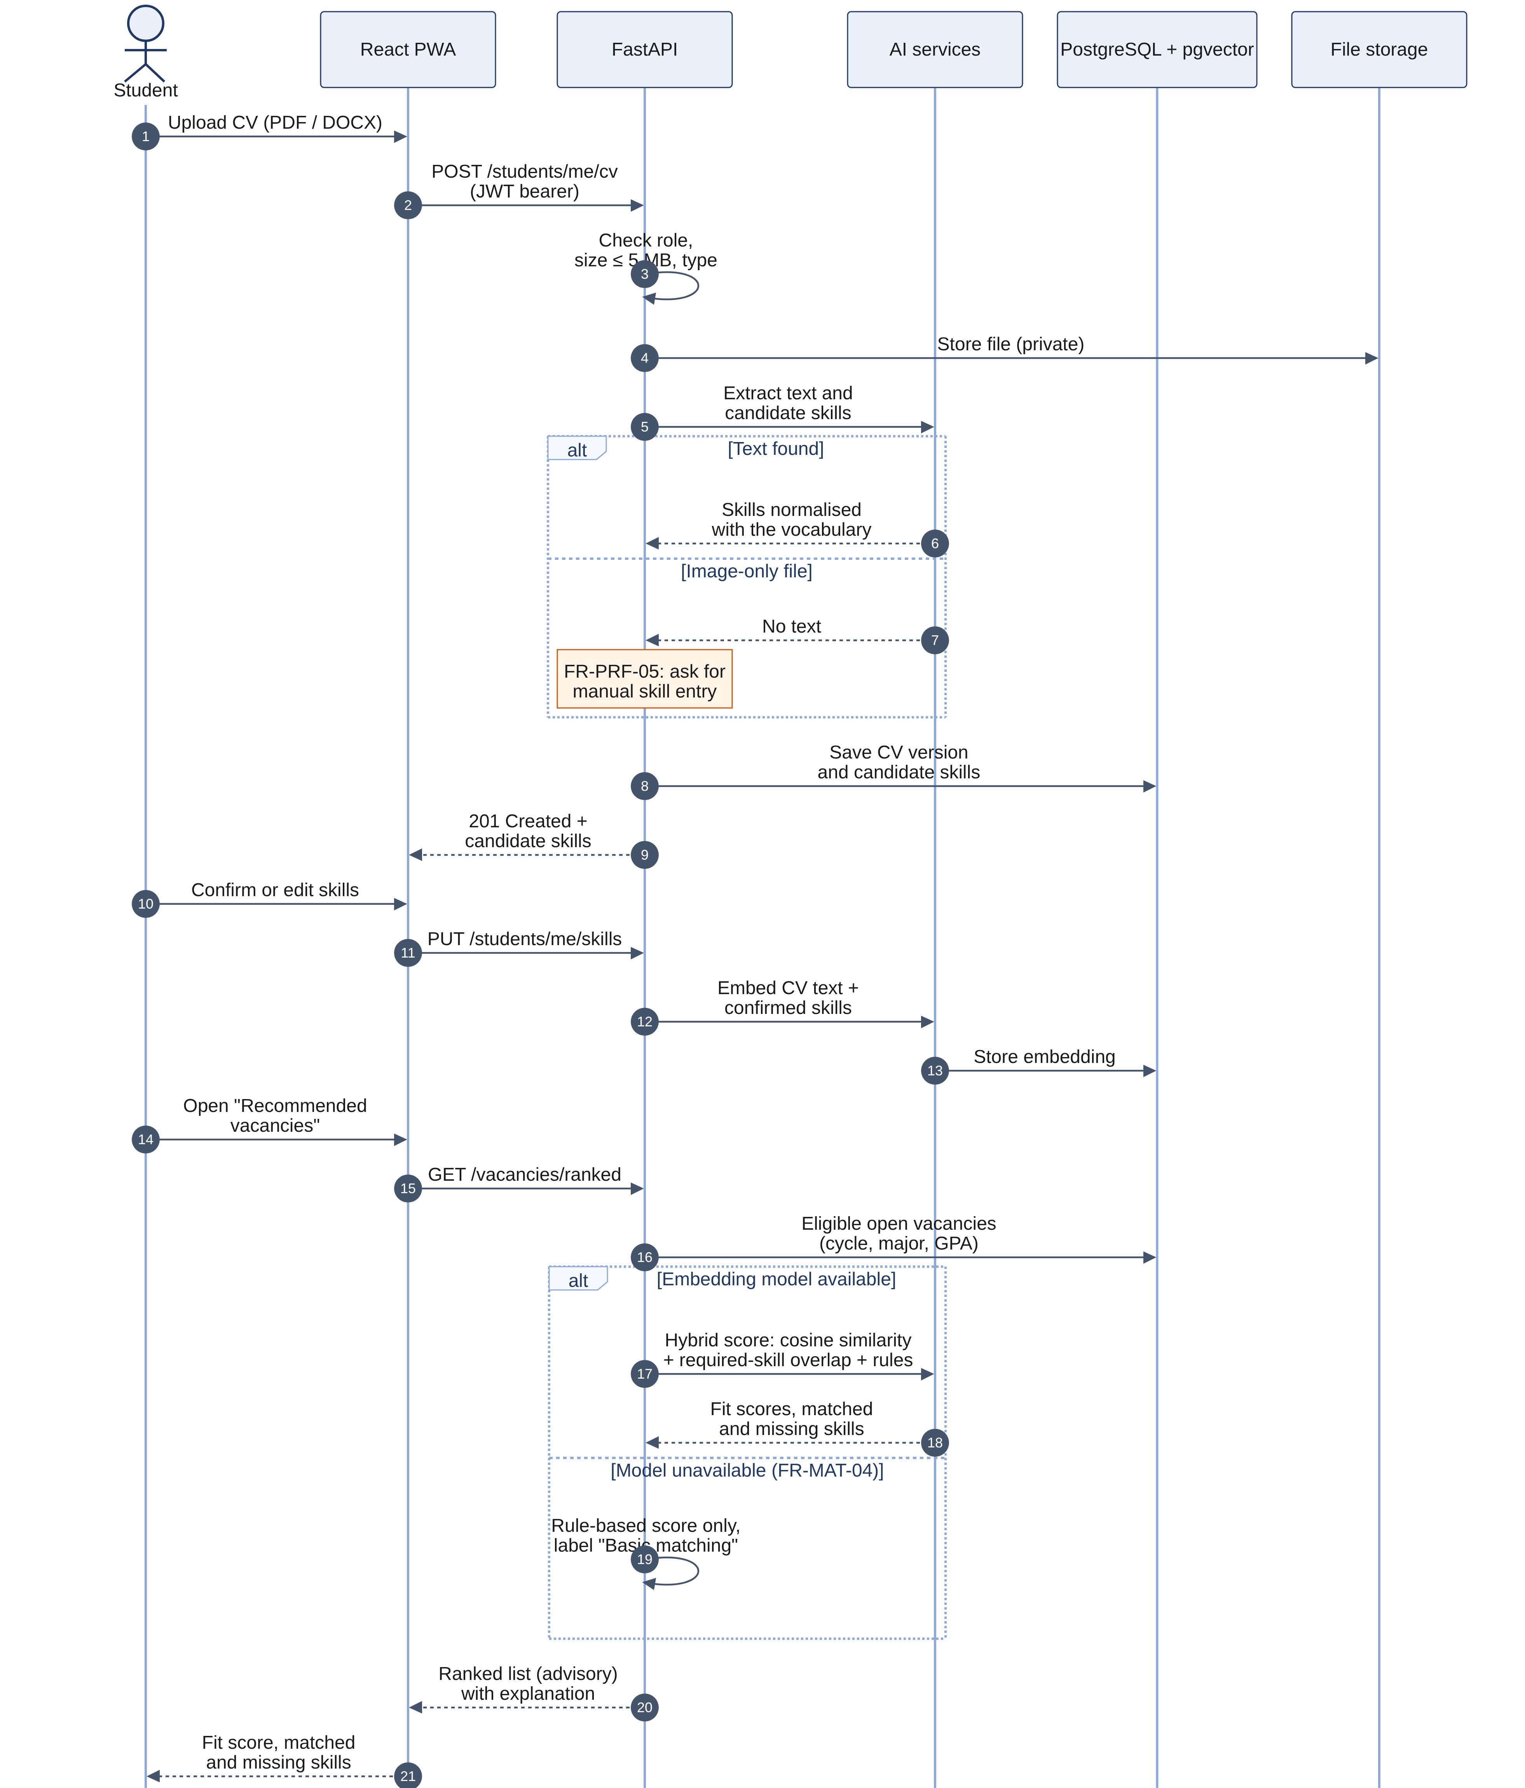
Figure 5.6 – Sequence: CV upload, skill extraction, and ranked vacancies
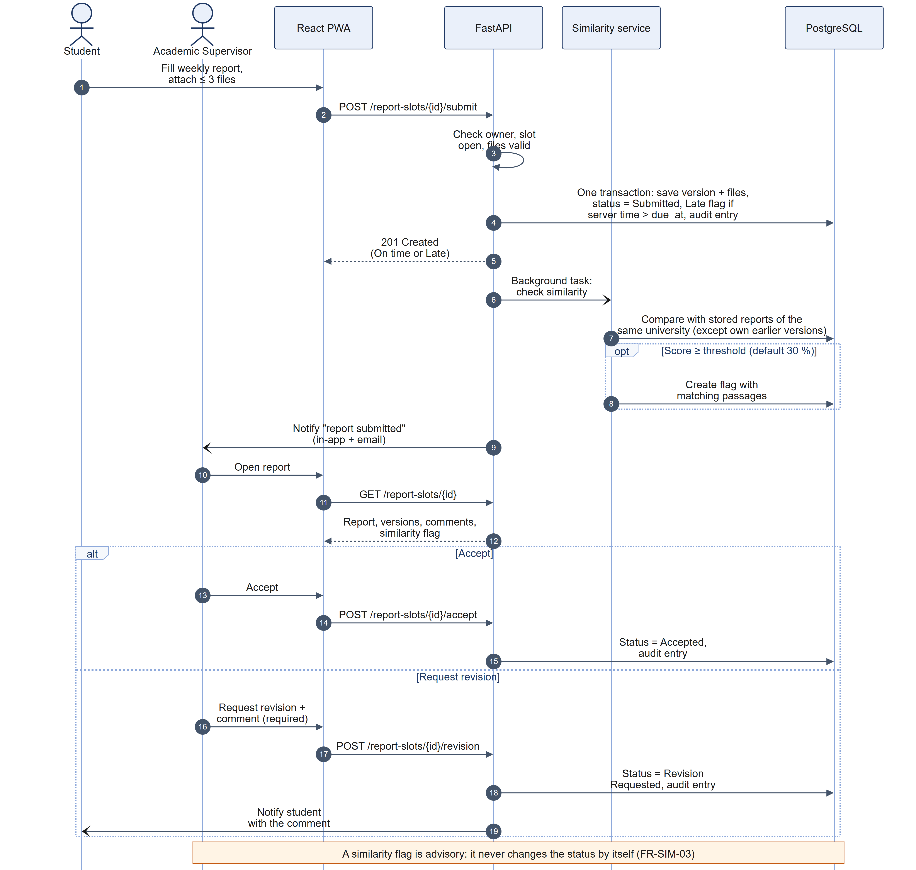
Figure 5.7 – Sequence: weekly report submission, similarity check, and review
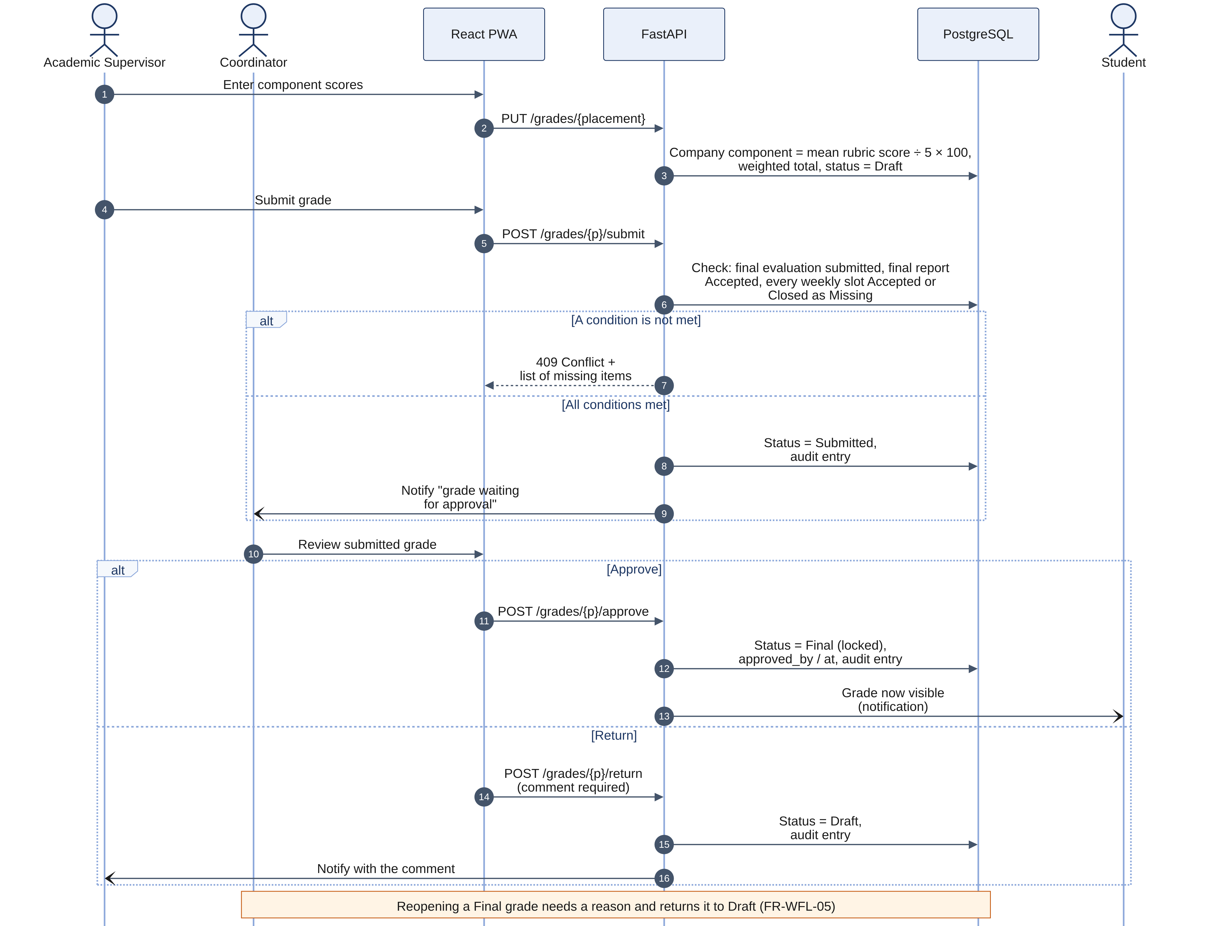
Figure 5.8 – Sequence: grade submission and approval
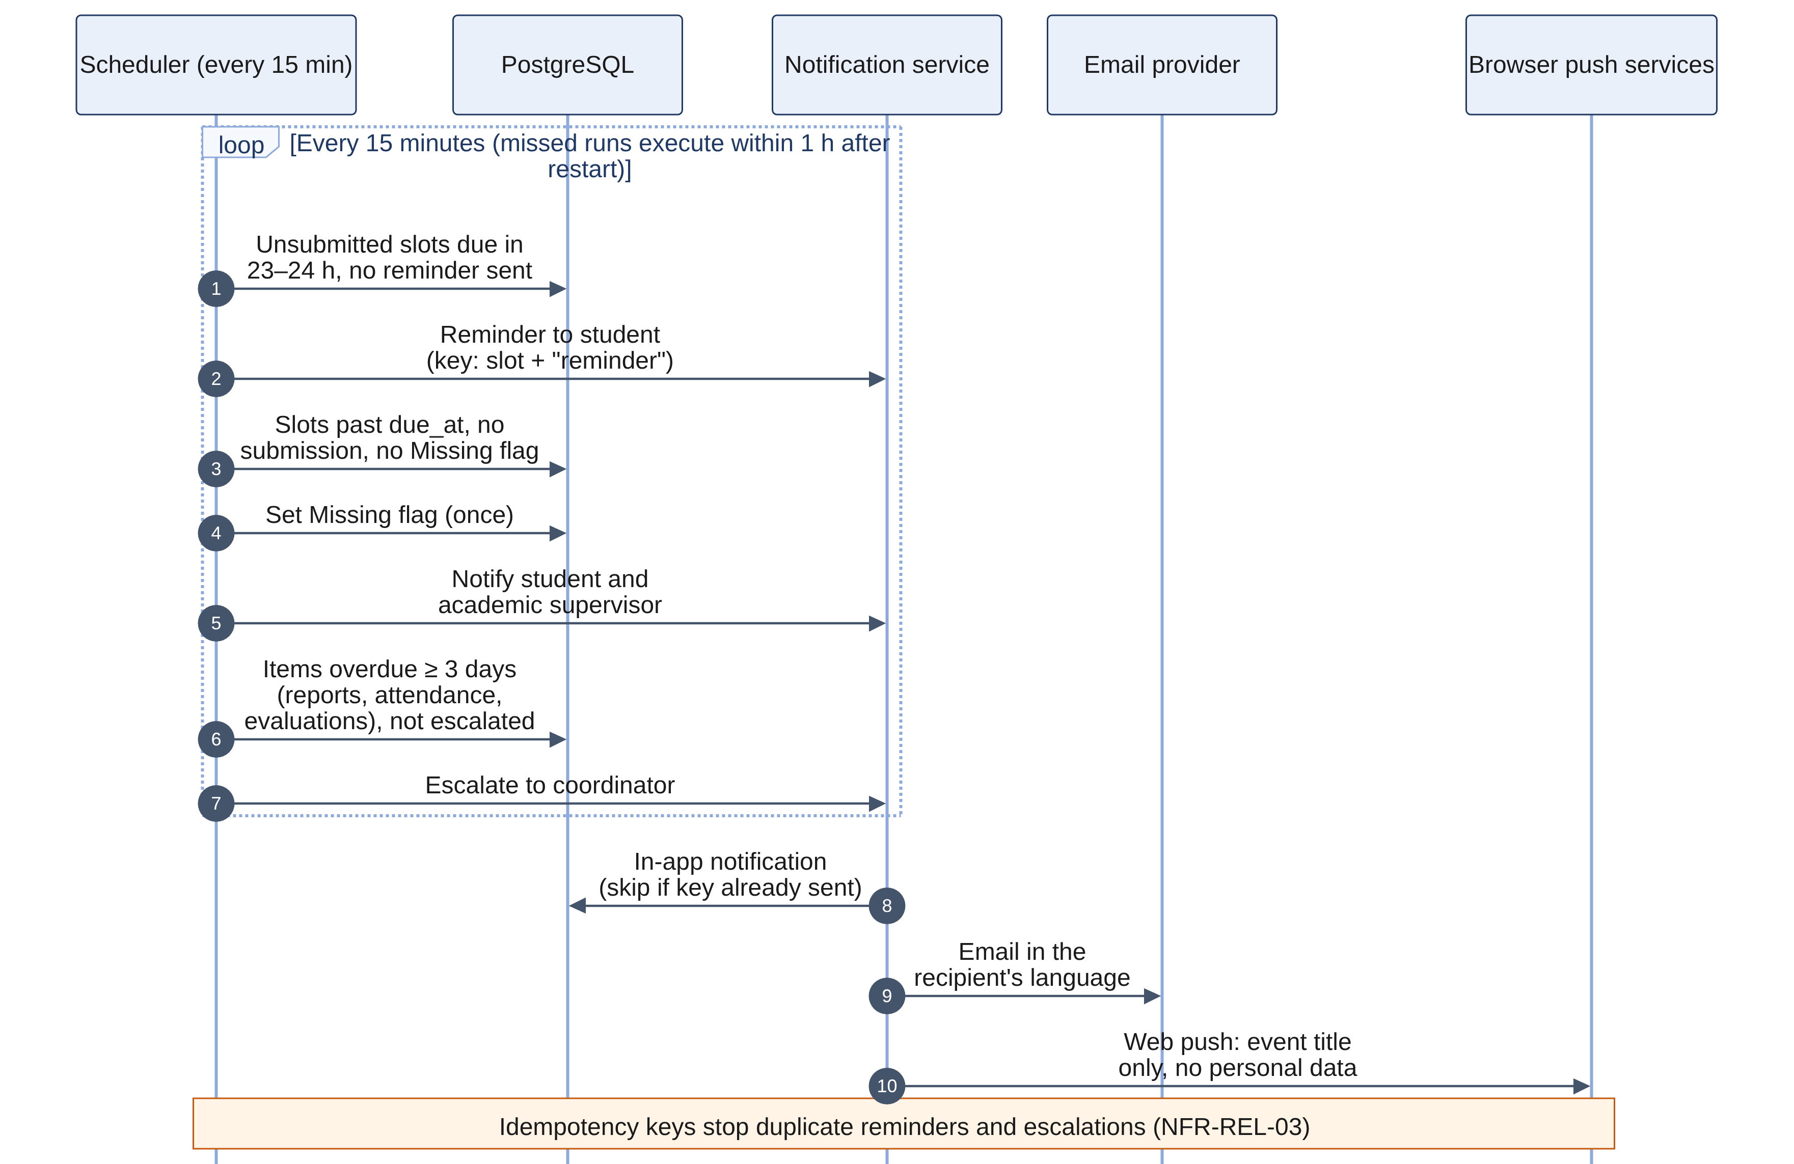
Figure 5.9 – Sequence: the scheduler's reminders, missing flags, and escalations

5.5 Activities
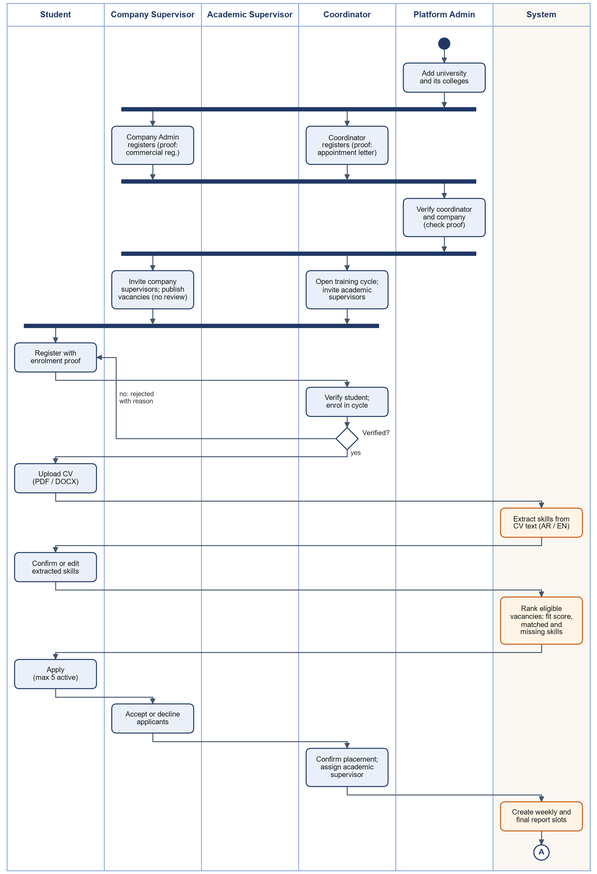
Figure 5.10 – Activity: from registration and verification to a confirmed placement
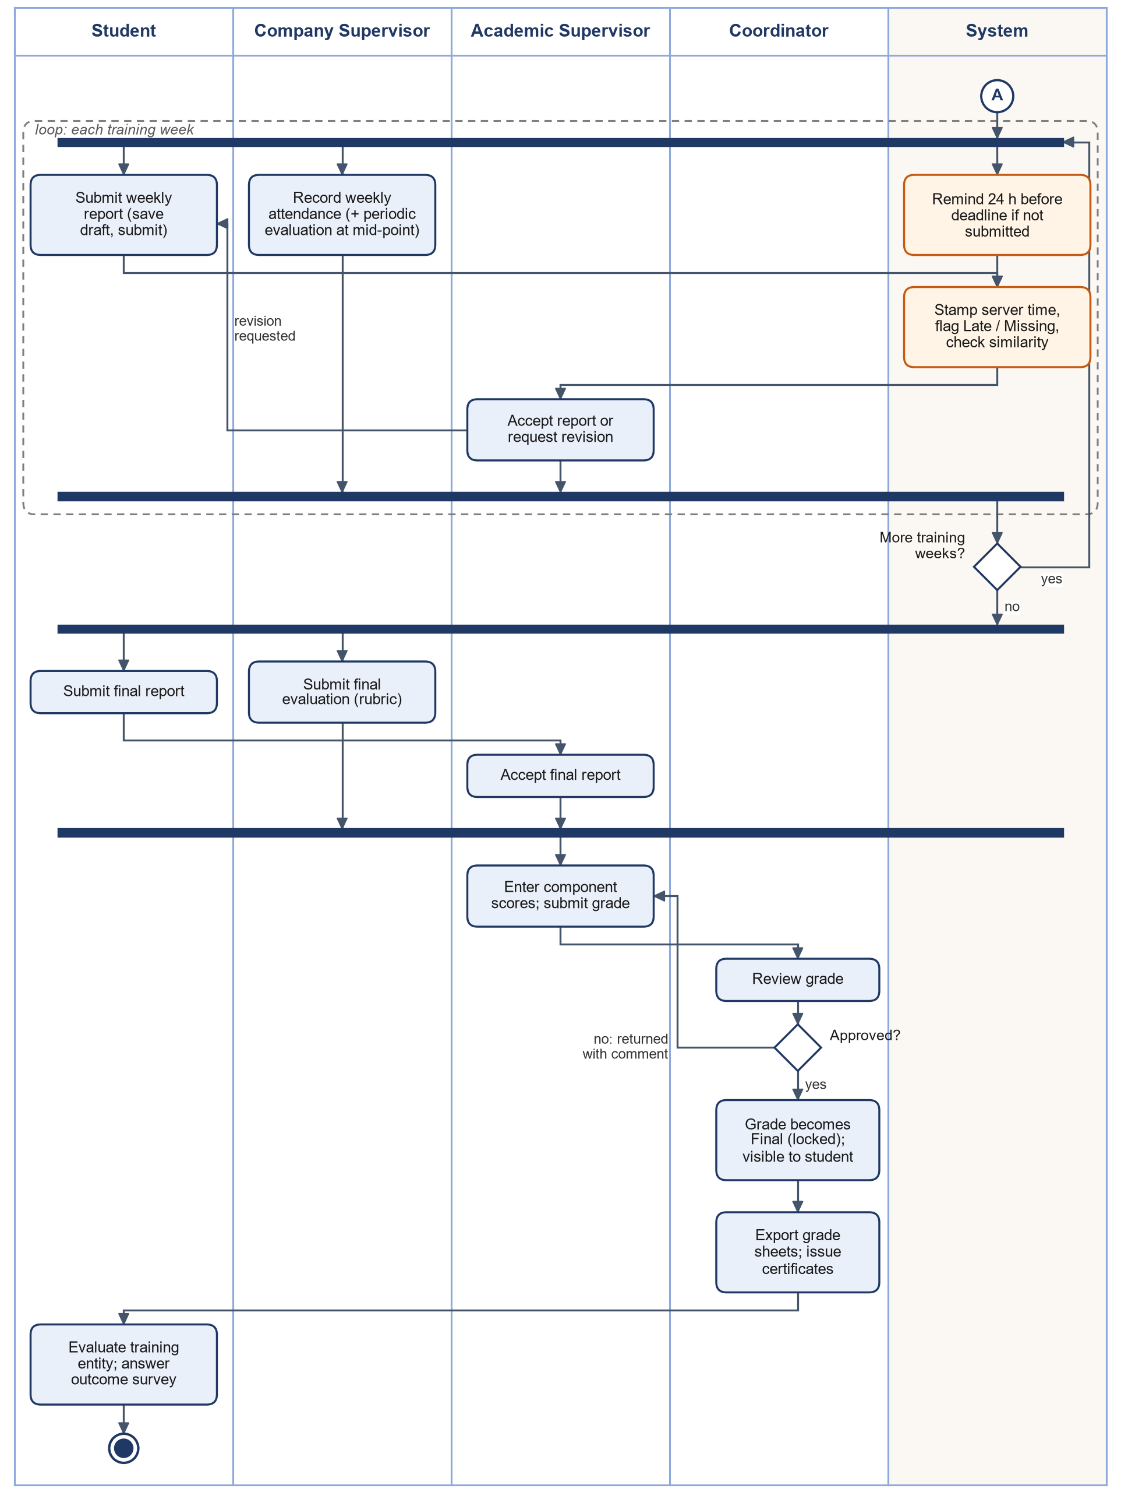
Figure 5.11 – Activity: from the first weekly report to the Final grade and the certificate

5.6 Algorithms
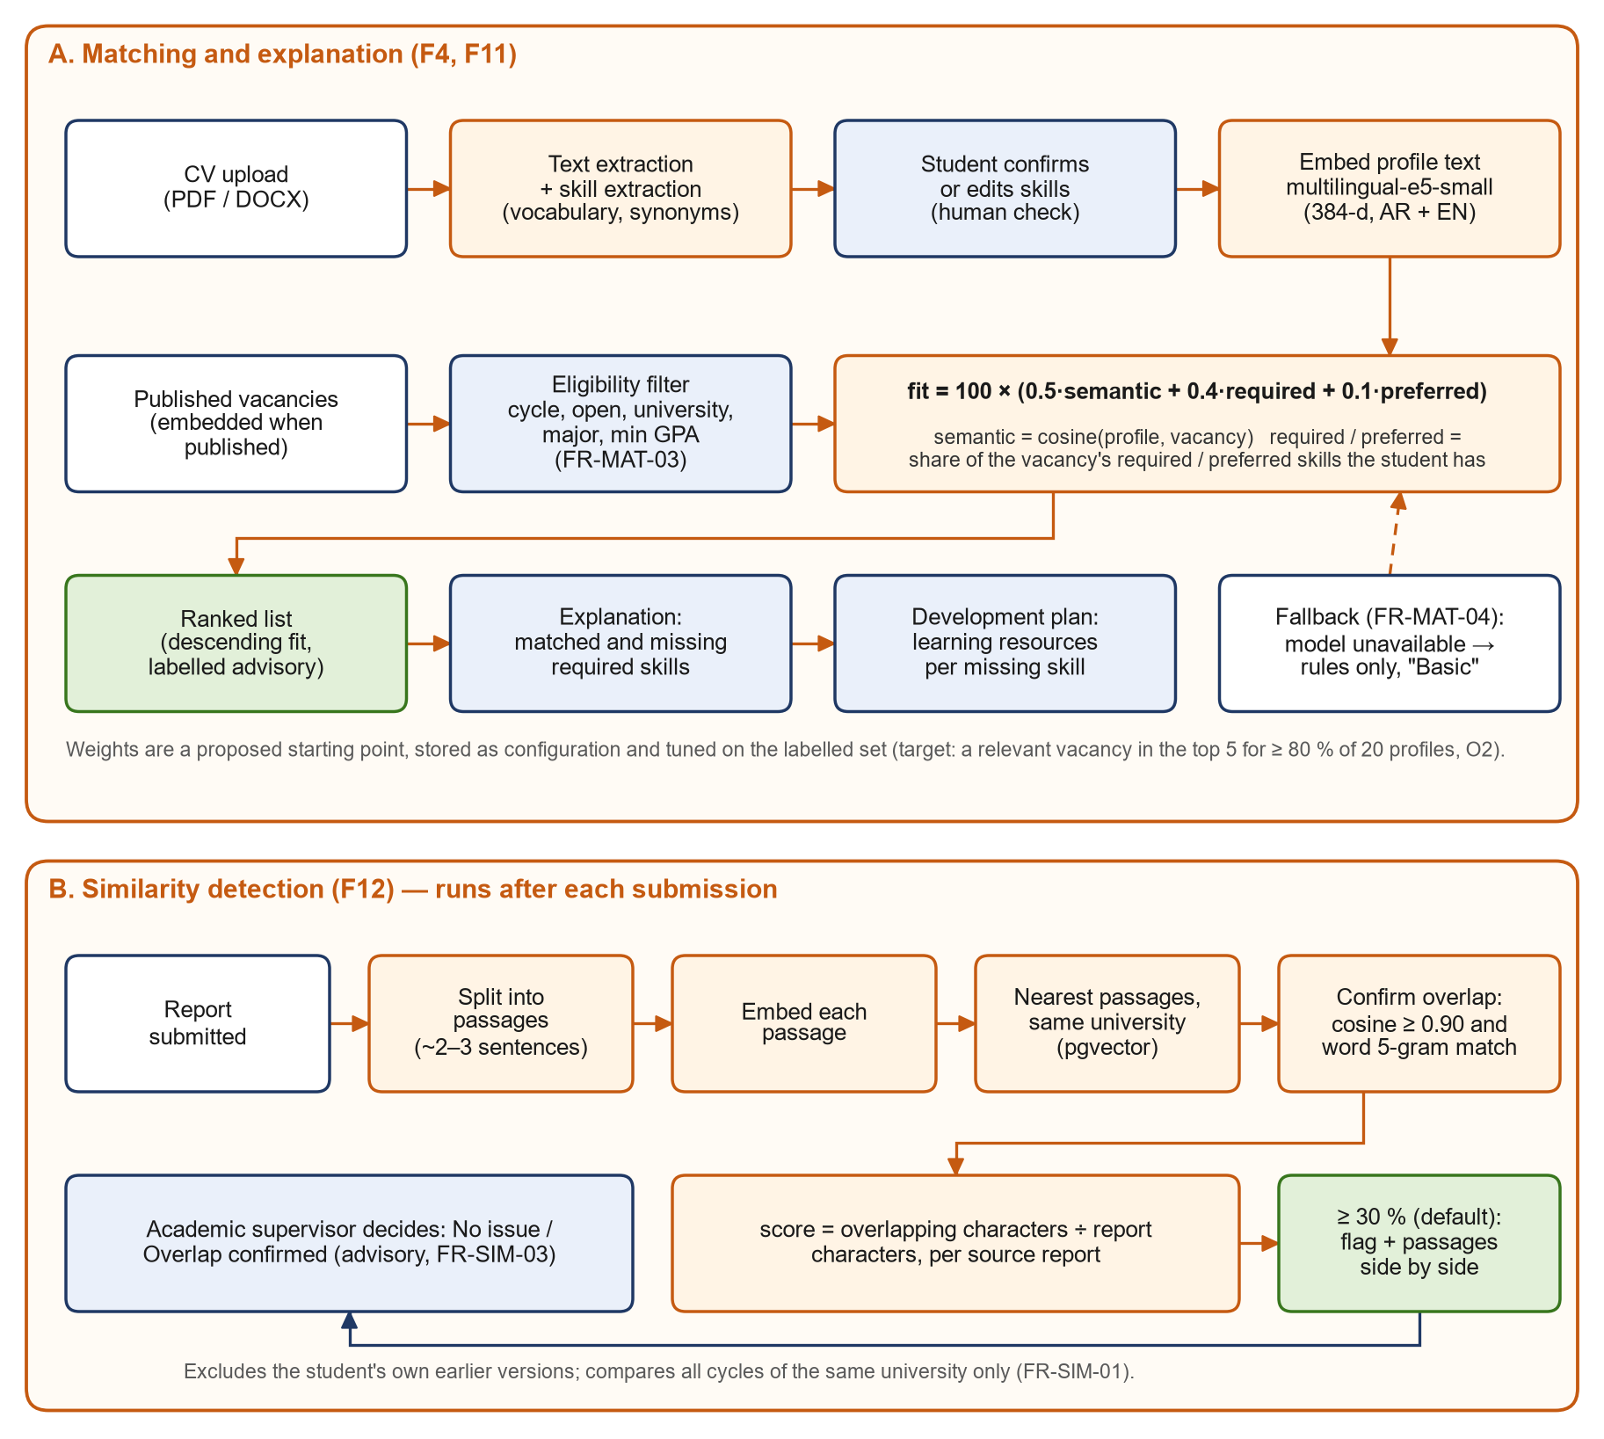
Figure 5.12 – AI pipelines: skill extraction, matching, and similarity detection

5.6.1 Skill Extraction (FR-PRF-04)
1. Extract the text with pypdf (PDF) or python-docx (DOCX). With fewer than 50 letters, the CV is marked "no text" and the student adds skills by hand (FR-PRF-05).
2. Normalize: lowercase Latin letters; for Arabic, remove diacritics and tatweel, unify أ/إ/آ to ا, ى to ي, and ة to ه.
3. Scan the normalized words with a dictionary of every skill's names and synonyms as phrases of one to four words; at each position the longest phrase wins.
4. Store the matches with an evidence snippet; only the skills the student confirms become profile skills.

5.6.2 Matching (FR-MAT-01 – 07)
1. Eligibility: the vacancy is published, before its deadline, open to the student's university, for the student's major, with GPA ≥ the minimum, and of the same training type as the student's cycle. Ineligible vacancies show their reason.
2. Semantic part: cosine similarity of the profile and vacancy embeddings, spread over 0–1: semantic = clamp((cos − 0.70) ÷ (0.95 − 0.70), 0, 1).
3. Skill parts: required = |S ∩ R| ÷ |R| and preferred = |S ∩ P| ÷ |P|, where S are the student's confirmed skills.
4. Fit score: fit = 100 × (0.5·semantic + 0.4·required + 0.1·preferred). Without embeddings, the score uses the skill parts only and is labelled "Basic matching" (FR-MAT-04).
5. Explanation: matched skills S ∩ R and missing skills R − S; the development plan lists a learning resource for each missing skill (FR-MAT-05, FR-MAT-06). The weights, floor, and ceiling are settings.

5.6.3 Similarity Detection (FR-SIM-01 – 03)
1. Split the report into passages of about one sentence (8 to 25 words) and embed each one.
2. For each passage, take the 5 nearest passages (HNSW index, cosine) from submitted reports of other slots of the same university.
3. A passage counts as overlap when a candidate reaches cosine ≥ 0.90 and at least 50% of its word 5-grams appear in that source's candidates.
4. The score for a source report is the share of the checked report's characters covered by confirmed passages. At 30% or more the check is flagged and the top 5 sources are kept with their passage pairs.
5. The academic supervisor records "No issue" or "Overlap confirmed" with a comment; nothing else changes.

5.6.4 Grade Computation (FR-WFL-02)
The company evaluation component is the mean of the final evaluation's criterion scores ÷ 5 × 100; the other components are entered by the academic supervisor (0–100). total = Σ (weight × score) ÷ 100, rounded half-up to two decimals. The weights of a cycle must total 100.

5.6.5 Deadlines (FR-CYC-01, FR-REP-04)
Week k covers start_date + 7(k−1) to start_date + 7k − 1; its report deadline is the configured weekday and time in Asia/Riyadh, stored in UTC. A submission is on time when submitted_at < due_at + 60 s: with a 23:59 deadline, 23:59:30 is on time and 00:00 is late.

5.7 Scheduled Jobs
All jobs run inside the API process under APScheduler. Each job runs in one transaction under a PostgreSQL advisory lock, so two containers never run the same job twice, and each selects work by state, so a run missed during downtime catches up on the next one (NFR-REL-03).
Job | Every | Does
send_reminders | 15 min | Reminds students of reports due in the next 24 hours (FR-NOT-02)
flag_missing | 15 min, and 30 s after start | Flags drafts past their deadline as missing; notifies the student and the supervisor (FR-REP-04, FR-NOT-03)
escalate_overdue | 15 min | Tells the coordinator about reports, attendance, and evaluations 3 or more days overdue (FR-NOT-04)
deliver_notifications | 1 min | Sends pending notifications by email (up to 5 attempts) and web push
similarity_retry | 5 min | Re-runs checks still pending after 5 minutes, or failed fewer than 3 times
purge_verification_documents | Daily | Deletes verification documents 30 days after the decision (FR-ORG-08)
cleanup | Daily | Deletes expired sessions, tokens, and old job runs

5.8 Security Design
Area | Design
Passwords | Argon2id; at least 8 characters with letters and digits; 5 failures lock the account for 15 minutes (NFR-SEC-02, NFR-SEC-03)
Links | Confirmation, invitation, and reset links are 32 random bytes; only their SHA-256 hash is stored; single use and time-limited
Sessions | JWT with a session ID; the session row enforces the 30-minute idle limit and logout; the token is kept in memory and sessionStorage, never in cookies
Authorization | Roles declared per route; record scope applied inside every query (own records for ST; own vacancies and placements for CS, the whole company for CA; assigned placements for AS; the college for CO; accounts and organizations only for PA)
Permission tests | A matrix lists all 163 endpoints with the callers allowed; a test calls every endpoint as every other caller and expects 401 or 403
Files | Type detected from the content, size capped, stored under random keys outside any web root, downloaded only through the API after the permission check
Data protection | Audit log append-only by trigger; AI runs in the API; push payloads hold a title and a link; backups encrypted; verification documents purged; closed cycles can be anonymized after the retention period (NFR-PRV-04)
Web | Strict Content-Security-Policy, X-Frame-Options, nosniff; OWASP ZAP scan weekly; pip-audit and npm audit in CI

5.9 User Interface Design
The screens follow the clickable wireframes made in task T3 (32 artboards). The interface is Arabic first (right to left) with an English mirror; spacing uses logical properties so one layout serves both directions. Status is always shown as text with a colour, never colour alone, and every AI result sits in a panel labelled "Advisory". Report submission, attendance, and evaluation each take at most three screens, and touch targets are at least 44 px. On phones the menu folds behind a "Main menu" button. Offline, a banner shows the time of the saved copy, opened pages stay readable, submit buttons are disabled, and drafts typed offline are saved when the connection returns.

6. Data Design

6.1 Conventions
- 49 tables with plural snake_case names. Primary keys are UUIDs, except link tables (composite keys), audit_log, report_passages, and job_runs (bigint identity), and system_settings (key).
- Every timestamp is timestamptz in UTC; deadlines are computed in Asia/Riyadh time and stored in UTC.
- Status values are text with a CHECK constraint listing the allowed values.
- Business records are never deleted: accounts are deactivated, placements cancelled, certificates revoked. Foreign keys use ON DELETE RESTRICT.
- Embeddings are halfvec(384) with an HNSW index on cosine distance; vacancy text search uses a pg_trgm index because PostgreSQL has no Arabic dictionary.
- Organization scope: students, academic supervisors, and coordinators carry users.college_id; company supervisors carry users.company_id; every scoped query joins to one of them.

6.2 Entity-Relationship Diagrams
The data model is drawn in four parts in crow's-foot notation; orange columns are vectors.
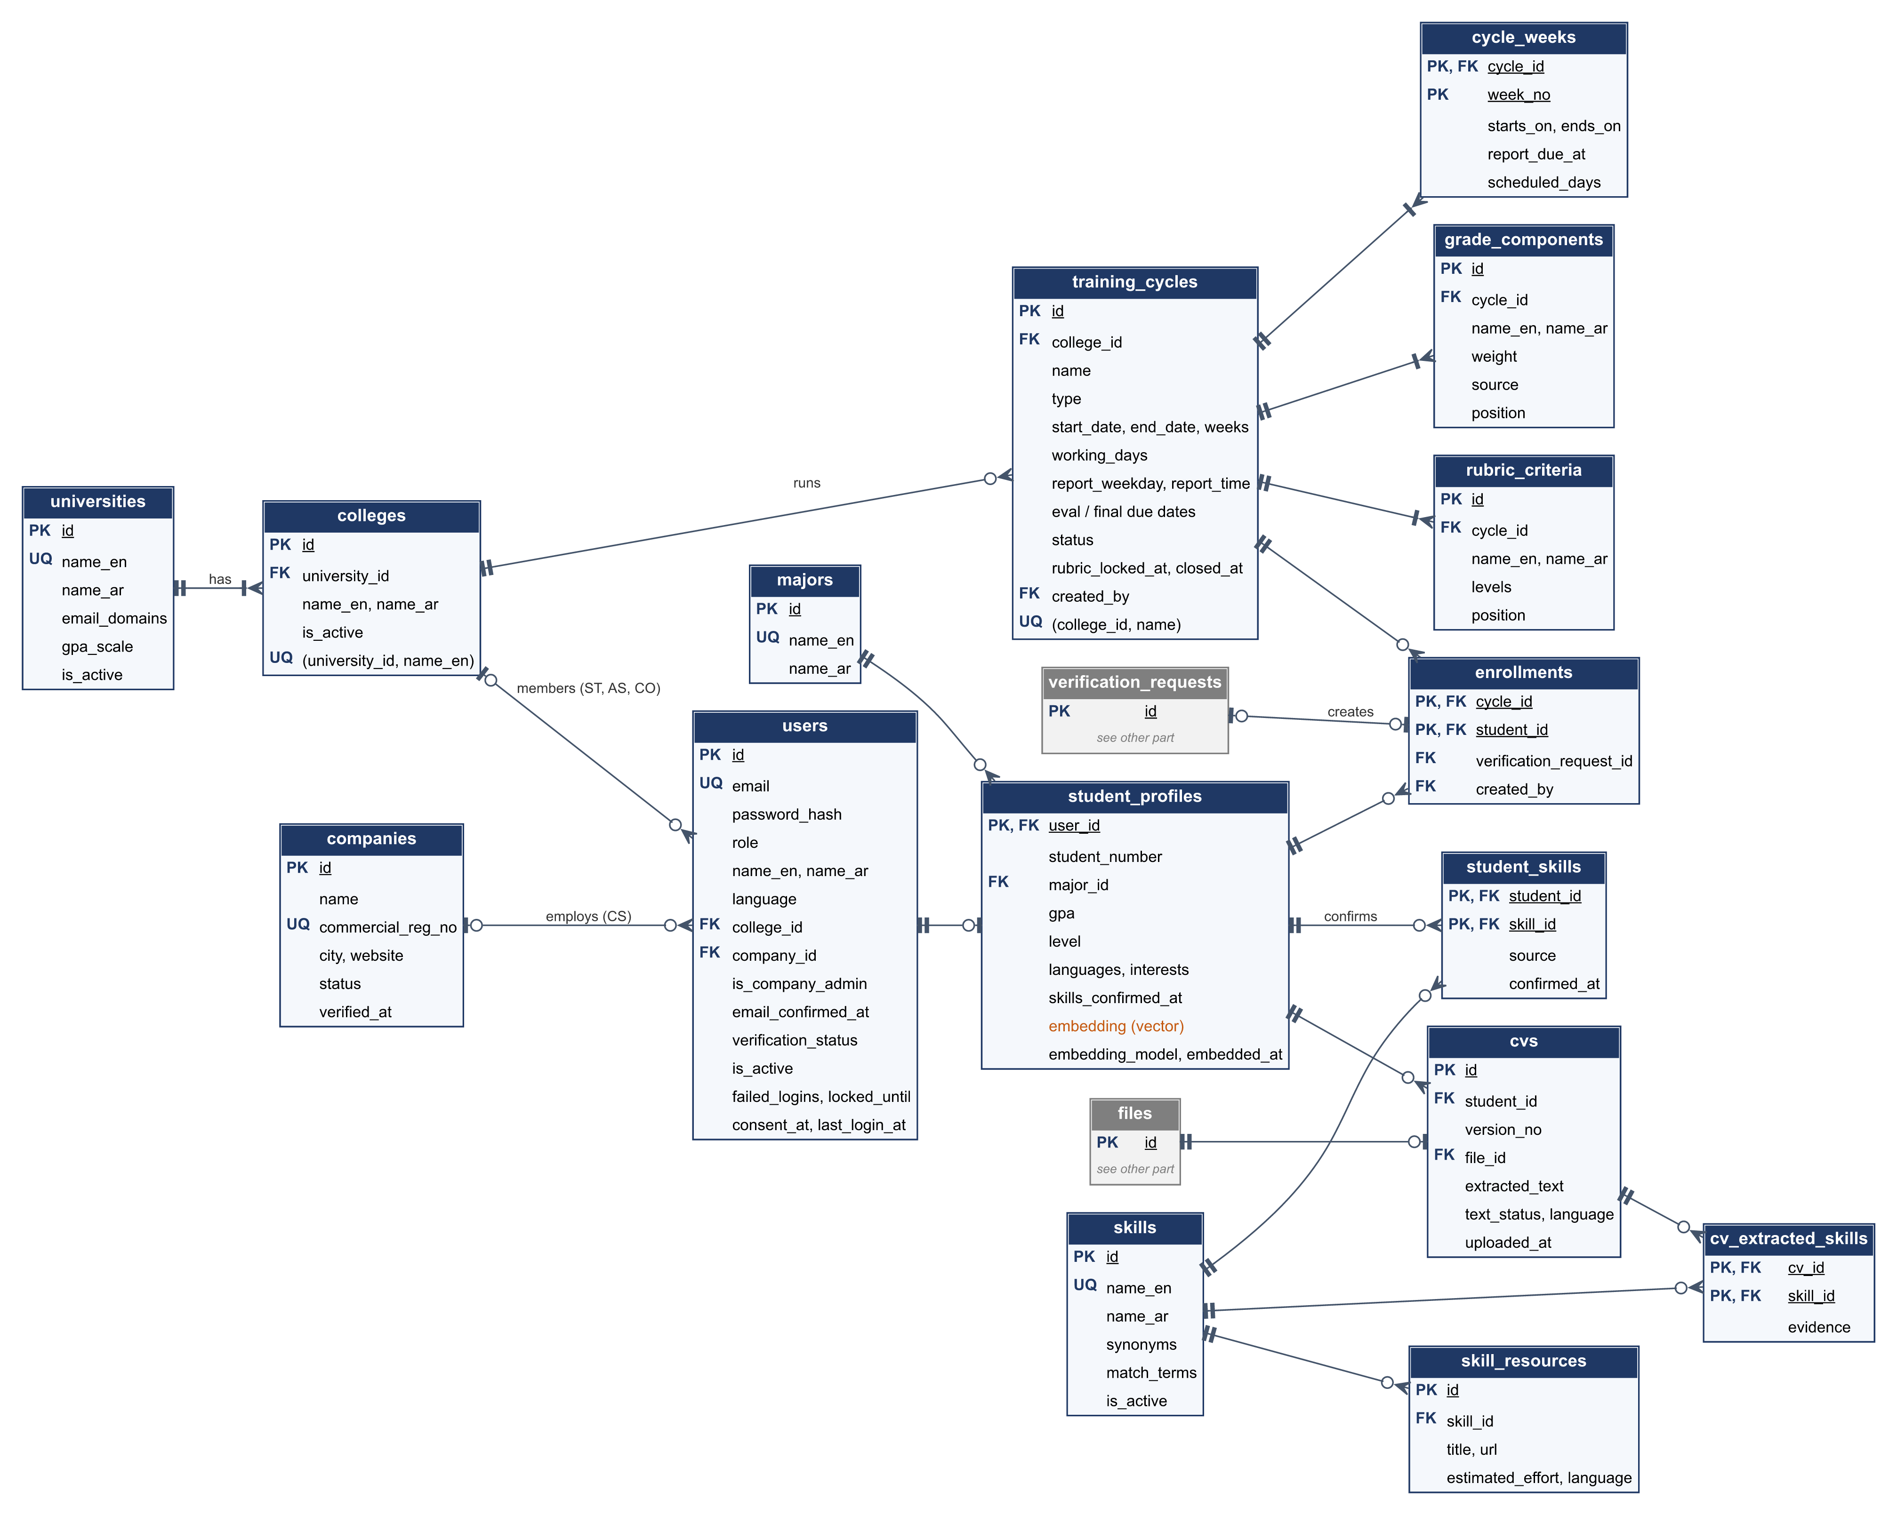
Figure 6.1 – ERD: organizations, accounts, cycles, and student profiles
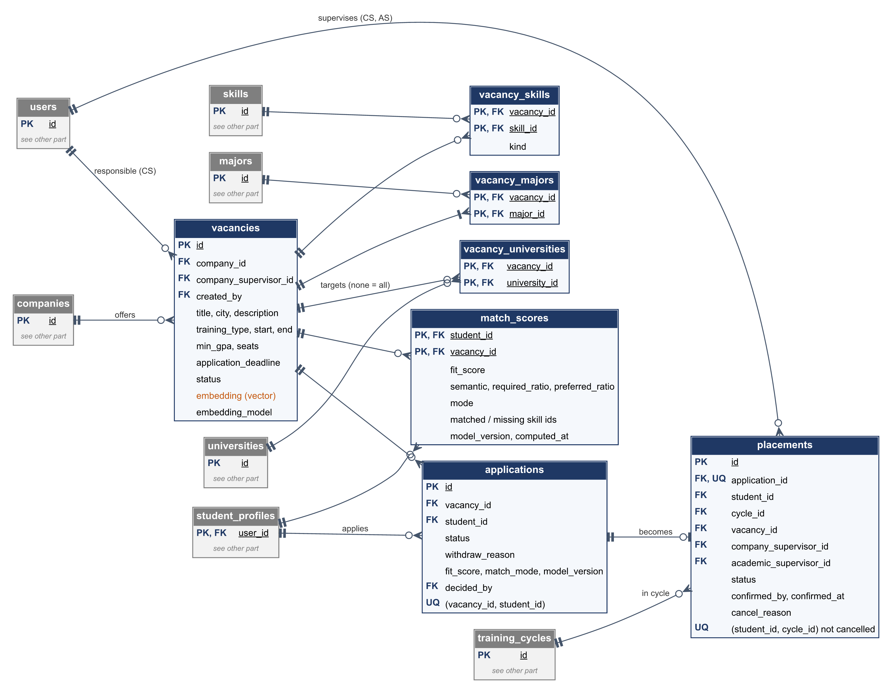
Figure 6.2 – ERD: vacancies, matching, applications, and placements
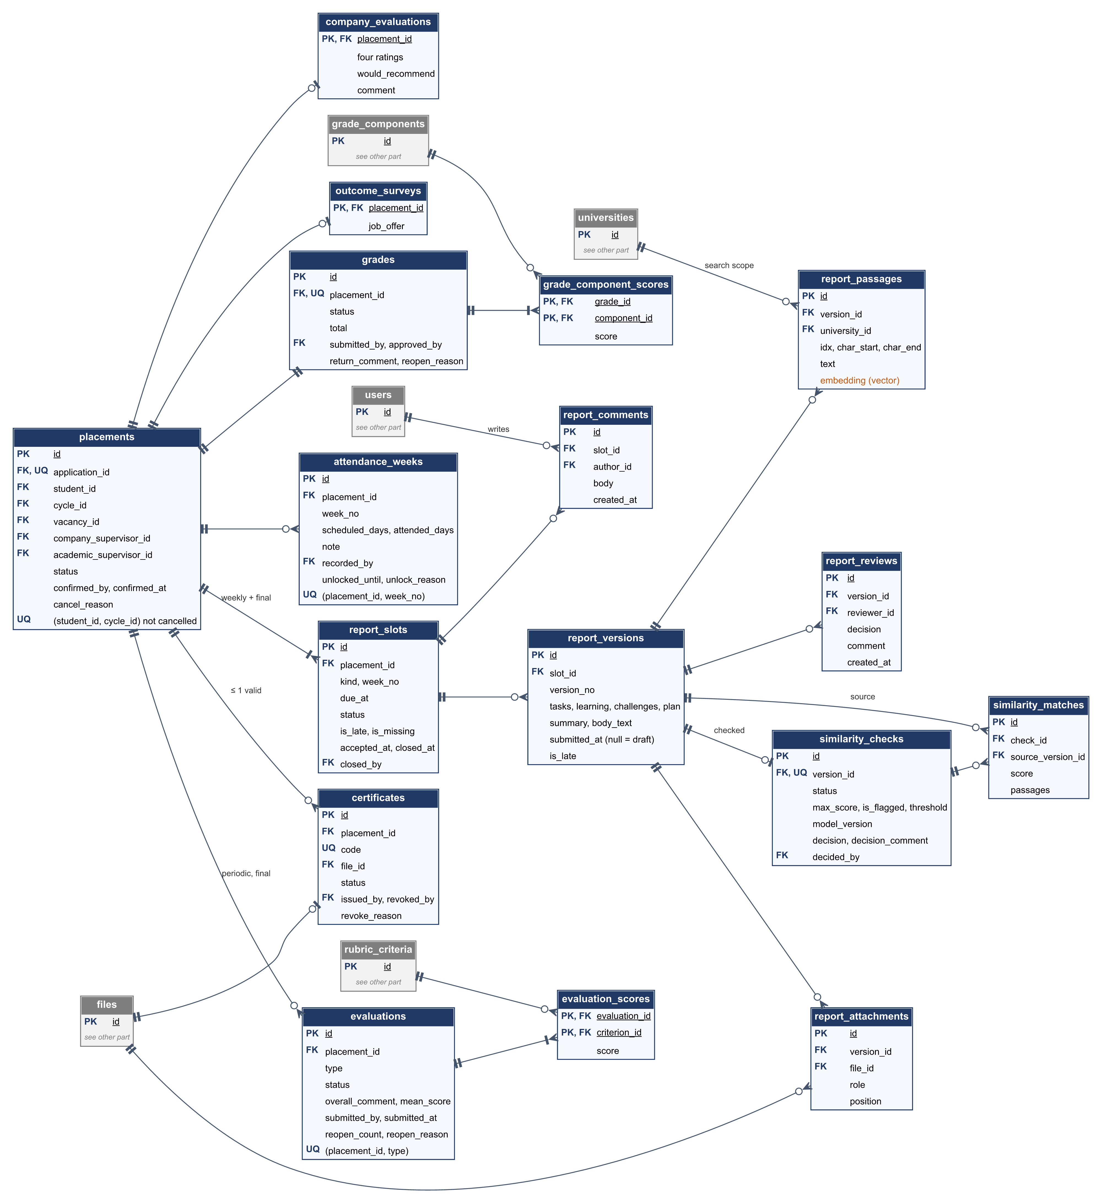
Figure 6.3 – ERD: reports, similarity, attendance, evaluations, grades, and certificates
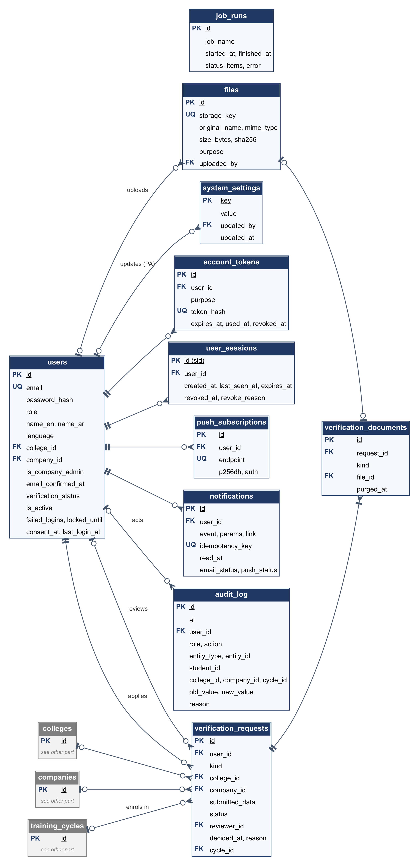
Figure 6.4 – ERD: verification and platform services (tokens, sessions, files, notifications, audit, settings, jobs)

6.3 Tables by Area
Table 6.1 – The 49 tables by area
Area | Tables | Key relationships
Organizations and accounts | universities, colleges, companies, users, verification_requests, verification_documents, account_tokens, user_sessions | A college belongs to a university; a user belongs to a college or a company; a verification request has documents
Cycles and configuration | training_cycles, cycle_weeks, grade_components, rubric_criteria, enrollments, majors, skills, skill_resources, system_settings | A cycle belongs to a college and has weeks, grade components, and rubric criteria; an enrolment links a student to a cycle
Students and CVs | student_profiles, cvs, cv_extracted_skills, student_skills | A profile has CV versions; extracted skills are candidates, student skills are confirmed
Vacancies and placement | vacancies, vacancy_skills, vacancy_majors, vacancy_universities, applications, placements, match_scores | A vacancy belongs to a company; an application links a student to a vacancy; a placement comes from one accepted application
Reports and similarity | report_slots, report_versions, report_attachments, report_reviews, report_comments, report_passages, similarity_checks, similarity_matches | A placement has report slots; a slot has versions and comments; a version has attachments, reviews, passages, and at most one similarity check
Attendance and evaluations | attendance_weeks, evaluations, evaluation_scores, company_evaluations, outcome_surveys | Per placement: one row per week, periodic and final evaluations with a score per rubric criterion
Grades and certificates | grades, grade_component_scores, certificates | One grade per placement with a score per component; certificates per placement
Platform services | files, notifications, push_subscriptions, audit_log, job_runs | Files are referenced by CVs, attachments, documents, exports, and certificates; notifications and subscriptions belong to users

The full data dictionary, with every column, key, and constraint, is in Section 4.3 of the System Design Document. The report side (13 tables with every column) is also drawn in the interactive diagrams (Appendix 8.2).

6.4 Derived Values and Retention
- Not stored but computed: a student's active applications, eligibility and its reason, the attendance percentage, dashboard counts, and the history of a record (from audit_log).
- Records stay for the life of the system. After the college's retention period, a coordinator can anonymize a closed cycle: names, contact details, CVs, report text, and certificate files are removed, while statuses, scores, and dates stay, so the cycle's statistics do not change.

7. External Interfaces

7.1 User Interface
The web app runs in current browsers on computers and phones and can be installed as a PWA. It offers role dashboards, forms, and lists in Arabic and English, a notification bell, and a public certificate page (/verify/<code>) reached from the QR code.

7.2 REST API
Table 7.1 – API conventions
Topic | Rule
Base URL | https://<api-host>/api/v1; locally http://localhost:8000/api/v1
Format | JSON in UTF-8; file uploads as multipart/form-data; snake_case fields
Authentication | Authorization: Bearer <token> from POST /auth/login; public endpoints need no token
Language | Errors and generated texts in the user's saved language, or Accept-Language before login
Dates | ISO 8601; the server returns UTC and the client shows Asia/Riyadh time as DD/MM/YYYY HH:mm
Lists | ?page=1&page_size=20 (maximum 100); answers carry items, page, page_size, total
Errors | application/problem+json with status, a stable code (for example INVALID_TRANSITION, FORBIDDEN, CYCLE_CLOSED), a detail in the user's language, and field errors
Contract | FastAPI generates the OpenAPI 3.1 document at /api/v1/openapi.json; the frontend client is generated from it

Table 7.2 – Endpoint groups (163 endpoints)
Group | Examples
Authentication and session | POST /auth/register, POST /auth/login, POST /auth/logout, GET /me, POST /me/consent
Organizations, verification, accounts | POST /me/verification, GET /verification-requests, POST /companies/{id}/suspend, invitations, role transfer
Cycles, skills, majors, settings | POST /cycles, PUT /cycles/{id}/grade-components, GET /skills
Profile and CV | PATCH /students/me/profile, POST /students/me/cvs, PUT /students/me/skills
Vacancies, applications, placements, matching | POST /vacancies, POST /vacancies/{id}/applications, POST /placements, GET /students/me/matches, GET /students/me/matches/{id}/plan
Reports and similarity | PUT /report-slots/{id}/draft, POST /report-slots/{id}/submit, POST /report-slots/{id}/accept, GET /report-versions/{id}/similarity
Attendance, evaluations, grades | Attendance weeks, evaluation forms, PUT /placements/{id}/grade, POST /grades/{id}/submit, POST /grades/{id}/approve
Dashboards, exports, certificates | Pending actions, statistics, grade sheet, certificate issue, GET /public/certificates/{code}
Notifications, audit, files, system | GET /notifications, push subscriptions, GET /audit-log, GET /files/{id}, GET /health

7.3 External Services and Protocols
External system | Protocol | Used for
Browsers | HTTPS, JSON; service worker | The web app and the API
PostgreSQL (Supabase or local) | PostgreSQL protocol over TLS | All records and vector search
Supabase Storage (or a local volume) | HTTPS REST with the service key | Private file storage
SMTP server (Gmail, or Mailpit locally) | SMTP with STARTTLS | Account emails and notifications
Browser push services | Web Push with VAPID keys | Push notifications (title and link only)
GitHub Actions, Vercel, Hugging Face | Git and HTTPS | CI, deployment, keep-alive, backups

7.4 Libraries
Library | Use
FastAPI, Pydantic, SQLAlchemy, Alembic, psycopg | API, validation, database access, migrations
sentence-transformers, pgvector, pypdf, python-docx, filetype | Embeddings, vector search, text extraction, file type detection
argon2-cffi, PyJWT | Passwords and tokens
APScheduler | Scheduled jobs
fpdf2, uharfbuzz, openpyxl, qrcode | PDF and Excel exports, certificate QR codes
pywebpush | Web push
React, React Router, TanStack Query, react-i18next, openapi-fetch, Tailwind CSS | Web app

8. Appendices

8.1 Glossary
Term | Meaning
Placement | A student's confirmed training at a company, created by the coordinator from an accepted application
Report slot | One weekly or final report a student owes for a placement, with its deadline and status
Training cycle | A college's training period (for example a summer term) with its weeks, deadlines, grade components, and rubric
Embedding | A list of 384 numbers that represents the meaning of a text, used to compare texts
Fit score | The 0–100 match between a student and a vacancy (Section 5.6.2)
Similarity check | The comparison of a submitted report with earlier reports of the same university (Section 5.6.3)
Outbox | The notifications table: notifications are written with the change and sent later by a job
Advisory lock | A PostgreSQL lock that lets only one process run a given job at a time
PWA | Progressive web app: a web app that can be installed and keeps working with a weak connection
RTL / LTR | Right to left (Arabic) / left to right (English)
Scope | The set of records a user may see: their own, their college's, or their company's

8.2 Supporting Diagrams
- The diagram pack (InternSync_Diagrams): use case, context, activity, state, architecture, ERD, sequence, AI pipeline, deployment, and schedule diagrams, with their sources.
- The interactive code diagrams (diagrams.html): architecture, the report submit and review workflow, the submit request sequence, the notification data flow, the report slot lifecycle, and the report-side database, each linked to the code lines it shows.
- The class diagram of Figure 5.1, made with the same tool from the models and services.

8.3 Traceability
SRS area | Module | Tables | API section
FR-AUT | auth, orgs | users, user_sessions, account_tokens | 3.1, 3.2
FR-ORG | orgs, auth, cycles | universities, colleges, companies, users, verification_requests, verification_documents, enrollments | 3.1, 3.2
FR-CYC | cycles | training_cycles, cycle_weeks, grade_components, rubric_criteria, skills, skill_resources, majors, system_settings | 3.3, 3.4
FR-PRF | profiles | student_profiles, cvs, cv_extracted_skills, student_skills | 3.5
FR-VAC | vacancies | vacancies, vacancy_skills, vacancy_majors, vacancy_universities, applications, placements | 3.6, 3.7
FR-MAT | matching | match_scores | 3.8
FR-REP, FR-WFL-01 | reports | report_slots, report_versions, report_attachments, report_reviews, report_comments | 3.9
FR-SIM | similarity | report_passages, similarity_checks, similarity_matches | 3.10
FR-ATT | attendance | attendance_weeks | 3.11
FR-EVL | evaluations | evaluations, evaluation_scores, company_evaluations | 3.12
FR-WFL-02 – 07 | grades | grades, grade_component_scores | 3.13
FR-DSH | dashboards, evaluations | (queries), outcome_surveys | 3.14
FR-EXP, FR-CER | exports, certificates | files, certificates | 3.15, 3.16
FR-NOT, FR-PWA-02 | notifications, jobs | notifications, push_subscriptions, job_runs | 3.17
FR-AUD | core | audit_log | 3.18

8.4 References
1. IEEE Std 1016-1998, IEEE Recommended Practice for Software Design Descriptions, IEEE Computer Society, 1998.
2. IEEE Std 830-1998, IEEE Recommended Practice for Software Requirements Specifications, IEEE Computer Society, 1998.
3. I. Sommerville, Software Engineering, 10th ed., Pearson, 2016.
4. Group 3, InternSync – Software Requirements Specification, version 1.6, Oct 28, 2026.
5. Group 3, InternSync – System Design Document, version 1.7, Oct 29, 2026, and API Specification, version 1.5, Oct 28, 2026.
6. L. Wang et al., "Multilingual E5 Text Embeddings: A Technical Report," arXiv:2402.05672, 2024.

Evaluation
To be completed by the instructor or supervisor.
6. Project SDD Report (36 points / 6 marks) – Week 13

Section | Excellent (Full Points) | Good (75%) | Fair (50%) | Poor (25% or below) | Points
1. Introduction (3 pts) | Purpose, scope, audience, and references are clearly explained and aligned with SRS. | Covers most parts but some vague. | Minimal explanation of purpose/scope. | Missing or irrelevant. | /3
2. System Overview (4 pts) | High-level architecture and design strategy clearly described with diagrams (e.g., context, layered). | Basic overview given, limited diagrams. | Vague overview, no clear design rationale. | Very poor or missing. | /4
3. Design Considerations (5 pts) | Assumptions, constraints, goals, and trade-offs are well-identified and justified. | Most elements present, some weak. | Limited mention of goals or constraints; unclear trade-offs. | Missing or irrelevant. | /5
4. Architectural Design (8 pts) | Comprehensive architecture description with diagrams (component, deployment). Clear decomposition and interactions. | Most elements present but incomplete. | Limited diagrams; weak explanation of interactions. | Very poor or missing. | /8
5. Detailed Design (8 pts) | Each module/component described in detail (data, algorithms, I/O, interactions). UML diagrams included (class, sequence, activity). | Most components covered, some lack detail. | Few components described; diagrams minimal. | Missing or irrelevant. | /8
6. Data Design (3 pts) | Data structures, schema, and relationships clearly defined (ERD/schema included). | Some data design described, missing relationships. | Minimal mention of data structures or schema. | Missing. | /3
7. External Interfaces (3 pts) | Interfaces with systems/components clearly specified (APIs, libraries, protocols). | Interfaces covered but vague. | Limited or unclear description. | Missing. | /3
8. Appendices & Supporting Info (2 pts) | Glossary, references, and supporting diagrams included. | Some appendices included. | Minimal (e.g., only glossary). | None provided. | /2

