A1-20171-SQL-DBS301

DUE DATE: Nothing will be accepted after this date. It will get a zero

**Due BEFORE MIDNIGHT on the FRIDAY of WEEK 6**

**PLAGIARISM**   
When you submit an assignment, you are saying that the submission is your own work and as such you wish to be given credit for the work.

Occasionally, especially when working on a design problem or writing programs (but never on exams or tests!), it may be necessary to ask someone for a small amount of help. You are permitted to do so, provided you meet the following two conditions.

1 You acknowledge the help on the work you hand in, including explaining the work or portion of the work done or assisted by another person.

2 You understand the work that you hand in, so that you could explain the reasoning behind the parts of the work done for you or assisted by another.

Any other assistance by another person constitutes a violation called plagiarism and will be treated as such.

When 2 or more of you work together as a group, only one assignment should be submitted with all the members’ names on it at the time of submission. If two submissions exist, that are essentially the same, then both submissions cannot possibly make the claim that the work is "solely their own". This is a serious matter and is considered plagiarism. It is recorded in accordance with College policy and may result in a penalty such as expulsion from the College. Please do not put yourself in this position. Plagiarism is very easy to detect.

**Anyone not in this list cannot be added to the group later**

Name(s) Student ID(s) Section A, B or C

______________________________________________________________________________

______________________________________________________________________________

______________________________________________________________________________

______________________________________________________________________________

The above acknowledges you understand.

INSTRUCTION:

1 Rename this WORD file A1-xxxxx where xxxxx is replaced with your email account name, not the whole email. If you are in a group pick one of them.

2 When finished email this back to me and CC everyone in your group as proof it was sent.

3 The following tables are used for this assignment. You will be given a script to load.

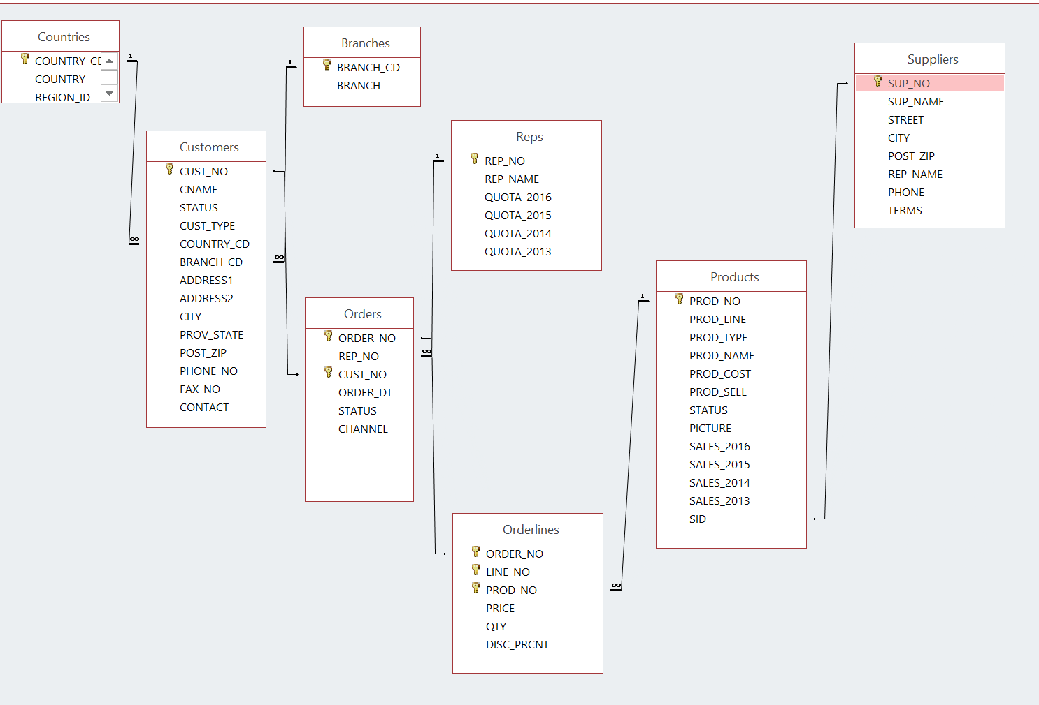

NOTE:

If any output goes on for more than 100 lines, only cut and paste the first 100 or so. I don’t want to get this word document too big.

1. Display the customer number, customer name and country code for all the customers that are in SPAIN. The country code for Spain is SPA. Please note that you are given SPA, or spa or SpA to use and not Spain.

**SQL:**

Select Cust_no, CName, upper(country_cd)

From customers

Where upper(country_cd) = “SPA”

**OUTPUT:**

2. How many orders have the product number 40302?

**SQL**

**Select count(order_no)**

**From orderlines**

**Where prod_no = 40302**

**Group by prod_no;**

**OUTPUT:**

3. List the customer number, customer name and order number for customers that ordered product 40302. Put result in customer number order.

**SQL:**

**Select c.cust_no, c.CName, c.Order_num**

**From customers c, orderlines o**

**Where c.order_num = o.order_num AND**

**C.prod_num = 40302;**

4 Display the customer number for Ultra Sports 5.

**SQL:**

**OUTPUT:**

5 Display all orders for United Kingdom. The word entered is United Kingdom and not UK. Show only cities that start with L.

Display the customer number, customer name, order number, product name, the total dollars for that line. Give that last column the name of TOTAL.

Put the output into customer number order from highest to lowest and display only order numbers less than 75

**SQL:**

**OUTPUT:**

6 Display a count of how many different country codes there are

**SQL:**

**Select count(country_cd)**

**From countries;**

**OUTPUT:**

7 Find the total dollar value for all orders from London. Each row will show customer name, order number and total dollars for the order. Sort by order number

**SQL:**

**Select c.CName, c.order_number, o.price**

**From customers c, orderlines o**

**Order by c.order_number**

**OUTPUT:**

**Going back to the same tables you have used for labs that came from demobld10g**

8 Display the (a) employee number, (b) full employee name, (c) job and (d) hire date.

- Limit the display to all employees hired in May or November of any year.

*- The most recently hired employees are displayed first.*

*- Exclude people hired in 1994 and 1995.*

*- Full name should be in the form 🡪 Lastname, Firstname -- with an alias called Full Name.*

- Hire date should point to the last day in May, June, July, August or December of that year (NOT to the exact hire date)

- The format is in the form of *May 31st of 1996* –better if there is no big gap between month and 31st

*- The hire date column should be called Start Date.*

**NOTE: Do NOT use a LIKE operator.**

You should display ONE row per output line by limiting the width of the *Full Name* to 25 characters.

**SQL:**

**Select e.Employee_id, (e.Last_name,** **e.First_name,) as “Full Name” d.department_name, e.hire_date as “start date”**

**From employees e, departments d**

**Where hire_date > ‘93-12-31’ OR hire_date < ‘95-01-01’**

**Order by hire_date desc**

**OUTPUT:**

9 List the employee number, full name, job and the modified salary for all employees

- whose monthly earning (without the increase) is outside the range $6,000 – $11,000

- and who are employed as a Vice Presidents or Managers (President is not counted here).

- You should use **Wild Card** characters for this.

- the modified salary for a VP will be 30% higher

- and managers a 20% salary increase.

- Sort the output by the top salaries (before this increase).

Heading will be: 🡪 *Employees with Increased Pay*

**The output lines should look like this sample line:**

Employee 101 named Neena Kochhar with Job ID of AD_VP will have a new salary of $22100

**SQL:**

**OUTPUT:**

10 Display last_name, job id and salary for all employees who earn more than all lowest paid employees per department that are in locations outside the US.

Exclude President and Vice Presidents from this query.

Sort the output by job id ascending.

If a JOIN is needed you must use a “newer” method (USING/JOIN)

**SQL:**

**OUTPUT:**

11 Who are the employees (show last_name, salary and job) who work either in IT , ACCOUNTING or MARKETING department and earn more than the worst paid person in the SHIPPING department.

Sort the output by the last name alphabetically.

**You need to use ONLY the Subquery method (NO joins allowed).**

**SQL:**

**OUTPUT:**

12 Display Department_id, Job_id and the Lowest salary for this combination but only if that Lowest Pay falls in the range $6000 - $18000.

Exclude people who

(a) work as some kind of *Representative* job from this query and

(b) departments IT and SALES

Sort the output according to the Department_id and then by Job_id.

You MUST NOT use the Subquery method.

**SQL:**

**OUTPUT:**