|  |
| --- |
| Networking Game |
| Bows and Arrows |
| Mitchel Box and Adam Parko |

Contents

Bow and Arrows 3

Purpose 3

Level Design 3

Health Deduction 3

Game layout 4

Attribute Growth 4

Player Algorithms 4

# Bow and Arrows

## Purpose

To kill or nock of the player off the other platform.

### Level Design

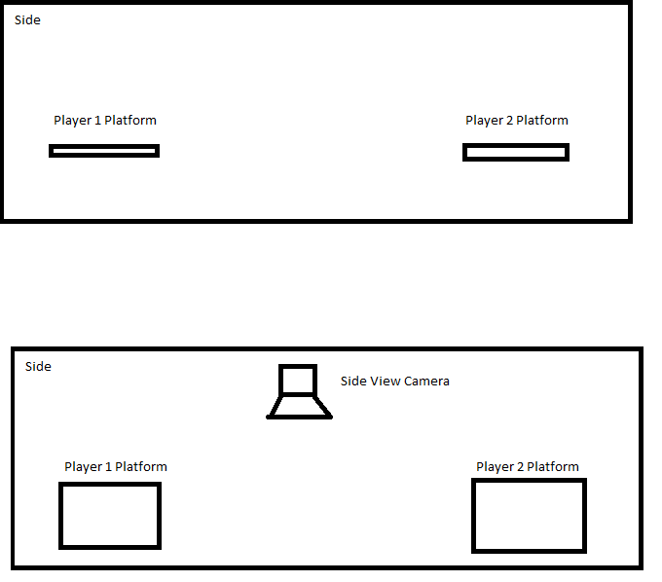

If the player falls from the platforms they are killed, each player has a set amount of health and depending on where the bullet impacts the player health is reduced accordingly.

## Health Deduction

(These are not fixed values)

Head: Instant Kill

Torso: Health / 2

Heart: Instant Kill

Thigh: health / 4

Calf: Health / 6

Feet: Health / 8

Upper Arm: Health / 4

Lower Arm: health / 6

Hand: Health / 8

## Game layout

The game will need 2 computers and/or a third screen for the side camera which is spectating the current fight happening. The side view camera is used by players to get a better perspective of what is happening on the world.

Arrows will be affected by Gravity, at the least and if time allows wind, and player strength.

As a player kills his enemy a attribute bar increases in the manner in which the player killed his opponent.

## Attribute Growth

If a the opposing player is killed and the shooter currently had low strength as he held the bow for too long he will increase in strength and stamina.

The further the bow is pulled back the more damage that can be performed.

Pullback is worked of the strength of the body

## Player Algorithms

Time the player can hold the arrow for:

mTimeHolding = Stamina * 10

Working out how much power is pushed onto the arrow after the player releases the arrow

if (mTimeHolding > 0)

mTimeHolding -= deltaT

Else

Stamina -= deltaT;

If (Stamina > 0)

mVelocityofArrow = Stamina * mHoldingTime

else

mVelocityofArrow = Stamina

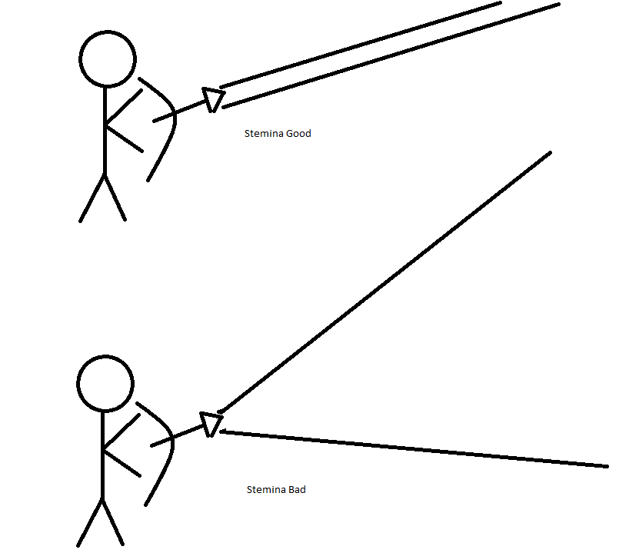

## Networking

Send a class