Walmart Sales Data Warehouse Project Report

Name: Salar Khan
ID: 23i-2607
Class: BDS-5A

1. Project Overview
This project is about building a data warehouse system for Walmart sales data. The main goal was to take raw transactional data that keeps coming in continuously (like a stream) and process it properly by combining it with master data about customers and products. Then we load everything into a structured data warehouse where we can run various business analyses.
The project had three major parts:
- First, designing the database schema with dimension and fact tables
- Second, implementing a special algorithm called HYBRIDJOIN to efficiently process and load the streaming transaction data
- Third, running different analytical queries to extract useful business insights
The dataset contains sales transactions from Walmart stores with information about customers, products, stores, suppliers, and dates. The transactional data arrives continuously and needs to be enriched with master data before being stored in the warehouse.
2. Data Warehouse Schema
For this project, I created a star schema which is a common design pattern for data warehouses. The star schema has one central fact table surrounded by multiple dimension tables.
Dimension Tables
dim_date: This table stores all date-related information. It has columns like date_id (primary key), full_date, day_of_month, day_name, month_number, month_name, quarter_number, year, and is_weekend. This helps in doing time-based analysis easily.
dim_customer: Stores customer information with customer_id as primary key. Other columns include gender, age_range, occupation_code, city_category, stay_in_city_years, and marital_status. This dimension helps analyze customer demographics.
dim_store: Contains store information with store_id as primary key, store_name, and city_category. Pretty straightforward table for store details.
dim_supplier: Has supplier_id as primary key and supplier_name. This tracks which suppliers provide which products.
dim_product: Stores product details with product_id as primary key. It includes product_category, unit_price, store_id, and supplier_id. The store_id and supplier_id are foreign keys linking to their respective dimension tables.
Fact Table
fact_sales: This is the central table that contains the actual sales transactions. It has a composite primary key made of order_id, customer_id, and product_id. Other important columns are store_id, supplier_id, date_id (all foreign keys to dimensions), quantity, unit_price, total_amount, and load_timestamp.
The fact table connects to all dimension tables through foreign key relationships, creating the star shape. This design makes queries faster and easier to write.
I also created several indexes on commonly queried columns to improve performance. For example, indexes on date_id, customer_id, product_id in the fact table, and indexes on category, gender, age_range in dimension tables.
3. HYBRIDJOIN Algorithm Explanation
The HYBRIDJOIN algorithm is the core of the ETL process. It's designed to handle streaming data efficiently by joining transactional data with master data before loading into the warehouse.
How It Works
The algorithm uses a hash-based approach combined with FIFO queue management. Here's how it operates step by step:
Step 1 - Producer Thread: There's a separate thread that reads transaction data from the CSV file line by line and puts each row into a stream buffer. This simulates real-time data arrival. The producer keeps track of how many rows have been streamed and eventually signals when it's done.
Step 2 - Master Data Loading: Before streaming starts, the algorithm loads all customer and product master data into memory. Customers are partitioned into buckets based on their ID modulo VP (partition size = 2000). This partitioning helps in quick lookups later. Products are stored in a simple dictionary for fast access.
Step 3 - Hash Table Building: As transaction rows arrive, they're organized in a hash table using customer_id as the key. All transactions for the same customer are grouped together. There's also a FIFO queue that tracks the order in which customers appeared, so we process them in the right sequence.
Step 4 - Memory Management: The hash table has a maximum size limit (HS = 50000 tuples). Once it fills up or when the oldest customer has enough transactions, the algorithm starts processing.
Step 5 - Joining Process: The algorithm picks the oldest customer from the FIFO queue, retrieves all their transactions from the hash table, and then looks up their master data from the pre-loaded customer partition. It also fetches product details for each transaction. Then it combines all this information (joins them) to create enriched records.
Step 6 - Batching and Loading: The joined records go into an output buffer. When the buffer reaches a certain size (BATCH_SIZE = 5000), all those records are inserted into the fact_sales table in one batch. This batching improves database performance significantly.
Step 7 - Cleanup: After processing a customer, their entries are removed from the hash table to free up memory for new incoming transactions.
The entire process runs with two threads working simultaneously - one streaming data in, and one joining and loading data out. This parallel processing makes the ETL pipeline much faster.
Configuration Parameters
The algorithm has several tunable parameters:
- HS = 50000 (maximum stream tuples in memory)
- VP = 2000 (customer partition size)
- BATCH_SIZE = 5000 (rows per database insert)
- STREAM_DELAY = 0.0 (delay between rows, set to 0 for maximum speed)
4. OLAP Query Outputs
I ran several analytical queries on the data warehouse using different OLAP operations. Here are three examples:
Query 1: Top Revenue Products by Weekend/Weekday
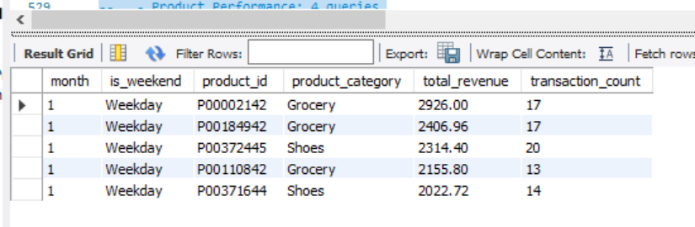

Query 2: Customer Demographics by Purchase Amount
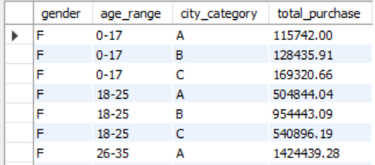
Query 4: Quarterly Purchase Trends by Gender and Age
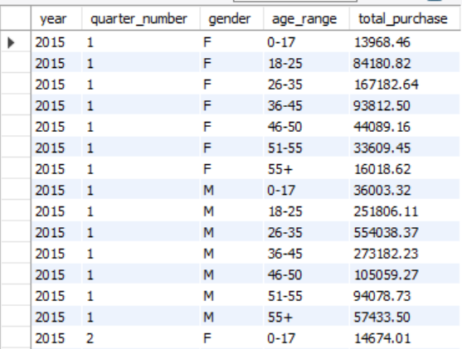
Query 5: Top Occupations Driving Each Product Category
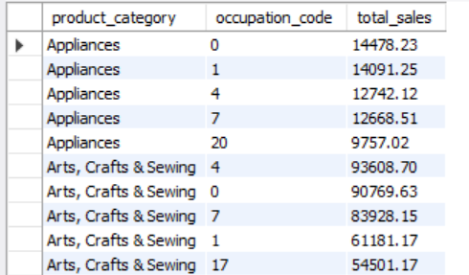
Q6: City and marital status last 6 months.
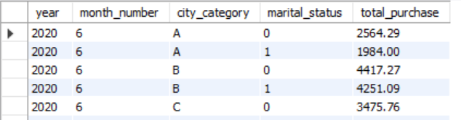

Query 7: Average Purchase by Stay Duration and Gender
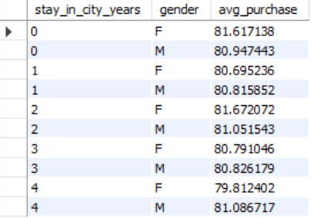
Query 8: Top Cities by Revenue for Each Product Category
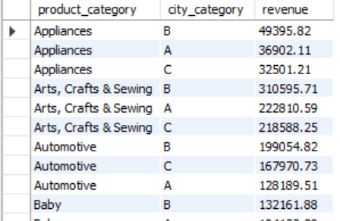
Query 9: Monthly Sales Growth by Product Category
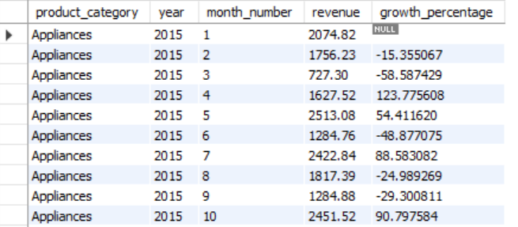

Query 10: Weekend vs Weekday Sales Comparison by Age Group
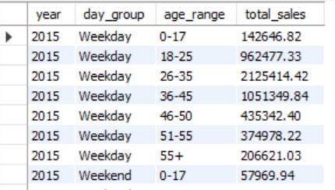

Query 11: Top Revenue Products by Day Type and Month (Parameterized)
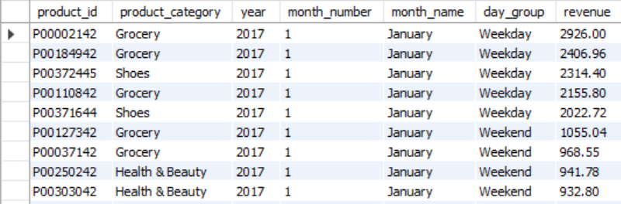
Query 12: Store Revenue Growth Rate - Quarterly for 2017
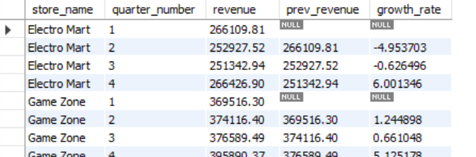
Query 13: Supplier Sales Contribution by Store and Product
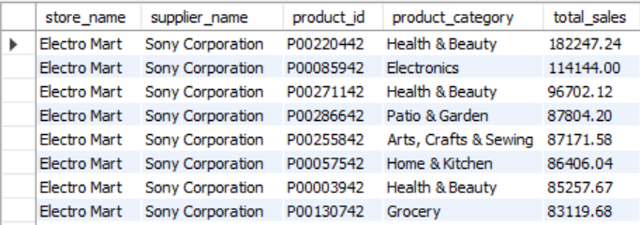

Query 14: Seasonal Product Sales Analysis
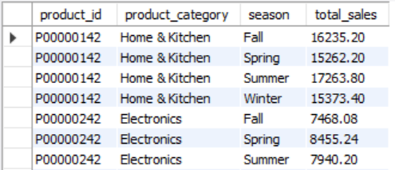
Query 15: Store and Supplier Monthly Revenue Volatility
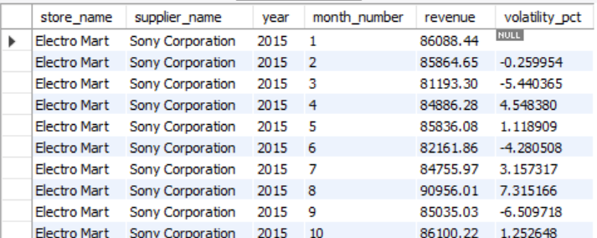
Query 16: Top Product Pairs Purchased Together
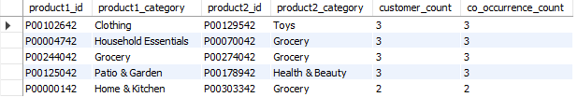

Query 17: Hierarchical Revenue Analysis with ROLLUP
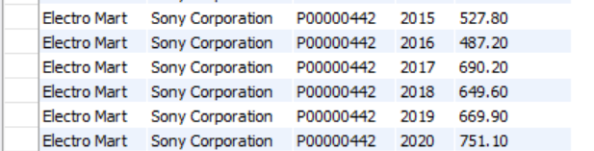

Query 18: Half-Year Revenue and Volume Comparison
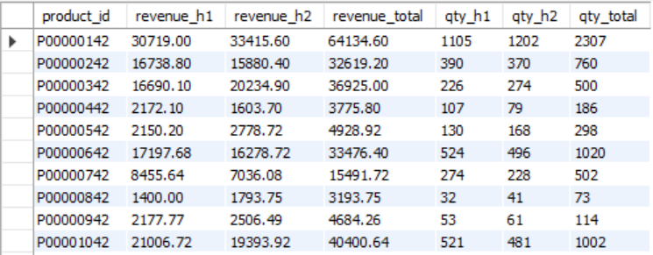
Query 19: Revenue Spike Detection and Outlier Identification
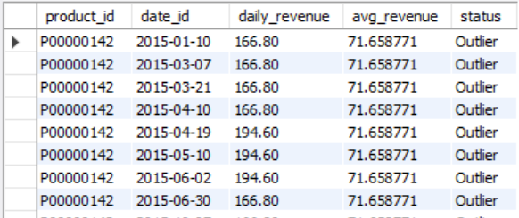
Query 20: Materialized View for Store Quarterly Sales
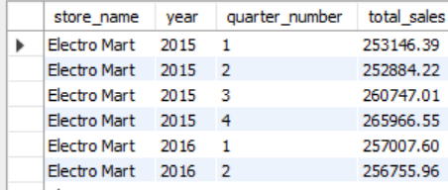

5. Three Shortcomings of HYBRIDJOIN
After implementing and testing the HYBRIDJOIN algorithm, I noticed several limitations:
Shortcoming 1: Memory Constraints
The algorithm keeps a lot of data in memory - the entire master data for customers and products, plus the hash table of stream tuples. For very large datasets with millions of customers and products, this could cause memory problems. The parameter HS limits the hash table size, but if transactions arrive faster than they can be processed, the stream buffer queue could grow indefinitely and crash the system. There's no disk spillover mechanism if memory runs out.
Shortcoming 2: No Handling of Master Data Updates
The algorithm loads master data once at the beginning and never refreshes it. In real business scenarios, customer information changes - people move to different cities, change their marital status, etc. Products also change - prices update, suppliers change. But HYBRIDJOIN doesn't have any mechanism to handle these updates. All transactions get joined with the old master data snapshot, which could lead to incorrect or outdated information in the warehouse.
Shortcoming 3: Sequential Processing Bottleneck
Even though there are two threads (producer and consumer), the actual joining and processing happens in a single thread. The hybrid join thread processes one customer at a time from the FIFO queue. For workloads where transactions are distributed across many customers, this sequential processing becomes a bottleneck. The algorithm can't take advantage of multiple CPU cores effectively. If we had more parallel processing where multiple customers could be processed simultaneously, the throughput would be much better.
6. What I Learned from This Project
This project taught me a lot about data warehousing and ETL processes that I never understood properly before.
First, I learned about star schema design and why it's useful. Before this project, I thought all databases should be normalized like in traditional OLTP systems. But I now understand that data warehouses have different goals - they're optimized for reading and analysis, not for avoiding data redundancy. The star schema with dimension and fact tables makes queries much simpler and faster.
Second, I got hands-on experience with stream processing and the challenges it brings. Reading about streaming data in theory is very different from actually implementing it. I struggled initially with managing the buffer and preventing memory overflow. I also learned about the trade-offs between throughput and latency - processing data in batches is more efficient but adds delay.
Third, I understood the importance of partitioning and indexing. When I first ran queries on the loaded data warehouse, they were quite slow. After adding proper indexes on foreign keys and frequently filtered columns, the query performance improved dramatically. The customer partitioning in HYBRIDJOIN also showed me how smart data organization can speed up lookups.
Overall, this project bridged the gap between theoretical data warehousing concepts and practical implementation. It was challenging but very rewarding to see the entire pipeline work end-to-end - from raw CSV files to a queryable data warehouse with meaningful analytical insights.

