Project: Data Design

February 28, 2020

Jess Sparrow

Said Barez

Christian Salas

Our consulting firm, IT Time Inc., has been tasked with developing a relational database design for a growing drug store chain. This includes being able to store and interact with patient, doctor, pharmaceutical company, drug, and pharmacy information in a secure and efficient manner. Being able to relate all of this information together and build a proper database requires developing and mapping an ER diagram to the relational database schema, creating the SQL table statements, normalizing the schema, coding and designing the JAVA servlets and HTML files, and testing sample data.

ER Diagram: Introduction & Description: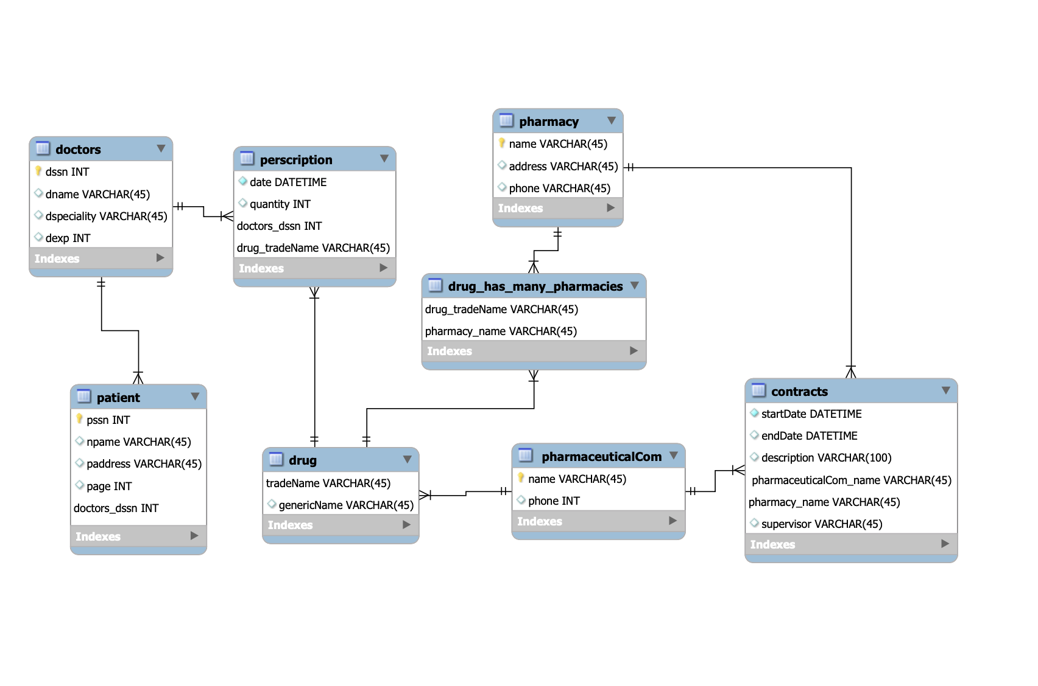

The ER Diagram is a useful tool which allows for conceptualization of a complex build. Beginning with doctor and patient, a doctor can have more than one patient, so a one-or-many cardinality is indicated to display that relationship. A patient must have at least one doctor so = cardinality is used to show this relation. The relation between drugs and pharmacies is a many-to-many relationship. This is because a drug could be at many pharmacies and a pharmacy could have many drugs so many-to-many relation is shown using a many-to-many cardinality indication.

Doctor and drug also has a many-to-many relation since a drug could be prescribed by many doctors and a doctor could prescribe many drugs. This relation is linked to prescription table which stores all data regarding prescriptions. A many-to-many relation is created using the prescription table. Pharmaceutical companies contract with pharmacies so there is also a many-to-many relation as a pharmacy could have contracts with many pharmaceutical companies, and similarly, a pharmaceutical company could have contracts with many pharmacies. Contracts is another table which connects these two tables as all contract information is stored in the contract object. Therefore, a many-to-many relation is created using contracts table.

ER Diagram: Challenges

Some ER diagram relations, such as how every patient has a primary physician and every doctor has at least one patient, were simple to draw. The challenging aspect was relations between two tables which includes another table between them. These were difficult to map out. One such example is how doctors prescribe drugs and pharmaceutical companies contract with pharmacies. To fulfill the relations requirement creating the prescription and contracts table is needed. One part that was not shown in the ER Diagram is if a doctor prescribes the same drug for the same patient more than once, only the last such prescription needs to be stored.  A prescription should technically indicate how many refills are allowed which may be from zero up to 6 times.

ER Diagram: Design Issues

Building the app, we were able to make a lot of relationships between two different tables, but we did however find myself wishing I had a closer relationship that didn’t require multiple joins to get the information we wanted. It was interesting seeing how a lot of the fields seems similar, but still differ in a huge way.

Updated ER Diagram: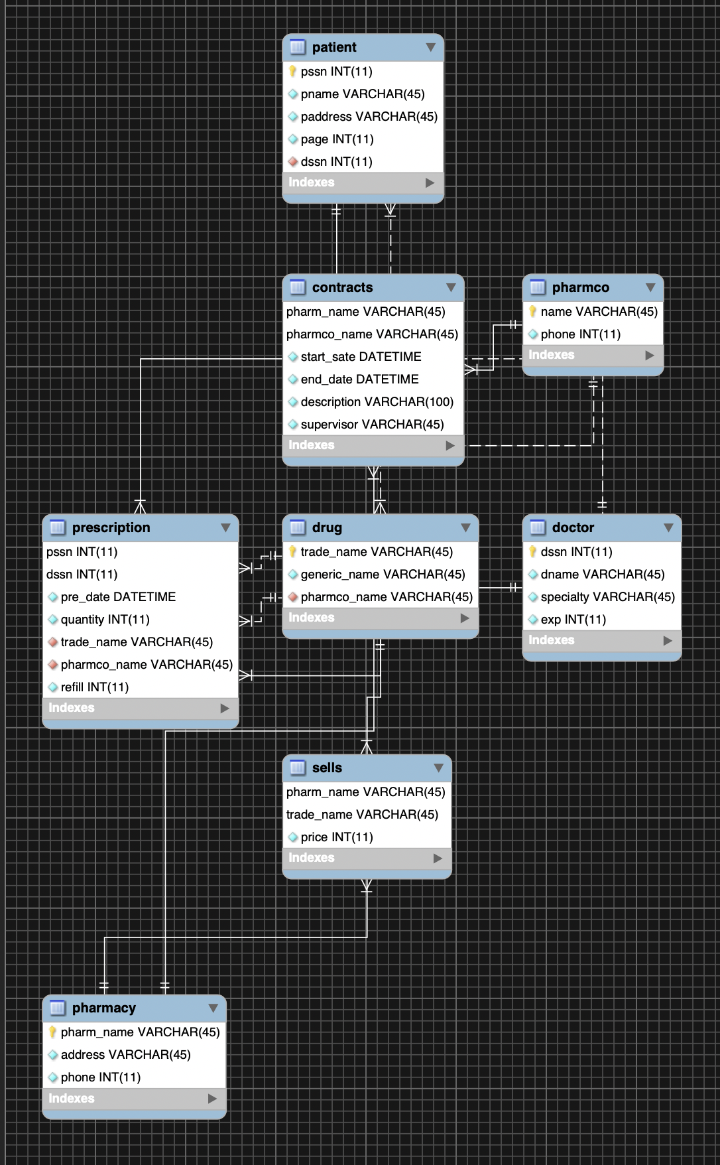

Java Screenshots:

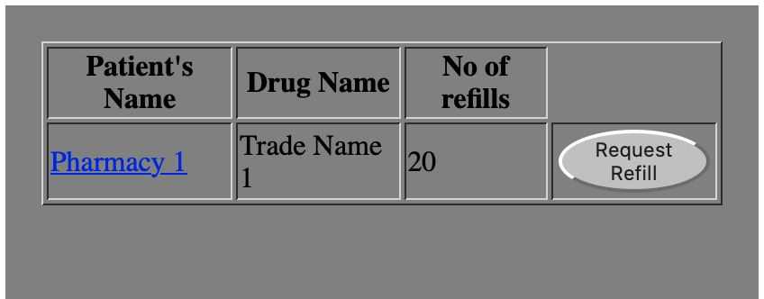When a patient goes to page and requests a refill

Going to a pharmacy page and looking at all drugs they have with price

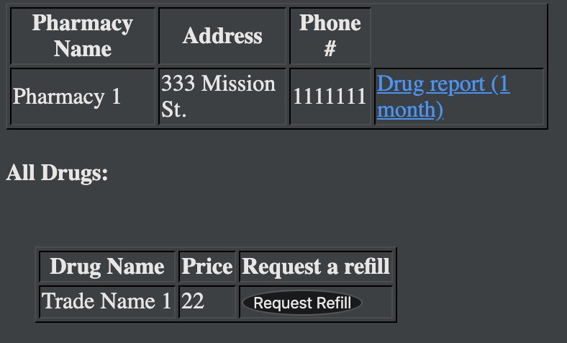

A patient going to their profile and seeing how many refills they have left

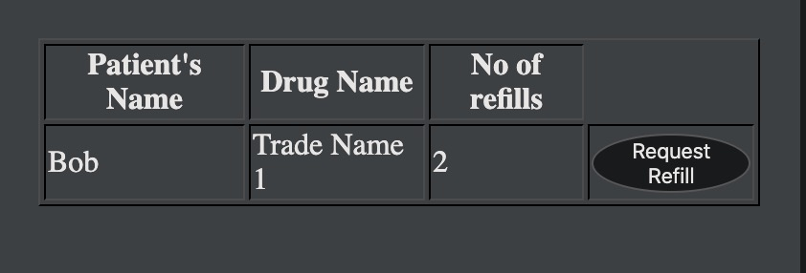

1 month progress report for a Pharmacy.

