Flask & MongoDB Assignment
Name: Salauddin
Project Name: Flask_and_MongoDB_Salauddin
1. Objective
The objective of this assignment is to create a Flask web application with a JSON API and a frontend form connected to MongoDB Atlas. The application should read backend data, store form submissions in MongoDB, and provide proper success and error handling.
2. Project Setup
A Python virtual environment was created and the required packages were installed.
python3 -m venv venv
source venv/bin/activate
pip install Flask pymongo python-dotenv
The project uses Flask for the web application, PyMongo for MongoDB connectivity, and python-dotenv for environment variables.
3. Task 1 – JSON API
A data.json file was created to store backend data. Flask reads this file and returns its contents through the /api route.
@app.route("/api")
def api():
data = load_data()
return jsonify(data)
The API was tested using:
http://127.0.0.1:5000/api
The JSON data was successfully displayed in the browser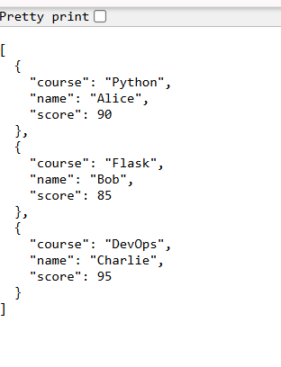
4. Task 2 – Frontend Form with MongoDB Atlas
A frontend form was created with three fields:
- Name
- Email
- Course
The submitted data is received by the /submit route and stored in MongoDB Atlas using PyMongo.
student_data = {
"name": name,
"email": email,
"course": course
}

collection.insert_one(student_data)
The data is stored in the submissions collection inside the flask_assignment database.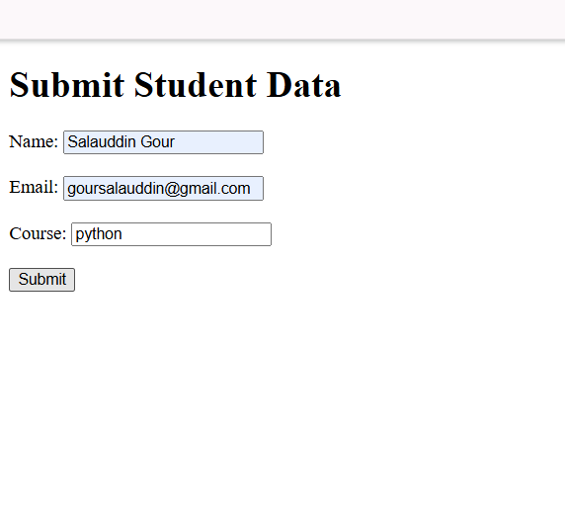
5. Success and Error Handling
After successful data insertion, Flask redirects the user to the success page.
return redirect(url_for("success"))
The success page displays:
Data submitted successfully
If an error occurs, the application remains on the same page and displays the error message using a try-except block.
except Exception as error:
return render_template("index.html", error=str(error))
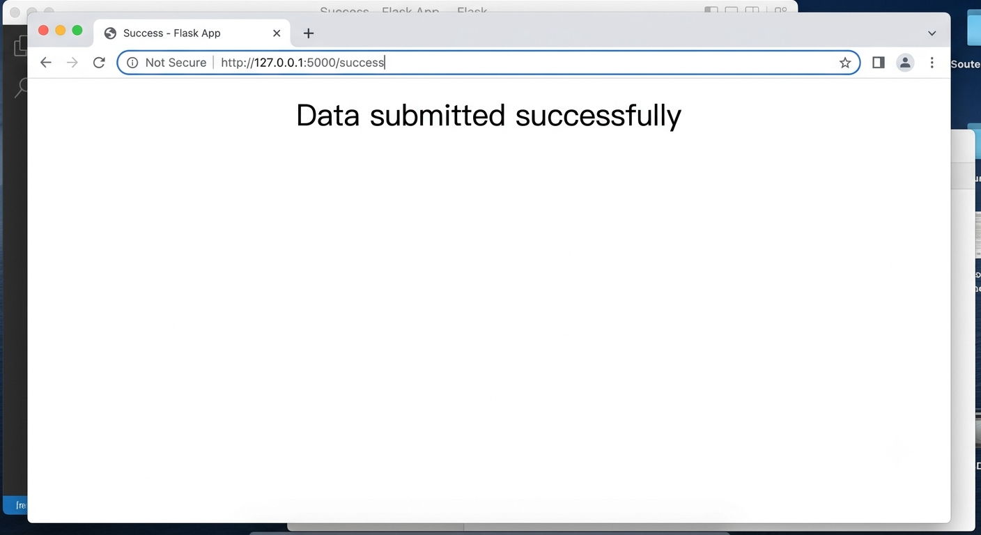
6. Project Structure
Flask_and_MongoDB_Salauddin/
├── app.py
├── data.json
├── requirements.txt
├── .env.example
├── .gitignore
└── templates/
├── index.html
└── success.html
The .env file contains MongoDB credentials and is excluded from GitHub using .gitignore.
7. GitHub Repository
The complete project was initialized using Git and pushed to GitHub.
git init
git add .
git commit -m "Complete Flask and MongoDB assignment"
git branch -M main
git push -u origin main
GitHub Repository:
https://github.com/Salauddinnnn/Flask_and_MongoDB_Salauddin
8. Conclusion
The Flask and MongoDB application was successfully implemented. The project includes a JSON API, frontend form, MongoDB Atlas integration, success redirection, and error handling. The complete source code has been pushed to GitHub.

