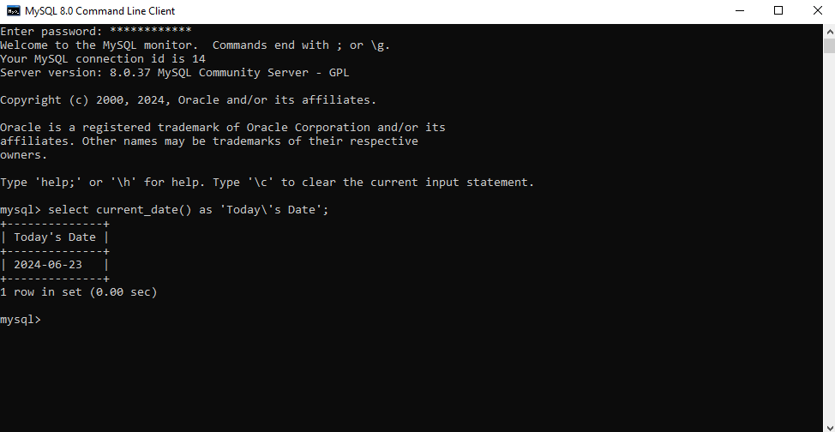

This function would be used if one would want to condense or extend a column name.

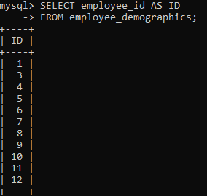

This would also be used for the same reason but this also shows how to include additional columns

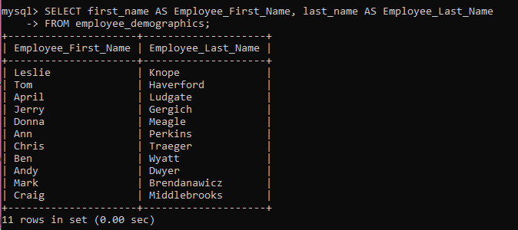

This command concatenates multiple columns into 1, this would be used if information needs to be combined into one column like an address or a full name.

