Before reading past below instructions:

1. Create an account in Github using your name in this format: lastname_firstname_section
2. Request access to [Lycevm<3Alabang · GitHub](https://github.com/Lycevm-3Alabang)
3. Upload this file ON YOUR GITHUB ACCOUNT with answer under the title / file name : E3_Assessment__[Section]_[LastnameFirstName]  
   example: E3_Assessment__BSCS32E1_AlamoNinoFrancisco

Help: [Get started with GitHub documentation - GitHub Docs](https://docs.github.com/en/get-started)

**Sample Assessment for Introduction to Programming**

This assessment is designed to evaluate your understanding of basic programming concepts in C#, HTML, CSS, and JavaScript.

Instructions: Read each question carefully and provide complete and clear answers. Avoid multiple-choice format responses. Focus on demonstrating your understanding through code, explanations, and discussions.

**Part 1: C# (30 points)**

(10 points) Write a C# program that calculates the area of a triangle given its base and height. Include user input for both values and display the calculated area.

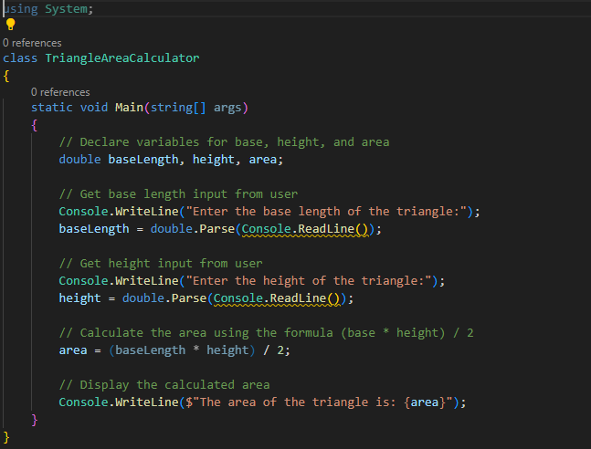

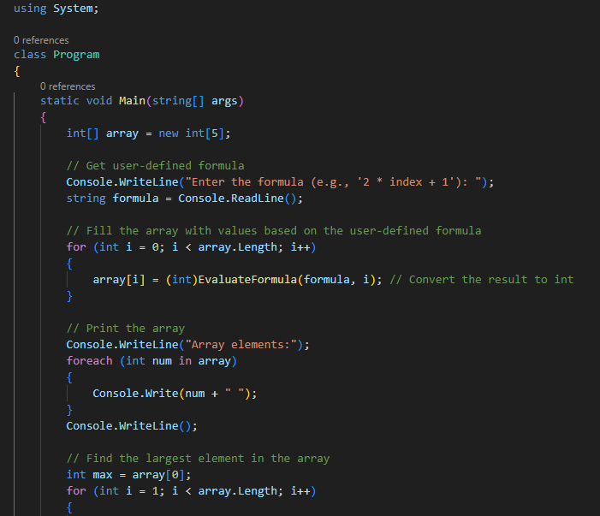**(10 points) Declare an array of 5 integers and fill it with values based on a user-defined formula (e.g., n^2). Then, print the largest element in the array.**

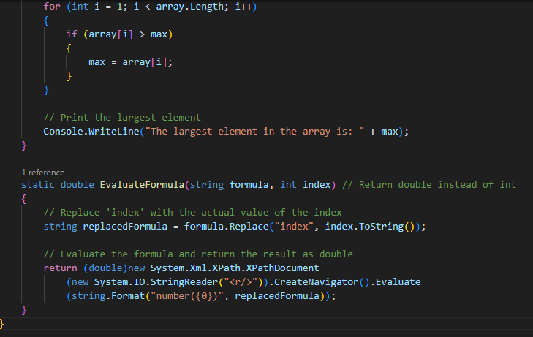

**(10 points) Implement a simple for loop that iterates from 1 to 10 and prints each number along with its square root.**

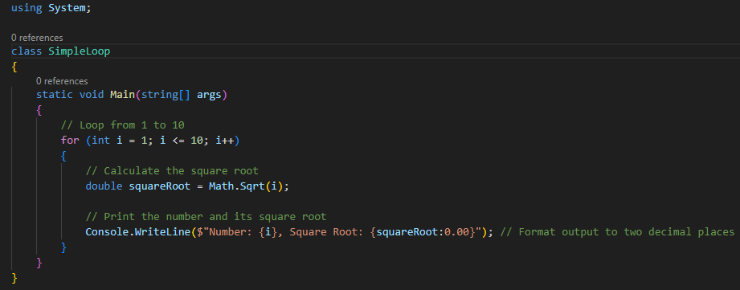

**Part 2: HTML, CSS, and JavaScript (30 points)**

**HTML (10 points):** You are provided with the following incomplete HTML code snippet:

**HTML**

**<!DOCTYPE html>**

**<html>**

**<head>**

**<title>My Website</title>**

**</head>**

**<body>**

**<h1>Welcome to...</h1>**

**<p>This is a paragraph...</p>**

**<ul>**

**<li>Item 1</li>**

**<li>Item 2</li>**

**</ul>**

**</body>**

**</html>**

Complete the code snippet by adding the following elements:

An image within the <body> tag with a relevant src attribute.

An ordered list (<ol>) with three items.

A hyperlink within a <p> tag that points to an external website.

A CSS styling rule using an inline style attribute to change the font color of the <h3> heading.

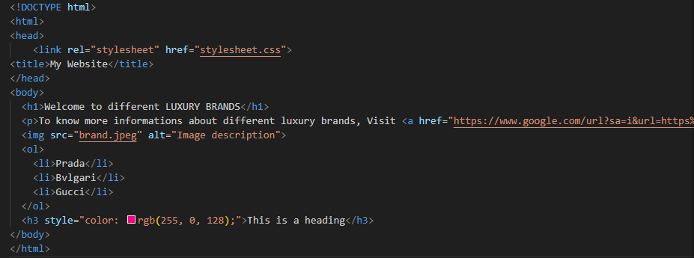

CSS (10 points): Create a CSS stylesheet that defines the following styles:

Change the background color of the body element to light blue.

Apply a padding of 20px to all headings (h1, h2, h3).

Set the font size of the <p> tag to 14px.

Make the list items (li) have a bullet point style instead of the default numbers.

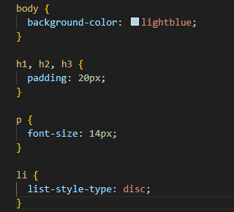

**JavaScript (10 points):** Write a JavaScript function that takes a number as input and returns a string indicating whether the number is even or odd. Then, add a button to your HTML page that, when clicked, calls this function and displays the result (even or odd) in a paragraph element below the button.

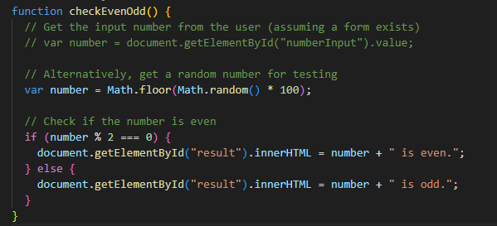

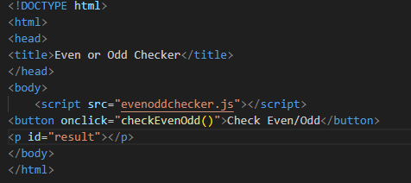

**Part 3: Essay Question (40 points)**

Discuss the importance of object-oriented programming (OOP) concepts in software development. Explain the key principles of OOP (encapsulation, inheritance, polymorphism, abstraction) and provide examples of how they can be used to create more efficient, maintainable, and reusable code. Include real-world scenarios or cases where OOP is particularly valuable.

The importance of object-oriented programming (OOP) in software development is it provides a powerful paradigm for organizing and designing software. It focuses on objects that contain activity and data, has various advantages that are crucial to the success of software development. OOP concepts offer a framework for building efficient, maintainable, and scalable software.It encourages the reuse of code, cuts down on redundancy, enhances code readability, and makes it easier to create software that can adjust to changing needs.

**4 KEY PRINCIPLES OF OOP**

**Encapsulation** - Encapsulation limits direct access to internal information by grouping together an object's methods (functions) and data (attributes). It permits regulated engagement with the object using established techniques.

Example: A "Car" object. Its attributes include "model," "color," and "speed," and methods like "accelerate" and "brake." Encapsulation restricts direct changes to internal values (like setting speed to negative) and provides controlled access through methods, ensuring data integrity.

**Inheritance** - The ability to inherit characteristics and behaviors from preexisting classes (super classes) enables the creation of new classes (subclasses). New features can be added by subclasses without having to rewrite shared code.

Example: When a child is born he or she inherits the features of parents such as beauty from mother and intelligence from father.

**Polymorphism -** Allows objects of different classes to respond to the same method call in different ways. This flexibility enables writing generic code that works with various object types without knowing their specific implementations.

Example: when you are in the university you act as an undergraduate when you are in a shop you act like a customer, when you are at home you act like a child. So here we can see the same person has different behaviors in different situations.

**Abstraction -** Focuses on exposing essential features and functionalities while hiding unnecessary details. It allows users to interact with objects without needing to understand their internal workings.

Example: When we log into Facebook we enter our email and password. Then when we press enter we can log into our account. But we do not know how the input data is sent and how it is verified from the server-side.

Points Distribution:

Each part carries equal weight (30 points).

Code clarity, functionality, and explanations will be considered in grading.

The essay question focuses on understanding and application of OOP concepts.