Blinkit Analysis
- See all the data imported:
SELECT * FROM blinkit_data
- DATA CLEANING;
Cleaning the Item_Fat_Content field ensures data consistency and accuracy in analysis. The presence of multiple variations of the same category (e.g., LF, low fat vs. Low Fat) can cause issues in reporting, aggregations, and filtering. By standardizing these values, we improve data quality, making it easier to generate insights and maintain uniformity in our datasets.

UPDATE blinkit_data
SET Item_Fat_Content =
CASE
WHEN Item_Fat_Content IN ('LF', 'low fat') THEN 'Low Fat'
WHEN Item_Fat_Content = 'reg' THEN 'Regular'
ELSE Item_Fat_Content
END;

- After executing this query check the data has been cleaned or not using below query

SELECT DISTINCT Item_Fat_Content
FROM blinkit_data;
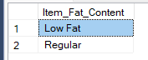

KPI’s Creations
Q1. Total Sales : The overall revenue generated from all items sold.​

SELECT
CONCAT(
CAST(SUM (Total_Sales)/1000000 AS decimal(10,2)),
'M'
) as Total_Sales_in_Million
FROM blinkit_data;

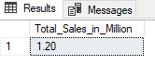
Q2. Average Sales : The average revenue per sale.​
SELECT
CONCAT(
CAST(AVG(Total_Sales) AS decimal(10,1)),
'M'
) AS Avg_Total_Sales_Million
FROM blinkit_data;

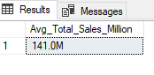
Q3. Number of Items : The total count of different items sold.

SELECT
COUNT(*) AS no_of_items_sold
FROM blinkit_data;

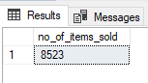

Q4. Average Rating: The average customer rating for items sold.

SELECT
CAST(AVG(Rating) AS decimal(10,1)) AS avg_rating
FROM blinkit_data;
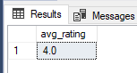

Business Requirements
Q5. Total Sales by Fat Content

select *
from blinkit_data;

SELECT Item_Fat_Content,
CONCAT(
CAST(SUM(Total_Sales)/1000000 AS DECIMAL(10,2)),
'M'
) AS Total_Fat_Content_Million
FROM blinkit_data
GROUP BY Item_Fat_Content;
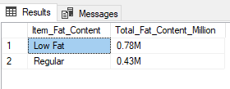
Q6. Total Sales by Item Type

SELECT Item_Type,
CONCAT(
CAST(SUM(Total_Sales)/100000 AS DECIMAL(10,2)),
'K'
)AS Total_Item_Type_Lakhs
FROM blinkit_data
GROUP BY Item_Type
ORDER BY Total_Item_Type DESC;
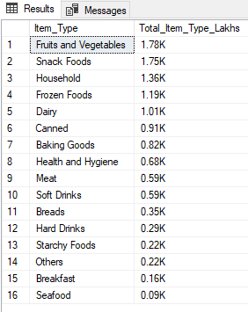

Q7. Fat Content by Outlet for Total Sales

with cte1 as(
SELECT
Outlet_Location_Type,
Item_Fat_Content,
CONCAT(
CAST(SUM(Total_Sales)/100000 AS decimal(10,2)),
'k'
) AS Total_Sales
FROM blinkit_data
GROUP BY Outlet_Location_Type,Item_Fat_Content)

,cte2 AS(

SELECT
Outlet_Location_Type,
MAX(case when Item_Fat_Content = 'Low Fat' THEN Total_sales end) AS Low_Fat_sales,
MAX(case when Item_Fat_Content = 'Regular' THEN Total_sales end) AS Regular_sales
FROM cte1
GROUP BY Outlet_Location_Type)

SELECT * FROM cte2;
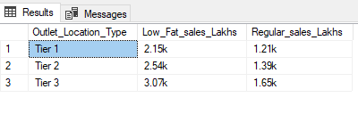
Q8. Total Sales by Outlet Establishment
SELECT Outlet_Establishment_Year,
COUNT(*) AS no_of_items,
CAST(SUM(Total_Sales) AS decimal(10,2)) AS total_sales,
CAST(AVG(Total_Sales) AS decimal(10,2)) AS avg_sales,
CAST(AVG(Rating) AS decimal(10,2)) AS avg_rating
FROM blinkit_data
GROUP BY Outlet_Establishment_Year
ORDER BY Outlet_Establishment_Year ASC;

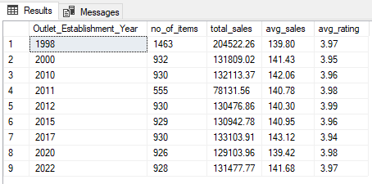

Q9. Percentage of Sales by Outlet Size
SELECT
Outlet_Size,
cast(SUM(Total_Sales) AS decimal(10,2)) AS total_sales,
cast(
SUM(Total_Sales)*100/
SUM(SUM(Total_Sales)) over() AS Decimal (10,2)
) AS total_percentage
FROM blinkit_data
GROUP BY Outlet_Size;



