# Parts List:

In [this folder](https://www.dropbox.com/sh/g0jkwyksssbp70x/AAAnj6zVM2WuqgwILcaqhdG3a?dl=0) are all the parts required to build the chronic implant (not including glue, dental cement, etc.). Be aware that files may change without notice. Therefore, please save a copy of the files you print for your own records.

Files are now ***adjustable*** using annotated parameter tables. Please watch “ParameterChangeGuide.mp4” if you are unfamiliar with these processes. You will also need Autodesk Inventor which is [free for educational use](https://www.autodesk.com/education/edu-software/overview?sorting=featured&filters=individual). This allows you to, for example, change the angle of the docking module, spacing between probes, or thickness of the walls. ***However***, be aware that parameters like “length of exposed probes” are estimates based on our own use and *not* exact. The default values are those we use in the lab for a typical insertion, although we change them as needed.

Files are also inter-linked, such that changes you make to the parameters of Payload_NP1 will cause changes in Docking_NP1, and DockingHolder_NP1. Usually, these are changes you *want* because it means all the parts will fit together. However, you should be aware that these are happening, and can be overridden if needed.

Files specific to versions 1 and 2 of Neuropixels are in NP1 and NP2 folders. Other parts are in the base folder and can be used (in some cases with a parameter change) for either version.

## “Payload_NP1” or “Payload_NP2”

This is the module that holds the probe(s). You will need one of these for each probe (or pair of probes) you use, and it is re-used across implantations. **Print in Natural Rigid Resin 4000, including 4x M1 threaded inserts.**

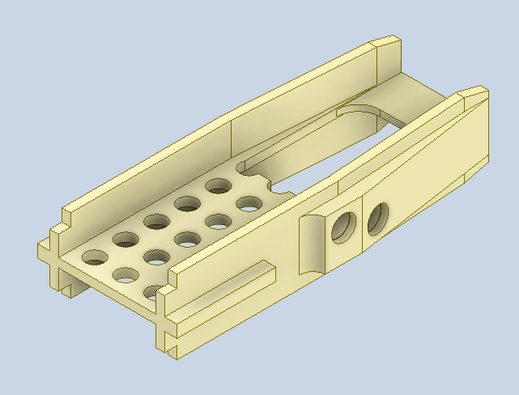 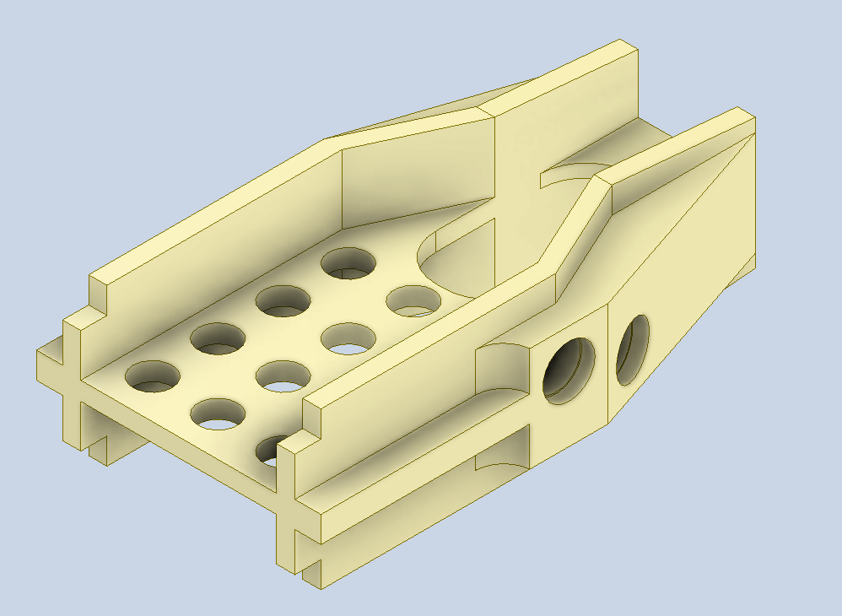

## “PayloadHolder”

This is a holder that can be attached to the Payload Module for construction, painting, implants, storage, carrying around etc. There are two versions which can be produced from the save file by adjusting the binary “REDUCEDHOLDERVERSION” parameter.

* If REDUCEDHOLDERVERSION is zero, you will see the version used for payload construction (below, left). You only need one of these. **Print in PA12, including 2x M3 insert.**
* If REDUCEDHOLDERVERSION is one, you will see the reduced version used general manipulation, storage, insertion etc. **You need as many of these as would be useful. Print in PA12, including 2x M3 insert.**

NOTE: to change the part for NP1 and NP2 versions, simply change the “SlotLength” parameter as instructed in the comments (14/9 mm for NP1/NP2). We have provided .stp files for all versions.

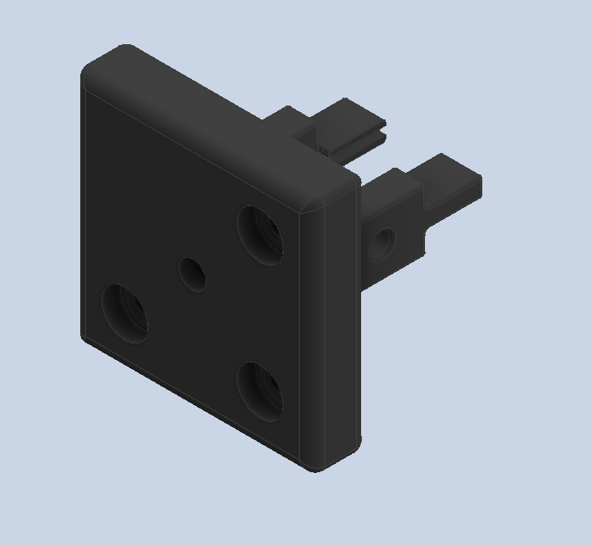

## “PayloadCap_NP1” or “PayloadCap_NP2”

This is the lid for Payload Module, to be attached with glue after the probe is cemented in position. You will need one per probe. **Print in PA12.**

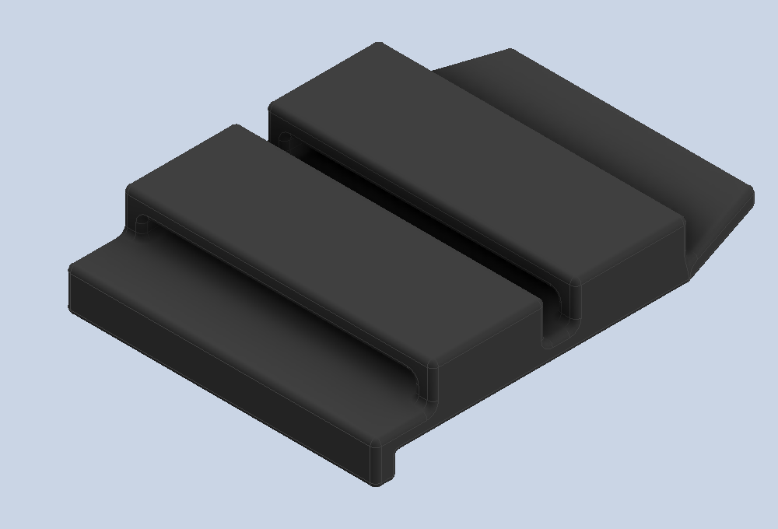

## “Docking_NP1” or “Docking _NP2”

This is the module that is cemented to the skull after being screwed to the Payload Module. A new Docking Module is required for each insertion. **Print in Natural Rigid Resin 4000.**

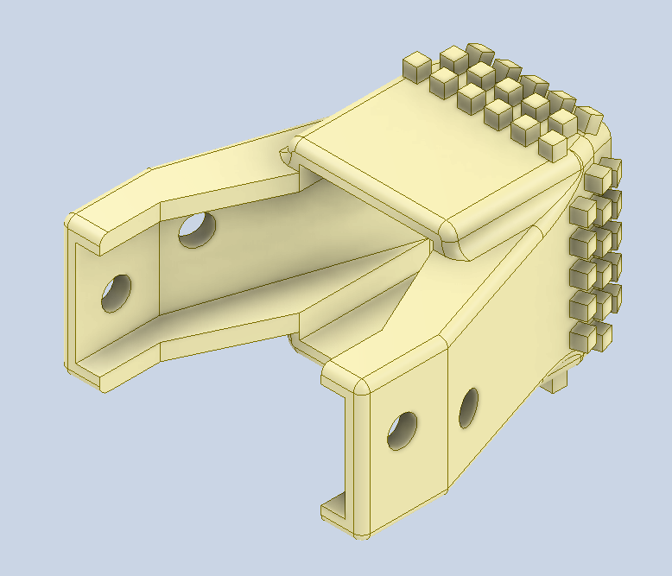

## “DockingHolder_NP1” or “DockingHolder_NP2”

This holds the Docking Module in place when using the constructor to combine the two modules. You only need one of these. **Print in Natural Rigid Resin 4000, including 4x M3 insert.**

## “ConstructorHead”

This forms one end of the constructor setup (used to “safely” combine the docking and payload modules). You will only need one of these. **Print in Natural Rigid Resin 4000**.

## “ProbeSharpener”

This is a simple part that we use to hold the probe itself in order to sharpen them prior to construction. Note that it uses a screw to hold the probe: **do not tighten it too much**, or the probe base will break.

## Additional screws and bolts (links are for reference but could be sourced elsewhere):

NOTE: the latest parts use brass inserts (no more “nuts”) which can be easily inserted using a soldering iron and mild pressure. We typically do this in-house, but your 3D-printing company may also do this for you upon request.

[M1 brass knurled inserts](https://www.ebay.co.uk/itm/124331900287?hash=item1cf2c23d7f:g:jwQAAOSwwNBakghm&amdata=enc%3AAQAHAAAA0Nb0tsNyBWOJb9QsE3jZ1h42iyrZmRq7NeTP15M7zXKdx1wXyjDScAGrlNwoSI0ZNxHPDQdtMK0ooSnxKgg3BbT1s%2B2VN1N3p6SPyqCZsakrPnlD%2BU%2BzEercClKMmaav9JwD94WuuBS9Dz12qifp%2BVETBgjTVQ3yozn50bhVZ5xhPy%2BOPDwvVOHwhl0C6MLDcmyif0T2JCWaJ34LmL57fiKkwdCF1yvT5rVZt8LDtKZeWHtLbQuDWdIRBBOYfjWRA6BhA%2FoJl4IZVsx9o64FSlg%3D%7Ctkp%3ABk9SR57L5YfeYQ): To be heat-inserted into the Payload after printing.

[M3 brass knurled inserts](https://uk.rs-online.com/web/p/threaded-inserts/2040620?cm_mmc=UK-PPC-DS3A-_-google-_-DSA_UK_EN_Fasteners+%26+Fixings_Index-_-Threaded+Inserts%7C+Products-_-DYNAMIC+SEARCH+ADS&matchtype=&dsa-1592138904419&cq_src=google_ads&cq_cmp=15904458476&cq_term=&cq_plac=&cq_net=g&cq_plt=gp&gclid=Cj0KCQjwn9CgBhDjARIsAD15h0AItIL4VHSuh_o8K6TBFmoyoC6-CRIIYITS1B7lSI7l9ImgpKE8NzoaAuLYEALw_wcB&gclsrc=aw.ds): To be heat-inserted into the PayloadHolder and DockingHolder after printing.

[M1 Screws](https://www.accu.co.uk/en/cheese-head-screws/6426-SFE-M1-3-A2): to lock modules together (4 per module).

[M3 5mm screws](https://www.accu.co.uk/en/flanged-button-screws/8592-SSBF-M3-5-A2): For connecting Payload Module holder to Thor Labs posts (3 total) and also for securing the Docking Module in its holder (2-4 depending on your preference)

[M3 10mm screws](https://www.accu.co.uk/en/flanged-button-screws/8595-SSBF-M3-10-A2): For connecting Constructor Head to Thor Labs posts (3 total)

[M3 20mm screws](https://www.accu.co.uk/en/flanged-button-screws/8600-SSBF-M3-20-A2): One per Payload Module holder for tightening.

[Thor labs posts](https://www.thorlabs.com/thorproduct.cfm?partnumber=MS3R/M): At least 3 for the constructor, potentially more to hold the probes etc.

**Assembly**

*This section describes how to put all the parts together. We recommend practicing on dummy probes (or even on probes that are already broken!) to get used to it, since specific steps can be finicky.*

Material:

* Blu Tack
* Epoxy glue (e.g., Araldite ARA-400007)
* Super glue
* Silver wire and soldering

1. Checking the parts:
   1. Before fixing the probe, perform full assembly procedure *without the probe* to ensure the parts fit together.

1. Fixing a probe to the payload module
2. Using Blu Tack, position payload module and coat it with a thin layer of epoxy (so that the probe will stick to it).
3. Carefully bring the probe (usually holding the flex with two fingers and pushing the probe down with the index finger) onto the payload module. Make sure you push it to the end of the payload module. Check for probe alignment, and readjust the angle manually. Add more epoxy to fix the probe to the module – you can cover the base and parts of the electronics, but it’s usually good to avoid covering the GND and REF electrodes since they can be used to check for good soldering (or to solder GND and REF here directly). While applying epoxy, you can keep the probe in position using the tip of forceps.
4. Short the GND and the REF by soldering a silver wire in between (this can also be done beforehand). This step and the overall grounding are currently being discussed and improved (see troubleshooting).
5. Fold the flex and insert it in the slot on the inside of the lid. Then push the lid down and glue it by putting super glue on both sides of contact with the payload module. If you’ve soldered a silver wire for your ground, make sure it sticks out. You can then fold the flex and slide the connectors end in the slot on the outside of the lid.
6. You can now use the payload holder to sharpen your probe (see <https://github.com/cortex-lab/neuropixels/wiki/Sharpening> for more information).

*Stage 2.3 (left) and 2.4 (right)*

1. Fixing a second probe to the payload module

*These steps are only if you want a second probe. If you don’t, you can close the empty side with a lid and make sure you close all gaps with epoxy or kwikcast. If you do, please follow these steps:*

1. You must first sharpen the second probe. To do so, you can use the temporary probe holder (we have been using “ProbeSharpener.stl” to hold the probe during this process, but this hasn’t been heavily optimized).
2. Then, you can assemble the second probe by repeating the same steps as before, while being extra careful not to touch the probe that is already attached to the docking module.

1. Assembling the payload and the docking modules
2. Position the docking module in the docking module holder.
3. Position the payload module (with the probes) in the payload module holder. This step is easier if the payload module holder is at that stage independent of the docking module holder. The probe is secured in the holder, and then the holder is screwed in. Check the alignment of the probe.
4. Slide the docking module holder until the docking module is fully covering the payload module and that the holes are aligned to the threads. While sliding, check for the good alignment of the probe. Screw in (we found using forceps to hold the screws was easier).
5. Unscrew the docking module from the docking module holder. You can now slide it away from the probe.
6. Unscrew the now fully assembled implant from the payload module holder.

*Stage 4.2 (left) and 4.5 (right)*

**Implantation**

*This section describes how to implant the probe once all the parts have been assembled. Note that the craniotomy is usually performed on the day before, or just before implanting.*

Material:

* Anaesthesia set up (Isoflurane % O2 delivery, scavenger, heatpad)
* Headfixation system
* Manipulator (we use Sensapex)
* Microscope
* DiI
* Dura-Gel ([Cambridge Neurotech](https://www.cambridgeneurotech.com/dura-gel))
* UV cement ([Norland Optical Adhesive 81](https://www.norlandprod.com/literature/81tds.pdf))
* Dental cement ([Super Bond C&B](http://www.generiqueinternational.com/docs/1_Super_Bond_CBblackbooklet.pdf))
* Kwik-Cast ([WPI](https://www.wpiinc.com/kwik-cast-kwik-cast-sealant))
* Biopsy punch (1.5mm) or drill
* Gelfoam **A picture containing text, screen

  Description automatically generated**

1. Preparing the cage
2. Remove anything in the cage to which the mouse’s implant could get tangled, a week in advance so that the mouse gets used to it.

1. Deciding the coordinates for craniotomies
2. One can plan trajectories using a combination of tools. The most up-to-date tool for 4-shank Neuropixels is Pinpoint (<https://github.com/VirtualBrainLab/Pinpoint>, Dan Birman).
3. To measure the spacing between your two probes, you can use a microscope with an integrated scale.

1. Coating and testing the probes

*NOTE: for 2-day procedures (craniotomy/implantation on days 1/2) this step should be on day 2.*

1. Using the payload holder (general purpose) assembled with 6mm-diameter rods from Thor labs, you can hold the probe on a manipulator.
2. Fill in an Eppendorf with DiI and bath the probe into it, several times. Make sure you have enough room to do so, especially with the dual implants.
3. Test the probe by connecting it to the recording system.

1. Preparing the implantation setup

*NOTE: for 2-day procedures (craniotomy/implantation on days 1/2) this step should be on day 2.*

1. Prepare the Isoflurane anaesthesia and face mask setup.
2. Check whether the materials for implantation are readily available: UV cement, dental cement, enough brushes, cortex buffer and saline injection, allen keys, screw drivers, eye ointment etc.

1. Performing craniotomies
2. Put the mouse under Isoflurane anaesthesia in the induction chamber, when under transfer it to the surgery setup. We keep the mouse at 1-2% Isoflurane concentration for the duration of the surgery. Fix the mouse in a stereotaxic frame.
3. Apply Chloramphenicol/Viscotears to protect eyes.
4. Inject Colvasone (intra muscular) and Rimadyl (subcutaneous).
5. To get rid of the clear skull cap, drill the UV cement edges and then lift the flap of the cement. A vacuum pump is useful during this process to easily get rid of the dust coming from drilling. Lifting the UV cement might cause some superficial bleeding to the skull, make sure to clean it out before progressing with the craniotomies.
6. Mark Bregma and Lambda with a marker. Assess if the skull is levelled by making sure Bregma and Lambda are on the same line—position the stereotax above the midline and move along the AP-axis, you should follow the midline. Then move the stereotax along the ML axis and see if the vertical distance is very different across hemispheres. Measure the coordinates for craniotomies and mark them with a marker. Measure the distance between bregma and lambda. **S**
7. Decide on the method of performing the craniotomies (biopsy punch or drill). We usually use the biopsy punch approach, as it seems to cause less stress on the brain, but some placements of the probes make the drilling approach easier.

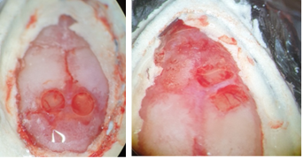

***Craniotomy with biopsy Punch (left) and Drill (right)***

1. Perform the craniotomies. When using biopsy punch, place the coordinates in the centre of the punching areas. When using the drill, we make rectangular craniotomies of size 2x1mm, centred at the coordinate and parallel to each other (if using the dual implant). Before lifting the bone flap, make sure that the working area is covered with the cortex buffer to avoid the dura drying out and detaching while lifting. Note that some placements of craniotomies might cause bleeding, it should be easily stopped with Gelfoam. Do not process until the bleeding is fully stopped. **S**
2. Seal the craniotomies with Dura-Gel.
3. **If you are NOT immediately implanting:**
4. Wait for Dura-Gel to set (at least 30min).
5. Cover the exposed skull with Kwik-Cast.
6. Transfer mouse to recovery cage placed on a heating pad and monitor until fully recovered.
7. **If you ARE immediately implanting:**
8. Wait for Dura-Gel to begin setting (at least 10 minutes)
9. Transfer the mouse to the chronic implantation rig if need be.
10. Clean up the surgery hood *OR* notify the next user that you are going to clean up after insertion. 
11. Implantation

***ATTENTION: the arrow pointing upwards on the manipulator is the one that descends.***

1. If present, remove the protective silicon cap (usually Kwik-Cast) covering the craniotomy. You may need to reapply Dura-Gel (step 4.6/4.7.1)
2. Ensure the skull is clean.
3. Bring the probe close to the craniotomies lowering the rod on the manipulator holder ‘by hand’.
4. Use the manipulator to lower the probes to ~0.5mm above the brain surface and check that there is enough manipulator range remaining in Z/D to achieve your desired depth.
5. Insert the probe at Speed 15 um/s until you have punched through the dura.
6. Once confident that all shanks of all probes are inside the brain. Then, begin automatic descent of the probe to the desired depth at speed 3-5 um/s.
7. While probe descending, monitor that nothing obstructing the implant, and that the shanks are not bending. **If the shanks are bending stop the descent immediately** clicking on the red stop button on the manipulator.
8. Stop the descent when at desired depth or if the docking module is almost touching the skull.
9. Make a ‘ring’ with UV cement to cover the gaps between the docking module and the skull. This completely isolates the shanks to facilitate dental cement application.
10. Finish the implant with the dental cement (typically 3 rounds of cement). Make sure you wait for the cement to harden in between rounds. Be sure not to put cement on the screws.
11. Unscrew the screw holding the payload module to its holder and lift the payload module holder.
12. Before removing the mouse, make sure the implant is evenly and sufficiently cemented. Also, make sure that the implant itself has no holes or gaps. If any, cover with Kwik-Cast (otherwise dirt can get inside, see troubleshooting).

***Insertion of dual-implant (5.4)***

1. Recovery
2. The animal should be fed Metacam (or Caprieve if it’s not under water restriction) daily.

**Explantation**

*This section describes how to explant the probe at the end of the experiment.*

1. Preparing the animal
2. Anaesthetize the animal.
3. Align the animal’s head to match the angle used for implantation.

1. Explanting
2. Position the payload module holder (by hand and with the manipulator) just above the implant.
3. Make sure the alignment between the payload module holder and the payload module is good.
4. With the manipulator, bring and slide the payload module holder down.
5. Secure the holding screw.
6. Unscrew the 4 screws connecting the payload and the docking module.
7. With the manipulator, slowly retract the probes.
8. Once the probes have been retracted, close craniotomies with Kwik-Cast and place animal in its cage.

1. Probe cleaning
2. We use the classic probe cleaning procedure: 12h in tergazyme, then in deionized water. If there are still pecks of dirt on the shank, you can use ultrasound in iso-propanol, or a silicon solvent (see troubleshooting).

**Troubleshooting**

*This section describes a few example issues that can occur and that we managed to find a solution for.*

1. **The recordings get noisy over time**

We’ve had issues with the wire breaking on the long term, and overall grounding degrading over time. We’re currently trying to come up with a better way to ground this, and our next efforts will focus on connecting the GND and the REF directly on the electronics board of the probe and having a pin that’s easier to connect.

1. **The probe is hard to explant**

It might be that the payload and the docking module stick together, due to dust, dry fluids, or else. You can try to slide forceps very carefully in between the payload and the docking modules, on the sides of the modules – this usually helps relieving tensions.

1. **The probe is dirty once explanted**

This can be a sign that there was a gap somewhere in the implant. You preventively can try to add kwikcast on any hole that you see, but the simpler solution we found was to add epoxy at the very tip of the lid, to close the gap between the tip of the lid and the probe. We usually manage to clean this dust by a combination of deionized water, tergazyme and ultrasound. Sometimes the duragel does not set and is permanently stuck on the probe. We found that a silicon solvent (DOWSIL-2025) can get rid of this, for this we immerse the probe in solvent for 24 hrs then wash with deionised water.

