**2021-CS-32**

**1: Question 1**

Create an account on Overleaf.

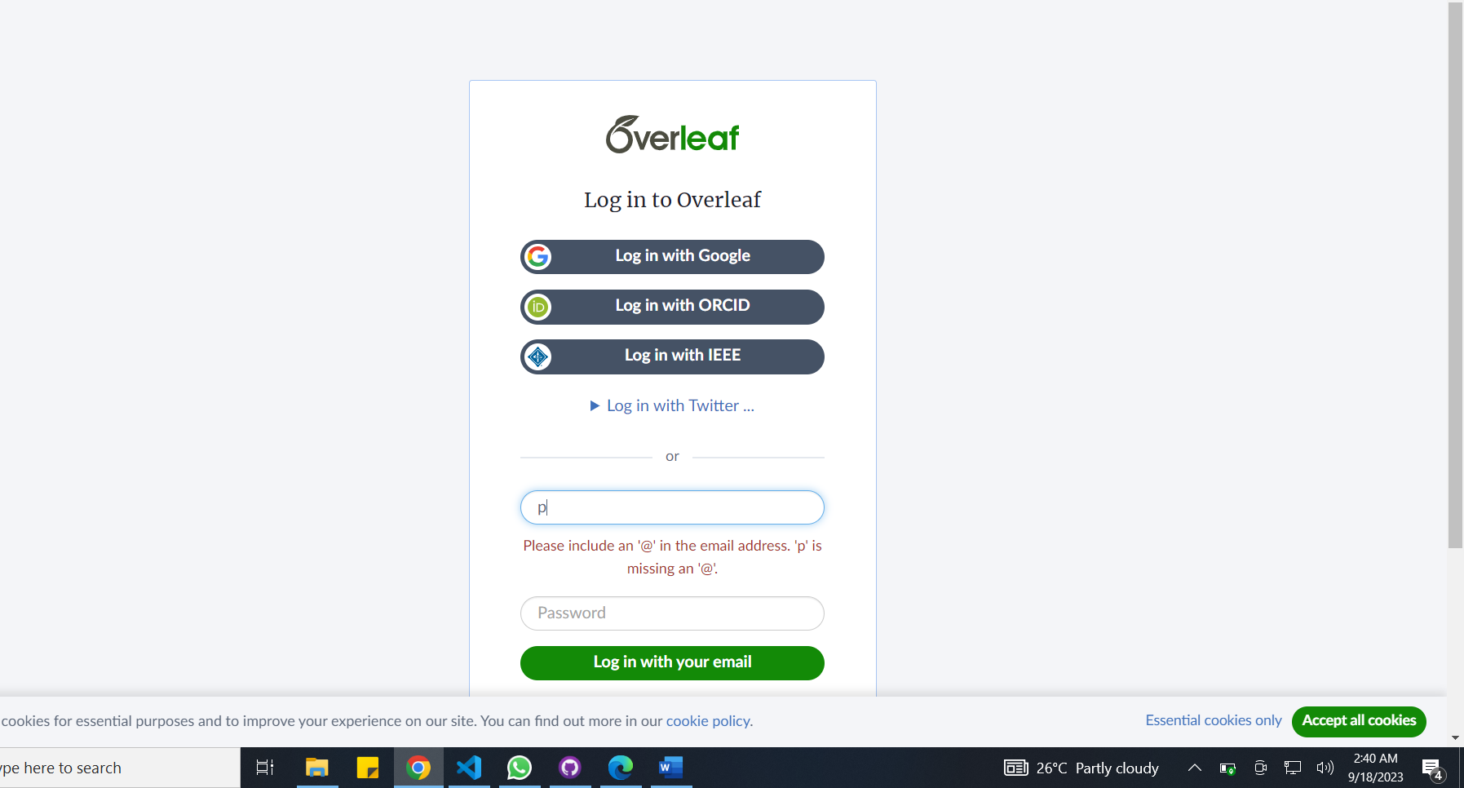

**2:Question 2**

Explore the types of templates available n the template section.

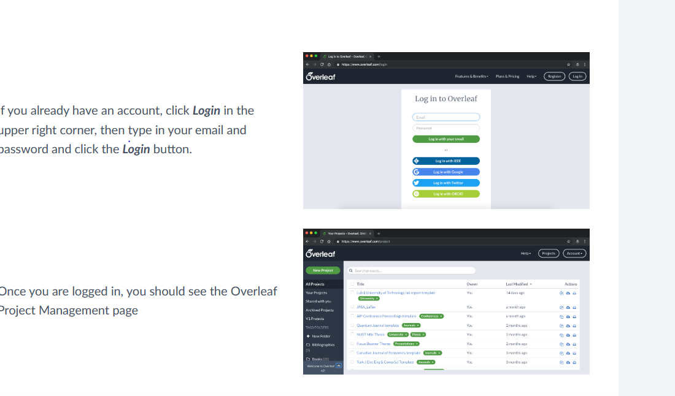

**3:Question 3**

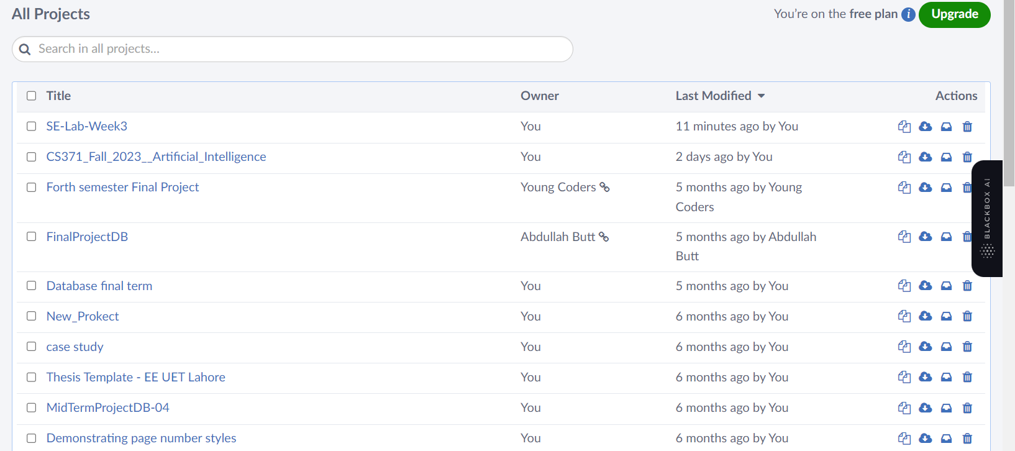

**4:Question 4**

Write your name, roll number, and subject name on the document.

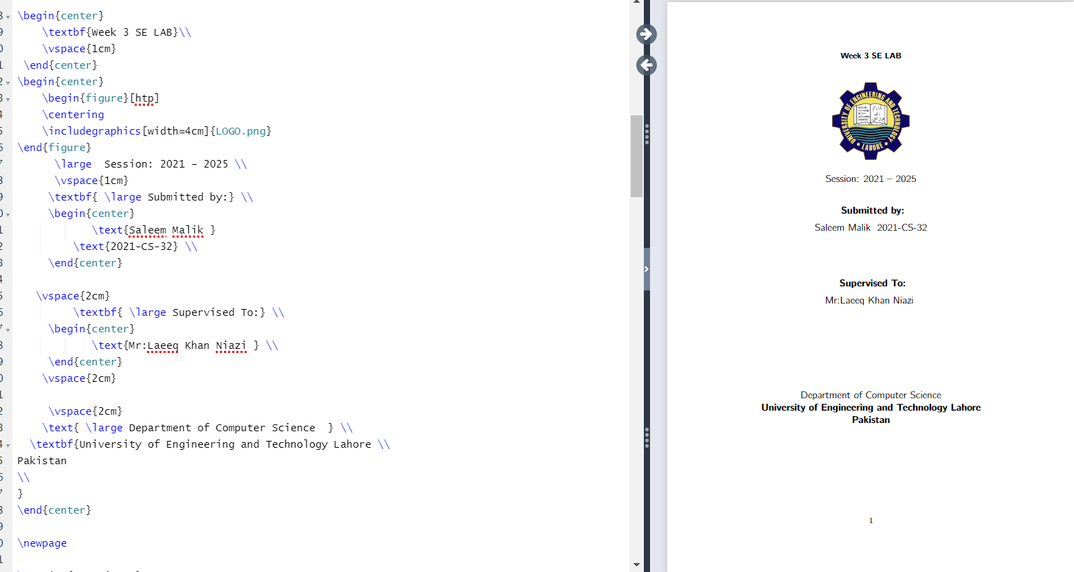

**5:Qurstion 5**

Apply formatting options such as bold, underline, and italics to the text.

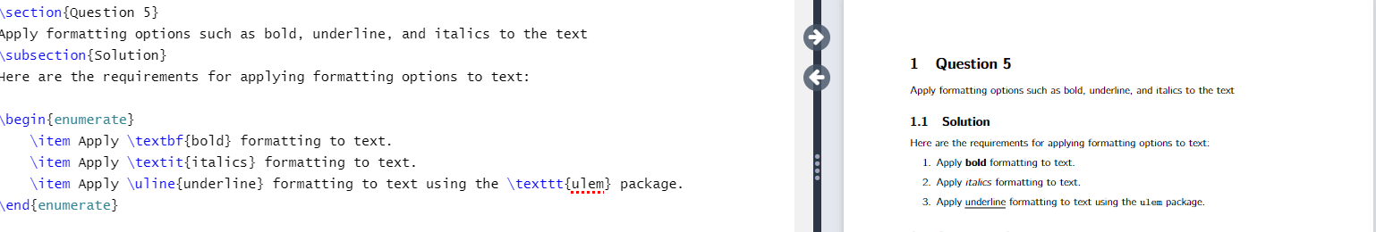

**Question 6**

Change the font of your text.

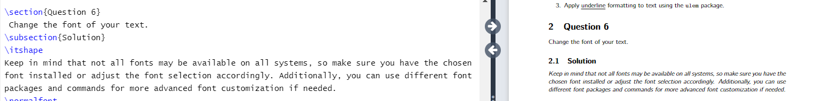

**Question 7**

Create ordered and unordered lists of sweet dishes and laptop company names, respectively.

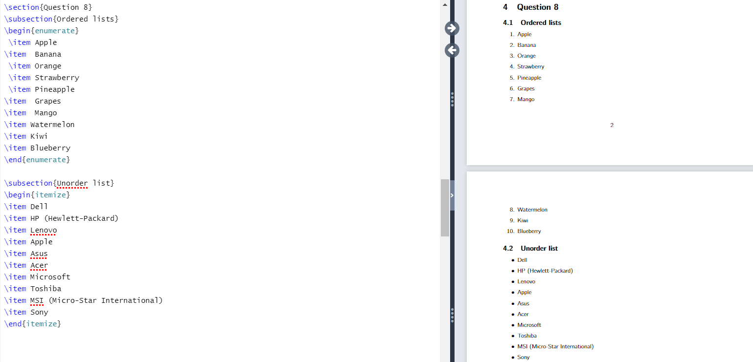

**Question 9**



**Question 10**

Use parentheses () and curly braces {} to write the following expression: {5 + 6 * (x + y)}



**Question 11**

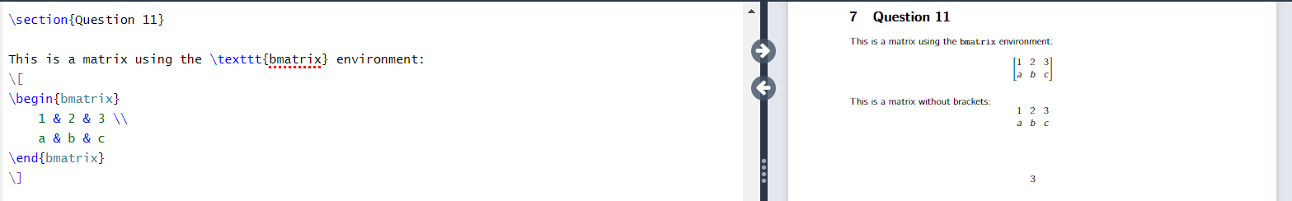

**Question 12**

Expressions

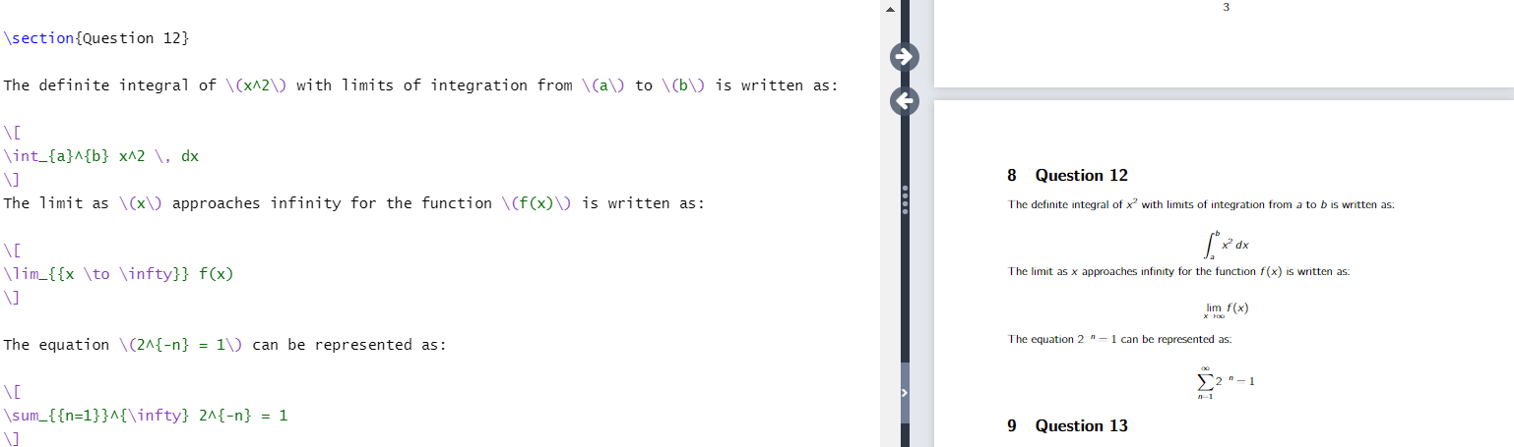

**Question 13**

Table with data of student roll number, name, CGPA and gender.

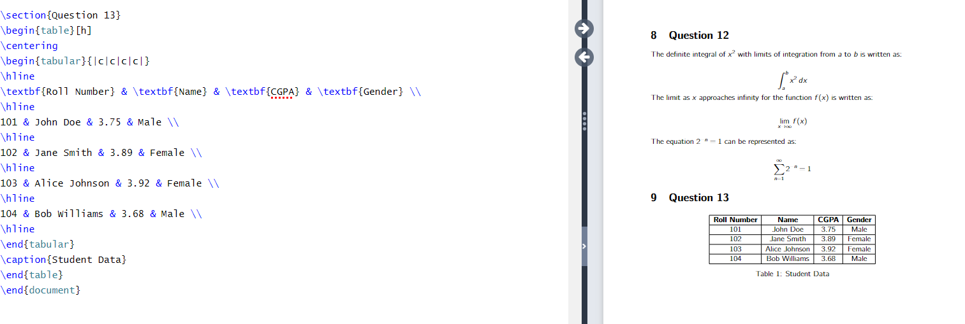

**Question 14, 15**

Add the picture in your document. And Position your picture in the center of your document page.

s