------------------+

| Beverage|

+------------------+

| Cold_Coffee|

| Cold_Espresso|

| Cold_LATTE|

| Cold_Lite|

| Cold_MOCHA|

| Cold_cappuccino|

| Double_Coffee|

| Double_Espresso|

| Double_Lite|

| Double_MOCHA|

| Double_cappuccino|

| ICY_Coffee|

| ICY_LATTE|

| ICY_Lite|

| ICY_MOCHA|

| ICY_cappuccino|

| LARGE_Coffee|

| LARGE_Espresso|

| LARGE_LATTE|

| LARGE_Lite|

| LARGE_MOCHA|

| LARGE_cappuccino|

Problem Scenario 6

Remove a row from the any Senario.

I removed last row from scenario 3b

| MED_Coffee|

| MED_Espresso|

| MED_Lite|

| MED_MOCHA|

| MED_cappuccino|

| Mild_Coffee|

| Mild_Espresso|

| Mild_LATTE|

| Mild_Lite|

| Mild_MOCHA|

| Mild_cappuccino|

| SMALL_Coffee|

| SMALL_Espresso|

| SMALL_LATTE|

| SMALL_Lite|

| SMALL_MOCHA|

| SMALL_cappuccino|

| Special_Coffee|

| Special_Espresso|

| Special_LATTE|

| Special_Lite|

| Special_MOCHA|

|Special_cappuccino|

| Triple_Coffee|

| Triple_Espresso|

| Triple_LATTE|

| Triple_Lite|

| Triple_MOCHA|

+------------------+

1a: What is the total number of consumers for Branch1?

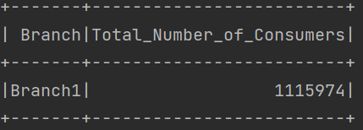

1b: What is the number of consumers for the Branch2?

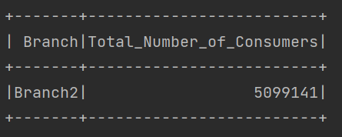

2a: What is the most consumed beverage on Branch1

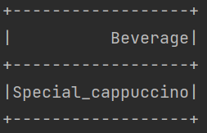

2b: What is the least consumed beverage on Branch2

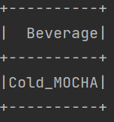

2c: What is the Average consumed beverage of Branch2

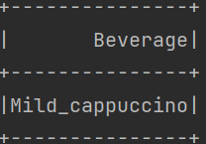

3a: What are the beverages available on Branch10, Branch8, and Branch1?

+------------------+

| Beverage|

+------------------+

| Cold_Coffee|

| Cold_LATTE|

| Cold_Lite|

| Cold_cappuccino|

| Double_Coffee|

| Double_Espresso|

| Double_LATTE|

| Double_MOCHA|

| Double_cappuccino|

| ICY_Coffee|

| ICY_Lite|

| ICY_cappuccino|

| LARGE_Coffee|

| LARGE_Espresso|

| LARGE_MOCHA|

| LARGE_cappuccino|

| MED_Coffee|

| MED_Espresso|

| MED_LATTE|

| MED_MOCHA|

| MED_cappuccino|

| Mild_Coffee|

| Mild_Espresso|

| Mild_cappuccino|

| SMALL_Espresso|

| SMALL_LATTE|

| SMALL_Lite|

| SMALL_MOCHA|

| Special_Espresso|

| Special_LATTE|

| Special_Lite|

| Special_MOCHA|

|Special_cappuccino|

| Triple_Coffee|

| Triple_Espresso|

| Triple_Lite|

| Triple_cappuccino|

+------------------+

3b: what are the common beverages available in Branch4,Branch7?

+------------------+

| Beverage|

+------------------+

| Cold_Coffee|

| Cold_Espresso|

| Cold_LATTE|

| Cold_Lite|

| Cold_MOCHA|

| Cold_cappuccino|

| Double_Coffee|

| Double_Espresso|

| Double_Lite|

| Double_MOCHA|

| Double_cappuccino|

| ICY_Coffee|

| ICY_LATTE|

| ICY_Lite|

| ICY_MOCHA|

| ICY_cappuccino|

| LARGE_Coffee|

| LARGE_Espresso|

| LARGE_LATTE|

| LARGE_Lite|

| LARGE_MOCHA|

| LARGE_cappuccino|

| MED_Coffee|

| MED_Espresso|

| MED_Lite|

| MED_MOCHA|

| MED_cappuccino|

| Mild_Coffee|

| Mild_Espresso|

| Mild_LATTE|

| Mild_Lite|

| Mild_MOCHA|

| Mild_cappuccino|

| SMALL_Coffee|

| SMALL_Espresso|

| SMALL_LATTE|

| SMALL_Lite|

| SMALL_MOCHA|

| SMALL_cappuccino|

| Special_Coffee|

| Special_Espresso|

| Special_LATTE|

| Special_Lite|

| Special_MOCHA|

|Special_cappuccino|

| Triple_Coffee|

| Triple_Espresso|

| Triple_LATTE|

| Triple_Lite|

| Triple_MOCHA|

| Triple_cappuccino|

+------------------+

4: create a partition,View for the scenario3.

Partitioned and Bucketed table:

+------------------+-------+-------+

| Beverage|BranchB|BranchA|

+------------------+-------+-------+

| Cold_Coffee|Branch7|Branch4|

| ICY_Lite|Branch7|Branch4|

| ICY_MOCHA|Branch7|Branch4|

| LARGE_Coffee|Branch7|Branch4|

| LARGE_MOCHA|Branch7|Branch4|

| Mild_Espresso|Branch7|Branch4|

| SMALL_Lite|Branch7|Branch4|

| SMALL_cappuccino|Branch7|Branch4|

|Special_cappuccino|Branch7|Branch4|

| Cold_Espresso|Branch7|Branch4|

| Double_MOCHA|Branch7|Branch4|

| ICY_Coffee|Branch7|Branch4|

| ICY_LATTE|Branch7|Branch4|

| MED_cappuccino|Branch7|Branch4|

| Mild_LATTE|Branch7|Branch4|

| SMALL_Espresso|Branch7|Branch4|

| SMALL_LATTE|Branch7|Branch4|

| Special_MOCHA|Branch7|Branch4|

| Triple_MOCHA|Branch7|Branch4|

| Triple_cappuccino|Branch7|Branch4|

+------------------+-------+-------+

only showing top 20 rows

View:

+-----------------+-------+-------+

| Beverage|BranchA|BranchB|

+-----------------+-------+-------+

| Cold_Coffee|Branch4|Branch7|

| Cold_Espresso|Branch4|Branch7|

| Cold_LATTE|Branch4|Branch7|

| Cold_Lite|Branch4|Branch7|

| Cold_MOCHA|Branch4|Branch7|

| Cold_cappuccino|Branch4|Branch7|

| Double_Coffee|Branch4|Branch7|

| Double_Espresso|Branch4|Branch7|

| Double_Lite|Branch4|Branch7|

| Double_MOCHA|Branch4|Branch7|

|Double_cappuccino|Branch4|Branch7|

| ICY_Coffee|Branch4|Branch7|

| ICY_LATTE|Branch4|Branch7|

| ICY_Lite|Branch4|Branch7|

| ICY_MOCHA|Branch4|Branch7|

| ICY_cappuccino|Branch4|Branch7|

| LARGE_Coffee|Branch4|Branch7|

| LARGE_Espresso|Branch4|Branch7|

| LARGE_LATTE|Branch4|Branch7|

| LARGE_Lite|Branch4|Branch7|

+-----------------+-------+-------+

only showing top 20 rows