TIME SERIES

TIME SERIES ANALYSIS
Time series analysis is the data collected over a period of time . Our purpose is to see what changes take place over the time in the event we are observing . We can try to predict the future behavior of that event based on the data available, hoping that the recent behavior of this series will overshadow earlier behavior..
Fore casting or predicting is an essential tool in any decision-making process. Time series analysis is a quantitative method in which we use to determine patterns in data collected over a period of time.
Analysis of time series helps us to understand the past behavior of time series data. With the knowledge of the past behavior , it would be possible, within certain limits, to forecast the probable future variations of the data. Thus it helps in planning future operations.
Time series is divided into three components
1.Long term variations (Trend)
2.Short term variations (periodic changes)
i)Seasonal variations
ii)Cyclical variations
3.Random or irregular variations

TREND
Trend means general tendency of the data to increase or decrease during a long period of time. The term ‘long period of time’ is a relative term and cannot be exactly defined. In some cases, a week days may become a long period of time and along time period as long as two years may become a small time period.
Foe example , the bacterial growth is very high for every five minutes and week days become a long period in the study of bacteria while 2 years in the agriculture production become a short time period. So the term trend depends upon the case under study.
Reasons for studying Trend:
- The study of secular trends allow us to describe a historical pattern.
- Studying secular trends permits us to project past pattern or trends into the future.

Various measures of trend
- graphical method
- Method of semi-averages
- Method of Least squares
- Method of moving Averages

    - Graphical Method (Free hand) Method:
Free hand method or graphic method is the simplest method for studying trend. In this method the actual figures (given data) are first plotted as points on a graph paper showing the time series data along the vertical axis and time along the horizontal axis. Then a straight line is drawn to fit as closely as possible the plotted points.
(To draw the line, leave equal number of points on both sides of it at more or less equal distance). The line so obtained shows the direction of the trend and the vertical distance of this line gives the trend value for each time period.
By this method a quick estimate of the trend can be obtained, but this depends too much on the judgment of the investigation. Different people will locate the line in different positions . This method should be used only when a quick approximate idea of the trend is required.
Fit a trend line to the following data by the free hand method
Year | 1970 | 1971 |  | 1972 | 1973 |  | 1974 |  | 1975 |  | 1976 |  | 1977
Sales in  million Rs) | 62 | 64 | 66 |  | 63.5 | 67 |  | 64.5 |  | 69 |  | 67

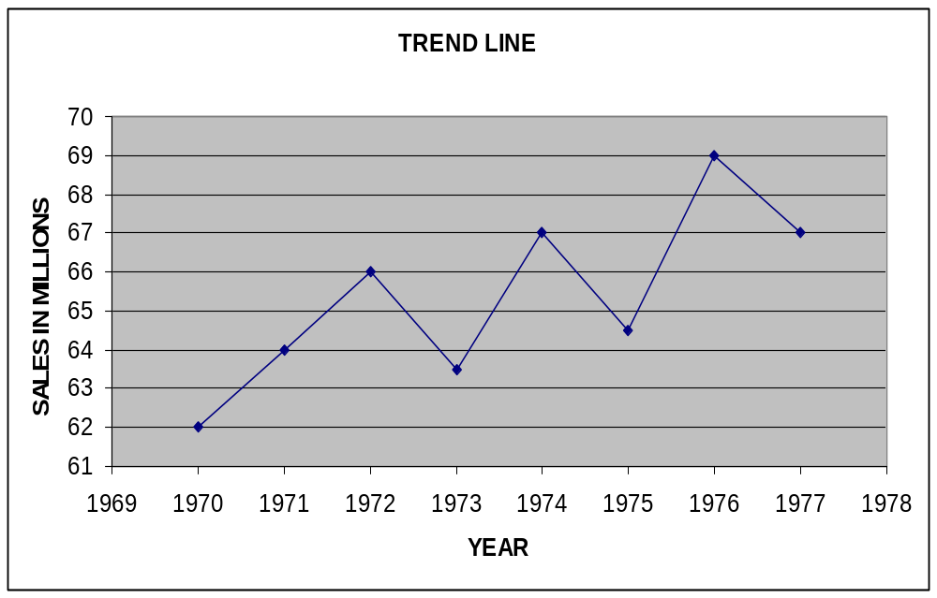

2)Semi Average Method
In the semi average method , the given data is first divided into two parts and an average for each part is found. Then these two averages are plotted on the graph paper against the mid points of the time intervals covered by the respective two parts. These two points are joined by a straight line. This straight line is the required trend line.
Although this method is simple to apply, it may lead to poor results when used indiscriminately . It is applicable only where the trend is linear or approximately linear.

Draw a trend line by the semi average method using the following data:
Year | 1973 | 1974 | 1975 | 1976 | 1977 | 1978
Production of steel  (in lakh tons) | 253 | 260 | 255 | 263 | 259 | 264

Sol:- The average production of steel for the first three years 253+260+255/3=256
The average production of steel for the last three years 263+259+264/3=262
Thus we get two points 256 and 262 which are plotted against the respective
middle years 1974 and 1977 of the two parts 1973-1975 and 1976-1978 . By
joining these two points , the required trend line is obtained.

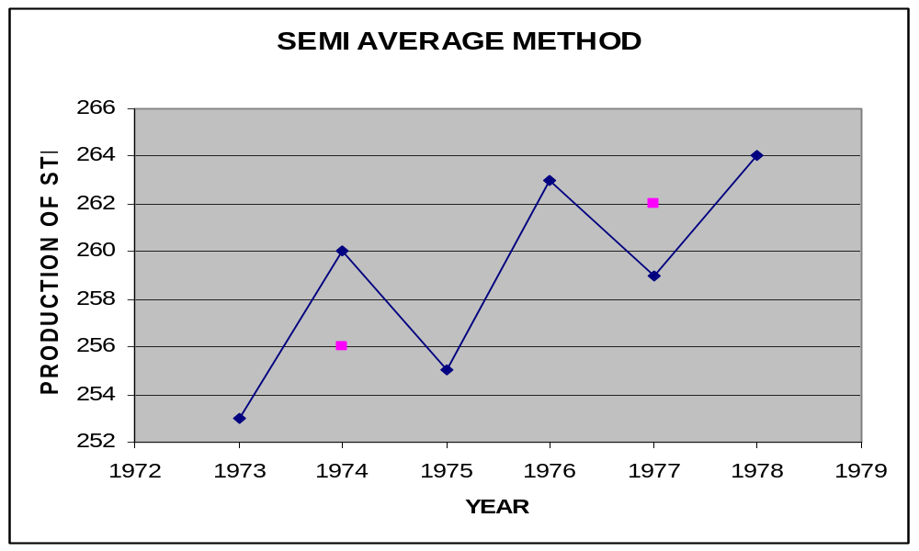

3 Method of least squares:
This method is widely used for measurement of trend.
Linear Trend:- Let (x₁,y₁),(x_{2,}y_{2)………….}(x_{n},y_{n}) be n pairs of observations where y_{i} represents time series and x_{i} represents time.
Let Y=a+bX be the linear equation of the straight line. The normal equations are
∑y = na + b∑x
∑xy = a∑x + b∑x²
Problem 1:-
Determine the equation of a straight line which best fits the following data:
Year | 1974 | 1975 | 1976 | 1977 | 1978
Sales(in’000) | 35 | 56 | 79 | 80 | 40
Sol:-
Year | Sales | X | Y | XY | X²
1974 | 35 | -2 | 35 | -70 | 4
1975 | 56 | -1 | 56 | -56 | 1
1976 | 79 | 0 | 79 | 0 | 0
1977 | 80 | 1 | 80 | 80 | 1
1978 | 40 | 2 | 40 | 80 | 4
 |  | 0 | 290 | 34 | 10
5a+0b=290
a0+10b=34 a=58 , b=3.4
Required straight line equation is:
Y=58+3.4(X-1976)
Y=-6660.4+3.4X
Problem2:-
Fit a straight line to the following data:
X | 1981 | 1982 | 1983 | 1984 | 1985 | 1986 | 1987 | 1988 | 1989 | 1990
Y | 42 | 50 | 61 | 75 | 92 | 111 | 120 | 127 | 140 | 138
Sol:-
X | Y | X-1986 | XY | X²
1981 | 42 | -5 | -210 | 25
1982 | 50 | -4 | -200 | 16
1983 | 61 | -3 | -183 | 9
1984 | 75 | -2 | -150 | 4
1985 | 92 | -1 | -92 | 1
1986 | 111 | 0 | 0 | 0
1987 | 120 | 1 | 120 | 1
1988 | 127 | 2 | 254 | 4
1989 | 140 | 3 | 420 | 9
1990 | 138 | 4 | 552 | 16
 | 956 | -5 | 511 | 85
10a-5b=956
-5a+85b=511 a=101.5939, b=11.9878
Y = 101.5939 + 11.9878(X-1986)
Y = -23706.177 + 11.9878 X

Problem3:-
Fit a trend line to the following data of sales of a commodity in a shop using least square theory and estimate the volume of sales in 1997
Year | 1990 | 1991 | 1992 | 1993 | 1994
Sales in ‘000 | 2.4 | 2.8 | 3.1 | 3.6 | 4.2
Sol:-

X | Y | X=X-1992 | XY | X²
1990 | 2.4 | -2 | -4.8 | 4
1991 | 2.8 | -1 | -2.8 | 1
1992 | 3.1 | 0 | 0 | 0
1993 | 3.6 | 1 | 3.6 | 1
1994 | 4.2 | 2 | 8.4 | 4
 | 16.1 | 0 | 4.4 | 10

Y= 3.22+0.44(X-1992)
Y=-873.28+0.44X
Y_{X=1997}= 5.42

Problem4:- (2002 march)
Mr.Ramesh the auditor of a Govt. public school has received the inventory records to determine if the current inventory holdings of text books are typical. The following inventory amounts are from the previous 5 years
Year | 1988 | 1989 | 1990 | 1991 | 1992
Inventory in Rs. | 4620 | 4910 | 5490 | 5730 | 5990
  - Find the linear equation that describes the trend in the inventory holdings.
  - Estimate the value of inventory for the year 1993

X | Y | X=X-1990 | XY | X²
1988 | 4620 | -2 | -9240 | 4
1989 | 4910 | -1 | -4910 | 1
1990 | 5490 | 0 | 0 | 0
1991 | 5730 | 1 | 5730 | 1
1992 | 5990 | 2 | 11980 | 4
 | 26740 | 0 | 3560 | 10

Y= 5348 + 356(X-1990)
Y= -703092 + 356X
Y_{x=1993} = 6416

Problem5:- (Dec 2003)
Fit a Straight line by Principle of least square to the data. Estimate the likely production for the year 2005.
X | 1995 | 1996 | 1997 | 1998 | 1999 | 2000
Y | 24 | 25 | 27 | 29 | 30 | 33

X | Y | X=X-1997 | XY | X²
1995 | 24 | -2 | -48 | 4
1996 | 25 | -1 | -25 | 1
1997 | 27 | 0 | 0 | 0
1998 | 29 | 1 | 29 | 1
1999 | 30 | 2 | 60 | 4
2000 | 33 | 3 | 99 | 9
 | 168 |  | 115 | 19

Y=27.1143 + 1.7714(X-1997)
Y= -3510.3715 + 1.7714
Y_{X=2005} = 41.2855

Problem6:- (Dec 2006)
Using 1964 as the origin obtain a straight line trend equation by the method of least squares. Find the trend value of the missing year 1961.
X | 1960 | 1962 | 1963 | 1964 | 1965 | 1966 | 1969
Y | 140 | 144 | 160 | 152 | 168 | 176 | 180

X | Y | X=X-1997 | XY | X²
1960 | 140 | -4 | -560 | 16
1962 | 144 | -2 | -288 | 4
1963 | 160 | -1 | -160 | 1
1964 | 152 | 0 | 0 | 0
1965 | 168 | 1 | 168 | 1
1966 | 176 | 2 | 352 | 4
1969 | 180 | 5 | 900 | 25
 | 1120 | 1 | 412 | 51

Y=159.2921 + 4.9551(X-1964)
Y_{X=1961} = 144.4268

Problem7:- (Dec 2005)
M/s Allwyn Ltd. Gives the following information relating to sales of refrigerators in past years. You are required to fit a straight line by the method of least squares and compute trend values. Estimate the sales for the year 2006.
Year | 1996 | 1997 | 1998 | 1999 | 2000 | 2001 | 2002 | 2003
Refrigerators sold in thousands | 10 | 11 | 11 | 13 | 15 | 19 | 19 | 22

X | Y | X=X-1999 | XY | X²
1996 | 10 | -3 | -30 | 9
1997 | 11 | -2 | -22 | 4
1998 | 11 | -1 | -11 | 1
1999 | 13 | 0 | 0 | 0
2000 | 15 | 1 | 15 | 1
2001 | 19 | 2 | 38 | 4
2002 | 19 | 3 | 57 | 9
2003 | 22 | 4 | 88 | 16
 | 120 | 4 | 135 | 44

Y=14.1071 + 1.7857(X-1999)
Y=-3555.5072 + 1.7857X

X | Trend values
1996 | 8.75
1997 | 10.5357
1998 | 12.3214
1999 | 14.1071
2000 | 15.8928
2001 | 17.6785
2002 | 19.4642
2003 | 21.25
2006 | 26.607

Problem8:- (Dec 2007)
Given below are the figures of production (in lakh kg.) of a sugar factory.Fit a straight line trend and tabulate the trend. Estimate the production for the year 2007.
Year | 1999 | 2000 | 2001 | 2002 | 2003 | 2004 | 2005
production | 40 | 45 | 46 | 42 | 47 | 50 | 46

X | Y | X=X-2002 | XY | X²
1999 | 40 | -3 | -120 | 9
2000 | 45 | -2 | -90 | 4
2001 | 46 | -1 | -46 | 1
2002 | 42 | 0 | 0 | 0
2003 | 47 | 1 | 47 | 1
2004 | 50 | 2 | 100 | 4
2005 | 46 | 3 | 138 | 9
 | 316 | 0 | 29 | 28

Y=45.1429 + 1.0357(X-2002)
Y=-2028.3285 + 1.0357X

X | Trend values
1999 | 42.0358
2000 | 43.0715
2001 | 44.1072
2002 | 45.1429
2003 | 46.1786
2004 | 47.2143
2005 | 48.25
2007 | 50.3214

Non – Linear Trend
Problem1:-
Y = a+bx+cx²
∑Y = na +b∑x+c∑x²
∑xy = a∑x+b∑x²+c∑x³
∑x²y=a∑x²+b∑x²+c∑x⁴

X | Y | X | XY | X² | X³ | X⁴ | X²Y
1985 | 13 | -2 | -26 | 4 | -8 | 16 | 52
1986 | 24 | -1 | -24 | 1 | -1 | 1 | 24
1987 | 39 | 0 | 0 | 0 | 0 | 0 | 0
1988 | 65 | 1 | 65 | 1 | 1 | 1 | 65
1989 | 106 | 2 | 212 | 4 | 8 | 16 | 424
 | 247 | 0 | 227 | 10 | 0 | 34 | 565

Y= 39.2572 + 22.7 (X-1987) + 5.0714 (X-1987)²

Problem2:- (April 2001)
The sales of a company in lakhs of rupees for the years 1975 through 1981 are
given below
Year | 1975 | 1976 | 1977 | 1978 | 1979 | 1980 | 1981
Sales | 32 | 47 | 65 | 92 | 132 | 190 | 275

Estimate sales figures for the year 1982 using an equation of the form Y=ab^{X}
Where x represents years and y represents sales.

YEAR | SALES | X=X-1978 | Y=LOG(Y) | XY | X²
1975 | 32 | -3 | 1.5051 | -4.5153 | 9
1976 | 47 | -2 | 1.6720 | -3.3440 | 4
1977 | 65 | -1 | 1.8129 | -1.8129 | 1
1978 | 92 | 0 | 1.9637 | 0 | 0
1979 | 132 | 1 | 2.1205 | 2.1205 | 1
1980 | 190 | 2 | 2.2787 | 4.5874 | 4
1981 | 275 | 3 | 2.4393 | 7.3179 | 9
 |  | 0 | 13.7923 | 4.3236 | 28

A=1.9704 ; B =0.1544

Y= 1.9704 + 0.1544 (X-1978)

Y = 93.4114 * 1.4269 ^{X}

Y_{X=1982} = 2.5881

Y= Antilog (2.58)= 387.2576

4.Method of Moving Averages:

It consists in measurement of trend by smoothening out the fluctuations of the data by means of a moving average . Moving average of extent ‘m’ is a series of successive averages of m terms at a time starting with 1_{st,}2_{nd},3_{rd……….}terms etc.
Thus the first average is the mean of the 1_{st} ‘m’ terms and the 2_{nd} to (m+1)^{th} term, the third is the mean of the m terms from 3_{rd} to (m+2)^{th} term and so on.
If m is odd =(2k+1) say, moving average is placed against the midvalue of the time interval it covers. i.e against t=k+1. and if m is even it is placed between the two middle values of the time interval it covers. i.e between t=k and t=k+1. In the latter case the moving average does not coincide with an original time period and an attempt is made to synchronize the moving averages and the original data by centering the moving averages which consists in taking a moving average of extenet two and putting these values against t=k+1. The graph obtained on plotting thr moving average against time gives trend.

Problem1:-
Work out the centered 4 yearly moving averages for the following data
Year | T | Four year  moving  Average | Two year  moving  Average
1971 | 2204
1972 | 2500
 |  | 2436
1973 | 2360 |  | 2463.5
 |  | 2491
1974 | 2680 |  | 2507.75
 |  | 2524.50
1975 | 2424 |  | 2592.50
 |  | 2660.50
1976 | 2634 |  | 2712.75
 |  | 2765
1977 | 2904 |  | 2858.50
 |  | 2952
1978 | 3098 |  | 2991.75
 |  | 3031.50
1979 | 3172 |  | 3074.50
 |  | 3117.50
1980 | 2952 |  | 3126.75
 |  | 3136
1981 | 3248
1982 | 3172

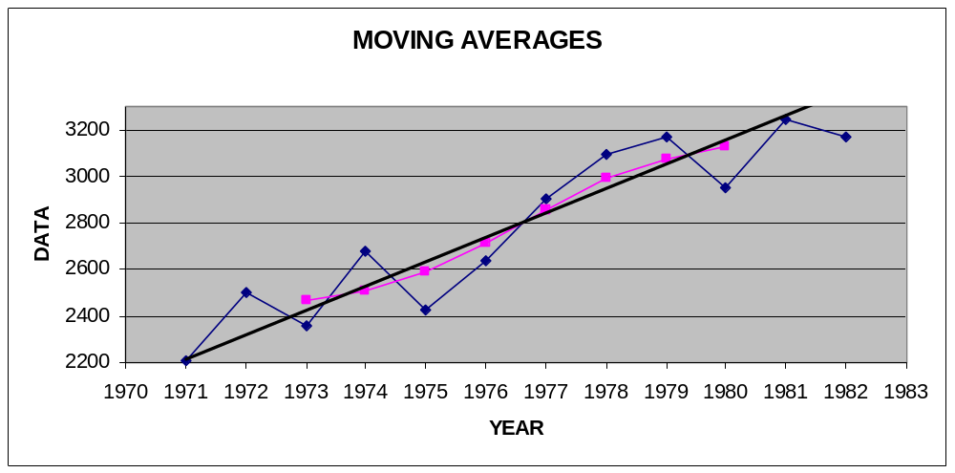

problem2:-
Calculate the 5 yearly moving average to the following data
Year | T | Moving average
1966 | 19.3
1967 | 20.9
1968 | 17.8 | 18.34
1969 | 16.1 | 18.04
1970 | 17.6 | 17.52
1971 | 17.8 | 17.42
1972 | 18.3 | 18.48
1973 | 17.3 | 18.82
1974 | 21.4 | 18.88
1975 | 19.3 | 19.12
1976 | 18.1 | 19.50
1977 | 19.5 | 19.66
1978 | 19.2 | 19.98
1979 | 22.2 | 20.66
1980 | 20.9 | 21.14
1981 | 21.5
1982 | 21.9

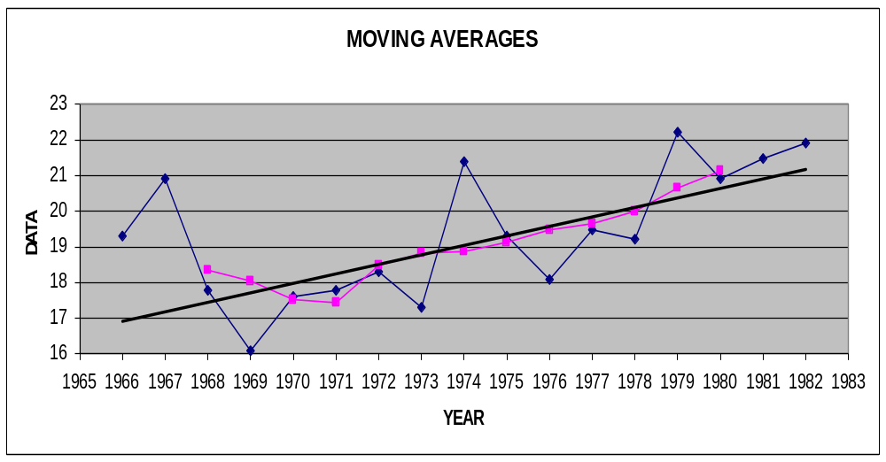

Problem3:-
The data below give the index of industrial production from 1961 to 1970:
Determine the trend by means of moving averages i)3 year ii)5 year
Year | 1961 | 1962 | 1963 | 1964 | 1965 | 1966 | 1967 | 1968 | 1969 | 1970
Index of production | 109.2 | 119.8 | 129.7 | 140.8 | 153.8 | 153.2 | 152.6 | 163.0 | 175.3 | 184.3

Year | Index | 3 yr avg
1961 | 109.2
1962 | 119.8 | 119.57
1963 | 129.7 | 130.10
1964 | 140.8 | 141.43
1965 | 153.8 | 149.27
1966 | 153.2 | 153.2
1967 | 152.6 | 156.27
1968 | 163.0 | 163.63
1969 | 175.3 | 174.2
1970 | 184.3

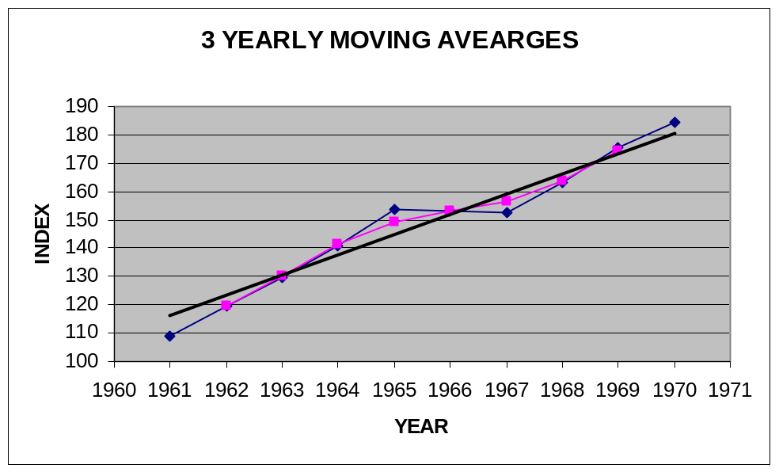

Year | Index | 5 yr avg
1961 | 109.2
1962 | 119.8
1963 | 129.7 | 130.66
1964 | 140.8 | 139.46
1965 | 153.8 | 146.22
1966 | 153.2 | 152.68
1967 | 152.6 | 159.58
1968 | 163.0 | 165.68
1969 | 175.3
1970 | 184.3

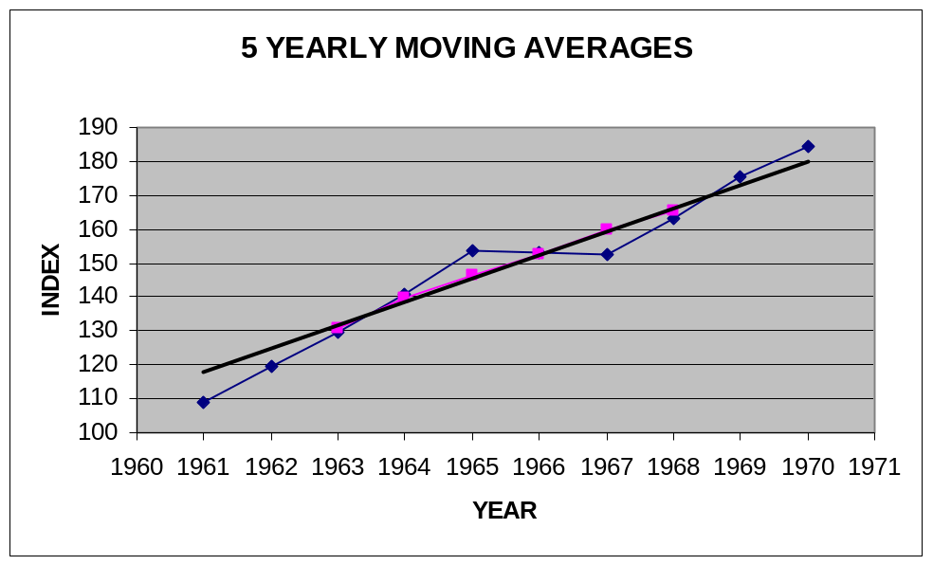

Algorithm:-
Step1: Enter the no. of observations i.n
Step2:Read all the paired observations (U_{t}, t)
Step3:Enter the extent of moving average i.e m
Step4: Calculate the mid values

M₁= (t₁+t₂+…….+t_{m} )/m
M₂= (t₂+t₃+…….+t_{m+1})/m
………………………….
………………………….
M_{q}= (t_{q}+t_{q+1}+……+t_{n} )/m

Step5:If m is odd i.e (m=2k+1) goto step6; else if m is even (m=2k) goto step7;
Step6:Place the moving average against the midvalue of the time interval it covers.
Step7:Place the moving average between the k^{th} and (k+1)^{th} time series
Step8:Synchronize the moving average so that the average is against the time period.

AUTOREGRESSIVE INTEGRATED MOVING AVERAGE (ARIMA)

Calculate the 5 yearly moving average to the following data

  Year | T | Moving average
  1966 | 19.3
  1967 | 20.9
  1968 | 17.8 | 18.34
  1969 | 16.1 | 18.04
  1970 | 17.6 | 17.52
  1971 | 17.8 | 17.42
  1972 | 18.3 | 18.48
  1973 | 17.3 | 18.82
  1974 | 21.4 | 18.88
  1975 | 19.3 | 19.12
  1976 | 18.1 | 19.50
  1977 | 19.5 | 19.66
  1978 | 19.2 | 19.98
  1979 | 22.2 | 20.66
  1980 | 20.9 | 21.14
  1981 | 21.5
  1982 | 21.9
  U_{t-1} | U_{t} | U_{t}.U_{t-1} | ΣU_{t-1}²
  18.34 | 18.04
  18.04 | 17.52
  17.52 | 17.42
  17.42 | 18.48
  18.48 | 18.82
  18.82 | 18.88
  18.88 | 19.12
  19.12 | 19.50
  19.50 | 19.66
  19.66 | 19.98
  19.98 | 20.66
  20.66 | 21.14
  226.42 | 229.22 | 4336.6912 | 4282.7372

U_{t}=a+bU_{t-1}

By the method of least squares the normal equations are

ΣU_{t}=na+bΣU_{t-1}
ΣU_{t}.U_{t-1}=a ΣU_{t-1}+ ΣU_{t-1}²

U_{t}=-1.771+1.106 .U_{t-1}

