NeighbourHub
Entity-Relationship Diagram — System Design Document
Group 9 Community Services Marketplace

1. Scope & Method
This ERD reflects the current implementation of the NeighbourHub project. The system includes JWT-based authentication, role-based access (Resident, Provider and Admin), provider profiles, service management, booking management, booking status updates (Pending, Accepted, Cancelled, Completed), provider dashboard statistics, resident dashboard, reviews (planned), notifications (planned), and Prisma ORM with PostgreSQL.
The implementation has been developed using React + TypeScript for the frontend, NestJS for the backend, Prisma ORM, PostgreSQL (Neon), and JWT authentication. The schema and relationships match the modules currently implemented in the project.

2. Entity Dictionary
Entity | Purpose
USERS | Core account for every person on the platform. Holds the role (Resident, Provider, Moderator, Admin) and links to a Zone.
PROVIDER_PROFILES | Extended profile created when a Resident self-upgrades to Provider: bio, categories, verification, response metrics, completeness score.
PROVIDER_AVAILABILITY | Recurring weekly availability slots a provider sets, checked automatically against incoming booking requests.
SERVICE_LISTINGS | A specific service a provider offers. Stores both the provider's rough draft and the AI-enhanced listing (AI Feature 1), or the fallback template.
BOOKINGS | A booking request from a Resident to a Provider for a Service Listing, moving through Sent -> Accepted/Declined -> In Progress -> Completed/Disputed.
TRUST_PROFILES | Cached output of AI Feature 3 (Review Sentiment Analyser): positive themes, recurring complaints, reliability score, summary - or the fallback average/count when fewer than 3 reviews exist.
NOTICEBOARD_POSTS | Community announcement posted by a Moderator; can be pinned.
NOTICEBOARD_COMMENTS | Resident comments on a noticeboard post.
FLAGGED_CONTENT | Any listing, message, or review flagged for moderator review (feeds the Moderator's Flagged Content queue).
NOTIFICATIONS | Real-time notification record delivered over WebSocket for booking status changes, new messages, dispute updates, etc.

3. Entity-Relationship Diagram
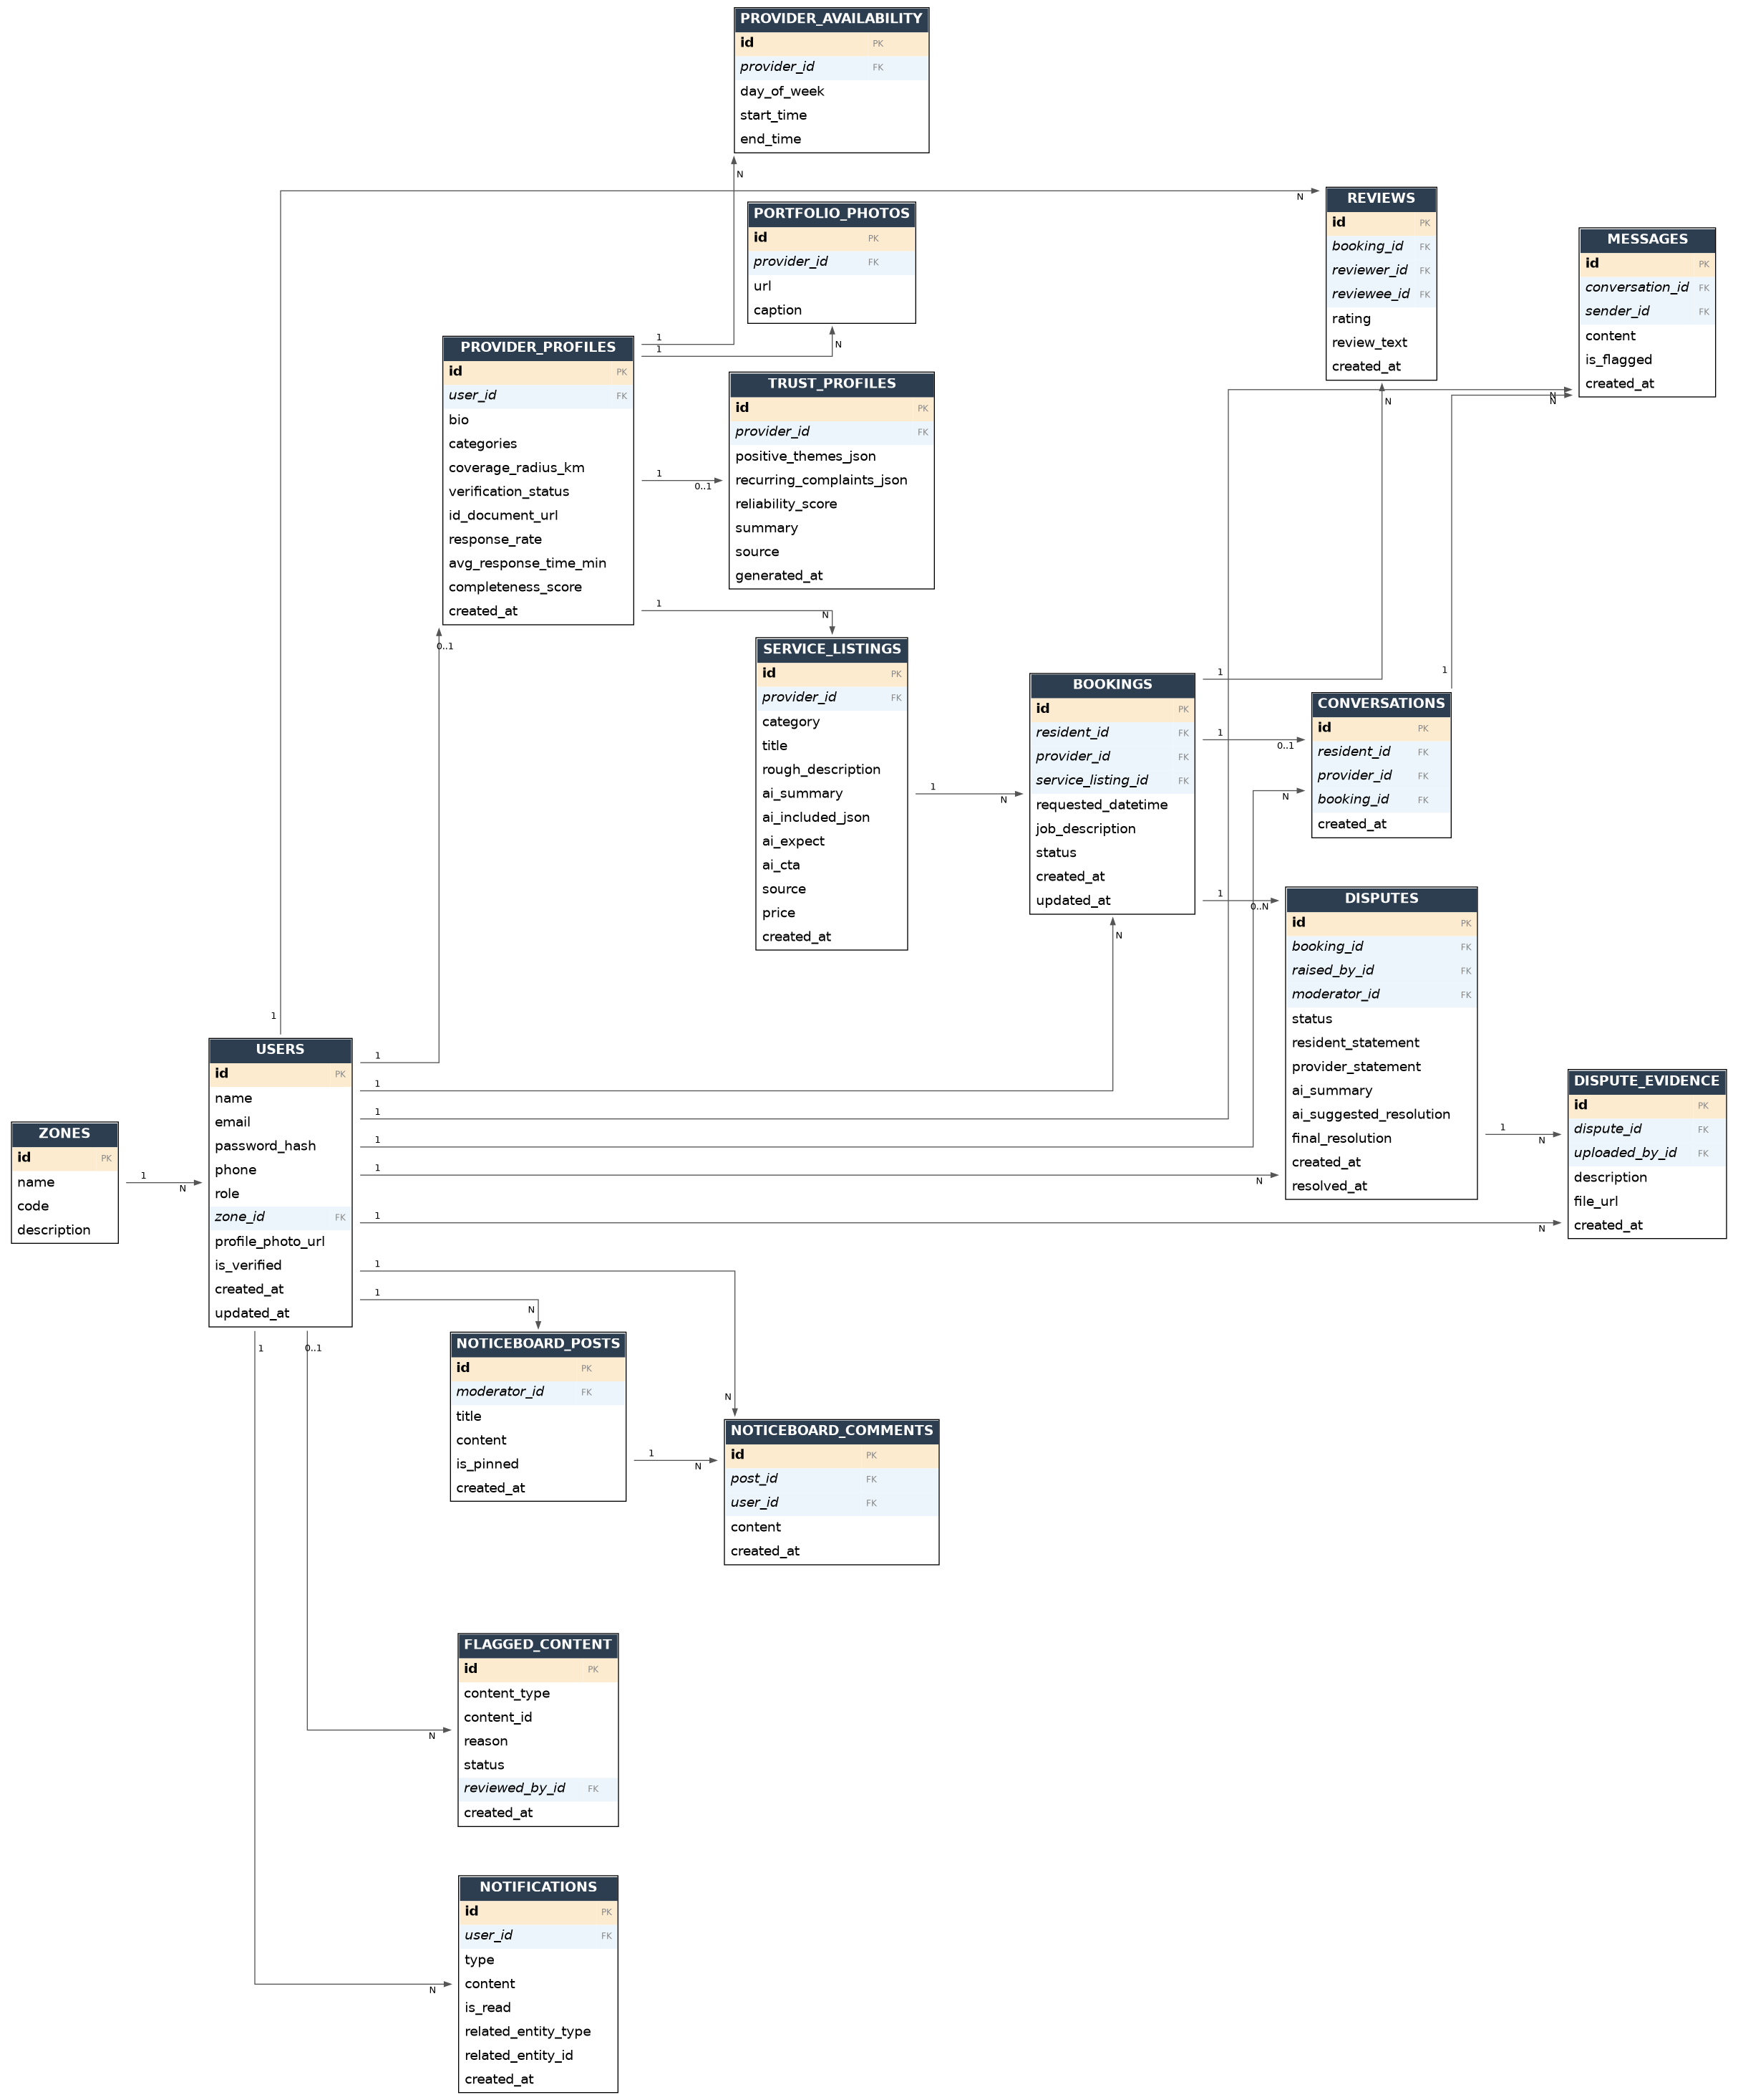
Bold = primary key · Italic = foreign key · Header colour groups each table

4. Key Relationships
From | To | Cardinality | Notes
ZONES | USERS | 1 : N | A zone contains many users (residents/providers).
USERS | PROVIDER_PROFILES | 1 : 0..1 | A user optionally becomes a provider after verification.
PROVIDER_PROFILES | PROVIDER_AVAILABILITY | 1 : N | A provider defines many recurring availability slots.
PROVIDER_PROFILES | PORTFOLIO_PHOTOS | 1 : N | A provider uploads many portfolio photos.
PROVIDER_PROFILES | SERVICE_LISTINGS | 1 : N | A provider publishes many service listings.
PROVIDER_PROFILES | TRUST_PROFILES | 1 : 0..1 | AI generates one active trust profile per provider (min. 3 reviews).
USERS | BOOKINGS | 1 : N (x2) | A user is linked to bookings both as resident and as provider.
SERVICE_LISTINGS | BOOKINGS | 1 : N | A listing can receive many booking requests.
BOOKINGS | REVIEWS | 1 : N | A completed booking produces up to two reviews (resident <-> provider).
USERS | REVIEWS | 1 : N (x2) | A user appears as reviewer on some reviews and reviewee on others.
BOOKINGS | CONVERSATIONS | 1 : 0..1 | A booking may have one associated conversation thread.
USERS | CONVERSATIONS | 1 : N (x2) | A user participates in many conversations, as resident or provider side.
CONVERSATIONS | MESSAGES | 1 : N | A conversation contains many persisted messages.
USERS | MESSAGES | 1 : N | A user sends many messages.
BOOKINGS | DISPUTES | 1 : 0..N | A booking can have a dispute raised against it.
USERS | DISPUTES | 1 : N (x2) | A user can raise disputes and a moderator can be assigned to many.
DISPUTES | DISPUTE_EVIDENCE | 1 : N | A dispute can have multiple evidence items attached.
USERS | NOTICEBOARD_POSTS | 1 : N | A moderator authors many noticeboard posts.
NOTICEBOARD_POSTS | NOTICEBOARD_COMMENTS | 1 : N | A post receives many resident comments.
USERS | FLAGGED_CONTENT | 0..1 : N | A moderator reviews many flagged items.
USERS | NOTIFICATIONS | 1 : N | A user receives many real-time notifications.

5. How the AI Features Map to the Schema
Read directly from ai.service.ts (enhanceDescription, matchProviders, analyzeSentiment) and the spec's bonus Dispute Mediator feature:
AI Feature | Entity | Mapping
AI Feature 1 - Description Enhancer | SERVICE_LISTINGS | rough_description is the provider's input; ai_summary, ai_included_json, ai_expect, ai_cta store the structured JSON the model returns, matching the systemPrompt shape in enhanceDescription(). source records 'ai' or 'fallback' exactly as returned by callLLM().
AI Feature 2 - Smart Provider Matcher | Computed at query time, not persisted | matchProviders() reads live PROVIDER_PROFILES / SERVICE_LISTINGS / BOOKINGS data (skills, availability, zone, review sentiment) to build the candidates list; ranked matches and explanations go straight to the frontend.
AI Feature 3 - Review Sentiment Analyser | TRUST_PROFILES | analyzeSentiment() aggregates REVIEWS.review_text for a provider (minimum 3) into positive_themes_json, recurring_complaints_json, reliability_score and summary; below the threshold, activated=false and only the raw review count is shown.
AI Feature 4 - Dispute Mediator (bonus) | DISPUTES | ai_summary and ai_suggested_resolution store the model's read of both statements plus booking details; final_resolution is always set by the Moderator, never overwritten by AI output.
Current AI-related features are planned for future implementation. The current system focuses on authentication, provider services, booking workflow, dashboards, and role-based management. Future versions may include AI-powered provider matching, service description enhancement, review sentiment analysis, and dispute assistance.

