Saleh Saed Alghool 422117042 CS471

P3 T2 S1-S4

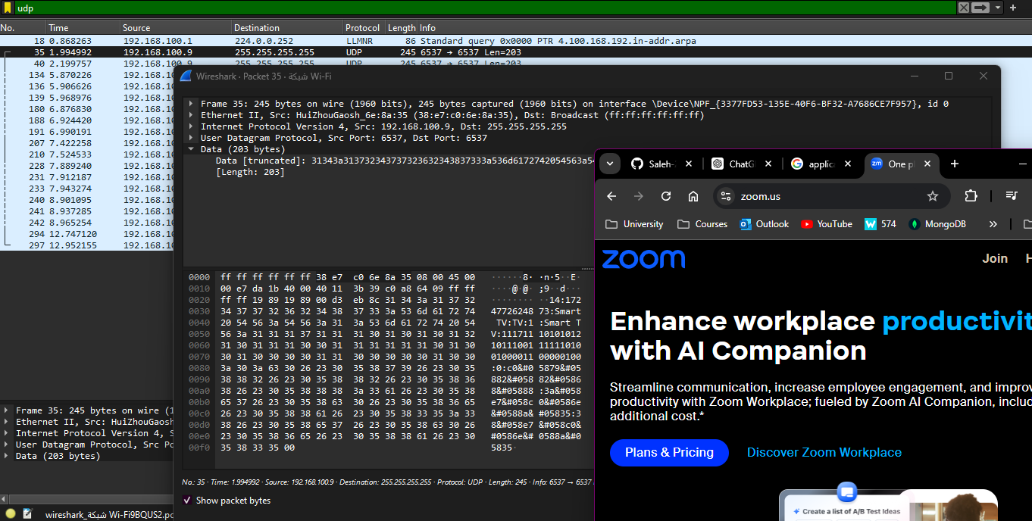

P2 T2 S1-S4

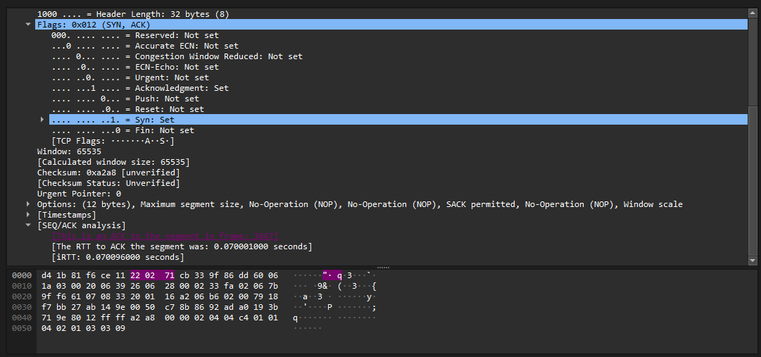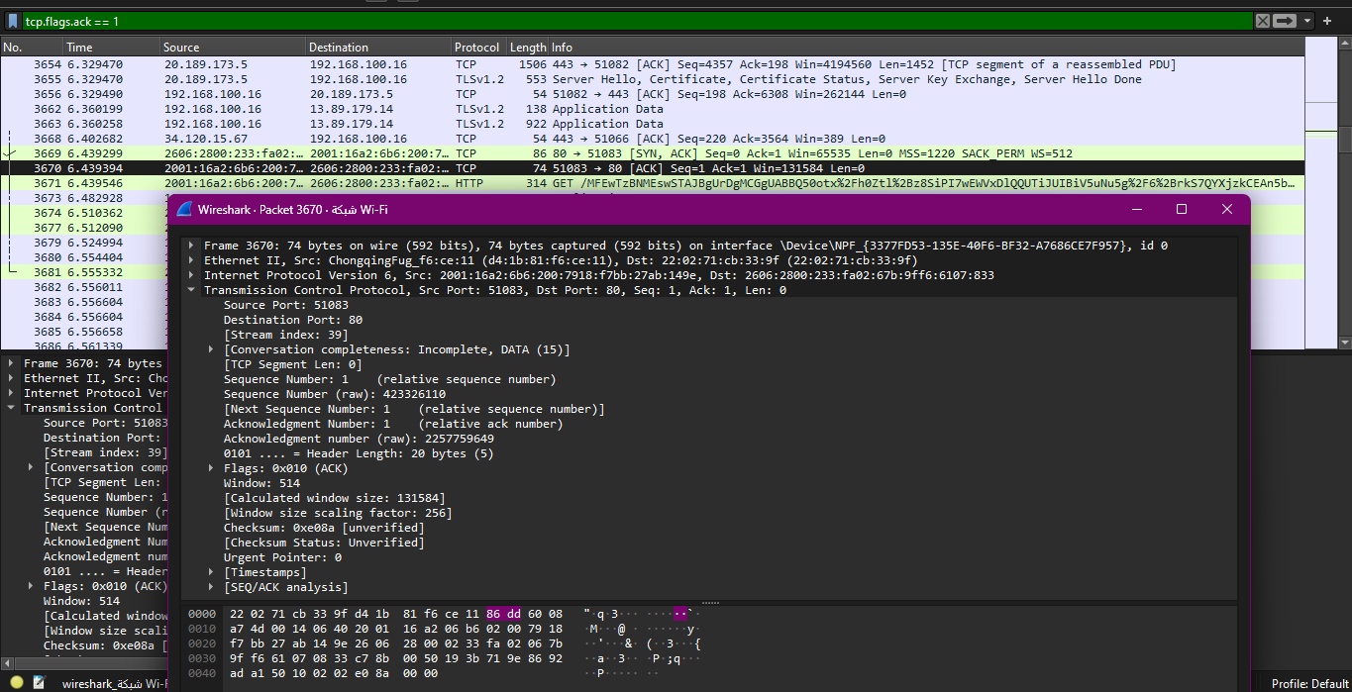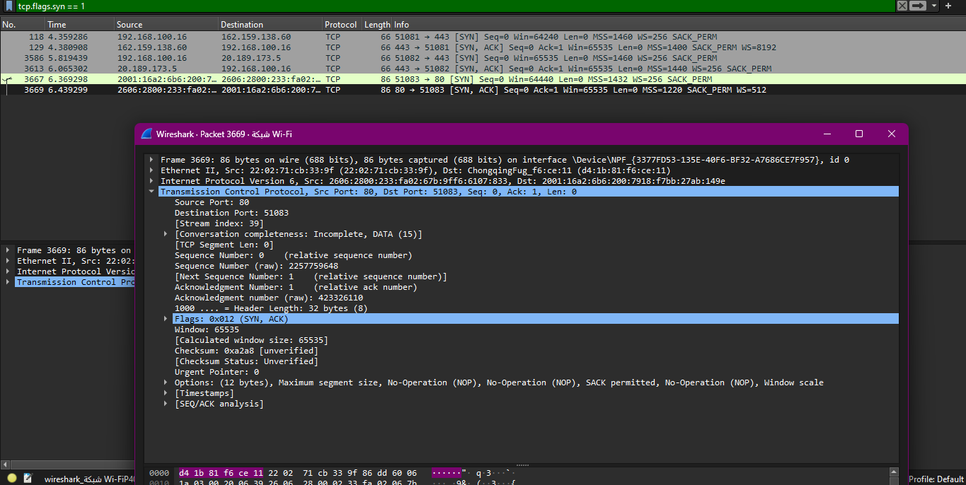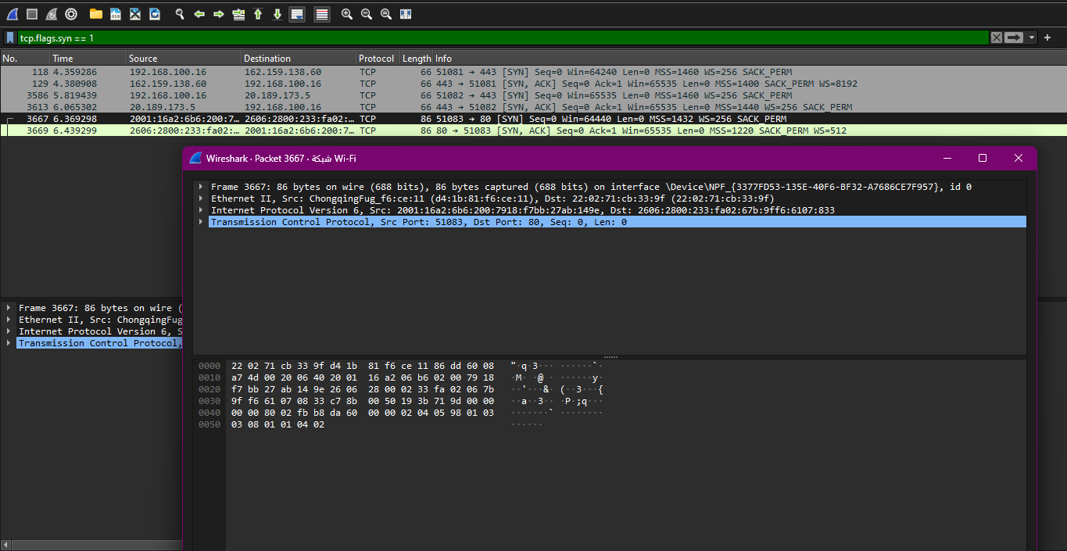

P1 T1 & T2

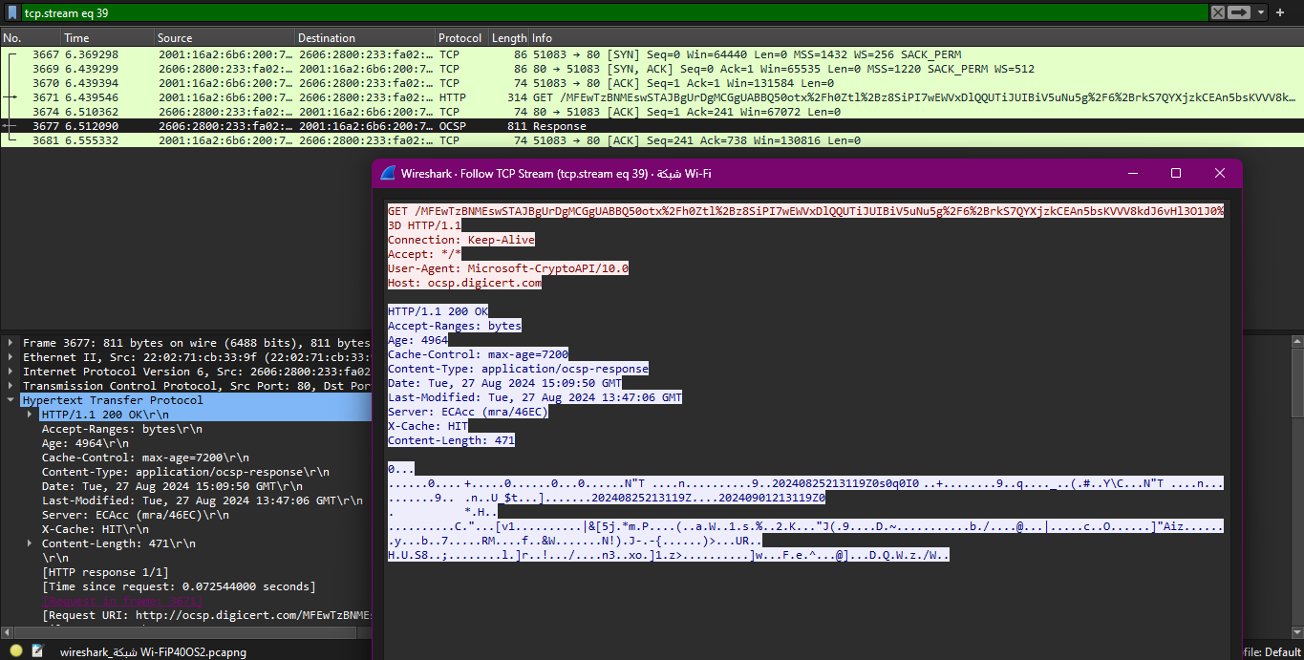

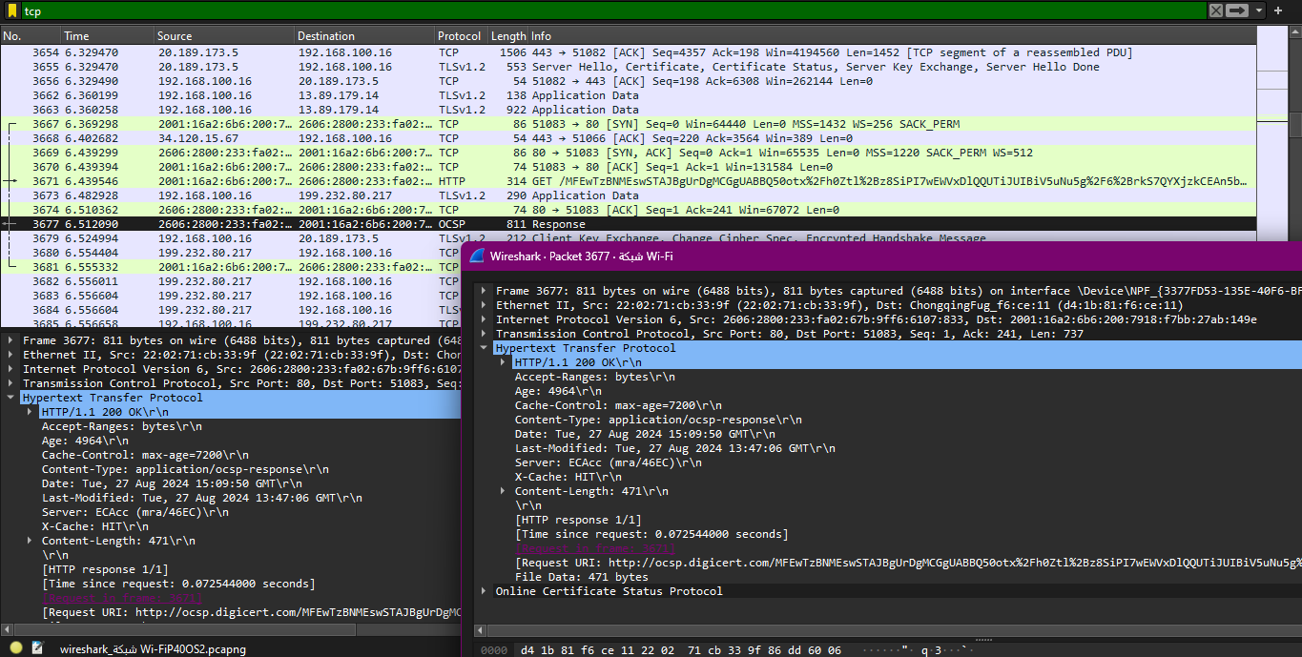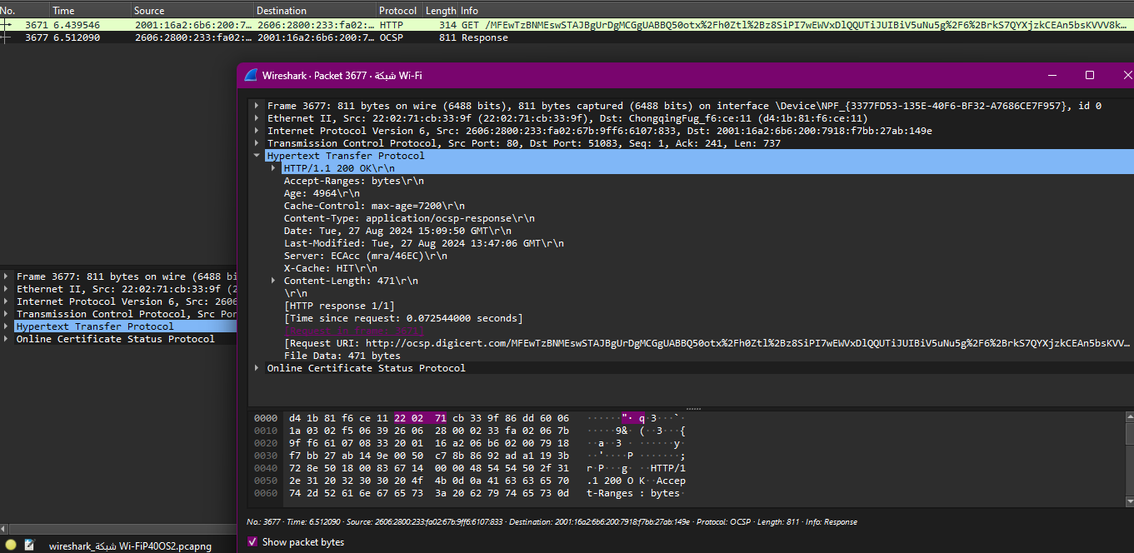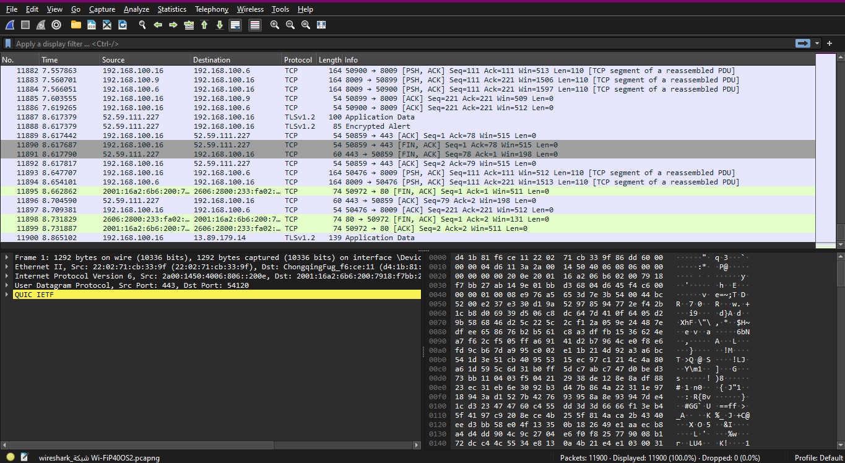

Task 2 Step 5:

**2. Simplicity of Functionality**

* **UDP:**
  + **No Connection Establishment:** UDP is connectionless, meaning it doesn’t establish a connection before sending data. This simplifies the protocol.
  + **No Reliability:** UDP doesn’t provide acknowledgment, retransmission, or ordering of packets. The simplicity of the header reflects this lack of control mechanisms.
  + **Minimal Overhead:** The 8-byte header carries only essential information, making it lightweight and faster.
* **TCP:**
  + **Connection-Oriented:** TCP requires a connection to be established (via the three-way handshake), adding complexity.
  + **Reliability and Control:** TCP provides sequencing, acknowledgment, flow control, and congestion control, requiring additional header fields and options.
  + **Complex Header:** The TCP header is more complex due to the need for reliability, error-checking, and data flow management.

