Name: Saleh Ahmad Alheeh , ID : 201614721

using System;

using System.Collections.Generic;

using System.Linq;

using System.Net;

using System.Net.Sockets;

using System.Text;

using System.Threading.Tasks;

namespace ConsoleApp3

{

class Server

{

public static void Main()

{

IPEndPoint localEP = new IPEndPoint(IPAddress.Parse("192.168.100.10"), 9050);

Socket server = new Socket(AddressFamily.InterNetwork, SocketType.Dgram, ProtocolType.Udp);

server.Bind(localEP);

Console.WriteLine("Waiting for a client...");

//dummy end-point

EndPoint remoteEP = new IPEndPoint(IPAddress.Any, 0);

int recv;

byte[] data;

while (true)

{

data = new byte[1024];

recv = server.ReceiveFrom(data, ref remoteEP);

Console.Write("Received from {0}: ", remoteEP.ToString());

Console.WriteLine(Encoding.ASCII.GetString(data, 0, recv));

server.SendTo(data, recv, SocketFlags.None, remoteEP);

}

}

}

}

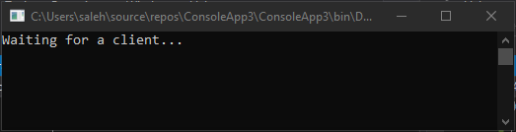

using System;

using System.Collections.Generic;

using System.Linq;

using System.Net;

using System.Net.Sockets;

using System.Text;

using System.Threading.Tasks;

namespace ConsoleApp4

{

class Client

{

public static void Main()

{

Socket client = new Socket(AddressFamily.InterNetwork, SocketType.Dgram, ProtocolType.Udp);

EndPoint remoteEP = new IPEndPoint(IPAddress.Parse("192.168.100.10"), 9050);

byte[] data;

string input;

int recv;

while (true)

{

Console.Write("Enter message for server or exit to stop: ");

input = Console.ReadLine();

if (input == "exit")

break;

client.SendTo(Encoding.ASCII.GetBytes(input), remoteEP);

data = new byte[1024];

recv = client.ReceiveFrom(data, ref remoteEP);

Console.Write("Echo from from {0}: ", remoteEP.ToString());

Console.WriteLine(Encoding.ASCII.GetString(data, 0, recv));

}

Console.WriteLine("Stopping client");

client.Close();

}

}

}

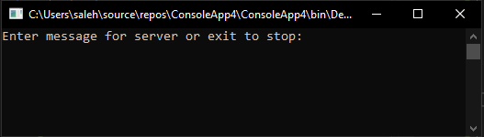

Both :

