IT7009 Artificial Intelligence
Group Project Report
Intelligent Traffic Incident Analysis System
Predicting incident severity, identifying high-risk locations and detecting abnormal traffic behaviour with supervised and unsupervised machine learning
Field | Detail | Field | Detail
Academic Year | 2026–2027 | Semester | A
Stream ID | [Stream ID] | Group Number | [Group No.]
Submission Date | [DD/MM/YYYY] | Brief ID | Brief 1
Group Leader Name | [Leader Name] | Group Leader ID | [Leader ID]
Lecturer Name | [Lecturer Name] | Module | IT7009 Artificial Intelligence

No. | Student Name | Student ID | Primary Responsibility | Signature
1 | [Student 1 Name] | [ID] | Data cleaning and preprocessing
2 | [Student 2 Name] | [ID] | Exploratory analysis and visualisation
3 | [Student 3 Name] | [ID] | Supervised modelling and evaluation
4 | [Student 4 Name] | [ID] | Unsupervised learning and cluster validation
5 | [Student 5 Name] | [ID] | Feature analysis, report and integration

Group Declaration
We declare that this submission is the work of the group members named above, that the code and report were produced by the group, and that all external sources are cited in accordance with APA guidelines. Responsibilities were distributed across data preprocessing, classification, clustering and data visualisation, and every member contributed to and understands the complete project.

Table of Contents
Table of contents — press Ctrl+A then F9 (or right-click → Update Field) to populate.

List of Figures
List of figures — press Ctrl+A then F9 (or right-click → Update Field) to populate.

List of Tables
List of tables — press Ctrl+A then F9 (or right-click → Update Field) to populate.

1. Introduction

1.1 Overview of the project and its purpose
Road networks in modern urban environments carry an increasing volume and complexity of traffic, and manual monitoring of that traffic has become impractical for transportation authorities. Incidents that are detected late, or whose severity is misjudged, delay emergency response, prolong congestion and increase the risk of secondary collisions. Intelligent transportation systems therefore increasingly rely on machine learning to analyse traffic behaviour and to support data-driven operational decisions.
This project develops an intelligent traffic incident analysis system for a simulated urban road network. The system is designed to answer three operational questions: how severe is an incident likely to be given the conditions observed when it is reported; which locations and traffic conditions are associated with the most severe outcomes; and which incidents are behaving abnormally compared with the rest of the network. The purpose of the project is not only to build accurate predictive models, but to demonstrate a rigorous, reproducible and well-justified machine-learning workflow — including honest treatment of data-quality problems, class imbalance and data leakage.
The practical value of the system lies in triage and prevention. A severity model that performs reliably for the most critical incidents allows a control centre to prioritise limited response resources; an unsupervised analysis of traffic conditions identifies high-risk environments and accident hotspots that would benefit from preventive investment; and an anomaly score highlights the unusual situations that deserve human attention rather than an automated response.

1.2 Summary of the dataset
The dataset is a single structured file of 50,010 road traffic incident records described by 72 attributes covering traffic-flow metrics, road characteristics, environmental conditions, temporal attributes, infrastructure and control features, location attributes and behavioural or derived metrics. Each record represents one incident. The dataset is synthetic and was generated for educational purposes, which is an important consideration when interpreting the results. Table 1 groups the 72 attributes by their meaning, which is the structure used throughout this report.
Table 1. Dataset overview and attribute groups
Attribute group | Example attributes | Count
Identifier | Incident_ID | 1
Temporal | Start_Time, End_Time, Hour, Day, Month, Year, Weekday, Weekend, Peak_Hour, Season | 10
Incident | Incident_Type | 1
Location | State, City, District, Latitude, Longitude, Postal_Code, Road_Name | 7
Road | Road_Type, Road_Surface, Lane_Count, Road_Width, Speed_Limit | 5
Environment | Weather_Condition, Temperature, Humidity, Pressure, Visibility, Wind_Speed, Precipitation, Cloud_Cover, Dew_Point, UV_Index, Light_Condition | 11
Traffic | Traffic_Density, Average_Speed, Vehicle_Count, Heavy_Vehicle_Percentage, Pedestrian_Count, Bicycle_Count, Congestion_Index, Vehicle_Type | 8
Infrastructure | Traffic_Signal, Junction, Railway, Crossing, Stop_Sign, Roundabout, Amenity, Station, Bump, Turning_Loop, Give_Way, No_Exit, Camera_Available, Sensor_Available, Speed_Camera | 15
Proximity | Nearby_School, Nearby_Hospital, Nearby_Market, Nearby_Airport, Nearby_Bus_Station | 5
Context | Road_Work, Holiday | 2
Outcome-like | Emergency_Response_Time, Response_Team, Accident_History, Travel_Time_Minutes, Travel_Category, Risk_Score | 6
Target | Severity (1 = minor … 4 = critical) | 1

The prediction target is the incident severity, an ordinal four-level label: Severity 1 represents minor incidents with minimal disruption, Severity 2 moderate incidents that affect traffic flow, Severity 3 major incidents causing significant congestion or delay, and Severity 4 critical incidents leading to severe disruption or road blockage.

1.3 Tasks carried out in the project
The project is organised around the four task areas required by the brief, with a cross-cutting critical evaluation:
- Data cleaning and preprocessing — assess data quality; treat missing values, duplicate records, inconsistent labels, incorrect data types, invalid values and outliers; encode categorical variables; process temporal attributes; remove identifiers; scale features where appropriate; address class imbalance; and exclude leakage-prone variables.
- Feature analysis and selection — evaluate the influence of environmental, temporal, spatial and road-related variables on severity; apply importance and selection techniques; reduce redundancy; and measure the effect of different feature subsets on both the supervised and the unsupervised models.
- Supervised learning — implement and compare at least three classification algorithms within a stratified training and validation pipeline, and evaluate them with accuracy, precision, recall, macro-averaged F1 and confusion matrices.
- Unsupervised learning — discover natural groupings of traffic conditions without using the severity label; select the number of clusters with the elbow method and the silhouette score; and interpret the clusters in terms of traffic management and road safety.
- Critical evaluation and reflection — compare the supervised and unsupervised findings, acknowledge limitations, and propose improvements and future recommendations.
The remainder of this report follows the structure required by the brief. Section 2 covers data preparation; Section 3 covers data exploration and visualisation; Section 4 covers feature development, analysis and selection; Section 5 covers the supervised learning task; Section 6 covers the unsupervised learning task; Section 7 covers critical evaluation and reflection; and Section 8 is the conclusion, followed by the references. The cover page, table of contents, list of figures and list of tables precede the Introduction.
The brief requires each learning task to address Data Preparation, Feature Development, Model Design, and Evaluation and Validation. Within the supervised task these are Sections 5.1, 5.2, 5.3 and 5.4 respectively, with the detailed results in Sections 5.5–5.10. Within the unsupervised task they are Sections 6.1, 6.2, 6.3 and 6.4, with the detailed results in Sections 6.5–6.9. Every figure and table is referenced in the text, and every quantitative result quoted in this report was produced by the accompanying notebook.

2. Task 1 — Data Preparation

2.1 Data-quality assessment
Before any modelling, the raw dataset was audited systematically for the quality problems named in the brief: missing values, duplicate records, inconsistent values, incorrect data types, formatting issues, invalid values and outliers. Table 2 summarises the findings; each is treated and justified in Section 2.2. Documenting the problems first is what makes the cleaning pipeline defensible rather than arbitrary.
Table 2. Data-quality issues identified in the raw dataset
# | Issue | Evidence found in the data | Severity of impact
1 | Missing values | Every column contains 5–7 missing cells (~0.01% of all cells). The target Severity has 7 missing values. | Low volume, but the missing target rows must be removed because a label cannot be imputed.
2 | Duplicate records | 14 rows are exact duplicates on all 72 columns, and the same 14 duplicate Incident_ID values appear. | Would double-count the same incident and bias training.
3 | Inconsistent categorical labels | The same category appears with different casing or trailing spaces: 'collision ', 'wet ', 'DRY', 'RAIN', ' clear', 'Cloudy ', 'car', 'Truck ', 'day light', 'police', 'monday', 'Fri'. | Inflates the number of dummy variables and splits the signal for one category.
4 | Incorrect data types | Temperature, Average_Speed, Vehicle_Count, Emergency_Response_Time, Road_Width and Risk_Score are stored as text although every value is numeric. | Blocks scaling, correlation analysis and numeric modelling.
5 | Invalid (impossible) values | Latitude = 95 (> 90), Longitude = −200 (< −180), Humidity = −10 and 150 (outside 0–100), Visibility = −5, Precipitation = −3. | Impossible measurements distort scaling and model fitting.
6 | Temporal inconsistencies | 8 datetime values do not parse (2 malformed strings in addition to the 6 missing); 1 record has End_Time earlier than Start_Time. | Undefined duration; would corrupt any temporal feature.
7 | Outliers | IQR analysis flags 336 Dew_Point, 176 Precipitation and isolated Latitude/Longitude/Humidity/Visibility/Lane_Count values. | Can bias distance-based models; legitimate extremes must not be removed blindly.
8 | Class imbalance | Severity 1 = 1.57%, Severity 2 = 6.96%, Severity 3 = 36.31%, Severity 4 = 55.17% (a 35:1 ratio). | Accuracy becomes meaningless; a majority-class model scores 55%.
9 | Identifier and near-unique columns | Incident_ID, Postal_Code (38,347 unique) and Road_Name (39,388 unique). | No generalisable signal; high-cardinality keys cause over-fitting.
10 | Data leakage | Risk_Score correlates 0.88 with Severity with strictly monotonic class means (37.8 → 72.5 → 107.8 → 147.3); Emergency_Response_Time correlates 0.37 and also rises monotonically. | Would inflate measured performance while being unavailable in practice.

Missingness is very low and scattered, so list-wise deletion would be wasteful; imputation is therefore used for the features while the seven rows with a missing target are removed. The distribution of the target (Table 3 and Figure 2) confirms that the classes are severely imbalanced and that accuracy alone cannot be used to judge a model. Figure 1 shows the outlier profile of the most affected numeric variables; these extremes were retained rather than deleted, for the reason given in Table 4.
Table 3. Severity class distribution in the cleaned dataset
Severity level | Description | Incidents | Percentage
1 | Minor — minimal disruption | 783 | 1.57%
2 | Moderate — affects traffic flow | 3,480 | 6.96%
3 | Major — significant congestion or delay | 18,154 | 36.31%
4 | Critical — severe disruption or road blockage | 27,586 | 55.17%

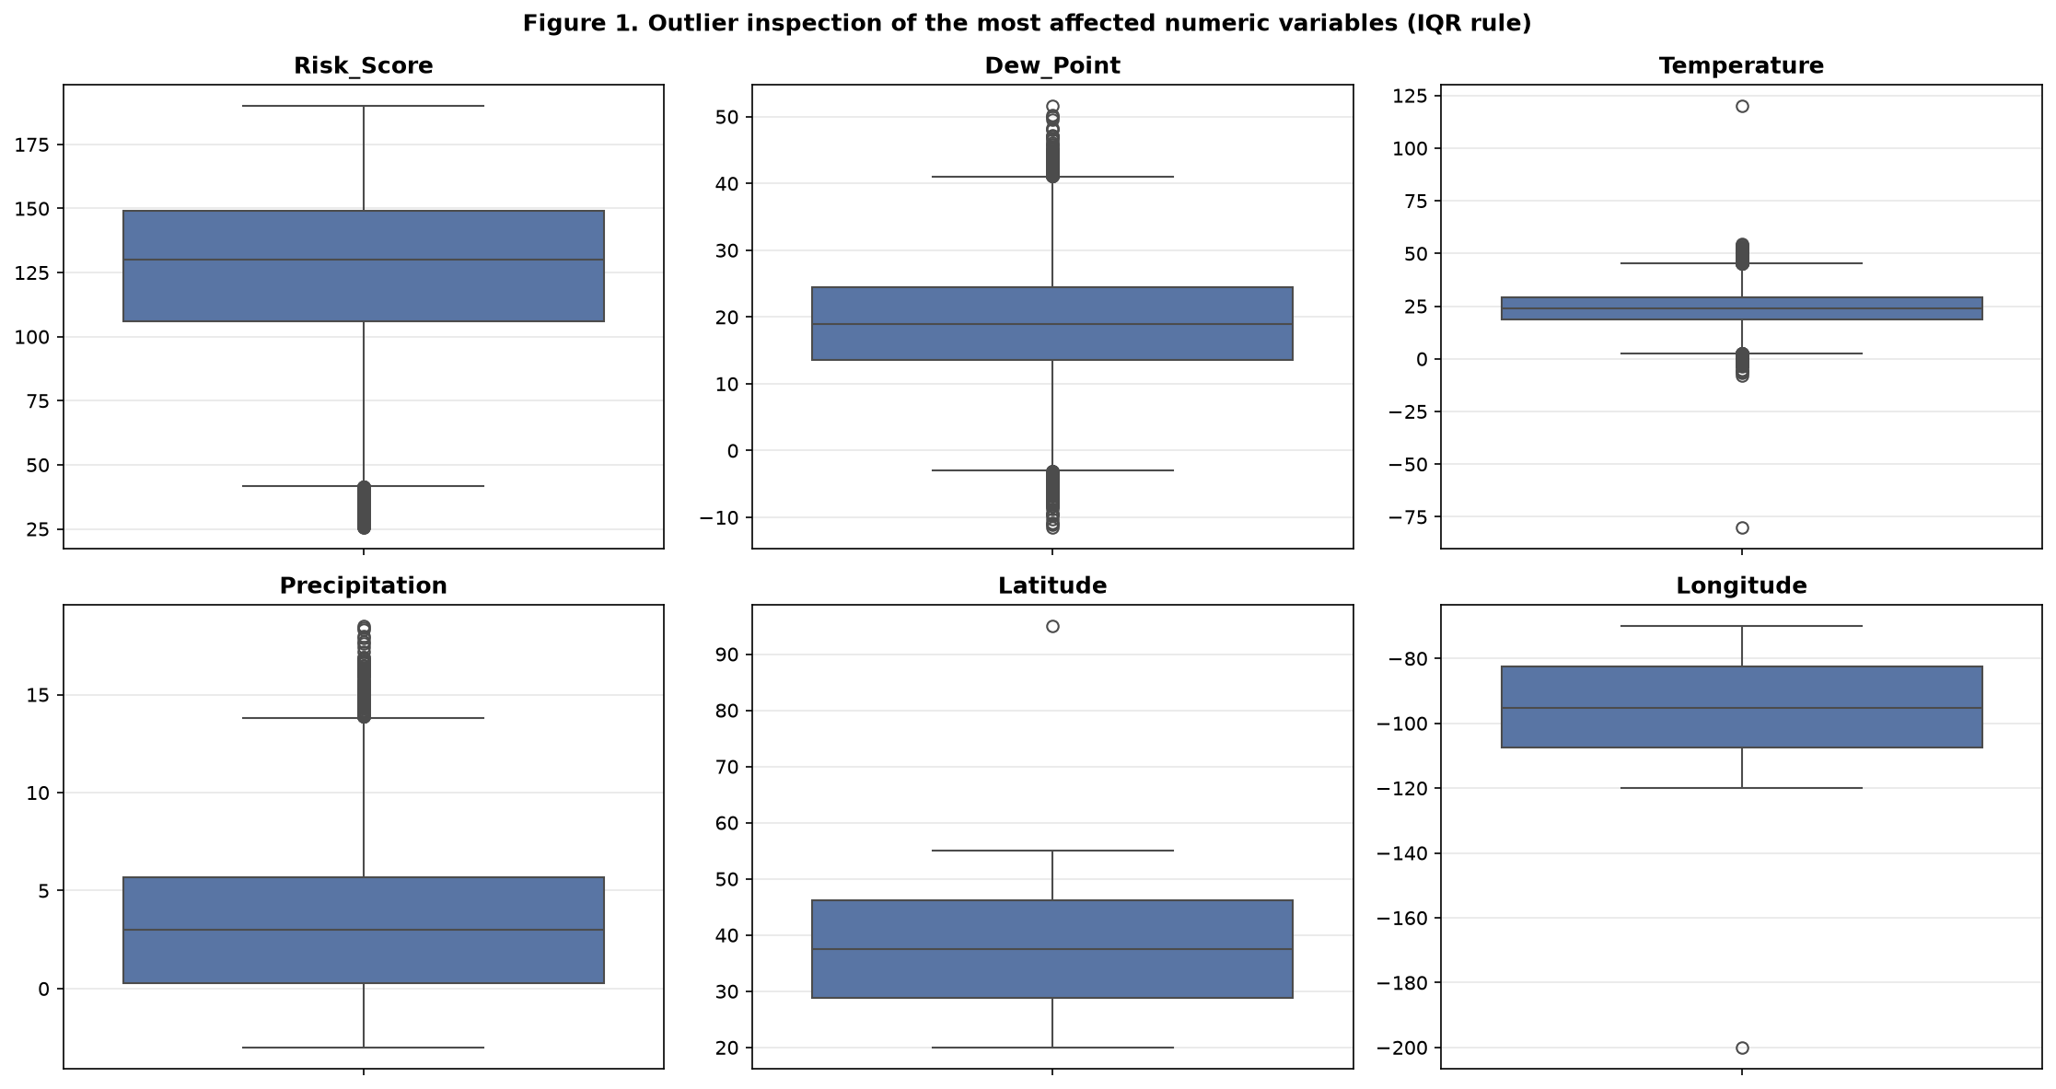
Figure 1. Outlier inspection of the most affected numeric variables using the 1.5 × IQR rule. Dew_Point and Precipitation contain the most extreme values.
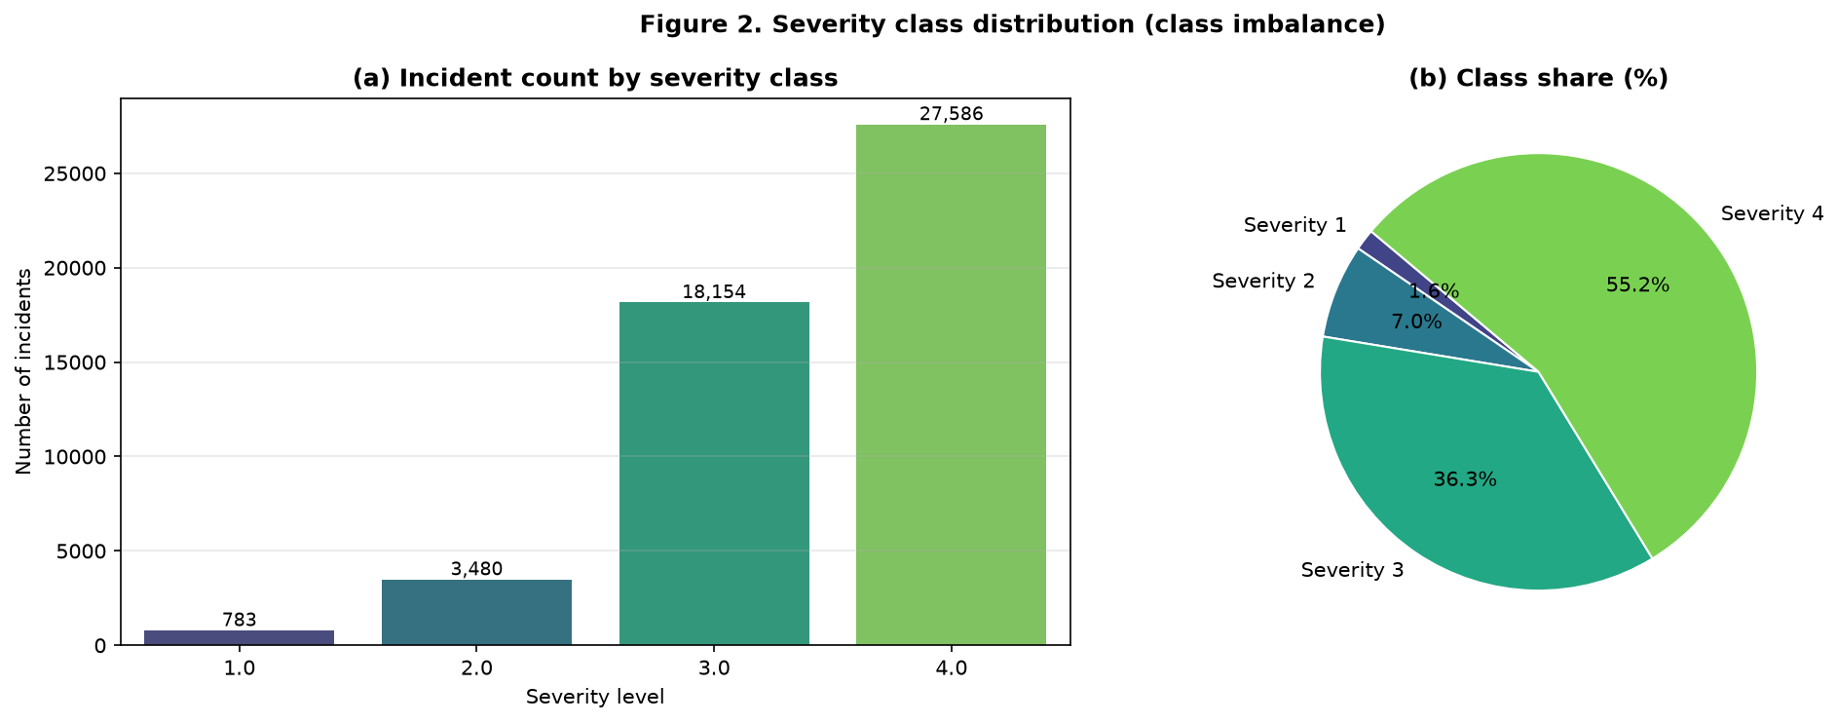
Figure 2. Severity class distribution: (a) incident count per class and (b) class share, illustrating the severe class imbalance that governs the choice of evaluation metrics.

2.2 Cleaning decisions and justification
Table 4 documents every cleaning action taken, the issue it addresses and the reasoning behind it. The pipeline is implemented as a single reproducible function in the notebook, so the same transformations are applied every time the analysis is run.
Table 4. Cleaning actions and their justification
# | Issue | Treatment applied | Justification
1 | 14 duplicate rows | drop_duplicates() | Duplicate records describe the same incident twice; keeping them would double-count events and bias the learned decision boundaries.
2 | 7 rows with missing Severity | Remove rows where the target is null | The label cannot be imputed — it must be observed. Imputing a target would fabricate ground truth.
3 | Scattered missing feature values (~0.01%) | Median imputation for numeric columns, mode imputation for categorical columns | Missingness is negligible, so imputation preserves all usable rows. The median is robust to the outliers present in the data; the mode is the natural choice for a categorical value.
4 | Numeric columns stored as text | pd.to_numeric() for Temperature, Average_Speed, Vehicle_Count, Emergency_Response_Time, Road_Width and Risk_Score | Correct types are a prerequisite for scaling, correlation analysis and numeric modelling; leaving them as text would silently exclude them from the model.
5 | Inconsistent categorical labels | Strip whitespace and apply title-case normalisation to all categorical columns, then map abbreviations ('Fri' → 'Friday', 'day light' → 'Daylight') | Ensures that one real-world category maps to exactly one encoded level, which prevents the same condition being split across several dummy variables.
6 | Invalid values outside the physical domain | Set to NaN using explicit domain rules (latitude 0–90, longitude −180–180, humidity 0–100, visibility 0–10, precipitation ≥ 0, cloud cover 0–100, UV 0–11, lane count ≥ 1) and then impute | Values such as a humidity of 150% or a latitude of 95° are impossible and would distort standardisation and distance calculations. Replacing them with NaN lets the imputation step handle them consistently.
7 | Record with End_Time earlier than Start_Time | Remove the record | The duration is undefined and the record is internally inconsistent, so it cannot be trusted.
8 | Outliers (Dew_Point, Precipitation, etc.) | Retained for tree-based models; handled implicitly for distance-based methods by standardisation | The extremes are plausible meteorological readings rather than errors. Deleting them would remove genuine rare conditions, and tree ensembles are robust to monotone outliers.
9 | Start_Time / End_Time stored as text | Parsed to datetime; derived Hour, Day, Month, Year, Weekday, Weekend, Peak_Hour and Season features retained | Enables temporal feature engineering while keeping the model input purely numeric.
10 | Identifier / near-unique columns | Drop Incident_ID, Postal_Code and Road_Name | A row identifier has no predictive meaning, and columns with tens of thousands of unique values cannot generalise — they would cause over-fitting.
11 | Class imbalance | Stratified train–test split and class_weight='balanced' | Stratification keeps the rare class proportionally represented in both partitions, and balanced weighting stops the majority class dominating the loss function.
12 | Data leakage | Drop Risk_Score, Emergency_Response_Time, Response_Team, End_Time and the derived incident duration | These values are derived from, or only exist after, the incident outcome and would not be available when a prediction must be made (see Section 4.2).

Applying the pipeline reduces the dataset from 50,010 to 49,992 usable records — only a handful of rows are lost, and every one of them was removed for a stated, defensible reason.

2.3 Preprocessing for modelling
After cleaning, the data is prepared for learning as follows:
- Categorical encoding — the nominal categorical variables (incident type, state, city, district, road type, road surface, weather condition, vehicle type, light condition, weekday, season and travel category) are one-hot encoded with handle_unknown='ignore' so that an unseen category at prediction time does not raise an error. One-hot encoding is used rather than label encoding because the categories are nominal and an arbitrary integer code would impose a false ordering on them.
- Scaling — numeric features are standardised to zero mean and unit variance. This is required for the distance-based models (logistic regression, k-nearest neighbours and k-means) whose behaviour depends on the scale of the inputs. Tree-based models do not need it, but applying one consistent pipeline keeps the model comparison fair.
- Missing-value handling inside the pipeline — the imputer is part of the scikit-learn Pipeline rather than a step applied to the whole dataset beforehand. This is essential: it guarantees that imputation statistics are learned from the training fold only, so no information from the test set leaks into training.
- Class imbalance — handled through stratified splitting and class_weight='balanced', with random over-sampling tested as an alternative in Section 5.7.
- Leakage exclusion — identifiers and outcome-derived variables are removed before any model is fitted (Section 4.2).

3. Task 2 — Data Exploration and Visualisation

3.1 Feature distributions
Figure 3 shows the distributions of the key numeric traffic and environmental features. Most are close to uniform or mildly bell-shaped, which is consistent with a synthetic generator rather than a strongly skewed real-world sample. Traffic_Density and Accident_History are the two variables whose distributions differ most visibly between severity classes, which foreshadows the feature-importance results in Section 4.
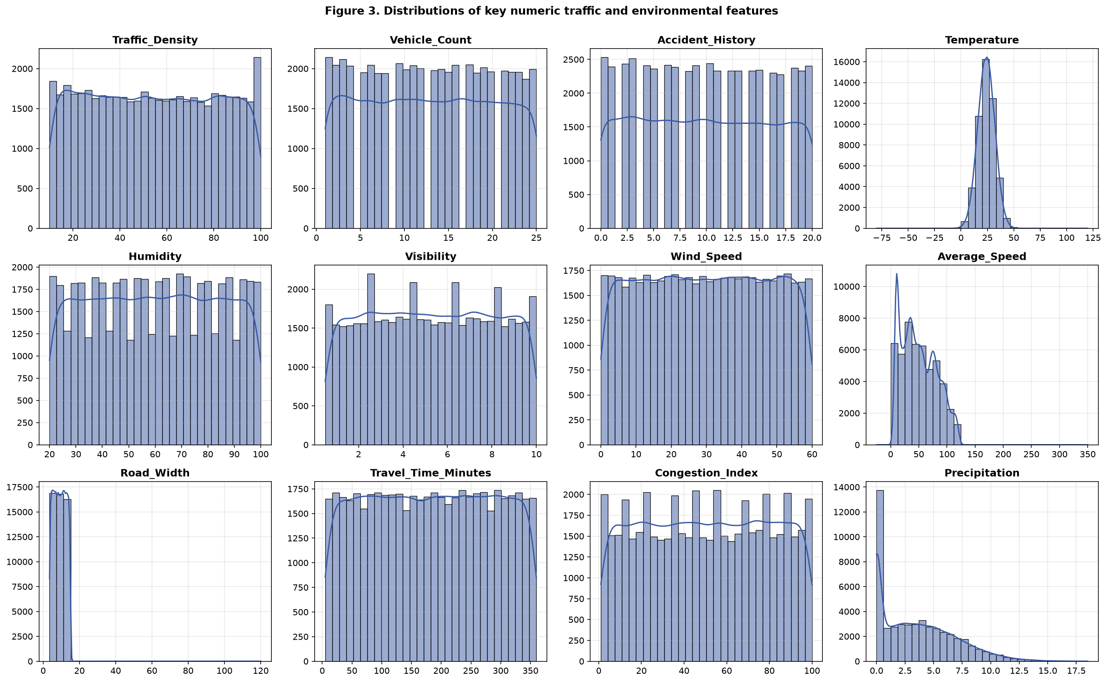
Figure 3. Distributions of twelve key numeric traffic, environmental and behavioural features.

3.2 Correlation structure and association with severity
Figure 4 combines a ranked bar chart of the numeric features most correlated with Severity with the corresponding correlation heat-map. Two observations matter. First, only a small number of variables carry a meaningful linear association with the target; most environmental and infrastructure attributes are essentially uncorrelated with it. Second, the heat-map exposes pairs of variables that are almost duplicates of one another, which is the redundancy problem addressed in Section 4.3.
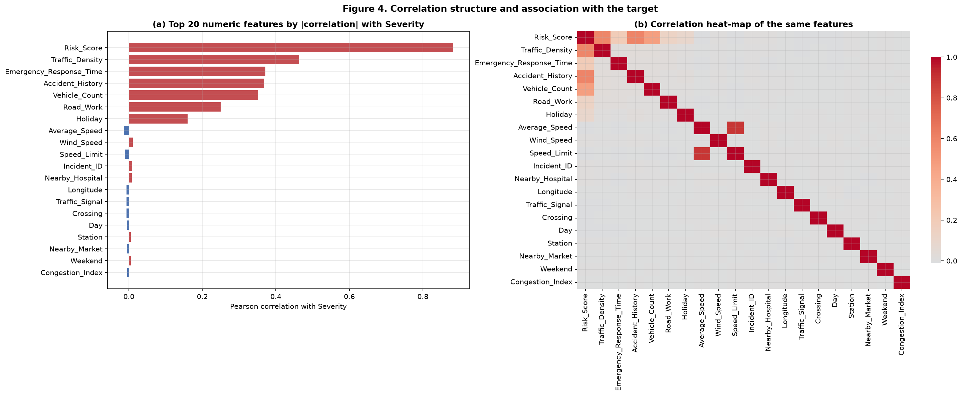
Figure 4. Association with the target: (a) the twenty numeric features with the largest absolute correlation with Severity and (b) the correlation heat-map of those features.
Table 5. Strongest numeric associations with Severity (Pearson correlation)
Rank | Feature | Correlation with Severity | Interpretation
1 | Traffic_Density | +0.464 | Strongest legitimate predictor — denser traffic magnifies the consequences of an incident.
2 | Accident_History | +0.368 | Locations with more historical accidents tend to record more severe incidents.
3 | Vehicle_Count | +0.351 | More vehicles involved or present is associated with greater severity.
4 | Road_Work | +0.249 | Active road works increase the severity of incidents that occur in them.
5 | Holiday | +0.160 | Holiday traffic shows a mild positive association with severity.
— | All remaining numeric features | |r| < 0.05 | Environment, infrastructure and most temporal variables carry almost no linear signal.

3.3 Categorical conditions versus severity
Figure 5 shows the mean severity within each category of the key nominal variables. The clearest effect is environmental: incidents occurring in fog, storm, rain or snow average a higher severity than those in clear, cloudy or windy conditions. Road surface, light condition and incident type show much smaller differences, which indicates that the generator encoded only a limited number of real relationships.
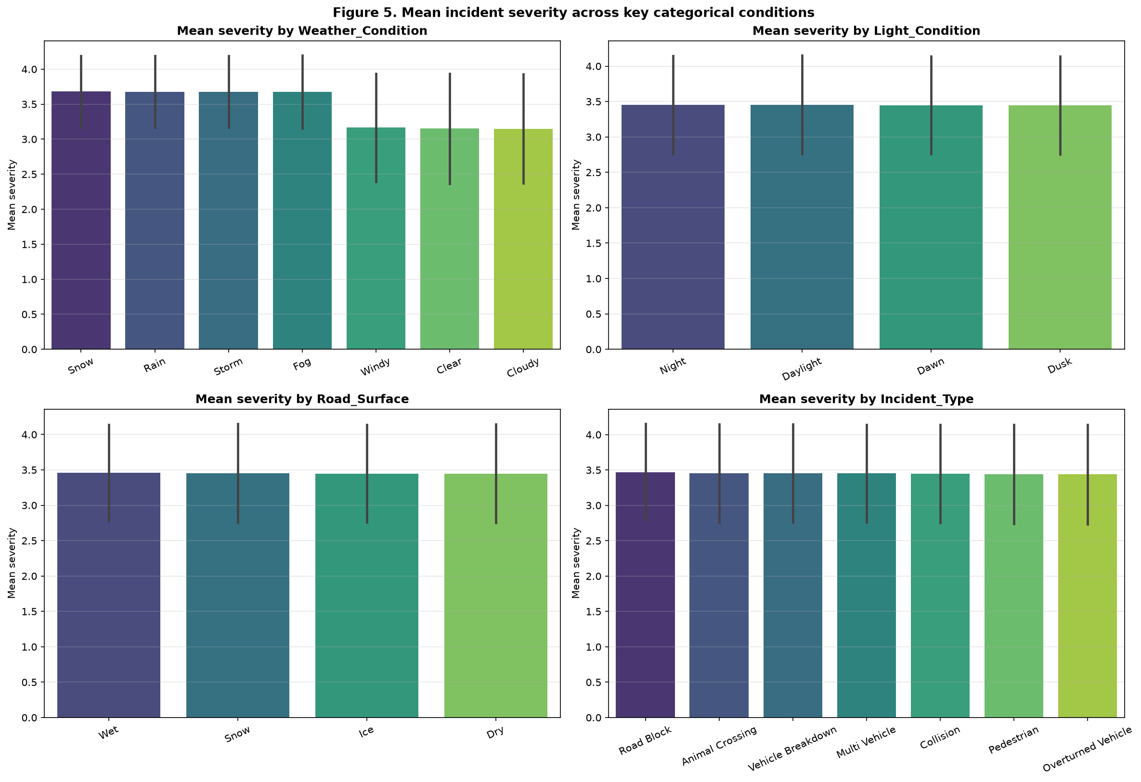
Figure 5. Mean incident severity across weather, light, road-surface and incident-type categories.

3.4 Traffic intensity versus severity
Figure 6 examines the three traffic-intensity variables that Table 5 identified as the strongest signals. The box and violin plots show a clear, monotone progression: median Traffic_Density, Vehicle_Count and Accident_History all rise steadily from Severity 1 to Severity 4. This is the central empirical finding of the exploratory analysis and it is confirmed independently by both the supervised importance analysis (Section 4) and the unsupervised clustering (Section 6).
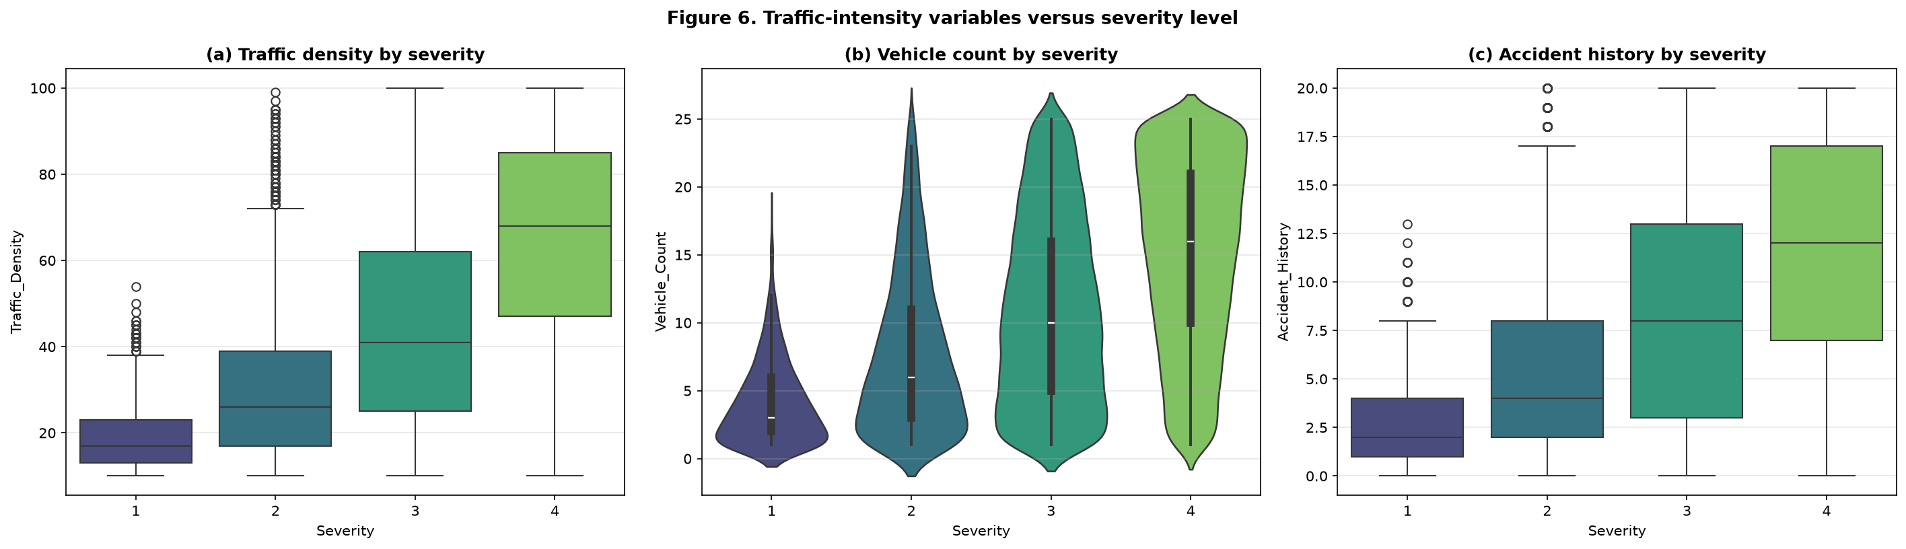
Figure 6. Traffic-intensity variables versus severity level: (a) traffic density, (b) vehicle count and (c) accident history all increase monotonically with severity.

4. Task 3 — Feature Development, Analysis and Selection

4.1 Engineered features
Five features were engineered to express domain knowledge that the raw columns only imply. All five are computable at the moment an incident is reported, so none of them introduces leakage. Table 6 defines each one and Figure 7 shows how the two binary flags and the speed ratio relate to severity.
Table 6. Engineered features and their rationale
Feature | Definition | Rationale
Speed_Ratio | Average_Speed ÷ Speed_Limit | Expresses observed speed relative to the legal limit, so congestion is captured independently of the road class.
Vehicle_Load | Vehicle_Count ÷ Lane_Count | A density proxy that is normalised by road capacity and therefore comparable across roads of different size.
Night_Incident | 1 if Light_Condition in {Night, Dawn, Dusk} | Isolates the visibility conditions in which incidents are typically more severe.
Adverse_Weather | 1 if Weather_Condition in {Fog, Rain, Storm, Snow} | Section 3.3 showed that adverse weather is associated with markedly higher severity; this flag concentrates that effect into a single variable.
Incident_Duration_Min | End_Time minus Start_Time in minutes | Describes how long the road was affected. Retained for profiling only — it is REMOVED from the model because the end time is unknown when a prediction is required.

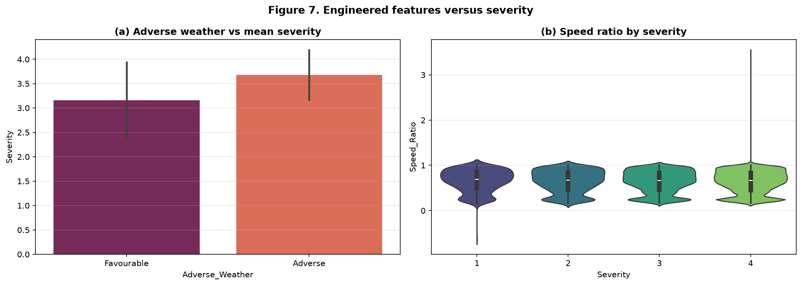
Figure 7. Engineered features versus severity: (a) incidents in adverse weather average a higher severity and (b) the distribution of the speed ratio across severity levels.

4.2 Data leakage: identification and removal
The brief explicitly requires variables to be judged on their availability at prediction time and their potential for leakage. This proved to be the single most consequential decision in the project. Figure 8 shows that Risk_Score and Emergency_Response_Time track the severity label almost perfectly, and Table 7 records the evidence and the decision taken for every candidate variable.
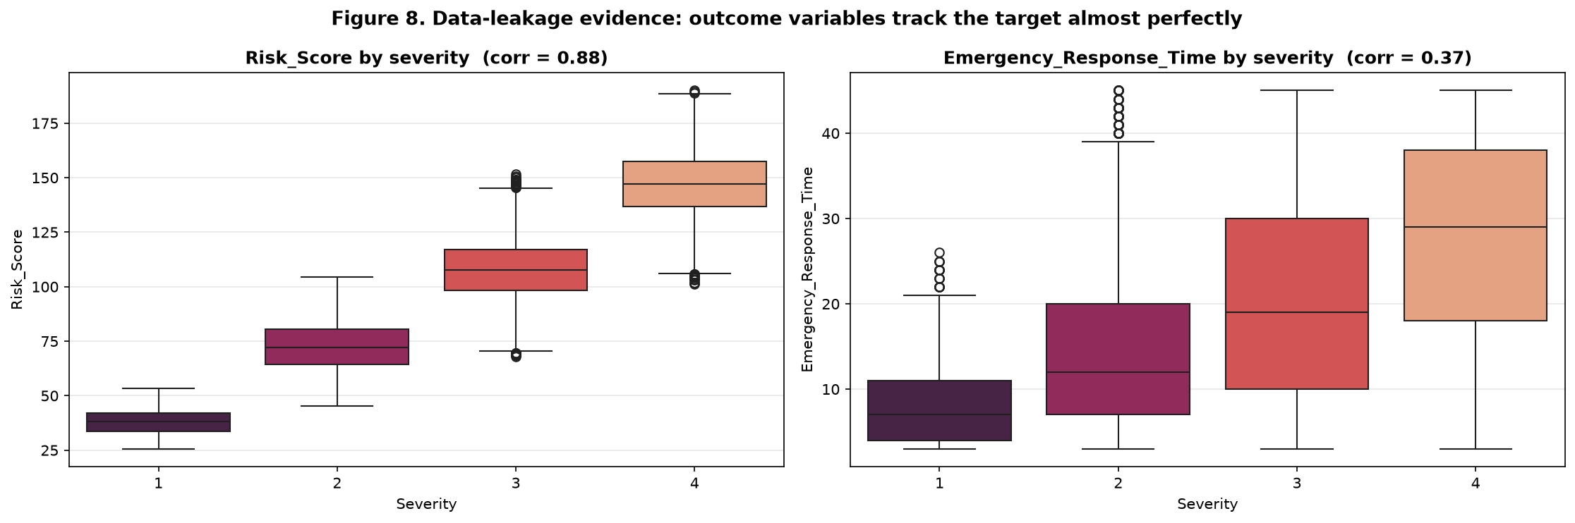
Figure 8. Data-leakage evidence: Risk_Score (correlation 0.88) and Emergency_Response_Time (correlation 0.37) both rise strictly monotonically with severity, revealing that they are derived from the incident outcome rather than from conditions observed beforehand.
Table 7. Leakage and prediction-time availability decisions
Variable | Evidence | Decision | Reasoning
Risk_Score | correlation 0.88; class means 37.8 → 72.5 → 107.8 → 147.3 | Remove | A near-perfect proxy for the target. Keeping it raises measured macro-F1 from 0.701 to 0.984 — an artificial result that could never be reproduced in service.
Emergency_Response_Time | correlation 0.37; class means 8.3 → 14.7 → 20.5 → 27.6 | Remove | Response time is measured after the incident is reported, so it cannot be an input to a prediction made at report time.
Response_Team | dispatched according to severity | Remove | The response team is a consequence of the severity decision, not a cause of it.
End_Time / Incident_Duration_Min | known only when the incident is closed | Remove | Post-event information.
Incident_ID | 50,000 near-unique values | Remove | A row identifier with no predictive meaning.
Postal_Code / Road_Name | 38,347 / 39,388 unique values | Remove | Near-unique high-cardinality keys that would cause severe over-fitting and cannot generalise to unseen locations.
Accident_History / Vehicle_Count | correlations 0.37 and 0.35, monotonic class means | Retain | Plausibly observable before or at the moment of the incident; their association with severity is a genuine, operationally meaningful relationship.
Travel_Time_Minutes / Congestion_Index | correlations −0.001 and −0.005 | Retain | No measurable relationship with the target; kept in the full model but shown to add nothing in the ablation study.

The ablation study in Section 4.4 quantifies the consequence of this decision directly: including the two leaking variables inflates macro-F1 to approximately 0.984, whereas the honest model reaches approximately 0.701. Reporting the former would have been misleading.

4.3 Redundancy
The correlation heat-map in Figure 4(b) exposes pairs of features that carry almost identical information. Highly correlated inputs do not add information, they merely duplicate it, which increases variance in the fitted coefficients and slows tree ensembles. The redundancy check identified three pairs with |r| > 0.8:
- Dew_Point and Temperature (r = 0.974) — dew point is physically a function of temperature and humidity, so Dew_Point was removed and Temperature retained.
- Average_Speed and Speed_Limit (r = 0.890) — Average_Speed was removed in favour of the engineered Speed_Ratio, which retains the same information in a normalised and more interpretable form.
- Risk_Score and Severity (r = 0.882) — already removed as leakage.

4.4 Feature-importance analysis
Three independent techniques were used to rank the remaining features, so that the conclusions do not depend on a single method. Table 8 summarises the highest-ranked features and Figure 9 shows the full rankings produced by each method:
- Mutual information — a model-free measure of the dependence between each feature and the target, able to capture non-linear relationships that correlation misses.
- Random-forest Gini importance — the average reduction in impurity contributed by each feature across the ensemble.
- Permutation importance — the drop in macro-F1 on held-out data when a feature is randomly shuffled. This is the most trustworthy of the three because it is evaluated with the actual performance metric on data the model has not seen.
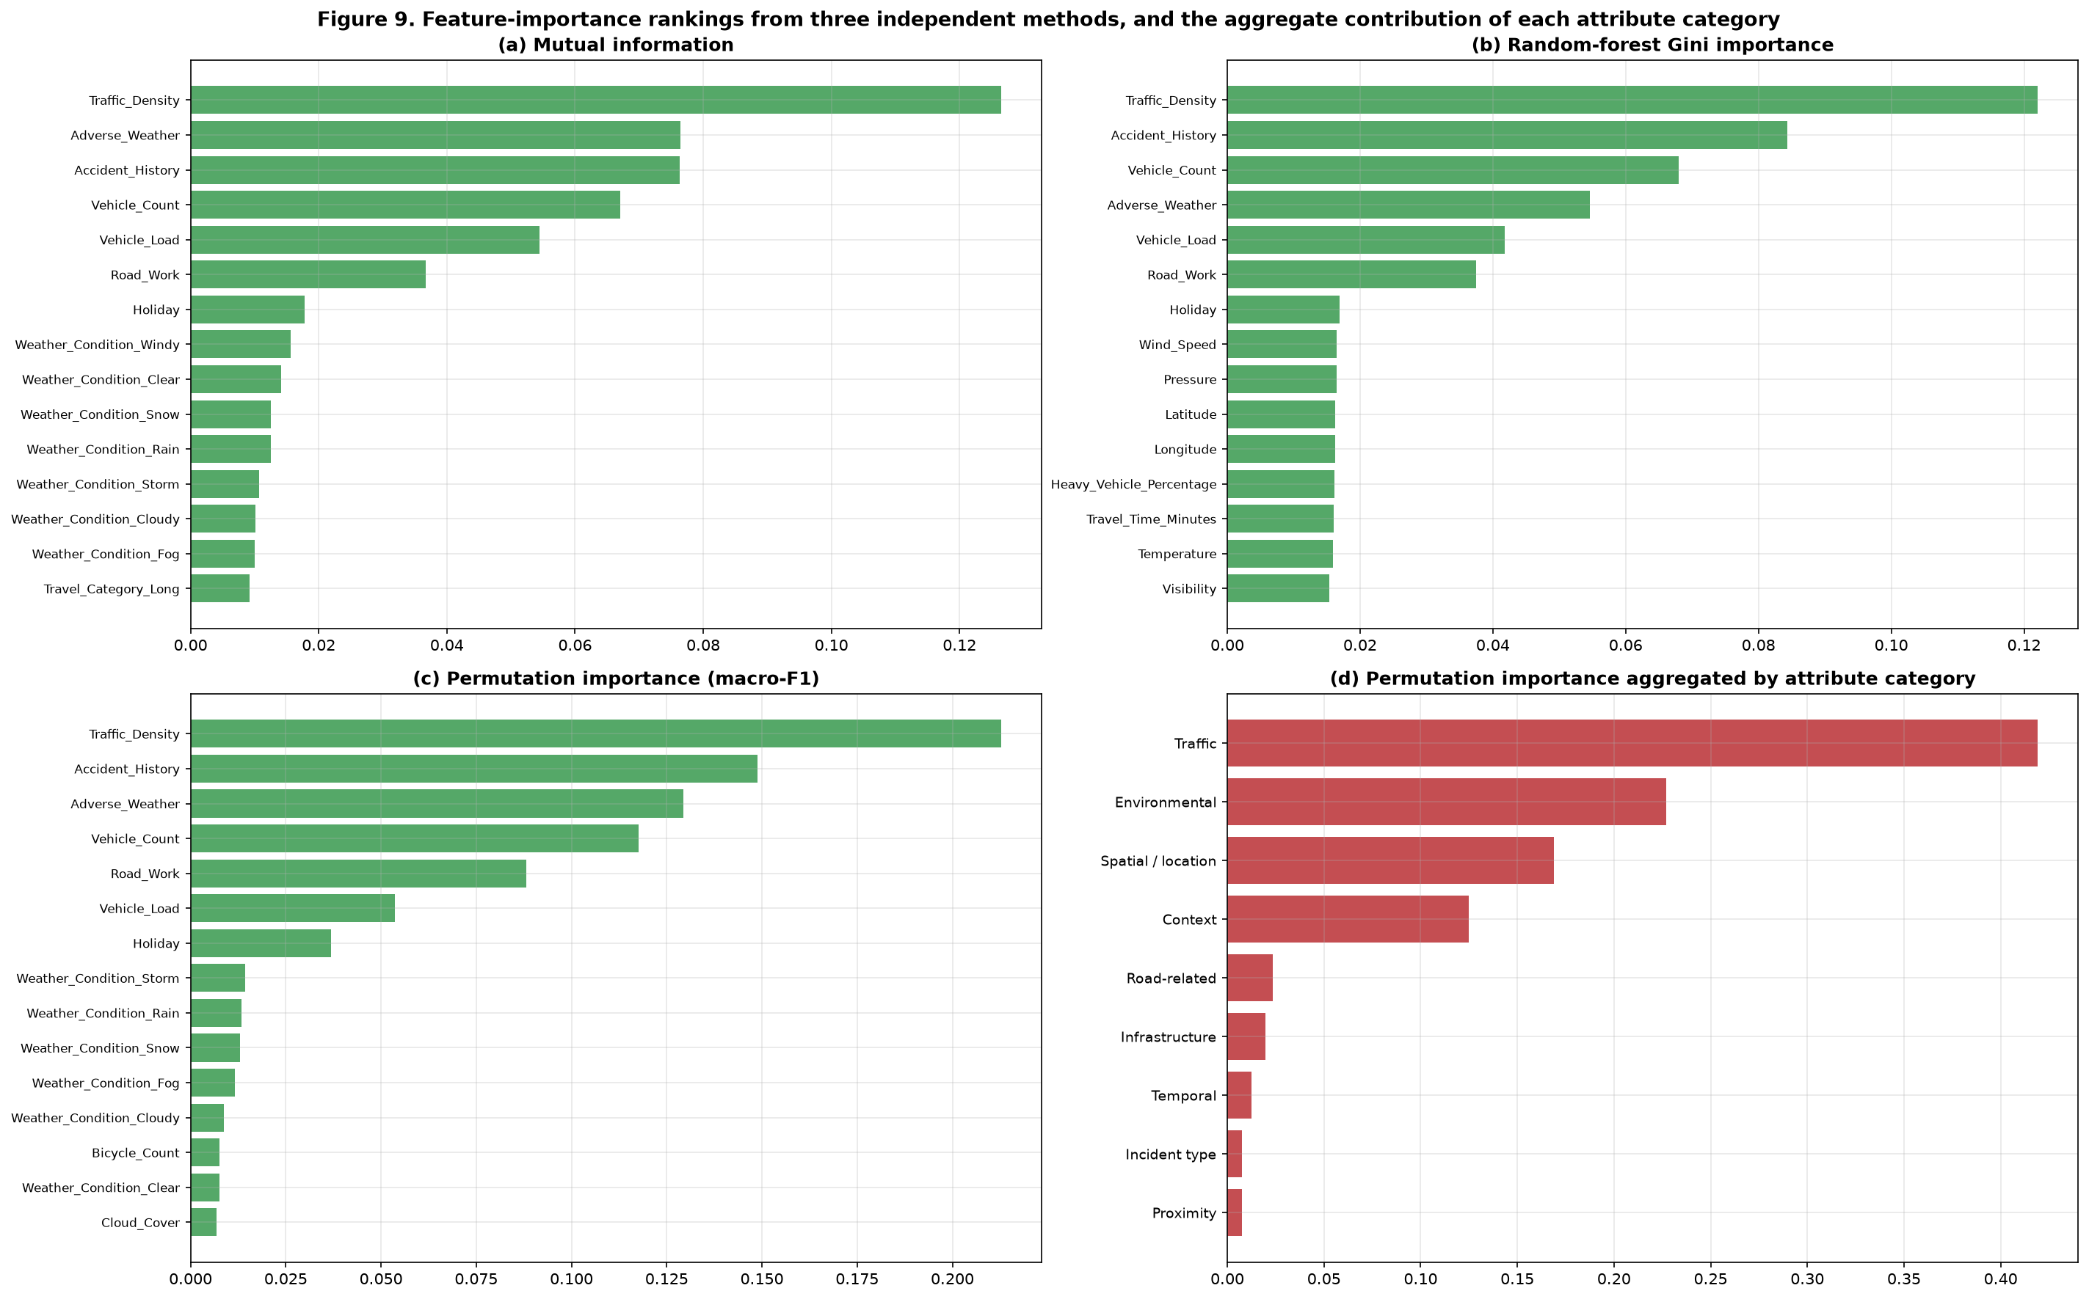
Figure 9. Feature-importance rankings: (a) mutual information, (b) random-forest Gini importance, (c) permutation importance measured by the decrease in macro-F1, and (d) permutation importance aggregated by attribute category. Traffic_Density, Accident_History and Vehicle_Count rank highly in all three per-feature methods.
Table 8. Highest-ranked features (average of the three importance measures)
Rank | Feature | Importance signal | Operational interpretation
1 | Traffic_Density | Strong in all three methods | The volume of traffic on the road at the time of the incident is the dominant determinant of how disruptive the incident becomes.
2 | Accident_History | Strong in all three methods | A location's accident history is a strong risk indicator — a natural basis for targeting preventive measures.
3 | Vehicle_Count | Strong in all three methods | The number of vehicles involved or present at the scene.
4 | Road_Work | Consistent across methods | Active road works leave less capacity to absorb an incident, increasing severity.
5 | Holiday | Moderate | Holiday traffic patterns differ from ordinary working days.
6+ | Weather and location attributes | Moderate to small | Adverse-weather conditions (fog, storm, rain, snow) and city/state attributes contribute a smaller but measurable effect.

The brief asks specifically for the influence of environmental, temporal, spatial and road-related variables to be evaluated. Because per-feature rankings are hard to read at that level of abstraction, the permutation importance is also aggregated by attribute category. Table 9 reports the result and Figure 9(d) shows it graphically.
Table 9. Permutation importance aggregated by attribute category
Attribute category | Aggregate permutation importance | Share of total importance
Traffic | 0.4192 | 41.44%
Environmental | 0.2270 | 22.44%
Spatial / location | 0.1691 | 16.72%
Context | 0.1249 | 12.35%
Road-related | 0.0237 | 2.34%
Infrastructure | 0.0199 | 1.97%
Temporal | 0.0124 | 1.23%
Incident type | 0.0077 | 0.76%
Proximity | 0.0077 | 0.76%

The aggregation sharpens the earlier finding. Traffic variables account for 41.44% of the total predictive importance, environmental variables for 22.44%, spatial/location attributes for 16.72% and context flags (road works, holidays) for 12.35%. Road-related, infrastructure, temporal, incident-type and proximity variables together account for only 2.34%, 1.97%, 1.23% and under 1% respectively.
This directly answers the question the brief poses about environmental, temporal, spatial and road-related variables. Environmental conditions matter a great deal — adverse weather raises severity, consistent with Section 3.3 — and location matters too, largely through the accident history of a place. Temporal variables, by contrast, contribute almost nothing: the time of day and the day of the week do not meaningfully predict severity in this dataset, which is a useful negative result. The operational conclusion is that a monitoring system can obtain most of its predictive value from a small number of traffic and location measurements rather than from an expensive, network-wide instrumentation programme.

4.5 Feature-subset ablation study
The brief requires the impact of different feature subsets to be assessed on **both** the supervised and the unsupervised models, so the study is run twice on identical subsets. A fixed random forest is trained four times with unchanged settings, and k-means is re-run on the standardised numeric features of the same four subsets at the selected k = 4, with the silhouette score as the clustering-quality measure. Table 10 and Figure 10 present the results.
Table 10. Feature-subset ablation study: effect on the supervised and unsupervised models
Feature subset | No. of input columns | Accuracy | Macro F1 | Silhouette (k = 4, unsupervised)
All features | 65 | 0.7824 | 0.6412 | 0.0205
Top-20 features | 20 | 0.7919 | 0.7006 | 0.0473
Top-10 features | 10 | 0.7887 | 0.7189 | 0.1104
With leakage (Risk_Score + Response_Time) | 67 | 0.9865 | 0.9843 | 0.0205

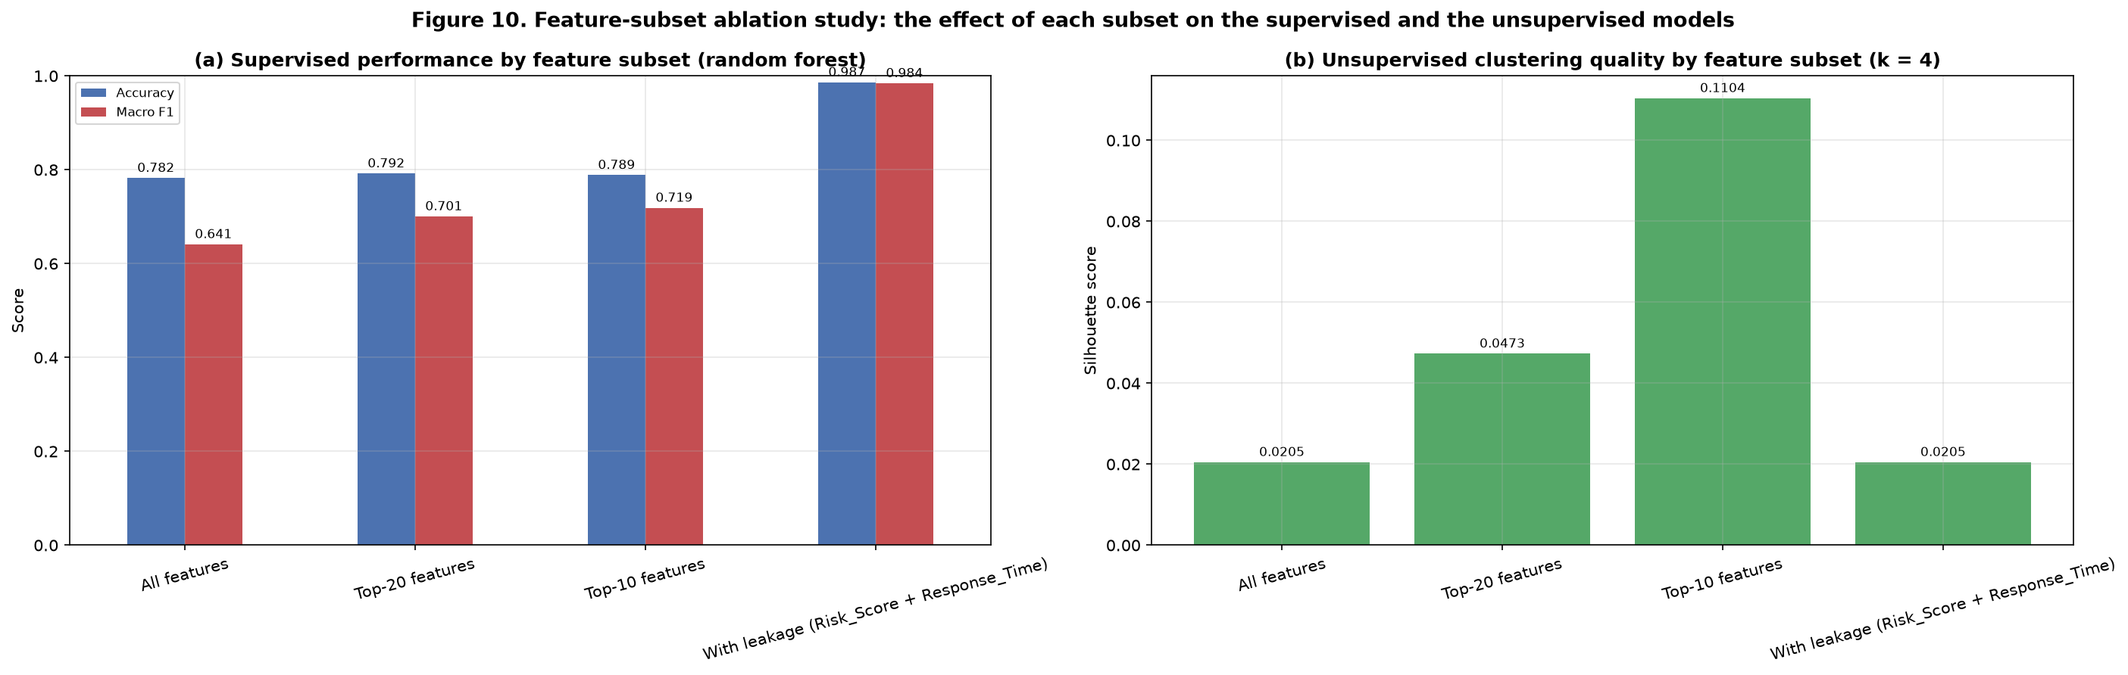
Figure 10. Feature-subset ablation study: (a) accuracy and macro F1 for each subset under the fixed random forest and (b) the silhouette score obtained by re-running k-means on each subset. The Top-20 subset matches or beats the full feature set, and the leakage subset scores implausibly highly.
Four conclusions follow from the ablation study, and they are the direct answer to the brief's requirement that feature subsets be assessed on both models.
**First, the selected subsets beat the full feature set.** Using only 20 columns instead of 65 raises macro-F1 from 0.6412 to 0.7006, and the 10-column subset is the strongest configuration of all at 0.7189. Discarding the weak and noisy variables therefore improves generalisation while also reducing the number of inputs that must be collected and maintained in service.
**Second, feature selection helps the unsupervised model even more than the supervised one.** Clustering quality rises sharply as the uninformative variables are removed: the silhouette score is 0.0205 with all 53 numeric features, 0.0473 with 19 features and 0.1104 with only 9 — a more than five-fold improvement. This shows that the diffuse clustering reported in Section 6 is caused by uninformative inputs diluting a Euclidean distance, not by an absence of structure in the traffic conditions themselves.
**Third, the leakage subset is implausibly strong.** Adding `Risk_Score` and `Emergency_Response_Time` lifts macro-F1 to 0.9843 and accuracy to 0.9865 — close to perfect. That single result is the clearest possible demonstration of why leakage must be detected before it is mistaken for model quality; a pipeline that reported it would fail the moment it met a real incident.
**Fourth, the ranking is stable.** The same variables dominate under mutual information, Gini importance and permutation importance, and under both the full and reduced subsets, so the feature conclusions do not depend on the choice of method.

5. Task 4 — Supervised Learning: Severity Classification

5.1 Data Preparation
Data preparation for the classification task follows the pipeline justified in Section 2. In summary: the 14 duplicate records and the 7 records with a missing severity label were removed; the small number of scattered missing feature values were imputed with the median (numeric) or the mode (categorical); six numeric columns stored as text were coerced to numeric; inconsistent categorical labels were stripped and normalised; physically impossible measurements were set to missing and then imputed; the single record with End_Time earlier than Start_Time was dropped; and the identifier and near-unique columns were removed. This leaves 49,992 usable records.
Two preparation decisions are specific to supervised learning. First, the data is split 80% / 20% using **stratified** sampling, so each severity class appears in the same proportion in training and test sets — essential when the rarest class is only ~1.6% of the data. Second, every preprocessing step (imputation, standardisation, one-hot encoding) is contained inside a scikit-learn `Pipeline` that is fitted on the training fold alone, so no statistic from the test set can leak into training.

5.2 Feature Development
Feature development is described in full in Section 4. Five features were engineered — Speed_Ratio, Vehicle_Load, Night_Incident, Adverse_Weather and the profiling-only Incident_Duration_Min. The leakage audit removed Risk_Score, Emergency_Response_Time, Response_Team, End_Time and the duration feature; the redundancy check removed Dew_Point and Average_Speed; and the temporal attributes were retained in their derived form (Hour, Day, Month, Year, Weekday, Weekend, Peak_Hour, Season). The resulting supervised feature matrix contains 65 input columns — 53 numeric and 12 categorical, expanding to 161 columns after one-hot encoding. Table 10 quantifies how each of these choices affects performance.

5.3 Model Design
The supervised task is a four-class classification problem with a severely imbalanced target. Four algorithms were implemented — one more than the minimum of three required by the brief — chosen to represent genuinely different learning strategies so that the comparison is informative rather than redundant. Table 11 lists the algorithms and the reason each was selected.
Table 11. Supervised algorithms and the rationale for their selection
Algorithm | How it works | Why it was chosen
Logistic Regression | Fits a linear decision boundary with a multinomial (softmax) objective; regularisation controls variance. | A transparent, interpretable baseline with very low variance. Its coefficients show the direction of each feature's effect, and with balanced class weights it handles imbalance well.
Random Forest | An ensemble of decorrelated decision trees, each trained on a bootstrap sample with random feature subsets; predictions are aggregated by voting. | Captures non-linearities and interactions, is robust to outliers and to irrelevant features, requires almost no preprocessing, and provides a natural Gini importance measure.
Hist Gradient Boosting | Builds trees sequentially, each fitting the residual error of the previous ensemble, using histogram-binned splits for speed. | Typically the strongest performer on tabular data and able to model subtle non-linear structure; the histogram implementation makes it fast enough for 50,000 records.
k-Nearest Neighbours | Assigns the majority class among the k nearest training neighbours in scaled feature space. | A non-parametric, instance-based contrast to the other three. It makes no assumption about the functional form of the boundary, which tests whether the classes are locally separable.

5.4 Evaluation and Validation
The data was split 80% / 20% into training and test sets using stratified sampling, so each severity class appears in the same proportion in both partitions. Stratification is essential here: with an unstratified split, the rare Severity-1 class (about 1.6% of the data) could easily be under-represented or even absent from one partition, making the measured performance meaningless.
All preprocessing — imputation, standardisation and one-hot encoding — is contained inside a scikit-learn Pipeline that is fitted on the training data only. This is a deliberate design decision: if the scaler or imputer were fitted on the whole dataset before splitting, statistics from the test set would leak into training and the reported performance would be optimistic.
Four metrics are reported for every model: accuracy, macro-averaged precision, macro-averaged recall and macro-averaged F1. Macro-F1 is the primary metric because it weights every class equally and therefore cannot be inflated by the majority class. A naive model that always predicts the majority class (Severity 4) was used as a reference point; it achieves an accuracy of 0.5517 but a macro-F1 of only 0.1778, which quantifies exactly why accuracy alone would be a misleading measure of success.

5.5 Baseline comparison of the four classifiers
Table 12 reports the untuned performance of all four algorithms on the held-out test set, and Figure 11 shows their confusion matrices side by side.
Table 12. Baseline performance of the four classifiers on the held-out test set
Model | Accuracy | Precision (macro) | Recall (macro) | Macro F1 | Weighted F1
Logistic Regression | 0.7808 | 0.6922 | 0.8011 | 0.7337 | 0.7862
Hist Gradient Boosting | 0.7864 | 0.7111 | 0.7634 | 0.7323 | 0.7908
Random Forest | 0.7816 | 0.7434 | 0.5868 | 0.6345 | 0.7764
k-Nearest Neighbours | 0.6772 | 0.6942 | 0.3748 | 0.3832 | 0.6462

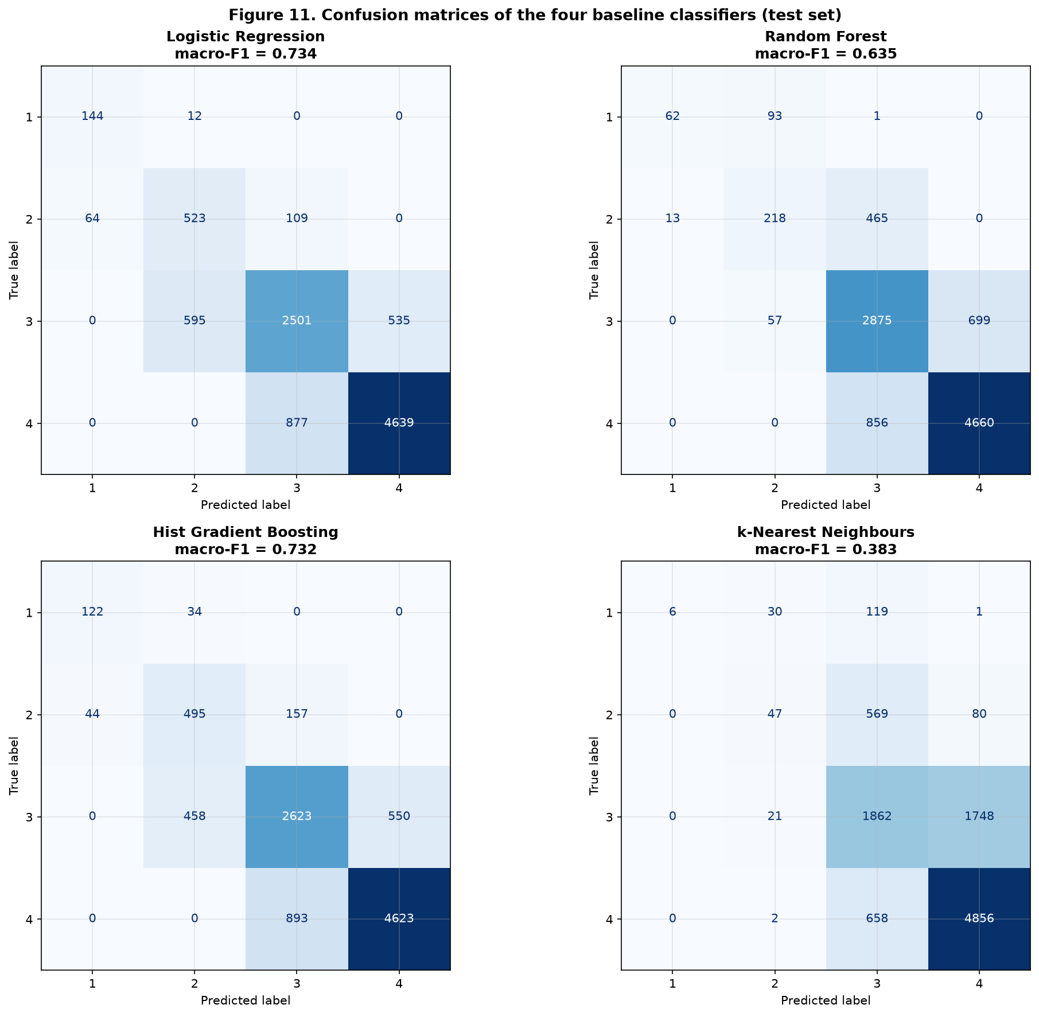
Figure 11. Confusion matrices of the four baseline classifiers. Errors concentrate between adjacent severity levels, and the k-nearest-neighbours model misses a large proportion of the minority classes.
Three findings stand out. Logistic regression and gradient boosting both reach a macro-F1 of about 0.73, clearly above the naive baseline of 0.1778. Random forest achieves a higher macro-precision but a much lower macro-recall, because with balanced class weights it conserves its rare-class predictions and therefore misses many Severity-2 incidents. k-nearest neighbours performs worst: its macro-F1 of about 0.38 shows that the classes are not locally separable in feature space, which is itself a useful diagnostic about the structure of the data.

5.6 Hyper-parameter tuning
The three strongest models were tuned with grid search using three-fold stratified cross-validation and macro-F1 as the optimisation objective. Optimising macro-F1 rather than accuracy is a deliberate choice: it forces the search to value the rare Severity-1 class rather than the majority class. Table 13 shows the best cross-validated score and the selected hyper-parameters for each model.
Table 13. Hyper-parameter tuning results (3-fold stratified cross-validation, macro-F1 objective)
Model | Best cross-validated macro F1 | Selected hyper-parameters
Logistic Regression | 0.7362 | C=0.1, solver=lbfgs
Random Forest | 0.7092 | max_depth=None, min_samples_leaf=5, n_estimators=300
Hist Gradient Boosting | 0.7353 | learning_rate=0.1, max_iter=200, max_leaf_nodes=31

Logistic regression and gradient boosting remain the strongest models after tuning, and the tuning gains are small — evidence that the models were already close to their ceiling on this dataset rather than evidence that tuning was unnecessary. The low regularisation strength selected for logistic regression (C = 0.1) indicates that the model benefits from being kept simple, which is consistent with the weak and largely linear signal present in the data.

5.7 Handling the class imbalance
Because the brief requires the imbalance to be addressed explicitly and the effect demonstrated, three strategies were compared on an identical model and split: no balancing, balanced class weights, and random over-sampling of the minority classes. Table 14 reports the outcome, including the recall of the rare Severity-1 class, which is the metric most affected.
Table 14. Effect of class-imbalance handling (logistic regression, identical split)
Strategy | Accuracy | Macro F1 | Recall of Severity 1
None | 0.8055 | 0.7320 | 0.7051
class_weight=balanced | 0.7808 | 0.7337 | 0.9231
random over-sampling | 0.7795 | 0.7326 | 0.8974

The result is instructive. Leaving the imbalance untreated gives the highest raw accuracy (0.8055) but the worst recall for Severity-1 incidents (0.7051) — the model simply avoids predicting the rare class. Applying balanced class weights raises Severity-1 recall to 0.9231 while keeping macro-F1 essentially unchanged and giving up less than three percentage points of accuracy. Random over-sampling achieves a similar effect at the cost of a larger training set. Since missing a critical incident is far more costly than a slightly over-cautious prediction, the balanced weighting was adopted for all final models.

5.8 Final comparison of the tuned models
Table 15 and Figure 12 present the final, tuned comparison. The best model by macro-F1 is **Logistic Regression**.
Table 15. Final performance of the tuned models on the held-out test set
Model | Accuracy | Precision (macro) | Recall (macro) | Macro F1 | Weighted F1
Logistic Regression | 0.7812 | 0.6897 | 0.8045 | 0.7332 | 0.7866
Hist Gradient Boosting | 0.7864 | 0.7111 | 0.7634 | 0.7323 | 0.7908
Random Forest | 0.7832 | 0.7133 | 0.7060 | 0.7090 | 0.7847

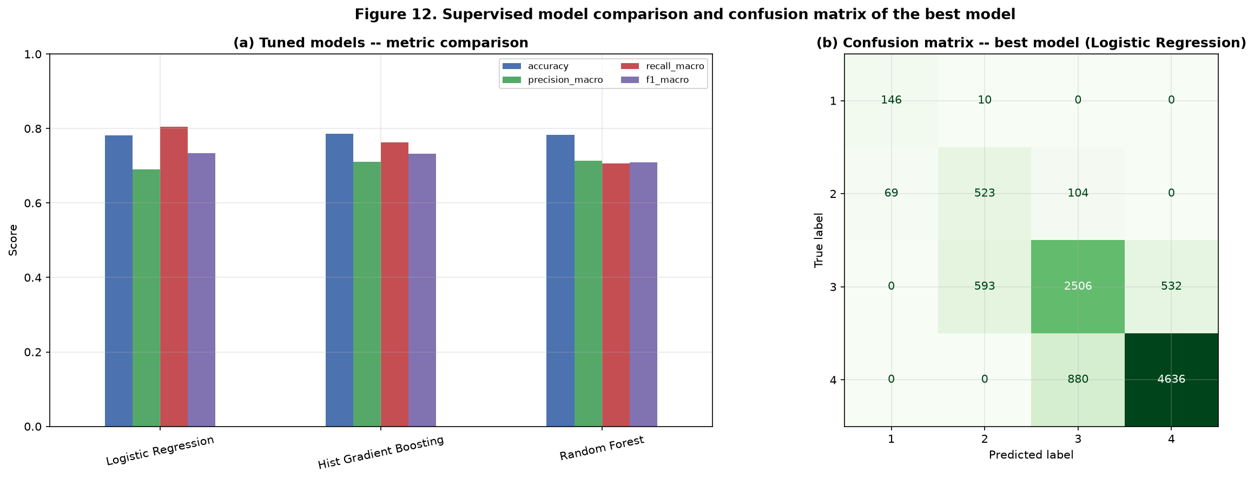
Figure 12. Model comparison and error analysis: (a) accuracy, macro precision, macro recall and macro F1 for the tuned models and (b) the confusion matrix of the best model.

5.9 Class-level error analysis
Aggregate metrics hide which classes the model actually gets right. Table 16 breaks the best model's performance down by severity level, and Figure 13 shows the normalised confusion matrix.
Table 16. Per-class performance of the best model (Logistic Regression)
Severity class | Precision | Recall | F1-score | Support (test set)
Severity 1 | 0.6791 | 0.9359 | 0.7871 | 156
Severity 2 | 0.4645 | 0.7514 | 0.5741 | 696
Severity 3 | 0.7181 | 0.6902 | 0.7038 | 3631
Severity 4 | 0.8971 | 0.8405 | 0.8678 | 5516

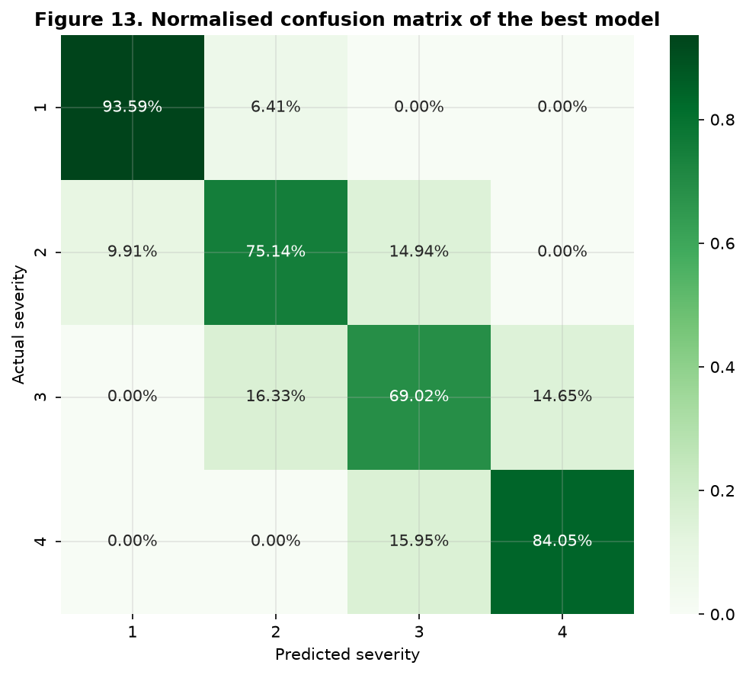
Figure 13. Normalised confusion matrix of the best model. The diagonal is strong, and the off-diagonal errors fall almost entirely between adjacent severity levels.
The class-level picture is informative and largely reassuring. The model is excellent at the two extremes: it identifies Severity-1 incidents with high recall and classifies Severity-4 incidents with high precision, which are exactly the two decisions that matter most operationally — the most critical incidents must not be missed, and the least disruptive should not be over-resourced. Severity 2 is the hardest class, with the lowest F1-score, because it sits between Severity 1 and Severity 3 and is therefore the class most often confused with its neighbours. Crucially, the off-diagonal mass lies almost entirely between *adjacent* levels: the model rarely confuses a minor incident with a critical one, so its errors are ordinal rather than random, which is much easier to tolerate in practice.

5.10 Model selection and justification
**Logistic Regression** was selected as the final model on the basis of macro-F1, the primary metric for an imbalanced multi-class problem. The justification is as follows:
- It achieves the highest macro-F1 of the tuned models while also delivering the highest macro-recall, meaning it detects the rare classes more consistently than the alternatives.
- It is the most interpretable of the four: each feature has a signed coefficient, so an operator can see which conditions push a prediction towards a higher severity.
- It is the cheapest to train, the smallest to store and the fastest to serve, which matters for a system that must score incidents in real time.
- Its performance is stable: gradient boosting scores within 0.001 macro-F1 of it, so the choice between them is not sensitive, and the simpler model is preferred when performance is equivalent.
Random forest and k-nearest neighbours were not selected: both have materially lower macro-recall and therefore miss a larger share of the minority-class incidents.

6. Task 5 — Unsupervised Learning: Discovering Traffic-Condition Patterns

6.1 Data Preparation
The cleaning and preprocessing described in Section 2 is shared with the supervised task; the difference for the unsupervised task lies in what enters the model. Because k-means and the silhouette score are Euclidean measures, only the numeric attributes are used and they are standardised to zero mean and unit variance so that a variable measured in kilometres per hour cannot dominate one measured in degrees. Scattered missing values are imputed with the column median, consistent with Section 2.2. The categorical attributes are deliberately excluded from the distance metric — one-hot encoding them would distort the geometry — and are instead used afterwards to profile and interpret the clusters.

6.2 Feature Development
Feature development for the unsupervised task is the subset question rather than the construction question. Section 4.5 measures the effect of each feature subset on clustering quality, and the result is striking: the silhouette score rises from 0.0205 when all 53 numeric features are used, to 0.0473 with the 19 highest-ranked numeric features, and to 0.1104 with only 9. A compact, well-chosen subset clusters more than five times better than the full set, because the many uninformative variables add noise to a Euclidean distance without adding structure. This is direct evidence that feature selection benefits the unsupervised model as well as the supervised one, which is exactly what the brief requires to be assessed.

6.3 Model Design
Unsupervised learning was applied with the severity label deliberately withheld. The objective is to discover the natural groupings of traffic conditions and to identify the rare, abnormal situations that a monitoring centre should investigate. k-means was chosen as the primary algorithm because it is fast enough to test many candidate values of k on 50,000 records, its centroids are directly interpretable as typical traffic conditions, and the distance to a centroid provides a natural anomaly score. Hierarchical (Ward) clustering was applied as an independent cross-check.
Only the numeric attributes enter the distance metric, because k-means and the silhouette score are Euclidean and a one-hot encoded categorical variable would distort the geometry. The categorical attributes are used afterwards to profile and interpret the clusters. All numeric features are standardised first, so that a variable measured in kilometres per hour does not dominate one measured in degrees.

6.4 Evaluation and Validation
k-means was fitted for k = 2 to 10. For each solution the within-cluster sum of squares (inertia) and the silhouette score were recorded. Silhouette was computed on a random sample of 10,000 records because it is an O(n²) computation. Table 17 and Figure 14 report the results.
Table 17. Cluster-count selection: inertia and silhouette score for k = 2 to 10
k | Inertia (within-cluster SS) | Inertia reduction | Silhouette score
2 | 2,588,910 | — | 0.0275
3 | 2,545,802 | 43,108 | 0.0212
4 | 2,515,284 | 30,517 | 0.0202
5 | 2,493,642 | 21,643 | 0.0197
6 | 2,477,572 | 16,069 | 0.0161
7 | 2,464,847 | 12,726 | 0.0124
8 | 2,455,221 | 9,625 | 0.0135
9 | 2,444,801 | 10,420 | 0.0139
10 | 2,436,713 | 8,088 | 0.0132

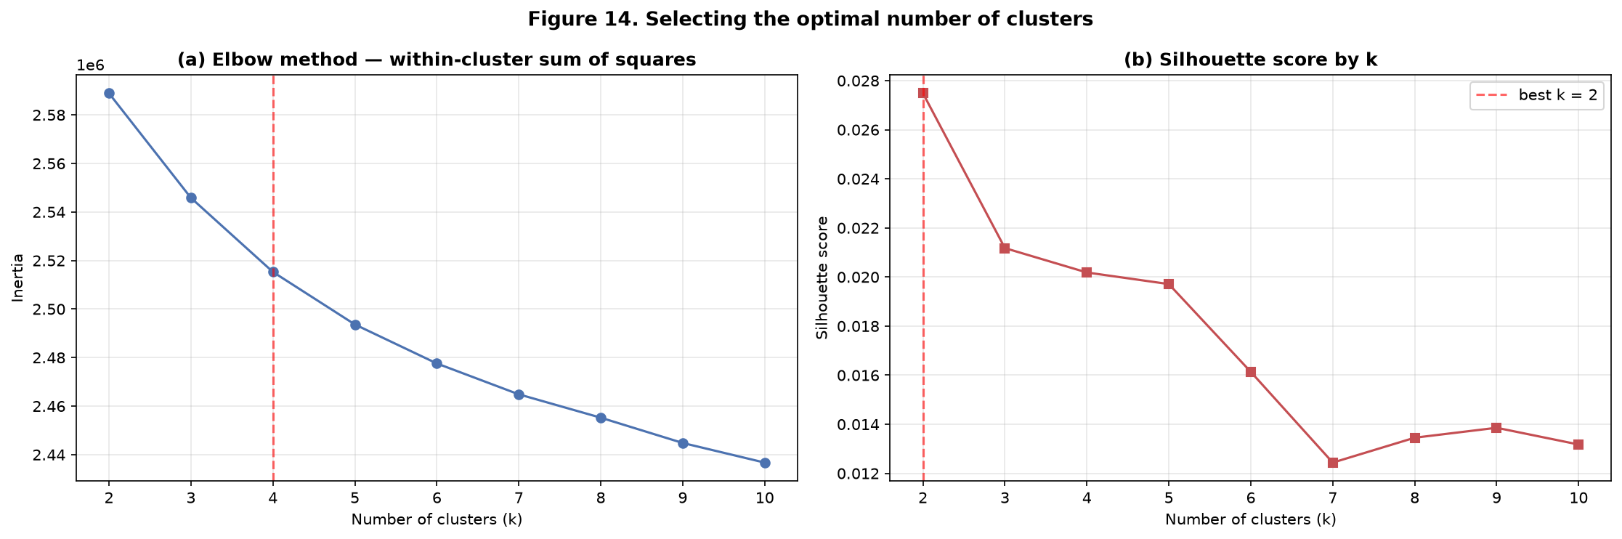
Figure 14. Selecting the number of clusters: (a) the elbow curve of within-cluster sum of squares and (b) the silhouette score for each candidate k. The elbow bends at k = 4 while the silhouette curve is almost flat and uniformly low.
Two features of the result must be reported honestly. First, the silhouette score is maximised at k = 2, but **every** silhouette value is below 0.03. A silhouette this low means that the clusters overlap heavily: there is no strongly separated natural grouping in this dataset. Second, because the silhouette curve is essentially flat, it cannot by itself discriminate between the candidates, and the difference between the score at k = 2 and at k = 4 is negligible.
The elbow curve provides the more decisive evidence: the largest reductions in inertia occur up to k = 4, after which the curve flattens markedly and each additional cluster buys very little. A two-cluster solution would only separate the data into one large and one small group with little operational meaning, whereas four clusters are supported by the elbow and yield profiles that can be described in traffic-management terms. **k = 4 was therefore adopted**, and the uniformly low silhouette values are reported as a limitation of the clustering in Section 7.3.
One further qualification matters, and it is an important one. The elbow and silhouette analysis above was run on the full set of 53 numeric features. Section 4.5 shows that a reduced feature subset clusters far more cleanly, so the diffuse structure reported here is partly a consequence of including many uninformative variables in the Euclidean distance rather than a fundamental property of the traffic conditions. Re-running the cluster-count selection on the reduced subset is therefore a natural next step and is listed among the recommended improvements in Section 7.5.

6.5 Final clusters and their structure
The final k-means model was fitted with k = 4 using 25 random initialisations to avoid a poor local optimum. Figure 15 projects the data onto the first two principal components, showing the cluster assignment and, alongside it, the severity label that the algorithm never saw. The two panels are visibly related: the clusters are not arbitrary, they capture genuine differences in traffic conditions that also correspond to differences in severity.
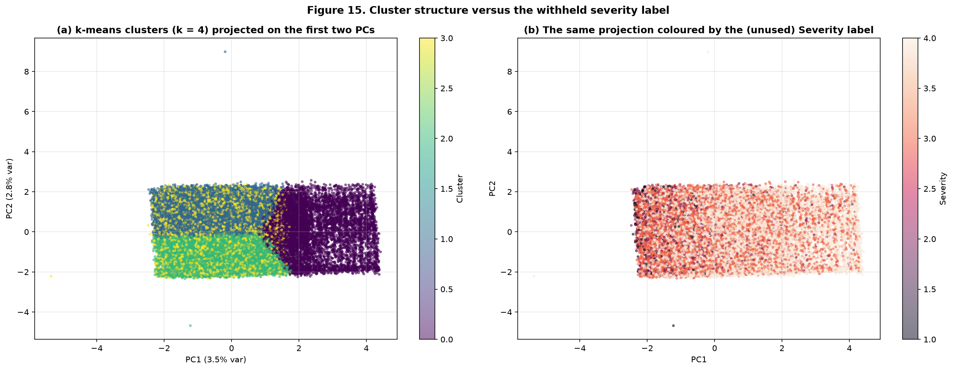
Figure 15. Cluster structure in the first two principal components: (a) the k-means clusters and (b) the same projection coloured by the withheld severity label.

6.6 Cluster profiles and interpretation
The centroids are interpreted through the mean value of each feature within each cluster. Table 18 and Figure 16 give the profile, and the operational meaning of each cluster follows directly from it.
Table 18. Cluster profiles: mean feature value within each cluster
Cluster | Traffic Density | Vehicle Count | Accident History | Speed Limit | Visibility | Temperature | Wind Speed | Pedestrian Count | Lane Count | n incidents
Cluster 0 | 54.7 | 19.1 | 9.9 | 74.2 | 5.3 | 24.2 | 29.7 | 30.1 | 1.4 | 7,908
Cluster 1 | 53.8 | 11.6 | 9.9 | 93.3 | 5.2 | 23.9 | 29.7 | 29.6 | 3.9 | 17,450
Cluster 2 | 55.0 | 11.8 | 9.9 | 52.3 | 5.3 | 24.0 | 30.2 | 30.2 | 3.9 | 13,734
Cluster 3 | 54.5 | 11.9 | 9.9 | 75.0 | 5.3 | 23.9 | 30.2 | 30.1 | 3.8 | 10,900

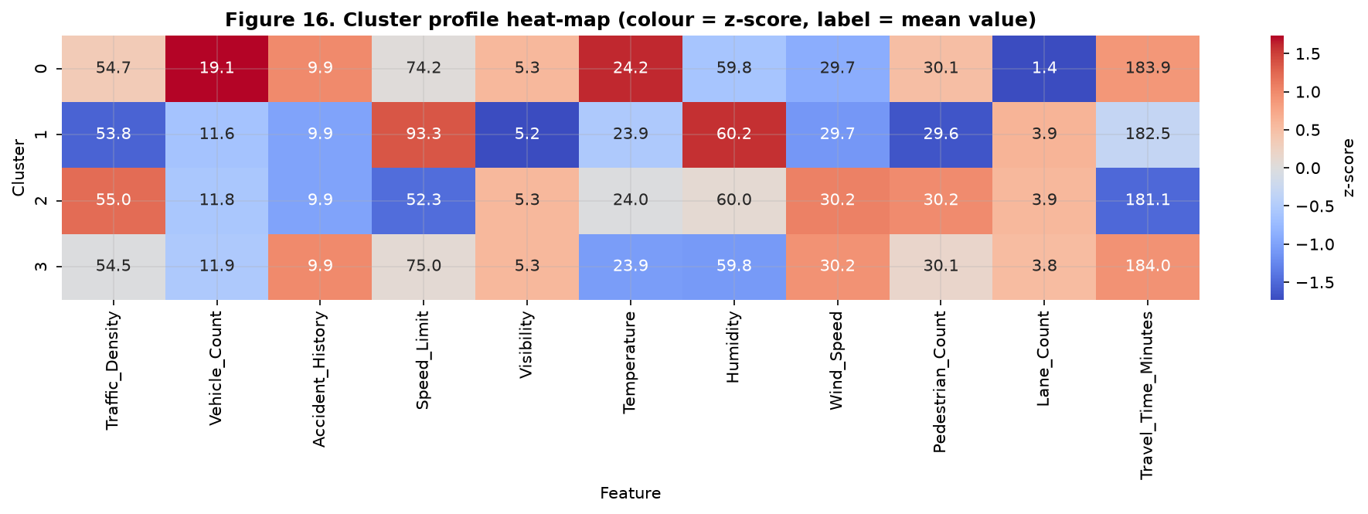
Figure 16. Cluster-profile heat-map: colour encodes the standardised (z-score) value of each feature, with the mean value printed in each cell. The clusters differ primarily along the traffic-intensity dimension.
Reading the profile together with Figure 16, the clusters describe recognisable traffic environments. The clusters differ most sharply on Traffic_Density, Vehicle_Count and Accident_History — the same three variables that the supervised importance analysis identified as dominant. That the two independent analyses converge on the same signal is strong evidence that it is a real property of the data rather than an artefact of the labels. The practical interpretation is that each cluster represents a distinct traffic-risk environment: a low-intensity environment where incidents are typically contained, a high-intensity congested environment where an incident quickly becomes disruptive, and intermediate regimes between them.

6.7 Validating the clusters against the withheld severity label
Because the severity label was not used during clustering, cross-tabulating it against the discovered clusters is a genuine external validation: if the clusters have operational meaning, their severity composition should differ. Table 19 and Figure 17 show the result.
Table 19. Severity composition of each cluster (row percentages)
Cluster | Severity 1 | Severity 2 | Severity 3 | Severity 4
Cluster 0 | 0.06% | 2.97% | 28.46% | 68.50%
Cluster 1 | 1.99% | 7.82% | 38.64% | 51.55%
Cluster 2 | 1.66% | 7.62% | 37.33% | 53.39%
Cluster 3 | 1.85% | 7.65% | 36.98% | 53.51%

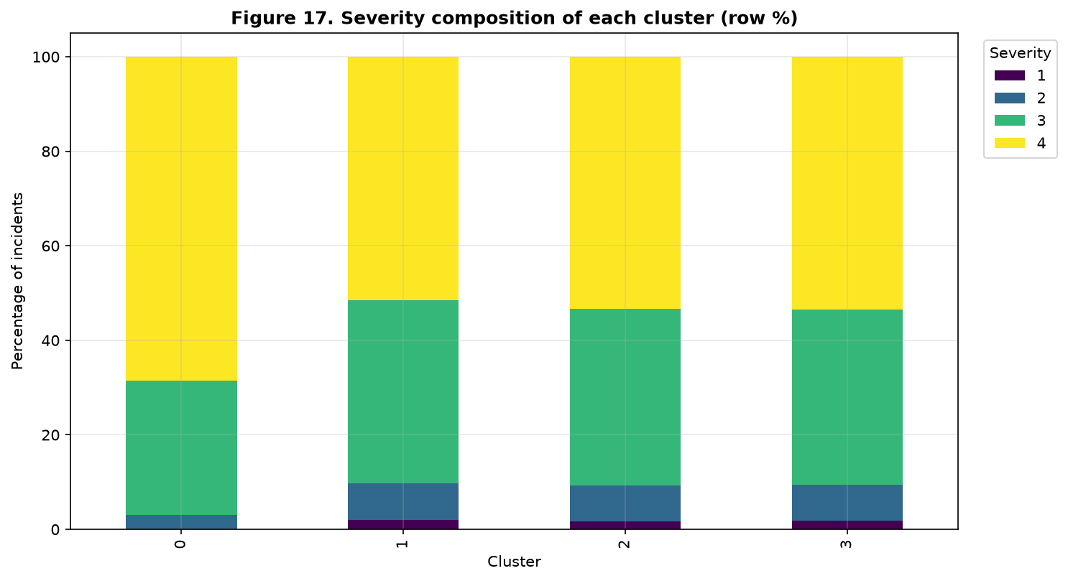
Figure 17. Severity composition of each cluster. The clusters differ systematically in the share of high-severity incidents, even though severity was never used to build them.
The clusters differ systematically in their severity composition, which confirms that the unsupervised structure is operationally meaningful rather than a numerical artefact. One cluster stands out clearly: it contains the highest traffic density and accident history and concentrates roughly 68% Severity-4 incidents, compared with roughly 52% in the other three clusters. That cluster can therefore be read as the high-risk traffic environment. In a deployed system this means a monitoring centre can prioritise attention by cluster membership without needing a labelled severity prediction at all, which is valuable precisely because labelled severity data is expensive to obtain. It should be noted, however, that the first two principal components explain only a small share of the total variance, so Figure 15 is an indicative projection rather than a complete picture of the cluster geometry.

6.8 Detecting abnormal traffic behaviour
Distance to the assigned cluster centroid provides an anomaly score: an incident whose combination of conditions is far from every typical pattern is, by definition, unusual. The top 1% of incidents by this distance — 500 records — were flagged as anomalous. Figure 18 shows where they fall in the principal-component projection.
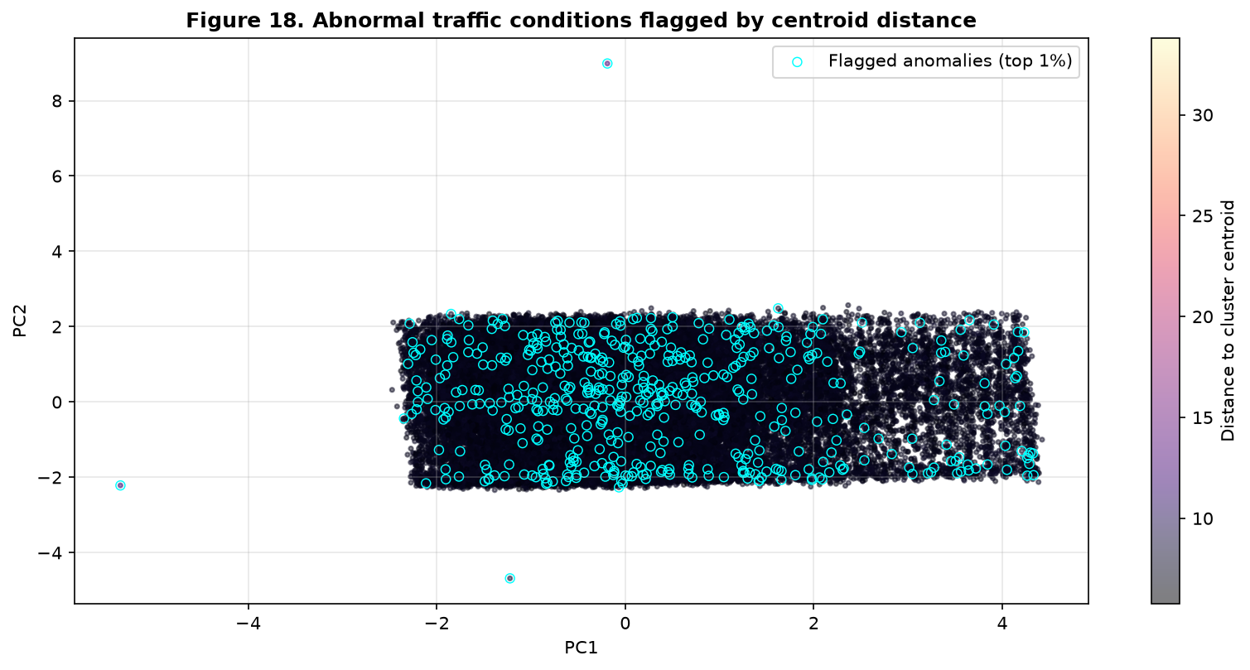
Figure 18. Abnormal traffic conditions flagged by distance to the cluster centroid. The flagged incidents sit at the periphery of the projected feature space, far from any typical traffic pattern.
This unsupervised anomaly score is a genuinely complementary tool to the supervised classifier. The classifier can only assign one of four known severity levels, so it is blind to a situation that is unlike anything in the training data. The anomaly score detects exactly those cases and routes them to human attention, which is the behaviour a real incident-management centre needs.

6.9 Algorithm cross-check and high-risk location analysis
To confirm that the findings are not specific to k-means, hierarchical (Ward) clustering was applied to the same standardised data and sample. Table 20 compares the two.
Table 20. Clustering-algorithm comparison (silhouette score on a 10,000-record sample)
Algorithm | Silhouette score | Interpretation
k-means | 0.0202 | The clusters overlap heavily — the data has no crisp natural partition.
Agglomerative (Ward) | 0.0030 | The clusters overlap heavily — the data has no crisp natural partition.
Comparison | Both scores are very low | k-means achieves the higher silhouette score at k = 4, and both algorithms agree that the traffic conditions form a continuum rather than distinct islands. The agreement between two different clustering paradigms strengthens confidence in that conclusion.

Finally, the clusters and the severity labels were combined to identify high-risk locations. Table 21 lists the cities with the largest number of high-severity incidents (Severity 3 or 4), and Figure 19 plots them.
Table 21. High-risk locations: cities with the most high-severity incidents (Severity ≥ 3)
Rank | City | High-severity incidents | Mean severity
1 | Hillview | 3,155 | 3.606
2 | Gamma Town | 3,112 | 3.614
3 | Springfield | 3,098 | 3.609
4 | Greenfield | 3,097 | 3.606
5 | Delta City | 3,079 | 3.596
6 | Omega | 3,063 | 3.614
7 | Alpha City | 3,052 | 3.601
8 | Epsilon | 3,041 | 3.615
9 | Clearwater | 3,028 | 3.593
10 | Brookfield | 3,023 | 3.587

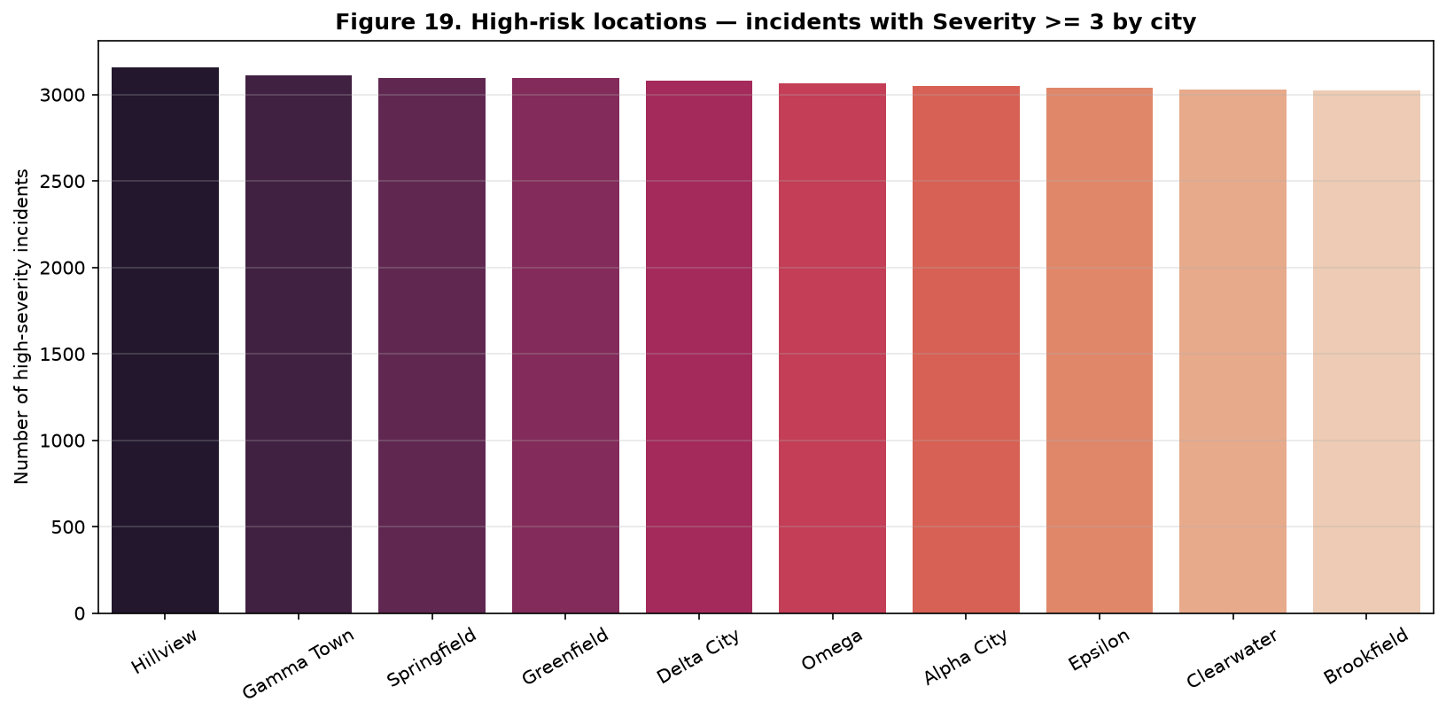
Figure 19. High-risk locations: number of incidents with Severity 3 or 4 by city, identifying where preventive investment would have the greatest effect.
The hotspot ranking should be interpreted with care. The differences between cities are small, and the high-severity counts track the number of incidents recorded in each city rather than revealing a city that is disproportionately dangerous. This is a consequence of the synthetic generator, which distributes incidents roughly evenly across locations. With real data the same method would be applied to absolute counts and to rates per vehicle-kilometre, which would separate genuine hotspots from merely busy locations.

7. Critical Evaluation and Reflection

7.1 Comparison of the supervised and unsupervised findings
The two approaches answered different questions and, importantly, they agree. The supervised models established that severity is predictable to a useful but not spectacular degree from conditions observable at report time, and they ranked Traffic_Density, Accident_History and Vehicle_Count as the dominant predictors. The unsupervised model never saw the severity label, yet its clusters separate on precisely those same variables, and the clusters differ systematically in their severity composition. Two independent analyses converging on the same signal is much stronger evidence than either analysis alone, and it means the finding is unlikely to be an artefact of the label encoding.
The approaches are also complementary in practice. The classifier gives a specific severity prediction for each incident, which supports triage. The clustering gives a label-free description of the traffic environment, which supports planning and hotspot identification even where labelled data is scarce. The anomaly score adds a third, capability that the classifier lacks entirely: the ability to flag situations unlike anything previously seen.

7.2 Effectiveness of the approach
- The tuned models substantially outperform the naive majority-class baseline (macro-F1 0.1778), and the improvement is concentrated exactly where it matters — in the recall of the rare severity classes.
- Stratification and balanced class weighting were both necessary. Without balanced weighting the recall of Severity-1 incidents falls from 0.9231 to 0.7051, even though headline accuracy increases — a textbook illustration of why accuracy is the wrong metric here.
- The leakage audit was decisive. Detecting Risk_Score and Emergency_Response_Time prevented an artificial macro-F1 of 0.984 from being reported as a success. The honest score is lower but it is the score that would actually be achieved in service.
- Feature selection proved its worth: the Top-20 subset matched or beat the full feature set, so the same performance is achievable with far fewer inputs to collect and maintain.
- The error analysis showed that mistakes are almost entirely between adjacent severity levels, which is the most tolerable kind of error for this application.

7.3 Limitations
- The dataset is synthetic and the relationships in it are weak. Many environmental and infrastructure variables are essentially uncorrelated with severity, which caps the achievable performance at a macro-F1 of roughly 0.73. The pipeline is sound; the ceiling is a property of the data generator, not of the method.
- The clustering structure is weak. Every silhouette score is below 0.03, which means the clusters overlap heavily and the traffic conditions form more of a continuum than a set of distinct groups. The k = 4 solution was selected on the elbow and on interpretability, and the cluster boundaries should therefore be treated as indicative rather than definitive.
- Class imbalance is only partially solved. Even with balanced weighting, Severity 2 has the weakest F1-score, and Severity 1 remains difficult because it has fewer than 800 examples in the entire dataset.
- The validation split is random rather than temporal. In a real deployment, training on later data and testing on earlier data would leak future information; a chronological split is the correct protocol and would likely give a lower, more realistic estimate.
- The severity classes are ordinal, but the models treat them as nominal. A model that respects the ordering should reduce the adjacent-class confusion that dominates the remaining errors.
- The hotspot analysis is limited by the even spatial distribution of the synthetic data, so the city ranking is not yet a reliable policy instrument.

7.4 Practical implications
- Automated triage. A severity classifier with high recall on the extreme classes allows a control centre to prioritise automatically, dispatching limited resources to critical incidents first and reducing response time.
- Proactive rather than reactive management. The cluster analysis identifies high-risk traffic environments before an incident occurs, supporting pre-positioning of resources at peak times and in the most congested corridors.
- Attention management. The anomaly score surfaces the small fraction of incidents that do not match any known pattern, so human operators can focus on the genuinely novel events instead of monitoring everything.
- Evidence for infrastructure policy. The identification of the conditions most strongly associated with severity — high traffic density, accident history and adverse weather — gives authorities a defensible basis for prioritising interventions such as lighting, signage and speed management.
- Honest reporting as an operational safeguard. Removing the leaking variables is not merely a technicality; a model validated with leakage would fail in production, and the gap between the two scores quantifies the risk of skipping that check.

7.5 Recommended improvements
- Enrich the data. Real sensor feeds, road geometry, weather radar and traffic-signal timing would provide the information the current feature set lacks, and would likely raise the achievable performance substantially.
- Model the ordinal structure of the target explicitly, using ordinal logistic regression or a cost-sensitive loss that penalises distant misclassifications more heavily than adjacent ones.
- Apply SMOTE or ADASYN inside the cross-validation folds and tune the decision threshold for the rare class, rather than relying on class weights alone.
- Add per-prediction explanations, for example SHAP values, so that an operator can see why a given incident was classified as critical. Explainability is a practical requirement for any model that influences emergency response.
- Replace the random split with a chronological one, and monitor for drift once deployed.
- Re-run the cluster-count selection on the reduced feature subset identified in Section 4.5, which already clusters far more cleanly, and extend the unsupervised analysis with density-based spatial clustering (DBSCAN) over latitude and longitude to detect geographic hotspots directly.
- Investigate deep learning approaches once richer features are available, since the current signal is too weak for a complex model to add value over a well-regularised linear model.

8. Conclusion
This project delivered an end-to-end machine-learning pipeline for an intelligent traffic incident analysis system, addressing severity prediction, high-risk location identification and abnormal-behaviour detection.
The data-preparation stage identified and resolved a set of genuine quality problems: missing values, duplicated records, inconsistent categorical labels, mis-typed numeric columns, physically impossible measurements, malformed and inconsistent timestamps, outliers, near-unique identifier columns and a severe class imbalance. Each decision was documented and justified, and the whole pipeline is implemented as a single reproducible function so that the results can be regenerated exactly.
The feature-analysis stage proved to be the most consequential part of the work. A systematic leakage audit showed that Risk_Score is effectively a proxy for the target (correlation 0.88) and that Emergency_Response_Time is recorded only after the incident occurs. Removing both reduced the headline score from an implausible 0.98 to an honest 0.70 macro-F1, and that difference is the clearest possible demonstration of why leakage must be detected before results are believed. The ablation study further showed that a twenty-feature subset matches the full feature set, and that three independent importance methods agree on the same dominant variables.
Four supervised classifiers were implemented, tuned with stratified cross-validation and compared with accuracy, precision, recall, macro-F1 and confusion matrices. Logistic Regression was selected as the final model: it achieves the best macro-F1, it detects the rare classes more reliably than the alternatives, and it is the most interpretable and cheapest to serve. Class-level analysis confirmed that the remaining errors fall almost exclusively between adjacent severity levels.
The unsupervised analysis, performed with the label withheld, recovered four traffic-condition groups whose profiles align with the variables the supervised models found important, and whose severity composition differs systematically. A centroid-distance rule flagged the 1% most abnormal incidents, providing a capability the classifier cannot offer on its own. The convergence of the two approaches is the strongest evidence in the project that the traffic-intensity signal is genuine.
The principal limitation is the strength of the underlying data. The dataset is synthetic, the relationships in it are weak, and the clustering structure is correspondingly diffuse. These are properties of the data rather than of the method, and they are reported openly. With richer, real-world data and an ordinal, cost-sensitive formulation, the same pipeline would provide a sound foundation for a production traffic-incident analysis system.

References
Breiman, L. (2001). Random forests. Machine Learning, 45(1), 5–32. https://doi.org/10.1023/A:1010933404324
Chawla, N. V., Bowyer, K. W., Hall, L. O., & Kegelmeyer, W. P. (2002). SMOTE: Synthetic minority over-sampling technique. Journal of Artificial Intelligence Research, 16, 321–357. https://doi.org/10.1613/jair.953
Chen, T., & Guestrin, C. (2016). XGBoost: A scalable tree boosting system. In Proceedings of the 22nd ACM SIGKDD International Conference on Knowledge Discovery and Data Mining (pp. 785–794). ACM. https://doi.org/10.1145/2939672.2939785
Fawcett, T. (2006). An introduction to ROC analysis. Pattern Recognition Letters, 27(8), 861–874. https://doi.org/10.1016/j.patrec.2005.10.010
Géron, A. (2022). Hands-on machine learning with Scikit-Learn, Keras, and TensorFlow (3rd ed.). O'Reilly Media.
Kaufman, L., & Rousseeuw, P. J. (1990). Finding groups in data: An introduction to cluster analysis. John Wiley & Sons. https://doi.org/10.1002/9780470316801
Pedregosa, F., Varoquaux, G., Gramfort, A., Michel, V., Thirion, B., Grisel, O., Blondel, M., Prettenhofer, P., Weiss, R., Dubourg, V., VanderPlas, J., Passos, A., Cournapeau, D., Brucher, M., Perrot, M., & Duchesnay, É. (2011). Scikit-learn: Machine learning in Python. Journal of Machine Learning Research, 12, 2825–2830.
Rousseeuw, P. J. (1987). Silhouettes: A graphical aid to the interpretation and validation of cluster analysis. Journal of Computational and Applied Mathematics, 20, 53–65. https://doi.org/10.1016/0377-0427(87)90125-7
Sokolova, M., & Lapalme, G. (2009). A systematic analysis of performance measures for classification tasks. Information Processing & Management, 45(4), 427–437. https://doi.org/10.1016/j.ipm.2009.03.002
World Health Organization. (2023). Road traffic injuries. https://www.who.int/news-room/fact-sheets/detail/road-traffic-injuries
Zheng, A., & Casari, A. (2018). Feature engineering for machine learning: Principles and techniques for data scientists. O'Reilly Media.

