Exploratory Testing and Bug Reports: ParaBank
Item | Detail
Tester | Saleh Desouky
Application | https://parabank.parasoft.com/parabank/index.htm
Session date | 17 October 2026
Browser / OS | Google Chrome (desktop) / Windows 10 Pro
Test user | Newly registered customer "Manager1 test" (password not recorded)
Findings | Two functional defects with different root causes (below), plus one lower-impact observation in section 2.2

Severity and priority definitions
 | Meaning | Scale
Severity | How serious the effect is on the system or data, regardless of schedule | S1 Critical: money or data integrity lost  S2 Major: feature broken, no workaround  S3 Minor: workaround exists  S4 Trivial
Priority | How soon the business needs it fixed | P1 Fix before release  P2 Fix this release  P3 Next release  P4 Backlog

Bug 1: Transfer Funds accepts a negative amount and moves money from the destination account into the source account
Field | Detail
Environment | ParaBank, https://parabank.parasoft.com/parabank/ (public demo). Google Chrome (desktop) on Windows 10 Pro. Tested 17 October 2026.
Preconditions | Logged-in customer with two accounts (here #14343 and #15009, the second created with Open New Account). Accounts Overview before the test: #14343 = $415.50, #15009 = $100.00.
Severity | S1 Critical. Money moves in the opposite direction to the customer’s instruction, and the transaction is recorded as a "-$40.00 transfer", so balances and history can no longer be trusted.
Priority | P1. Any customer can trigger it from the standard Transfer Funds screen with no special knowledge. If the same logic served transfers to other parties, it would let a customer pull money out of someone else’s account.

Steps to reproduce
- Log in and open Accounts Overview. Note the balances of both accounts (#14343 = $415.50, #15009 = $100.00).
- Click Transfer Funds.
- Enter Amount -40, select From account 14343 and To account 15009.
- Click Transfer.
- Open Accounts Overview again and compare the balances.

Expected vs actual
 | Detail
Expected | The transfer is rejected with a validation message (amount must be greater than zero). No balance changes.
Source of expectation | The app’s own confirmation describes a transfer as money moving from the source to the destination, so a negative amount contradicts its own definition. This matches the basic banking rule that a transfer amount must be positive.
Actual | "Transfer Complete! -$40.00 has been transferred from account #14343 to account #15009." Balances afterwards: #15009 fell from $100.00 to $60.00 and #14343 rose by $40.00. Money moved from the destination into the source.

Evidence
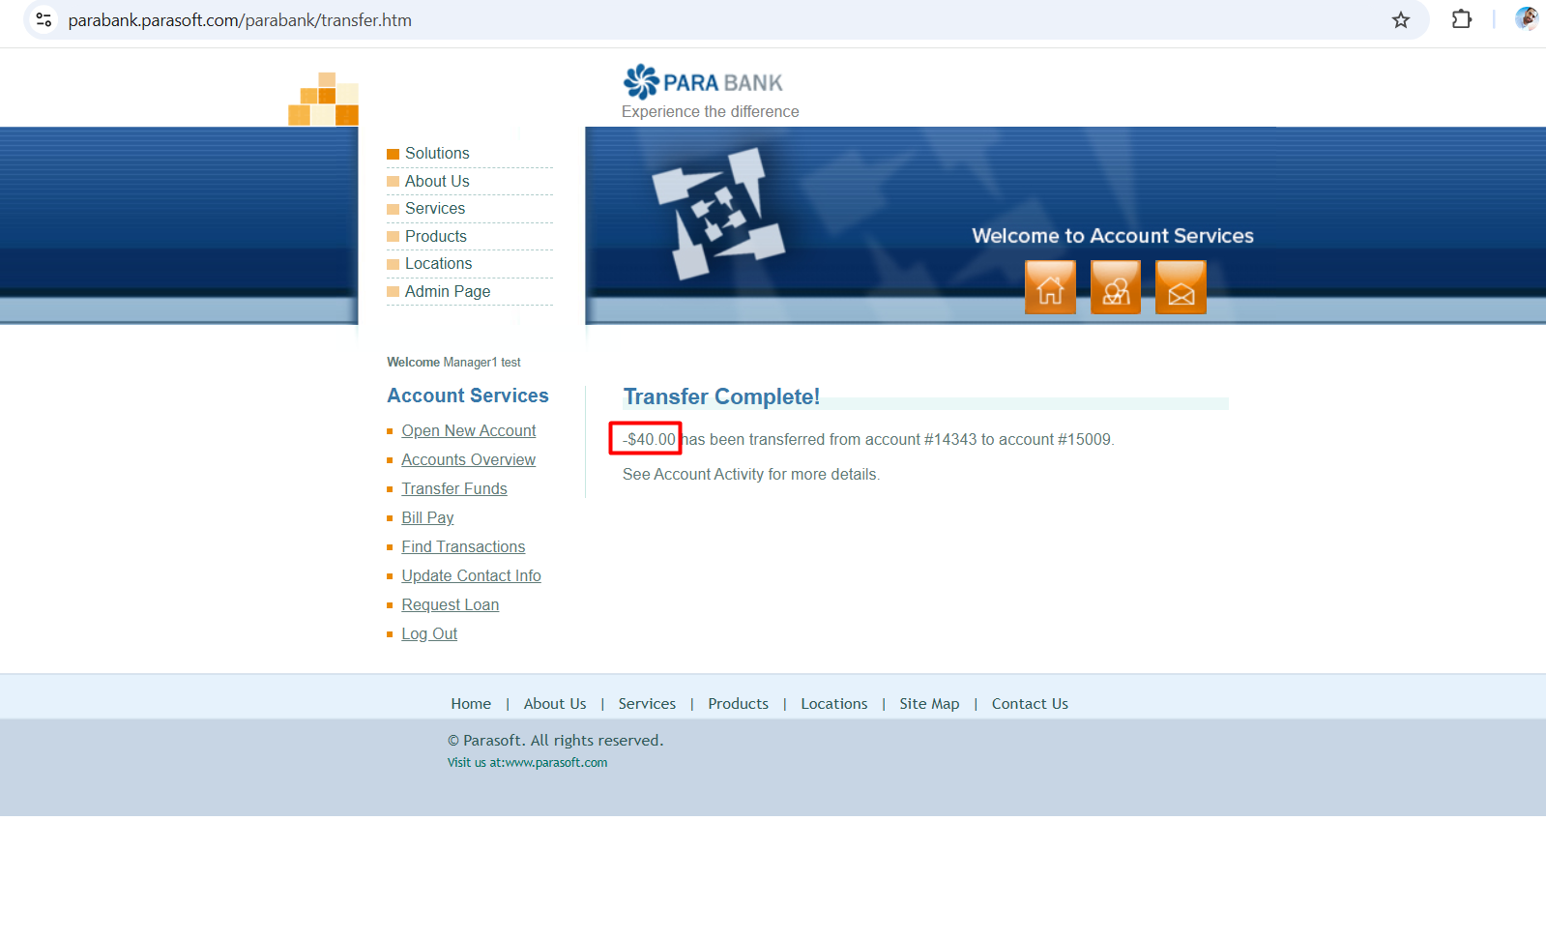
Figure 1. Confirmation of a -$40.00 transfer (evidence/bug-1-transfer-negative-amount-result.png)
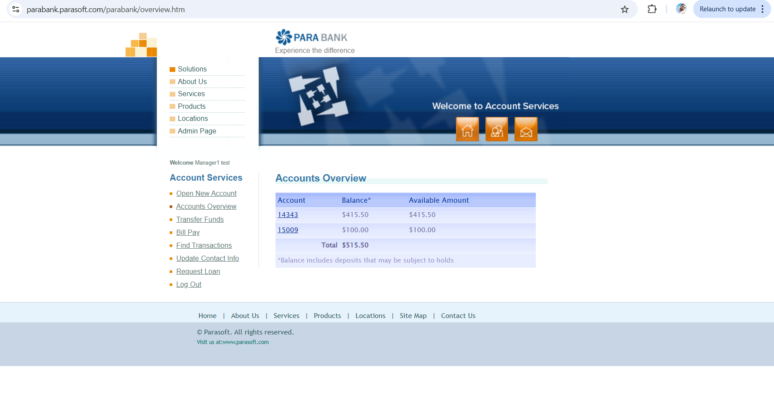
Figure 2. Before: #15009 = $100.00 (evidence/accounts-overview-before.png)
After: #15009 = $60.00, shown in Figure 4 (under Bug 2).

Bug 2: Bill Pay completes a payment larger than the available balance, taking the account negative
Field | Detail
Environment | ParaBank, https://parabank.parasoft.com/parabank/ (public demo). Google Chrome (desktop) on Windows 10 Pro. Tested 17 October 2026.
Preconditions | Logged-in customer. Source account #14343 with an available balance far below the payment amount (it held $415.50 at the start of the session, and at most $455.50 before the payment).
Severity | S1 Critical. The bank pays out money the customer does not have. In a real bank that is a direct credit loss, and the account balance becomes meaningless.
Priority | P1. Any customer can do it from the standard Bill Pay screen, for any amount, as often as they like.

Steps to reproduce
- Log in and open Accounts Overview. Note the Available Amount of account #14343.
- Click Bill Pay and complete the payee details (Payee Name test1, plus address, phone and payee account number).
- Enter Amount 5656, an amount far above the available balance, and select From account 14343.
- Click Send Payment.
- Open Accounts Overview and check #14343.

Expected vs actual
 | Detail
Expected | The payment is rejected with an insufficient-funds message. No debit.
Source of expectation | ParaBank itself shows an Available Amount for each account, which implies payments are limited to it. No overdraft facility is offered to this customer. A payment should not exceed the funds available.
Actual | "Bill Payment Complete: Bill Payment to test1 in the amount of $5656.00 from account 14343 was successful." Account #14343 went negative. At the end of the session it showed a balance of -$5,900.50 with an Available Amount of $0.00.
Balance trail | $415.50 + $40.00 (Bug 1) − $5,656.00 (this payment) − 7 × $100.00 (accounts opened, see below) = -$5,900.50, exactly the balance shown. The payment did debit the account.

Same root cause, second symptom (not reported separately)
Open New Account has the same missing funds check. With #14343 already negative and showing $0.00 available, I opened seven new accounts (#21225 to #21891). Each was funded with $100.00 taken from #14343, pushing it further negative. Because the cause is the same as above (a debit is never checked against available funds), I am treating this as one defect rather than two.

Evidence
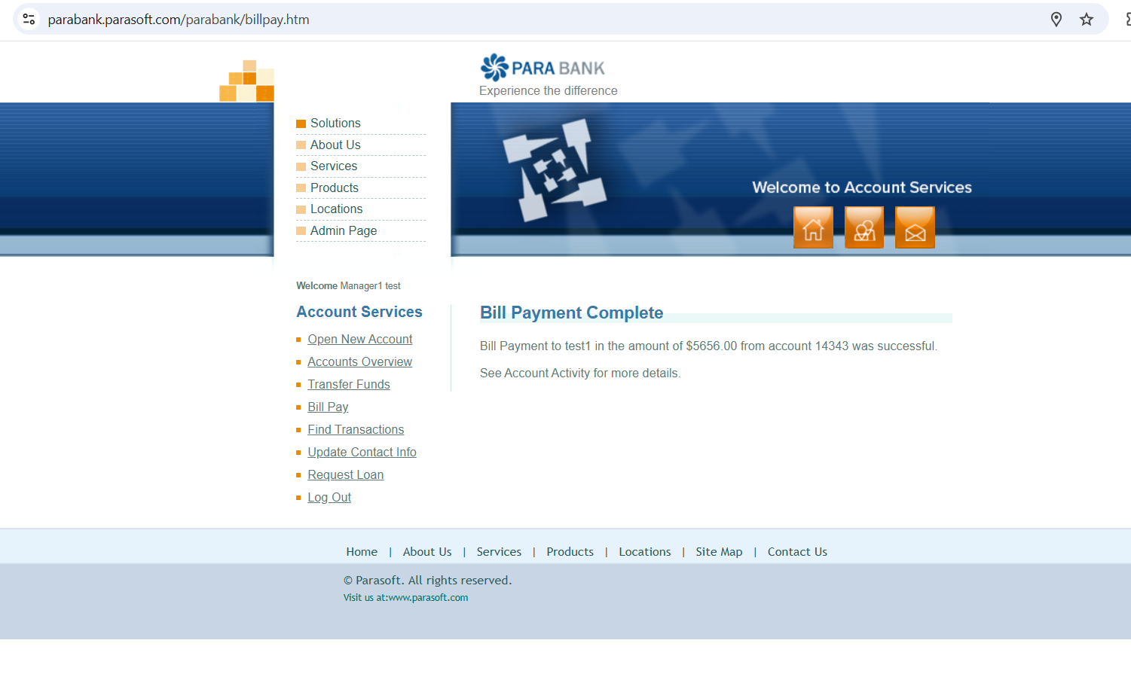
Figure 3. Bill payment of $5,656.00 reported as successful (evidence/bug-2-billpay-5656-result.png)
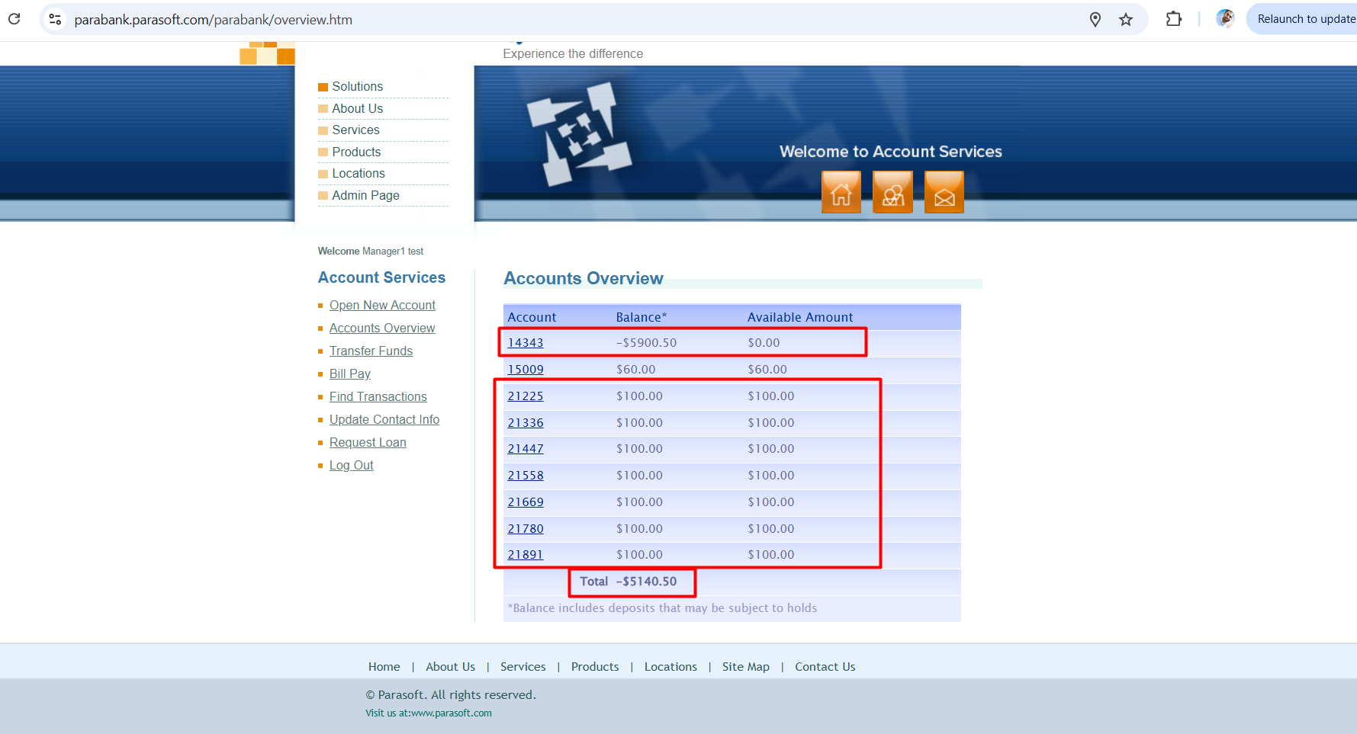
Figure 4. After: #14343 = -$5,900.50 with $0.00 available; seven new $100 accounts funded from it (evidence/accounts-overview-after.png)

2.2 Approach
Where I started and why. I went straight to money movement (Transfer Funds and Bill Pay), because that is where a defect costs a bank customer money. Login and navigation are low-risk for a 25-minute session. My oracle was the application itself: after every action I compared what the confirmation message said had happened with what Accounts Overview showed afterwards, and checked that the balance arithmetic added up.
What I tried. In Transfer Funds I probed the amount (a negative value) and the account selection (the same account as both source and destination). In Bill Pay I sent a payment far larger than the balance. When the account was already overdrawn I tried Open New Account repeatedly, to see whether any feature checked available funds before debiting.
What stood out. Every money operation reported success regardless of input. The app knew the account had $0.00 available, because it said so on Accounts Overview, yet it kept debiting. I grouped the overdraft symptoms by root cause rather than reporting each screen separately.
Additional observation (lower impact, not one of the two bugs). Transfer Funds accepted a $599.00 transfer from account #14343 to the same account #14343 and reported "Transfer Complete!". No money is lost, but it creates a meaningless transaction record and suggests the source and destination are never compared.
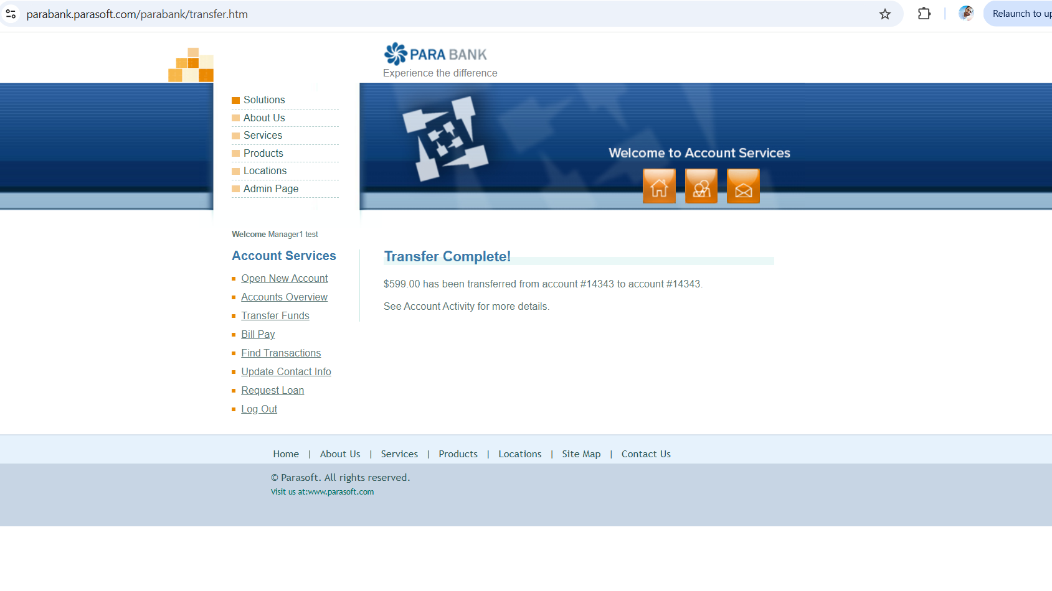
Figure 5. Transfer from #14343 to #14343 accepted (evidence/observation-same-account-transfer.png)
With two more hours I would look at:
- The REST API behind these screens, to confirm whether the missing checks are missing on the server or only in the UI.
- How the negative transfer appears in Find Transactions and Account Activity (sign and direction of each entry).
- Request Loan from an overdrawn account: whether the loan decision uses the real balance.
- Two transfers submitted at the same time from two tabs, and whether Update Contact Info changes persist.

