**Automated Inventory Manager**

Senior Project

by

**Saleh H.Kanaan,**

**Hussien A.Naserddine**

Submitted to the School of Engineering of the

Lebanese International University

Beirut, Lebanon

in partial fulfillment of the requirements for the degree of

**BACHELOR OF SCIENCE IN COMMUNICATION ENGINEERING**

**Spring 2023-2024**

**Approved by:**

**Supervisor**  

Dr. Amin Haj-Ali



**Committee Member**

Dr. TBA



**DEDICATION**

To someone I know and I care for

Saleh H. Kannan

To someone I know and I care for

Hussein A. Naserddine

**ACKNOWLEDGMENT**

We would like to thank our supervisor and the dean and the rest of the people who spared no effort in

**ABSTRACT**

The abstract goes here with double space 12pt font. The abstract consists of one paragraph with first line indentation. The page should be numbered. The abstract goes here with double space 12pt font. The abstract consists of one paragraph with first line indentation. The page should be numbered. The abstract goes here with double space 12pt font. The abstract consists of one paragraph with first line indentation. The page should be numbered. The abstract goes here with double space 12pt font. **The abstract consists of one paragraph with first line indentation**. The page should be numbered. The abstract goes here with double space 12pt font. The abstract consists of one paragraph with first line indentation. The page should be numbered.

**TABLE OF CONTENTS**

**ACKNOWLEDGMENT iii**

**ABSTRACT iv**

**TABLE OF CONTENTS v**

**LIST OF FIGURES viii**

**LIST OF TABLES ix**

**LIST OF SYMBOLS x**

**CHAPTER 1 INTRODUCTION 1**

1.1 Background 1

1.2 Problem Statement 1

1.3 General overview of the project 1

1.4 Thesis Outline 1

**CHAPTER 2 Survey of Existing Methods and Similar Systems 2**

2.1 Introduction 2

2.2 Method 1 / System 1 2

2.3 Method 2 / System 2 2

2.4 Method 3 / System 3 2

2.5 Methods/Systems Comparison 2

2.6 Conclusion and Motivation 3

**CHAPTER 3 System Design 5**

3.1 Introduction 5

3.2 Requirements and Specification Analysis 5

3.2.1 Functional Requirements 5

3.2.2 Use Case Diagrams 5

3.3 System Architecture 6

3.4 Class Diagrams 6

3.5 Sequence Diagrams 6

3.6 Activity Diagrams 7

3.7 Entity-Relationship (ER) Diagrams 7

3.8 Non-Technical Aspects 7

3.8.1 Financial Viability 7

3.8.2 Stakeholders 8

3.8.3 Scope 8

3.8.4 Risks 8

3.8.5 Schedule and Milestones 9

3.8.6 Ethical and Social Considerations 9

3.8.7 Environmental and Sustainability Considerations 9

3.8.8 Relevant Standards 10

3.9 Conclusion 10

**CHAPTER 4 Implementation/Simulation and Testing 11**

4.1 Introduction 11

4.2 Implementation Tools 11

4.3 Implementation Summary 11

4.4 Test Cases and Acceptance Criteria 11

4.5 Conclusion 11

**CHAPTER 5 Conclusion and Future Work 12**

5.1 Conclusion 12

5.2 Future Work 12

**APPENDIX A: Implementation Details 13**

**APPENDIX B: USER Manual 14**

**APPENDIX C: deployment and configuration Manual 15**

**REFERENCES 16**

**LIST OF FIGURES**

Figure ‎3-1- System Architecture 6

Figure ‎3-2- Cost Benefit Analysis 8

Figure ‎3-3- Scheduling Tasks and Milestones 9

**LIST OF TABLES**

Table 2-1: Comparison Table Based on Graphical Interfaces 3

Table 2-2: Comparison Table Based on Content and Functionality 3

Table 2-3: Comparison Table Based on Features 3

**LIST OF SYMBOLS**

MUST LISTED IN ASCENDING ALPHABETICAL ORDER. Examples:

Ω: Resistance

μ: Viscosity

A: Ampere

BW: Bandwidth

CD: Compact Disk

COVID: Corona Virus Disease

ISO: International Standardization Organization

LCD: Liquid Crystal Display

LIU: Lebanese International University

WiFi: Wireless Fidelity

# INTRODUCTION

## Background

After knowing and inspecting the importance of a good and smooth inventory operation through my internship at Aramex , my partner and I started researching on how to fulfill such conditions . automation process, thus we've developed I.M.S (Inventory Management System ) a system that holds the solution to ensure the business models are future proof and up to date with reducing the waiting time to check if a product is available or not and retrieving a desired product as well as a software that is responsible for the interactions between the employees and our system, thus resulting in a smoother and quicker experience for customer that would leave a good impression.

## Problem Statement

Embracing automation in the inventory process is a crucial step to revitalize a simple and outdated stocking model; this change can bring great advantages while acknowledging some inherent disadvantages. some major advantages can be summarized in increasing the efficiency of finding and retrieving any product thus making the customer interaction much smoother and faster, this does result also in having a organized system thus simplifying logistical processes, in which it would result in some disadvantages such as reducing job availability as this manual task becomes automated. Another disadvantage is the high cost for large business inventory that result in scalability challenges

## General overview of the project

Embracing automation in the inventory process is a crucial step to revitalize a simple and outdated stocking model; this change can bring great advantages while acknowledging some inherent disadvantages. some major advantages can be summarized in increasing the efficiency of finding and retrieving any product thus making the customer interaction much smoother and faster, this does result also in having a organized system thus simplifying logistical processes, in which it would result in some disadvantages such as reducing job availability as this manual task becomes automated. Another disadvantage is the high cost for large business inventory that result in scalability challenges.

## Thesis Outline

The following chapters will discuss about:

* Chapter 1: General introduction about the project.
* Chapter2: will present and compare similar systems and existing methods.
* Chapter 3 includes design parts of the system.

# Survey of Existing Methods and Similar Systems

## Introduction

This chapter will cover the comparison of the existing methods and similar systems : (3D printer, website) to IMS (Inventory Management System) based on their functionalities and features.

## Method 1 / 3DPrinter

A 3D-Printer is a type of additive manufacturing technology that creates three-dimensional objects layer by layer from digital models or computer-aided design(CAD) files and in order for this technology to print its models, the 3D printer’s nozzle moves along X, Y, Z axes for building the platform layer by layer.

In this project will apply the same concept in moving the object only X and Y that allow the platform flexible movements along all the shelfs and rows.

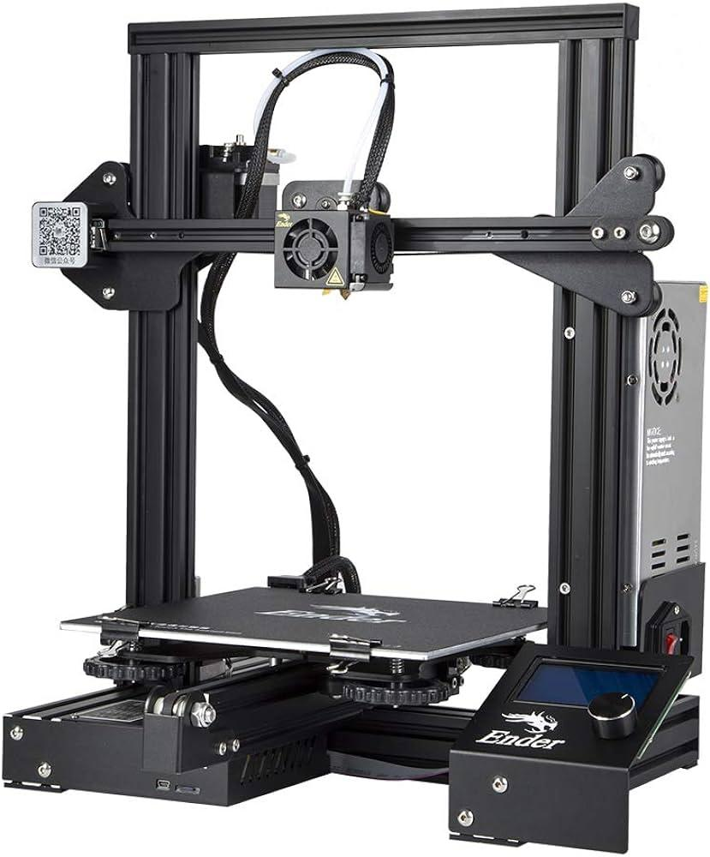

## Method 2 / Katranji System site

It is a system for the employees that allow them to access all the components inside the stock of the company and serve the clients and customer’s services from different kinds and types of electronic components.



## Methods/Systems Comparison

**Table 2-1: Comparison Table Based on Graphical Interfaces**

|  |  |  |
| --- | --- | --- |
| **Criterion 1** | **System 1** | **System 2** |
| **Graphical Interface** |
| Good user interface | yes | yes |
| Easy and effective navigation | no | no |
| Simple and professional Design | no | yes |
| Responsive | yes | yes |

**Table 2-2: Comparison Table Based on Content and Functionality**

|  |  |  |
| --- | --- | --- |
| **Criterion 2** | **System 1** | **System 2** |
| **Content and Functionality** |
| Quality content structure | yes | yes |
| Usability | yes | yes |
| Dynamic content | yes | yes |
| Content management system | yes | no |

**Table 2-3: Comparison Table Based on Features**

|  |  |  |
| --- | --- | --- |
| **Criterion 3** | **System 1** | **System 2** |
| **Features** |
| Security measures | yes | yes |
| Third party integration | yes | no |
| Accessible content and location | yes | no |
| Registration form | no | no |

## Conclusion and Motivation

In conclusion, the mentioned systems above have their own functionalities either in the industrial field or printing fields. So, by implementing these functionalities in our project it will result in the most flexible, fast and dynamic storing of products in stock management systems as well as auto retrieve them using automation. These revolutions will lead companies to be more efficient thus resulting in a simpler and smoother experience to the client .

In the next chapter, we will discuss the steps of creation and implementation of our project.

# System Design

## Introduction

Through this chapter, we will discuss a detailed description about the project goals and functionalities as well as the tools used to build such a project. Besides, we will move through the technical part that shows the system architecture of various diagrams including sequence diagrams, use case diagrams, class diagrams, and entity-relationship diagrams. Then, we will discuss the non-technical part consist of the stakeholders, cop as well as the potential risks and ethical consideration that may rise from this project.

## Requirements and Specification Analysis

This section is meant to explain to the reader use cases for the project, activity diagrams, as well as specification, documentation and requirements of the project. This section can have sub-sections.

### Functional Requirements

**For Stock Employee:**

* Login into the IMS mobile application.
* Scan the product’s bars and their location and save them inside database.
* Adjust the quantity desired.

**For Web Employee:**

* Log in to the IMS website.
* Allow them to browse the site for the customer’s needs for a product
* Allow the employee to view their selected item and its details inside the table.
* Provide a page to view the terms and services of the application
* Request the product to be delivered automatically from it’s location.
* Provide a monthly progress selling target for each employee

**For Manager:**

* Login as the manager of the company.
* Allow him to browse inside the stock.
* Allow him to check the transactions of the company done by the employees.
* Provide a page to view the terms and services of the application
* Provide a page for shop owners to view their total earnings sold by each employee with the total quantity sold.

### Use Case Diagrams

In figure below, it shows the use case diagram of the software system:

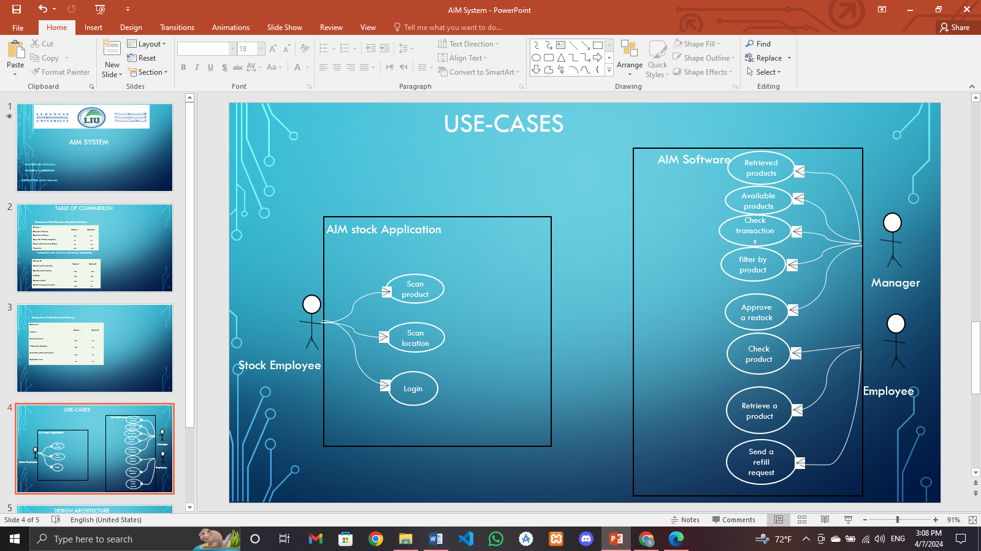

## System Architecture

Define the overall architecture of the system. Layered, Dataflow, Multi-tier, Client-Server, etc. It is worth noting the underlying technologies to be used. Draw a figure that shows the complete system Example of such figures:

Webserver

HTTPS

HTTPS

Stock Employee

Employee

Insert Data

Display Data

Database

HTTPS

IMS Rack

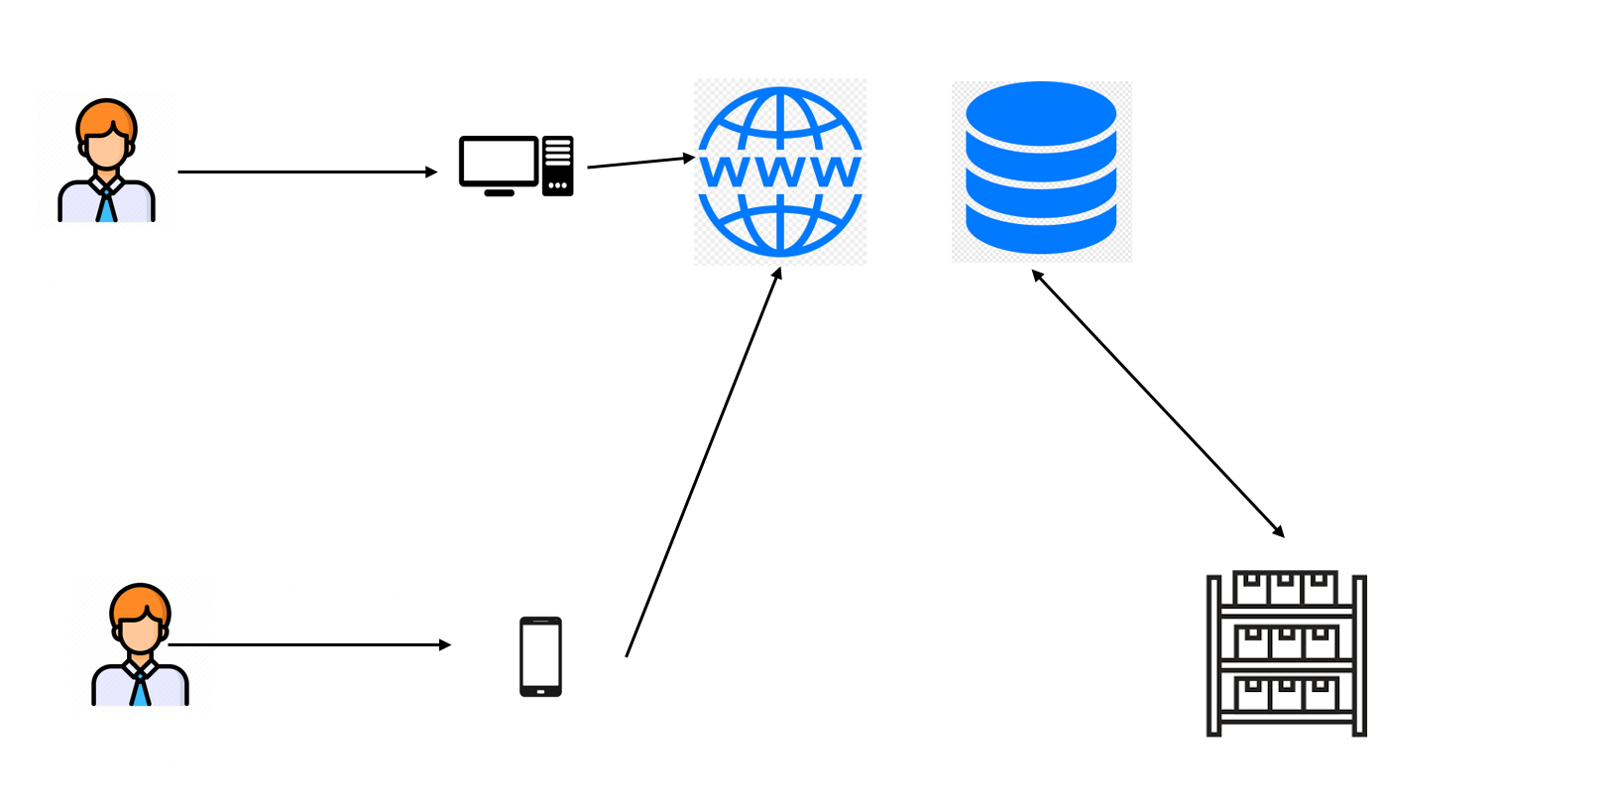

In this figure, it shows the architecture of the whole project process.

## Class Diagrams

In this part, it will show all class diagrams for Stock and web employee and manager.

* **Class Diagram (Stock Employee):**

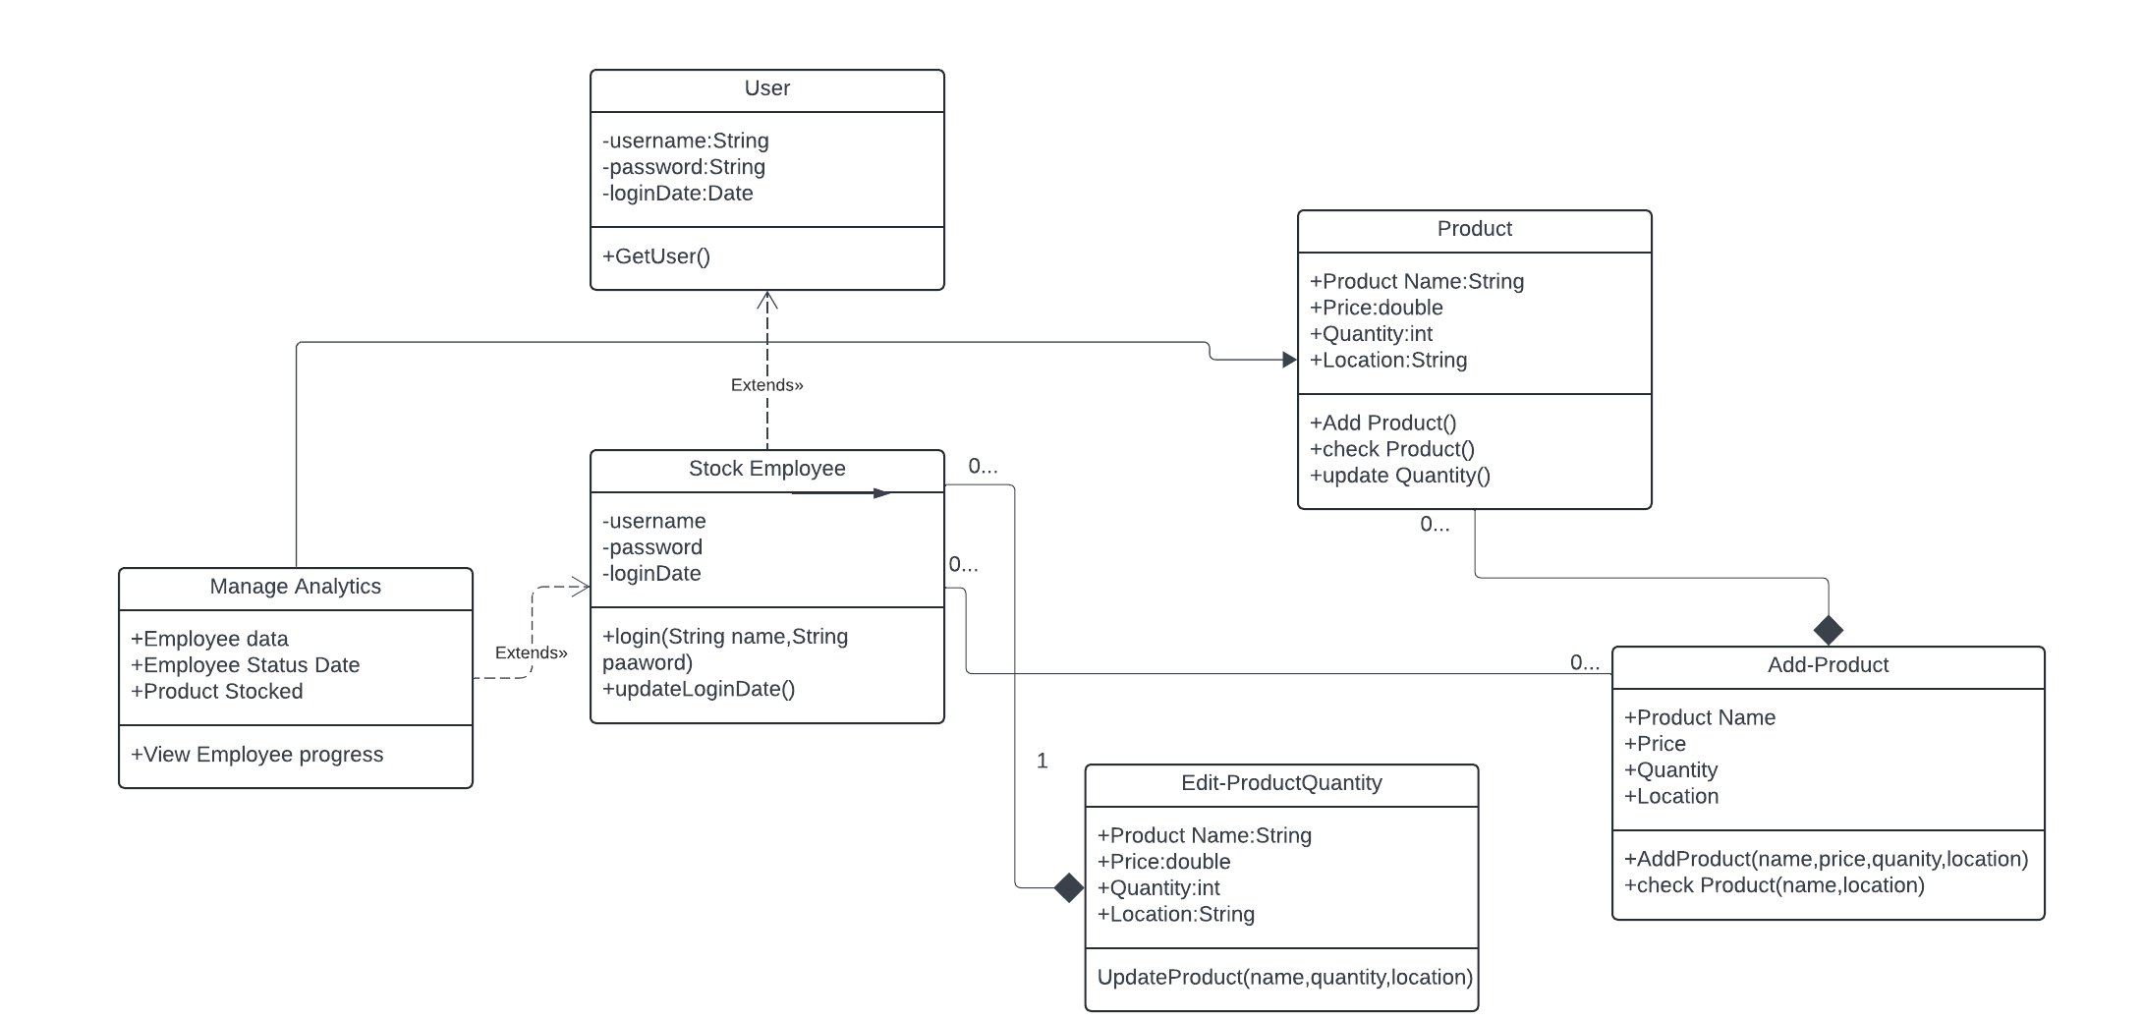

* **Class Diagram (Customer-Services Employee/Manager):**

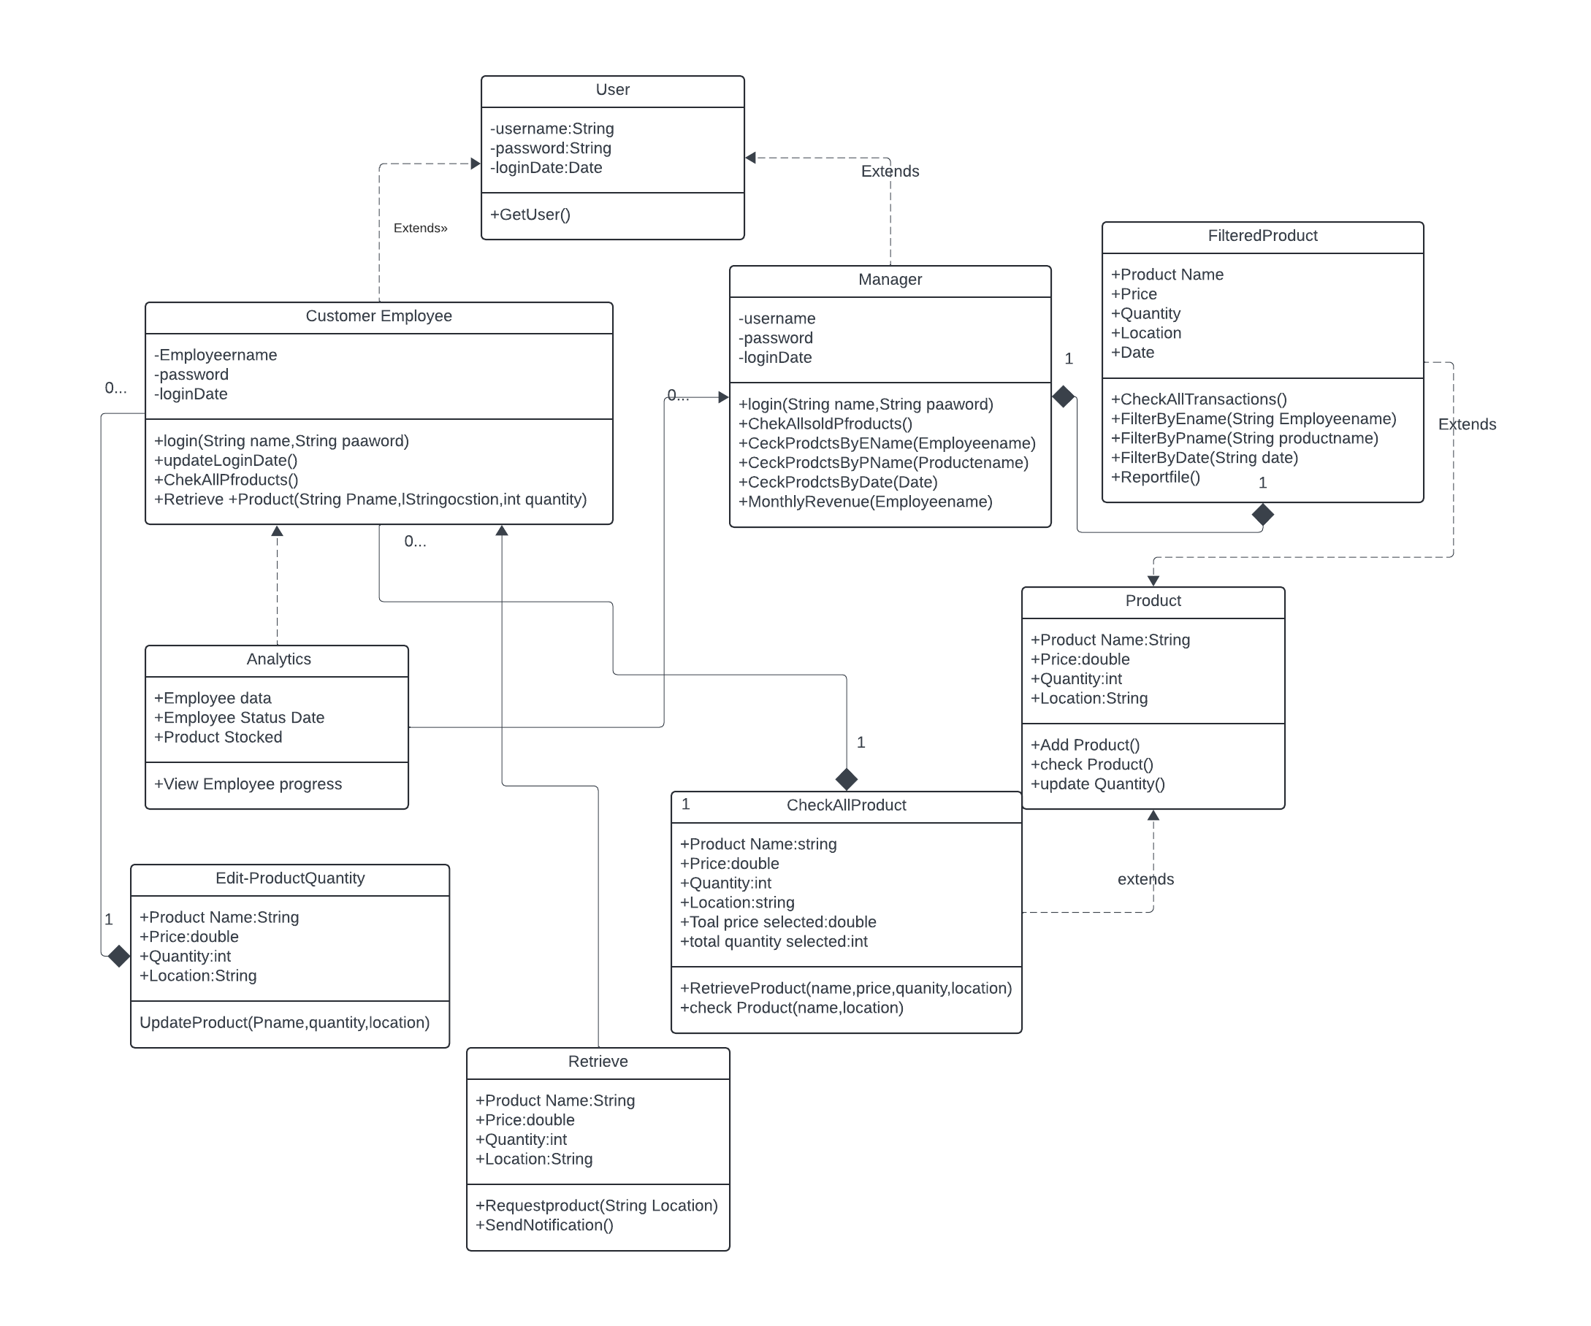

## Sequence Diagrams

* Sequence Diagram (Web Employee):

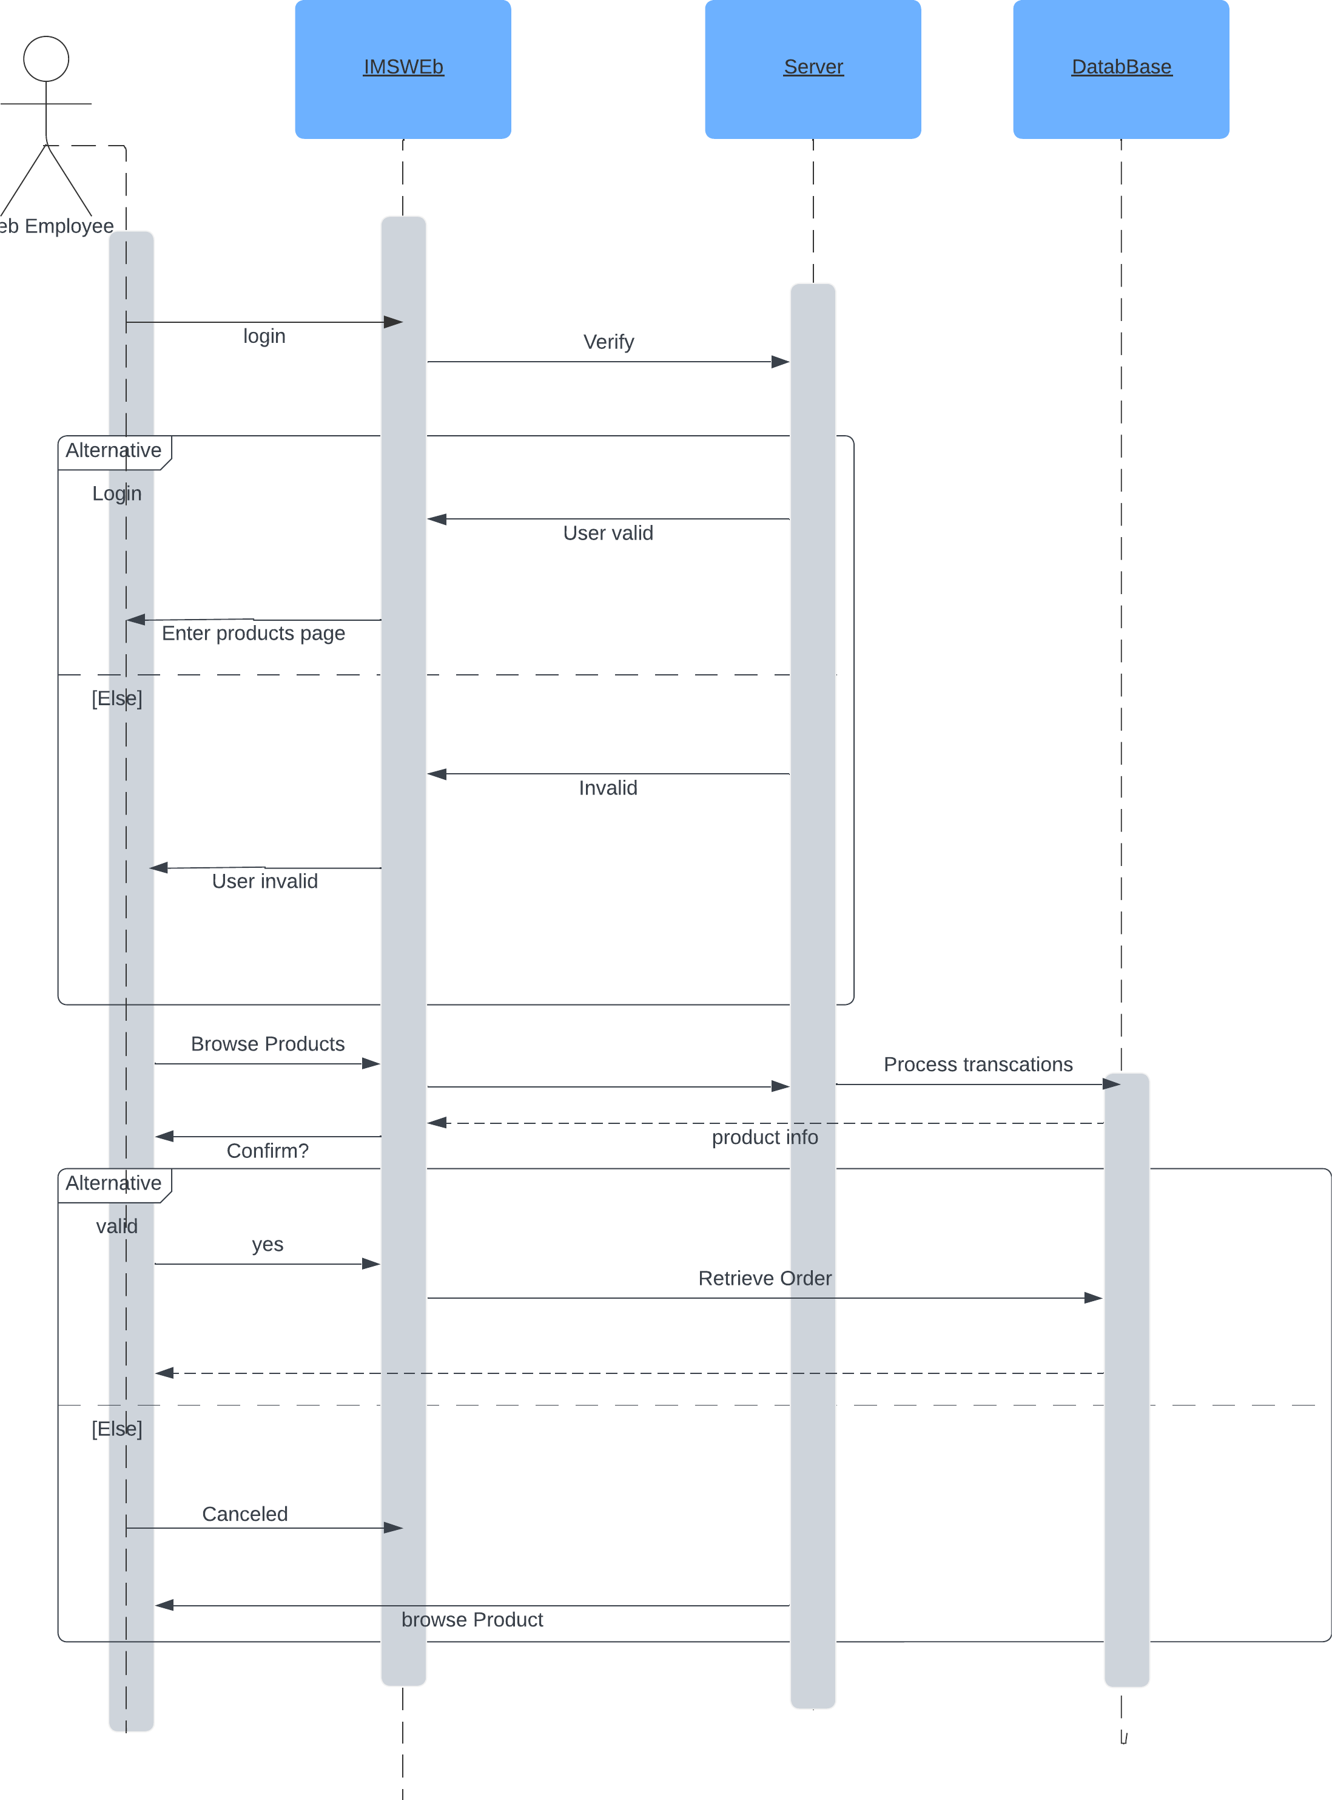

Sequence Diagram(manager):

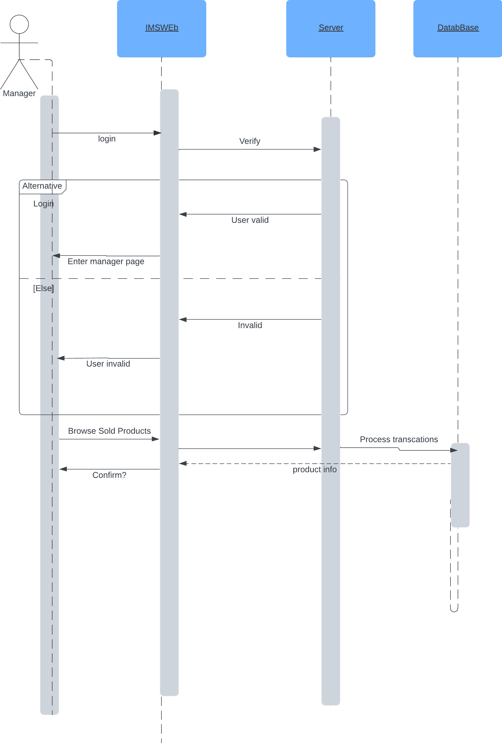

* Sequence Diagram(Stock Employee):

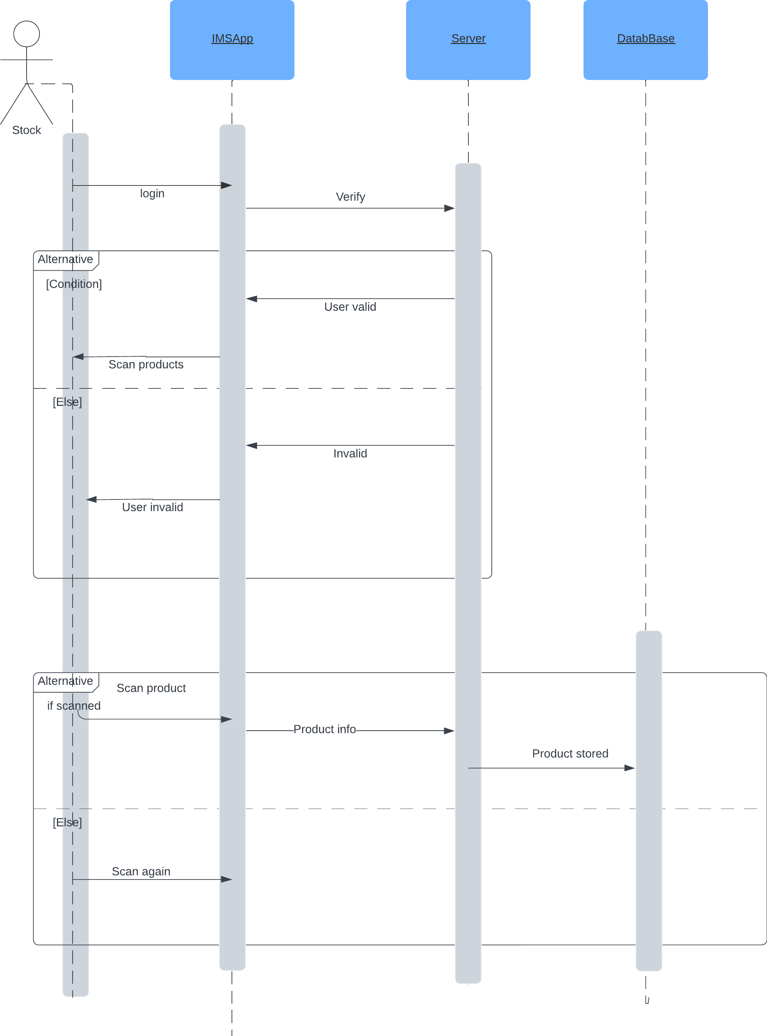

## Activity Diagrams

* Activity Diagram(Stock):

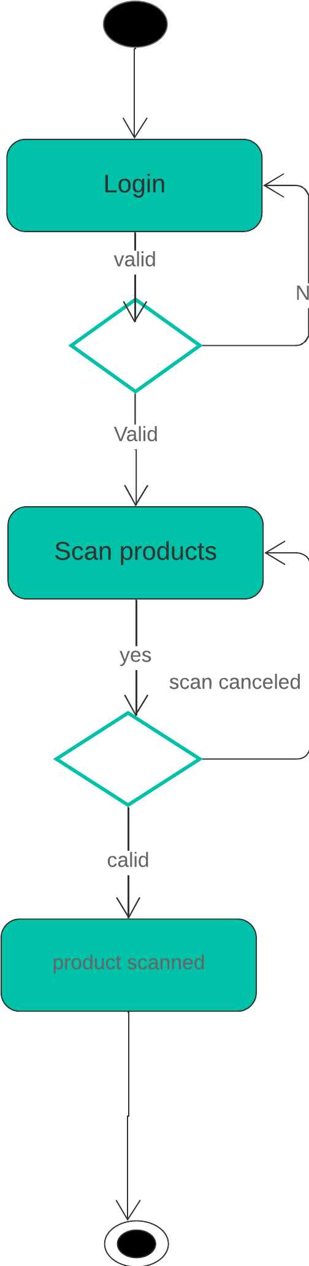

* Activity Diagram (customer service employee):

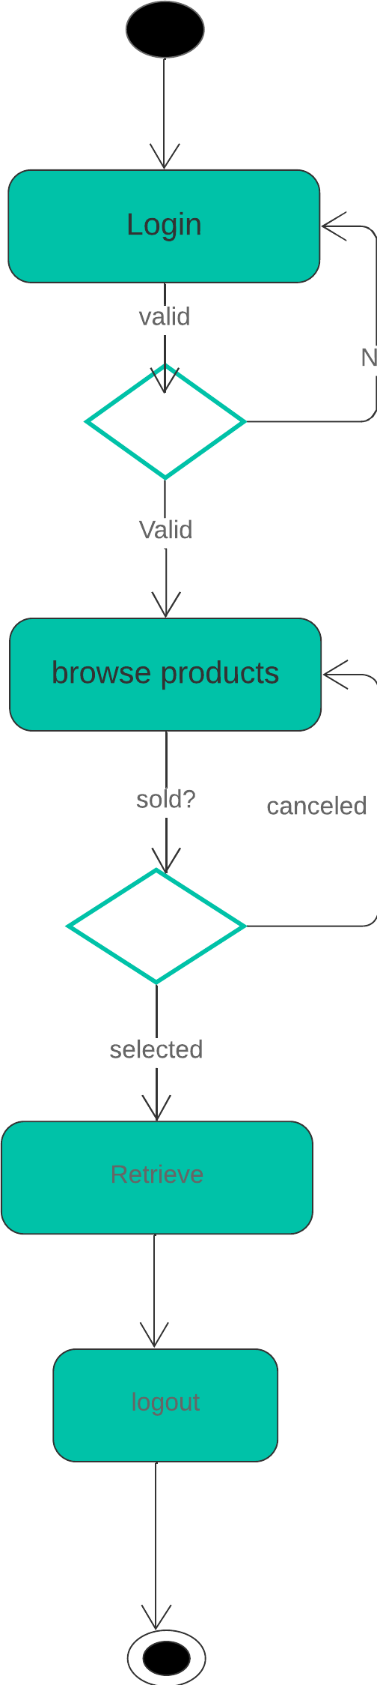

* Activity Diagram (Manager):

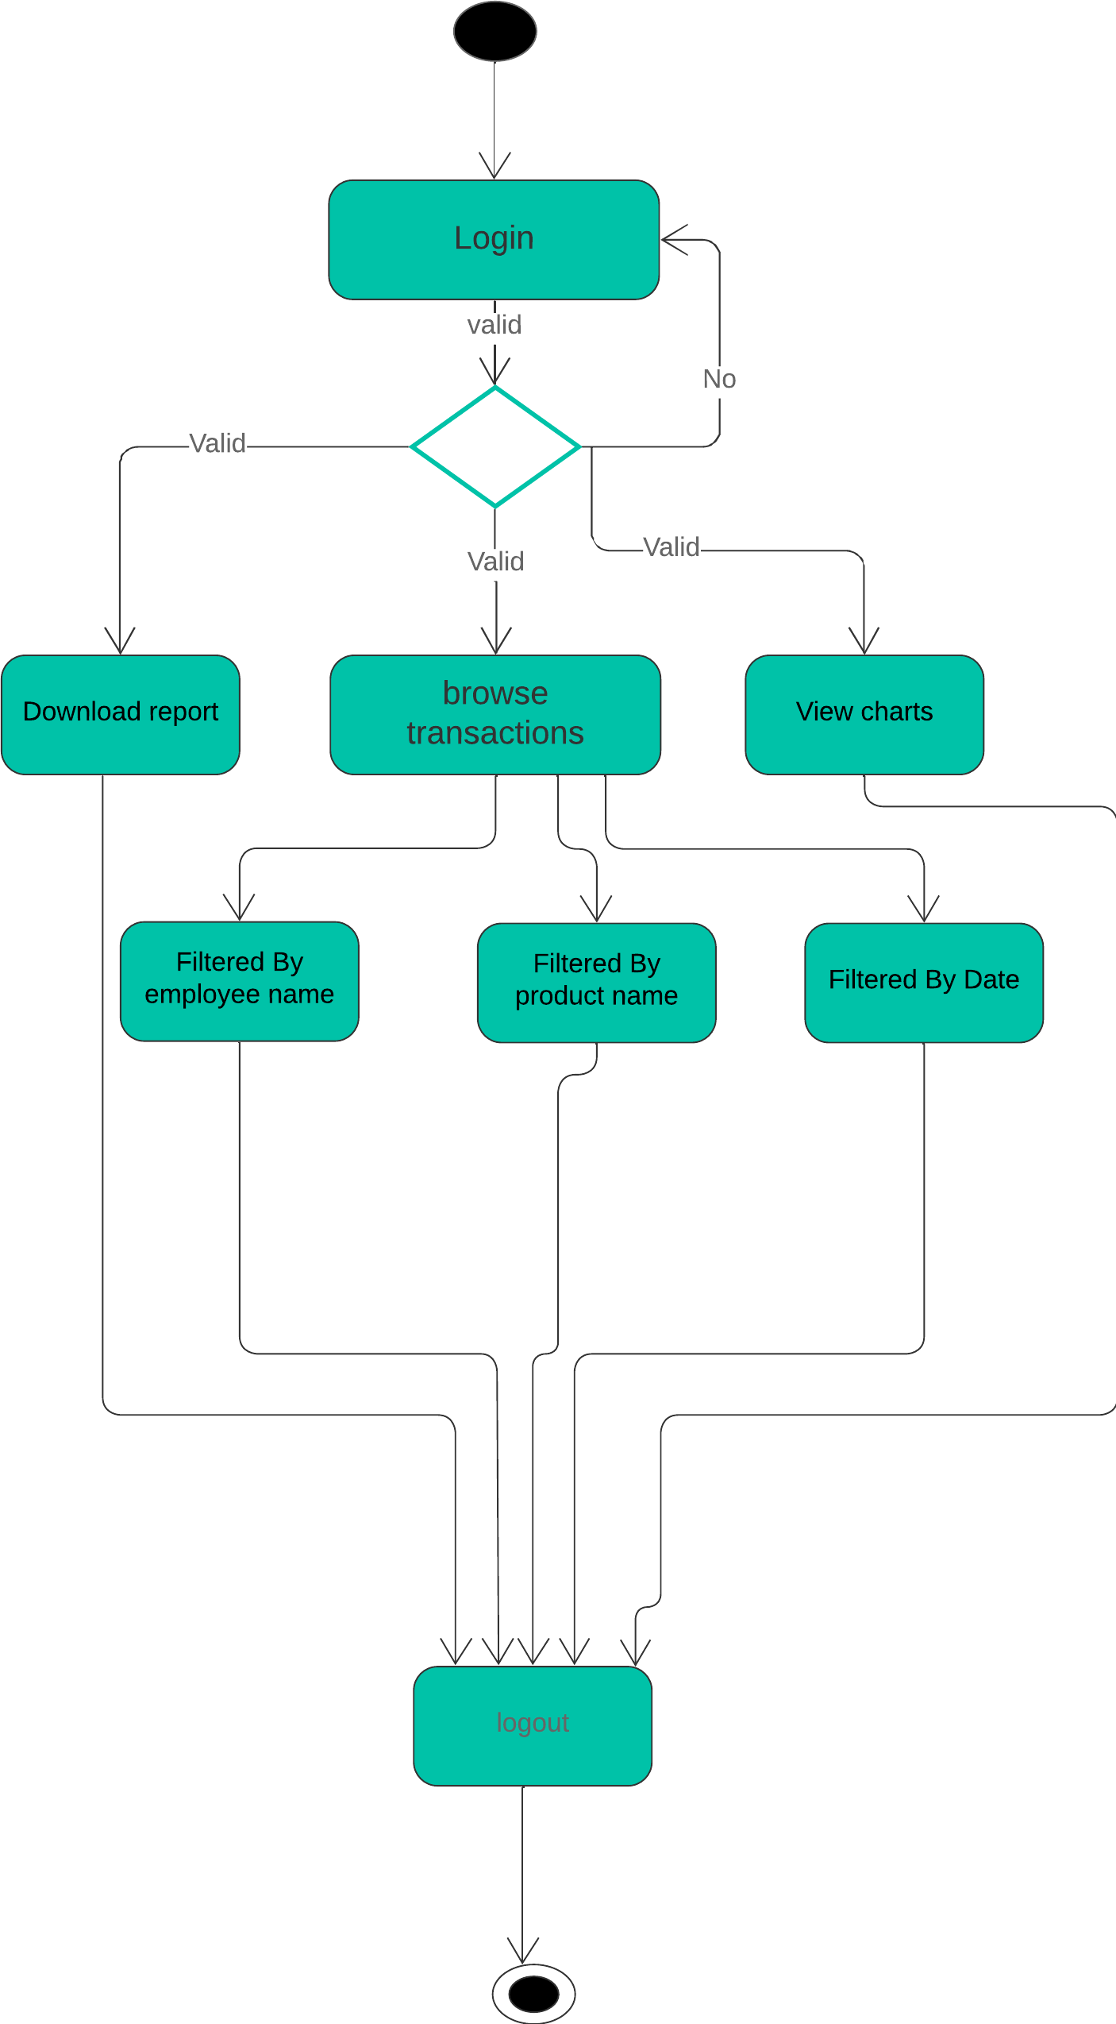

## Entity-Relationship (ER) Diagrams

ER diagram is implemented and attached below to show and make the understanding of database easier and much clear:

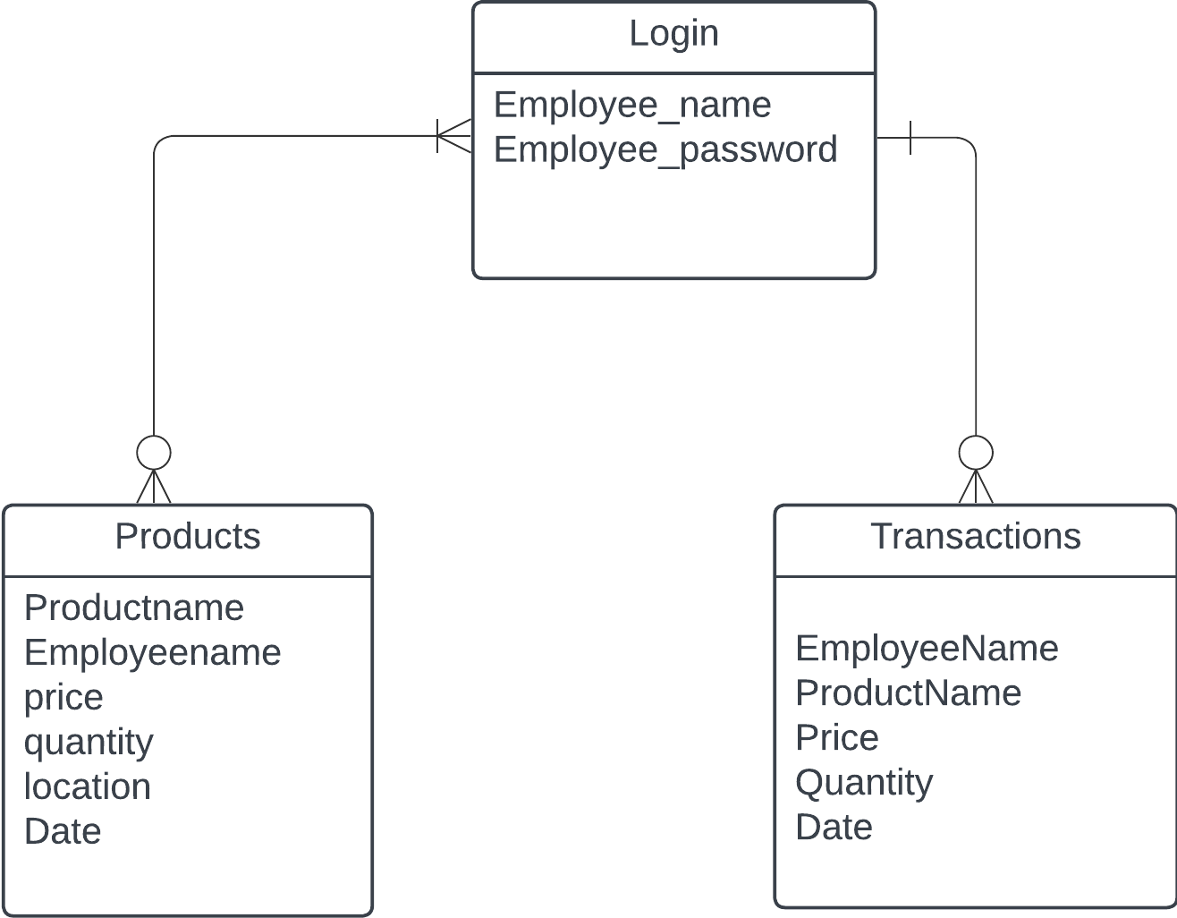

## Non-Technical Aspects

### Financial Viability

A cost benefit analysis of the project. Here is an example:

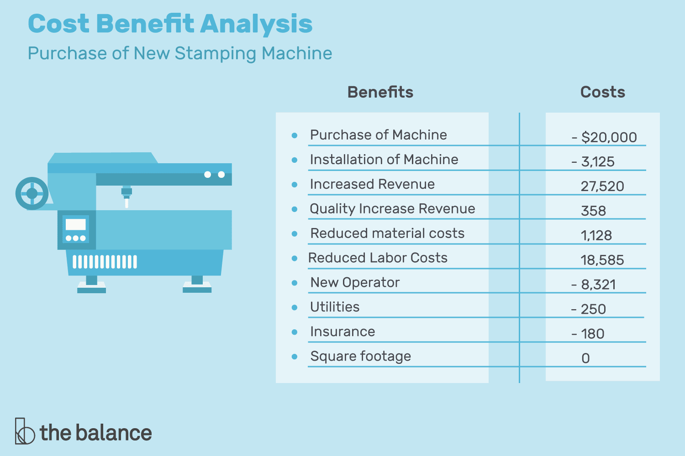

**Figure ‎**3-2- Cost Benefit Analysis

### Stakeholders

Who will benefit? Who may be harmed? Who should have a say in how the project works?

### Scope

Exactly what will be done in the project, sometimes it is helpful to state what will not be done in the project.

### Risks

Things that may stop the project from achieving the goals in the scope.

### Schedule and Milestones

What will be completed and when. Here is an example:

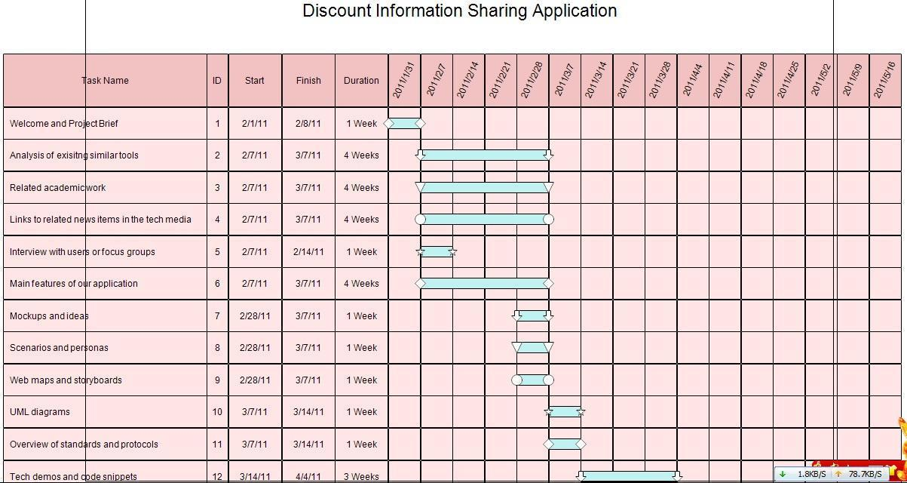

**Figure ‎**3-3- Scheduling Tasks and Milestones

### Ethical and Social Considerations

Are there any ethical issues that should be taken into consideration when completing the design?

### Environmental and Sustainability Considerations

Are there any environmental issues to write about? It is ok to write that this project has no environmental impact.

### Relevant Standards

The Technical Standards are:

* WIFI
* A Smart phone for stock employee
* Computer for customer service
* The creation and implementation of the hardware platform for product retrieve.

## Conclusion

This paragraph in meant to draw conclusions highlighting the main ideas in this chapter.

# Implementation/Simulation and Testing

## Introduction

This paragraph in meant to introduce the topics to be covered in this chapter.

## Implementation Tools

List the tools used for implementing the system. This includes hardware, compilers, IDE, frameworks, CASE tools, etc...

## Implementation Summary

Description of detailed implementation steps. Demonstrate the typical code fragments (details of implementation, e.g. source code listings must be included in an appendix and saved on an accompanying CD/DVD)

## Test Cases and Acceptance Criteria

Describe the test cases used and the acceptance criteria.

## Conclusion

This paragraph in meant to draw conclusions highlighting the main ideas in this chapter.

# Conclusion and Future Work

## Conclusion

Any concluding remarks, lesson learned, etc…

## Future Work

Describe the opportunities for expanding the work done in this thesis.

**APPENDIX A:   
Implementation Details**

Any details not fit in chapter 5: e.g. detailed calculation, complex algorithms, etc…

**APPENDIXB:  
 USER Manual**

Fill in the instruction manual for using the application

**APPENDIXC:   
deployment and configuration Manual**

Outline the deployment and configuration details in addition to any know troubleshooting techniques.

**REFERENCES**

|  |  |
| --- | --- |
| [1] | John Smith and John Doe, "Wireless Sensor Networks," *IEEE Transaction on Mobile Computing ,* vol. 1, no. 2, p. 12, 05 2010. |
| [2] | John Smith et al., How to add IEEE Reference style to Microsoft Word, Beirut, Lebanon: LIU, 2011. |